Food Security and Nutrition Network Gender Task Force
These core competencies can be used together with the TOPS Self-Rating Tool to adapt the TOPS Self-Assessment Toolkit to your needs.

Gender Staff∗
Gender lead staff in a development food security program can be known as advisors, specialists, managers or by other titles. They are typically located in the country where programs are implemented and provide guidance to other technical leads and senior management on designing and/or modifying activities for gender integration. They also assist in monitoring activities and results, paying particular attention to unintended negative impacts on different social groups (men, women, children, etc). Gender leads take into account contextually relevant considerations such as socioeconomic conditions, religion/faith/spirituality, language, and the physical, environmental, political, and cultural environments.
The gender staff core competency areas include:
- Gender concepts
- Gender Analysis, Thematic Studies, Formative Research
- Gender Training
- Implementation of Gender Strategies and Activities
- Monitoring, Evaluation, and Reporting

Gender Concepts

Demonstrated understanding of gender equality and equity, gender integration, engaging key influencers as agents of change, and women’s empowerment.

Familiarity with key USAID policy documents including the 2012 Gender Equality and Female Empowerment Policy, ADS 205, and Food for Peace’s 2016-2025 Food Assistance and Food Security Strategy.

Understanding of the following within the program context:

Laws, policies, regulations, and institutional practices (for example, abuse, discrimination, land rights).

Cultural norms and beliefs

Distribution of gender roles, responsibilities, and time use

Access to and control over assets and resources for women and men

Patterns of power and decision-making

Demonstrated knowledge of gender integration in the key programmatic areas of food assistance programming which may include nutrition, health, WASH, markets, value chains, financial systems, natural resource and environmental risk management, on and off-farm livelihoods, and social protection.

Demonstrated knowledge of gender integration strategies when working with individuals, households, groups, and local government.

Gender Analysis, Thematic Studies, Formative Research

Serve as the key point of contact for the research team conducting the formal gender analysis to inform program design. The gender lead should be involved in the following activities, but their level of engagement may vary from project to project:

Develop the Scope of Work for the gender analysis activities, including key gender research questions and stakeholder involvement.

Knowledge of and ability to provide relevant secondary data to the research team.

Contribute to the development of qualitative and quantitative data collection tools.

Support or assist with data collection activities, such as conducting interviews, facilitating focus group discussions, or conducting surveys.

Contribute to the development of data organization and analysis tools that will allow gender inequalities to be identified (e.g., sex-disaggregated qualitative matrices).

Provide assistance with the interpretation of data.

Review and provide feedback on draft copies of the gender analysis.

In coordination with the M&E/MEAL teams and senior management of the program, incorporate gender findings in the project theory of change.

Determine when additional gender research and analysis is needed as gaps are identified.

Gender Training

Design and deliver context-specific trainings on gender topics relevant to programmatic components.

Work with sector-specific technical staff and other stakeholders to develop formal trainings and informal sessions with a gender lens utilizing new or existing resources.

Identify and adapt to the local context existing gender resources and tools to support gender integration within the program and activities, collaborating with technical sector staff.

Train staff on the delivery of gender-specific topics with particular emphasis on addressing sensitive issues (i.e., gender-based violence, child marriage), mitigating for unintended negative impacts resulting from the trainings, promoting actions adjusted to the context of the program and the area where the program will be implemented.

Identify and train a cadre of staff to serve as trainers. This could include other gender staff or specialists/managers within the program interested in becoming a trainer on gender integration.

Implementation of Gender Strategies and Activities

Advise on and revise proposed strategies and activities as needed and when required (program start-up, after the gender analysis), including budget implications.

Actively engage in developing an action plan to incorporate recommendations from the gender analysis

Based on formal and informal feedback, update strategies to address key gender targets as needed.

Coordinate with key program staff, including managers and technical specialists, to ensure the implementation of gender strategies and gender integration into program activities.

Foster internal and external relationships for coordination and collaboration. This includes, but is not limited to, program partners and organizations doing similar work, including governmental entities.

M&E and Reporting

Actively support the design of M&E data collection tools that are able to inform gender indicators and monitor negative impacts.

Coordinate with the M&E/MEAL team to ensure findings from the gender analysis guide annual and routine data collection.

Interpret results and present findings, recommendations, lessons learned and best practices to colleagues to further learning through communities of practice, online communities, webinars, conference presentations, training sessions and other knowledge sharing mechanisms.

During annual review of program theory of change, apply the gender findings and modify as needed.

Use findings to make recommendations on how project can modify activities or mitigate negative impacts.

Provide input for reports to the donor as requested which may include providing case studies or examples of program successes or challenges related to gender integration.

Notes on Program Implementation
Gender is often presented as a cross-cutting issue within development food assistance programs. Senior management should be held responsible for ensuring the following occurs prior to and during the implementation of a program with a focus on sustainability. Senior management should also facilitate conditions for women and men to complete their work in an equitable environment.
- Staff are held accountable for their role in promoting gender equitable opportunities and identifying and reporting potentially harmful strategies and activities. This accountability should be outlined in job descriptions and measured in annual performance evaluations. Buy-in from staff on the benefit of acknowledging and reacting to gender-specific needs is key to achieving this shared accountability.
- Sex-ratios of personnel should be determined by the need to reach beneficiaries of different sexes where the sex of the extensionist, volunteer, or field staff person may be crucial to achieving project outcomes (e.g., Health/Nutrition behavioral change communication among men, or providing goods, services, or training to women in many Muslim cultures).
  - Consider the importance of soft skills such as communication and relationship building that will open the pool of candidates to more women as well as benefit many positions, especially those that are field-based.
  - Understand that ratios may be unequal due to the availability of qualified people. Because of differing levels of access and different methods of learning about opportunities or sharing information, ensure that positions are posted where both males and females will access them. Program leadership is also strongly encouraged to mentor and offer capacity strengthening opportunities to those individuals who express interest in pursuing a position usually held by a member of the opposite sex.
  - Understand a potential implementing partner’s gender policies and be sure to explain expectations for gender in programming and at an organizational level. Expectations for staff qualifications, training, and monitoring and evaluation of gender should be discussed prior to agreeing to partner and expressed in formal commitments.
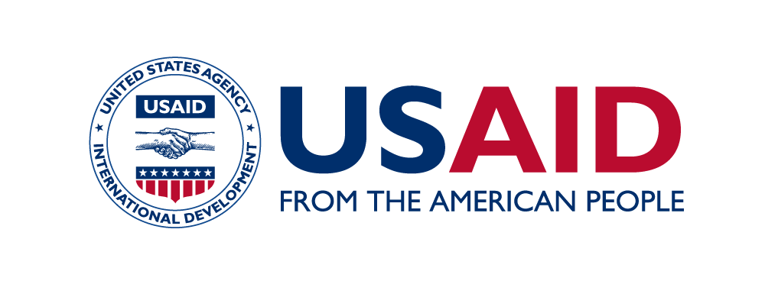
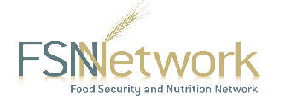
The Technical and Operational Performance Support (TOPS) Program is the U.S. Agency for International Development (USAID) Office of Food for Peace-funded learning initiative, bringing the highest quality information, knowledge, and promising practices in food assistance programming to implementers and donors around the world to ensure more communities and households benefit from the U.S. Government’s investments to fight global hunger.
The TOPS Program Core Competency Series is made possible by the generous support of the American people through the USAID. The contents are the responsibility of The TOPS Program and do not necessarily reflect the views of USAID or the United States Government.
This is Version 2 of the core competencies for Gender Staff, produced in September 2017.
The TOPS Program
899 North Capital Street, NE, Suite 900
Washington, DC 20002
info@TheTOPSProgram.org
The Core Competency Series was developed by staff from The Technical and Operational Performance Support (TOPS) Program with significant contributions from the various task forces of the Food Security and Nutrition (FSN) Network. The series intends to provide hiring managers, program managers, and program staff with explanations of the basic skills and knowledge senior technical staff may possess to carry out their positions effectively. Official job titles, functions, and requirements may vary based on organization and program.

∗This is a working document to be reviewed and updated as needed. Contributors to the August 2017 edition include Tiruset Haile, Flor Idalia Muñoz López, Libertad Teresita Rodriguez López, Aissatou Abdoulaye, Carolyne Kamba, Vero Ramananjohany, Alinane Kamlongera, Wubit Shiferaw Managdie, Dudu Sikosana, Caroline Agalheir, Mariama Maizama and CRS Niger, and Anaïs Vibranovski.

