Session 3.2: Instructions for small group work.
Designate group members to fill the following roles:
  - One Chief of Party- to make a final decision when the group comes to an impasse.
  - One graphic guru- to capture assumptions and rationales in the TOC diagram
  - Two note takers to complete the assumptions and rationale matrices
Handouts and Tools for this exercise:
- Complementary Documentation matrices

ASSUMPTIONS
- Start with your electronic TOC diagram and the Complementary Documentation matrices on your USB.
- Select one pathway and check for assumptions between each pre-condition and the outcome above it.
- Insert assumptions in the TOC diagram using a different color and shape. Assign each assumption a number (A1, A2 etc.).
- Record the assumption and the evidence that supports the assumption in the Complementary Documentation matrix on your USB).
See other side for instructions on rationales.

RATIONALES
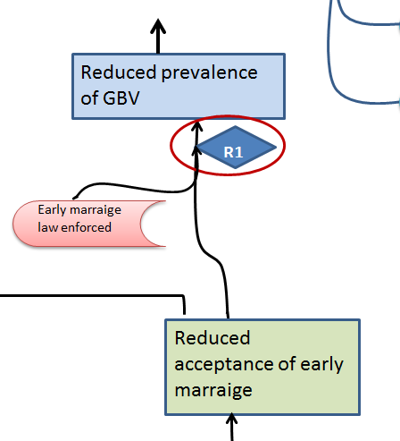
- Discuss linkages where rationales might be needed—areas where the causal logic might not be clear to all users.
- Add an identifier (R1,R2, R3) in the TOC diagram, using a distinct shape and color.
- Enter notes to support the rationale in the Complementary Documentation matrices. This includes web links, references to literature, or other evidence.
- If time, repeat steps 1-7 for other pathways.

