Infant and Young Child Feeding Recommendations When COVID-19 is Suspected or Confirmed:

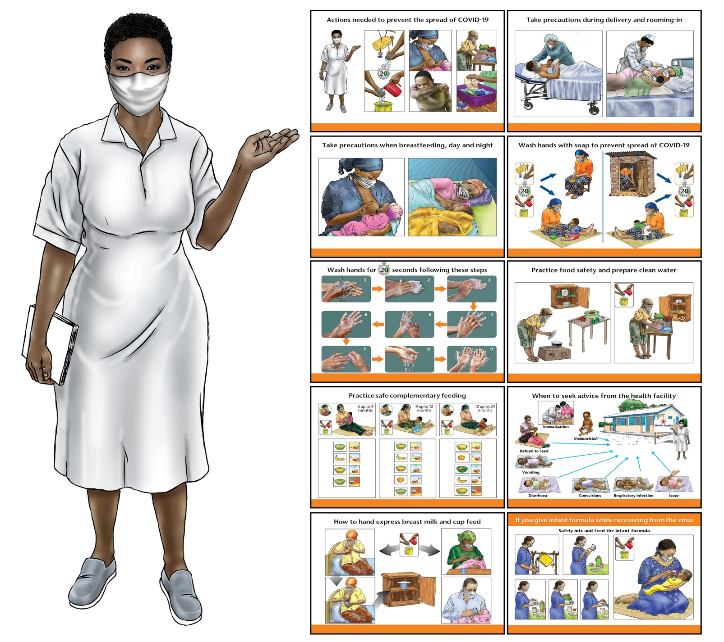
Recommended Practices Booklet

Updated May 15, 2020

Infant and Young Child Feeding Recommendations

When COVID-19 is Suspected or Confirmed

Recommended Practices Booklet
May 15, 2020

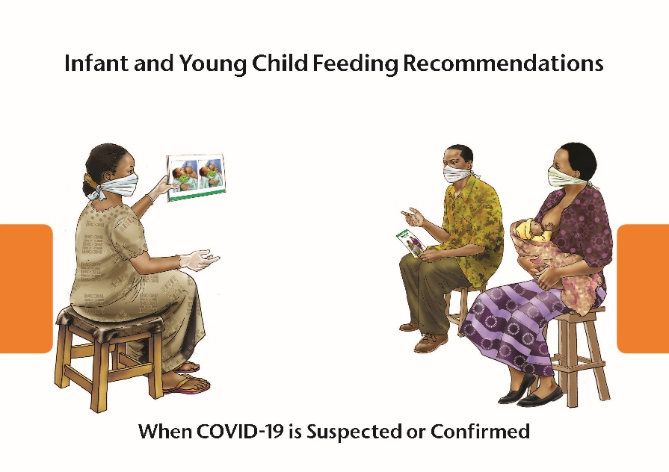

Acknowledgments:

The development of the Infant and Young Child Feeding Recommendations When COVID-19 is Suspected or Confirmed Package, including Counselling Cards and Recommended Practices Booklet, is the result of the collaborative efforts of multiple agencies during the conceptualization, development, field testing, and finalization of these generic tools. The work was led by UNICEF and USAID Advancing Nutrition, with the support of the Infant Feeding in Emergencies (IFE) Core Group, represented by Save the Children and Safely Fed Canada.
We greatly appreciate the UNICEF and Save the Children country and regional offices that supported review and enhancement of the counselling cards through their inputs and the field testing, engaging professionals, Infant and Young Child Feeding (IYCF) counsellors, health workers, and mothers from different cultures, countries, and contexts. We are also grateful for the technical review by the World Health Organization, which helped to ensure consistency and harmonization of the recommended practices with the broader technical and scientific recommendations.
Lastly, we would like to recognize the financial support provided by USAID that allowed us to engage with qualified artists and behavior change professionals in translating the latest global guidance on IYCF in the context of COVID-19 issued by WHO and UNICEF as of May 2020. These user-friendly graphic materials are designed to be adapted to local contexts and may be periodically updated to reflect new or emerging evidence.
Disclaimer: This document was produced with the support of the U. S. Agency for International Development. It was prepared under the terms of contract 7200AA18C00070 awarded to JSI Research & Training Institute, Inc. The contents are the responsibility of JSI and do not necessarily reflect the views of USAID or the U.S. Government.

Key references for the recommended practices:

- WHO. Frequently Asked Questions: Breastfeeding and COVID-19 for health care workers. https://www.who.int/news-room/detail/28-04-2020-new-faqs-address-healthcare-workers-questions-on-breastfeeding-and-covid-19
- WHO. Clinical management of severe acute respiratory infection (SARI) when COVID-19 disease is suspected. Interim Guidance, March 13, 2020. https://www.who.int/publications-detail/clinical-management-of-severe-acute-respiratory-infection-when-novel-coronavirus-(ncov)-infection-is-suspected
- WHO. Home care for patients with COVID-19 presenting with mild symptoms and management of their contacts. Interim Guidance. March 17, 2020. https://www.who.int/publications-detail/home-care-for patients-with-suspected-novel-coronavirus-(ncov)-infection-presenting-with-mild-symptoms-and-management-of-contacts
- UNICEF, GNC, GTAM. Infant and Young Child Feeding in the context of Covid 19. Brief no. 2 v.1, March 30, 2020. https://www.nutritioncluster.net/sites/default/files/2020-04/IYCF%20Programming%20in%20the%20context%20of%20COVID-19%20Brief%202_v1%2030%20March%202020_%20corrected%20for%20distribution.pdf
- WHO. 5 keys to safer food. https://www.who.int/foodsafety/publications/consumer/en/5keys_en.pdf?ua=1
- UNICEF. Community Infant and Young Child Feeding (C-IYCF) Counselling Package. https://www.unicef.org/nutrition/index_58362.html

Counselling Cards: Recommended Practices

1. Actions needed to prevent the spread of COVID-19 1
2. Take precautions during delivery and rooming-in 2
3. Take precautions when breastfeeding, day and night 3
4. Wash hands with soap to prevent spread of COVID-19 4
5. Wash hands for 20 seconds following these steps 5
6. Practice food safety and prepare clean water 6
7. Practice safe complementary feeding 7
8. When to seek advice from the health facility 8
9. How to hand express breast milk and cup feed 9
10. If you give infant formula while recovering from the virus 11

Infant and Young Child Feeding Recommendations

When COVID-19 is Suspected or Confirmed

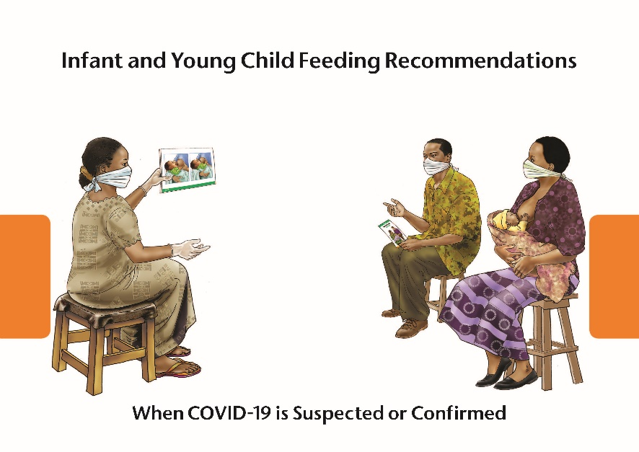

Notes for health care providers and counsellors:
- All recommended IYCF practices remain the same, based on global guidelines:
- Initiate breastfeeding within 1 hour of birth
- Exclusively breastfeed for the first 6 months
- Introduce age-appropriate, adequate, safe, and properly fed complementary foods starting from 6 months up to 2 years of age
- Continue breastfeeding for up to 2 years of age or beyond.
- Refer to the Key Messages Booklet in the UNICEF Community Infant and Young Child Feeding Counselling Package for additional important information about complementary feeding (https://www.unicef.org/nutrition/files/Key_Message_Booklet_2012_small.pdf).
- Health care providers should re-assure and support all mothers to initiate and continue to breastfeed their infants – even if they are suspected or confirmed to have COVID-19.
- To date, active virus has not been found in breast milk. It appears unlikely, therefore, that COVID-19 would be transmitted through breastfeeding or by giving breastmilk that has been expressed by a mother who is confirmed/suspected to have COVID-19.
- Some mothers may need extra support in feeding their infants while they are recovering from COVID-19.
- These user-friendly graphic materials are designed to be adapted to local contexts and may be periodically updated to reflect new or emerging evidence.

1. Actions needed to prevent the spread of COVID-19

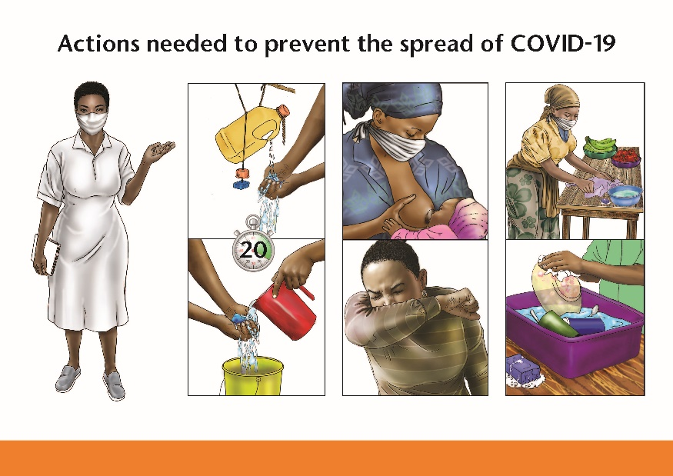

- Wash your hands frequently with soap and clean running water for 20 seconds. Washing hands with soap kills the COVID-19 virus.
- Ask family members to wash their hands with soap and clean running water for 20 seconds.
- Wear a medical mask when available or a cloth face covering when feeding or caring for your baby.
- Ask family members and others who are caring for your baby to use a medical mask when available or a cloth face covering.
- Do not touch your face, nose, or eyes, and ask family members and other to avoid touching their face, nose, or eyes.
- If you, or others, have to cough or sneeze, cover your mouth and nose with your bent elbow or use a tissue to prevent droplets from spraying. Safely dispose of used tissues after use and wash your hands with soap and clean running water.
- Clean frequently touched surfaces with soap and water if you have or suspect you have COVID-19.
- Practice physical distancing. Stay at least 1 meter away from other persons. Two meters are suggested.
- Stay at home and avoid going to market, crowded places, or any public events.
- Ask family members to stay at home and avoid going to market, crowded places, or any public events.
- If someone needs to go out to buy food, fetch water, buy medicines, or visit the health center, avoid crowds, and practice physical distancing as much as possible.

2. Take precautions during delivery and rooming-in

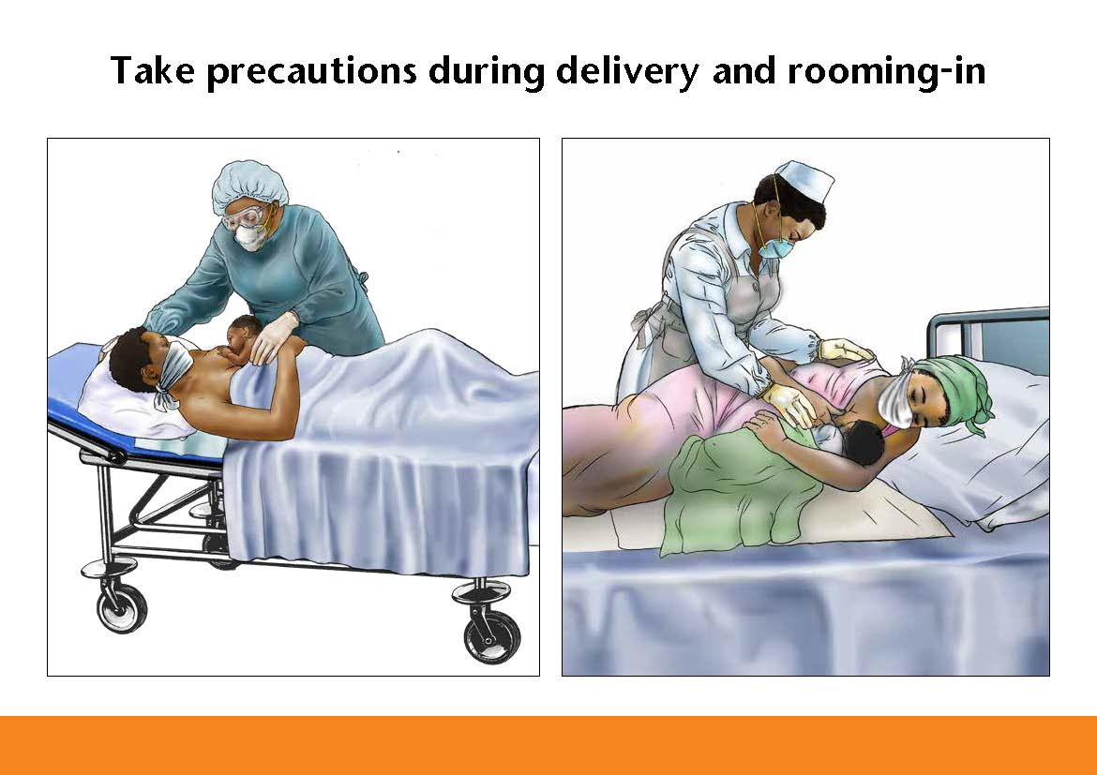

- If you are suspected or confirmed to have COVID-19, the health workers will take extra precautions when you deliver to help protect your baby, and to protect others in the hospital or maternity clinic.
- The health worker will wear extra protective coverings and will help you wear a medical mask when available or a cloth face covering when your baby is given to you to hold and breastfeed.
- Holding your baby skin-to-skin immediately after birth will keep your baby warm and breathing well, help him or her reach the breast easily, and help you and your baby feel close.
- Begin breastfeeding within the first hour of birth. Early breastfeeding helps the baby learn to breastfeed while the breast is still soft.
- Colostrum, the first milk, protects your baby from illness and infections.
- Stay together with your newborn during the whole time you are in the hospital or clinic.
- The health worker will wear extra protective coverings and will help you wear a medical mask when available or a cloth face covering, especially when you are holding and breastfeeding your baby.
- Breastfeed frequently to help your breast milk ‘come in’ and to ensure that you produce plenty of breast milk for your baby.
- Do not give water or any other liquids to your baby during the first days after birth and avoid giving water or any other liquids up until your baby is 6 months of age.
- When you go home from the hospital or maternity clinic, you will need extra rest and extra help in caring for your baby while you continue to recover from COVID-19.

3. Take precautions when breastfeeding, day and night

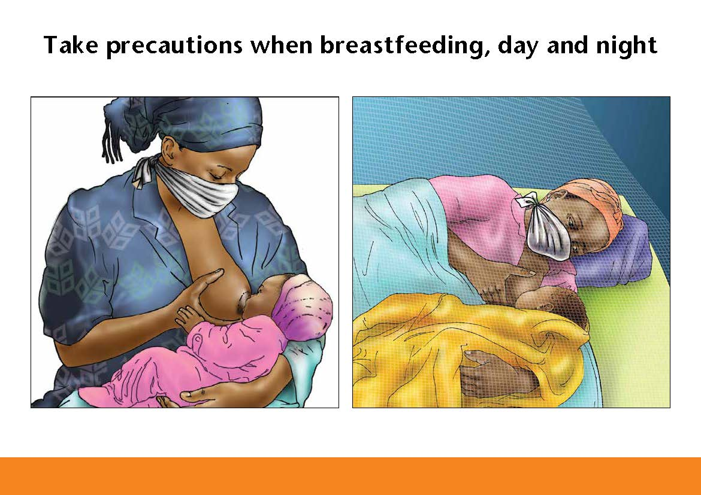

- To help protect your baby while you are recovering from COVID-19, wash your hands with soap and clean running water for 20 seconds before and after contact with your baby.
- Ask family members and others who are helping to take care of the baby to wash their hands with soap and clean running water for 20 seconds.
- Wear a medical mask when available or a cloth face mask or cloth face covering when feeding or caring for baby until you recover fully.
- If you, or others who are around the baby, have to cough or sneeze, cover your mouth and nose with your bent elbow or use a tissue to prevent droplets from spraying. Safely dispose of used tissues after use and wash your hands with soap and clean running water afterwards.
- Breastfeeding helps to protect your baby even if you are infected
- All recommended breastfeeding practices remain the same.
- Breastfeed on demand, day and night.
- Breastfeed exclusively for 6 months. Your breast milk provides all the food and water that your baby needs during this time. Breast milk also protects your baby against sickness or infection.
- Do not give any other food or liquids to your baby, not even water, during your baby’s first 6 months.
- Even during very hot weather, breast milk will satisfy your baby’s thirst.
- Giving your baby anything other than breast milk will cause him or her to suckle less and will reduce the amount of breast milk that you produce and may make your baby sick.

4. Wash hands with soap to prevent spread of COVID-19

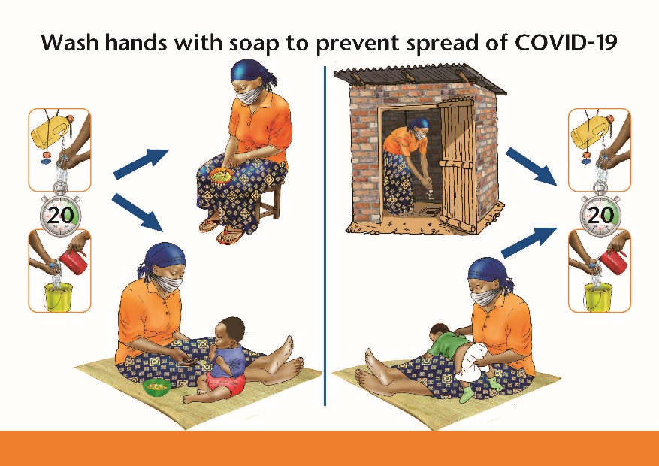

- Washing hands with soap and clean running water for 20 seconds is critical to fighting the spread of COVID-19, and is important for the health of your baby, and your entire family.
- Always wash your hands during these critical times:
    - Before preparing and eating foods
    - Before feeding infants and young children
    - After using the toilet or latrine
    - After cleaning your baby’s bottom
- It is also important to wash hands frequently, especially after blowing your nose, coughing or sneezing into a tissue, cleaning your home and compound, after practicing agriculture, and after handling livestock or other animals.

5. Wash hands for 20 seconds following these steps

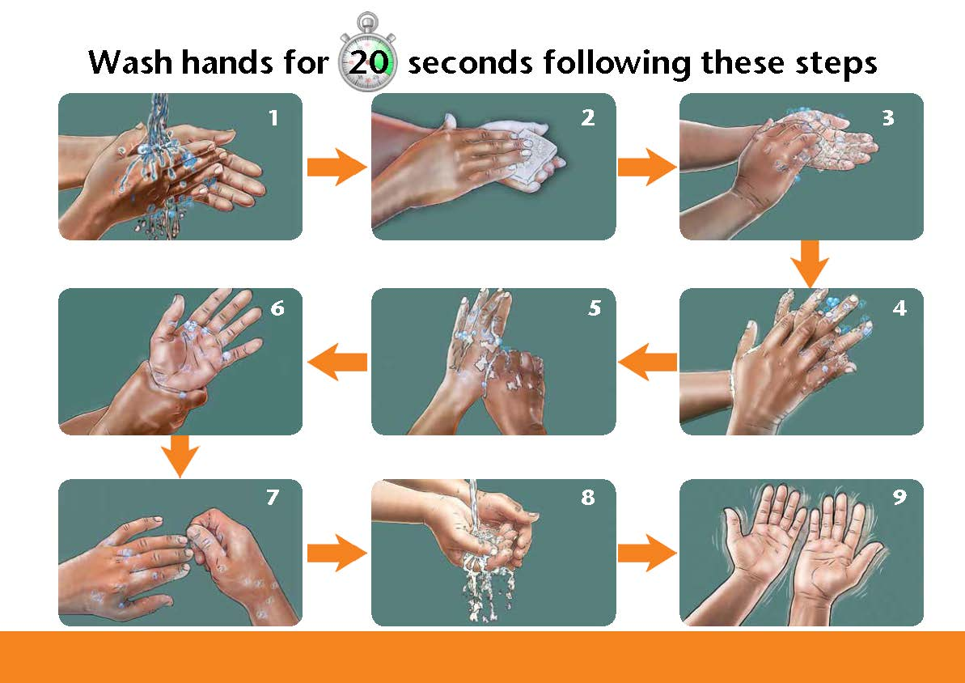

- Always spend at least 20 seconds carefully washing your hands and your children’s hands. Follow these steps:
- Wet your hands with clean running water.
- Create foam in your hands by rubbing them together with the soap.
- Rub your palms together.
- Interlock your fingers and rub them together (back and front).
- Rub each thumb.
- Rub around your wrists and up toward your elbows.
- Clean under your fingernails.
- After at least 20 seconds of scrubbing, rinse your hands with clean running water.
- Shake your hands dry in the air.

6. Practice food safety and prepare clean water

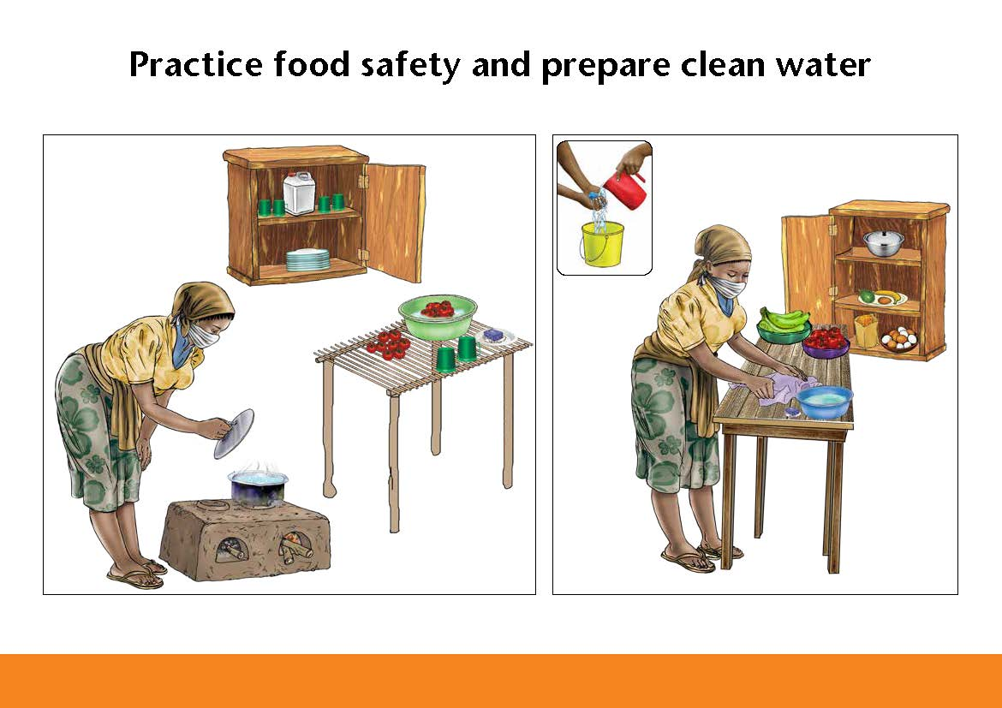

- While you are recovering from the virus, encourage other family members to help safely prepare food and clean water.
- Always wash hands with soap and running water before and after preparing food.
- Wear a medical mask when available or a cloth face covering when preparing food.
- Use safe water for drinking and cooking. If you are not sure about the safety of the water, boil it. You can also use a small amount of bleach (chlorine), a water treatment product, or a water filter system.
- If possible, use dedicated eating utensils for those suspected/confirmed. These utensils should be cleaned with soap and clean water after use.
- Carefully clean all pots, dishes, bowls, and utensils with soap and water, and store them in a clean, safe place.
- Wash and rinse raw fruits, and vegetables well with safe water before cooking and eating them.
- Clean all food preparation areas, including tables and cutting boards, with soap and clean water.
- Keep raw meat, fish, and poultry separate from other foods before cooking, to prevent spreading germs.
- Cook meat, fish, and eggs thoroughly.
- Serve food immediately after preparation.
- Feed your baby using clean hands, his or her own clean bowl and spoon, clean utensils, and clean cups.
- Prepared food should be given to the young child within 2 hours of cooking. Reheat cooked food thoroughly.

7. Practice safe complementary feeding

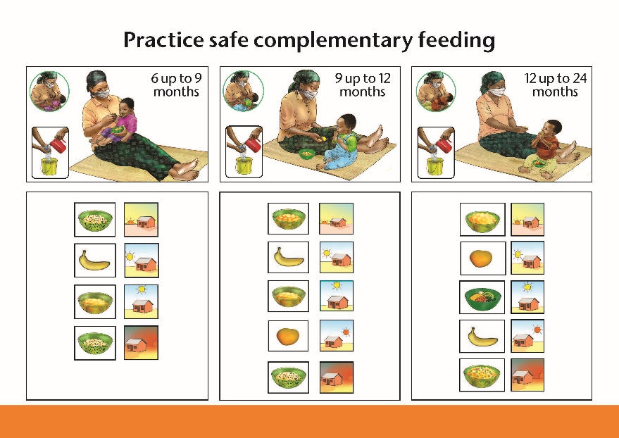

- If you or others in your family are recovering from COVID-19, it is especially important to practice safe complementary feeding, starting at 6 months of age up to 24 months.
- Wash your hands, and have others wash their hands, with soap and clean running water for 20 seconds before preparing foods and before feeding your baby.
- Clean food preparation areas, including tables and cutting boards, with soap and clean water.
- If you or others have COVID-19, wear a medical mask when available or a cloth face covering when feeding the baby.
- If you or others have to cough or sneeze, cover your mouth and nose with your bent elbow or use a tissue to prevent droplets from spraying. Safely dispose of used tissues and wash your hands with soap and clean running water afterwards.
- Feed your baby from his or her own clean spoon and bowl.
- All recommended complementary feeding practices remain the same. Follow national recommendations on complementary feeding practices regarding frequency, amount, thickness, variety, responsive feeding, and hygiene.
- Feed your baby with care. Be patient and actively encourage your baby to eat. Do not force your baby to eat.
- When possible, try to give your baby a variety of foods, including fruits, vegetables, legumes and animal source foods such as eggs, meat, poultry, organ meats, fish, and dairy products.
- Do not give foods that are high in sugar, salt, and fat, such as fried foods, sweets, juices and salted snacks. These foods are not healthy for your child.
- Do not give foods that are pre-chewed to your child.
- If your child gets sick, he or she will need extra fluids and foods to recover faster. Breastfeed your child more often and encourage your child to eat soft and appetizing foods during sickness.
- After sickness, feed your child more often than usual for about two weeks, to help your child regain strength.

8. When to seek advice from the health facility

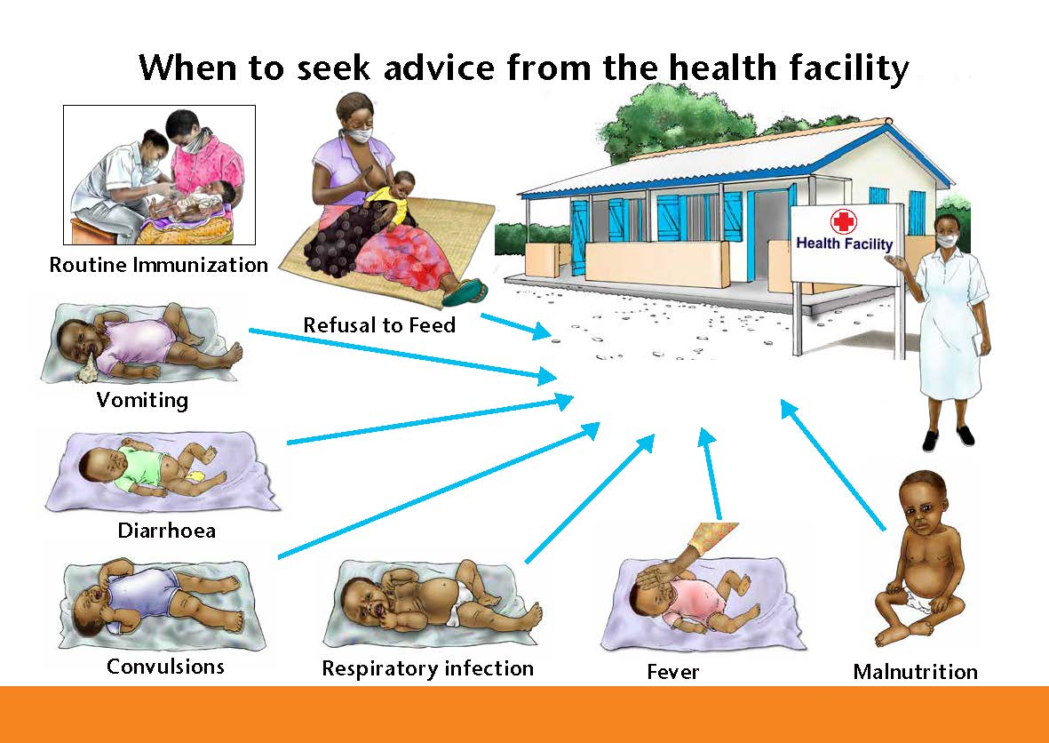

- It is important to continue to take your child for routine immunizations, following your national immunization schedule.
- Continue with follow-up services according to local recommendations. Appointment frequency and locations may change.
- If you are not well, ask a family member who is well to take your child for immunizations and follow-up services, and to ask questions about your child’s growth, health, and nutrition.
- Take your child immediately to a trained health worker or clinic if any of the following symptoms are present:
- COVID-19 symptoms, including fever, dry cough, and difficulty in breathing
- Refusal to feed and limp, or weak
- Vomiting (cannot keep anything down)
- Diarrhoea (more than 3 loose stools a day for two days or more and/or blood in the stool, sunken eyes)
- Convulsions (rapid and repeated contractions of the body, shaking)
- The lower part of the chest sucks in when the child breathes in, or it looks as though the stomach is moving up and down (respiratory infection)
- Fever
- Malnutrition (visible thinness or swelling of the body)

9. How to hand express breast milk and cup feed

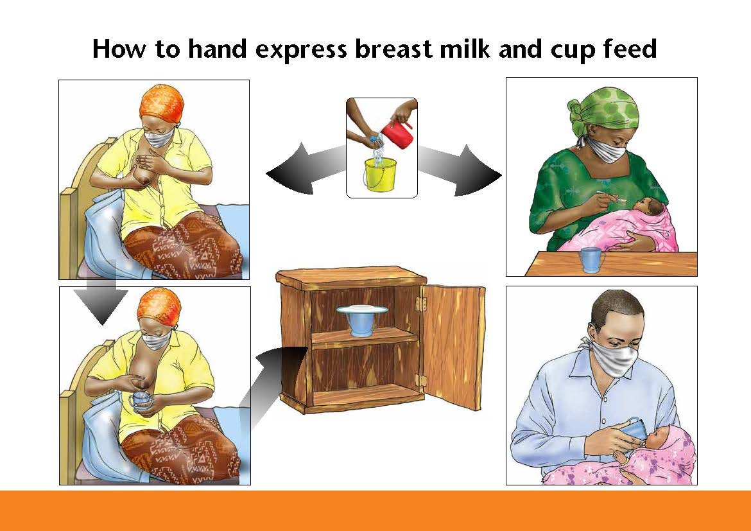

Why express breast milk?
- A mother can express her own breast milk:
- To help establish or maintain milk production if health worker recommends separation from her baby, until she recovers
- When she wants to re-establish her milk production after being separated from the baby
- When she knows she is going to be away from her baby and miss a feeding

Steps in expressing breast milk:
- Wear a medical mask when available or a cloth face covering while preparing and expressing your milk.
- Wash your hands with soap and clean running water for 20 seconds.
- The cup or container you use to collect breast milk should be clean.
- Get comfortable.
- It is sometimes helpful to gently stroke or massage your breasts. A warm cloth may help stimulate the flow of milk.
- Put your thumb on the breast above the dark area around the nipple (areola) and the other fingers on the underside of the breast behind the areola.
- With your thumb and first two fingers press a little bit in towards chest wall and then press gently towards the dark area (areola).
- Milk may start to flow in drops, or sometimes in fine streams. Collect the milk in the clean container.
- Avoid rubbing the skin, which can cause bruising, or squeezing the nipple, which stops the flow of milk.
- Rotate the thumb and finger positions and press or compress and release all around the areola.
- Express one breast for at least 3 to 5 minutes until the flow slows, then express the other breast, then repeat both sides again (20 to 30 minutes total).

How to store and feed expressed breast milk:
- Clean the exterior of the cup or container with soap and water before storing.
- Store breast milk in a clean, covered container.
- Breast milk can be stored for about 8 hours at room temperature (in the shade) and up to 24 hours in the refrigerator.
- Wear a medical mask when available or a cloth face covering when feeding the baby if you have any signs of being infected by COVID-19 or if you have been exposed to someone with COVID-19.
- Pour just enough breast milk from the clean covered container into the feeding cup. Ask health worker to show you.
- Give baby expressed breast milk from a cup. Bring cup to rest against the corners of baby’s upper lip and allow baby to take small amounts of milk, lapping the milk with his or her tongue. Do not pour the milk into baby’s mouth.
- Bottles are unsafe to use because they are difficult to wash and can spread germs to baby.

Note: Feeding a baby who is younger than 6 months any other foods or liquids, including animal milks or water, increases the chances of the baby becoming sick.

10. If you give infant formula while recovering from the virus

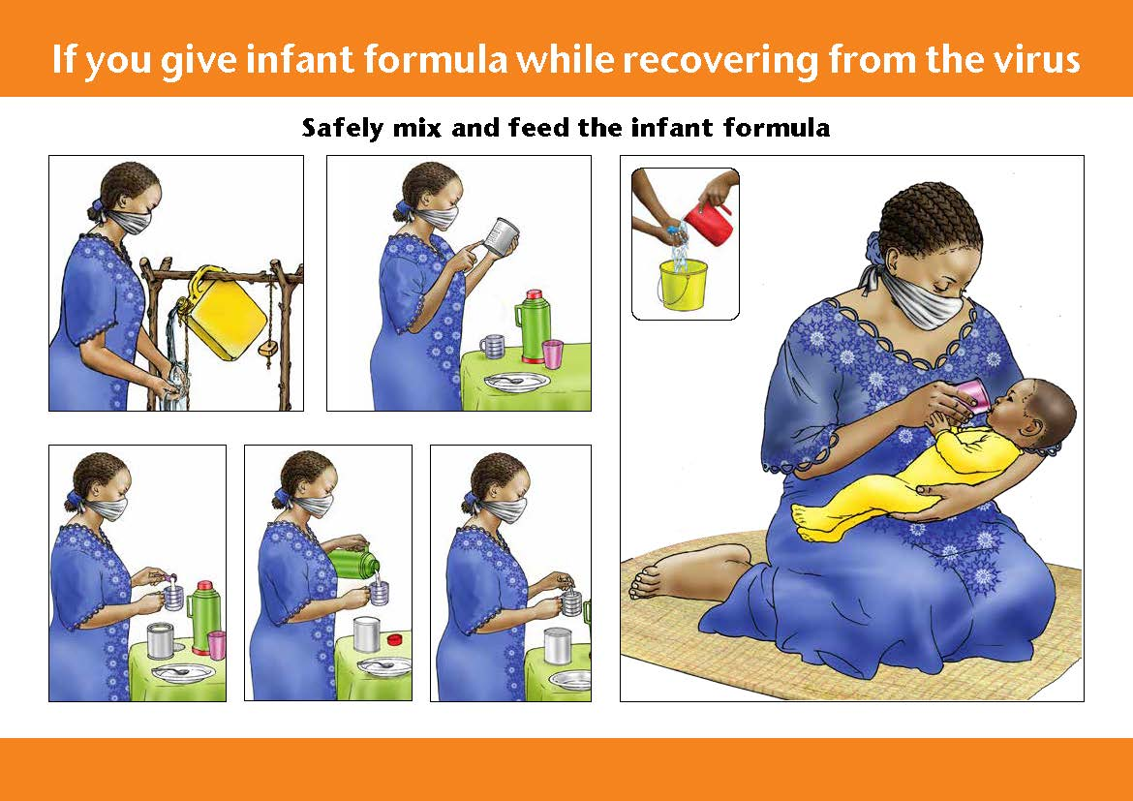

Safely mix and feed the infant formula:
- Giving infant formula may be recommended as a last resort while a mother is recovering from COVID-19, and until breastfeeding can be established or re-established.
- If you give infant formula while recovering from the virus, it is very important that you safely mix and feed the infant formula

Safely mix the infant formula using these steps:
- Wear a medical mask when available or a cloth face covering when preparing the infant formula.
- Wash your hands with soap and clean running water for 20 seconds before starting to prepare infant formula.
- Clean all surfaces and boil equipment to sanitize.
- Read and follow the instructions that are printed on the tin very carefully. Ask for more explanation if you do not understand.
- Only prepare as much as the baby will need within one hour.
- Carefully measure the amount of clean boiled or treated water to mix with the dry infant formula.
- Carefully measure the amount of dry infant formula required.
- Mix the dry infant formula and water until all the powder is completely dissolved.

How to feed infant formula to your baby:
- Wear a medical mask when available or a cloth face covering when feeding the infant formula.
- Wash your hands with soap and clean running water for 20 seconds before starting to feed infant formula.
- Give baby infant formula from a cup that has been cleaned and boiled.
- Bring cup to the baby’s lower lip and allow baby to take small amounts of milk, lapping the milk with his or her tongue. Do not pour the milk into baby’s mouth.
- Bottles are unsafe to use because they are difficult to wash and can spread germs to baby.

Note: Feeding a baby who is younger than 6 months any other foods or liquids, including animal milks or water, increases the chances of the baby becoming sick.

