Worksheets

Focusing on Social Norms
A Practical Guide for Nutrition Programmers to Improve Women’s and Children’s Diets

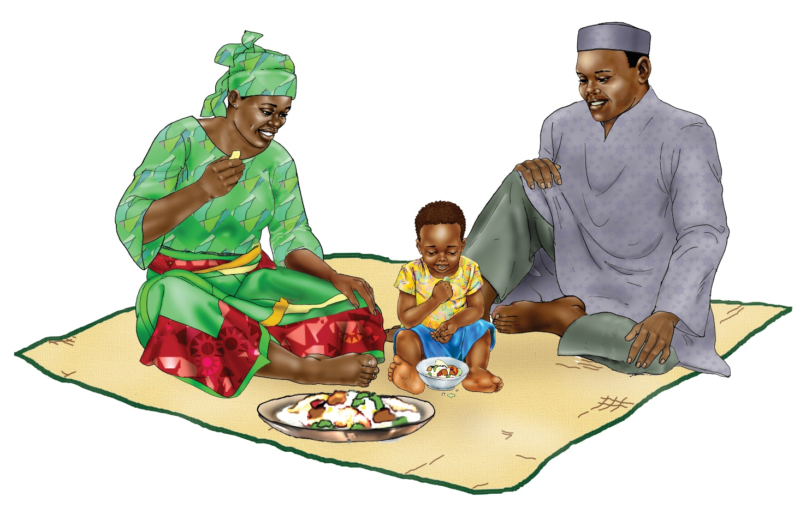

Worksheet 1A: Listing and Ranking the Social Norms that Influence a Behavior
Priority Behavior to Improve Diets:

Participant Group (who will practice the behavior):

Subgroups of the main Participant Group
(if any, e.g., mothers living in rural
communities, mothers who are adolescents):
 | 1) List the norms identified in the assessment. | 2) Based on the team’s analysis, write the most important norms identified by the assessment.
Which norms most relate to a priority practice? | Which social norms influence priority dietary practices?  From discussion notes and field reports, list all of the social norms that influence each priority dietary practice. | • Are some norms having a more important influence on dietary practices than others?  • Do they work the same across subgroups or segments of participant groups (if relevant)?  Using the questions below, and based on the field notes, discuss each listed norm and circle the social norms that most relate to the priority behaviors.

WORKSHEET 1B: DEVELOPING DESCRIPTIONS OF THE MOST IMPORTANT NORMS AND THE INFLUENCERS OF A PRIORITY BEHAVIOR
Priority Behavior to Improve Diets:

Participant Group (who will practice the behavior):

Subgroups of the main Participant Group
(if any, e.g., mothers living in rural
communities, mothers who are adolescents):
 | Extent the norm influences the behavior | Most important influences on behavior
List each norm circled in worksheet 1A in one of the rows below.  Then answer the questions at right. | • What proportion (some, few, many) of the participants comply with the norm in project communities?  • Does the norm work the same across subgroups (if relevant)?  • Is this norm supportive of the behavior, or is it harmful? | • Who are the important influencers on the person who needs to do the behavior (woman, man, market vendor, etc.)?  • Are influencers the same across subgroups (if relevant)?
Norm 1
Norm 2

Worksheet 2A: Creating a Behavior Profile with a Highlight on Social Norms
Behavioral analysis |  |  | Strategy
1) PRIORITY BEHAVIOR & STEPS  What steps are needed for the main participant group to practice this behavior? | 2) FACTORS  What socio-normative factors may prevent or support practicing the behavior now? | 3) INFLUENCERS: ACTORS & ACTIONS  Who needs to do what to reduce the barrier or support the motivator? | 4) POSSIBLE PROGRAM STRATEGIES  What strategies will best focus our efforts to reduce barriers or support motivators?
List Behavior and Steps here. | Structural: | Policies, Institutions, and Services: | Enabling policy and institutional environment:
 | Social:  Social norms | Community: | Systems, services, and products
 | Individual (include internalized norms): | Family & Household: | Demand and use:

Worksheet 2B: Mapping Behaviors, Norms, and Influencers to Plan Coordinated SBC Responses to Social Norms
Behavior: women eat a diverse diet each day | Influencers identified in the formative assessment
Norms identified in the formative assessment | CHWs | Ag. extensionists | Community leaders | Religious leaders | Men | Grandmothers/ Elder women | Peers of women
Example: Most people expect men and other family members are first to eat before women. | X |  | X | X | X | X
Example: Women should not eat between meals. | X |  | X |  |  | X | X
Norm 1:
Norm 2:

Worksheet 3: Checking Whether Intervention Activities Have Norms-Shifting Characteristics
Characteristic | To what extent do strategies and activities: | Ranking  Low | Medium | High
Seeks community-level change | Seek community-level change about social expectations, not just individual attitudes and behaviors?  Clearly articulate social change outcomes at the community level?
Engages people, especially influencers, at multiple levels | Use multiple strategies to engage people at different levels of the ecological model: individual, family, community, and policy/legal?
Uses “organized diffusion” to spread new ideas and model behaviors at community level | Spark critical reflection to change norms first within a core group who then engage others by promoting sharing outside of programs to have community-level impact?
Creates safe spaces for critical reflection by community members | Deliberately promote sustained, critical reflection that goes beyond trainings, one-off campaigns, or ad hoc outreach, often in small group settings?
Confronts power imbalances particularly related to gender | Confront power imbalances particularly related to gender and intergenerational dynamics?
Roots the issues within the community’s own value systems | Root the issues in a community’s value system, identifying how a norm serves or contradicts a community’s own values, rather than labeling a practice as “bad” within a given community?
Corrects misperceptions around harmful norms | Correct misperceptions of harmful norms? Sometimes individuals engage in a harmful behavior because they mistakenly think these behaviors are common, that “everyone does it” (when in reality they don’t). In such instances, correcting misperceptions by revealing the actual, healthier norm can be effective.
Creates positive, new norms | Create new, shared beliefs when harmful norms have strong support within groups? While it is common to focus on negative consequences of a behavior, this can unintentionally reinforce that behavior by making it seem widespread.

Worksheet 4: Pause-and-Reflect Matrix to Guide Reflections on Norm-Responsive Programming
Intervention components | What is working? (Successes)  What is not working? (Challenges) | How is our work affecting people and stakeholders, things, systems, and practices? | What signs of change have you seen in the past three months?  Which are supportive/not supportive of project aims? | How have frontline workers reacted to such changes?  How have staff reacted? | If not working well: Can you imagine doing the activity in a completely different way?  What might the value be? | Proposed changes and next steps
Example: Monthly project caregiver group meetings with follow-up home visits | • Participation is high in group meetings.  • Neither meetings nor home visits engage family members. | • Key strategies to challenge some existing norms are building peer support for new ideas and modeling new practices. | • Group members seem more empowered to make changes.  • Some practices are not shifting yet: feeding children when ill. | • Frontline workers resist engaging family members during home visits.  • They don’t want to intrude. | • Send invitations to family members to join groups.  • Invite community leaders to in-home visits to understand issues and advocate. | • Consult with community leaders and family member champions
Change agent advocacy
Community dialogues and events
Media broadcasts

Worksheet 5: Assess the Completeness and Quality of Social Norms Indicators in Evaluations
Included? | Characteristics of a promising social norms indicator | Why is it important to include?
Yes | No | 1. Is specific about a concrete scenario and an expected outcome | Since norms are often unconsciously practiced, using typical scenarios and outcomes enhances validity and reliability.
Yes | No | 2. Refers to specific behaviors | Norms uphold behaviors, so they can only be assessed with the outcome in mind.
Yes | No | 3. Refers to influencers or the general community | If not, it measures an individual’s attitude.
Yes | No | 4. Measures both injunctive and descriptive norms | Because they operate differently in upholding practices, both types need to be assessed for program improvement.
Yes | No | 5. Determines whether sanctions exist and how much they matter | The presence or absence of sanctions measures the intensity of injunctive norms.
Yes | No | 6. May measure collective norms (aggregated attitudes rather than perceived norms) | There is new thinking on repurposing KAP survey data in the absence of norms-specific indicators. Aggregating attitudes held by a representative sample of a community allow inference on how a norm is operating.

Actions to Take at Each Step
Step 1: Conduct an Assessment to Understand Social Norms that
Influence Women’s and Children’s Diets
Develop an assessment plan and tools to identify and understand the influence of social norms
With key behaviors and questions defined, select methods that are useful for collecting norms information
Step 2: Use Collected Norms Information to Design an SBC Strategy
Analyze priority behaviors
Select intervention activities to respond to norms
Design an SBC strategy that is responsive to social norms
Identify and group social norms that influence priority behaviors, influencers, and interventions
Step 3: Implement Norm-Responsive Activities to Improve Women’s and
Children’s Diets
Check that intervention activities have norms-shifting attributes
Step 4: Monitor Norm-Responsive Activities to Improve Women’s and
Children’s Diets
Monitor changes throughout the program cycle
Pause and reflect to use monitoring data for adjustments to intervention activities
Step 5: Evaluate Norm-Responsive Activities to Improve Women’s and
Children’s Diets
Develop measures to evaluate normative shifts
Develop methods to evaluate changes in social norms

