State Committee on Food and Nutrition

Orientation
Package
Participant Handbook
Table of Contents
Acronyms 8
Foreward 9
Acknowledgements 10
Introduction 11
Orientation Package Objectives 11
Materials Used in the Orientation Package 11
Training Structure and Duration 12
Opening 13
Unit 1 14
Nutrition and Malnutrition Fundamentals 14
Objectives for This Unit 14
Agenda 14
Session 1.1 15
What Is Nutrition and Why Does Nutrition Matter? 15
What Is nutrition? 15
What Is malnutrition? 15
Why Is Nutrition Important? 15
Session 1.2 17
Key Concepts and Terms 17
Malnutrition 17
Triple Burden of Malnutrition 17
Food Security 17
Hunger 18
The First 1,000 Days 18
Multi-Sectoral Approach 20
Micronutrient Deficiency 20
Nutrition Situation 20
Overnutrition 20
Overweight 20
Obesity 20
Undernutrition 21
Stunting 21
Underweight 22
Wasting 22
Edema (bilateral pitting edema) 23
Intergenerational Cycle of Malnutrition 23
Session 1.3 25
Causes of Malnutrition 25
Conceptual Framework on the Causes of Malnutrition 25
Immediate Causes of Malnutrition 25
Underlying Causes of Malnutrition 26
Enabling Determinants of Malnutrition 26
Session 1.4 28
Vulnerable Groups 28
Children Under Five 28
Pregnant and Lactating Women 28
Adolescent Girls and Women of Reproductive Age 29
Elderly 29
Infectious Diseases 29
Unit 1 Personal reflection 31
UNIT 2 33
Nutrition Policy Environment in Nigeria 33
Objectives for This Unit 33
Agenda 33
Session 2.1 34
Global Nutrition Frameworks 34
Global, Regional, and National Frameworks 34
National Nutrition Policies/Legislation, Strategies, and Initiatives 34
Session 2.2 38
Nutrition Situation in X State 38
Overview of Maternal and Child Nutrition Outcomes 38
Underlying Determinants of Nutrition 38
Basic Determinants of Nutrition 38
Session 2.3 39
Nigeria National Policy Environment 39
Policy Environment 39
Vision Statement of the Food and Nutrition Policy 41
Goal of the Food and Nutrition Policy 41
Objectives of the Food and Nutrition Policy 41
Session 2.4 43
Nigeria Multi-Sectoral Nutrition Coordination Framework 43
Education 44
Health 44
Agriculture 44
Planning 45
WASH 45
Social Development 45
Trade and Industry 46
Information 46
Leadership, Structures, and Institutions 46
Session 2.5 50
Roles and Responsibilities of National Nutrition Coordination Committees 50
Session 2.6 54
Roles and Responsibilities of SCFNs 54
Session 2.7 58
Additional Stakeholders and Collaborators 58
How does the SCFN work at the community and civil society level? 58
How does the SCFN work with the private sector? 58
How does the SCFN work with development partners? 58
Session 2.8 60
Configuration of SCFNs 60
List of All SCFN Members 60
Roles and Responsibilities in the SCFN 60
Session 2.9 62
Subcommittees and Working Groups in SCFNs 62
The Annual Budget Implementation and Tracking Subcommittee— 62
The Technical and M&E Subcommittee— 62
The Advocacy Subcommittee— 62
Unit 2 Personal Reflection 64
UNIT 3 66
Roles and Links between Nutrition Coordination Committees 66
Objectives for This Unit 66
Agenda 66
Session 3.1 67
Roles of Government, Councils, and Working Groups in Nutrition Governance 67
Nutrition Partners Forum 67
National Nutrition Network 67
SUN Movement 67
Technical Working Groups and National-Level Subcommittees 68
Session 3.2 70
Links between State and Local Nutrition Coordination Committees 70
Mandate of the LGCFN 70
Unit 3 Personal reflection 74
UNIT 4 76
SCFN Monitoring, Evaluation, and Reporting 76
Objectives for This Unit 76
Agenda 76
Session 4.1 77
M&E Key Concepts and Terms 77
Session 4.2 79
SCFN M&E System 79
M&E System 79
Session 4.3 81
Procedures for M&E—Roles and Responsibilities of Different Actors 81
Federal MDAs 81
NCFN 81
State MDAs 81
SCFN 82
LGCFN 83
Session 4.4 84
SCFN Indicators for Annual Reporting for Implementation of the MSNAP at the State Level 84
Session 4.5 86
SCFN Reporting to the National Nutrition Scorecard 86
Purpose of the National Nutrition Scorecard 86
Session 4.6 88
SCFNs’ Role in the Nutrition Information System 88
Session 4.7 89
SCFN Quarterly Reporting 89
Timing and Frequency 89
Session 4.8 91
LGCFN Monitoring and Supportive Supervision Checklist 91
Purpose of the Tool 91
Using the Tool 91
Dissemination and Feedback 91
Unit 4 Personal reflection 93
UNIT 5 94
Action Plan to Operationalize Nutrition Coordination Committees 94
Objectives for This Unit 94
Agenda 94
Session 5.1 95
SCFN Action Planning 95
Annual State Financing Process for Nutrition 95
Session 5.2 98
OCAT Tool and Process 98
Objectives of the OCAT 98
Description of the OCAT 98
The OCAT Process 99
Unit 5 Personal reflection 102
Unit 6 103
Gender and Equity 103
Objectives for This Unit 103
Agenda 103
Session 6.1 104
Key Concepts, Terms, and Definitions 104
Introductory questions 104
Session 6.2 107
Gender and Equity Domains 107
Gender-Transformative Program/Activities 107
Session 6.3 109
Gender and Equity Action Planning for Multi-Sectoral Nutrition Plans 109
Why Consider Gender in Nutrition Action Plans? 109
Gender-Transformative Approaches 110
Developing and Reviewing Nutrition Plans through a Gender Lens 110
Integrating Gender into Situational Analysis 110
Integrating Gender into Stakeholder Planning 110
Integrating Gender into Capacity Strengthening and Assessments 111
Integrating Gender into M&E 111
Unit 6 Personal reflection 113
Closing Session 114
Closing Personal reflection 115
Annexes 116
Annex 1 117
List of Contributors 117
Annex 2 121
Pre-and Post-Training Assessment 121
Annex 3 123
Glossary of Terms 123
Annex 4 125
Problems/Gaps Associated with Food System/Security and Likely Solutions 125
Annex 5 126
Sample (screenshots of) OCAT Tool (please see USAID Advancing Nutrition for Implementation Guide and OCAT) 126
Annex 6 132
SCFN Quarterly Reporting Template (summary table) 132
Annex 7 133
SCFN Quarterly Reporting Template 133
Annex 8 134
National Nutrition Scorecard 134
Annex 9 135
Sample SCFN Appointment Letter 135
Annex 10 136
SCFN Monitoring and Supportive Supervision Checklist 136
Annex 11 145
National/State Multi-Sectoral Plan of Action for Food and Nutrition Implementation M&E Tool/Checklist 145
Annex 12 165
Indicators That Can Be Compiled for Nutrition Situation 165
Annex 13 169
References 169

Acronyms
AOP annual operational plan
BMI body mass index
CBO community-based organization
CMAM community-based management of acute malnutrition
CSO civil society organization
DHIS2 District Health Information Software (formerly known as)
DPRS Department of Planning, Research and Statistics
FAO Food and Agriculture Organization of the United Nations
FMARD Federal Ministry of Agriculture and Rural Development
FME Federal Ministry of Education
FMFBNP Federal Ministry of Finance, Budget and National Planning
FMIC Federal Ministry of Information and Culture
FMOH Federal Ministry of Health
FMWASD Federal Ministry of Women Affairs and Social Development
FMWR Federal Ministry of Water Resources
GESI Gender Equality and Social Inclusion
LGA local government area
LGCFN local government committee on food and nutrition
M&E monitoring and evaluation
MDA ministry, department, or agency
MNCH maternal, newborn, and child health
MSNAP Multi-Sectoral Nutrition Action Plan
NAFDAC National Agency for Food and Drug Administration and Control
NBS National Bureau of Statistics
NCFN National Committee on Food and Nutrition
NCN National Council on Nutrition
NGF Nigeria Governors’ Forum
NGO nongovernmental organization
NNN National Nutrition Network
NPHCDA National Primary Health Care Development Agency
OCAT Organizational Capacity Assessment Tool
PPT PowerPoint
RUTF ready-to-use therapeutic food
SCFN State Committee on Food and Nutrition
SDG Sustainable Development Goals
SMARD State Ministry of Agriculture and Rural Development
SMART Specific, Measurable, Achievable, Relevant, and Time-Bound
SOME State Ministry of Education
SMOH State Ministry of Health
SMOI State Ministry of Information
SMOWA State Ministry of Women Affairs
SMOWR State Ministry of Water Resources
SPHCDA State Primary Health Care Development Agency
SUN Scaling Up Nutrition
TWG technical working group
UNICEF United Nations Children’s Fund
USAID United States Agency for International Development
WASH water, sanitation, and hygiene
WHO World Health Organization

Foreword
The National Policy on Food and Nutrition in Nigeria outlines the mandate of the State Committees on Food and Nutrition (SCFNs) and the responsibilities of the secretariats. However, it does not provide guidance on how this mandate and the responsibilities should be fulfilled or which mechanisms can be used to ensure appropriate coordination across the SCFNs’ membership. In addition, no targeted orientation or training has been provided to SCFN members or leadership on these tasks.
United States Agency for International Development (USAID) Advancing Nutrition worked closely with the National Council on Nutrition (NCN), the National Committee on Food and Nutrition (NCFN), and SCFNs to develop this Orientation Package for SCFNs, which provides an overview of their mandate and roles and a primer on key multi-sectoral nutrition content.
The development of this Orientation Package is thanks to many contributors and reviewers. USAID Advancing Nutrition convened a development workshop in September 2022 in Abuja, with representatives from five SCFNs who were divided into thematic working groups for each priority area. The working groups, comprising key nutrition officers, development partners, and other stakeholders under the leadership of the relevant SCFN, were responsible for articulating the needs analysis, developing an outline, and providing the proposed content for each thematic area. USAID Advancing Nutrition convened a review workshop in February 2023 in Lagos, with representatives from seven SCFNs who shared lessons learned and reviewed each section of materials. USAID Advancing Nutrition piloted the semifinal Orientation Package with SCFN members in Kebbi, Eboyni, and Federal Capital Territory in July 2023, using participant feedback to further refine the content, approaches, and tools.
This Orientation Package is designed to support new and existing SCFN members and outline their roles and responsibilities per the National Policy on Food and Nutrition in Nigeria.
Thank you to all contributors and reviewers. (See Annex 1 for the full list.)

Acknowledgements
This handbook would not be possible without support and input from key stakeholders in Nigeria. We relied on staff from Helen Keller International, the National Governors Forum, the National Committee for Food Security and Nutrition, State Committees for Food and Nutrition, particularly those in Sokoto, Kebbi, Bauchi, Sokoto, and the Federal Capital Territory, and other local experts – including Dr. Tayo Adeyemi, Matthew Kola Anigo, Livinus Ibiang, Oluwaseun Ariyo, Anthony Oku-Isu, Folashade Adekunle, Bukar Abdullahi, and Rabiu Aliyu. This work would not have been possible without the support of USAID through the USAID Advancing Nutrition project, particularly Stanley Nwosu. We would also like to recognize the leadership provided by Sean Maher, international development consultant.

Introduction

Orientation Package Objectives
This State Committee on Food and Nutrition (SCFN) Orientation Package Participant Handbook is intended for use in building the capacity of nutrition coordination structures at the state level by outlining the roles and responsibilities of committee members; providing information on the nutrition situation, the policy environment, local government committees on food and nutrition (LGCFNs), technical committees, and local government areas (LGAs); and providing guidance on monitoring and reporting to be conducted by SCFNs on multi-sectoral nutrition interventions.
Specifically, by the end of the orientation, participants will have an enhanced
understanding of—
- the nutrition situation in Nigeria
- the policy environment for nutrition and the Nigeria multi-sectoral nutrition coordination framework
- the composition, roles, and responsibilities of SCFNs at the local government level
- the links among SCFNs, technical planning committees, and councils
- the criteria for measuring the functionality of the SCFNs
- SCFN monitoring and reporting on coordination of multi-sectoral nutrition interventions
- how to develop an action plan to operationalize the SCFNs’ areas for improvement based on their Organizational Capacity Assessment Tool (OCAT) scores
- how to apply gender (sensitive and transformative) and equity to SCFN work and to multi-sectoral nutrition plans.

Materials Used in the Orientation Package
Participant Handbook: This handbook includes reference materials to support you during this orientation and when you return to your state/LGA. The handbook outlines the purpose and objectives of each unit; includes key definition and session agendas; and, most importantly, provides a place for you to record your reflections, observations, and ideas to consider during the orientation.
Other materials that are important for you are—
- National Policy on Food and Nutrition (2016–2025)
- National Multi-Sectoral Plan of Action for Food and Nutrition (2021–2025)
- Health Sector National Strategic Action Plan for Nutrition (2021–2025)
- Agricultural Sector Food Security and Nutrition Strategy (2016–2025).
Facilitator’s Manual: The facilitator will use an accompanying manual to guide them on preparations to lead this orientation focused on the learning objectives. The manual includes—
- a step-by-step description of the units and sessions
- an overview of each session’s objectives and agenda
- timing information for each topic to keep facilitators on track
- notes on learning materials, transitions, and activities.
Presentation deck: A PowerPoint slide deck is provided for use with the Participant Handbook and Facilitator’s Manual throughout the orientation.

Training Structure and Duration
The training is divided into six units, with opening and closing sessions. The orientation is designed to take place over four days. Although the training can be adapted to meet the needs of stakeholders, it is recommended that at least three days be allocated to complete the work described in the sessions.

Opening
Objectives for this session are—
- to introduce facilitators and welcome participants
- to review Orientation Package material and agenda
(note additional resources available)
- to agree on ground rules and expectations
- to complete pretraining assessment (see Annex 2).

Group Exercise: Introductions
Instructions:
Introduce yourself with your name, location, and job/role in a ministry, department, or agency (MDA) or SCFN. Answer the following questions:
- What do you want to get from this training?
- What question have you always wondered related to global nutrition?

Opening Personal reflection
Write three expectations that you have for this training. Check back on them at the end of the training to see if they were met.

Unit 1

Nutrition and Malnutrition Fundamentals

Objectives for This Unit
The objectives for this unit are to—
- provide an overview of key issues, terms, and concepts in nutrition programming
- answer any questions you have about nutrition fundamentals
- give you a “big picture” perspective that allows you to explain why nutrition matters
- define the forms and causes of malnutrition, including why it is important to SCFN members.

Agenda
- Session 1.1: What Is Nutrition and Why Does Nutrition Matter?
- Session 1.2: Key Concepts and Terms
- Session 1.3: Causes of Malnutrition
- Session 1.4: Vulnerable Groups

Session 1.1

What Is Nutrition and Why Does Nutrition Matter?

What Is nutrition?
Nutrition refers to the process of obtaining, consuming, and using nutrients from food to support growth, health, and overall well-being. It is a vital aspect of human life, as the nutrients derived from the foods we eat provide essential elements necessary for the proper functioning of our bodies. Nutrition plays a crucial role in health and development, impacting infant, child, and maternal well-being; immune strength; pregnancy safety; and longevity. Improved nutrition fosters better learning in children, enhances productivity, and offers opportunities to break the cycles of poverty and hunger.
Nutrition is a complex and dynamic field influenced by various factors, including cultural practices, socioeconomic status, access to food, and individual dietary choices. As a result, promoting and maintaining good nutrition is a multifaceted endeavor that requires a comprehensive approach involving education, public policies, health care interventions, and community engagement to improve overall health and well-being.

What Is malnutrition?
Malnutrition refers to deficiencies, excesses, or imbalances in a person’s intake of energy or nutrients; a condition that results when a person’s diet does not provide adequate nutrients for growth and maintenance; or the inability for a person to fully use the food eaten because of illness. It includes an emphasis on consumption and use. Sufficient quality food may be available, but if it is not consumed and used by the body, malnutrition can result.
Malnutrition, in all its forms, poses significant health risks. The world currently grapples with a dual burden of malnutrition, encompassing both undernutrition and overweight, particularly in low- and middle-income nations. Multiple manifestations of malnutrition exist, including undernutrition (wasting or stunting), vitamin or mineral deficiencies, overweight, obesity, and noncommunicable diseases linked to dietary patterns (World Health Organization [WHO] 2021. The global burden of malnutrition has far-reaching consequences across developmental, economic, social, and medical domains. It affects about one-third of the world’s population, especially women and children, emphasizing the urgency of addressing this complex challenge.

Why Is Nutrition Important?
A wide range of research has demonstrated the consequences associated with malnutrition. Measurable impacts include loss of life and economic costs for a nation’s health system and gross domestic product. According to the WHO, global estimates reveal concerning figures related to malnutrition and overweight:
- Among children under age five, 149.2 million are stunted, and 45.4 million are wasted, with stunting declining globally except in Africa, and severe wasting affecting over three-fourths of children in Asia.
- Undernutrition is a major contributor to child mortality, accounting for approximately 45 percent of deaths in children under five, predominantly in low- and middle-income countries.
- Anemia poses a significant public health challenge, affecting 40 percent of children under five and 37 percent of pregnant women globally, with 30 percent of women of reproductive age experiencing anemia.
- The burden of overweight and obesity is also alarming, with 1.9 billion adults worldwide being overweight or obese, and 38.9 million children under five being overweight, particularly in high-income and upper-middle-income countries, where rates are rising.
You may not realize it, but malnutrition impacts virtually all sectors. Good nutrition is the foundation for human health and productivity, so it is important that nutrition-relevant sectors have members in the SCFN.

Group Exercise: Importance of Nutrition
Instructions:
Let’s discuss why nutrition is important for us. Brainstorm answers to the questions below and hold a brief group discussion about the findings.
- Why is understanding nutrition essential for you in your work? How does malnutrition affect your work?
- How can addressing malnutrition strengthen or further your work?
- What do you need/want to learn more about?

Session Notes

Session 1.2

Key Concepts and Terms
Let’s look at some key definitions. These terms are the foundation for some of our most basic concepts and frameworks and are important to use with precision. This is not an exhaustive list; it is intended only to give SCFN members more background for their work. See Annex 3 for a glossary of terms.

Malnutrition
Malnutrition refers to deficiencies, excesses, or imbalances in a person’s intake of energy or nutrients; a condition that results when a person’s diet does not provide adequate nutrients for growth and maintenance; or the inability for a person to fully use the food eaten because of illness. It includes an emphasis on consumption and use. Sufficient quality food may be available, but if it is not consumed and used by the body, malnutrition can result.
People are malnourished if their diet is not balanced with their nutritional needs. Malnutrition includes both undernutrition (stunting, wasting, underweight, and micronutrient deficiencies) and overnutrition (overweight and obesity).

Triple Burden of Malnutrition
The “triple burden” is the combination of three different forms of malnutrition: (1) undernutrition (wasting, stunting); (2) overnutrition (overweight, obesity); and (3) micronutrient deficiencies. It is a growing global problem.
The triple burden can happen at individual, household, and population levels. In many countries, an epidemic of obesity and noncommunicable diseases sits alongside continuing problems of undernutrition and infectious diseases, creating a multifaceted burden of nutrition-related illnesses and straining health systems. The causes of this triple burden of malnutrition stem from changing diets arising from urbanization, globalization, rising incomes, and the increasing availability of processed foods. Remember that overconsumption of calorie-dense, nutrient-poor foods coexists amid poverty and income inequality, not just in wealthy nations, and a person consuming a diet high in “junk foods” may be obese and at the same time can be deficient in essential nutrients.

Food Security
Food security is when all people always have both physical and economic access to sufficient food to meet their dietary needs for a productive and healthy life. Our definition focuses on access—which means food is available to people that is sufficient to meet their nutrition and health needs.
Food security is broken down into two levels: (1) high food security is when there are no reported indications of food access problems or limitations, and (2) marginal food security is when one has anxiety over food sufficiency or shortage of food available.
Food insecurity is broken down into two levels: (1) low food security is seen in reports of reduced quality, variety, or desirability of diet and shows little or no indication of reduced food intake, and (2) very low food security is seen in reports of multiple indications of disrupted eating patterns and reduced food intake. See a matrix of problems and gaps associated with food systems and security and possible solutions in Annex 4.

Hunger
When we speak about hunger, we are explicitly referring to an uncomfortable or painful sensation caused by insufficient food energy consumption, food deprivation, and the distress associated with the lack of food, specifically, consuming fewer than 1,800 calories per day (Food and Agriculture Organization of the United Nations [FAO] et al. 2021, 191). Good nutrition depends on food availability, access, and use by the body.
Let’s look more closely at a broad range of definitions.

The First 1,000 Days
There is a period known as the “first 1,000 days,” a window of opportunity during which major gains in malnutrition prevention can be made. The first 1,000 days are the approximate number of days between a child’s conception in the mother’s womb and that child’s attainment of age two. Here we highlight two target groups: pregnant women and children under five, specifically those up to age two.
Good nutrition in children under five begins with the mother’s nutritional status, because good growth and development begin during pregnancy. If a mother is malnourished, the baby growing inside will experience poor growth and development, leading to low birthweight and continued poor development.
The period from conception up to age two has been identified as a key period for growth and development, especially as it relates to stunting, because catch-up growth has been shown to be much more difficult to achieve after age two (see figure 1).

Figure 1: The First 1,000 Days
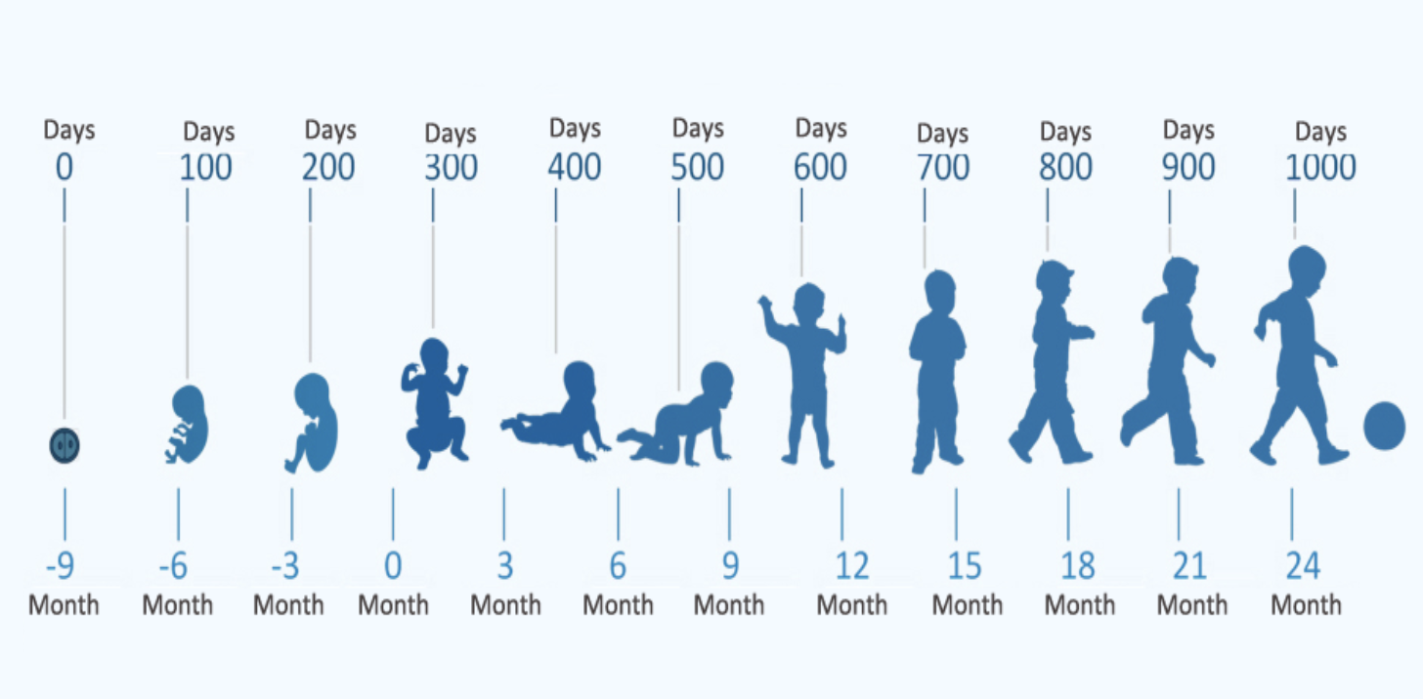
Source: Sarihusada (https://www.sarihusada.co.id/en/About-Us/First-1000-Days-of-Life/Detail-For-the-First-1000-Days-of-Life)
(UNICEF) video on First 1,000 Days (2015)
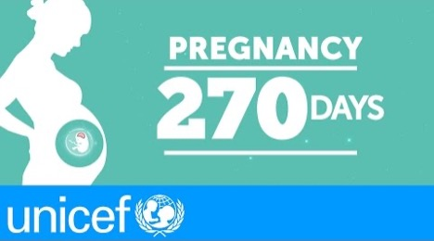
Source: UNICEF, 2015

Multi-Sectoral Approach
This is an approach to nutrition planning and programming in which different departments across several ministries (e.g., health, agriculture, women’s affairs) coordinate and collaborate to address direct and underlying causes of malnutrition.

Micronutrient Deficiency
This is inadequate intake of micronutrients (vitamins and minerals) for the body’s needs. The most common micronutrient deficiencies are vitamin A deficiency, iron deficiency anemia, iodine deficiency, and zinc deficiency. Micronutrient deficiency is also known as “hidden hunger.”

Nutrition Situation
This describes the result of all factors that contribute to the nutrition outcomes of the population. They include factors that cause malnutrition, the existing multi-sectoral nutrition-related interventions, stakeholders, and the food security situation.

Overnutrition
Overnutrition happens when a person’s daily energy intake consistently exceeds energy requirements. If this continues over time, a person may become overweight or obese (see figure 2). Overnutrition—and overweight and obesity—are risk factors for noncommunicable diseases, such as hypertension, diabetes, stroke, and some cancers.

Overweight
Overweight is a range of weight that exceeds what is generally considered healthy for a given height. For adults, overweight is having a body mass index (BMI) from 25 to 29.9. In children under five, overweight is a BMI-for-age z-score more than two standard deviations (> +2 SD) above the median of the WHO Child Growth Standards. In children ages 5–19, overweight is a BMI-for-age z-score more than one standard deviation (> +1 SD) above the median.

Obesity
Obesity is a range of weight that is much greater than what is generally considered healthy for a given height. For adults, obesity is having a BMI of 30 or higher. In children under five, obesity is a BMI-for-age z-score that is more than three standard deviations (> +3 SD) above the median of the WHO Child Growth Standards. In children ages 5–19, obesity is a BMI-for-age z-score that is more than two standard deviations (> +2 SD) above the median.

Figure 2. Illustrations of Overweight and Obesity
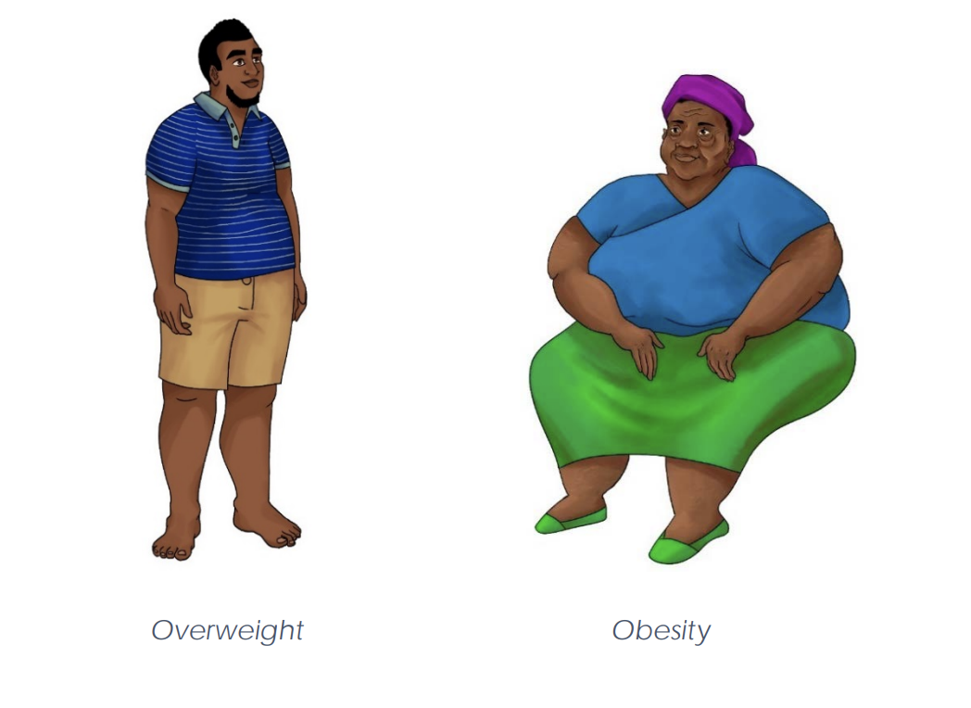
Image: IYCF image bank

Undernutrition
Undernutrition is a consequence of a deficiency in nutrient intake or absorption in the body. The different forms of undernutrition, which can appear alone or in combination, are acute malnutrition (bilateral pitting edema or wasting), stunting, underweight (combined form of wasting and stunting), and micronutrient deficiencies.

Stunting
Stunting occurs when a child fails to grow at a healthy pace and is shorter than expected for a healthy child of the same age and sex. Stunting develops over a long period because of long-term inadequate nutrition (including poor maternal nutrition and poor infant and young child feeding practices) or repeated illness or infection. Stunted children have a higher risk of death from diarrhea, pneumonia, and measles. Stunting is associated with poor cognitive and motor development and lower school achievement. In children under five it is defined as a height-for-age z-score of more than two standard deviations below the median (<-2 SD) of the WHO Child Growth Standards (children under five) (see figure 3).

Figure 3. Illustration of Stunting
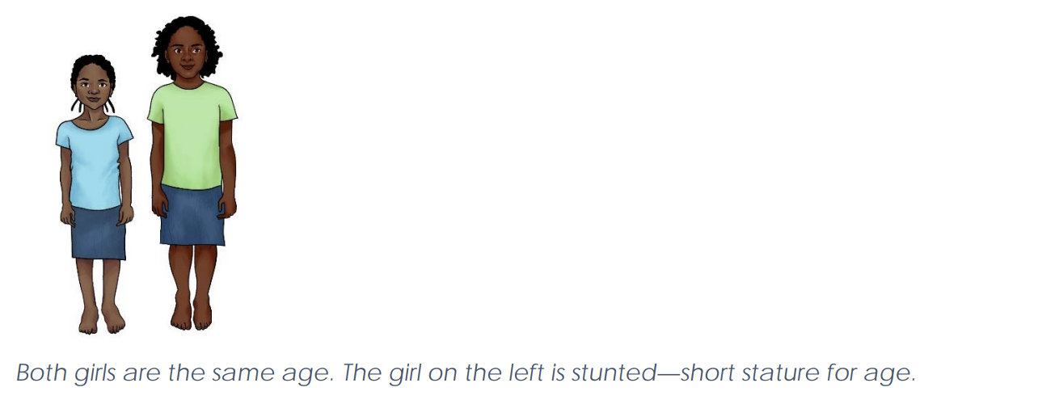
Image: IYCF image bank

Underweight
This form of undernutrition includes elements of stunting and wasting. It is defined in children under five as a weight-for-age z-score of more than two standard deviations below the median (<-2 SD) of the WHO Child Growth Standards. This indicator is commonly used in growth monitoring and promotion and in child health and nutrition programs aimed at prevention and treatment of undernutrition.

Wasting
Wasting occurs when an individual is very thin for his or her height. It happens when a person loses weight rapidly or a growing child does not gain adequate weight relative to his or her growth in height. Wasting may be caused by inadequate food intake, such as a drop in food consumption or suboptimal infant and young child feeding practices; by disease or infection, including HIV or tuberculosis; or by a combination. In children under five, it is defined as a weight-for-height z-score of more than two standard deviations below the median (<-2 SD) of the WHO Child Growth Standards or a mid-upper arm circumference under 125 mm. Wasting is one form of acute malnutrition (see figure 4).

Figure 4. Illustration of Wasting
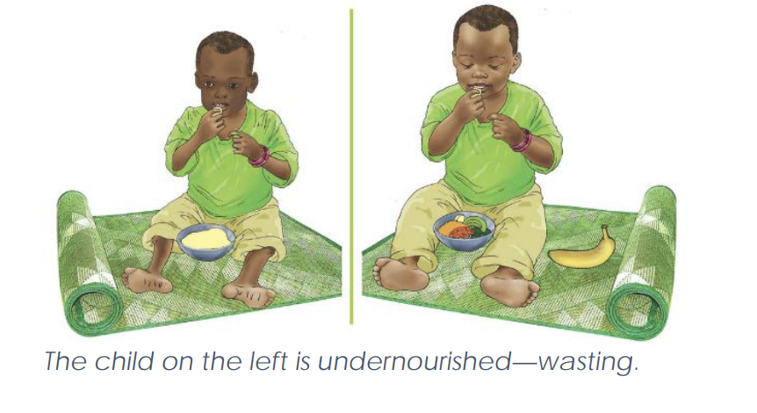
Image: IYCF image bank

Edema (bilateral pitting edema)
Edema refers to an excess accumulation of fluid that starts in both feet and can progress to other parts of the body. Also known as nutritional edema or edematous malnutrition, bilateral pitting edema is a sign of severe acute malnutrition. It is verified when thumb pressure applied on the tops of both feet for three seconds leaves an indentation after the thumb is lifted (see figure 5).
Figure 5. Illustrations of Edema
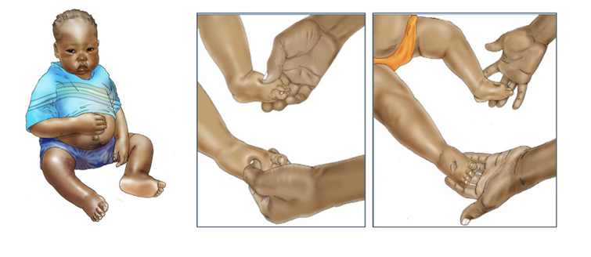
Image: IYCF image bank

Intergenerational Cycle of Malnutrition
The intergenerational cycle of malnutrition refers to what happens when a low-birthweight baby becomes a malnourished child, a malnourished adolescent, then a malnourished woman who, in turn, has another low-birthweight baby (Ahmed, Hossain, and Sanin 2012). Global evidence has shown that the consequences of malnutrition will continue to be passed on unless something stops the cycle to ensure adequate nutrition for a child or a woman; this cycle is a key factor in the broader cycle linking nutrition with poverty (see figure 6).
Figure 6. Intergenerational Consequences of Malnutrition
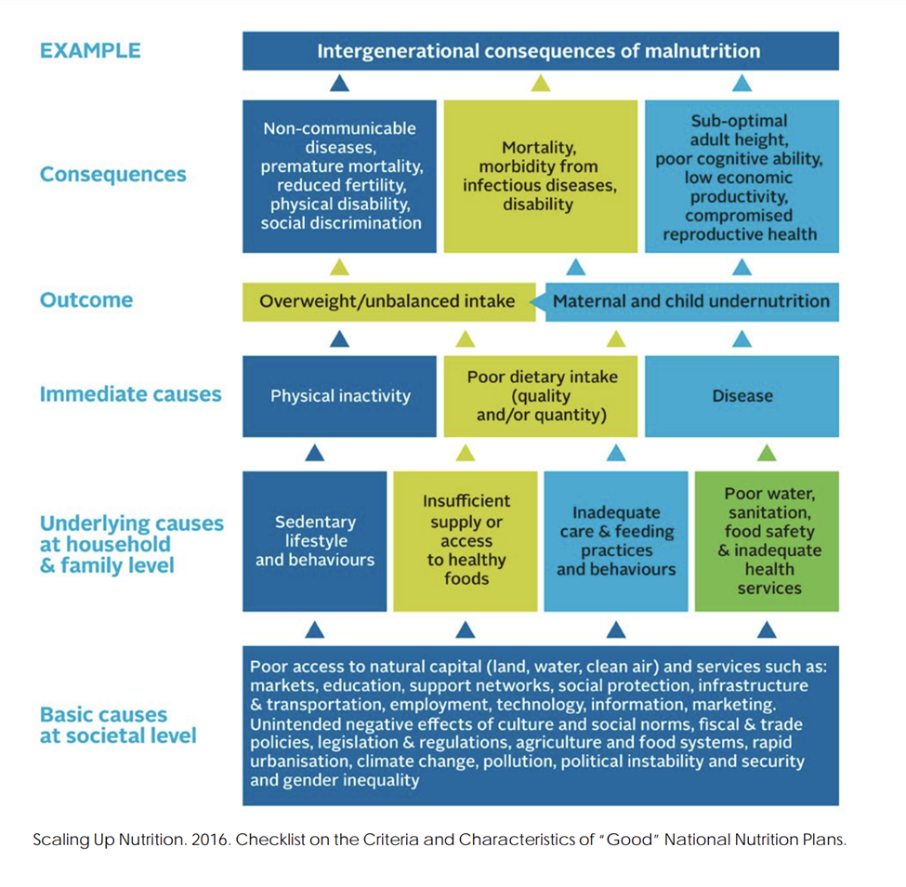
Source: Scaling Up Nutrition (SUN) 2016

Session Notes

Session 1.3

Causes of Malnutrition

Conceptual Framework on the Causes of Malnutrition
Developed by UNICEF (2020), the conceptual framework on the causes of malnutrition defines three categories of causes: immediate, underlying, and enabling determinants.
Figure 7. UNICEF Conceptual Framework on the Causes of Malnutrition
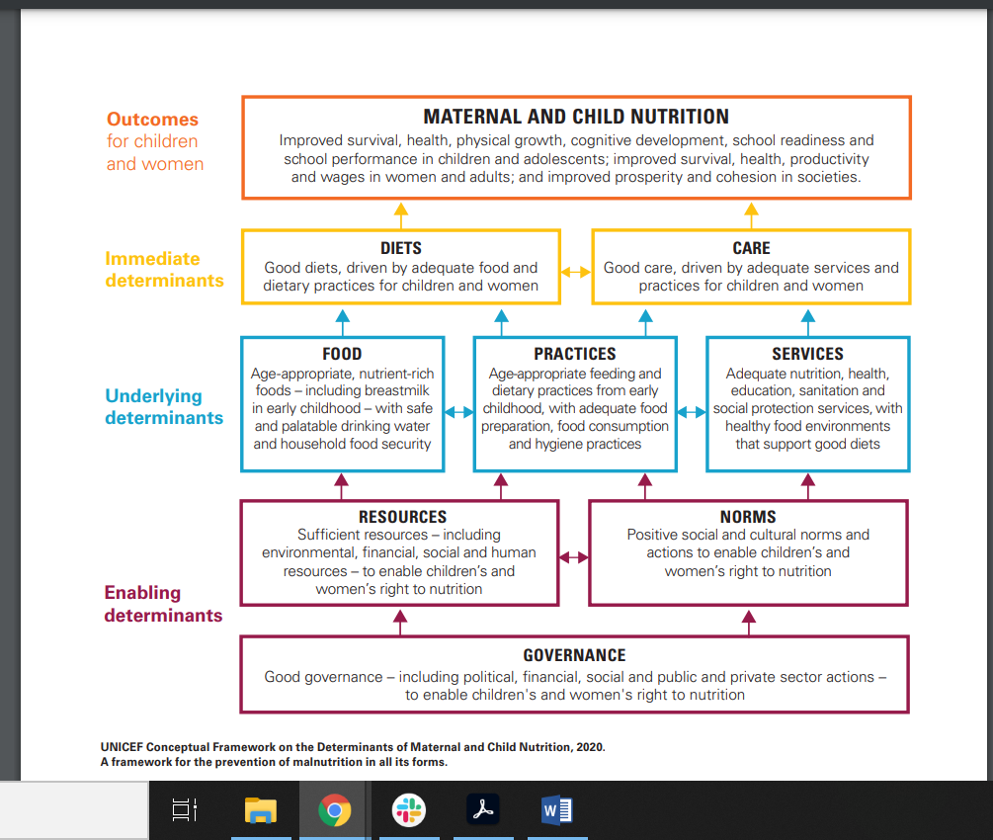
Source: UNICEF, 2020.

Immediate Causes of Malnutrition
The first category, immediate causes, refers to nutrient intake and health status that affect nutritional status in interrelated ways. Inadequate nutrient intake may result from eating too little food overall or from a diet that lacks diversity or is missing nutrients.
Likewise, a person’s health status can affect nutrition because certain conditions can affect the individual’s nutrition needs and how the body consumes and uses nutrients. For example, living with chronic diseases, such as HIV, increases nutritional needs but may limit appetite. Repeated diarrhea, which often results from poor sanitation and hygiene, can damage the intestinal lining’s capacity to absorb nutrients.
These causes of malnutrition are interrelated and affect one another. Interventions designed to directly increase nutrient intake or improve health status are called nutrition-specific interventions. They respond to these immediate causes of malnutrition.

Underlying Causes of Malnutrition
The second category is the underlying causes of malnutrition. They include factors that affect the direct or immediate causes, specifically—
- food insecurity
- care capacity and practices
- health care
- water, sanitation, and hygiene (WASH) and food safety.
Food insecurity occurs when people are unable to meet their minimum food requirements over a sustained period. Food security exists when all people at all times have both physical and economic access to sufficient food to meet their dietary needs for a productive and healthy life. Food security is determined by a variety of factors, including stability in a setting, availability and affordability of food, and absence of food access problems or limitations.
Care capacity and practice is another important underlying factor in malnutrition. The practice of how people care for themselves and others, including children, is influenced by their capacity, knowledge, skills, available time, space, and other resources. Caregivers at the household level and health service providers require sufficient capacity and resources to provide safe and nurturing care to others. Health care, including essential nutrition actions, immunizations, and the treatment of illnesses, affect health status and thereby nutrition.
WASH and food safety have important implications for nutrition because intestinal infections and other illnesses can be transmitted through unsafe practices related to food, water, and the physical environment.Enabling Determinants of Malnutrition
WASH and food safety have important implications for nutrition because intestinal infections and other illnesses can be transmitted through unsafe practices related to food, water, and the physical environment.

Enabling Determinants of Malnutrition
The last category is the enabling determinants of malnutrition, which involve factors of a more structural nature. These causes relate to the availability of, access to, and distribution of resources; political, legal, and cultural forces in the enabling environment; education; poverty; income inequality; institutions; and policies and markets.
Group Exercise: Consequences of Malnutrition
Instructions:
Brainstorm the effects of malnutrition on individuals, households, and the community, with reference to health, education, productivity, and economic development.
Write each challenge on a card and display it at the front of the room.
In your group, discuss the possible causes of malnutrition in your state/LGA. Make sure to discuss the challenges in each MDA (e.g., education, health, agriculture, planning, water, social development, trade and industry, and administration) that could contribute to malnutrition.
Write the identified causes on Post-It notes and paste them at the front of the room.

Session Notes

Session 1.4

Vulnerable Groups
The last crucial issue to emphasize as foundational for understanding malnutrition and program responses relates to the question: Who is most vulnerable?
Global evidence in the past 10 years has demonstrated that women of reproductive age, infants, and young children are most vulnerable to becoming malnourished. They suffer the greatest impact, and their condition greatly affects the overall welfare of families and communities (Bhutta et al. 2013). The intergenerational cycle of malnutrition refers to what happens when a low-birthweight baby becomes a malnourished child, a malnourished adolescent, then a malnourished woman who, in turn, has another low-birthweight baby (Ahmed, Hossain, and Sanin 2012).

Children Under Five
Children under age five are at high risk of malnutrition, especially those under age two because they are growing the fastest and need adequate nutrition to grow and develop properly. Children who are malnourished are at greater risk of infections (such as diarrhea and pneumonia), which in turn increases the risk of malnutrition. Malnourished children also have a greater risk of developing chronic diseases (such as diabetes and heart disease) in adulthood. In addition, low-birthweight babies are four times more likely to die within the first month of life than other babies.

Pregnant and Lactating Women
Pregnancy and lactation increase a woman’s nutritional needs. Among women who are already malnourished, the increased nutritional needs present additional challenges. Women who are malnourished have a higher risk of dying from pregnancy-related causes. Children born to undernourished women are more likely to be born premature and to be small for gestational age or have low birthweight. This, in turn, leads to a higher risk of stunting, an increased risk of death within one month of birth, and future developmental challenges. In addition, being overweight can increase pregnancy complications. Pregnant and lactating women are at risk, in part, due to high fertility rates.
Birth spacing has important nutritional consequences. Children conceived less than 24 months after the birth of the next older sibling have a greater risk of dying and becoming malnourished than children born further apart. When a birth occurs within 24 months of a previous birth, it gives the mother little time to replenish her own body’s nutrients. Women have increased nutritional needs during pregnancy to support the growth of the fetus; high fertility and frequent pregnancies prevent them from rebuilding nutritional stores between pregnancies.
In addition, childbearing begins early in Nigeria, which has serious consequences because—relative to an older mother—an adolescent girl is more likely to be malnourished and have a low-birthweight baby who is more likely to become malnourished. Therefore, adolescent girls need to be the focus of both family planning and nutrition interventions.

Adolescent Girls and Women of Reproductive Age
To ensure healthy pregnancy outcomes for the mother and baby, it is important to support adolescent girls and women of reproductive age before they become pregnant. Adolescence is also a time of rapid growth and development. Girls need to be well nourished during this time to ensure they grow properly. Women who are underweight and short are more likely to have babies with low birthweight. Good nutrition during the first 1,000 days that carries through to adolescence can help mitigate such nutritional complications. In addition, being overweight is a problem during pregnancy; therefore, it is important to educate young girls about a good diet. Coupled with access to family planning and efforts to retain girls in school, supporting this age group is critical to breaking the cycle of malnutrition (Bhutta et al. 2013).

Elderly
The elderly population in Nigeria faces vulnerability to malnutrition because of factors such as limited access to nutrient-rich foods, reduced appetite, digestive issues, loneliness and social isolation, health conditions and medications, dental problems, poverty and food insecurity, lack of nutrition education, and caregiver constraints. These challenges can lead to inadequate nutrient intake and contribute to malnutrition and nutrient deficiencies, affecting bone density, immune system protection, and overall health among the elderly in the country.

Infectious Diseases
People with infectious diseases, such as HIV or tuberculosis, are more at risk for malnutrition because of their higher calorie and nutrient requirements as their bodies battle these conditions. Nutrition assessment, counseling, and support are examples of interventions that targets these groups.

Session Notes

Unit 1 Personal reflection
What new things did you learn from the presentation? What surprised you? Do you recognize any of these situations or concepts from your experience in your state/LGA?

Do you have any questions or requests for clarification for the facilitator?

When you go back to your state/LGA and share what you have learned in this unit, what new understanding of nutrition issues and causes of malnutrition will you share?

How would you teach this to a new SCFN member?

UNIT 2

Nutrition Policy Environment in Nigeria

Objectives for This Unit
The objectives for this unit are to explain—
- the nutrition situation in Nigeria, including key statistics, and the causes and consequences of malnutrition
- the policy environment at global, regional, and national levels to address malnutrition
- the national multi-sectoral nutrition coordination framework, including the composition, roles, and responsibilities of nutrition coordination committees.

Agenda
- 2.1: Global Nutrition Frameworks
- 2.2: Nutrition Situation in X State
- 2.3: Nigeria National Policy Environment
- 2.4: Nigeria Multi-Sectoral Nutrition Coordination Framework
- 2.5: Roles and Responsibilities of National Nutrition Coordination Committees
- 2.6: Roles and Responsibilities of SCFNs
- 2.7: Additional Stakeholders and Collaborators
- 2.8: Configuration of SCFNs
- 2.9: Proposed Subcommittees and Working Groups in the SCFNs

Session 2.1

Global Nutrition Frameworks

Global, Regional, and National Frameworks
Although the national development agenda inform multi-sectoral nutrition planning and programming, efforts have been made to align strategies and activities to the global and regional nutrition development agenda. Refer to the key global, regional, and national frameworks described below.
At the global level, these resources stand out as guiding nutrition frameworks:
- Global Nutrition Targets 2025 (WHO) (see figure 8)
- 2030 Agenda for Sustainable Development and the Sustainable Development Goals (SDG) (see figure 9)
- SUN Movement Strategy and Roadmap (2016–2020)
- United Nations Decade of Action on Nutrition 2016–2025 (see figure 10).

National Nutrition Policies/Legislation, Strategies, and Initiatives
Nigeria’s commitment to improving nutrition is outlined in the following documents, which align with the government’s Vision 2020, Agenda 2050, and National Development Plan (2021–2025):
- Health Sector National Strategic Action Plan for Nutrition (2021–2025)
- National Policy on Food and Nutrition (2016–2025)
- National Policy on Maternal Infant and Young Child Feeding in Nigeria (2010)
- Agricultural Sector Food Security and Nutrition Strategy (2016–2025)
- Nigeria National Multi-Sectoral Plan of Action for Food and Nutrition (2021–2025)
- Nigeria Food and Nutrition Response Plan to COVID-19 (April 2020)
- National Policy on the Health and Development of Adolescents and Young People in Nigeria (2020–2024)
- National Food Safety Policy (2017–2026)
- National Agricultural Technology and Innovation Policy (2022–2027)
- National Multi-Sectoral Action Plan for the Prevention and Control of Non-Communicable Diseases (2019–2025)
- The Partnership for Expanded Water Supply, Sanitation and Hygiene Strategy (2016–2030)
- Basic Health Care Provision Fund.

Figure 8. Global Nutrition Targets 2025
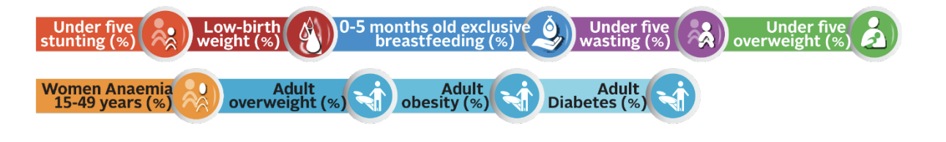
Source: WHO 2017
Recognizing that accelerated global action is needed to address the pervasive and corrosive problem of the double burden of malnutrition, in 2012 the World Health Assembly Resolution 65.6 endorsed a comprehensive implementation plan on maternal, infant, and young child nutrition, which specified a set of six global nutrition targets that by 2025 aim to—
- achieve a 40 percent reduction in the number of children under five who are stunted
- achieve a 50 percent reduction of anemia in women of reproductive age
- achieve a 30 percent reduction in low birthweight
- ensure there is no increase in childhood overweight
- increase the rate of exclusive breastfeeding in the first six months up to at least 50 percent
- reduce and maintain childhood wasting to less than 5 percent.

Figure 9. Nutrition and the SDG/2030 Agenda for Sustainable Development and the SDG
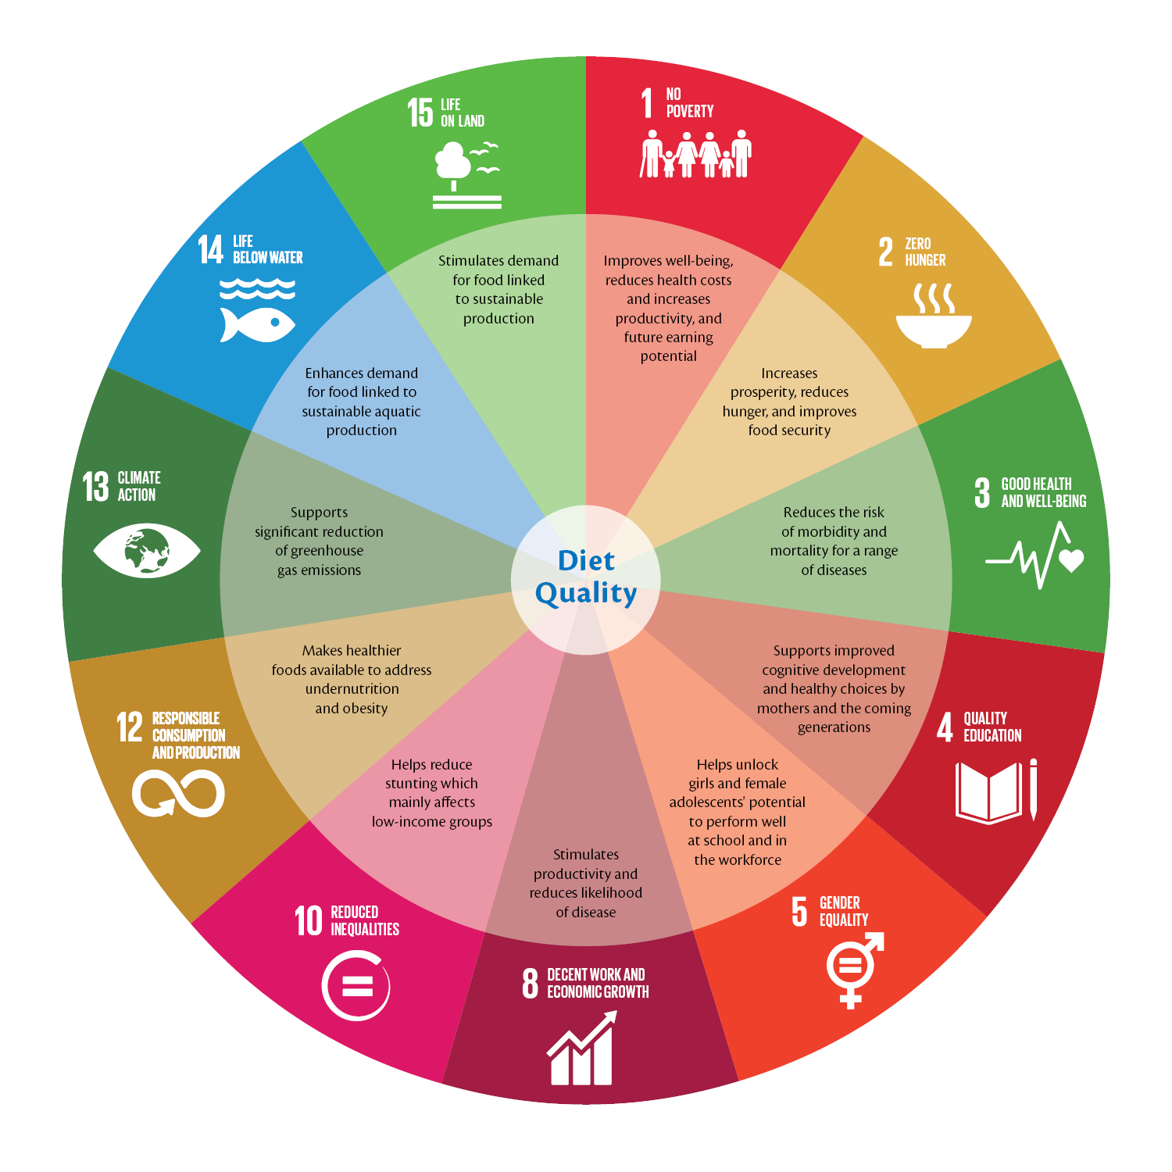
Source: Scaling Up Nutrition 2017
The 2030 Agenda builds on the Millennium Development Goals and consists of a declaration, 17 SDGs, 169 targets, a section on means of implementation and renewed global partnership, and a framework for review and follow-up. The 2030 Agenda went into effect on January 1, 2016.
Over the next 15 years, the SDGs commit all governments to comprehensive, integrated, and universal transformations, including ending hunger and malnutrition by 2030. Countries will mobilize efforts to end all forms of poverty, fight inequalities, and tackle climate change, while ensuring no one is left behind.
Without adequate and sustained investments in good nutrition, the SDGs will not be realized. The ambition to “end hunger, achieve food security and improved nutrition and promote sustainable agriculture” is captured in SDG 2, however, at least 12 of the 17 SDGs contain indicators that are highly relevant to nutrition.
Malnutrition will represent an often invisible impediment to the successful achievement of the SDGs. It results not just from a lack of sufficient and adequately nutritious and safe food, but from a host of intertwined factors linking health, care, education, water, sanitation and hygiene, access to food and resources, women’s empowerment, and more.
Figure 10. Six Pillars for Nutrition Action/United Nations Decade of Action on Nutrition 2016–2025
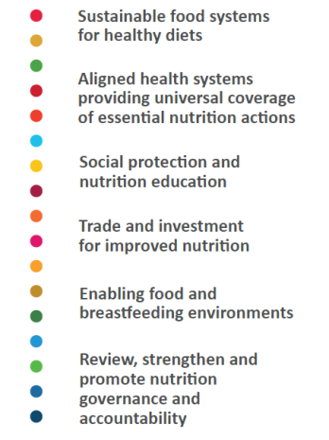
Source: WHO 2017
The UN Decade of Action on Nutrition is a UN-wide, FAO- and WHO-convened, Member State–driven global collective effort to set, track, and achieve policy commitments to end all forms of malnutrition worldwide. It is built around six pillars for nutrition action, which are based on the commitments of the Rome Declaration on Nutrition and the recommendations included in the International Conference on Nutrition Framework for Action.

Session 2.2

Nutrition Situation in Your State
This section is intended to be a one-page introduction to the nutrition situation in your state, tailored to the state and written by the state. Your facilitator may cover the following points.

Overview of Maternal and Child Nutrition Outcomes
- Health: Instruct participants to discuss state-level data. What are the most pressing issues? What is being done to address these issues? How can your SCFN plan to address them?

Underlying Determinants of Nutrition
- Food Security: Discuss state-level data. What are the most pressing issues? What is being done to address these issues? How can your SCFN plan to address them?
- WASH: Hold a discussion about state-level data. What are the most pressing issues? What is being done to address these issues? How can your SCFN plan to address them?

Basic Determinants of Nutrition
- Hold a discussion about state-level data. What are the most pressing issues? What is being done to address these issues? How can your SCFN plan to address them?
Compiling the table in Annex 12 is a first step toward describing the state nutrition situation.

Session Notes

Session 2.3

Nigeria National Policy Environment

Policy Environment
The Government of Nigeria has signed and endorsed many international frameworks to reduce poverty and improve the health and nutritional status of its population. It is a signatory of the Comprehensive Africa Agriculture Development Programme Compact (2009), has been a member of the SUN Movement since 2012, has had a SUN Business Network since 2017, and is part of the Economic Community of West African States Zero Hunger Initiative (2014).
These global initiatives are reflected in the multi-sectoral nature of Nigeria’s nutrition, agriculture, and food systems policies, strategies, and plans:
- The National Policy on Food and Nutrition in Nigeria was revised in 2016. It provides the overarching policy framework for multi-sectoral action to reduce malnutrition in the country.
- Learning from past challenges created by the siloing of interventions, the Federal Ministry of Finance, Budget and National Planning (FMFBNP) was designated as the focal point for national-level food and nutrition policy, planning, and coordination.
- The NCN is the highest-level decision-making body on food and nutrition in Nigeria. The NCN is composed of ministers from the relevant MDAs, a representative from the state governors, and private sector and nutrition-related agencies. The vice president serves as the chair of the NCN.
- The NCFN is housed under the FMFBNP and serves as the technical arm of the NCN (Ministry of Budget and Economic Planning 2016). This structure is mirrored at state and local government levels with the coordination of multi-sectoral nutrition activities undertaken by the state and local government budget and planning authorities.
- Similarly, SCFNs and LGCFNs support these focal points. Similar structures are meant to exist at the ward level; however, very few have been established. The same is true of the LGCFNs.
- In January 2021, the NCN approved the National Multi-Sectoral Plan of Action for Food and Nutrition 2021–2025 (NMPFAN). The plan is meant to guide the implementation of nutrition-specific and nutrition-sensitive interventions across sectors to address the challenges of hunger and malnutrition. The NMPFAN sets national targets to reduce the proportion of people who suffer malnutrition by 50 percent, increase the exclusive breastfeeding rate to 65 percent, and reduce stunting among children under five to 18 percent (FMFBNP 2021).
- The National Agricultural Technology and Innovation Policy (2022–2027) and the Nigerian Agricultural Sector Food Security and Nutrition Strategy (2016–2025) provide strategic direction to improve nutrition and achieve food systems transformation through the agriculture sector in Nigeria. These policies are meant to work in synergy with other nutrition-related policies, such as the National Policy on Food and Nutrition, the NMPFAN, the National Policy on Infant and Young Child Feeding in Nigeria (2010), and the Nigeria National Social Protection Policy (2016).
- The National Health Policy (2016), Second National Strategic Health Development Plan (2018–2022), and Health Sector National Strategic Action Plan for Nutrition (2021–2025) provide strategic direction to improve nutrition, especially undernutrition, through the health sector and services. The National Multi-Sectoral Action Plan for the Prevention and Control of Non-Communicable Diseases (2019–2025) further highlights strategies for addressing overweight and obesity.
- The Partnership for Expanded Water Supply, Sanitation and Hygiene Strategy (2016–2030) recognizes improved nutrition and reductions in stunting as an outcome area for the water and sanitation sector in Nigeria, and it outlines approaches for increasing national supply to WASH services.
- The Nigerian Sustainable Urban and Rural Water Supply, Sanitation and Hygiene Program for Results (2021) aims to increase access to WASH services and strengthen sector institutions.
- The Revised National Social Protection Policy (2021) outlines actions to facilitate adequate nutrition among poor and marginalized groups and reduce inequities in nutritional status.

Group Exercise: Nutrition in State/LGA Plans
Instructions:
Group work; assign a recorder and reporter and plan to present your findings.
- What are the nutrition interventions included in the five-year state or LGA development plan?
- What are the nutrition interventions included in the department annual work plans?
- What nutrition interventions are included in the State Multi-Sectoral Plan of Action for Food and Nutrition?
- What are the policy environments in your state that support nutrition?

Overview of the National Policy on Food and Nutrition in Nigeria
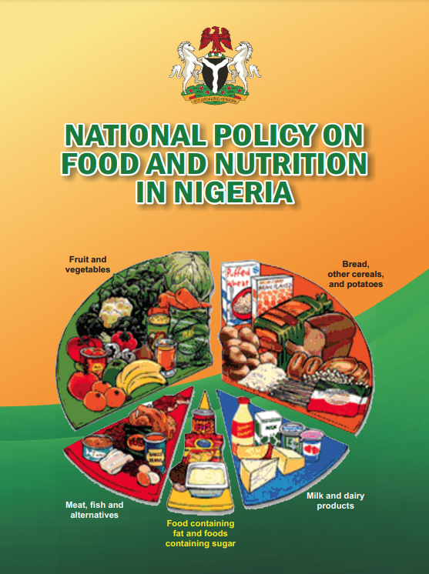
Source: National Policy on Food and Nutrition 2016

Vision Statement of the Food and Nutrition Policy
A country where the people are equitably food- and nutrition-secure, with high quality of life and socioeconomic development contributing to human capital development objectives of the Nigeria Vision 20:20:20 and beyond.

Goal of the Food and Nutrition Policy
To attain optimal nutritional status for all Nigerians, with particular emphasis on the most vulnerable groups, such as children, adolescents, women, elderly, and groups with special nutritional needs.

Objectives of the Food and Nutrition Policy
To achieve the goal of attaining an optimal nutritional status by the year 2025, several objectives are articulated:
- Improve food security at national, community, and household levels.
- Reduce undernutrition among infants and children, adolescents, and women of reproductive age.
- Significantly reduce micronutrient deficiency disorders, especially in the vulnerable groups.
- Increase the knowledge of nutrition in the populace and nutrition education in formal and informal training.
- Promote optimum nutrition for people in especially difficult circumstances, including people living with HIV and AIDS.
- Prevent and control chronic nutrition-related noncommunicable diseases.
- Incorporate food and nutrition considerations in federal, state, and local government sectoral development plans.
- Promote and strengthen research, monitoring, and evaluation (M&E) of food and nutrition programs.
- Strengthen systems for providing early warning information on the food and nutrition situation.
- Ensure universal access to nutrition-sensitive social protection.

Group Exercise: What is our role?
Nutrition governance represents actions taken to provide an institutional framework and systems to facilitate the institutionalization of nutrition in existing government structures, policies, and frameworks. Nutrition governance includes information management, coordination and partnership, advocacy, communication, and policy development and implementation.
- What LGAs and communities are most affected by malnutrition?
- Which local government, wards, or communities would you prioritize for support and why?
- Prepare a short presentation to share with the larger group.

Session Notes

Session 2.4

Nigeria Multi-Sectoral Nutrition Coordination Framework

The multi-sectoral causes of malnutrition, as highlighted in the UNICEF framework, require that nutrition be addressed using multi-sectoral approaches. Malnutrition is a multifaceted problem requiring the involvement of all government sectors directly or indirectly involved in promoting nutrition and preventing and controlling malnutrition. While a multi-sectoral approach with central coordination is necessary to deal with the complex nature of malnutrition, to appreciate the intricate interplay of numerous determinants, individual technically sound programs need be implemented by each critical sector, according to its mandate and in line with the National Policy on Food and Nutrition and the multi-sectoral strategy for its implementation. Figure 11 summarizes the sectors and MDAs that could be involved in addressing various aspects of nutrition determinants.
Figure 11. Sectors Involved in Addressing Malnutrition
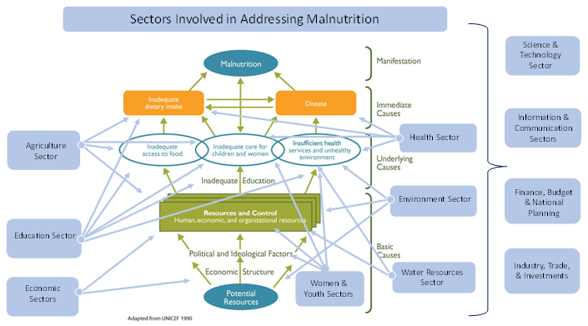
Source: Transform Nutrition West Africa
To address the multi-sectoral causes of malnutrition, the Government of Nigeria designated the FMFBNP as the national focal point for food and nutrition policy, program planning, and coordination in the country. In May 2007, the NCN was approved by the Federal Executive Council. Its membership includes ministers from relevant MDAs, one Nigeria Governors’ Forum (NGF) representative, and organized private sector and nutrition-related agencies. NCN is the highest policymaking body for nutrition in the country.

Various Sectors’ Contributions to Nutrition
Each MDA (education, health, agriculture, planning, WASH, social development, information, trade and industry, and administration), contributes to addressing malnutrition. The following is a brief overview of how and what they contribute.

Education
The education sector can improve nutrition in several ways. Children born to parents with more years of education are better nourished than children whose parents have fewer years of education. Formal education can facilitate increased knowledge about appropriate child feeding and care practices.
Education promotes self-efficacy and confidence and contributes to positive decision-making around food consumption, health seeking, and WASH. Apart from impacts through parental education, the education sector can directly affect child nutrition through nutrition and hygiene education, delivery of health care, and regular provision of nutritious school meals. Therefore, the education sector must integrate nutrition in the curriculum and service delivery from preschool to tertiary levels and thereby contribute to reductions in malnutrition in current and future Nigerian children.

Health
Disease or poor health is one of the immediate causes of malnutrition. Maternal health during pregnancy has serious implications for a woman’s own nutrition and that of her unborn child. The health sector is important in ensuring that women have access to comprehensive antenatal care that reduces the risks of malnutrition in women and children. Child spacing or family planning services provided by the health sector help women nutritionally recover from one pregnancy before having another and thereby support improved maternal and child nutrition.
The health sector is also key in delivering vital nutrition-specific interventions, including micronutrient supplements, ready-to-use therapeutic foods for treating severe acute malnutrition, and improved feeding behaviors and stimulation. For the health sector to effectively address nutrition, it must deliver nutrition services and ensure nutrition is integrated in core health care, such as family planning, antenatal care, child delivery, post-delivery care, vaccinations, well-child clinics, and sick child visits.

Agriculture
There are several ways agriculture contributes to nutrition. Agriculture is the source of all food and influences the amounts, diversity, stability, quality, and safety of foods available. Agricultural practices influence the demand and supply of food and, thereby, food prices and affordability. Agriculture is the main livelihood and source of income for a significant portion of the Nigerian population and therefore affects food and non-food expenditures, including expenditures on health, education, and WASH.
Agriculture can be a source of environmental contamination, increasing the risks of diseases and, thus, malnutrition. It is therefore important for the agricultural sector to contribute to improved nutrition by ensuring adequate availability of diverse, nutritious, safe, and affordable foods, while saving time and energy for women involved in agricultural activities.

Planning
Adequate nutrition requires that the same individuals have adequate food, health, and care at the same time. Given that the interventions related to these three nutrition determinants are delivered by different sectors and MDAs, it is the role of planning MDAs to ensure other MDAs are effectively coordinated to achieve simultaneous delivery of interventions to communities, households, and individuals. Such coordination includes joint planning across MDAs to select communities and households that will receive interventions in a specified period, as well as accountability mechanisms to ensure each MDA effectively delivers its interventions to the correct households in the stipulated period.

WASH
The WASH sector is important to achieve the health determinants of nutritional status. Poor WASH can result in illnesses and diseases that increase malnutrition. For example, diarrhea, a common outcome of poor WASH, has been clearly linked to stunting and other forms of malnutrition. Poor WASH can also result in poor intestinal (gut) health or even intestinal damage and thereby result in malnutrition.

The WASH sector can contribute to improved nutrition by scaling up safely managed water and sanitation services and optimal hygiene services among recipients of other nutrition interventions. Nutrition and hygiene education must also be integrated in the delivery of WASH services.

Social Development
There are inequalities in malnutrition in Nigeria, including economic, gender, and geographic inequalities. Many of the inequalities in malnutrition are due to differing access to services because of socioeconomic status, gender, geographical location, or other social and demographic characteristics. The role of social development MDAs, including the Ministries of Women Affairs, Youth Development, Humanitarian Affairs, and similar MDAs, is to reduce the differences that result in disparate nutrition statuses across social strata. Such reduction in differences will involve targeting vulnerable groups, like people who are poor, and facilitating increased access to nutrition-related services, including through social assistance, social insurance, increased economic opportunities, and social equity.

Trade and Industry
The food and health industries involve very powerful actors determining the nutrition of populations, including in Nigeria. Industry and trade determine what foods and drugs are available to households and individuals and determine the prices at which foods and drugs are accessible. The role of trade and industry MDAs in improving nutrition includes ensuring healthy food products are available to all segments of the population at affordable prices. These food products can include fortified foods, foods in packaging that extends their shelf life and increases their months of availability, and specially formulated foods to address specific nutrition concerns. Trade and industry MDAs also need to ensure essential drugs, including micronutrient supplements, are available and affordable to all.
Trade and industry MDAs can fulfill their roles by increasing the ease, and thereby reducing the costs, of doing business; streamlining bureaucratic processes for registering and rolling out products; facilitating access to financing, improved infrastructure, and other inputs required by industry for successful businesses; and creating regulations and incentives to reduce the availability and affordability of unhealthy foods. Trade and industry MDAs can further intervene to address supply chain bottlenecks to reaching low-income populations with nutritious food products and drugs, create mechanisms to signal healthy/nutritious foods to consumers, and reward remarkable industry efforts to increase access to nutrition-promoting foods and drugs. Above all, trade and industry MDAs must ensure that regulatory processes prioritize consumer needs.

Information
The Federal Ministry of Information and Culture contributes through newspapers and online publications on the importance of adequate nutrition and by organizing food fair shows through TV and radio.

Leadership, Structures, and Institutions
The Nutrition Division, located in the Department of Family Health in the Federal Ministry of Health (FMOH), is the government body where the country focal person for the SUN Movement sits. Apart from the coordination structures in the FMFBNP, the SUN Movement focal point also convenes government ministries and departments, including the Ministries of Health, Education, Agriculture, Women Affairs, Finance, Information, Science and Technology, and Water Resources.
The implementation of the National Policy on Food and Nutrition is the responsibility of authorities at the three levels of government (federal, state, and LGA) in collaboration with other stakeholders, including the organized private sector, development partners, professional bodies, civil society organizations (CSOs) (e.g., nongovernmental organizations [NGOs], faith-based organizations), and communities.
State and local government counterparts of the FMFBNP will be the focal points for coordinating food and nutrition programs at state and LGA levels and will be assisted by the SCFNs and LGCFNs. Implementation agencies at federal, state, and LGA levels are responsible for implementing specific projects and programs relevant to the policy.
The focal points at federal, state, and LGA levels will have responsibility for identifying and mobilizing resources for executing given projects or activities in a coordinated manner and emphasizing the need for harmonization and synergy in each body’s geographic boundaries and authority.

Figure 12. Institutional Structure for the Coordination of Policy Implementation
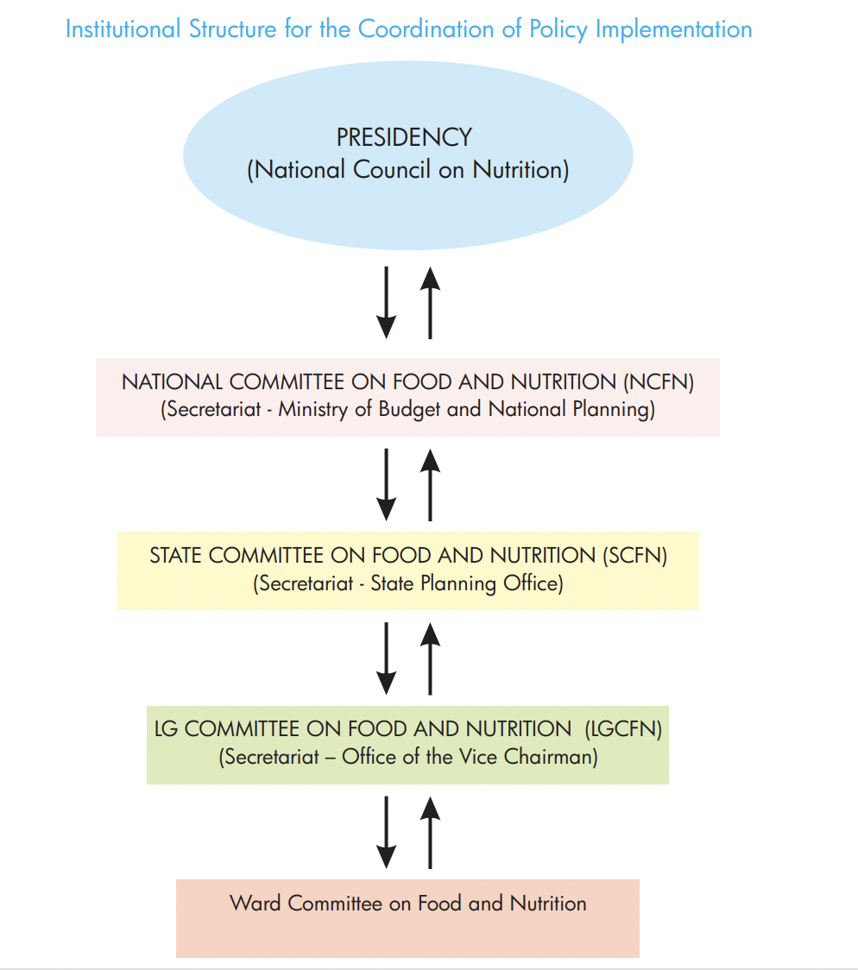
Source: National Policy on Food and Nutrition 2016
Group Exercise: What is our role?
Instructions:
Using a large sheet of flip-chart paper, draw the institutional structure from above and list in the margins the types of information that are communicated to each level, the types of resources supported from each level, etc. (For example, from SCFN to LGCFN is xx data and xx resources. From LGCFN to SCFN is xx data and xx resources.) Complete for each level for data, resources, and other forms of support.

Session Notes

Session 2.5

Roles and Responsibilities of National Nutrition Coordination Committees
The following descriptions of structures come from the National Policy on Food and Nutrition (2016). Let’s spend some time reviewing and unpacking them to better understand each structure’s roles and responsibilities and how they engage with other structures.

Overview of the FMFBNP
The FMFBNP will serve as the national focal point for food and nutrition policy program planning and coordination in the country. The FMFBNP will also serve as the secretariat for both the NCFN and NCN, will coordinate with the state secretariats, and will have regular forums for interactions. The FMFBNP will have at least one qualified and experienced nutritionist (not less than a deputy director) as the administrative head of the division or department that will house the NCFN Secretariat.
Mandate of the FMFBNP—
- to provide day-to-day support that will enhance the effectiveness of the NCN
- to serve as the focal point for the coordination and harmonization of all food- and nutrition-related policies and programs being implemented by various ministries and agencies into a national program consistent with the goals and aspirations outlined in this policy document
- to provide a forum for the exchange of views and experiences among the bodies implementing nutrition programs in Nigeria and, thereby, foster and strengthen their respective roles in the program
- to coordinate the review, on a continuous basis, of policies and programs regarding their potential impact on food and nutrition issues
- to ensure the effective implementation of the different policies and programs by putting in place effective processes for M&E
- to maintain ongoing advocacy for food and nutrition issues
- to ensure adequate financial provisions and the timely release of allocated funds in the National Development Plan and annual budget
- to liaise with international donor agencies, financial institutions, the private sector, community-based organizations (CBOs), and NGOs when soliciting funds and material support to complement government resources and efforts; and ensure that development partners incorporate nutritional considerations in their development strategies across all sectors, especially food security, maternal and child health, social protection, education, agricultural research, and gender-based programs
- to coordinate the analysis and dissemination of the results of important food and nutrition studies, statistics, and data.
Now, let’s unpack these specific duties of the FMFBNP. As explained by the National Policy on Food and Nutrition (2016), the FMFBNP provides technical advice to national committees and activities and carries out reviews.
In practice, how do they do this?
- What role does the Permanent Secretary of the Ministry play?
- How frequently do a Nutrition Partners Forum, national working groups, and subcommittees on food and nutrition meet?
- What are some roles within the technical team?
- How does the FMFBNP engage with the NCFN and NCN? What do they provide?

Overview of the NCN
National Council on Nutrition
The NCN is the highest decision-making body on food and nutrition. It serves as the policy body for all efforts geared to ensuring food and nutrition security for all Nigerians. The NCN will be chaired by the Vice President of the Federal Republic of Nigeria and will be composed of ministers from relevant MDAs, one representative from Nigerian governors, and representatives of organized private sector/industry as approved by the Federal Executive Council in May 2007. The Council will meet on a biannual basis.
Terms of reference for the NCN —
- identify, analyze, and ascertain the problem of nutrition in Nigeria
- identify the efforts already in place for tackling child malnutrition in Nigeria
- review strategies and their impact on household, community, local government, state, national, and international levels
- assess further action to be employed in dealing with malnutrition based on regular reviews of M&E reports and periodic surveys
- coordinate and harmonize efforts, strategies, and programs of nutrition
- ensure adequate resource mobilization and allocation to address nutrition issues.
Now, let’s unpack the specific duties of the NCN, as explained in the National Policy on Food and Nutrition (2016). The NCN is housed in the Office of the Vice President. It is charged with identifying, analyzing, and dealing with problems of nutrition by reviewing strategies and their impact at the household, community, local government, state, national, and international levels; coordinating and harmonizing efforts, strategies, and programs of nutrition; and ensuring adequate resource mobilization and allocation to address nutrition issues.
Tasks include—
- national-level coordination of multi-sectoral nutrition stakeholders
- coordination of the National Policy on Food and Nutrition (2016) and its implementation at decentralized levels
- multi-sectoral nutrition knowledge management and information sharing through experience sharing and learning events at global, regional, and national levels
- quarterly monitoring and supportive supervision to the SCFNs.

Overview of the NCFN
National Committee on Food and Nutrition
To achieve the National Policy on Food and Nutrition objectives and implement its programs, a NCFN has been established, located in the FMFBNP, to assist the FMFBNP to assess and enhance the various policies on food and nutrition and to plan national programs on food and nutrition matters. Membership of the committee is drawn from relevant MDAs of government and representatives of universities dealing with issues of food and nutrition, CSOs, and relevant private sector institutions.
Mandate of the NCFN—  - providing necessary technical and professional assistance and support to the FMFBNP on food and nutrition policy planning and implementation  - proposing and reviewing, on a continuous basis, policies and programs that have a potential impact on food and nutrition issues  - ensuring that the representatives of relevant sectors on the Committee undertake effective implementation of their various policies and programs  - advising on the formulation of appropriate strategies for policy and program M&E  - supporting the FMFBNP in the maintenance of ongoing advocacy for food and nutrition issues  - assisting the FMFBNP to set up and manage a database of nutrition activities. | The NCFN Secretariat will have several responsibilities:  - The NCFN will have a secretariat established in the FMFBNP that will be a division in the Ministry responsible to the chair of the NCFN in the implementation of the decisions of the NCFN and the day-to-day operations of the national food and nutrition program.  - The division will be fully staffed with the requisite human and material resources, with the required mix of staff and competencies in nutrition, food, and M&E.  - In addition, the secretariat will be responsible for—  servicing all statutory NCFN meetings  establishing appropriate links with other departments in the Ministry of Budget and National Planning  undertaking any other duties as may be assigned by the Ministry of Budget and National Planning for the effective implementation of this policy.

As explained in the National Policy on Food and Nutrition (2016), NCFN provides technical advice to national- and state-level activities, monitors and evaluates nutrition activities, carries out reviews, and provides technical advice to SCFNs. Now, let’s unpack the specific duties of the NCFN.
The NCFN is housed in the FMFBNP. It is charged with the day-to-day functions of coordination, management, administration, and reporting on multi-sectoral nutrition programs to ensure the smooth implementation of the nutrition policy, strategies, and action plans.
Tasks include—
- multi-sectoral nutrition knowledge management and information sharing through experience sharing and learning events at global, regional, and national levels
- quarterly monitoring and supportive supervision to the SCFNs
- implementation of the National Policy on Food and Nutrition (2016) M&E framework.

Session Notes

Session 2.6

Roles and Responsibilities of SCFNs
The following description comes from the National Policy on Food and Nutrition (2016).
Overview of the NCFN
State Committee on Food and Nutrition
To achieve the National Policy on Food and Nutrition objectives and implement its programs, a SCFN will be established and located in the State Planning Ministry (or equivalent in the state). Membership of the committee will be drawn from relevant MDAs of government and representatives of tertiary institutions dealing with issues of food and nutrition.
Mandate of the SCFN —  - providing necessary technical and professional assistance and support to the Secretariat (State Planning Ministry or its equivalent in the state) on food and nutrition planning and program implementation  - ensuring adequate financial provision and timely release of allocated funds in state development plans  - proposing and reviewing, on a continuous basis, programs that have a potential impact on food and nutrition issues  - ensuring that the representatives of relevant sectors on the committee undertake effective implementation of their various policies and programs  - advising on the formulation of appropriate strategies for program M&E  - supporting the State Planning Ministry (or equivalent in the state) in the maintenance of ongoing advocacy for food and nutrition issues  - assisting the State Planning Ministry (or equivalent in the state) to set up and manage a database of nutrition activities. | The SCFN Secretariat will have several responsibilities:  - The SCFN will have a secretariat established in the State Planning Ministry (or equivalent in the state) that will be a division in the Ministry responsible to the chair of the SCFN in the implementation of the decisions of the SCFN and the day-to-day operations of the state food and nutrition program.  - The Permanent Secretary of the Ministry or its equivalent will head the SCFN and the state nutrition officer will serve as the secretary.  - The division will be fully staffed with the requisite human and material resources, and with the required mix of staff and competencies in nutrition, food, and M&E.  - In addition, the secretariat will be responsible for—  servicing all statutory SCFN meetings  establishing appropriate links with other departments in the Planning Ministry (or equivalent in the state)  undertaking any other duties as may be assigned by the Planning Ministry (or equivalent in the state) for the effective implementation of this policy.
As explained by the National Policy on Food and Nutrition (2016), SCFNs provide technical advice to committees, MDAs, and implementers; monitor and evaluate nutrition activities; carry out reviews; and provide technical advice to LGCFNs and LGAs. Now, let’s unpack these specific duties of an SCFN.

Technical guidance—
- the SCFN provides nutrition technical guidance to all state government MDAs, including departments, partners, technical planning committees, and councils, to ensure proper nutrition planning and the quality of service delivery
- this includes identifying capacity-strengthening needs (see Annex 5 for an example of an OCAT Assessment).

Coordination and partnership with nutrition stakeholders—
- the SCFN provides a platform on which nutrition stakeholders from all departments can share information and build consensus on how best to address nutrition problems, use available resources, and harmonize the implementation of nutrition activities at state and LGCFN/LGA levels
- the SCFN provides knowledge management and sharing, helping MDAs learn from best practices among themselves and from other states
- the SCFN has the responsibility to identify and build partnerships with nutrition stakeholders who can contribute to state/LGA nutrition goals and objectives
- the SCFN provides strategic coordination at both state and LGA levels to ensure proper activity implementation for synergy and avoid duplication.

Support and oversight to the LGCFN—
- the SCFN provides nutrition technical guidance to the LGCFNs; it oversees and provides support to ensure proper nutrition planning and the quality of service delivery
- the SCFN conducts joint monitoring and supportive supervision visits to LGCFNs to provide oversight on activity implementation
- the SCFN conducts advocacy to raise nutrition awareness in the state and among LGCFN/LGA leaders
- the SCFN identifies and works with nutrition champions to support advocacy efforts at the LGCFN and LGA levels.

Monitoring and reporting—
- the SCFN conducts joint monitoring and supportive supervision visits to food and nutrition activities in the state and lower-level LGCFNs, departments, and partners to provide oversight on activity implementation
- the SCFN is also responsible for submitting quarterly reports to the NCFN (see Annex 6 and 7) and the National Nutrition Scorecard (see Annex 8)
- reporting requirements capture progress on nutrition governance activities and on the implementation of activities in the Multi-Sectoral Nutrition Action Plan (MSNAP).

Planning, budgeting, and resource mobilization—
- the SCFN ensures the integration and alignment of nutrition interventions in all state government development planning frameworks, including development plans, annual work plans, and budgets
- the SCFN should also mobilize internal and external resources to address resource gaps (e.g., local revenues, partners) through proposal development.

Advocacy—
- the SCFN conducts advocacy to raise nutrition awareness in the state and among LGCFN/LGA leaders
- the SCFN should also identify and work with nutrition champions to support advocacy efforts at the state and LGA levels.

Group Exercise: How well does our SCFN work together?
We covered a lot of material, some of it directly from the National Policy on Food and Nutrition (2016) and some from real-life experiences. Let’s use this time to reflect on how closely our operations match the terms of reference and mandate of the SCFN.
Discussion
- How closely do your SCFN’s activities match the description in the National Policy on Food and Nutrition (2016)? What did you learn today that can be applied to your SCFN? Be precise and expand on how you will make these changes.
- How does your SCFN work with the NCN and NCFN? How could your SCFN work with them better? What is the value added and how do we capture it?

Session Notes

Session 2.7

Additional Stakeholders and Collaborators
A multi-sectoral approach will include many stakeholders and collaborators, including political leaders, civil society, and implementing partners. Additional players may include academia, religious and cultural leaders, media, and the private sector. Some of these stakeholders and collaborators have financial and technical resources and political influence. They can be effective supporters of the SCFN’s work, even though they are not official committee members.
SCFNs should engage with these stakeholders and collaborators to advance shared goals that are appropriate for the local context, because these actors are well placed to mobilize nutrition resources and can contribute technical assistance in such areas as data collection.

How does the SCFN work at the community and civil society level?
Nigeria has a diverse and vibrant community structure comprising various traditional, religious, and other normative groups, all of which are pertinent to the country’s nutrition outcomes. Pursuant to the policy, it is critical that all community structures (e.g., traditional and religious leaders, ward development committees, facility health committees), CBOs, and CSOs are meaningfully and continually engaged in multi-sectoral nutrition planning, implementation, and M&E.

How does the SCFN work with the private sector?
Nigeria has a robust private sector that accelerates growth in food supplies and manufactures essential drugs, plant machinery, and equipment. The private sector supports Nigeria’s food and nutrition program effort by collaborating in specific areas, including—
- fortification of certain identified foods with mandatory micronutrients such as vitamin A, B vitamins, zinc, and iron
- development of low-cost nutritious complementary foods and ready-to-use therapeutic food
- promotion of nutrition education that complies with quality-control standards
- participation and support of knowledge sharing on research findings
- adoption and transformation of research findings into commercially viable products.

How does the SCFN work with development partners?
Development agencies and implementing partners work closely with the Nigerian government on food and nutrition issues in the areas of program design, training and capacity building, research, pilot implementation, and regional and national programs. Nigeria appreciates the assistance provided by donor agencies to execute the National Policy on Food and Nutrition, including—
- resource mobilization in the forms of grants and loans
- best practices to be used in refining and redesigning existing programs and introducing new ones
- full participation in program implementation, review, and M&E.

Group Exercise: How does the SCFN work with other stakeholders?
Break into three groups. Each will address a set of questions to discuss.
Group 1: Community and Civil Society
How does your SCFN work with civil society, NGOs, other local groups, etc.? Please be as specific as possible, naming organizations and activities.
How could your SCFN work with them better? What is the value add and how do we capture it?
Group 2: Private Sector
How does your SCFN work with the private sector, food suppliers, manufacturers, etc.? Please be as specific as possible, naming companies and activities.
How could your SCFN work with the private sector better? What is the value add and how do we capture it?
Group 3: Development Partners
How does your SCFN work with development partners? Please be as specific as possible, naming partners and activities.
How could your SCFN work with development partners better? What is the value add and how do we capture it?

Session Notes

Session 2.8

Configuration of SCFNs

List of All SCFN Members
Each SCFN includes the following members:
- representative of Agriculture and Rural Development
- representative of Health
- representative of Education
- representative of Information
- representative of Youth Development
- representative of Budget and Planning
- representative of Women Affairs and Social Development
- representative of Finance
- representative of Science and Technology
- representative of Water Resources
- representative of National Institute of Medical Research
- representative of National Agency for Food & Drug Administration & Control
- representative of Pediatric Association of Nigeria
- representative of Nutrition Society of Nigeria
- two representatives from food industry
- representative, development partners
- representative, civil society.

See Annex 9 for an example of a SCFN Appointment Letter from Permanent Secretary (Representative of State Ministry of Budget and Economic Planning) to appoint new members to a SCFN.

Roles and Responsibilities in the SCFN
The role of chairperson is served by the Permanent Secretary of the Ministry of Budget and Planning. The chairperson chairs all SCFN meetings and is responsible for—
- general coordination of the committee
- sourcing of funds and releases in the SCFN account
- follow-up actions on all SCFN activities in the state
- attendance at NCFN meetings.
The deputy chairperson takes over the functions in the absence of the chairperson, except for funds release. The deputy chairperson is not clearly mentioned in the National Policy. However, each state committee can decide whether it needs a deputy chairperson and who it will be.
The role of secretary is served by the state nutrition officer. The secretary—
- organizes meetings and takes minutes of the meeting
- generally runs the secretariat
- writes requests for funding to implement the SCFN’s activities
- manages the committee’s database
- attends NCFN meetings
- follows up on all SCFN activities and gives a report to the chairperson.

Session Notes

Session 2.9

Subcommittees and Working Groups in SCFNs
There is so much work to do in food and nutrition, and with a large multi-sectoral committee, the SCFN needs to organize subcommittees, such as an executive committee and various subcommittees to play different roles in relation to nutrition governance, as summarized below. (The constitution of committees will be at the SCFN’s discretion.)

The Annual Budget Implementation and Tracking Subcommittee—
- monitors budget implementation and tracks fund releases
- reviews annual SCFN budget contributions for multi-sectoral nutrition interventions
- reviews annual LGCFN/LGA budget contributions for multi-sectoral nutrition interventions.

The Technical and M&E Subcommittee—
- provides technical assistance and supervision visits to LGCFNs on nutrition interventions and relevant indicators in the development plans, M&E plan, annual work plans, and budgets
- harmonizes operational plans of each MDA on nutrition interventions
- reviews the status of implementation of nutrition interventions
- provides supervisory oversight to all MDAs and LGCFNs
- reviews the annual operational plan to measure achievements versus targets.

The Advocacy Subcommittee—
- provides technical leadership and develops advocacy briefs and documents
- conducts advocacy to appropriate authorities
- uses special days and weeks, such as World Food Day and Maternal, Newborn, and Child Health Week, to conduct sensitization on special key issues around food and nutrition.

Group Discussion: How are SCFNs organized to meet their needs?
As noted, there is so much work to do in food and nutrition, and with a large multi-sectoral committee, the SCFN needs to organize subcommittees. Let’s discuss how your SCFN is organized.
Discussion
- Does your SCFN have subcommittees, such as those listed above?
- Do you see the need for additional subcommittees? What would their roles be and how do we organize to meet the needs?

Session Notes

Unit 2 Personal Reflection
When you go back to your state/LGA and share what you have learned in this unit, consider the following questions:
What is your view on how you can contribute in a multi-sectoral nutrition program?

What could be a key contribution from your state/LGA that aligns with national nutrition priorities?

Is any information missing or unclear that you should check on when back in your state/LGA?

How would you teach this to a new SCFN member?

UNIT 3

Roles and Links between Nutrition Coordination Committees

Objectives for This Unit
The objectives for this unit are to explain—
- the different structures and committees and their roles and responsibilities in the multi-sectoral nutrition landscape
- the links between the SCFN and LGA.

Agenda
- Session 3.1: Roles of Government, Councils, and Working Groups in Nutrition Governance
- Session 3.2: Links between State and Local Nutrition Coordination Committees

Session 3.1

Roles of Government, Councils, and Working Groups in Nutrition Governance

Nutrition Partners Forum
All relevant ministries are engaged through the Nutrition Partners Forum, which meets four times a year with external partners, including national and international NGOs, United Nations agencies, donors, the private sector, and the media, to discuss strategy development and decisions related to funding and nutrition emergencies. However, all partners engagement at the state-level can (and should) happen at the SCFN level.
Administrative arrangements involving the NCN, FMFBNP, the NCFN, federal and state ministries, and local governments will form the basis for planning and implementation of the National Policy on Food and Nutrition. The focal points at federal, state, and LGA levels will be responsible for identifying and mobilizing resources to execute given projects or activities in a coordinated manner, emphasizing the need for harmonization and synergy in each body’s geographic boundaries and authority.

National Nutrition Network
The National Nutrition Network (NNN) is a platform for the NCFN and SCFNs to meet annually to share experiences and deliberate on annual progress, achievements, and challenges and to chart a way forward for subsequent years. The FMFBNP, through the NCFN, will organize the NNN meeting with representation from the federal and state levels, development partners, and other relevant stakeholders.

SUN Movement
This is located in the FMOH. It is focused on promoting the implementation of evidence-based nutrition interventions, scaling up successful practices, and integrating nutrition goals in broader efforts in critical sectors, such as public health, education, social protection, food, and agriculture.
The following SUN networks are active in Nigeria and are members of the NCFN:
- SUN Civil Society Network
- SUN Business Network
- SUN Academia and Research Network
- SUN Donor Network
- Government Network.
The activities of SUN networks can be strengthened at subnational levels and encouraged to play a more active role in the SCFNs through engagement and participation in advocacy efforts, generation of evidence for decision-making, capacity building, program implementation, and supportive supervision.
The SUN Network engages with the NCFN and SCFNs through advocacy, meetings, and membership of the committee. More information can be found at https://scalingupnutrition.org/sun-countries/nigeria.

Technical Working Groups and National-Level Subcommittees
Working groups will be established, with appropriate chairs from relevant MDAs, to aid the operational efficiency and effectiveness of the NCFN and SCFNs, such as—
- Micronutrient Deficiency Control Advisory Committee
- National Fortification Alliance
- Maternal Infant and Young Child Nutrition Working Group
- National Technical Committee on the Implementation of International Code of Marketing of Breast-milk Substitutes
- Universal Salt Iodization Task Force
- Integrated Management of Acute Malnutrition Task Force.
The technical working groups (TWGs) and committees engage with the NCFN and SCFNs through attendance at meetings and technical sessions and by meeting at least bimonthly to share key information.

Group Discussion: How might we?
Instructions:
This is a group brainstorming exercise where participants get five to seven Post-It notes and write one idea per note. After five minutes of idea generation, participants stick their notes on the wall. As they are read out loud, they are organized into categories.
Consider the questions:
- How might we work better with the NNN? How will this improved collaboration be seen in our work? (What is the outcome?)
- How might we work better with the SUN Network? How will this improved collaboration be seen in our work? (What is the outcome?)
- How might we engage with the TWG? What will our collaboration improve? How will this improved collaboration be seen in our work? (What is the outcome?)
- How would you teach this to a new SCFN member?

Session Notes

Session 3.2

Links between State and Local Nutrition Coordination Committees
Although each SCFN has responsibility for planning, implementing, monitoring, and reporting on nutrition activities in its respective state, LGAs contribute to overall state nutrition plans, objectives, and goals. The LGCFN oversees the work of all LGA nutrition activities in wards and communities. The links between the LGCFN and the state-level structures are unpacked below.
One of the most important roles of the SCFN is to oversee and support the LGCFN. The LGCFN is established and located in the Office of the LGA Vice Chairman. Its purpose is to achieve the National Policy on Food and Nutrition objectives and implement its programs.
Membership of the LGCFN is similar to that of the SCFN and will be drawn from departments and representatives of CSOs dealing with issues of food and nutrition. The LGCFN Secretariat, similar to the SCFN Secretariat, is in the Office of the LGA Vice Chairman, who will serve as chair of the LGCFN. The LGA nutrition focal person will serve as the secretary.

Mandate of the LGCFN
The mandate from the National Policy is broken into sections below. The LGCFN’s specific roles and the SCFN’s supporting and oversight roles appear as bullet points below the National Policy sections.
Providing necessary technical and professional assistance and support to the secretariat (Office of the LGA Vice Chairman) on food and nutrition program implementation—
- the LGCFN is responsible for planning, implementing, monitoring, and reporting on nutrition activities in its respective LGA
- the LGCFN contributes to overall state nutrition plans, objectives, and goals
- the SCFN oversees the work of all LGCFN in the state and provides technical assistance
- the SCFN conducts joint planning, monitoring, and supportive supervision visits to the LGCFN to provide oversight on activity implementation.
Ensuring adequate financial provision and timely release of allocated funds in state development plans—
- the LGCFN hosts a budget development subcommittee that is responsible for the annual plan development and budget, submitted to the unit director and shared with the SCFN
- the SCFN reviews the annual LGCFN/LGA budget contributions for multi-sectoral nutrition interventions.
Proposing and reviewing, on a continuous basis, programs that have a potential impact on food and nutrition issues—
- the SCFN reviews LGCFN/LGA budgets, reports, and work plans, reports on progress of implementation of multi-sectoral nutrition interventions, and ensures alignment and integration with national nutrition goals.
Ensuring that the representatives of relevant sectors on the committee undertake effective implementation of their various policies and programs—
- the LGCFN supports nutrition focal persons to implement planned activities and tracks activities of other nutrition actors in the LGA
- the SCFN conducts joint monitoring and supportive supervision visits to LGCFNs to provide oversight on activity implementation.
Implementing appropriate strategies for program M&E—
- the LGCFN collects data from the ward/LGA level and transmits them to the SCFN
- the LGCFN hosts an M&E subcommittee for data collection, analysis, and reporting oversight
- the SCFN provides technical assistance and supportive supervision visits to the LGCFN on M&E
- the SCFN collects and collates up-to-date data to complete its section of the report, ensuring data quality and compliance with established standards and specifications, validating the accuracy of data before submission to the national M&E system, and submitting timely data and M&E reports to the national M&E system.
Supporting the Office of the LGA Vice Chairman in the maintenance of ongoing advocacy for food and nutrition issues—
- the LGCFN conducts advocacy visits to traditional rulers, district and village heads, and other community opinion leaders
- the SCFN conducts advocacy to raise nutrition awareness in the state and among their LGCFN and LGA leaders
- the SCFN identifies and works with nutrition champions to support advocacy efforts at the LGCFN and LGA levels.
Managing and maintaining a database of nutrition activities—
- the LGCFN properly documents all nutrition activities across all LGAs
- the SCFN provides technical assistance for the development of data collection and use into protocols that ensure accurate and consistent nutrition data.
Coordinating nutrition program implementation at the LGA level—
- the LGCFN supervises the implementation of activities at community and ward levels
- the SCFN supports the LGCFN to hold a biannual meeting with the chairperson of the LGCFN to discuss annual priorities and progress of the committee.
In addition, the SCFN provides supportive supervision:
- The SCFN has the mandate to coordinate multi-sectoral nutrition efforts at the LGA level, including monitoring and supportive supervision of the LGCFN.
- See Annex 10 for the Monitoring and Supportive Supervision Checklist developed for this task.
- The SCFN can use the tool to monitor the implementation of nutrition activities at the LGA level, check on the functionality of the LGCFNs, identify gaps, and make recommendations to the LGA.

Group Discussion: Map your catchment area
Instructions:
Break into small groups (about five people). Draw a map of the state on a flip chart, including LGA boundaries (e.g., LGCFNs, wards), or use a map.
Using the traffic light system, indicate on the map the nutrition situation in the LGAs:
- The LGA with a poor nutrition situation is colored RED.
- The LGA with a moderate nutrition situation is colored ORANGE.
- The LGA with a good nutrition situation is colored GREEN.
On a separate flip chart, group the LGAs by ranking and add notes on the following:
Explain the immediate and root causes that contribute to the nutrition situation (good, moderate, poor).
Who is the most affected by the nutrition problems and why?
What actions are needed to improve the situation for these groups? Remember that you can refer to your state/LGA data to help you with this exercise.
Gather for a debrief and discussion:
Which LGAs/wards/communities are most affected by malnutrition?
Which LGAs/wards/communities would you prioritize for support and why?
How does the LGCFN relationship work in reality? What is the process and does it alter the outcomes?

Session Notes

Unit 3 Personal reflection
When you go back to your state/LGA and share what you have learned in this unit, consider the following questions and follow-on steps:
How would you teach this to a new SCFN/LGCFN member?

What is your view on how you can improve coordination among multi-sectoral nutrition programs and better support the LGA/LGCFN in their work?

What could be a key contribution from your state to support the LGA/LGCFN to help it reach nutrition goals?

What is the link between the various levels of multi-sectoral nutrition committees? Are these links functional in your state/LGA?

UNIT 4

SCFN Monitoring, Evaluation, and Reporting

Objectives for This Unit
The objectives for this unit are to—
- provide an overview of SCFN monitoring and reporting requirements
- explain the tools, timing, and process for monitoring, evaluation, and reporting
- define the elements of M&E.

Agenda
- Session 4.1: M&E Key Concepts and Terms
- Session 4.2: SCFN M&E System
- Session 4.3: Procedures for M&E—Roles and Responsibilities of Different Actors
- Session 4.4: SCFN Indicators for Annual Reporting for the Implementation of the MSNAP at the State Level
- Session 4.5: SCFN Reporting to the National Nutrition Scorecard
- Session 4.6: SCFNs’ Role in the Nutrition Information System
- Session 4.7: SCFN Quarterly Reporting
- Session 4.8: LGCFN Monitoring and Supportive Supervision Checklist

Session 4.1

M&E Key Concepts and Terms
Let’s look at some key definitions. These terms are the foundation for some of our most basic concepts and frameworks and are important to use with precision. This is not an exhaustive list; it is intended only to give SCFN members more background on their work.
Monitoring is the routine checking of information to confirm that progress is occurring against the defined direction. It is a continual function that uses the systematic collection of data on specified indicators to provide management and stakeholders with information on an ongoing intervention with indications of the extent of progress, achievement of objectives, and use of allocated funds. With the advent of high-frequency reporting, data can be collated and reported daily; however, it commonly involves monthly, quarterly, and semesterly to yearly reporting on outputs, activities, and the use of resources to ensure the plan is going forward as intended and with the resources allocated.
Evaluation is a selective exercise that attempts to systematically and objectively assess progress toward achieving an outcome or impact. It is used to ensure the direction chosen is correct and that the right mix of strategies and resources were used to get there. Evaluation can typically be formative (i.e., helping develop learning and understanding by stakeholders) or summative (i.e., indicating the degree of achievement). It focuses on outcomes and their relationship to outputs. Evaluation is done at the formative stage, mid-term, and the end of project and includes assessments and surveys.
Inputs are resources that go into the intervention at the start-up phase or during implementation to help the intervention achieve its objectives. The inputs (e.g., number and qualifications of personnel, financial resources, institutional setup, timing) must meet the requirements to achieve the objective. The inputs should be distributed to meet all targeted groups and be accessible financially, socially, and technically. If this does not happen, the outputs may not be achieved.
Activities are actions taken or work performed through which inputs, such as funds, technical assistance, or other types of resources, contribute to produce specific outputs. They are what an intervention does or provides to accomplish its objectives (e.g., advocacy visits, stakeholders seminars, training).
Outputs are all goods and services delivered to the target population by the intervention. Inputs must be transformed into outputs. The quantity and quality of the outputs is very important.
Outcomes are changes in behaviors and practices because of the intervention. The outputs—if of the right quantity and quality—should produce an outcome. For example, the skills of service providers should change, and if they do their tasks well, the detrimental behavior and practices of parents or other caregivers should change to improve their children’s health. The change in skills of service providers or the change in behaviors and practices of parents is the outcome of the intervention. The outcome is expected to influence the problem.
Impact is the effect of the intervention on the beneficiaries. The change in the problem is the impact of the intervention on the beneficiaries. It helps demonstrate success or failure and provide accountability to all stakeholders, including donors and beneficiaries. Impact can be positive and negative, primary and secondary long-term effects produced by an intervention, directly or indirectly, intended or unintended—whereas outcomes are the likely or achieved short-term and medium-term effects of an intervention’s outputs.

Session Notes

Session 4.2

SCFN M&E System
The SCFN will use the NPMFAN’s M&E framework to monitor and evaluate its activities. The national multi-sectoral indicators will be considered to assess whether targets and goals are being reached. The M&E system will use the information generated through the food and nutrition information system, in addition to the scheduled National Nutrition and Health Survey; Nigeria Demographic and Health Survey; Multiple Indicator Cluster Survey; National Food Consumption and Micronutrient Survey; and Specific, Measurable, Achievable, Relevant, and Time-Bound (SMART) surveys to inform decision makers of the results achieved and their impacts.
To achieve this, a database will be created to keep accurate and relevant information through vertical and horizontal collation of data from the LGA, state, and federal levels so that progress and changes are tracked and impact is measured. The LGCFN M&E subcommittee collates data at the LGA level and shares them with the SCFN M&E subcommittee to populate the state dashboard. After validation, the data are shared by the SCFN chairperson with the NCN/NCFN monthly or quarterly.
The system will use a simple M&E approach with the primary aim of enabling planners at each level to collect data that will assist them in the ongoing planning and implementation of food and nutrition programs and activities. A feedback mechanism will be introduced to enable “downward” sharing of data through regular communication about the progress of food and nutrition programs and activities at national, state, and LGA levels.
The specific indicators that the SCFN and NCFN are responsible for are outlined in the next section.

M&E System
The main focus of the M&E system will be to collect accurate, reliable, and timely data on the food and nutrition program results at prescribed intervals using appropriate tools. This will include data from health facilities and other relevant institutions and population-based data. The FMFBNP will have responsibility for overall M&E.
Additional objectives of M&E are to—
- measure progress, achievements, and performance through the strategy results framework and a set of specific indicators on food and nutrition
- provide policymakers and different stakeholders with relevant qualitative and quantitative information to enable them to—
  - undertake the strategy performance assessment to make corrections for a satisfactory implementation and capitalization of best practices
  - draw conclusions about the effectiveness of achievements
  - increase skills in quality assurance in food and nutrition strategy implementation and use appropriate information for policy adjustment
  - provide data (on financial flows, inputs, results, and performance) to all stakeholders, creating a transparent information environment.

Session Notes

Session 4.3

Procedures for M&E—Roles and Responsibilities of Different Actors

Federal MDAs
In each ministry, the Department of Planning, Research and Statistics (DPRS) will be responsible for the collation and management of M&E data and also for—
- ensuring data quality and compliance with established specifications
- validating the accuracy of data before submission to the national M&E system
- submitting timely data and M&E reports to the national M&E system.

NCFN
The NCFN Secretariat, in collaboration with the M&E office of the FMFBNP, will be responsible for—
- providing overall coordination of the food and nutrition M&E system
- sourcing and collating M&E data from relevant MDAs at federal, state, and LGA levels for incorporation in the national M&E database
- working with the M&E departments of state and relevant MDAs to ensure the timely submission and quality of data
- preparing yearly reports on the progress of implementation and the achievement of objectives as stated in the policy
- identifying gaps and recommending necessary adjustments in program implementation
- preparing and submitting country reports on food and nutrition situations at intervals as contained in the performance management plan
- engaging the National Bureau of Statistics for the administration of surveys and the collection of data at specified intervals to document the achievements of results
- facilitating capacity building for M&E officers and personnel
- providing data quality assurance.

State MDAs
In each state, the planning office has a statutory role similar to that of the Ministry of Budget and National Planning at the federal level and will be responsible for coordinating the overall M&E system at the state level. It is expected to be linked to the Planning, Research and Statistics department of the relevant state MDAs for data collection, collation, and submission to the national M&E office.
The vertical M&E role of the planning officer is of line management and hierarchical structure, where they are obligated to report to the national level. In this case, the SCFN reports to the NCFN and the NGF, while the horizontal M&E role is in relation to sharing ideas among MDAs and ensuring nutrition-related data are collected from all MDAs for the SCFN and onward sharing to the NCFN.

SCFN
As discussed in Unit 2, Session 2.10, the SCFN Technical and M&E Subcommittee is responsible for—
- providing technical assistance and supervision visits to LGCFNs on nutrition interventions and relevant indicators in the development plans, M&E plans, annual work plans, and budgets
- developing annual work plans, budgets, and action plans that support the alignment of nutrition interventions across departments
- receiving reports from MDAs and LGCFNs that implement nutrition interventions
- providing supervisory oversight to all MDAs and LGCFNs
- reviewing the annual operational plan to measure achievements versus targets.

SCFNs’ additional responsibilities and collaboration with the M&E department of the FMFBNP will include quarterly reporting and supporting supervision.
For quarterly reporting, the SCFN should—
- refer to the annual Multi-Sectoral Nutrition Implementation Workplan and Budget and the Multi-Sectoral Nutrition M&E Framework from the MSNAP to report on quarterly progress toward each activity’s annual target
- call on partners and MDAs to provide updates and data
- ensure data quality and compliance with established standards
- validate the accuracy of data before submission to the national M&E system
- submit timely data and M&E reports to the national M&E system.
Regarding supportive supervision, the SCFN has the mandate to coordinate multi-sectoral nutrition efforts at the LGA level, including monitoring and supportive supervision of LGCFNs. A Monitoring and Supportive Supervision Checklist was developed to support this task and can be found in Annex 10. The SCFN can use the tool to monitor the implementation of nutrition activities at the LGA level, check on the functionality of the LGCFNs, identify gaps, and make recommendations to the LGA.

LGCFN
In collaboration with the M&E office of the FMFBNP, the LGCFN will be responsible for—
- collating data at the LGA level
- ensuring data quality and compliance with established standards
- validating the accuracy of data before submission to the state M&E system
- submitting timely data and M&E reports to the state M&E system
- carrying out quarterly local-level nutrition data reviews at the LGA level.

Session Notes

Session 4.4

SCFN Indicators for Annual Reporting for Implementation of the MSNAP at the State Level
This session will help you become familiar with the indicators and the frequency and means of verification for state- and national-level reporting. It is not intended to be an M&E training (see the full tools in Annexes 6, 7, 8, 10, and 11). To monitor and evaluate the nutritional impact of the National Policy on Food and Nutrition and its consequent programs, the National Policy on Food and Nutrition created a set of indicators to assess whether targets and goals are being reached.
They are to be scored on a five-point Likert scale:
- 1.0 to 1.4 indicates no success.
- 1.5 to 2.4 indicates minimal success.
- 2.5 to 3.4 indicates little success.
- 3.5 to 4.4 indicates moderate success.
- 4.5 to 5.0 indicates considerable success.
The M&E system will use the information generated through the food and nutrition information system, in addition to the scheduled Nigeria Demographic and Health Survey, Multiple Indicator Cluster Survey, and SMART surveys to inform decision makers on the results achieved and their impacts.
Most of the indicators applicable to the SCFN are reported semiannually.

Group Exercise: M&E Indicators and Gallery Walk
Instructions:
Using flip charts, brainstorm national-level M&E indicators—as many as you can—and include the means of verification and frequency of reporting.
Repeat this exercise for the state-level M&E indicators.
Once completed, post your flip charts around the room and walk around to look at the flip charts and hear a short description from each group (mini-presentation format). As you visit the work of the other teams, think about how many of your indicators were similar. Do you see room for additional custom indicators?
If you are presenting your team’s work, note suggestions, questions, and comments you receive from visitors and share them with your team members.
As a final step, one member of the group will refer to the reporting tool and verify the correct indicators.

Session Notes

Session 4.5

SCFN Reporting to the National Nutrition Scorecard
The NGF and the Data for Decisions to Expand Nutrition Transformation project in 2019–2021 collaboratively designed a subnational nutrition scorecard (see figure 13 and Annex 8) that aims to hold Nigeria’s governors accountable for nutrition commitments.
The NGF is the nonpartisan association of Nigeria’s 36 elected state governors. Policy advisors who are staff of the NGF Secretariat provide administrative and technical support aligned with the NGF’s vision to promote good governance and sustainable development. The NGF has a strong track record of using data to support decision-making and advocacy among Nigeria’s governors.

Purpose of the National Nutrition Scorecard
Nigeria’s 36 state governors are well positioned to advance the nutrition agenda by authorizing and supporting increased nutrition investment and providing oversight to nutrition activities. However, the governors face many competing priorities and demands for available resources in their scope of influence. In this regard, the National Nutrition Scorecard was developed as an advocacy, accountability, and monitoring tool for nutrition commitments targeted toward achieving better nutrition outcomes.
Originally called the NGF Nutrition Scorecard, the National Nutrition Scorecard provides a snapshot of nutrition at the national and subnational levels. It tracks high-level commitments and interventions that are critical to the success of the country’s nutrition programming. The scorecard has 20 indicators that track two main types of measures: those describing the enabling environment (governance, finance, human resources) and outputs and outcome measures that enable states to monitor and evaluate their progress in implementing nutrition policies. The scorecard is expected to be shared with the governors at least semiannually.

Figure 13. National Nutrition Scorecard
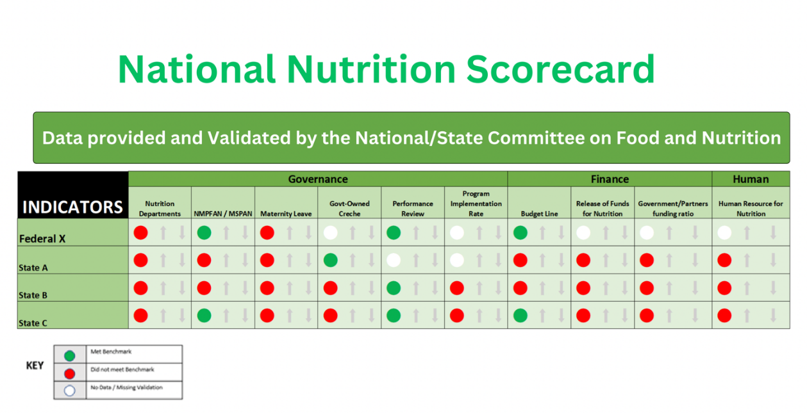

Session Notes

Session 4.6

SCFNs’ Role in the Nutrition Information System
The nutrition information system will warehouse data coming from the six result areas of the NMPFAN. The SCFN should review the data available in the DHIS2 (formerly known as District Health Information Software) in preparation for their transfer to the nutrition information system, when operational.
The SCFN can review nutrition data in the DHIS2 during quarterly review meetings.

Session Notes

Session 4.7

SCFN Quarterly Reporting
The SCFN should refer to the annual Multi-Sectoral Nutrition Implementation Workplan and Budget and the NMPFAN Implementation M&E Tool/Checklist (see Annex 11) from the MSNAP to report on quarterly progress toward each activity’s annual target. The SCFN should call on partners and MDAs to provide updates and data.

Timing and Frequency
The SCFN should provide updates on activities planned for and completed during the quarter and activities anticipated for the upcoming quarter. Examples of the types of activities to be reported on under each section of the report are detailed below:
- Technical Guidance: nutrition guidance provided by the SCFN to departments and partners, including capacity-strengthening activities and issues presented to the technical planning committee during the quarter and the resulting actions
- Coordination and Partnerships with Nutrition Stakeholders: the number of coordination meetings and joint activities conducted with stakeholders, detailing those involved and platforms used; results of stakeholder coordination efforts; and planned next steps
- Planning, Budgeting, and Resource Mobilization: efforts made to align MDA and partners’ plans with activities, challenges implementing plans, budgetary challenges, and resource mobilization activities
- Monitoring and Reporting: frequency and types of data provided to the SCFN by MDA and partners; descriptions of supervision activities undertaken; and actions taken because of monitoring, supervision, and reporting
- Advocacy: advocacy efforts undertaken by the SCFN during the quarter and actions taken by stakeholders because of advocacy efforts; the SCFN should refer to its advocacy implementation plan when completing this section
- Additional comments: describe overall SCFN achievements; nutrition innovations from community members, partners, or stakeholders; and any upcoming opportunities that the LGCFN hopes to pursue, and detail any support required from the national level to achieve these efforts.

Session Notes

Session 4.8

LGCFN Monitoring and Supportive Supervision Checklist

Purpose of the Tool
The SCFN has the mandate to coordinate multi-sectoral nutrition efforts at the LGA level, including monitoring and supportive supervision of the LGCFN. The Monitoring and Supportive Supervision Checklist was developed to support this task. The SCFN can use the tool to monitor the implementation of nutrition activities at the LGA level, check on the functionality of the LGCFNs, identify gaps, and make recommendations to the LGA. See Annex 10 for a copy of the tool.

Using the Tool
The questions in the tool seek to gather information about key aspects of nutrition governance. This includes LGCFN composition and the thematic areas that make up the LGCFN’s core roles and responsibilities.
Responses to the questions will be gathered during group discussions held with LGCFN members. LGCFN members should come from the following core departments, among others: administration and planning, community development, education, health, and water and sanitation. Participation of the LGCFN chairperson and secretary should be ensured because they are key LGCFN informants.
It typically takes the group one to two hours to complete the checklist. During the discussion, the group also agrees on and completes the summary report.

Dissemination and Feedback
The SCFN secretary is responsible for tracking progress and performance and for providing feedback to the LGCFN. The LGCFN secretary will be provided with a completed version of the checklist and the summary supervision report by the SCFN.

Session Notes

Unit 4 Personal reflection
When you go back to your state/LGA and share what you have learned in this unit, consider the following questions and follow-on steps:
What are the key nutrition indicators for which your unit will contribute?

How will you contribute to data collection, processing, analysis, and documentation?

UNIT 5

Action Plan to Operationalize Nutrition Coordination Committees

Objectives for This Unit
The objectives for this unit are to provide an overview of—
- organizational assessment tools and processes
- how to develop an action plan
- how to operationalize the OCAT and Action Planning processes.

Agenda
- Session 5.1: SCFN Action Planning
- Session 5.2: OCAT and Process

Session 5.1

SCFN Action Planning
As discussed in Unit 2, the SCFN Annual Budget Implementation and Tracking Subcommittee is responsible for—
- reviewing annual SCFN budget contributions for multi-sectoral nutrition interventions
- reviewing annual LGCFN/LGA budget contributions for multi-sectoral nutrition interventions.

Annual State Financing Process for Nutrition
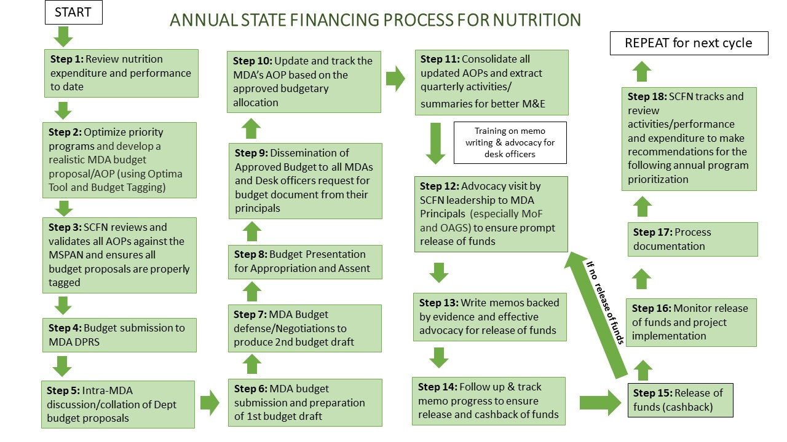

Conduct capacity building training on the budget cycle and advocacy:
- Step 1: review the current year’s nutrition budget (expenditure and performance)—at MDA level by the desk officer.
- Step 2: each MDA conducts optimization of priority nutrition programs using the MSNAP and develops its nutrition budget proposal/annual operational plan (AOP)—at MDA level by the desk officer.
- Step 3: SCFN conducts meeting to review and validate all AOPs against the MSNAP—at state level by the SCFN.
- Step 4: nutrition budget proposal is submitted to MDA budget office/DPRS, backed by internal advocacy to MDA principal officers—at MDA level by the desk officer.
- Step 5: intra-MDA discussion and collation of departmental budget proposals are conducted—at MDA level by MDA principal officers.
- Step 6: MDA budget is submitted and first budget draft is prepared—at state level by the MDA and Ministry of Budget and Economic Planning.
- Step 7: MDA budget defense/negotiations/bilateral discussions to produce second budget draft are conducted—at state level by the MDA, Ministry of Budget and Economic Planning, and State Executive Council.
- Step 8: budget is presented for appropriation and assent—at state level by the executive council and state houses of assembly.
- Step 9: disseminate approved budget to all MDAs and within MDAs—at state and MDA levels by the Ministry of Budget and Economic Planning and MDA principal officers, respectively.
This process marks the beginning of a new year (January):
- Step 10: update the MDA’s AOP based on the approved budgetary allocation—at MDA level by the desk officer.
- Step 11: consolidate all updated AOPs and extract quarterly activities and summaries for better M&E—at state level by the SCFN.
Capacity building on memo writing and advocacy occurs:
- Step 12: SCFN leadership conducts advocacy visit to MDA principals (especially MoF and OAGS) to ensure prompt release of funds for implementation—at state level by the SCFN.
- Step 13: write memos backed by evidence and effective advocacy for release of funds—at MDA level by the desk officer.
- Step 14: follow up and track memo progress to ensure release and cashback of funds—at MDA and state levels by the desk officer and MDA principal officer, respectively.
- Step 15: cashback of funds occurs.
In case there’s no cashback, refer to step 13:
- Step 16: monitor release of funds and project implementation—at MDA and state levels by the MDA M&E and Ministry of Budget and Economic Planning, respectively.
- Step 17: processes are documented—at MDA level by the desk officer.
- Step 18: SCFN reviews performance and expenditure to make recommendations for the following fiscal year.
This process occurs annually and is mandated by the Government of Nigeria as part of the fiscal year budgeting process.

Session Notes

Session 5.2

OCAT Tool and Process
An organizational capacity assessment can be done annually (or more or less frequently) to track progress from the prior year. The OCAT is strictly for capacity strengthening purposes and is outside regular FMOH and FMFBNP reporting. It can be used to check on areas of strength and areas that need improvement. It is closely linked to the Action Planning process, which can improve areas identified by the OCAT.

Objectives of the OCAT
The OCAT, revised by United States Agency for International Development (USAID) Advancing Nutrition, is a self-assessment tool used to draw insights from an SCFN’s leadership and members to qualitatively diagnose the SCFN’s planning, budgeting, oversight, and organizational capacity and competency to implement state nutrition policies and programs.
Findings from the assessment can be used to identify areas where gaps exist and to produce an action plan for addressing them. The tool will help the SCFN prioritize where it should focus its improvement efforts, decide on responsibilities and time frames, and know when to request technical assistance. Specifically, the OCAT results will be used to—
- inform the development of capacity-building plans by identifying specific areas that should be prioritized
- demonstrate progress in building the SCFN’s capacity through the USAID Advancing Nutrition project.

Description of the OCAT
The OCAT is a semi-quantitative assessment tool. It can provide a good understanding of an organization’s capacity across all necessary functions (i.e., highlight the key strengths and weaknesses).
One of its advantages is that it serves as a learning tool and an assessment tool when applied as a self-assessment, giving respondents a concrete image of higher levels of capacity to strive for and a deeper understanding of one another’s views of the organization’s capacity. The OCAT is semi-quantitative because indicators are scored on a five-point Likert scale but some indicators also allow for qualitative responses.
By providing a specific description of capacity for each possible score on the scale for each indicator, the tool reduces the subjectivity associated with traditional tools, which ask respondents to rate indicators on a scale that uses vague terms such as “weak” and “strong.” It increases reliability and decreases variability among participants. However, the descriptions are considered only a guide. Participants are to select the stage that they feel best describes their organization’s capacity for that indicator at the time, even if not every word in the description is accurate for their organization.
The OCAT tool assesses six capacity areas:
- institutional context
- structure and functions
- gender equality and social inclusion (GESI)
- finance and operations
- monitoring, evaluation, and learning
- state and LGA offices.
Under each capacity area, several indicators are listed in the form of questions. For each indicator, five stages of progress are defined:
- low capacity/no attainment
- minimal capacity/start of formal activity
- adequate capacity/some progress shown
- good capacity/good progress shown
- excellent capacity/complete attainment.

The OCAT Process
The OCAT is to be filled out in a participatory setting with the relevant leaders and members of the SCFN. An external facilitator will guide the group discussion of each question and enter the responses that the group agrees on. In case of disagreement, lack of consensus, or non-applicability of the question, the facilitator can leave the response blank and note the reason in the comments section.
Participant selection works as such:
- Before the assessment, the SCFN will determine which committee members will participate in the scoring and discussions for each capacity area.
- There should be a balance of committee leaders and committee members to the extent possible.
- If the SCFN has LGA offices, it may consider including some representatives from the LGA in some or all scoring groups.
- Note that for some capacity areas, not everyone in the room is familiar with all functions that they will be scoring.
Before the workshop, the following should occur:
- A few days before the start of the workshop, all scorers will be provided with hard and soft copies of the OCAT and an Excel-based scoring template.
- Scorers should read through the capacity areas that they will be scoring and discussing and begin thinking about the stage of progress that they believe the organization is currently at for each indicator (i.e., the score they would select).
- They should come to the first day of the workshop with any questions or clarifications that they want on the indicators.
Guidelines for the OCAT facilitators are as follows:
- The OCAT workshop will be facilitated by an external facilitator who has been trained in conducting OCAT assessments.
- Partner staff may support the facilitator during the workshop sessions and will participate in analyzing scores and developing capacity-building plans.
The OCAT workshop will operate as such:
- The day will be divided into scoring sessions, with one capacity area being scored in each session, as mentioned above (see participant selection guidance).
- In each scoring session, the facilitators introduce one capacity area at a time, review the questions to ensure proper understanding, and allow a discussion aimed at establishing a mutual understanding among the participants of the SCFN’s processes surrounding the indicators and an agreement on the SCFN score.
- Note that discussion is critical to the OCAT process and should be allowed to continue. It is often the most important part of the OCAT. If the group is small, one tool can be used with a recorder assigned. The process is repeated for each capacity area being scored by that group.
OCAT scores are compiled in an automated table that produces summary tables with a composite score for each capacity area. The facilitators analyze the scores to identify capacity areas and indicators with significantly disparate scores and identify areas of relative strengths versus the need for capacity development.
Toward the end of the process, the facilitators present the self-assessment results, highlighting the strongest and weakest capacity areas and indicators. If there are any indicators that received significantly disparate scores (determined via a formula) from the organization’s committee members and the facilitators are not able to correct for it (e.g., by removing a single outlier), the facilitators will lead a discussion to explore the reasons for the disparate scores and bring the group to a consensus.
The day ends with the facilitators leading a participatory process to select priority capacity areas to inform the capacity-building plan. After the workshop, the participants divide into groups to begin developing the capacity-building plan for each capacity area.

Session Notes

Unit 5 Personal reflection
When you go back to your state/LGA and share what you’ve learned in this unit, how will you teach new SCFN members about this process?

How will the OCAT and Action Planning contribute to a stronger SCFN, specifically in which areas?

Unit 6

Gender and Equity

Objectives for This Unit
The objectives for this unit are to—
- teach general gender concepts and how gender affects nutrition and health outcomes
- identify differences between men’s and women’s roles and status in your community
- discuss how SCFN activities can be adapted to be more gender equitable and promote women’s empowerment.

Agenda
- Session 6.1: Key Concepts, Terms, and Definitions
- Session 6.2: Gender and Equity Domains
- Session 6.3: Gender and Equity Action Planning for Multi-Sectoral Nutrition Plans

Session 6.1

Key Concepts, Terms, and Definitions

Introductory questions
What is your experience with gender equality, either personally or through programming? What do you hope to learn here?

Group Exercise: Values Clarification
Instructions for this exercise are as follows:
Stand in the middle of the room.
The facilitator will read aloud a statement.
Step to the right if you agree.
Step to the left if you disagree.
The facilitator will ask a few people to explain their answer.
Everyone step backs to the middle.
Once completed, let’s gather as a group to reflect on the exercise: Even though we may be familiar with gender equality concepts, some questions are still difficult for us to answer. Our own experience with and beliefs on gender can affect how we view and understand our projects, programs, and participants. We need to keep this in mind as we ask fellow staff, partners, and project beneficiaries to discuss gender issues.

Let’s look at some key definitions. These terms are the foundation for some of our most basic concepts and frameworks, and they are important to use with precision. This is not an exhaustive list; it is intended only to give SCFN members more background for their work.

Sex
This refers to the biological differences between males and females. Sex is typically assigned at birth.

Gender
This describes what it means to be a man or a woman based on culture, beliefs, attitudes, and norms. Each place and culture has a different understanding of what it means to be a “real man” or “real woman.”

Gender and Nutrition
Globally, women are twice as likely to be malnourished than men and are more likely to experience food insecurity than men. Girls are more likely to be wasted, stunted, and overweight than boys of the same age group.

Gender-sensitive programming
Gender-sensitive programming takes into consideration the differences and inequalities between women and men and girls and boys. It considers and raises awareness on the socially constructed roles, behaviors, activities, and attributes that society considers appropriate for each and their related dynamics (UNICEF 2018).

Gender-responsive programming
Gender-responsive programming goes one step further and not only considers gender norms, roles, and inequalities but also ensures measures are taken to actively reduce their harmful effects. Gender-sensitive efforts need to be accompanied by gender-responsive actions to achieve gender equality and transform gender relationships and power structures (UNICEF 2018).

Gender-transformative programming
Gender-transformative programming is the highest level of gender-responsive programming. It considers not only the gender norms, roles, and inequalities for men and women but also the specific needs of men and women and girls and boys and how all these affect access to and control over resources. It also addresses the causes of gender-based inequalities, including ways to transform harmful gender norms, roles, and relations, was well as strategies to foster progressive changes in power relationships between men and women (WHO 2011).

Gender Equality
Equality refers to equal chances and opportunities for women and men, or girls and boys, to access and control social, economic, and political resources, including protection under the law. Gender equality is when men and women enjoy equal freedom, liberties, and well-being.

Gender Equity
Equity refers to fairness and considers women’s and men’s and boys’ and girls’ different needs to achieve gender equality. Simply put, it the process of being fair to men and women.

Empowerment
When women and men are able to make decisions about their own health, nutrition, and life overall.

Male engagement
When men and boys are involved and support women’s and girls’ well-being, for example in caregiving, fatherhood, and domestic labor.

Gender-based violence
This is violence directed at people based on their biological sex, gender identity, or culturally defined expectations of being a woman, man, girl, or boy.

Group Exercise: What Did You Learn Q&A
Do you remember the difference between “sex” and “gender”? Let’s see! The facilitator will read aloud a statement. If you think this statement refers to a person’s gender, then stay seated.
Once completed, let’s gather as a group to reflect on the exercise: We may have assumptions about work, tasks, or certain foods for men, women, boys, and girls. But as we learned earlier, beliefs around what is “right” for each gender can change over time. In our work, we can examine whether certain gender-related beliefs, attitudes, and norms are harmful or helpful to good nutrition and health. We can then work with community members, religious leaders, and authority figures to support helpful gender norms and shift harmful ones.

Session Notes

Session 6.2

Gender and Equity Domains
Group Exercise: How do tasks get assigned
Instructions for this exercise are as follows:
- Brainstorm a list of task for about 10 minutes.
- Circle the tasks usually done by a woman or girl.
- Underline the tasks usually done by a man or boy.
- Circle and underline the tasks done by women and men.
The facilitator will ask groups a few questions about their answers.
Once completed, let’s gather as a group to reflect on the exercise: Men and women, boys and girls do not always have equal division of tasks. Some activities take a lot of time, and some require a lot of energy. Women’s and girls’ tasks at home, on the farm, and in the community may limit their time for ensuring their own good health and nutrition and the good health and nutrition of their children.

Gender-Transformative Program/Activities
When conducting programs and activities, consider the following:
- Challenge harmful gender norms, roles, and dynamics.
- Recognize and strengthen supportive gender norms.
- Promote relative position of women, girls, and other marginalized groups.
- Change social structures, policies, and norms that allow gender inequality to continue.
- Do no harm—under no circumstance should the projects or activities take advantage of gender inequalities and stereotypes or worsen gender inequalities.

Session Notes

Session 6.3

Gender and Equity Action Planning for Multi-Sectoral Nutrition Plans

Why Consider Gender in Nutrition Action Plans?
Socially constructed gender roles can lead to unequal access to and control of education, resources, information, income, and political forums, which can reduce a household’s ability to provide sufficient food, care, and health care to all its members. Considering gender in national-level policies and programs can support actions that will eliminate barriers to maximum nutrition improvement.
By integrating gender into nutrition planning, the SCFN can contextually understand the differences that exist between men and women and boys and girls and what cultural, societal, and infrastructural factors contribute to existing inequalities. The SCFN can then develop the appropriate actions to improve household food security and consumption of diverse, nutritious foods by all household members.

Group Exercise: How can we promote gender equity and women’s empowerment in our activities?
Instructions for this exercise are as follows:
Brainstorm a list of existing SCFN activities.
Discuss how you can adapt them to be more gender sensitive and equitable.
Use the table below and present to the group when finished.
SCFN Activity | Adaptations to Promote Gender Equity  and Women’s Empowerment
Once completed, let’s gather as a group to reflect on the exercise. The facilitator will ask groups a few questions about their proposals.

Gender-Transformative Approaches
Suggestions for gender-transformative approaches include the following:
- Strengthen family support for nutrition of pregnant and lactating women.
- Nurture shared family responsibility and care for women with shared household tasks.
- Support “harmonious households” for improved communication between couples.
- Facilitate collective action on traditional gender roles and social norms for greater gender equality.
- Engage families to empower adolescent girls for improved nutrition and health. Support and empower women leaders in the community.

Developing and Reviewing Nutrition Plans through a Gender Lens
A core aim of SUN was to ensure equity, equality, and nondiscrimination for all, with women and girls at the center of efforts.

Integrating Gender into Situational Analysis
Situational analysis information includes sex-disaggregated data by key age groups (e.g., children under five and adolescents) for both nutrition-specific and nutrition-sensitive indicators.
When reviewing a multi-sectoral nutrition plan, ask: Does the situational analysis include sex-disaggregated data for key nutrition-sensitive indicators?
The situational analysis includes gender-related analysis beyond data disaggregation alone, particularly discussion around gender norms, roles, and relations and how this may influence nutrition (e.g., the typical roles of men and women, the influence of gender roles on time and decision-making).
When reviewing a multi-sectoral nutrition plan, ask: Does the situational analysis include discussion of the gender dimensions of nutrition beyond data disaggregation alone?

Integrating Gender into Stakeholder Planning
The planning actions include incorporating gender dimensions of nutrition based on the needs identified in the situational analysis (e.g., actions that promote women’s decision-making, girls’ education, and male involvement or activities targeting men).
When reviewing a multi-sectoral nutrition plan, ask: Does the plan contain actions that incorporate gender dimensions of nutrition?
The planning actions also include consulting stakeholders and groups with gender expertise (e.g., Ministry of Women’s Affairs, women’s rights organizations, and gender divisions in the UN).
When reviewing a multi-sectoral nutrition plan, ask: Does the plan reference if and how stakeholders with gender expertise were consulted and included in the plan development process?

Integrating Gender into Capacity Strengthening and Assessments
The capacity assessment includes—
- discussion of the unique needs of men and women and potential barriers to participation
- measures to encourage active participation of both men and women
- gender discussions integrated into capacity-building efforts to address gaps in knowledge and action.
When reviewing a multi-sectoral nutrition plan, ask: Do the capacity assessment and planned capacity-building actions consider and address the unique needs of men and women?

Integrating Gender into M&E
The M&E plan includes—
- gender consideration in how progress will be measured, analyzed, and reported
- gender equality indicators to assess power dynamics, empowerment, gender norms, resource control, gender-based violence, employment, household decision-making, and women’s status
- gender-sensitive indicators: quantitative measures disaggregated by sex and age to assess outcome differences.
When reviewing a multi-sectoral nutrition plan, ask: Does the M&E framework include gender equality indicators and/or gender-sensitive indicators?
The M&E framework (data collection/analysis plan) includes—
- disaggregation of data by sex and age to evaluate equity of the plan with respect to women, men, girls, and boys
- discussion around addressing data gaps where sex-disaggregated data is not currently available
- an analysis plan that includes use of sex-disaggregated data to inform decision-making.
When reviewing a multi-sectoral nutrition plan, ask: Does the M&E plan include planned collection and disaggregation of relevant data by sex and age, how data gaps will be addressed, and analysis of disaggregated data to inform decision-making?

Session Notes

Unit 6 Personal reflection
When you go back to your state/LGA and share what you’ve learned in this unit, how will you teach new SCFN members about this process?

How will the GESI aspects of multi-sectoral action planning contribute to a stronger SCFN, specifically in which areas?

Closing Session
Objectives for this session are—
- facilitators close the orientation, debrief on lessons, and solicit feedback for improvement
- participants complete post-training assessment (see Annex 2)
- participants complete orientation evaluation.

Group Exercise: Final Reflection
Gather as a group to reflect on the exercise:
- What did you learn?
- How did this orientation meet your expectations?
- What questions came up during the orientation?
- What will you bring back to your SCFN and how will you transfer this knowledge to new SCFN members?
The facilitator will ask a few questions about participants’ answers.

Closing Personal reflection
Revisit your three expectations from the opening session. Take a few minutes to reflect on whether they were met and what additional questions may have come up.

Annexes
Annex 1: List of Contributors
Annex 2: Pre-and post-training assessment
Annex 3: Glossary of Terms
Annex 4: Problems/Gaps Associated with Food System/Security and Likely Solutions
Annex 5: Sample OCAT Tool/Assessment
Annex 6: SCFN Quarterly Reporting Template (summary table)
Annex 7: SCFN Quarterly Reporting Template
Annex 8: National Nutrition Scorecard
Annex 9: Sample SCFN Appointment Letter
Annex 10: Monitoring and Supportive Supervision Checklist
Annex 11: National/State Multi-Sectoral Plan of Action for Food and Nutrition Implementation M&E Tool/Checklist
Annex 12: Indicators to be Collected for State for Nutrition Situation
Annex 13: References

Annex 1

List of Contributors
LIST OF PARTICIPANTS AT THE SCFN ORIENTATION PACKAGE DEVELOPMENT WORKSHOP (February 1–3, 2023 Lagos)
S/N | NAMES | ORGANIZATION
1 | Joel Aiki | Kebbi State Ministry of Agriculture (Kebbi SCFN Member)
2 | Dr. Yusuf A. Bashir | Federal University Birnin Kebbi (Kebbi SCFN Member)
3 | Idris Saleh Giade | Bauchi State Ministry of Budget & Economic Planning (Bauchi SCFN Member)
4 | Mahmood Bala Umar | Bauchi State Ministry of Agriculture (Bauchi SCFN Member)
5 | Oluwatosin Abayomi | Office of the vice President
6 | Chidinma Ezenwa | Nigerian Governors Forum
7 | Unah Nnenna Alice | Ebonyi State Ministry of Budget and Planning (Ebonyi SCFN Member)
8 | Nwankwo Ifeoma | Ebonyi State Primary Health Care Development Agency
9 | Henrietta Ugwu | Enugu SCFN
10 | Mr. Yehuza Abdullahi | Niger SCFN
11 | Linda Yakubu | Kaduna SCFN
12 | Olubunmi Braheem | Lagos SCFN
13 | Clementina Okoro | FCT Primary Health Care Development Board
14 | Adekunle Folashade | Office of the vice President
15 | Chukuma Anene | USAID Advancing Nutrition
16 | Stantley U.Nwosu | USAID Advancing Nutrition
17 | Hadiza Joy Marcus | USAID Advancing Nutrition
18 | Zainab Sauri Omiunu | USAID Advancing Nutrition
19 | Grace Matu | USAID Advancing Nutrition
20 | Dahiru Mohammed Bello | Sokoto State Primary Health Care Development Agency
21 | Ijanada Aliyu Jacob | USAID Advancing Nutrition
22 | Umar Sulaiman | USAID Advancing Nutrition
23 | Augustine Ajijelek | USAID Advancing Nutrition
24 | Prof Kola Anigo | Lead Capacity Strengthening Consultant
25 | Livinus Ibiang | Lead Capacity Strengthening Consultant
26 | Ishola Jonathan Adekunle | Civil Society Scaling Up Nutrition in Nigeria (CS-SUNN)
27 | Adeoluwa Adegbemile | Nigerian Governors Forum

LIST OF PARTICIPANTS AT THE SCFN ORIENTATION PACKAGE DEVELOPMENT WORKSHOP (September 2022—Abuja)
1 | Mohammed Sani Umar | NHHCA
2 | Mr. Joel AIKI | Kebbi State Ministry of Agriculture
3 | Idris Saleh Giade | Bauchi Ministry of Budget and Economic Planning
4 | Yakubu Jibrin Abdullahi | Ministry of Agriculture
5 | Mahmood Bala Umar | State Ministry of Agriculture Bauchi
6 | Abubakar Saleh | Bauchi State Primary Health Care Development Agency
7 | Usman Umar Muhammad | Bauchi Ministry of Budget and Economic Planning
8 | Michael Daniel Eveshoyan | USAID Advancing Nutrition
9 | Ibrahim Bashir Ibrahim | USAID Advancing Nutrition
10 | Israel Odiba | USAID Advancing Nutrition
11 | Olugbodi Toluwalope | USAID Advancing Nutrition
12 | Dr Yusuf A. Bashir | Federal University Birnin Kebbi
13 | Abdulmalik Muhammad | Kebbi State Primary Health Care Development Agency
14 | Shuaibu Am. Bankanu | Ministry of Agriculture Sokoto
15 | Usman Arzika | Ministry of Budget and Economic Planning, Sokoto
16 | Sean Maher | JSI Capacity Strengthening consultant
17 | Zainab L. Tumaki | Ministry of Budget and Economic Planning, Sokoto
18 | Umar Sulaiman | USAID Advancing Nutrition
19 | Dr Abubakar A. Kaoje | Kebbi State Primary Health Care Development Agency
20 | Hadiza Joy Marcus | USAID Advancing Nutrition
21 | Adedayo Abiodun | USAID Advancing Nutrition
22 | Marvellous Olatunji | Nigerian Governors’ Forum
23 | Chukwuma Anene | USAID Advancing Nutrition
24 | Nelson Chito | Federal Ministry of Budget and National Planning
25 | Muhammad Ali Hamza | Sokoto State Primary Health Care Development Agency
26 | Barrister Nnena Unah | Ministry of Finance and Economic Development, Ebonyi
27 | Nwankwo Ifeoma | Ebonyi State Ministry of Health
28 | Utobo Ukamaka C. | Ministry of Agriculture, Ebonyi
29 | Ogbona Cyprian | Ebonyi State Primary Health Care Development Agency
30 | Okike Onwuasuanyas | Agric Development Program, Ebonyi
31 | Adamu A. Romo | Sokoto State Primary Health Care Development Agency

Annex 2

Pre-and Post-Training Assessment

STATE/LOCAL GOVERNMENT COMMITTEE ON FOOD
AND NUTRITION ORIENTATION PACKAGE
Pre- and Post-Test Orientation Assessment

Name:______________________________ Date:_________________________________

- Nutrition is not a critical part of health and development:
- True
- False
- Failure to prevent and treat malnutrition can result in all of the following, except:
- Long-term cognitive and growth impacts
- Loss of income for households and up to 15 percent GDP loss for Nigeria
- Long life and prosperity
- Increased morbidity and potential death
- At least 12 of the 17 SDGs contain indicators that are highly relevant for nutrition which reflects nutrition’s central role in SDGs:
- (a) True
- (b) False
- What is/are the effects of malnutrition?
- Low birthweight
- Premature death
- Low productivity and increased health care cost
- Weakened immune system
- All of the above
- The Nutrition Governance Framework comprises the following:
- Inter-sectoral cooperation
- Sustainable funding
- Vertical coordination
- All of the above

- The SCFN is established to help in achieving the National Food and Nutrition Policy:
- True
- False
- The SCFN Secretariat is located in the
- State Ministry of Budget, Finance, and Economic Planning
- State Ministry of Agriculture and Rural Development
- State Ministry of Information
- State Ministry of Health
- One of the mandates of the SCFN is to provide necessary technical and professional assistance and support to the Secretariat on food and nutrition planning and program implementation:
- True
- False
- The role of the SCFN is to enhance the domestication of the National Policy on Food and Nutrition in the state and also develop a strategic costed work plan for the domesticated policy:
- (a) True
- (b) False
- According to the policy establishing the SCFN, the Chairperson is the Permanent Secretary of which Ministry _______________ and the Secretary should be _________________. (fill in the blanks)

Annex 3

Glossary of Terms
Adequate diet: Food consumed that contains all the nutrients (calories, protein, fats, vitamins, and minerals) in amounts and proportions required to promote growth and good health in an individual.
At-risk groups: Persons or segments of the population most likely to suffer from nutritional deprivation.
Baby-friendly hospital initiative: A hospital-based program that seeks to promote good breastfeeding practices by mothers (e.g., exclusive breastfeeding for the first six months of life).
Complementary foods: Foods, in addition to breast milk, given to infants after six months of age.
Food groups: A composite of nutrients (protein, fat, carbohydrates, vitamins, and minerals) consumed, digested, and ultimately used to meet the body’s needs.
Food security: Access by all people at all times to enough food all year round for an active, healthy life.
Food insecurity: When a household is unable to provide adequate food for its members on a sustainable basis either due to inability to produce its own food or through food purchases.
Growth monitoring and promotion: A process that involves regular weighing of a child, plotting the weight on a growth chart, using the information obtained to assess how the child is growing, and then taking appropriate actions to improve or promote the health and growth of the child.
Household food security: The ability of a household to gain access to adequate food (both in quantity and quality) to meet its nutritional requirements for an active life throughout the year.
Intrauterine growth retardation: Gradual decline in the development of a fetus due to maternal factors, such as illness or malnutrition.
Iodine deficiency disorders: The spectrum of disorders resulting from inadequate iodine intake, including mental retardation, reduced growth, spontaneous abortions, still-births, and physical disabilities.
Iron deficiency anemia: Reduced hemoglobin and oxygen carrying capacity of the blood due to inadequate iron intake or high iron losses (e.g., blood loss), characterized by fatigue, decreased capacity to work, learning disorders, and increased complications of pregnancy.
Macronutrients: Carbohydrates, fats, and proteins, comprising the major components of most foods that supply energy and amino acids for proper growth and development.
Malnutrition: The impairment of health due to a deficiency, excess, or imbalance of nutrients. It includes undernutrition, which refers to a deficiency of calories and other nutrients and overnutrition, which refers to excess of calories and nutrients (but usually of calories).
Micronutrients: These are the vitamins and minerals present in foods and required by the body in very small quantities for proper functioning.
Night blindness: An inability to see in the dark, due to a deficiency of vitamin A resulting from inadequate vitamin A intake in the diet.
Nutrition: The end result of various processes in society (e.g., social, economic, cultural, psychological, agricultural, and health) that culminate in food being eaten by an individual and subsequently absorbed and used by the body for physiological processes.
Nutritional surveillance: The process of keeping watch over the nutritional situation of a community or a population and the factors that affect it to take appropriate actions that will forestall problems or lead to improvement in nutrition.
Nutritive value: The amounts of a given nutrient in a food item that will be potentially available for use by the body.
Prenatal mortality: Death of babies before birth.
Prevalence rate: The percentage of individuals in a sample or population who are affected by a certain disorder or condition.
Provitamin A: A substance (beta carotene) found in plants that can be converted by the body to vitamin A.

Annex 4

Problems/Gaps Associated with Food System/Security
and Likely Solutions
S/N | PROBLEMS/GAPS | SOLUTIONS
1. | Limited access to extension services by farmers to produce nutritious food | Smart Led Farmers pass information to other farmers
2. | Wasting and hunger in the lean season | Provision of food bank
3. | High inputs cost | Private sector extension services  Private sector-led credit financing
4. | Improper use of agro chemicals and consumption of chemical residues | Private sector sensitization on non-organic agriculture
5. | Limited access to financing to small scale farmers | Pre-financing farmers by private sector
6. | Limited access to mechanization | Linking farmers to private sector mechanization service providers to hire tractors
7. | Limited access to nutritious foods by people in the base of the pyramid (low-income populations) | Support private sector actors to adapt their business models, marketing, and distribution strategies to ensure that nutritious food products reach low-income communities

Annex 5

Sample (screenshots of) OCAT Tool (please see USAID Advancing Nutrition for Implementation Guide and OCAT)
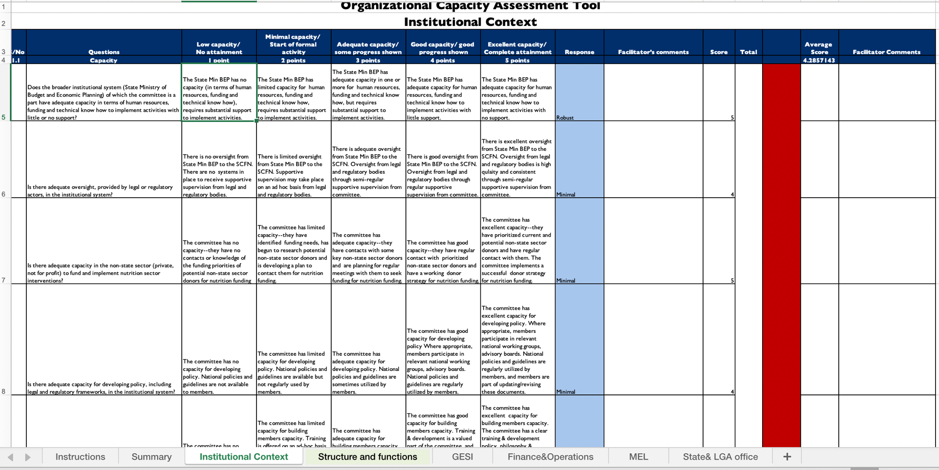

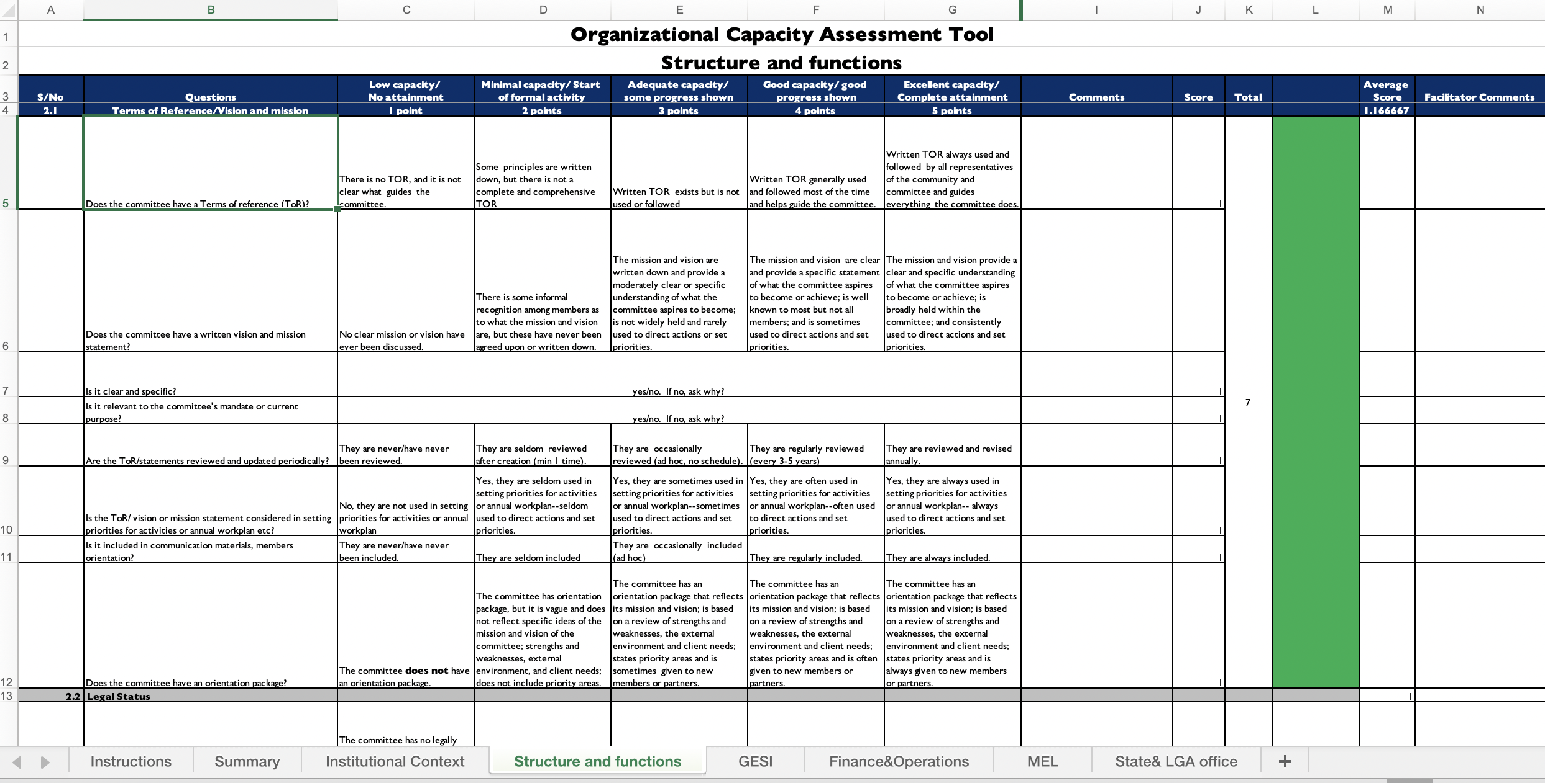

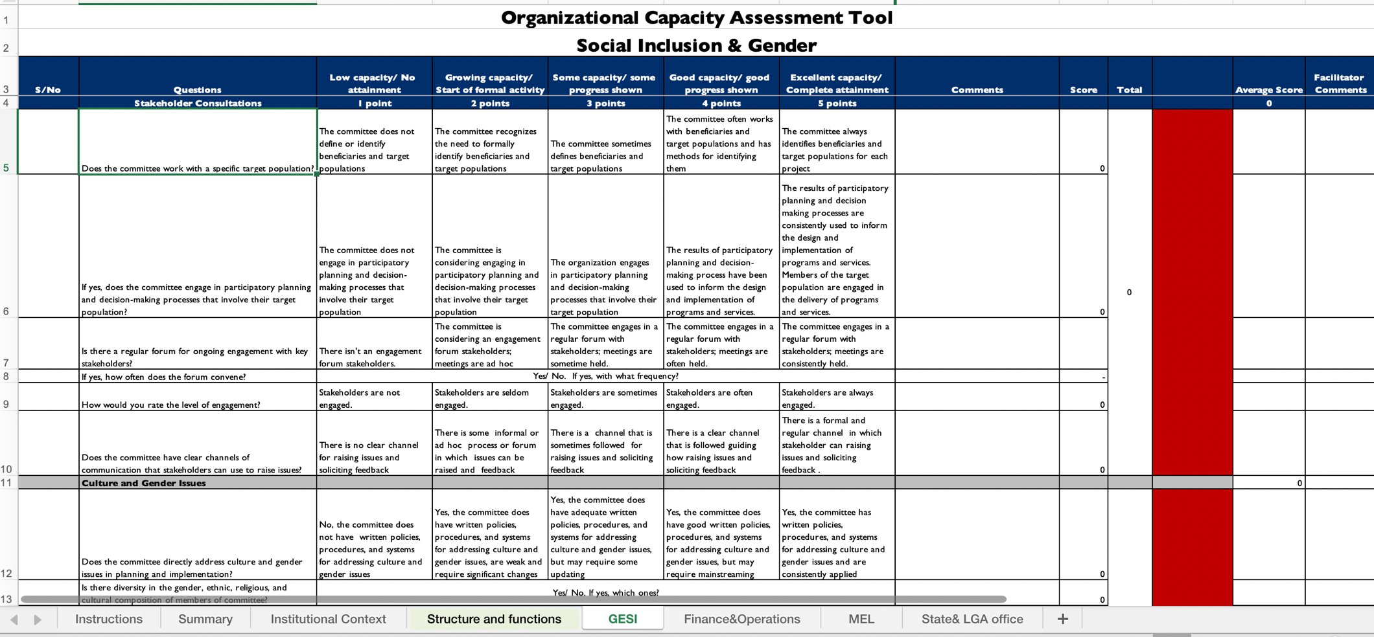

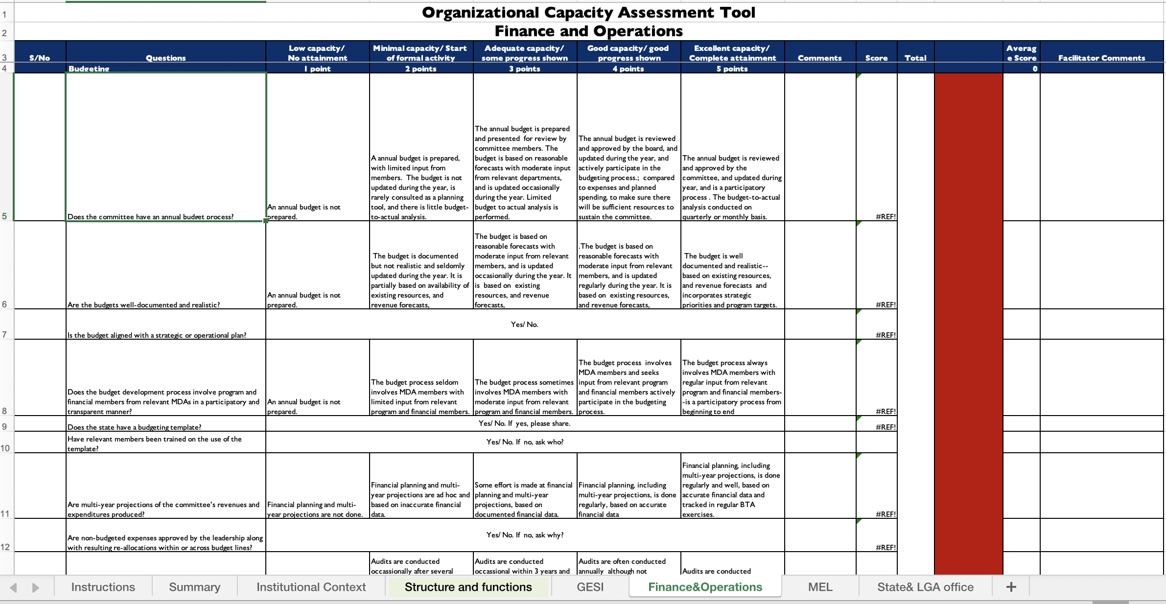

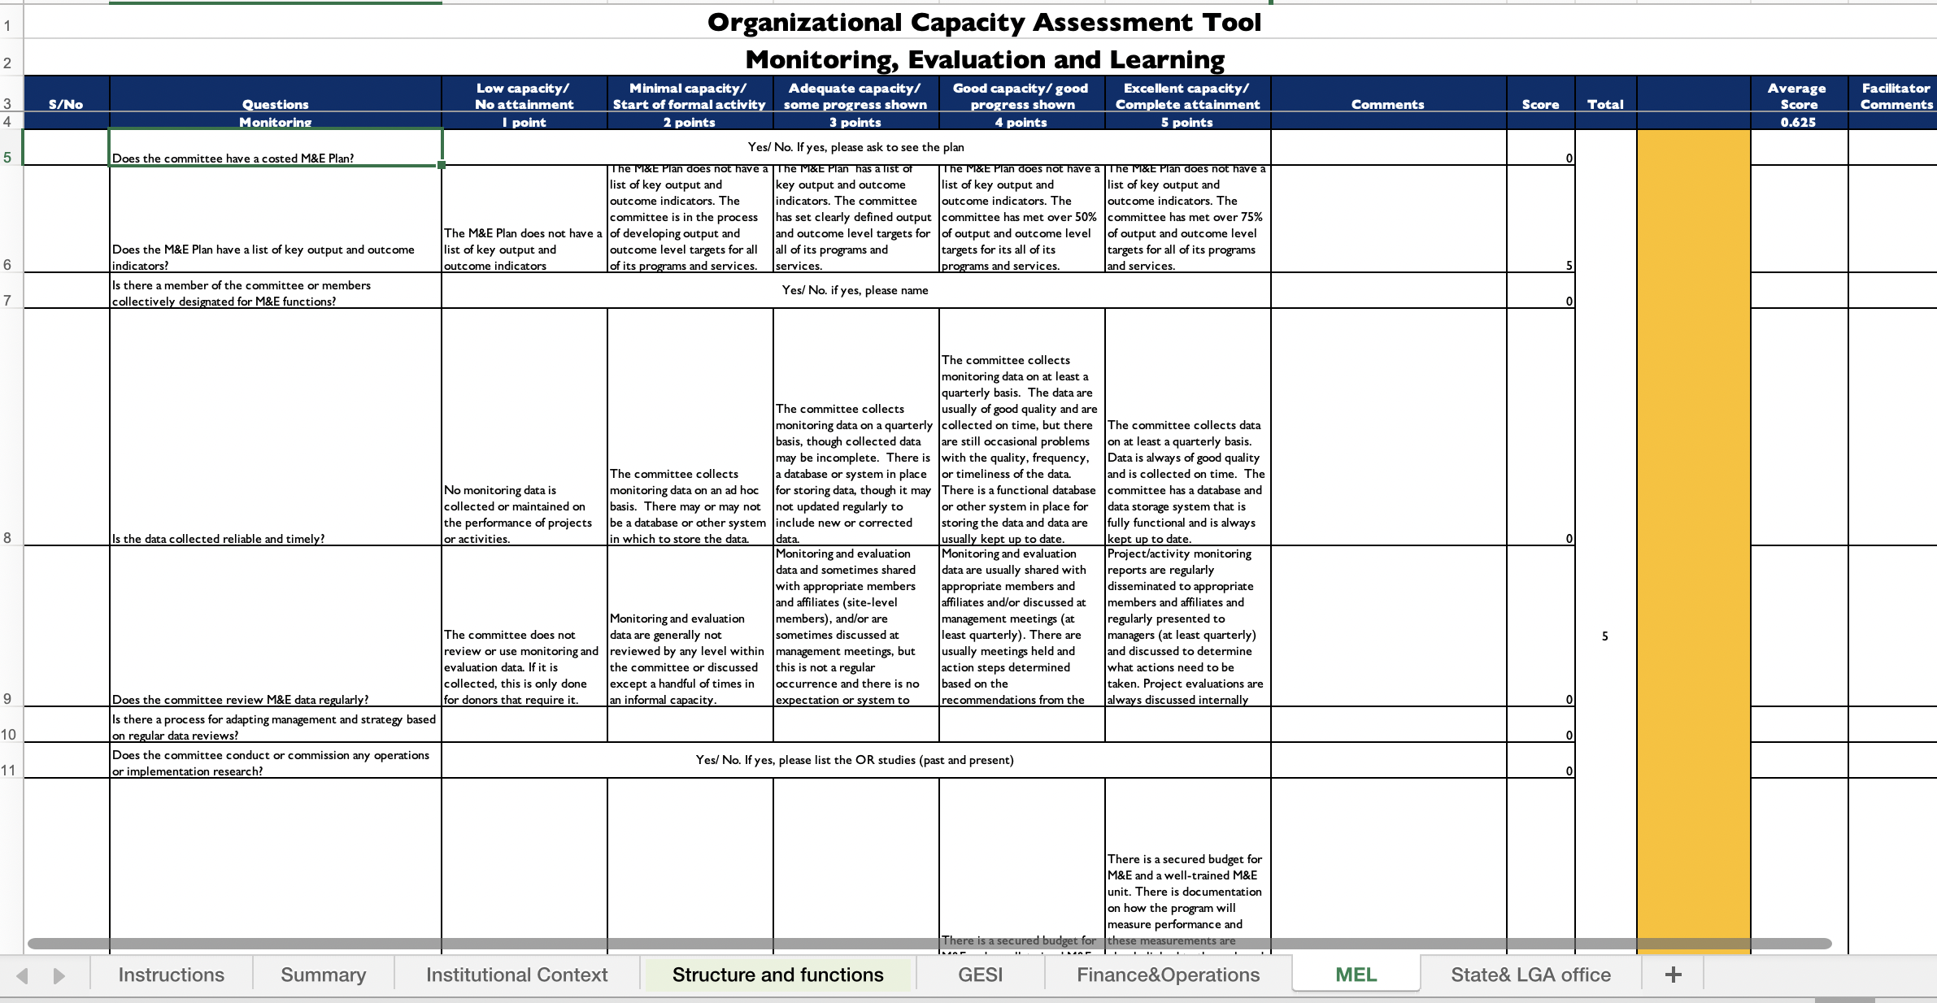

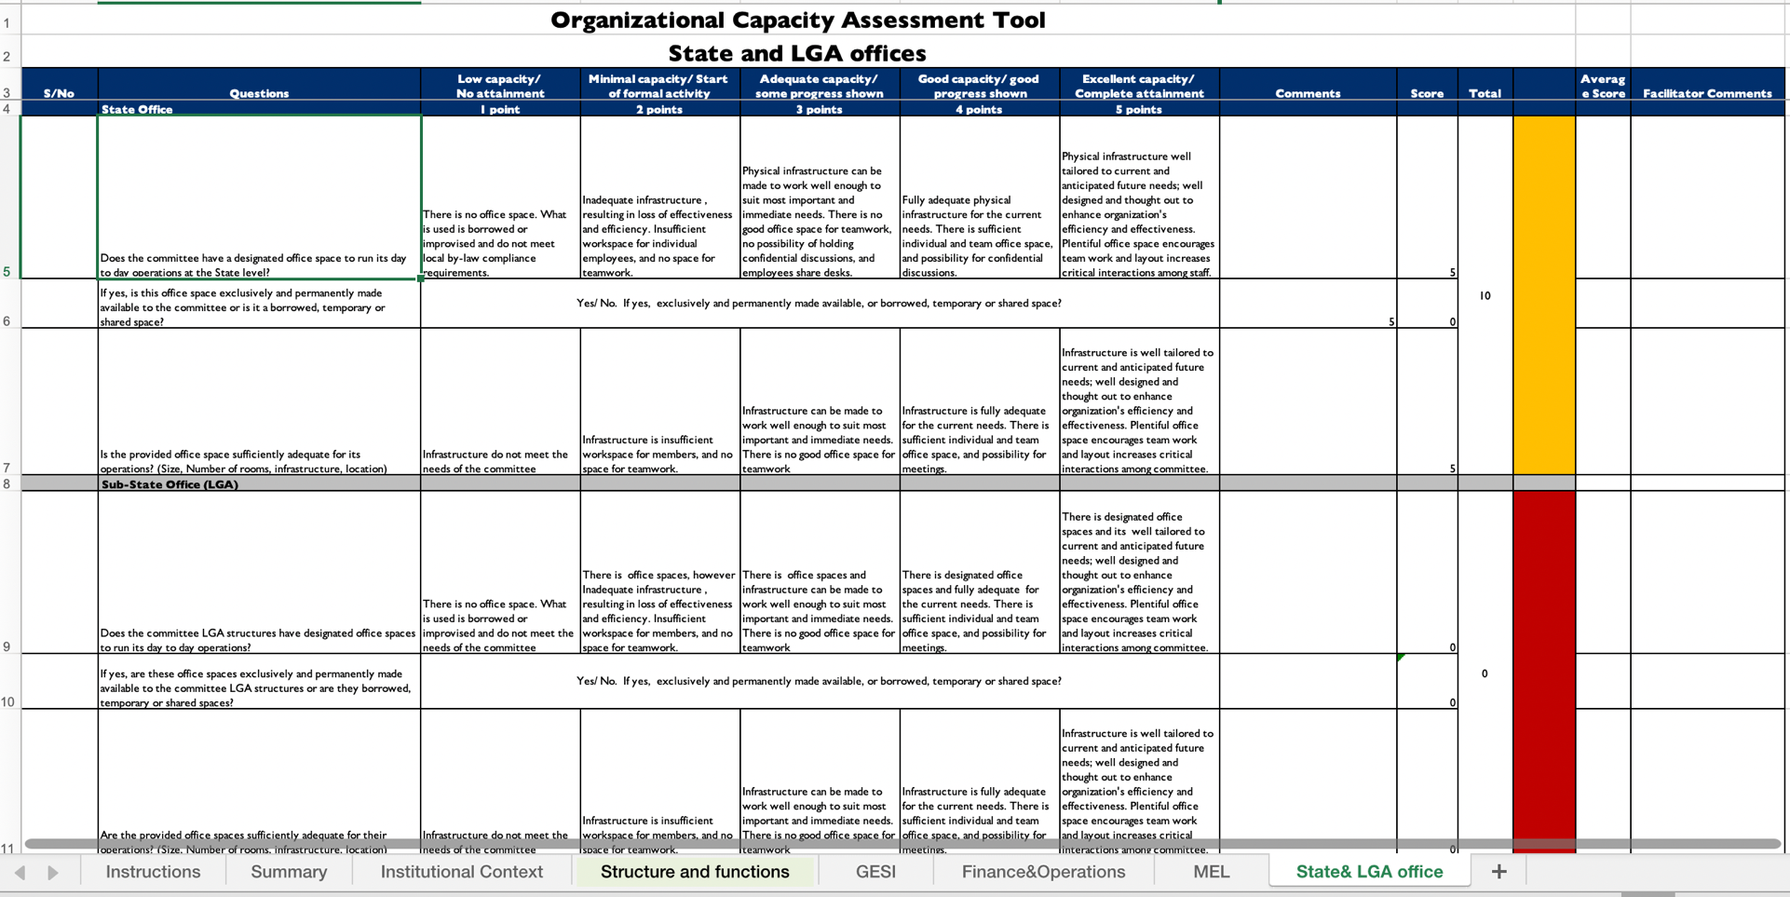

Annex 6

SCFN Quarterly Reporting Template (summary table)
SCFN:
Reporting period (Quarter, Year):
Report compiled by:
Responsibility area | Planned activities for quarter | Activities conducted this quarter | Planned activities for the next quarter
Technical Guidance
Coordination and Partnerships with Nutrition Stakeholders
Planning, Budgeting, and Resource Mobilization
Monitoring and Reporting
Advocacy
Additional comments:

Annex 7

SCFN Quarterly Reporting Template

Sn | Activities | Indicator | Quarterly Targets |  |  |  | Annual Target | Department/ partner responsible for collection | Quarterly Budget |  |  |  | Cumulative budget
 |  |  | Q1 | Q2 | Q3 | Q4 |  |  | Q1 | Q2 | Q3 | Q4
1.0 | Objective 1
1.2
1.3
2.0 | Objective 2
2.1
2.2
3.0 | Objective 3
2.3
3.1

Annex 8

National Nutrition Scorecard
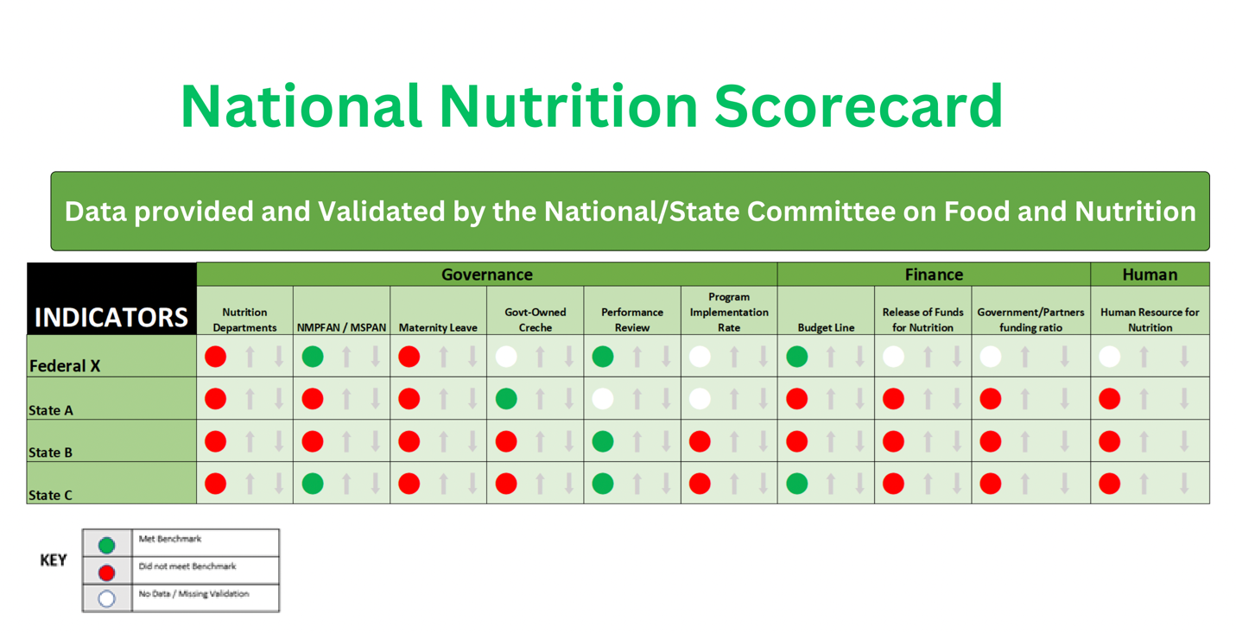

Annex 9

Sample SCFN Appointment Letter
Below is a sample of an appointment letter from the Permanent Secretary of the State Ministry of Budget and Economic Planning to the appointees to add new members to a SCFN.
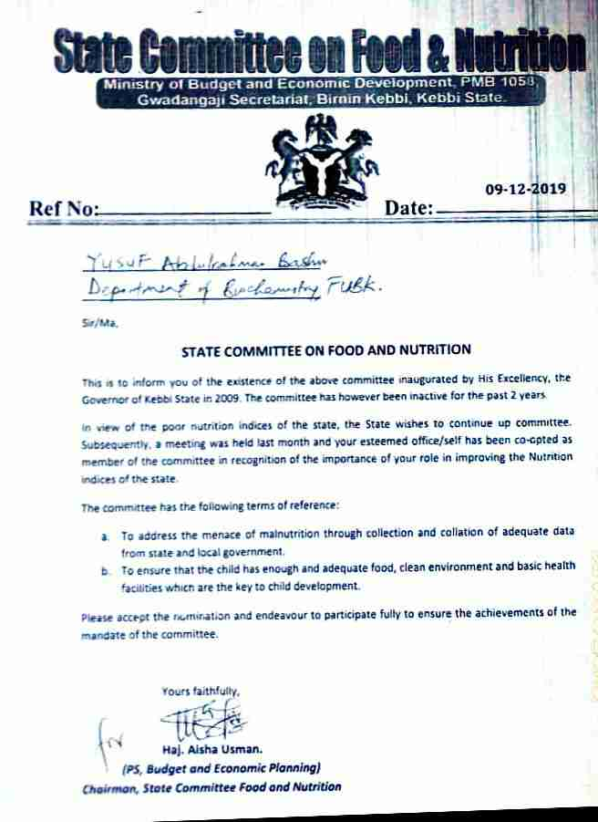

Annex 10

SCFN Monitoring and Supportive Supervision Checklist

LGA
Core departments represented
Date
Administered by (Name/Position/Institution)
SECTION 1: LGCFN COMPOSITION
No. |  | Questions |  |  |  |  |  |  |  | Responses
Q 1.1 |  | Does the LGCFN include all core departments?  Tick all that apply  ☐ Administration ☐ Community development  ☐ Education  ☐ Health  ☐ Production  ☐ Planning  ☐ Trade and industry  ☐ Water |  |  |  |  |  |  |  | ☐ Yes (If yes, skip to 1.2) ☐ No  If no, list core departments that are missing and state why they are not included.  What is being done to engage missing departments with the LGCFN?  Means of verification  - Circular on formation of LGCFN
Q 1.2 |  | Have all members received letters of assignment from the Chairperson? |  |  |  |  |  |  |  | ☐ Yes. Probe if the letters include clear terms of reference/roles and responsibilities.  ☐ No. Probe for who has not received, why, and what is being done.  Means of verification  - Copies of assignment letters
SECTION 1: LGCFN COMPOSITION
No. |  | Questions |  |  |  |  |  |  |  | Responses
Q 1.3 |  | Has the Chairperson formally designated a nutrition officer for the LGCFN? |  |  |  |  |  |  |  | ☐ Yes. Probe who is the appointed nutrition officer and list the position:  ☐ No. Probe why the nutrition officer has not been appointed and what is being done to recruit one.  Means of verification  - Copy of nutrition officer assignment letter
Additional comments on LGCFN composition:
SECTION 2: TECHNICAL GUIDANCE
No. |  | Questions |  |  |  |  |  |  |  | Responses
Q 2.1 |  | For municipalities only:  How many divisions does the municipality have? |  |  |  |  |  |  |  | Number of divisions:  How many have established a LGCFN?  What is being done to facilitate the establishment of the remaining LGCFN?  Means of verification  - Circular on formation of LGCFN
Q 2.2 |  | Has the SCFN oriented the LGCFN? |  |  |  |  |  |  |  | ☐ Yes. Probe to find out if any institution supported the orientation.  ☐ No. Probe what is being done to orient the LGCFN.  Means of verification  - Orientation report
SECTION 2: TECHNICAL GUIDANCE
No. |  | Questions |  |  |  |  |  |  |  | Responses
Q 2.3 |  | What nutrition issues were presented to the TWG in the last quarter? |  |  |  |  |  |  |  | List the nutrition issues presented:  What actions have been taken because of presenting nutrition issues to the TWG in the last quarter?  Probe for challenges if no nutrition issues were presented.  Means of verification  - Action memo from the technical planning committee on nutrition issues
Q 2.4 |  | What nutrition issues were presented by the TWG in the last quarter? |  |  |  |  |  |  |  | List the nutrition issues presented:  What actions have been taken because of presenting nutrition issues to the Council in the last quarter?  Probe for challenges if no nutrition issues were presented.  Means of verification  - Council minutes with nutrition issues
SECTION 3: COORDINATION AND PARTNERSHIPS WITH NUTRITION STAKEHOLDERS
No. | Questions |  |  |  |  |  |  |  | Responses
Q 3.1 | Does the LGCFN have an approved annual coordination work plan for the LGA? |  |  |  |  |  |  |  | ☐ Yes.  ☐ No. Probe what is being done to develop an  annual coordination work plan.  Means of verification:  - Copy of the approved annual coordination work plan
Q 3.2 | Were any nutrition coordination meetings held in the last quarter? |  |  |  |  |  |  |  | ☐ Yes.  ☐ No. Probe what is being done to overcome the  challenge.  Means of verification  - Minutes and action memos from coordination meetings
Q 3.3 | Were any joint activities undertaken with stakeholders in the last quarter? |  |  |  |  |  |  |  | ☐ Yes. Provide details of activities.  ☐ No. Explain.  Means of verification  - Activity reports
Q 3.4 | Is there an up-to-date nutrition partner database? |  |  |  |  |  |  |  | ☐ Yes.  ☐ No. Probe what is being done to develop or  update the database.  Means of verification  - Database of nutrition partners
Q 3.5 | What platforms did the LGA use in the last quarter to share nutrition information (e.g., reports, presentations, results) with relevant stakeholders?  Tick all that apply  ☐ Council meetings  ☐ Sectoral committee meetings  ☐ Senior management meetings  ☐ Technical Planning Committee meetings  ☐ Nutrition Coordination Committee meetings  ☐ Extended Technical Planning Committee meetings  ☐ Departmental meetings  ☐ School management meetings  ☐ Budget conferences  Probe for examples of the types of information shared, the stakeholders and LGCFN members involved, and what is being done to continue or improve nutrition information sharing in the LGA.  Means of verification  - Minutes, reports, action memos  ☐ Experience sharing events ☐ Other (list)
Additional comments on coordination and partnerships with nutrition stakeholders:
SECTION 4: PLANNING, BUDGETING, AND RESOURCE MOBILIZATION
No. | Questions |  |  |  |  |  | Responses
Questions for LGCFNs and/or first monitoring and supervision visit:
Q 4.1 | Does the LGA have a 5- year development plan? |  |  |  |  |  |  | ☐ Yes.  If yes, list all cross-cutting issues (verify information provided from the development plan):  ☐ No. Probe for the stage the LGA is at in the development of the development plan. What is being done to ensure that nutrition issues are included?  Means of verification:  - Copy of the development plan
Q 4.2 | Does the LGA have an approved MSNAP? |  |  |  |  |  |  | ☐ Yes.  ☐ No. Probe for the stage the LGA is at in the development of the MSNAP. What is being done to ensure its development/approval?  Means of verification:  - Copy of the MSNAP
Q 4.3 | Does the LGA have an approved annual multi- sectoral nutrition implementation work plan and budget? |  |  |  |  |  |  | ☐ Yes.  ☐ No. Probe for the stage the LGA is at in the development of the annual multi-sectoral nutrition implementation work plan and budget. What is being done to ensure its development/approval?  Means of verification:  - Copy of the annual multi-sectoral nutrition implementation work plan and budget
Q 4.4 | What resources are available for nutrition in the LGA? |  |  |  |  |  |  | Tick all that apply  ☐ Local revenue  ☐ Central government grants ☐ Implementing partners  ☐ In-kind  ☐ Direct support  ☐ Private sector  ☐ Other (list)  Which of the above resources are currently being used for nutrition?  Is there a resource gap (provide % if known)? What is being done to mobilize additional resource for nutrition?
Q 4.5 | Were activities undertaken to mobilize additional resources in the last quarter? |  |  |  |  | ☐ Yes. Provide details of activities.  ☐ No. Probe what is being done to overcome the challenge.
Additional comments on planning, budgeting, and resource mobilization:
SECTION 5: MONITORING AND REPORTING
No. | Questions |  |  |  |  | Responses
Q 5.1 | For municipalities only:  Did the LGCFN conduct joint monitoring and supportive supervision visits for the LGCFNs in the last quarter? |  |  |  |  | ☐ Yes. Probe for the report and check for the composition of the monitoring team.  Which platforms were used to share the reports?  ☐ LGCFN meeting  ☐ Extended Technical Planning Committee meetings  ☐ Others (list)  What nutrition actions were taken because of the LGCFN monitoring and supportive supervision visit?  ☐ No. Probe for the challenges and what is being done to facilitate this action.  Means of verification  - Monitoring and supportive supervision reports
Q 5.2 | Did the LGCFN receive a joint monitoring and supportive supervision visit in the last quarter? |  |  |  |  | ☐ Yes. Probe for the report and check for the composition of the monitoring team.  If yes, did you receive feedback on your LGCFN monitoring and supportive supervision visit? What nutrition actions were taken because of the LGCFN monitoring and supportive supervision visit?  ☐ No. Probe what is being done to overcome the challenge.  Means of verification  - Monitoring and supportive supervision reports
Q 5.3 | Did the LGCFN prepare a consolidated quarterly coordination report last quarter? |  |  |  | ☐ Yes  ☐ No. Probe for the challenges and what is being done.  If yes, which departments submitted written reports to the LGCFN to be included in the consolidated report?  Tick all that apply:  ☐ Administration  ☐ Community development ☐ Education  ☐ Health  ☐ Production  ☐ Planning  ☐ Trade and industry  ☐ Water  Others  ☐ Implementing partners (list):  Did the LGCFN share the consolidated quarterly report?  Probe who they shared the report with.  What actions were taken because of the LGCFN quarterly  report?  Means of verification  - Consolidated LGCFN quarterly report
Additional comments on monitoring and reporting:
SECTION 6: ADVOCACY
No. | Questions |  |  | Responses
Q 6.1 | Does the LGCFN have an approved advocacy implementation plan? |  |  | ☐ Yes.  ☐ No. Probe for the stage the LGA is at in the development of the advocacy implementation plan. What is being done to ensure its development/approval?  Means of verification:  - Copy of the approved advocacy implementation plan
Q 6.2 | Has the LGCFN identified nutrition champions at the LGA level? |  | ☐ Yes.  ☐ No. Probe for the challenges and what is being done.  Means of verification:  - Database of nutrition champions
Q 6.3 | What nutrition advocacy activities were conducted in the last quarter? List the activities:

Annex 11

National/State Multi-Sectoral Plan of Action for Food and Nutrition Implementation
M&E Tool/Checklist
SN | ITEM | MDAs | No success (1.0 -1.4) | Minimal success (1.5-2.4) |  | Little success (2.5-3.4) |  | Moderate success (3.5-4.4) |  | Considerable success  (4.5-5.0) |  | Means of verification
A | SO 1: REDUCED HUNGER AT HOUSEHOLD LEVEL
 | IR 1.1: Increased availability of nutritious food
1 | Establishment of Farmers cooperatives/clusters for commercial production of food crops by government and private sector | Federal Ministry of Agriculture and Rural Development (FMARD)/State Ministry of Agriculture and Rural Development (SMARD) |  |  |  |  |  |  |  |  |  | Activity reports
2 | Review all land tenure and land use laws with a view to increasing women access to land for agricultural activities | SMARD/HOA |  |  |  |  |  |  |  |  |  | Copy of legislation
3 | Facilitate the reactivation of prison farms in each geopolitical zone | FMIA |  |  |  |  |  |  |  |  |  | Activity reports
4 | Provide starter packs for fruits and vegetable farming (in seven agro-ecological zones) for 1000 smallholder farmers by zone (including women for Household gardening) | FMARD/SMARD |  |  |  |  |  |  |  |  |  | Activity reports
5 | Provide small ruminant starter packs (five sheep/goats, concentrates, minerals and vitamins, vaccines and drugs) to vulnerable women farmers | FMARD/SMARD |  |  |  |  |  |  |  |  |  | Activity reports
6 | Provide smoking kilns to clusters of small-scale fish processors/farmers including women fish farmers | FMARD/SMARD |  |  |  |  |  |  |  |  |  | Activity reports
7 | Provide improved planting materials (staple crops including plantain, banana, and pineapple) to farmers across the country to promote food security | FMARD/SMARD |  |  |  |  |  |  |  |  |  | Activity reports
8 | Advocate for rehabilitation of the existing rural road network and construction of new ones for easy transportation of farm produce | Federal Ministry of Works, Housing and Power/  Agricultural Development Programme |  |  |  |  |  |  |  |  |  | Activity reports
9 | Advocate for the establishment of uniform Receipt system for warehouses in government food storage centers | FMARD/SMARD |  |  |  |  |  |  |  |  |  | Activity reports
10 | Promote regulation for the establishment of commodity trading centers | FMARD/SMARD |  |  |  |  |  |  |  |  |  | Activity reports
11 | Advocate for scale-up of offtake mechanism for food crops to increase availability of food products | FMARD/SMARD |  |  |  |  |  |  |  |  |  | Activity reports
12 | Promote access to agricultural inputs (including improved seeds, information on agricultural practices, and irrigation) to scale up production of fruits and vegetable | FMARD/SMARD |  |  |  |  |  |  |  |  |  | Activity reports
13 | Train farmers on appropriate use of fertilizers, herbicides, and pesticides | FMARD/SMARD |  |  |  |  |  |  |  |  |  | Training reports
14 | Promote the use of Aflasafe and activities to minimize aflatoxin contamination along the value chain, including GAP and modern drying and storage | FMARD/SMARD |  |  |  |  |  |  |  |  |  | Activity reports
15 | Sensitization of Farmers on proper use of environmentally friendly agricultural technologies | FMARD/SMARD |  |  |  |  |  |  |  |  |  | Activity reports
16 | Scale up the production and promote the consumption of Vitamin A, and micronutrient-rich foods (orange flesh sweet potato, provitamin A cassava, yellow maize, iron sorghum, and cowpea) | FMARD/SMARD |  |  |  |  |  |  |  |  |  | Activity reports
17 | Scale up the activities on enforcement of food fortification and salt iodization programs | NAFDAC (National Agency for Food and Drug Administration and Control) |  |  |  |  |  |  |  |  |  | Activity reports
18 | Support the production and diversification of fruits and vegetables around the homesteads, schools, orchards, and farms. | FMARD/SMARD |  |  |  |  |  |  |  |  |  | Activity reports
19 | Advocate for increase in import levies and excise duties on commodities that can be locally produced | Federal Ministry of Information |  |  |  |  |  |  |  |  |  | Activity reports
 | IR 1.2: Increased access to nutritious food
20 | Review and disseminate existing legislation on fortification to cover staples food and promote hammer mill and household level fortification of cereal, root crops and legumes not presently covered, (e.g., industrially processed rice, noodles and palm oil) | Standard Organization of Nigeria |  |  |  |  |  |  |  |  |  | Activity reports
21 | Cottage industries using improved varieties of micronutrient in final food products/processing | SMARD/OPS |  |  |  |  |  |  |  |  |  | Activity reports
22 | Establish home and school farms and gardens | FMARD/SMARD |  |  |  |  |  |  |  |  |  | Activity reports
23 | Conduct regular Stakeholders meeting on reduction of postharvest losses | FMARD/SMARD |  |  |  |  |  |  |  |  |  | Activity reports
24 | Promote and provide hermetic storage bags to local farmers for food preservation | FMARD/SMARD |  |  |  |  |  |  |  |  |  | Activity reports
 | IR 1.3: Increased utilization of nutritious food at household level
25 | Consumption of micronutrient-rich foods in household | State Ministry of Information (SMOI)/OPS |  |  |  |  |  |  |  |  |  | Activity reports
26 | Promote safe, quality, and hygienic food along the food supply chain | FMARD/State Ministry of Health (SMOH) |  |  |  |  |  |  |  |  |  | Activity reports
27 | Register and license food handlers and food operators engaged in quality and safe food processing and storage | NAFDAC/SMOLG |  |  |  |  |  |  |  |  |  | Activity reports
28 | Promote dietary diversification through the consumption of locally produced staples—functional and under-utilized crops | FMARD/SMARD |  |  |  |  |  |  |  |  |  | Activity reports
B | SO 2: INCREASED ACCESS AND UTILIZATION OF CAREGIVERS TO NUTRITION SERVICES
 | IR 2.1: Availability of nutritious services, products, and commodities
29 | Procure and distribute zinc, L-ORS and deworming tablet for community-based management of acute malnutrition (CMAM) and routine services | National Primary Health Care Development Agency (NPHCDA)/State Primary Health Care Development Agency (SPHCDA) |  |  |  |  |  |  |  |  |  | Activity reports
30 | Health facilities carrying out nutrition counseling during antenatal care | NPHCDA/SPHCDA |  |  |  |  |  |  |  |  |  | Activity reports
31 | Support local production of ready-to-use therapeutic food (RUTF) through advocacy to potential industries in Nigeria | FMITI |  |  |  |  |  |  |  |  |  | Activity reports
32 | Support local production of micronutrient powder or premixes through advocacy to potential industries in Nigeria | FMITI |  |  |  |  |  |  |  |  |  | Activity reports
33 | Procure and distribute RUTF for CMAM | NPHCDA/SPHCDA |  |  |  |  |  |  |  |  |  | Activity reports
34 | Procure and distribute iron-folic acid supplementation to pregnant women during maternal, newborn, and child health (MNCH) weeks | NPHCDA/SPHCDA |  |  |  |  |  |  |  |  |  | Activity reports
35 | Procure and distribute vitamin A supplements during MNCH weeks and other supplementary activities for children under age five | NPHCDA/SPHCDA |  |  |  |  |  |  |  |  |  | Activity reports
36 | Monitor and evaluate micronutrient supplementation program performance at all levels | FMOH/SMOH |  |  |  |  |  |  |  |  |  | Activity reports
37 | Advocate for legislation of the prolongation of maternity leave and enactment of paternity leave | Federal Ministry of Women Affairs and Social Development (FMWASD)/State Ministry of Women Affairs (SMOWA) |  |  |  |  |  |  |  |  |  | Activity reports
 | IR 2.2: Resources made available
38 | Production and distribution of materials on micronutrient-rich foods | SPHCDA/OPS |  |  |  |  |  |  |  |  |  | Activity reports
39 | Provision of health facilities with required growth monitoring equipment | NPHCDA/SPHCDA |  |  |  |  |  |  |  |  |  | Activity reports
40 | Community level action on nutritional care of vulnerable groups and utilization of primary health care services encouraged | FMWASD/SPHCDA |  |  |  |  |  |  |  |  |  | Activity reports
41 | Review minimum standards, print and distribute standard operating procedures (nutrition and health) for early-child care centers | Federal Ministry of Education (FME)/FMOH/State Ministry of Education (SMOE)/SMOH |  |  |  |  |  |  |  |  |  | Activity reports
42 | Conduct annual assessment of household consumption of iodized salt using primary school children | FME/National Bureau of Statistics (NBS)/SMOE |  |  |  |  |  |  |  |  |  | Activity reports
43 | Scale up implementation of community infant and young child feeding for optimal infant and young child feeding | NPHCDA/FMoH/  SPHCDA |  |  |  |  |  |  |  |  |  | Activity reports
44 | Promote the establishment of nutrition and food demonstration corner (optimal infant and young child feeding practices) in the health facilities | NPHCDA/FMoH/  SPHCDA |  |  |  |  |  |  |  |  |  | Activity reports
45 | Establishment of crèches in workplaces to promote exclusive breastfeeding | FMWASD/SMOWA |  |  |  |  |  |  |  |  |  | Activity reports
46 | Implementation of baby-friendly initiative in all health facilities and delivery maternities | NPHCDA/SPHCDA |  |  |  |  |  |  |  |  |  | Activity reports
 | IR 2.3: Improved capacity of Nutrition service providers
47 | Promote safe, quality, and hygienic food along the food supply chain and training of personnel | Nutrition Society of Nigeria |  |  |  |  |  |  |  |  |  | Activity reports
48 | Conduct capacity building and provide materials for food and nutrition teachers and food vendors on the need to provide nutritionally adequate meals using locally available foods through linking food vendors and school system | FME/SMOE |  |  |  |  |  |  |  |  |  | Training reports
49 | Strengthen nutrition education and training in the curricula of early child care, primary, and secondary schools | SMOE |  |  |  |  |  |  |  |  |  | Published Curricular
50 | Build the capacity of agricultural science teachers to strengthen the establishment of school farms and garden | FMARD/SMOE |  |  |  |  |  |  |  |  |  | Training reports
51 | Scale-up activities in enforcing the provisions of the International Code of Marketing of Breast-milk Substitutes | NAFDAC/SMOH |  |  |  |  |  |  |  |  |  | Activity reports
52 | Promote awareness of girl child education, ending child marriage, adolescent nutrition, and health-related practices | FMWASD/SMOWA |  |  |  |  |  |  |  |  |  | Activity reports
53 | Provide orientation for health staff to improve antenatal care attendance | NPHCDA/SPHCDA |  |  |  |  |  |  |  |  |  | Activity reports
 | IR 2.4 Improved quality of service provided
54 | Regular monitoring of growth and development of children under age five at health facilities and communities | NPHCDA/SPHCDA |  |  |  |  |  |  |  |  |  | Activity reports
55 | Support distribution of iron-folate supplements to adolescent (boys and girls) in schools and communities | FMOH/SPHCDA |  |  |  |  |  |  |  |  |  | Activity reports
56 | Sustain and scale up distribution of micronutrient powder for children 6–23 months | FMOH/SPHCDA |  |  |  |  |  |  |  |  |  | Activity reports
57 | Distribute iron-folic acid supplementation to pregnant women during MNCH weeks | NPHCDA/SPHCDA |  |  |  |  |  |  |  |  |  | Activity reports
C | SO 3: REDUCED MORBIDITY AND MORTALITY ASSOCIATED WITH MALNUTRITION
 | IR 3.1: Increased capacity in management of acute malnutrition
58 | Scale up and strengthen CMAM sites | NPHCDA/SPHCDA |  |  |  |  |  |  |  |  |  | Activity reports
 | IR 3.2: Improved management of childhood diseases
59 | Listed health care commodities distributed in health facilities | NPHCDA/SPHCDA |  |  |  |  |  |  |  |  |  | Activity reports
60 | Distribute zinc, L -ORS, deworming tablet, and RUTF for CMAM and routine services | NPHCDA/SPHCDA |  |  |  |  |  |  |  |  |  | Activity reports
61 | Training on hygiene promotion, Community Water Safety Plan, and triggering on Community-Led Total Sanitation | Federal Ministry of Water Resources (FMWR)/ State Ministry of Water Resources (SMOWR) |  |  |  |  |  |  |  |  |  | Activity reports
62 | Provide portable water supply in primary health care to enhance sanitation and hygiene | MOWR |  |  |  |  |  |  |  |  |  | Activity reports
 | IR 3.3: Increased awareness on diet-related noncommunicable diseases
63 | Health promotion activities to provide education and increasing services for prevention and management of diet-related noncommunicable diseases | FMOH/SMOH/SMOI |  |  |  |  |  |  |  |  |  | Activity reports
64 | Conduct awareness campaign on healthy living, good dietary habits, and food quality and safety | Federal Ministry of Information and Culture (FMIC)/FMoH/SMOH/SMOI |  |  |  |  |  |  |  |  |  | Activity reports
 | IR 3.4: Increased awareness on infant and maternal nutrition
65 | Disseminate information on nutrition and key household practices through mass media | FMIC/SCFN/  National Orientation Agency |  |  |  |  |  |  |  |  |  | Activity reports
66 | Conduct social and behavior change communication activities on IYCF and intra-household food distribution targeted at adolescents, pregnant women, and caregivers at all levels | FMIC/FMoH/  SPHCDA/National Orientation Agency |  |  |  |  |  |  |  |  |  | Activity reports
D | SO 4: REDUCED NUMBER OF HOUSEHOLDS WITH POVERTY INDEX
 | IR 4.1: Increased equitable access to resources leading to increased household income
67 | Support effective implementation of conditional cash transfer programs, food rations, or food supplements in emergency situation | National Emergency Management Authority/State Emergency Management Authority |  |  |  |  |  |  |  |  |  | Activity reports
68 | Procurement and distribution of complementary food packages to nutrition-in-emergency affected people | SMOH |  |  |  |  |  |  |  |  |  | Activity reports
69 | Support water supply interventions in emergency settings and rural areas | FMWR/SMOWR |  |  |  |  |  |  |  |  |  | Activity reports
70 | Construction of sanitation and hygiene facilities in internally displaced person camps, public places, and institutions | FMWR/SMOWR |  |  |  |  |  |  |  |  |  | Activity reports
71 | Strengthen coordination platform for early warning mechanisms to cope with food emergencies at community level | FMARD/State Emergency Management Authority |  |  |  |  |  |  |  |  |  | Activity reports
72 | Advocate to relevant banks to promote increased access to microcredit facilities for farmers, especially women farmers, to expand farm operations (interest rates and collaterals) | FMFBNP/SMARD |  |  |  |  |  |  |  |  |  | Activity reports
73 | Promote the formation of women farmers into sustainable cooperative groups for the provision of grants and revolving loans | FMARD/FMITI/  SMARD |  |  |  |  |  |  |  |  |  | Activity reports
74 | Empower farmer cooperatives and clusters for commercial production to received grants and loans | FMARD/SMARD |  |  |  |  |  |  |  |  |  | Activity reports
75 | Strengthen nutrition surveillance for early warning mechanisms to cope with emergency | FMARD, FMOH/SMARD/  SMOH |  |  |  |  |  |  |  |  |  | Activity reports
76 | Training emergency managers on mainstreaming nutrition in feeding programs targeted at the vulnerable groups in emergency situations | FMoH/SMOH |  |  |  |  |  |  |  |  |  | Training reports
E | SO 5: INCREASED NUTRITION KNOWLEDGE AND PRACTICE
 | IR 5.1: Increased medium of disseminating nutrition information to the public
77 | Promote and disseminate of research findings on food processing and preservation technology for use in households | FMST/SMARD |  |  |  |  |  |  |  |  |  | Activity reports
78 | Promote awareness on improved food quality and safety through electronic and print media | FMIC/SMOI |  |  |  |  |  |  |  |  |  | Activity reports
79 | Conduct sustained advocacy to policymakers, both traditional and religious leaders, for improved nutrition funding | FMFBNP/SPC |  |  |  |  |  |  |  |  |  | Activity reports
80 | Conduct stakeholders (consultation) meetings for nutrition-related investment and sectoral policies including social protection policies | FMFBNP/SPC |  |  |  |  |  |  |  |  |  | Activity reports
81 | Advocate and accelerate the implementation of the State Health Insurance Scheme to incorporate the Community Health Insurance health care to vulnerable groups, especially women and children | SMOH |  |  |  |  |  |  |  |  |  | Activity reports
82 | Conduct Annual Nutrition Week on topical issues in nutrition | FMFBNP |  |  |  |  |  |  |  |  |  | Activity reports
83 | Annual review meeting of SCFN with NCFN | FMFBNP |  |  |  |  |  |  |  |  |  | Activity reports
84 | Mid and End-line Review of implementation of the National Multi-Sectoral Plan of Action for Nutrition | FMFBNP |  |  |  |  |  |  |  |  |  | Activity reports
85 | Conduct regular and periodic monitoring on food and nutrition activities in collaboration with partners and the private sector at all levels | NCFN/SCFN/  LGFN |  |  |  |  |  |  |  |  |  | Activity reports
86 | Organize annual NNN meeting of all nutrition stakeholders | FMFBNP/SCFN |  |  |  |  |  |  |  |  |  | Activity reports
 | IR 5.2: Increased knowledge on nutrition and practice by the public
87 | Collaboration with network providers like MTN, Airtel, GLO, and 9mobile to disseminate nutrition information to the general public | FMIC/SCFN |  |  |  |  |  |  |  |  |  | Activity reports
88 | Strengthen LGAs for regular and sustained monitoring and inspection on the preparation of food in restaurants, eateries, and food vending | SMOH |  |  |  |  |  |  |  |  |  | Activity reports
 | IR 5.3: Improved information on locally available diets
89 | Provide small grants to conduct food and nutrition research on standardization of food recipes and portion sizes of locally available diets | FMARD/SPC |  |  |  |  |  |  |  |  |  | Activity reports
90 | Review, publish, and disseminate the Food Based Dietary Guidelines for healthy living | FMOH/SMARD |  |  |  |  |  |  |  |  |  | Activity reports
91 | Promotion of safe practices on pesticide utilization for food stuff preservation | NAFDAC/FMARD  /SMARD |  |  |  |  |  |  |  |  |  | Activity reports
 | IR 5.4: Increased practice of good dietary habits by the public
92 | Conduct the National Food Consumption and Nutrition Survey | FMARD |  |  |  |  |  |  |  |  |  | Activity reports
93 | Review, update, publish, and disseminate existing food composition table for Nigeria | Agricultural Research Council of Nigeria/National Universities Commission/Research Institutes |  |  |  |  |  |  |  |  |  | Activity reports
94 | Building the capacity of farmers on cultivation of underutilized crop varieties | FMARD/SMARD |  |  |  |  |  |  |  |  |  | Activity reports
95 | Promote dietary diversification through the consumption of locally produced staples | FMARD/SMARD |  |  |  |  |  |  |  |  |  | Activity reports
F | SO 6: INCREASED ALLOCATION AND UTILIZATION OF FUNDING FOR NUTRITION
 | IR 6.1: Increased nutrition funding by government and partners
96 | Conduct regular budget tracking to evaluate budget performance of food and nutrition in all sectors | FMFBNP/SPC |  |  |  |  |  |  |  |  |  | Activity reports
97 | Domesticate and disseminate state policy on food and nutrition and the Plan of Action at the state levels | FMFBNP/SPC |  |  |  |  |  |  |  |  |  | Printed Policy and Plan
98 | Conduct assessment at all levels on determinants of low financial investments in food and nutrition programs compared to other life-saving interventions in partnership with private sector | FMFBNP/SPC |  |  |  |  |  |  |  |  |  | Activity reports
99 | Ensure adequate implementation of the policy through sufficient budgetary allocation | FMFBNP/SPC |  |  |  |  |  |  |  |  |  | Activity reports
 | IR 6.2: Budget lines for nutrition in MDAs created
100 | Build the capacity of nutrition desk officers in MDAs or LGAs and leaders of professional associations in nutrition through training and retraining on nutrition programming, resource mobilization, and allocation | FMFBNP/SPC |  |  |  |  |  |  |  |  |  | Activity reports
101 | Advocacy for the creation of budget lines on food and nutrition activities in MDAs or LGAs and ensure timely release of funds | FMFBNP/SPC |  |  |  |  |  |  |  |  |  | Activity reports
 | IR 6.3: Increased funding releases for nutrition
102 | Ensure adequate implementation of the policy through sufficient timely release of funds. | FMFBNP/SCFN |  |  |  |  |  |  |  |  |  | Activity reports
 | IR 6.4: Increased MDAs with established nutrition departments
103 | Advocate for the creation of nutrition department and incorporate nutrition objectives into MDAs’ development policies, plans, and programs | FMFBNP/SCFN |  |  |  |  |  |  |  |  |  | Activity reports
104 | Ensuring adequate staffing of relevant MDAs at state and LGAs levels implementing sectoral nutrition programs with skilled and qualified nutritionists | Head of Service/FMFBNP/SPC |  |  |  |  |  |  |  |  |  | Activity reports
 | IR 6.5: Established multi-sectoral nutrition portal (National Information System)
105 | Establish a nutrition portal for the collection of core nutrition data in partnership with key stakeholders | NBS/FMFBNP |  |  |  |  |  |  |  |  |  | Activity reports
106 | Conduct training and retraining of state, LGAs, community-based agencies and organizations, and other stakeholders in the planning and implementation of food and nutrition programs and activities | SPC |  |  |  |  |  |  |  |  |  | Activity reports
107 | Build the capacity of Nutrition implementers (OICs, NFPs, M&E), agriculture extension officers, and other nutrition officers/workers at all levels on the use and management of level appropriate nutrition dashboard | NBS/FMFBNP/SPC |  |  |  |  |  |  |  |  |  | Activity reports
108 | State the amount in budget proposal by your MDA for nutrition (in Naira) | MDAs |  |  |  |  |  |  |  |  |  | Documented budgeting reports
109 | What is the allocated in your approved budget (in Naira)? | MDAs |  |  |  |  |  |  |  |  |  | Documented evidence of budgetary allocation
110 | What was the amount released (in Naira)? | MDAs |  |  |  |  |  |  |  |  |  | Documented evidence of fund release
111 | What was the amount expended (in Naira)? | MDAs |  |  |  |  |  |  |  |  |  | Documented evidence of fund expended
H | CHALLENGES/SUGGESTIONS
112 | What are barriers to the smooth implementation of nutrition programs? | MDAs
113 | What are challenges to the allocation and release of funds? | MDAs
114 | What do you see as major opportunities? | MDAs
115 | What do you think would help achieve meaningful impacts in nutrition? | MDAs

Annex 12

Indicators to be Collected for State Nutrition Situation
 | Characteristics | Indicator Definition | State
 | Child Anthropometry
 | Percentage Stunting | Height-for-age percent below -2 SD
 | Percentage Wasting | Weight-for-height percent below -2 SD
 | Percentage Overweight | Weight-for-height percent below +2 SD
 | Percentage Underweight | Weight-for-age percent below -2 SD
 | Maternal Anthropometry
 | Percentage Height Too Short | Height percentage below 145 cm
 | Percentage Underweight | Body mass index <18.5 (total thin)
 | Percentage Overweight or Obese | Body mass index ≥25.0 (total overweight or obese)
 | Percentage Overweight | Body mass index 25.0–29.9 (overweight)
 | Percentage Obese | Body mass index ≥30.0 (obese)
 | Micronutrient Deficiencies
 | Percentage Anemia in Children 6–59 Months Old | Any anemia (<11.0 g/dl)
 | Percentage Anemia in Women 15–49 Years Old | Any anemia: non-pregnant (<12.0g/dl), pregnant (<11.0g/dl)
 | Diets (6–23 Months Old)
 | Percentage Minimum Acceptable Diets | Percentage of children who received minimum acceptable diet
 | Diets (Women 15–49 Years Old)
 | Percentage Minimum Dietary Diversity in Women | Consumed ≥5 food groups
 | Child Illnesses
 | Percentage Diarrhea in Two Weeks Preceding Survey | Percentage of children who in the last two weeks had an episode of diarrhea
 | Percentage Acute Respiratory Infection (ARI) in Two Weeks Preceding Survey | Percentage of children who in the last two weeks had symptoms of ARI
 | Percentage Fever in Two Weeks Preceding Survey | Percentage of children who in the last two weeks had an episode of fever
 | Nutrition-Specific Interventions
 | Percentage 6–59 Months Who Received Iron Supplements in Preceding Seven Days (NDHS 2018, page 287) | Among all children age 6–59 months percentage given iron supplements in past seven days
 | Percentage 6–59 Months Who Received Vitamin A in Preceding Six Months | Among all children age 6–59 months percentage given vitamin A supplements in past six months
 | Percentage 12–59 Months Who Were Dewormed in Preceding Six Months | Among all children age 6–59 months percentage given deworming medication in past six months
 | Percentage 90 Days of Iron Supplementation in Pregnancy | Number of days women took iron tablets or syrup during pregnancy of last birth 90+
 | Household Food Security
 | Percentage Food Insecurity | Percentage of household population experiencing food insecurity in the previous 12 months: moderate or severe
 | Food Expenditure as a Share of Total Expenditure | Total food consumption expenditure: (%) share in total expenditure
 | Care Practices (6–23 Months Old)
 | Percentage Early Initiation of Breastfeeding | Percentage of children who were first breastfed within one hour of birth
 | Percentage Exclusive Breastfeeding | Children age 0–5 months percent exclusively breastfed
 | Percentage Minimum Dietary Diversity | Percent of child who received minimum dietary diversity
 | Percentage Minimum Meal Frequency | Percent of child who received minimum meal frequency
 | Health
 | Percentage No Antenatal Care Visit | Percentage of women by number of antenatal care visits: no visits
 | Percentage ANC at Least Four Visits (MICS 2021, page 121) | Percentage of women by number of antenatal care visits: four or more visits to any provider
 | Percentage Skilled Attendance at Delivery | Delivery assisted by any skilled attendant
 | Percentage Children 12–23 Months Who Received Basic Antigens | Percentage of children age 12–23 months who received: basic antigens
 | Percentage Children 12–23 Months Who Received All First Year of Life (1YL) Antigens | Percentage of children age 12–23 months who received: all 1YL antigens
 | % Children 12–23 Months Who Received No Vaccinations | Percentage of children age 12–23 months who received: no vaccinations
 | % Children Age 24–35 Months Who Received Basic Antigens | Percentage of children age 24–35 months who received: basic antigens
 | % Children Age 24–35 Months Who Received All Antigens | Percentage of children age 24–35 months who received: no antigens
 | % Children Age 24–35 Months who Received No Vaccinations | Percentage of children age 24-35 months who received: no vaccinations
 | % Household Members Living in Households using Clean Fuels and Technologies for Cooking | Primary reliance on clean fuels and technologies for cooking (in households that reported cooking)
 | Water, Sanitation, and Hygiene
 | Percentage Basic Drinking Water Services | Drinking water: basic service
 | Percentage Basic Sanitation Services | Sanitation: basic service
 | Percentage of Household Members with Handwashing Facility Where Water and Soap Are Present | Handwashing: basic facility
 | Percentage Who Have All of Basic Drinking Water and Basic Sanitation and Basic Hygiene | Basic drinking water, sanitation, and hygiene service
 | Percentage Children Age 0–2 Years Whose Stools Were Disposed of Safely | Percentage of children whose last stools were disposed of safely
 | Socioeconomic Context
 | Percentage Women Literate | Total percentage literate
 | Percentage Men Literate | Total percentage literate
 | Average HH Size | Average household size
 | HH Dependency Ratio | Dependency ratio
 | Percentage Poverty | Poverty headcount rate
 | Inequality Index: Gini Coefficient | Gini coefficient
 | Shocks
 | Percentage Experienced Increase in Price of Major Food Items Consumed | Percentage of HH reporting shocks in last three years: Increase in price of major food items consumed
 | Percentage Experienced Theft of Crops, Cash, Livestock or Other Property | Percentage of HH reporting shocks in last three years: Theft of crops, cash, livestock, or other property
 | Percentage Experienced Death, Disability, Illness, or Departure of Working Household Member | Percentage of HH reporting shocks in last three years: Death, disability, illness, or departure of working household member
 | Percentage Experienced Nonfarm Business Failure | Percentage of HH reporting shocks in last three years: Nonfarm business failure
 | Percentage Experienced Death of Someone Who Sends Remittances to the Household | Percentage of HH reporting shocks in last three years: Death of someone who sends remittances to the household
 | Percentage Experienced Poor Rains, Flooding, Fire or Pest that caused Harvest Failure | Percentage of HH reporting shocks in last three years: Poor rains, flooding, fire or pest that caused harvest failure
 | Percentage Experienced Death of Livestock Due to Illness | Percentage of HH reporting shocks in last three years: Death of livestock due to illness
 | Percentage Experienced Increase in Price of Inputs | Percentage of HH reporting shocks in last three years: Increase in price of inputs

Annex 13

References
Ahmed, Tahmeed, Muttaquina Hossain, and Kazi Istiaque Sanin. 2012. “Global Burden of Maternal and Child Undernutrition and Micronutrient Deficiencies.” Annual of Nutrition and Metabolism 61, Sup. 1:8–17. doi.org/10.1159/000345165.
Bhutta, Zulfiqar A., Jai K. Das, Arjumand Rizvi, Michele F. Gaffey, Neff Walker, Susan Horton, Patrick Webb, Anna Lartey, Robert E. Black. 2013. “Evidence-Based Interventions for Improvement of Maternal and Child Nutrition: What Can Be Done and at What Cost?” The Lancet 382(9890):452–477. doi.org/10.1016/S0140-6736(13)60996-4.
Ministry of Budget and Economic Planning. 2016. National Policy on Food and Nutrition in Nigeria.
UNICEF. 2020. UNICEF Conceptual Framework on Maternal and Child Nutrition. Accessed April 8, 2022. https://www.unicef.org/documents/conceptual-framework-nutrition.

Development Initiatives. 2017. 2017 Global Nutrition Report: Nourishing the SDGs. Bristol, UK: Development Initiatives.
Development Initiatives. 2020. 2020 Global Nutrition Report: Action on Equity to End Malnutrition. Bristol, UK: Development Initiatives.

Development Initiatives. 2021. 2021 Global Nutrition Report: The State of Global Nutrition. Bristol, UK: Development Initiatives.

FAO (Food and Agriculture Organization of the United Nations), IFAD (International Fund for Agricultural Development), UNICEF, WFP (World Food Program), and WHO (World Health Organization). 2021. State of Food and Nutrition in the World Report: Transforming Food Systems for Food Security, Improved Nutrition, and Affordable Healthy Diets for All. Rome: FAO. https://doi.org/10.4060/cb4474en

Ministry of Agriculture and Rural Development, 2016. Agricultural Sector Food Security and Nutrition Strategy (2016–2025)

Ministry of Budget and National Planning (2016) National Policy on Food and Nutrition in Nigeria

Ministry of Finance, Budget and National Planning (2020) National Multi-sectoral Plan of Action for Food and Nutrition (NMPFAN) 2021 - 2025

Ministry of Health, 2021. Health Sector National Strategic Action Plan for Nutrition (2021–2025)

Nigeria Governors' Forum (2021) NGF Nutrition Scorecard

UNICEF-WHO, 2015. Checklist on the Criteria and Characteristics of “Good” National Nutrition Plans. https://scalingupnutrition.org/sites/default/files/2022-01/Scaling-Up-Nutrition-Quality-national-plan-checklist.pdf

SCALING UP NUTRITION, 2016. Linking nutrition and the SDGs. https://scalingupnutrition.org/resources/nutrition-info/nutrition-action/linking-nutrition-and-sdgs
UNICEF. 2016. “The First 1000 Days of Life.” Accessed March 23, 2023. https://www.youtube.com/watch?v=mpyD19SIiaw

UNICEF. 2020. UNICEF Conceptual Framework on Maternal and Child Nutrition. Accessed April 8, 2022. https://www.unicef.org/documents/conceptual-framework-nutrition

United Nations. 2019. SDG 2: End Hunger, Achieve Food Security and Improved Nutrition, and Promote Sustainable Agriculture.. https://unstats.un.org/sdgs/report/2021/goal-02/

WHO (World Health Organization). 2021a. “Malnutrition.” https://www.who.int/news-room/fact-sheets/detail/malnutrition

WHO (World Health Organization). 2021b. “Overweight and Obesity.” https://www.who.int/news-room/fact-sheets/detail/obesity-and-overweight

WHO (World Health Organization). 2016. “A Decade of Action on Nutrition”. https://www.who.int/news-room/events/detail/2016/04/01/default-calendar/decade-of-action-on-nutrition

WHO. Global nutrition targets 2025: policy brief series (WHO/NMH/NHD/14.2). Geneva: World Health Organization; 2014.https://www.who.int/publications/i/item/WHO-NMH-NHD-14.2

This version was revised in June 2022 and is fit for the purpose of SCFN assessment in USAID Advancing Nutrition–supported states in Nigeria. The OCAT served as the basis of the tool and incorporates elements from the Organizational Performance Index and Government Performance Index.

