State Committee on Food and Nutrition

Orientation  
Package

Facilitator’s Manual

Table of Contents

Acronyms 7

Foreword 9

Acknowledgements 9

Introduction 10

Orientation Package Objectives 10

Materials Used in the Orientation Package 10

Training Structure and Duration 11

Facilitation 11

Participants 11

Location and Venue 12

Required Materials 12

Preparation and Facilitation 14

Opening 15

SESSION A.1 16

Opening and Introductions 16

Objective 16

Steps 16

Facilitation Tips 16

Session A.2 17

Training Objectives and Expectations 17

Objectives 17

Facilitation Method 17

Steps 17

Unit 1 18

Nutrition and Malnutrition Fundamentals 18

Session 1.1 19

What Is Nutrition and Why Does Nutrition Matter? 19

Session 1.2 22

Key Concept and Terms 22

Session 1.3 30

Causes of Malnutrition 30

Conceptual Framework on the Causes of Malnutrition 30

Category: Immediate Causes of Malnutrition 31

Category: Underlying Causes of Malnutrition 32

Category: Enabling Determinants of Malnutrition 32

Session 1.4 34

Vulnerable Groups 34

Unit 2 37

Nutrition Policy Environment in Nigeria 37

Session 2.1 38

Global Nutrition Frameworks 38

National Nutrition Policies/Legislation, Strategies, and Initiatives 38

Session 2.2 42

Nutrition Situation in [X State] 42

Session 2.3 43

Nigeria Policy Environment 43

Overview of the National Policy on Food and Nutrition 45

Vision Statement of the National Food and Nutrition Policy 46

Goal 46

Objectives 46

Session 2.4 48

Nigeria Multi-Sectoral Nutrition Coordination Framework 48

Leadership, Structures, and Institutions 51

Session 2.5 54

Roles and Responsibilities of National Nutrition Coordination Committees 54

Session 2.6 60

Roles and Responsibilities of SCFNs 60

Session 2.7 64

Additional Stakeholders and Collaborators 64

Introduction 64

Session 2.8 67

Configuration of SCFNs 67

Session 2.9 69

Subcommittees and Working Groups in the SCFN 69

Unit 3 71

Roles and Links between Nutrition Coordination Committees 71

Session 3.1 72

Roles of Government, Councils, and Working Groups in Nutrition Governance 72

Nutrition Partners Forum 72

National Nutrition Network 72

SUN Movement 72

Technical Working Groups and National-Level Subcommittees 73

Session 3.2 75

Links between State and Local (LGA) Nutrition Coordination Committees 75

Mandate of the LCGFN 75

UNIT 4 79

SCFN Monitoring, Evaluation, and Reporting 79

Session 4.1 80

M&E Key Concepts and Terms 80

Session 4.2 82

SCFN M&E System 82

M&E SYSTEM 82

Session 4.3 84

Procedures for M&E—Roles and Responsibilities of Different Actors 84

Federal MDAs 84

NCFN 84

SCFN 85

LGCFN 86

Session 4.4 87

SCFN Indicators for Annual Reporting for Implementation of the MSNAP at the State Level 87

Session 4.5 89

SCFN Reporting to the National Nutrition Scorecard 89

Purpose of National Nutrition Scorecard 89

Session 4.6 91

SCFNs’ Role in the Nutrition Information System 91

Session 4.7 92

SCFN Quarterly Reporting 92

Session 4.8 94

LGCFN Monitoring and Supportive Supervision Checklist 94

UNIT 5 95

Action Plan to Operationalize Nutrition Coordination Committees 95

Session 5.1 96

SCFN Action Planning 96

Conduct capacity building training on the budget cycle and advocacy: 97

Conduct capacity building training on the budget cycle and advocacy: 97

This process marks the beginning of a new year (January): 97

Capacity building on memo writing and advocacy occurs: 98

In case there’s no cashback, refer to step 13: 98

Session 5.2 99

OCAT Tool and Process 99

Objectives of the OCAT 99

Description of the OCAT 100

The OCAT Process 101

Selection of Participants 101

Before the Workshop 101

OCAT Facilitators 102

OCAT Workshop 102

OCAT Scores 102

Unit 6 104

Gender and Equity 104

Session 6.1 105

Key Concepts, Terms, and Definitions 105

Session 6.2 111

Gender and Equity Domains 111

Gender-Transformative Program/Activities 111

Session 6.3 114

Gender and Equity Action Planning for Multi-Sectoral Nutrition Plans 114

Closing Session 119

Annexes 120

Annex 1 121

List of Contributors 121

Annex 2 124

Sample Four-Day Agenda 124

Annex 3 125

Pre- and Post-Training Assessment 125

State/Local Government Committee on Food and Nutrition Orientation Package 125

Annex 4 127

Glossary of Terms 127

Annex 5 129

Problems/Gaps Associated with Food System/Security and Likely Solutions 129

Annex 6 130

Sample (screenshots of) OCAT Tool (please see USAID Advancing Nutrition for Implementation Guide and OCAT for full versions and guidance) 130

Annex 7 136

SCFN Quarterly Reporting Template (summary table) 136

Annex 8 137

SCFN Quarterly Reporting Template 137

Annex 9 138

National Nutrition Scorecard 138

Annex 10 139

Sample SCFN Appointment Letter 139

Annex 11 140

Monitoring and Supportive Supervision Checklist 140

Annex 12 146

National/State Multi-Sectoral Plan of Action for Food and Nutrition Implementation M&E Tool/Checklist 146

Annex 13 171

References 171

# Acronyms

AC area councils

BMI body mass index

CBO community-based organization

CSO civil society organization

CS-SUNN Civil Society Scaling Up Nutrition in Nigeria

DHIS2 District Health Information Software

EA (formerly known as) extension agent

FAO Food and Agriculture Organization of the United Nations

FBO faith-based organization

FCT Federal Capital Territory

FMFBNP Federal Ministry of Finance, Budget and National Planning

FY fiscal year

GESI Gender Equality and Social Inclusion

ICYF infant and young child feeding

IMAM Integrated Management of Acute Malnutrition

JSI John Snow Inc.

LGA local government area

LGCFN local government committee on food and nutrition

MDA ministry, department, and agency

M&E monitoring and evaluation

MFBNP Ministry of Finance, Budget and National Planning

MIYCN maternal, infant, and young child nutrition

MSNAP Multi-Sectoral Nutrition Action Plan

NCFN National Committee on Food and Nutrition

NCN National Council on Nutrition

NGF Nigeria Governors’ Forum

NGO nongovernmental organization

NIS National Information System

NMPFAN National Multi-Sectoral Plan of Action for Food and Nutrition

NNN National Nutrition Network

OCAT Organizational Capacity Assessment Tool

SDG Sustainable Development Goals

SMPFAN State Multi-Sectoral Plan of Action for Food and Nutrition

SCFN State Committee on Food and Nutrition

SUN Scaling Up Nutrition

TWG technical working group

UNICEF United Nations Children’s Fund

HoS Head of Service

MDA Ministries, Departments and Agencies

## Foreword

The National Policy on Food and Nutrition in Nigeria outlines the mandate of the State Committees on Food and Nutrition (SCFNs) and the responsibilities of the secretariats. However, it does not provide guidance on how this mandate and the responsibilities should be fulfilled or which mechanisms can be used to ensure appropriate coordination across the SCFNs’ membership. In addition, no targeted orientation or training has been provided to SCFN members or leadership on these tasks.

United States Agency for International Development (USAID) Advancing Nutrition worked closely with the National Council on Nutrition (NCN), the National Committee on Food and Nutrition (NCFN), and SCFNs to develop this Orientation Package for SCFNs, which provides an overview of their mandate and roles and a primer on key multi-sectoral nutrition content.

The development of this Orientation Package is thanks to many contributors and reviewers. USAID Advancing Nutrition convened a development workshop in September 2022 in Abuja, with representatives from five SCFNs who were divided into thematic working groups for each priority area. The working groups, comprising key nutrition officers, development partners, and other stakeholders under the leadership of the relevant SCFN, were responsible for articulating the needs analysis, developing an outline, and providing the proposed content for each thematic area. USAID Advancing Nutrition convened a review workshop in February 2023 in Lagos, with representatives from seven SCFNs who shared lessons learned and reviewed each section of materials. USAID Advancing Nutrition piloted the semifinal Orientation Package with SCFN members in Kebbi, Eboyni, and Federal Capital Territory in July 2023, using participant feedback to further refine the content, approaches, and tools.

This Orientation Package is designed to support new and existing SCFN members and outline their roles and responsibilities per the National Policy on Food and Nutrition in Nigeria.

Thank you to all contributors and reviewers. (See Annex 1 for the full list.)

### Acknowledgements

This handbook would not be possible without support and input from key stakeholders in Nigeria. We relied on staff from Helen Keller International, the National Governors Forum, the National Committee for Food Security and Nutrition, State Committees for Food and Nutrition, particularly those in Sokoto, Kebbi, Bauchi, Sokoto, and the Federal Capital Territory, and other local experts – including Dr. Tayo Adeyemi, Matthew Kola Anigo, Livinus Ibiang, Oluwaseun Ariyo, Anthony Oku-Isu, Folashade Adekunle, Bukar Abdullahi, and Rabiu Aliyu. This work would not have been possible without the support of USAID through the USAID Advancing Nutrition project, particularly Stanley Nwosu. We would also like to recognize the leadership provided by Sean Maher, international development consultant.

# Introduction

## Orientation Package Objectives

This State Committee on Food and Nutrition (SCFN) Orientation Package **Facilitator’s Manual** is intended for use in building the capacity of nutrition coordination structures at the state level by outlining the roles and responsibilities of committee members; providing information on the nutrition situation, the policy environment, local government committees on food and nutrition (LGCFNs), technical committees, and local government areas (LGAs); and providing guidance on monitoring and reporting to be conducted by SCFNs on multi-sectoral nutrition interventions.

Specifically, the objectives of this guide are to train participants on—

* the nutrition situation in Nigeria
* the policy environment for nutrition and the Nigeria multi-sectoral nutrition coordination framework
* the composition, roles, and responsibilities of SCFN at the local government level
* the linkages among the SCFN, technical planning committees, and councils
* the criteria for measuring the functionality of the SCFN
* SCFN monitoring and reporting on coordination of multi-sectoral nutrition interventions
* how to develop an action plan to operationalize the SCFNs’ areas for improvement based on their Organizational Capacity Assessment Tool (OCAT) scores.

### Materials Used in the Orientation Package

**Participant Handbook:** The Participant Handbook includes reference materials to support participants during this orientation and when they continue work back in their states or LGAs. The handbook outlines the purpose and objectives of each unit; includes key definitions and session agendas; and provides a place for participants to record their reflections, observations, and ideas to consider during the orientation.

Other materials that are important for participants are—

* National Policy on Food and Nutrition (2016–2025)
* National Multisectoral Plan of Action for Food and Nutrition (2021–2025)
* Health Sector National Strategic Action Plan for Nutrition (2021–2025)
* Agricultural Sector Food Security and Nutrition Strategy (2016–2025).

**Facilitator’s Manual:** This Facilitator’s Manual guides the trainer through leading this orientation and keeps the trainer focused on the learning objectives. The manual includes—

* a step-by-step description of the units and sessions
* an overview of each session’s objectives and agenda
* timing information for each topic to keep facilitators on track
* notes on learning materials, transitions, and activities.

**Presentation deck:** A PowerPoint (PPT) slide deck is provided for use with the Participant Handbook and Facilitator’s Manual throughout the orientation.

### Training Structure and Duration

The training consists of six units, with opening and closing sessions. The orientation takes place over four days. Although the training can be adapted to meet the needs of stakeholders, allocating at least three days is ideal for completing the work described in the sessions. A sample timetable is available in Annex 2.

During the training, facilitators should be flexible with the timing of sessions to allow adequate time for teams to input their group work results in the Multi-Sectoral Nutrition Action Plan (MSNAP) template. However, designating a timekeeper who is not part of the facilitation team will keep the training sessions running on time and enable completion of all sessions by the end of the three days.

### Facilitation

* A team of two to three facilitators per group of 20 to 30 participants (i.e., facilitator to participant ratio of 1 facilitator per 10 participants) should conduct the training.
* Facilitators support the training sessions, small group discussions, and exercises.
* Facilitators’ backgrounds should include the following:
  + At least one facilitator should be conversant in government planning systems at both national and state or LGA levels.
  + At least one facilitator should be a nutritionist who understands multi-sectoral nutrition programming in Nigeria.

### Participants

Participants should represent all ministries and departments that make up an SCFN. Having the full participation of the SCFN is important.

Participation of key political leaders and other state or LGA nutrition stakeholders is also encouraged because they can support the functions of a multi-sectoral nutrition committee, at the discretion of the SCFN Chairman.

### Location and Venue

* If possible, conduct the training in the state where the participants work, at a location accessible to participants from all ministries and departments.
* The venue should be comfortable and have enough space to display multiple flip charts on the walls and to project slides on a white screen or wall. The room should be set up with space for participants to easily work in teams.
* There should also be access to multiple power sources so that participants can use laptops during the MSNAP drafting process. In addition, a table for registration, a table or space for facilitator materials, and space for breaks should be available.

### Required Materials

#### Facilitator’s Manual

The Facilitator’s Manual contains information to plan the sessions and lead participants through the training, including—

* detailed instructions for each session
* guidance on session preparation and materials
* sample timetable for a three-day training (Annex 2)
* pre- and post-test training assessment (Annex 3).

#### Participant’s Handbook

The primary purpose of the handbook is to provide a place for participants to take notes on the training proceedings, document how their SCFN team relates to the content, and note what areas require follow-up after the conclusion of the training.

In addition, the Participant Handbook contains key terms and concepts, guidance on group work and other reference materials.

The Participant Handbook has a Personal Reflection sections for the participant to answer questions, record their thoughts and reflect on the situation within their SCFN. Encourage this time for reflection by pausing often to allow time for reflection and writing.

#### Presentations

* PPT presentations have been prepared to guide the facilitation team through each session outlined in the Facilitator’s Manual.
* Presentation files are organized by unit, with subsections for each session.

#### Resource Materials

In addition to the materials included in the training package, other resource documents and supplies are helpful in conducting the training, see hyperlinks to Government of Nigeria websites.

* [National Policy on Food and Nutrition (2016–2025)](https://ngfrepository.org.ng:8443/handle/123456789/3151#:~:text=The%20National%20Food%20and%20Nutrition,up%20to%20the%20national%20level.)
* [National Multisectoral Plan of Action for Food and Nutrition (2021–2025)](https://ngfrepository.org.ng:8443/handle/123456789/3255)
* [Health Sector National Strategic Action Plan for Nutrition (2021–2025)](https://health.gov.ng/doc/Final_NSPAN_2.pdf)
* [Agricultural Sector Food Security and Nutrition Strategy (2016–2025)](https://www.nipc.gov.ng/product/agricultural-sector-food-security-and-nutrition-strategy-2016-2025/)

#### Facilitator/Trainer Materials

* Facilitator’s Guide and Participant Handbook
* registration sign-in sheets
* name tags
* PPT presentations
* resource pack
* projector
* flip charts and stand.

#### Participant Materials

For each participant—

* participant handbook
* markers and tape
* pre- and post-test training assessment (two copies for each person)
* name tag
* pen or pencil
* training timetable.

For each team—

* resource pack
* flip charts
* colored cards or large sticky notes
* marker(s).

### Preparation and Facilitation

The required materials and advance preparation are given at the start of each unit and session.

Additional facilitation tips are provided at the start of each session, presenting strategies to meet session objectives. Session guidance and PPTs should be adapted to fit the appropriate SCFN level and context before conducting this training. The training uses participatory methods to encourage active learning and to keep participants interested and alert.

Presentations, facilitated group work, and cross-team sharing and reflection are some of the main methods used throughout the training.

Facilitation methods use a multi-stakeholder partnerships approach. The multi-stakeholder partnerships approach engages different perspectives and points of view to clarify and agree on common objectives and expectations.

# Opening

TIME TO COMPLETE: 1 HOUR

**Instructions for the facilitator:** The purpose of this unit is to take participants through the orientation outline, introductions, objectives, and expectations.

Objectives

* Understand the purpose and objectives of the training.
* Discuss expectations of the training and the facilitation team.
* Complete a self-assessment on knowledge of multi-sectoral planning for nutrition.

Presentation Slides: This unit covers slides 1-9:

* Orientation Outline: Slide 3
* Introductions: Slides 5
* Objectives: Slide 6
* Expectations: Slide 7

Preparation

* Load PPT.
* Set up a registration table with sign-in sheets and name tags for participants.
* Confirm the venue is set up correctly with a projector, adequate space for group work, and power access for each team.
* Set up each table with the materials for individual participants and teams.

Sessions

* A.1 Opening and Introductions
* A.2 Training Objectives and Expectations
* A.3 Introduction to Materials and Roles and Pre-Training Assessment

# SESSION A.1

## Opening and Introductions

TIME TO COMPLETE: 30 MINUTES

### Objective

Welcome and introduce facilitators and participants.

### Steps

Step 1: If appropriate, have an official welcome for the participants, then open the training.

Step 2: Facilitators introduce themselves.

Step 3: Invite participants to introduce themselves.

* Tailor the length of the introductions to the size of the overall group.
* In addition to names, location, and job or role in a ministry, department, or agency (MDA) or SCFN, answer the following questions:
  + What do you want to get from this training?
  + What question have you always wondered a global about nutrition?

|  |
| --- |
| Group Exercise: Introductions |
| **Instructions:**   * Introduce yourself with your name, location, and job or role in MDA or SCFN. * Answer the following questions:   What do you want to get from this training?  What question have you always wondered about global nutrition? |

### Facilitation Tips

* Emphasize the need to work as a team to reach consensus on what to include in the nutrition action plans.
* Check that everyone has a copy of the training timetable.
* Facilitator’s Note: Introductions.

# Session A.2

## Training Objectives and Expectations

TIME TO COMPLETE: 30 MINUTES

### Objectives

* Ensure participants clearly understand the training objectives.
* Ensure facilitators clearly understand participants’ expectations.
* Complete the self-assessment.

### Facilitation Method

Continue the presentation of PPT.

### Steps

Step 1: Outline the training objectives and have participants ask questions.

Step 2: Set aside a few minutes for personal reflections.

* Ask each participant to write three expectations that they have for the training. Participants will check back on them at the end of the training to see if they were met.
* Discuss participants’ expectations from the training.

Step 3: Explain. The pre-training test is administered either at the very start or before the training begins. A pre-training test aims at identifying the level of knowledge and skills of the individuals to help trainers prepare the training modules depending on who needs more training and attention.

* Hand out two copies to each participant.
* Administer pre-test (and have participants save one copy for their post-test).

# Unit 1

## Nutrition and Malnutrition Fundamentals

TIME TO COMPLETE: 3.5 HOURS

**Instructions for the facilitator:** The purpose of this unit is to enhance participant understanding and appreciation of the magnitude, causes, and consequences of malnutrition in Nigeria and the overall policy environment for addressing malnutrition.

Objectives:

* Provide an overview of key issues, terms, and concepts in nutrition programming, and answer any participant questions about nutrition fundamentals.
* By the end of this unit, participants will have a “big picture” perspective that allows them to explain why nutrition matters.
* Define the forms and causes of malnutrition, including why it is important to SCFN members.

Sessions: This unit covers SLIDES [10-61]:

* Session 1.1: What Is Nutrition and Why Does Nutrition Matter?
* Session 1.2: Key Concepts and Terms
* Session 1.3: Causes of Malnutrition
* Session 1.4: Vulnerable Groups

# Session 1.1

## What Is Nutrition and Why Does Nutrition Matter?

TIME TO COMPLETE: 45 MINUTES

I**nstructions for the facilitator:** The purpose of this session is to understand the impact of nutrition at different levels.

This session covers slides 12-19:

* Nutrition
* Malnutrition: slides 15-16
* Why is nutrition important—for us?: slides 17-18

|  |
| --- |
| Facilitator Discussion Question: What is nutrition? |
| What impact does nutrition have on an individual and one’s community or even country? |
| What factors could influence a person’s nutritional status? |

#### SLIDE [13]: What Is nutrition?

Nutrition refers to the process of obtaining, consuming, and using nutrients from food to support growth, health, and overall well-being. It is a vital aspect of human life, as the nutrients derived from the foods we eat provide essential elements necessary for the proper functioning of our bodies. Nutrition plays a crucial role in health and development, impacting infant, child, and maternal well-being; immune strength; pregnancy safety; and longevity. Improved nutrition fosters better learning in children, enhances productivity, and offers opportunities to break the cycles of poverty and hunger.

SLIDE [14]: Nutrition is a complex and dynamic field influenced by various factors, including cultural practices, socioeconomic status, access to food, and individual dietary choices. As a result, promoting and maintaining good nutrition is a multifaceted endeavor that requires a comprehensive approach involving education, public policies, health care interventions, and community engagement to improve overall health and well-being.

SLIDE [15]: What Is malnutrition?

Malnutrition refers to deficiencies, excesses, or imbalances in a person’s intake of energy or nutrients; a condition that results when a person’s diet does not provide adequate nutrients for growth and maintenance; or the inability for a person to fully use the food eaten because of illness. It includes an emphasis on consumption and use. Sufficient quality food may be available, but if it is not consumed and used by the body, malnutrition can result.

SLIDE [16]: Malnutrition, in all its forms, poses significant health risks. The world currently grapples with a dual burden of malnutrition, encompassing both undernutrition and overweight, particularly in low- and middle-income nations. Multiple manifestations of malnutrition exist, including undernutrition (wasting or stunting), vitamin or mineral deficiencies, overweight, obesity, and noncommunicable diseases linked to dietary patterns (World Health Organization [WHO] 2021).The global burden of malnutrition has far-reaching consequences across developmental, economic, social, and medical domains. It affects about one-third of the world’s population, especially women and children, emphasizing the urgency of addressing this complex challenge.

#### SLIDE [17]: Why Is Nutrition Important?

A wide range of research has demonstrated the consequences associated with malnutrition. Measurable impacts include loss of life and economic costs for a nation’s health system and gross domestic product. According to the WHO, global estimates reveal concerning figures related to malnutrition and overweight:

* Among children under age five, 149.2 million are stunted, and 45.4 million are wasted, with stunting declining globally except in Africa, and severe wasting affecting over three-fourths of children in Asia.
* Undernutrition is a major contributor to child mortality, accounting for approximately 45 percent of deaths in children under five, predominantly in low- and middle-income countries.
* Anemia poses a significant public health challenge, affecting 40 percent of children under five and 37 percent of pregnant women globally, with 30 percent of women of reproductive age experiencing anemia.
* The burden of overweight and obesity is also alarming, with 1.9 billion adults worldwide being overweight or obese, and 38.9 million children under five being overweight, particularly in high-income and upper-middle-income countries, where rates are rising.

#### SLIDE [18]: Why is Nutrition Important—For Us?

You may not realize it, but malnutrition impacts virtually all sectors. Good nutrition is the foundation for human health and productivity, so it is important that nutrition-relevant sectors have members in the SCFN.

|  |
| --- |
| Group Exercise: Importance of Nutrition |
| **Instructions:**  Let’s discuss why nutrition is important for us. Brainstorm answers to the questions below and hold a brief group discussion about the findings.  TIME TO COMPLETE: 15 MINUTES |
| * Why is understanding nutrition essential for you in your work? How does malnutrition affect your work? * How can addressing malnutrition strengthen or further your work? * What do you need or want to learn more about? |

|  |
| --- |
| **Key Takeaways:** Before we break, take a minute to think of one or two things you learned that you’re going to take away from this session and how this new knowledge can apply to your work. |

# Session 1.2

## Key Concept and Terms

TIME TO COMPLETE: 90 MINUTES

**Instructions for the facilitator:** The purpose of this session is to introduce key concepts and terms to provide participants with more background for the training in Nigeria.

This session covers slides 20-41:

* Nutrition-related terms and definitions: slides 21-26
* Causes of Malnutrition: slides 30-31
* Consequences of Malnutrition: slides 32-40

SLIDE [21]: These terms are the foundation for some of our most basic concepts and frameworks, and using them with precision is important. This is not an exhaustive list; it is intended only to give SCFN members more background for their work.

#### SLIDE [23]: Key Concept and Terms

**Malnutrition:** Malnutrition refers to deficiencies, excesses, or imbalances in a person’s intake of energy or nutrients; a condition that results when a person’s diet does not provide adequate nutrients for growth and maintenance; or the inability for a person to fully use the food eaten because of illness. It includes an emphasis on consumption and use. Sufficient quality food may be available, but if it is not consumed and used by the body, malnutrition can result.

People are malnourished if their diet is not balanced with their nutritional needs. Malnutrition includes both undernutrition (stunting, wasting, underweight, and micronutrient deficiencies) and overnutrition (overweight and obesity).

|  |
| --- |
| **Facilitator Discussion Question:** What is the triple burden? Can you provide an example? |

SLIDE [24]: The “triple burden” is the combination of three different forms of malnutrition: (1) undernutrition (wasting, stunting); (2) overnutrition (overweight, obesity); and (3) micronutrient deficiencies. It is a growing global problem.

The triple burden can happen at individual, household, and population levels. In many countries, an epidemic of obesity and noncommunicable diseases sits alongside continuing problems of undernutrition and infectious diseases, creating a multifaceted burden of nutrition-related illnesses and straining health systems. The causes of this triple burden of malnutrition stem from changing diets arising from urbanization, globalization, rising incomes, and the increasing availability of processed foods. Remember that overconsumption of calorie-dense, nutrient-poor foods coexists amid poverty and income inequality, not just in wealthy nations, and a person consuming a diet high in “junk foods” may be obese and at the same time can be deficient in essential nutrients.

#### SLIDE [25]: Key Concept and Terms (Cont’d.)

Food Security: Food security is when all people always have both physical and economic access to sufficient food to meet their dietary needs for a productive and healthy life. Our definition focuses on access—which means food is available to people that is sufficient to meet their nutrition and health needs.

Food security is broken down into two levels: (1) high food security is when there are no reported indications of food access problems or limitations, and (2) marginal food security is when one has anxiety over food sufficiency or shortage of food available.

Food insecurity is broken down into two levels: (1) low food security is seen in reports of reduced quality, variety, or desirability of diet and shows little or no indication of reduced food intake, and (2) very low food security is seen in reports of multiple indications of disrupted eating patterns and reduced food intake.

#### SLIDE [26]: Key Concept and Terms (Cont’d.)

Hunger: When we speak about hunger, we are explicitly referring to an uncomfortable or painful sensation caused by insufficient food energy consumption, food deprivation, and the distress associated with the lack of food, specifically, consuming fewer than 1,800 calories per day (Food and Agriculture Organization of the United Nations [FAO] et al. 2021, 191).

Good nutrition depends on food availability, access, and use by the body.

Let’s look more closely at a broad range of definitions.

#### SLIDE [27]: Key Concept and Terms (Cont’d.)

The First 1,000 Days

|  |
| --- |
| **Facilitator Discussion Question:** Who can tell us what the first 1,000 days are? Why is this concept important? |

There is a period known as the “first 1,000 days,” a window of opportunity during which major gains in malnutrition prevention can be made. The first 1,000 days are the approximate number of days between a child’s conception in the mother’s womb and that child’s attainment of age two. Here we highlight two target groups: pregnant women and children under five, specifically those up to age two.

Good nutrition in children under five begins with the mother’s nutritional status, because good growth and development begin during pregnancy. If a mother is malnourished, the baby growing inside will experience poor growth and development, leading to low birthweight and continued poor development.

The period from conception up to age two has been identified as a key period for growth and development, especially as it relates to stunting, because catch-up growth has been shown to be much more difficult to achieve after age two.  
[SLIDE 27]: The image below shows the number of days and age of a child in its first 1,000 days.

Figure 1. The First 1,000 Days

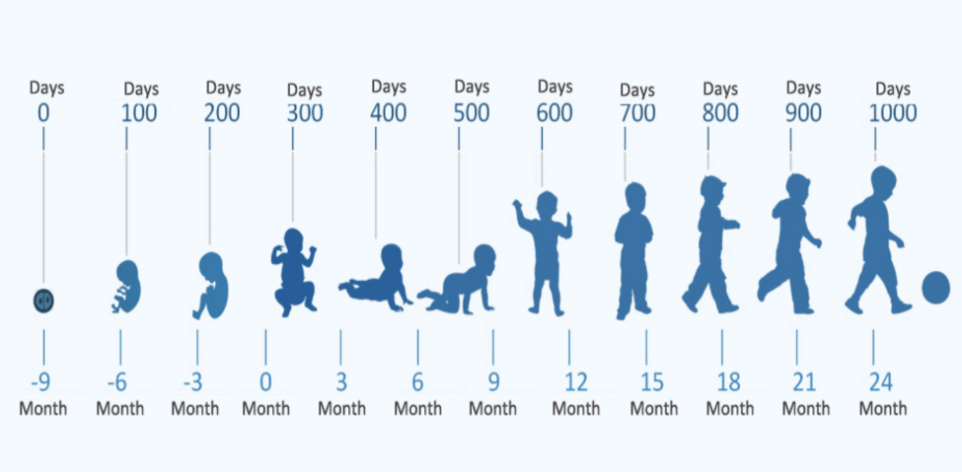

Source: Source: Sarihusada (https://www.sarihusada.co.id/en/About-Us/First-1000-Days-of-Life/Detail-For-the-First-1000-Days-of-Life)

[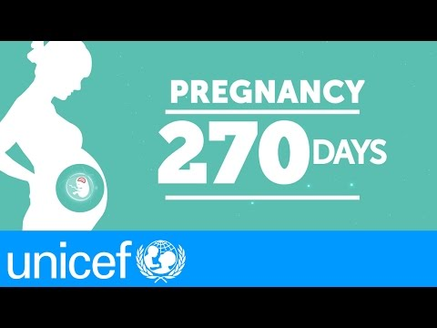](http://www.youtube.com/watch?v=mpyD19SIiaw)

Source: [UNICEF 2015](https://www.youtube.com/watch?v=mpyD19SIiaw)

#### SLIDE [29]: Key Concept and Terms (Cont’d.)

**Multi-Sectoral Approach:** This is an approach to nutrition planning and programming in which different departments across several ministries (e.g., health, agriculture, women’s affairs) coordinate and collaborate to address direct and underlying causes of malnutrition.

**Micronutrient Deficiency:** This is inadequate intake of micronutrients (vitamins and minerals) for the body’s needs. The most common micronutrient deficiencies are vitamin A deficiency, iron deficiency anemia, iodine deficiency, and zinc deficiency. Micronutrient deficiency is also known as “hidden hunger.”

**Nutrition Situation:** This describes the result of all factors that contribute to the nutrition outcomes of the population. They include factors that cause malnutrition, the existing multi-sectoral nutrition-related interventions, stakeholders, and the food security situation.

#### SLIDE [32]: Key Concept and Terms (Cont’d.)

**Overnutrition:** Overnutrition happens when a person’s daily energy intake consistently exceeds energy requirements. If this continues over time, a person may become overweight or obese (see figure 2). Overnutrition—and overweight and obesity—are risk factors for noncommunicable diseases, such as hypertension, diabetes, stroke, and some cancers.

**Overweight:** Overweight is a range of weight that exceeds what is generally considered healthy for a given height. For adults, overweight is having a body mass index (BMI) from 25 to 29.9. In children under five, overweight is a BMI-for-age z-score more than two standard deviations (> +2 SD) above the median of the WHO Child Growth Standards. In children ages 5–19, overweight is a BMI-for-age z-score more than one standard deviation (> +1 SD) above the median.

#### SLIDE [33]: Key Concept and Terms (Cont’d.)

**Obesity:** Obesity is a range of weight that is much greater than what is generally considered healthy for a given height. For adults, obesity is having a BMI of 30 or higher. In children under five, obesity is a BMI-for-age z-score that is more than three standard deviations (> +3 SD) above the median of the WHO Child Growth Standards. In children ages 5–19, obesity is a BMI-for-age z-score that is more than two standard deviations (> +2 SD) above the median.

Figure 2 shows the images of two people, with one being considered overweight and the other being obese.

Figure 2. Illustration of Overweight and Obesity

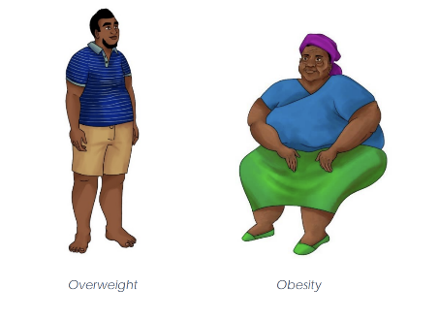

Image: IYCF image bank

#### SLIDE [35]: Key Concept and Terms (Cont’d.)

**Undernutrition:** Undernutrition is a consequence of a deficiency in nutrient intake or absorption in the body. The different forms of undernutrition, which can appear alone or in combination, are acute malnutrition (bilateral pitting edema or wasting), stunting, underweight (combined form of wasting and stunting), and micronutrient deficiencies.

|  |
| --- |
| **Facilitator Discussion Question:** Who can tell us what stunting is and its causes? What are stunted children at higher risk for? |

**Stunting:** Stunting occurs when a child fails to grow at a healthy pace and is shorter than expected for a healthy child of the same age and sex. Stunting develops over a long period because of long-term inadequate nutrition (including poor maternal nutrition and poor infant and young child feeding practices) or repeated illness or infection. Stunted children have a higher risk of death from diarrhea, pneumonia, and measles. Stunting is associated with poor cognitive and motor development and lower school achievement. In children under five it is defined as a height-for-age z-score of more than two standard deviations below the median (<-2 SD) of the WHO Child Growth Standards (children under five).

Looking at this image, both girls are the same age. The girl on the left is stunted because she has short stature for her age.

Figure 3. Illustration of Stunting

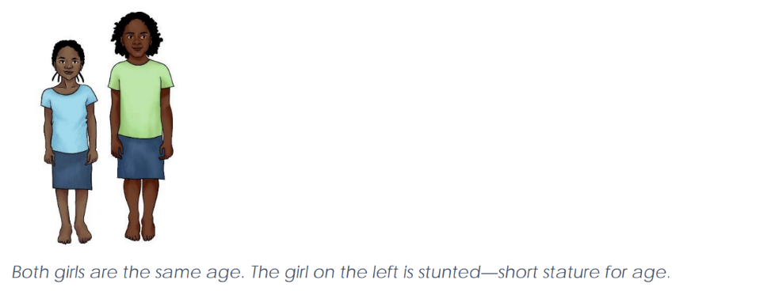

Image: IYCF image bank

#### SLIDE [37]: Key Concept and Terms (Cont’d.)

**Underweight:** This form of undernutrition includes elements of stunting and wasting. It is defined in children under five as a weight-for-age z-score of more than two standard deviations below the median (<-2 SD) of the WHO Child Growth Standards. This indicator is commonly used in growth monitoring and promotion and in child health and nutrition programs aimed at prevention and treatment of undernutrition.

**Wasting:** Wasting occurs when an individual is very thin for his or her height. It happens when a person loses weight rapidly or a growing child does not gain adequate weight relative to his or her growth in height. Wasting may be caused by inadequate food intake, such as a drop in food consumption or suboptimal infant and young child feeding practices; by disease or infection, including HIV or tuberculosis; or by a combination. In children under five, it is defined as a weight-for-height z-score of more than two standard deviations below the median (<-2 SD) of the WHO Child Growth Standards or a mid-upper arm circumference under 125 mm. Wasting is one form of acute malnutrition.

In this next image, which child would be considered undernourished (or wasting)?

Figure 4. Illustration of Wasting

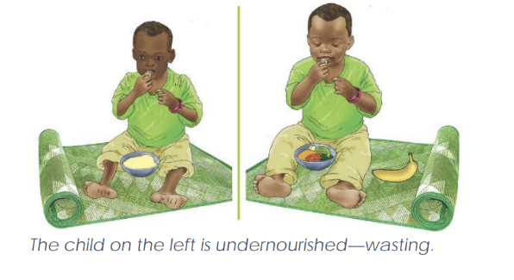

Image: IYCF image bank

#### SLIDE [39]: Key Concept and Terms (Cont’d.)

**Edema (bilateral pitting edema):** Edema refers to an excess accumulation of fluid that starts in both feet and can progress to other parts of the body. Also known as nutritional edema or edematous malnutrition, bilateral pitting edema is a sign of severe acute malnutrition. It is verified when thumb pressure applied on the tops of both feet for three seconds leaves an indentation after the thumb is lifted.

The image below is an example of a child with edema.

Figure 5. Illustration of Edema

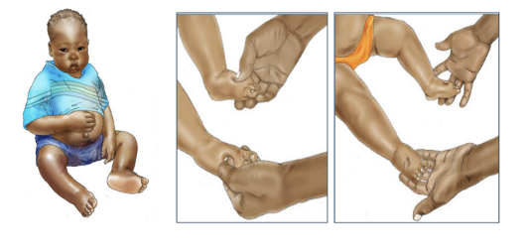

Image: IYCF image bank.

FACILITATOR: The intergenerational cycle of malnutrition refers to what happens when a low-birthweight baby becomes a malnourished child, a malnourished adolescent, then a malnourished woman who, in turn, has another low-birthweight baby (Ahmed, Hossain, and Sanin 2012).

FACILITATOR: Global evidence has shown that the consequences of malnutrition will continue to be passed on unless something stops the cycle to enable adequate nutrition for a child or a woman. This cycle is a key factor in the broader cycle linking nutrition with poverty, as we see in this graphic.

#### SLIDE [40]: Key Concept and Terms (Cont’d.)

Figure 6. Intergenerational Consequences of Malnutrition

##### A bottom-up flowchart runs as follows. Step 1. Basic causes at societal level, which comprises the following. Poor access to natural capital (land, water, clean air) and services such as markets, education, support networks, social protection, infrastructure and transportation, employment, technology, information, marketing. Unintended negative effects of culture and social norms, fiscal and trade policies, legislation and regulations, agriculture and food systems, rapid urbanization, climate change, pollution, political instability and security, and gender inequality. Step 2. Underlying causes at household and family level, which comprises the following. Sedentary lifestyle and behaviors. Insufficient supply or access to healthy foods. Inadequate care and feeding practices and behaviors. Poor water, sanitation, food safety and inadequate health services. Step 3. Immediate outcomes, which comprises the following. Physical activity. Poor dietary intake (quality and or or quantity). Disease. Step 4. Outcome, which comprises the following. Overweight or unbalanced intake. Maternal and child undernutrition. Step 5. Consequences, which comprises the following. non-communicable diseases, premature mortality, reduced fertility, physical disability, social discrimination. Mortality, morbidity from infectious diseases, disability. Sub-optimal adult height, poor cognitive ability, low economic productivity, compromised reproductive health. Step 6. Example. Intergenerational consequences of malnutrition.

Source: Scaling Up Nutrition (SUN) 2016

|  |
| --- |
| **Key Takeaways:** Before we break, take a minute to think of one or two things you learned that you’re going to take away from this session and how this new knowledge can apply to your work. |

# Session 1.3

## Causes of Malnutrition

TIME TO COMPLETE: 45 MINUTES

I**nstructions for the facilitator:** The purpose of this session is to understand the conceptual framework on the causes of malnutrition.

This session covers slides 42-51

* Conceptual framework on the causes of malnutrition: slides 43-44
* Immediate causes of malnutrition: slide 45
* Underlying causes of malnutrition slides 46-49
* Basic determinants of malnutrition: slide 50

|  |
| --- |
| **Facilitator Discussion Question:** What are the causes of malnutrition? What are some of the possible factors behind those causes? |

### Conceptual Framework on the Causes of Malnutrition

SLIDE [44]: The following three categories describe the causes of malnutrition and guide associated responses. Developed by the United Nations Children’s Fund (UNICEF) (2020), the conceptual framework defines three categories of causes: immediate, underlying, and enabling determinants.

#### SLIDE [44]: UNICEF Conceptual Framework on the Causes of Malnutrition

Figure 7. UNICEF Conceptual Framework on the Causes of Malnutrition

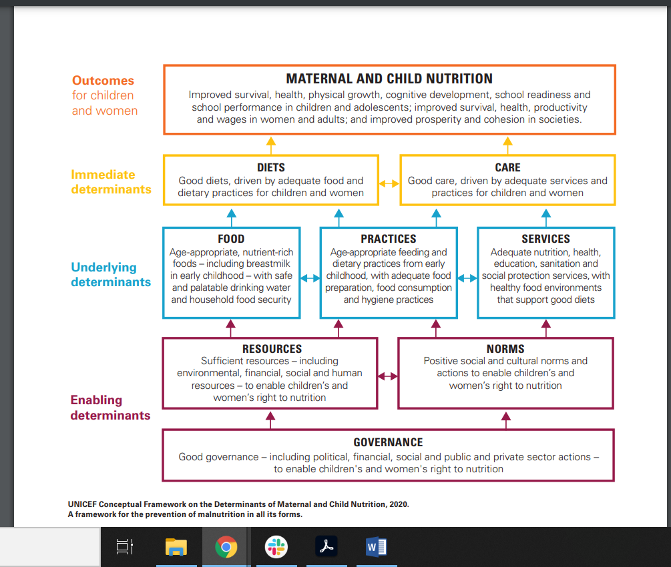Source: UNICEF 2020

### Category: Immediate Causes of Malnutrition

SLIDE [45]: The first category, immediate causes, refers to nutrient intake and health status that affect nutritional status in interrelated ways:

* Inadequate nutrient intake may result from eating too little food overall or from a diet that lacks diversity or is missing nutrients.
* Likewise, a person’s health status can affect nutrition because certain conditions can affect the individual’s nutrition needs and how the body consumes and uses nutrients. For example, living with chronic diseases, such as HIV, increases nutritional needs but may limit appetite.
* Repeated diarrhea, which often results from poor sanitation and hygiene, can damage the intestinal lining’s capacity to absorb nutrients.
* These causes of malnutrition are interrelated and affect one another.
* Interventions designed to directly increase nutrient intake or improve health status are called nutrition-specific interventions. They respond to these immediate causes of malnutrition.

### Category: Underlying Causes of Malnutrition

SLIDE [46]: The second category is the underlying causes of malnutrition. They include factors that affect the direct or immediate causes, specifically—

* food insecurity
* care capacity and practices
* health care
* water, sanitation, and hygiene (WASH) and food safety.

SLIDE [47]: Food insecurity occurs when people are unable to meet their minimum food requirements over a sustained period. Food security exists when all people at all times have both physical and economic access to sufficient food to meet their dietary needs for a productive and healthy life. Food security is determined by a variety of factors, including stability in a setting, availability and affordability of food, and absence of food access problems or limitations.

#### SLIDE [48-49]: Underlying Causes of Malnutrition (Cont’d.)

Care capacity and practice is another important underlying factor in malnutrition. The practice of how people care for themselves and others, including children, is influenced by their capacity, knowledge, skills, available time, space, and other resources. Caregivers at the household level and health service providers require sufficient capacity and resources to provide safe and nurturing care to others. Health care, including essential nutrition actions, immunizations, and the treatment of illnesses, affect health status and thereby nutrition.

WASH and food safety have important implications for nutrition because intestinal infections and other illnesses can be transmitted through unsafe practices related to food, water, and the physical environment.

### Category: Enabling Determinants of Malnutrition

SLIDE [50]: The last category is the enabling determinants of malnutrition, which involve factors of a more structural nature. These causes relate to the availability of, access to, and distribution of resources; political, legal, and cultural forces in the enabling environment; education; poverty; income inequality; institutions; and policies and markets.

|  |
| --- |
| Group Exercise: Consequences of Malnutrition |
| **Instructions:**  Brainstorm the effects of malnutrition on individuals, households, and the community, with reference to health, education, productivity, and economic development.  Write each challenge on a card and display it at the front of the room.  TIME TO COMPLETE: 15 MINUTES |
| In your group, discuss the possible causes of malnutrition in your state/LGA. Make sure to discuss the challenges in each MDA (e.g., education, health, agriculture, planning, water, social development, trade and industry, and administration) that could contribute to malnutrition.  Write the identified causes on Post-It notes and paste them at the front of the room. |

|  |
| --- |
| **Key Takeaways:** Before we break, take a minute to think of one or two things you learned that you’re going to take away from this session and how this new knowledge can apply to your work. |

# Session 1.4

## Vulnerable Groups

TIME TO COMPLETE: 30 MINUTES

Instructions for the facilitator: The purpose of this session is to understand and define characteristics of groups vulnerable to malnutrition.

This session covers slides 52-61

* Children under age five: slide 53
* Pregnant and lactating women: slide 54
* Adolescent Girls and Women of Reproductive Age: slides 56-57
* Elderly: slide 58
* People at risk of infectious disease: slide 59

|  |
| --- |
| **FACILITATOR QUESTION:** The last crucial issue for us to emphasize as foundational for understanding malnutrition and program responses relates to the question: Who is most vulnerable? Why do you think these groups are most vulnerable? |

SLIDE [52]: Global evidence in the past 10 years has demonstrated that women of reproductive age, infants, and young children are most vulnerable to becoming malnourished. They suffer the greatest impact, and their condition greatly affects the overall welfare of families and communities (Bhutta et al. 2013; Ruel and Alderman 2013).

The intergenerational cycle of malnutrition refers to what happens when a low-birthweight baby becomes a malnourished child, a malnourished adolescent, then a malnourished woman who, in turn, has another low-birthweight baby (Ahmed, Hossain, and Sanin 2012).

SLIDE [53]: Children under age five are at high risk of malnutrition, especially those under age two because they are growing the fastest and need adequate nutrition to grow and develop properly. Children who are malnourished are at greater risk of infections (such as diarrhea and pneumonia), which in turn increases the risk of malnutrition. Malnourished children also have a greater risk of developing chronic diseases (such as diabetes and heart disease) in adulthood. In addition, low-birthweight babies are four times more likely to die within the first month of life than other babies.

SLIDE [54]: **Pregnant and lactating women:** Pregnancy and lactation increase a woman’s nutritional needs. Among women who are already malnourished, the increased nutritional needs present additional challenges. Women who are malnourished have a higher risk of dying from pregnancy-related causes. Children born to undernourished women are more likely to be born premature and to be small for gestational age or have low birthweight. This, in turn, leads to a higher risk of stunting, an increased risk of death within one month of birth, and future developmental challenges. In addition, being overweight can increase pregnancy complications. Pregnant and lactating women are at risk, in part, due to high fertility rates.

SLIDE [55]: Birth spacing has important nutritional consequences. Children conceived less than 24 months after the birth of the next older sibling have a greater risk of dying and becoming malnourished than children born further apart. When a birth occurs within 24 months of a previous birth, it gives the mother little time to replenish her own body’s nutrients. Women have increased nutritional needs during pregnancy to support the growth of the fetus; high fertility and frequent pregnancies prevent them from rebuilding nutritional stores between pregnancies. In addition, childbearing begins early in Nigeria, which has serious consequences because—relative to an older mother—an adolescent girl is more likely to be malnourished and have a low-birthweight baby who is more likely to become malnourished. Therefore, adolescent girls need to be the focus of both family planning and nutrition interventions.

SLIDE [56-57]: **Adolescent Girls and Women of Reproductive Age:** To ensure healthy pregnancy outcomes for the mother and baby, it is important to support adolescent girls and women of reproductive age before they become pregnant. Adolescence is also a time of rapid growth and development. Girls need to be well nourished during this time to ensure they grow properly. Women who are underweight and short are more likely to have babies with low birthweight. Good nutrition during the first 1,000 days that carries through to adolescence can help mitigate such nutritional complications. In addition, being overweight is a problem during pregnancy; therefore, it is important to educate young girls about a good diet. Coupled with access to family planning and efforts to retain girls in school, supporting this age group is critical to breaking the cycle of malnutrition.

SLIDE [58]: The elderly population in Nigeria faces vulnerability to malnutrition because of factors such as limited access to nutrient-rich foods, reduced appetite, digestive issues, loneliness and social isolation, health conditions and medications, dental problems, poverty and food insecurity, lack of nutrition education, and caregiver constraints. These challenges can lead to inadequate nutrient intake and contribute to malnutrition and nutrient deficiencies, affecting bone density, immune system protection, and overall health among the elderly in the country.

SLIDE [59]: **Infectious Diseases****:** People with infectious diseases, such as HIV or tuberculosis, are more at risk for malnutrition because of their higher calorie and nutrient requirements as their bodies battle these conditions. Nutrition assessment, counseling, and support are examples of interventions that target these groups.

|  |
| --- |
| 1.4 Group Discussion: Key Takeaways |
| **Instructions for the facilitator:**   * Ask the groups the question below. * Direct participants to take time to complete their personal reflections.   TIME TO COMPLETE: 10 MINUTES |
| Before we break, take a minute to think of one or two things you learned that you are going to take away from this session and how this new knowledge can apply to your work. |

|  |
| --- |
| As we close this unit, take a few minutes to write your personal reflections in your handbook, see the prompts. If you only have time for one question, ask yourself, “When I go back to your state or LGA and share what I’ve learned in this unit, how will I teach new SCFN members about this process? |

# Unit 2

## Nutrition Policy Environment in Nigeria

TIME TO COMPLETE: 5 HOURS

**Instructions for the facilitator:** The purpose of this unit is to enhance participant understanding and appreciation of the magnitude, causes, and consequences of malnutrition in Nigeria and the overall policy environment for addressing malnutrition.

Objectives:

* Understand the nutrition situation in Nigeria, including key statistics, and the causes and consequences of malnutrition.
* Understand the policy environment at global, regional, and national levels to address malnutrition.
* Understand the national multi-sectoral nutrition coordination framework, including the composition, roles, and responsibilities of nutrition coordination committees.

This unit covers slides 62-71

* Session 2.1: Global Nutrition Frameworks
* Session 2.2: Nutrition Situation in X State
* Session 2.3: Nigeria Policy Environment
* Session 2.4: Nigeria Multi-Sectoral Nutrition Coordination Framework
* Session 2.5: Roles and Responsibilities of National Nutrition Coordination Committees
* Session 2.6: Roles and Responsibilities of SCFNs
* Session 2.7: Additional Stakeholders and Collaborators
* Session 2.8: Configuration of SCFNs
* Session 2.9: Proposed Subcommittees and Working Groups in the SCFNs

# Session 2.1

## Global Nutrition Frameworks

TIME TO COMPLETE: 30 MINUTES

**Instructions for the facilitator:** The purpose of this session is to understand how the global nutrition environment impacts national and regions strategies and activities to the global and regional nutrition development agendas.

This session covers slides 65-71:

SLIDE [66]: Although the national development agenda inform multi-sectoral nutrition planning and programming, efforts have been made to align strategies and activities to the global and regional nutrition development agenda. Refer to the key global, regional, and national frameworks described below.

At the global level, note the following guiding frameworks:

* Global Nutrition Targets 2025 (WHO)
* 2030 Agenda for Sustainable Development and the Sustainable Development Goals (SDGs)
* SUN Movement Strategy and Roadmap (2016–2020)
* United Nations Decade of Action on Nutrition 2016–2025.

### National Nutrition Policies/Legislation, Strategies, and Initiatives

SLIDE [67-68]: Nigeria’s commitment to improving nutrition is outlined in the following documents, which align with the government’s Vision 2020, Agenda 2050, and the National Development Plan (2021–2025):

* Health Sector National Strategic Action Plan for Nutrition (2021–2025)
* National Policy on Food and Nutrition (2016–2025)
* National Policy on Maternal Infant and Young Child Feeding in Nigeria (2010)
* Agricultural Sector Food Security and Nutrition Strategy (2016–2025)
* Nigeria National Multi-Sectoral Plan of Action for Food and Nutrition (2021–2025)
* Nigeria Food and Nutrition Response Plan to COVID-19 (April 2020)
* National Policy on the Health and Development of Adolescents and Young People in Nigeria (2020–2024)
* Nigeria National Social Protection Policy (2017)
* National Food Safety Policy (2017–2026)
* National Agricultural Technology and Innovation Policy (2022–2027)
* National Multi-Sectoral Action Plan for the Prevention and Control of Non-Communicable Diseases (2019–2025)
* The Partnership for Expanded Water Supply, Sanitation and Hygiene Strategy (2016–2030)
* Basic Health Care Provision Fund.

#### SLIDE [69]: This figure shows the Global Nutrition Targets set by WHO.

Figure 8. Global Nutrition Targets

A set of 9 stamps of the 2025 global nutrition targets, which are as follows. Under five stunting percentage, low birth weight percentage, 0 to 5 months old exclusive breastfeeding percentage, under five wasting percentage, under five overweight percentage, women anemia (15 to 49 years old) percentage, adult overweight percentage, adult obesity percentage, adult diabetes percentage, Each icon represents a specific health condition, and the numbers indicate how widespread these conditions are.


Source: WHO 2017

SLIDE [69]: Recognizing that accelerated global action is needed to address the pervasive and corrosive problem of the double burden of malnutrition, in 2012 the World Health Assembly Resolution 65.6 endorsed a comprehensive implementation plan on maternal, infant, and young child nutrition, which specified a set of six global nutrition targets that by 2025 aim to—

* achieve a 40 percent reduction in the number of children under five who are stunted
* achieve a 50 percent reduction of anemia in women of reproductive age
* achieve a 30 percent reduction in low birthweight
* ensure there is no increase in childhood overweight
* increase the rate of exclusive breastfeeding in the first six months up to at least 50 percent
* reduce and maintain childhood wasting to less than 5 percent.

Figure 9. Nutrition and the SDGs/2030 Agenda for Sustainable Development and the SDGs

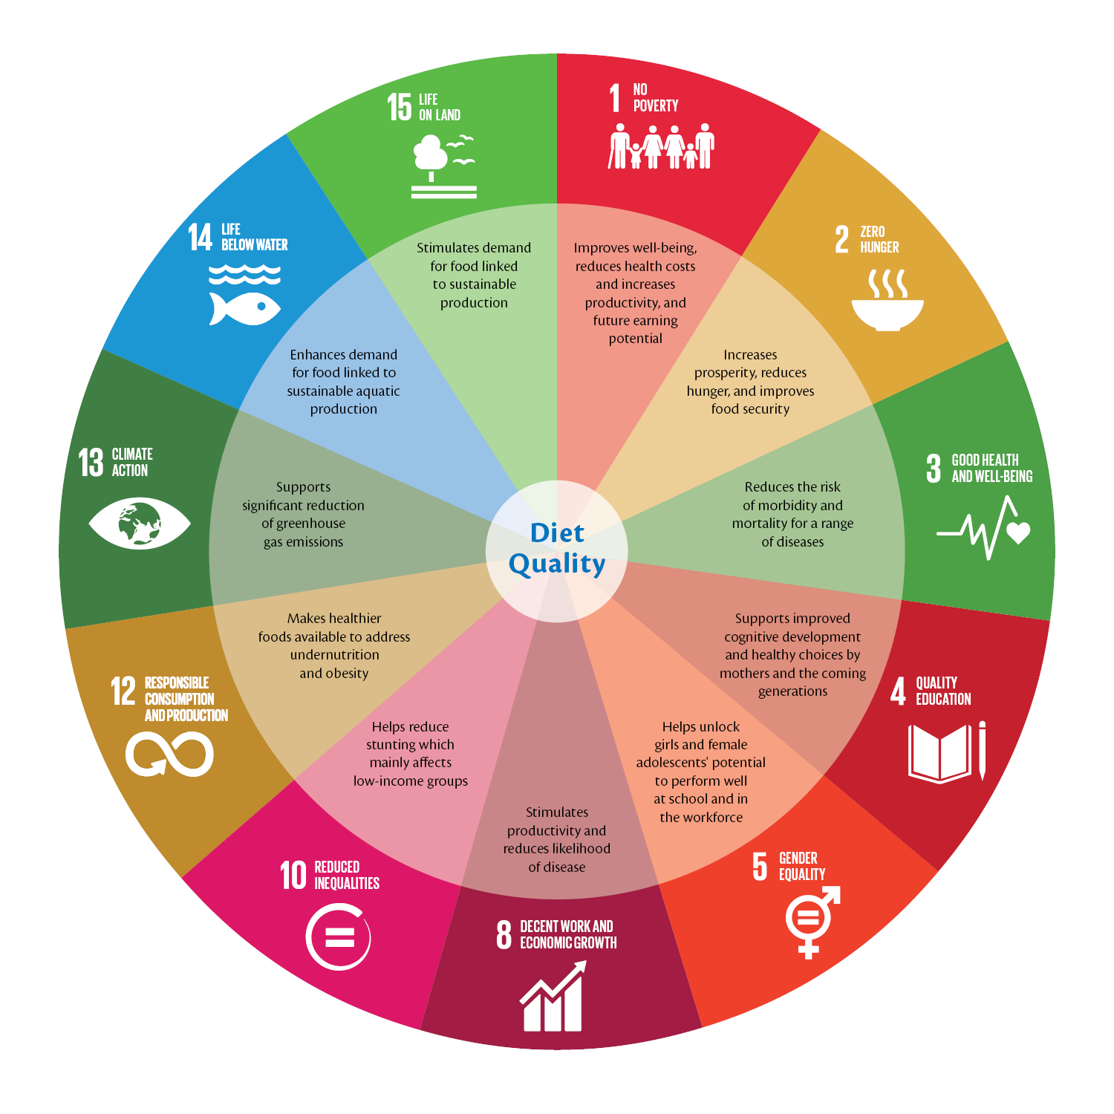

Source: Scaling Up Nutrition 2017

SLIDE [70]: Over the next 15 years, the SDGs commit all governments to comprehensive, integrated, and universal transformations, including ending hunger and malnutrition by 2030. Countries will mobilize efforts to end all forms of poverty, fight inequalities, and tackle climate change, while ensuring no one is left behind.

SLIDE [71]: On this slide, the figure presents the Six Pillars for Nutrition Action/United Nations Decade of Action on Nutrition 2016–2025.

Figure 10. Six Pillars for Nutrition Action

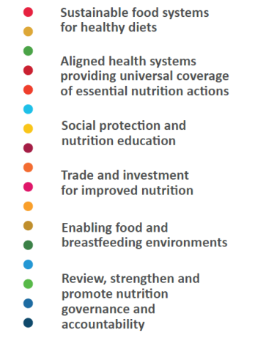

Source: WHO 2017

SLIDE [71]: The UN Decade of Action on Nutrition is a UN-wide, FAO- and WHO-convened, Member State–driven global collective effort to set, track, and achieve policy commitments to end all forms of malnutrition worldwide. It is built around six pillars for nutrition action, which are based on the commitments of the Rome Declaration on Nutrition and the recommendations included in the International Conference on Nutrition Framework for Action.

|  |
| --- |
| **Key Takeaways:** Before we break, take a minute to think of one or two things you learned that you’re going to take away from this session and how this new knowledge can apply to your work. |

# Session 2.2

## Nutrition Situation in [X State]

TIME TO COMPLETE: 30 MINUTES

**Instructions for the facilitator:** The purpose of this session is to enhance participant understanding and appreciation of the magnitude, causes, and consequences of malnutrition in Nigeria, with particular focus in their state. This section will need to be updated depending on the state of focus. Facilitators are encouraged to update the highlighted information below.

This session covers slides #–# - starts on slide 72:

* Overview of Maternal and Child Nutrition Outcomes: slides #–#:
* Immediate Determinants of Nutrition: slides #–#:
* Underlying Determinants of Nutrition: slides #–#:
* Basic Determinants of Nutrition: slides #–#:

Note that the slides include nutrition statistics for national and regional levels; however, if state or LGA statistics are also available, these slides can be updated to reflect the local context.

Suggested organization below:

* Overview of Maternal and Child Nutrition Outcomes
  + Health: Instruct participants to have a discussion about state-level data. What are the most pressing issues? What is being done to address these issues? How can your SCFN plan to address them?
* Underlying Determinants of Nutrition
  + Food Security: Hold a discussion about state-level data. What are the most pressing issues? What is being done to address these issues? How can your SCFN plan to address them?
* WASH: Hold a discussion about state-level data. What are the most pressing issues? What is being done to address these issues? How can your SCFN plan to address them?
* Basic Determinants of Nutrition
  + Hold a discussion about state-level data. What are the most pressing issues? What is being done to address these issues? How can your SCFN plan to address them?

|  |
| --- |
| **Key Takeaways:** Before we break, take a minute to think of one or two things you learned that you’re going to take away from this session and how this new knowledge can apply to your work |

# Session 2.3

## Nigeria Policy Environment

TIME TO COMPLETE: 45 MINUTES

**Instructions for the facilitator:** The purpose of this session is to enable an enhanced understanding of the overall policy environment for addressing malnutrition.

This session covers slides 74-84:

* Policy Environment slides 75-80

SLIDE [75]: The Government of Nigeria has signed and endorsed many international frameworks to reduce poverty and improve the health and nutritional status of its population:

* It is a signatory of the Comprehensive Africa Agriculture Development Programme Compact (2009).
* Nigeria has been a member of the SUN Movement since 2012 and has had a SUN Business Network since 2017.
* Nigeria is part of the Economic Community of West African States Zero Hunger Initiative (2014).

SLIDE [75]: These global initiatives are reflected in the multi-sectoral nature of Nigeria’s nutrition, agriculture, and food systems policies, strategies, and plans:

* The National Policy on Food and Nutrition in Nigeria was revised in 2016. It provides the overarching policy framework for multi-sectoral action to reduce malnutrition in the country.

SLIDE [77]: In January 2021, the NCN approved the National Multi-Sectoral Plan of Action for Food and Nutrition (NMPFAN) 2021–2025:

* The plan is meant to guide the implementation of nutrition-specific and nutrition-sensitive interventions across sectors to address the challenges of hunger and malnutrition.
* The NMPFAN sets national targets to reduce the proportion of people who suffer malnutrition by 50 percent, increase the exclusive breastfeeding rate to 65 percent, and reduce stunting among children under age five to 18 percent (FMFBNP 2021).

SLIDE [78]: The National Agricultural Technology and Innovation Policy (2022–2027) and the Nigeria Agricultural Sector Food Security and Nutrition Strategy (2016–2025) provide the strategic direction to improve nutrition and achieve food systems transformation through the agriculture sector in Nigeria:

* These policies are meant to work in synergy with other nutrition-related policies, such as the National Policy on Food and Nutrition (2016–2025), the NMPFAN (2021–2025), the National Policy on Infant and Young Child Feeding in Nigeria (2010), and the Nigeria National Social Protection Policy (2016).

SLIDE [79]: The National Health Policy (2016), Second National Strategic Health Development Plan (2018–2022), and Health Sector National Strategic Action Plan for Nutrition (2021–2025) provide the strategic direction to improve nutrition, especially undernutrition, through the health sector and services. The National Multi-Sectoral Action Plan for the Prevention and Control of Non-Communicable Diseases (2019–2025) further highlights strategies for addressing overweight and obesity.

SLIDE [80]: The Partnership for Expanded Water Supply, Sanitation and Hygiene Strategy (2016–2030) recognizes improved nutrition and reductions in stunting as an outcome area for the water and sanitation sector in Nigeria, and it outlines approaches for increasing national supply to WASH services.

SLIDE [80]: The Nigeria Sustainable Urban and Rural Water Supply, Sanitation and Hygiene Program for Results (2021) aims to increase access to WASH services and strengthen sector institutions.

* The Revised National Social Protection Policy (2021) outlines actions to facilitate adequate nutrition among poor and marginalized groups and reduce inequities in nutritional status.

|  |
| --- |
| Group Exercise: Nutrition in State/LGA Plans |
| Instructions for the facilitator:   * Break participants into groups of five participants or fewer. * Assign a recorder and reporter to present the findings. * Give each group 10 minutes to discuss the questions below. * Ask each group to present its findings at the end of this exercise.   Materials:   * None   TIME TO COMPLETE: 10 MINUTES |
| **Questions:**  What are the nutrition interventions included in the five-year state or LGA development plan?  What are the nutrition interventions included in the department annual work plans?  What nutrition interventions are included in the State Multi-Sectoral Plan of Action for Food and Nutrition?  What are the policy environments in your state that support nutrition? |

|  |
| --- |
| **Key Takeaways:** Before we break, take a minute to think of one or two things you learned that you’re going to take away from this session and how this new knowledge can apply to your work. |

### Overview of the National Policy on Food and Nutrition

SLIDE [74]: Introduction to Session 2.3: The purpose of this session is to enable an enhanced understanding of the national policy environment on food and nutrition in Nigeria.

SLIDE [82]: This image is the National Policy on Food and Nutrition in Nigeria.

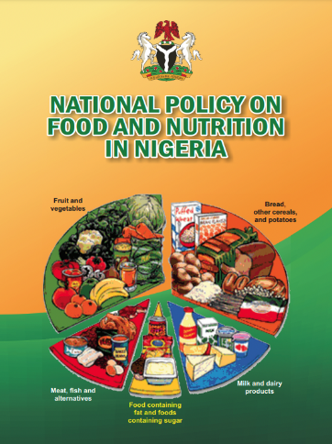

Source: National Policy on Food and Nutrition 2016

### Vision Statement of the National Food and Nutrition Policy

SLIDE [82]: A country where the people are equitably food and nutrition-secure with high quality of life and socioeconomic development contributing to human capital development objectives of Nigeria Vision 20:20:20 and beyond.

### Goal

SLIDE [83]: To attain optimal nutritional status for all Nigeria, with particular emphasis on the most vulnerable groups, such as children, adolescents, women, elderly, and groups with special nutritional needs.

### Objectives

SLIDE [83]: To achieve the goal of attaining an optimal nutritional status by the year 2025, several objectives are articulated:

* Improve food security at national, community, and household levels.
* Reduce undernutrition among infants and children, adolescents, and women of reproductive age.
* Significantly reduce micronutrient deficiency disorders, especially in the vulnerable group.
* Increase the knowledge of nutrition in the populace and nutrition education in formal and informal training.
* Promote optimum nutrition for people in especially difficult circumstances, including people living with HIV and AIDS.
* Prevent and control chronic nutrition-related noncommunicable diseases.
* Incorporate food and nutrition considerations into federal, state, and local government sectoral development plans.
* Promote and strengthen research, and monitoring and evaluation (M&E) of food and nutrition programs.
* Strengthen systems for providing early warning information on the food and nutrition situation.
* Ensure universal access to nutrition-sensitive social protection.

|  |
| --- |
| Group Discussion: What is our role? |
| Nutrition governance represents actions taken to provide an institutional framework and systems to facilitate the institutionalization of nutrition in existing government structures, policies, and frameworks. Nutrition governance includes information management, coordination and partnership, advocacy, communication, and policy development and implementation. |
| * What LGAs or communities are most affected by malnutrition? * Which local government, wards, or communities would you prioritize for support and why? * Prepare a short presentation to share with the larger group. |

|  |
| --- |
| **Key Takeaways:** Before we break, take a minute to think of one or two things you learned that you’re going to take away from this session and how this new knowledge can apply to your work. |

# Session 2.4

## Nigeria Multi-Sectoral Nutrition Coordination Framework

TIME TO COMPLETE: 45 MINUTES

**Instructions for the facilitator:** The purpose of this session is to guide participants through the nutrition coordination framework for Nigeria from national to state to LGA levels.

This session covers slides 86-104:

* Various Sectors’ Contributions to Nutrition slides 89-99
* Leadership, Structures, and Institutions: slides 100-102

SLIDE [86]: The multi-sectoral causes of malnutrition, as highlighted in the UNICEF framework, require that nutrition also be addressed using multi-sectoral approaches. This figure summarizes the sectors and MDAs that could be involved in addressing various aspects of nutrition determinants.

Figure 11. Sectors Involved in Addressing Malnutrition

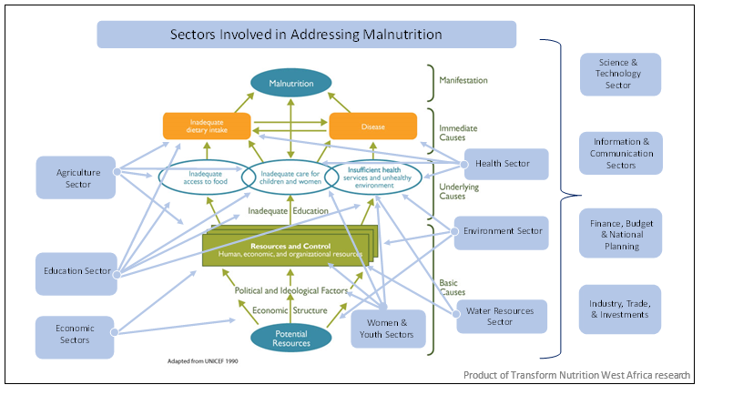

Source: Transform Nutrition West Africa, adapted from UNICEF, 1990.

#### SLIDE [87]: The Multi-Sectoral Nutrition Coordination Framework (cont’d.)

Malnutrition is a multifaceted problem requiring the involvement of all government sectors directly or indirectly involved in promoting nutrition and preventing and controlling malnutrition. While a multi-sectoral approach with central coordination is necessary to deal with the complex nature of malnutrition, to appreciate the intricate interplay of numerous determinants, individual technically sound programs need be implemented by each critical sector, according to its mandate and in line with the national policy on food and nutrition and the multi-sectoral strategy for its implementation.

#### SLIDE [88]: The Multi-Sectoral Nutrition Coordination Framework (cont’d.)

* To address the multi-sectoral causes of malnutrition, the Government of Nigeria designated the FMFBNP as the national focal point for food and nutrition policy, program planning, and coordination in the country.
* In May 2007, the NCN was approved by the Federal Executive Council. Its membership includes ministers from relevant MDAs, one representative from the Nigeria Governors’ Forum (NGF), and organized private sector and nutrition-related agencies.
* NCN is the highest policymaking body for nutrition in the country.

#### SLIDE [89]: Various Sectors’ Contributions to Nutrition

Each MDA (e.g., education, health, agriculture, planning, water, social development, information, trade and industry, and administration) contributes to addressing malnutrition. The next few slides present a brief overview of how and what they contribute.  
SLIDE [90]: **Education:** The education sector can contribute to improving nutrition in several ways. Children born to mothers or fathers with a higher number of years of education are better nourished than children whose parents have fewer years of education. Formal education can facilitate increased knowledge about appropriate child feeding and care practices.

SLIDE [90]: Education promotes self-efficacy and confidence and contributes to positive decision-making around food consumption, health seeking, and WASH. Apart from impacts through parental education, the education sector can directly affect child nutrition through nutrition and hygiene education, delivery of health care, and regular provision of nutritious school meals.

SLIDE [91]: **Health:** Disease or poor health is one of the immediate causes of malnutrition. Maternal health during pregnancy has serious implications for a woman’s own nutrition and that of her unborn child. The health sector is important for ensuring that women have access to comprehensive antenatal care that reduces the risks of malnutrition in women and children. Child spacing or family planning services provided by the health sector help women to nutritionally recover from one pregnancy before having another and thereby support improved maternal and child nutrition.

SLIDE [91]: The health sector is also key in delivering vital nutrition-specific interventions, including micronutrient supplements, ready-to-use therapeutic foods for the treatment of severe acute malnutrition, and improved feeding behaviors and stimulation. For the health sector to effectively address nutrition, it must deliver nutrition services and also integrate nutrition into core health care, such as family planning, antenatal care, child delivery, post-delivery care, vaccinations, well-child clinics, and sick child visits.

SLIDE [92]: **Agriculture:** There are several ways agriculture contributes to nutrition. Agriculture is the source of all food and influences the amounts, diversity, stability, quality, and safety of foods available. Agricultural practices influence the demand and supply of food and, thereby, food prices and affordability. Agriculture is the main livelihood and source of income for a significant portion of the Nigerian population and therefore affects food and non-food expenditures, including expenditures on health, education, and WASH. Agricultural labor can have serious effects on the health and nutrition of women.

SLIDE [93]: **Agriculture:** Agriculture can be a source of environmental contamination, increasing the risks of diseases and thus malnutrition. It is therefore important for the agricultural sector to contribute to improved nutrition by ensuring adequate availability of diverse, nutritious, safe, and affordable foods, while saving time and energy for women involved in agricultural activities.

SLIDE [94]: **Planning:** Adequate nutrition requires that the same individuals have adequate food, health, and care at the same time. Given that the interventions related to these three nutrition determinants are delivered by different sectors and MDAs, it is the role of planning MDAs to ensure other MDAs are effectively coordinated to achieve simultaneous delivery of interventions to communities, households, and individuals.

Such coordination includes joint planning across MDAs to select communities and households that will receive interventions in a specified period, as well as accountability mechanisms to ensure each MDA effectively delivers its interventions to the correct households in the stipulated period.   
SLIDE [95]: **WASH:** The WASH sector is important to achieve the health determinants of nutritional status. Poor WASH can result in illnesses and diseases that increase malnutrition. For example, diarrhea, a common outcome of poor WASH, has been clearly linked to stunting and other forms of malnutrition. Poor WASH can also result in poor intestinal (gut) health or even intestinal damage and thereby result in malnutrition.

The WASH sector can contribute to improved nutrition by scaling up safely managed water and sanitation services and optimal hygiene services among recipients of other nutrition interventions. Nutrition and hygiene education must also be integrated in the delivery of WASH services.

SLIDE [97]: **Social Development:** There are inequalities in malnutrition in Nigeria, including economic, gender, and geographic inequalities. Many of the inequalities in malnutrition are due to differing access to services because of socioeconomic status, gender, geographical location, or other social and demographic characteristics. The role of social development MDAs, including the Ministries of Women Affairs, Youth Development, Humanitarian Affairs, and similar MDAs, is to reduce the differences that result in disparate nutrition statuses across social strata. Such reduction in differences will involve targeting vulnerable groups, like people who are poor, and facilitating increased access to nutrition-related services, including through social assistance, social insurance, increased economic opportunities, and social equity.

SLIDE [98]: **Trade and industry:** The food and health industries involve very powerful actors determining the nutrition of populations, including in Nigeria. Industry and trade determine what foods and drugs are available to households and individuals and determine the prices at which foods and drugs are accessible. The role of trade and industry MDAs in improving nutrition includes ensuring healthy food products are available to all segments of the population at affordable prices. These food products can include fortified foods, foods in packaging that extends their shelf life and increases their months of availability, and specially formulated foods to address specific nutrition concerns. Trade and industry MDAs also need to ensure essential drugs, including micronutrient supplements, are available and affordable to all.

Trade and industry MDAs can fulfill their roles by increasing the ease, and thereby reducing the costs, of doing business; streamlining bureaucratic processes for registering and rolling out products; facilitating access to financing, improved infrastructure, and other inputs required by industry for successful businesses; and creating regulations and incentives to reduce the availability and affordability of unhealthy foods. Trade and industry MDAs can further intervene to address supply chain bottlenecks to reaching low-income populations with nutritious food products and drugs, create mechanisms to signal healthy/nutritious foods to consumers, and reward remarkable industry efforts to increase access to nutrition-promoting foods and drugs. Above all, trade and industry MDAs must ensure that regulatory processes prioritize consumer needs.

SLIDE [99]: **Information:** The Federal Ministry of Information and Culture contributes through newspapers and online publications on the importance of adequate nutrition and by organizing food fair shows through TV and radio.

### Leadership, Structures, and Institutions

SLIDE [100]: The Nutrition Division, located in the Department of Family Health in the Federal Ministry of Health (FMOH), is the government body where the country focal person for the SUN Movement sits. Apart from the coordination structures in the FMFBNP, the SUN Movement focal point also convenes government ministries and departments, including the Ministries of Health, Education, Agriculture, Women Affairs, Finance, Information, Science and Technology, and Water Resources.

SLIDE [100]: The implementation of the National Policy on Food and Nutrition is the responsibility of authorities at the three levels of government (federal, state, and LGA) in collaboration with other stakeholders, including the organized private sector, development partners, professional bodies, civil society organizations (CSOs) (e.g., nongovernmental organizations [NGOs], faith-based organizations), and communities.

SLIDE [101]: State and local government counterparts of the FMFBNP will be the focal points for coordinating food and nutrition programs at state and LGA levels and will be assisted by the SCFNs and LGCFNs. Implementation agencies at federal, state, and LGA levels are responsible for implementing specific projects and programs relevant to the policy.

SLIDE [102]: The focal points at federal, state, and LGA levels will have responsibility for identifying and mobilizing resources for executing given projects or activities in a coordinated manner and emphasizing the need for harmonization and synergy in each body’s geographic boundaries and authority.

SLIDE [103]: As you can see in the Institutional Structure for the Coordination of Policy Implementation below…

Figure 12. Institutional Structure for the Coordination of Policy Implementation

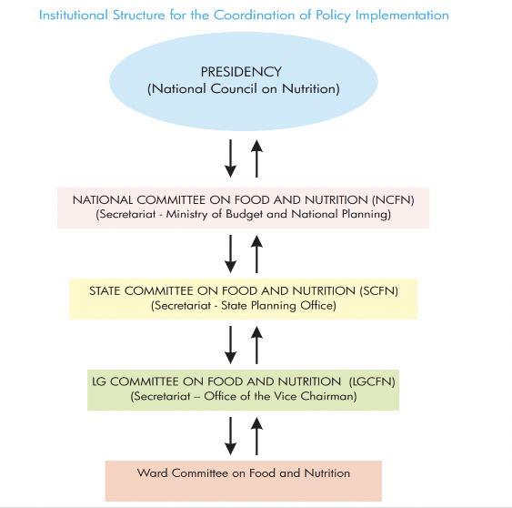

Source: National Policy on Food and Nutrition 2016

|  |
| --- |
| Group Exercise: How do the various levels of food- and nutrition-focused MDAs work together? |
| **Instructions for the facilitator:**   * Make sure that each group has the supplies it needs ahead of time to complete this exercise. * Go over the instructions. * Give the groups [X] minutes to complete the exercise. * Give each group two to three minutes to share its findings at the end of the exercise.   Objectives:   * Simulate holding an annual planning meeting to agree on food and nutrition-relevant projects to be captured in their individual budgets. * Ensure proper understanding of their individual roles and responsibilities.   Supplies:   * Flip chart paper * Markers   TIME TO COMPLETE: 15 MINUTES |
| Instructions for participants:   1. With your group, discuss how the various levels of food- and nutrition-focused MDAs work together. 2. Simulate holding an annual planning meeting to agree on food and nutrition-relevant projects to be captured in their individual budgets. 3. Ensure proper understanding of their individual roles and responsibilities. 4. Using a large sheet of flip chart paper, draw the institutional structure from above and list in the margins the types of information that are communicated to each level, including what resources are supported from each level.   NOTES:   1. This may look like a list in the margin, (i.e., from SCFN to LGCFN would be XX data, XX resources; from LGCFN to SCFN would be XX data and XX resources). 2. Complete for each level for data, resources, and other forms of support. |

|  |
| --- |
| **Key Takeaways:** Before we break, take a minute to think of one or two things you learned that you’re going to take away from this session and how this new knowledge can apply to your work. |

# Session 2.5

## Roles and Responsibilities of National Nutrition Coordination Committees

TIME TO COMPLETE: 60 MINUTES

**Instructions for the facilitator:** The purpose of this session is to guide participants through the roles and responsibilities of various government coordination committees.

This session covers slides 105-108

SLIDE [106]: **Introduction to the Session:** The following descriptions of structures come from the National Policy on Food and Nutrition (2016). Let’s spend some time reviewing and unpacking them to better understand each structure’s roles and responsibilities and how they engage with other structures.

For this section, we will refer to the Participant Handbook. There are no accompanying slides.

|  |
| --- |
| Overview of the FMFBNP |
| The FMFBNP will serve as the national focal point for food and nutrition policy program planning and coordination in the country. The FMFBNP will also serve as the secretariat for both the NCFN and NCN, will coordinate with the state secretariats, and will have regular forums for interactions. The FMFBNP will have at least one qualified and experienced nutritionist (not less than a deputy director) as the administrative head of the division or department that will house the NCFN Secretariat. |
| **Mandate of the FMFBNP—**   * to provide day-to-day support that will enhance the effectiveness of the NCN * to serve as the focal point for the coordination and harmonization of all food- and nutrition-related policies and programs being implemented by various ministries and agencies into a national program consistent with the goals and aspirations outlined in this policy document * to provide a forum for the exchange of views and experiences among the bodies implementing nutrition programs in Nigeria and, thereby, foster and strengthen their respective roles in the program * to coordinate the review, on a continuous basis, of policies and programs regarding their potential impact on food and nutrition issues * to ensure the effective implementation of the different policies and programs by putting in place effective processes for M&E * to maintain ongoing advocacy for food and nutrition issues * to ensure adequate financial provisions and the timely release of allocated funds in the National Development Plan and annual budget * to liaise with international donor agencies, financial institutions, the private sector, community-based organizations (CBOs), and NGOs when soliciting funds and material support to complement government resources and efforts; and ensure that development partners incorporate nutritional considerations in their development strategies across all sectors, especially food security, maternal and child health, social protection, education, agricultural research, and gender-based programs * to coordinate the analysis and dissemination of the results of important food and nutrition studies, statistics, and data. |

FACILITATOR: Now, let’s unpack these specific duties of the FMFBNP. As explained by the National Policy on Food and Nutrition (2016), the FMFBNP provides technical advice to national committees and activities and carries out reviews.

This part should be a facilitated discussion and can be in a Q&A format. Please ensure that all bullet points are covered (the order is not important).

In practice, how do they do this?

* What role does the Permanent Secretary of the Ministry play?
* How frequently do a Nutrition Partners Forum, national working groups, and subcommittees on food and nutrition meet?
* What are some roles within the technical team?
* How does the FMFBNP engage with the NCFN and NCN? What do they provide?

For this section, we will refer to the Participant Handbook. There are no accompanying slides.

|  |
| --- |
| Overview of the NCN |
| **National Council on Nutrition**   * The NCN is the highest decision-making body on food and nutrition. It serves as the policy body for all efforts geared to ensuring food and nutrition security for all Nigerians. * The NCN will be chaired by the Vice President of the Federal Republic of Nigeria and will be composed of ministers from relevant MDAs, one representative from Nigeria governors, and representatives of organized private sector/industry as approved by the Federal Executive Council in May 2007. The Council will meet on a biannual basis. |
| **Terms of reference for the NCN—**   * identify, analyze, and ascertain the problem of nutrition in Nigeria * identify the efforts already in place for tackling child malnutrition in Nigeria * review strategies and their impact on household, community, local government, state, national, and international levels * assess further action to be employed in dealing with malnutrition based on regular reviews of M&E reports and periodic surveys * coordinate and harmonize efforts, strategies, and programs of nutrition * ensure adequate resource mobilization and allocation to address nutrition issues. |

FACILITATOR: Now, let’s unpack the specific duties of the NCN, as explained in the National Policy on Food and Nutrition (2016). The NCN is housed in the Office of the Vice President. It is charged with identifying, analyzing, and dealing with problems of nutrition by reviewing strategies and their impact at the household, community, local government, state, national, and international levels; coordinating and harmonizing efforts, strategies, and programs of nutrition; and ensuring adequate resource mobilization and allocation to address nutrition issues.

Tasks include—

* national-level coordination of multi-sectoral nutrition stakeholders
* coordination of the National Policy on Food and Nutrition (2016) and its implementation at decentralized levels
* multi-sectoral nutrition knowledge management and information sharing through experience sharing and learning events at global, regional, and national levels
* quarterly monitoring and supportive supervision to the SCFNs.

For this section, we will refer to the Participant Handbook. There are no accompanying slides.

|  |  |
| --- | --- |
| Overview of the NCFN | |
| **National Committee on Food and Nutrition**  To achieve the National Policy on Food and Nutrition objectives and implement its programs, a NCFN has been established, located in the FMFBNP, to assist the FMFBNP to assess and enhance the various policies on food and nutrition and to plan national programs on food and nutrition matters. Membership of the committee is drawn from relevant MDAs of government and representatives of universities dealing with issues of food and nutrition, CSOs, and relevant private sector institutions. | |
| Mandate of the NCFN—   * providing necessary technical and professional assistance and support to the FMFBNP on food and nutrition policy planning and implementation * proposing and reviewing, on a continuous basis, policies and programs that have a potential impact on food and nutrition issues * ensuring that the representatives of relevant sectors on the Committee undertake effective implementation of their various policies and programs * advising on the formulation of appropriate strategies for policy and program M&E * supporting the FMFBNP in the maintenance of ongoing advocacy for food and nutrition issues * assisting the FMFBNP to set up and manage a database of nutrition activities. | The NCFN Secretariat will have several responsibilities:   * The NCFN will have a secretariat established in the FMFBNP that will be a division in the Ministry responsible to the chair of the NCFN in the implementation of the decisions of the NCFN and the day-to-day operations of the national food and nutrition program. * The division will be fully staffed with the requisite human and material resources, with the required mix of staff and competencies in nutrition, food, and M&E. * In addition, the secretariat will be responsible for— * servicing all statutory NCFN meetings   establishing appropriate links with other departments in the Ministry of Budget and National Planning  undertaking any other duties as may be assigned by the Ministry of Budget and National Planning for the effective implementation of this policy. |

FACILITATOR: As explained in the National Policy on Food and Nutrition (2016), NCFN provides technical advice to national- and state-level activities, monitors and evaluates nutrition activities, carries out reviews, and provides technical advice to SCFNs. Now, let’s unpack the specific duties of the NCFN.

The NCFN is housed in the FMFBNP. It is charged with the day-to-day functions of coordination, management, administration, and reporting on multi-sectoral nutrition programs to ensure the smooth implementation of the nutrition policy, strategies, and action plans.

Tasks include—

* multi-sectoral nutrition knowledge management and information sharing through experience sharing and learning events at global, regional, and national levels
* quarterly monitoring and supportive supervision to the SCFNs
* implementation of the National Policy on Food and Nutrition (2016) M&E framework.

|  |
| --- |
| 2.5 Group Discussion: Key Takeaways |
| Instructions for the facilitator:   * Ask the groups the questions below. * Direct participants to take time to complete their personal reflections. |
| 1. What new things did you learn in this discussion?  2. Are there aspects of the NCN and NCFN’s work that were not covered in the discussion? If so, what, and how can we better mainstream these activities to benefit the SCFN?  TIME TO COMPLETE: 10 MINUTES |

|  |
| --- |
| **Key Takeaways:** Before we break, take a minute to think of one or two things you learned that you’re going to take away from this session and how this new knowledge can apply to your work |

# Session 2.6

## Roles and Responsibilities of SCFNs

TIME TO COMPLETE: 60 MINUTES

**Instructions for the facilitator:** The purpose of this session is to guide participants through the roles and responsibilities of the SCFN. This session covers slides 109-118.

For this section, we will refer to the Participant Handbook.

|  |  |
| --- | --- |
| Overview of the SCFN | |
| **State Committee on Food and Nutrition**  To achieve the National Policy on Food and Nutrition objectives and implement its programs, a SCFN will be established and located in the State Planning Ministry (or equivalent in the state). Membership of the committee will be drawn from relevant MDAs of government and representatives of tertiary institutions dealing with issues of food and nutrition. | |
| **Mandate of the SCFN—**   * providing necessary technical and professional assistance and support to the Secretariat (State Planning Ministry or its equivalent in the state) on food and nutrition planning and program implementation * ensuring adequate financial provision and timely release of allocated funds in state development plans * proposing and reviewing, on a continuous basis, programs that have a potential impact on food and nutrition issues * ensuring that the representatives of relevant sectors on the committee undertake effective implementation of their various policies and programs * advising on the formulation of appropriate strategies for program M&E * supporting the State Planning Ministry (or equivalent in the state) in the maintenance of ongoing advocacy for food and nutrition issues * assisting the State Planning Ministry (or equivalent in the state) to set up and manage a database of nutrition activities. | **The SCFN Secretariat will have several responsibilities:**   * The SCFN will have a secretariat established in the State Planning Ministry (or equivalent in the state) that will be a division in the Ministry responsible to the chair of the SCFN in the implementation of the decisions of the SCFN and the day-to-day operations of the state food and nutrition program. * The Permanent Secretary of the Ministry or its equivalent will head the SCFN and the state nutrition officer will serve as the secretary. * The division will be fully staffed with the requisite human and material resources, and with the required mix of staff and competencies in nutrition, food, and M&E. * In addition, the secretariat will be responsible for—   servicing all statutory SCFN meetings  establishing appropriate links with other departments in the Planning Ministry (or equivalent in the state)  undertaking any other duties as may be assigned by the Planning Ministry (or equivalent in the state) for the effective implementation of this policy. |

As explained by the National Policy on Food and Nutrition (2016), SCFNs provide technical advice to committees, MDAs, and implementers; monitor and evaluate nutrition activities; carry out reviews; and provide technical advice to LGCFNs and LGAs. Now, let’s unpack these specific duties of an SCFN.

#### SLIDE [111]: Technical Guidance

* The SCFN provides nutrition technical guidance to all state government MDAs, including to departments, partners, technical planning committees, and councils to ensure proper nutrition planning and the quality of service delivery.
* This guidance also includes the identification of capacity strengthening needs. See Annex 6 in OCAT Assessment.

#### SLIDE [112]: Coordination and Partnership with Nutrition Stakeholders

* The SCFN provides a platform on which nutrition stakeholders from all departments can share information and build consensus on how best to address nutrition problems, use available resources, and harmonize the implementation of nutrition activities at both state and LGCFN or LGA levels.
* The SCFN also has the responsibility to identify and build partnerships with nutrition stakeholders who can contribute to state or LGA nutrition goals and objectives.
* The SCFN provides strategic coordination at both state and LGA levels to ensure proper activity implementation for synergy and to avoid duplication.

#### SLIDE [113]: Support and Oversight to the LGCFNs

* The SCFN provides nutrition technical guidance to the LGCFNs. It oversees and provides support to ensure proper nutrition planning and the quality of service delivery.
* The SCFN conducts joint monitoring and supportive supervision visits to the LGCFNs to provide oversight on activity implementation.
* The SCFN conducts advocacy to raise nutrition awareness in the state and among their LGCFN or LGA leaders.
* The SCFN identifies and works with nutrition champions to support advocacy efforts at LGCFN or LGA levels.

#### SLIDE [114] Monitoring and Reporting

* The SCFN conducts joint monitoring and supportive supervision visits to food and nutrition activities in the state and their lower-level LGCFNs, departments, and partners to provide oversight on activity implementation.
* The SCFN is also responsible for submitting quarterly reports to the NCFN (see Annex 7) and the Governors’ Forum Scorecard (see Annex 9).
* Reporting requirements capture progress on nutrition governance activities and on the implementation of activities in the Multi-Sectoral Nutrition Action Plan.

#### SLIDE [115]: Planning, budgeting, and resource mobilization

* The SCFN ensures the integration and alignment of nutrition interventions in all state government development planning frameworks, including development plans, annual work plans, and budgets.
* The SCFN should also mobilize internal and external resources to address resource gaps (e.g., local revenues, partners, and through proposal development).

#### SLIDE [116]: Advocacy

* The SCFN conducts advocacy to raise nutrition awareness in the state and among their LGCFN or LGA leaders.
* The SCFN should also identify and work with nutrition champions to support advocacy efforts at state and LGA levels.

|  |
| --- |
| Group Exercise: How well does our SCFN work together? |
| We covered a lot of material, some of it directly from the National Policy on Food and Nutrition (2016) and some from real-life experiences. Let’s use this time to reflect on how closely our operations match the terms of reference and mandate of the SCFN.  TIME TO COMPLETE: 15 MINUTES |
| Discussion   * How closely do your SCFN’s activities match the description in the National Policy on Food and Nutrition (2016)? What did you learn today that can be applied to your SCFN? Be precise and expand on how you will make these changes. * How does your SCFN work with the NCN and NCFN? How could your SCFN work with them better? What is the value added and how do we capture it? |

|  |
| --- |
| **Key Takeaways:** Before we break, take a minute to think of one or two things you learned that you’re going to take away from this session and how this new knowledge can apply to your work. |

# Session 2.7

## Additional Stakeholders and Collaborators

TIME TO COMPLETE: 30 MINUTES

**Instructions for the facilitator:** The purpose of this session is to help participants better understand the additional stakeholders and collaborators who are part of a multi-sectoral approach to nutrition.

This session covers slides 119-125.

### Introduction

SLIDE 120: A multi-sectoral approach will include many stakeholders and collaborators, including political leaders, civil society, and implementing partners. Additional players may include academia, religious and cultural leaders, media, and the private sector. Some of these stakeholders and collaborators have financial and technical resources and political influence. They can be effective supporters of the SCFN’s work, even though they are not official committee members.

SLIDE 120: SCFNs should engage with these stakeholders and collaborators to advance shared goals that are appropriate for the local context, because these actors are well placed to mobilize nutrition resources and can contribute technical assistance in such areas as data collection.

#### SLIDE 122: From the National Policy on Food and Nutrition (2016)

* To enable proper coordination of activities and to avoid duplication of efforts, the coordinating agencies at federal, state, and local government levels will work closely with relevant professional bodies (including the Nutrition Society of Nigeria, Dietetic Association of Nigeria, and Nigeria Institute for Food Science and Technology), NGOs, CBOs, CSOs, FBOs, and local communities in pursuit of the National Policy on Food and Nutrition objectives.
* These partnerships could benefit policy implementation through: (1) resource mobilization; (2) project implementation; (3) community mobilization, participation, and ownership at the grassroots level; and (4) sustainability.

SLIDE 121: How does the SCFN work with the community and civil society level?? (from the National Policy on Food and Nutrition 2016):

* Nigeria has a diverse and vibrant community structure comprising various traditional, religious, and other normative groups, all of which are pertinent to the country’s nutrition outcomes. Pursuant to the policy, it is critical that all community structures (e.g., traditional and religious leaders, ward development committees, facility health committees), CBOs, and CSOs are meaningfully and continually engaged in multi-sectoral nutrition planning, implementation, and M&E.

SLIDE 123: How does the SCFN work with the private sector? (From the National Policy on Food and Nutrition 2016):

* Nigeria has a robust private sector that accelerates growth in food supplies and manufactures essential drugs, plant machinery, and equipment. The private sector support Nigeria’s food and nutrition program effort by collaborating in specific areas, including—
* fortification of certain identified foods with mandatory micronutrients such as vitamin A, B vitamins, zinc, and iron
* development of low-cost nutritious complementary foods and ready-to-use therapeutic food
* promotion of nutrition education that complies with quality-control standards
* participation and support of knowledge sharing on research findings
* adoption and transformation of research findings into commercially viable products.

SLIDE 124: How does the SCFN work with development partners? (From the National Policy on Food and Nutrition 2016):

* Development agencies and implementing partners work closely with the Nigerian government on food and nutrition issues in the areas of program design, training and capacity building, research, pilot implementation, and regional and national programs. Nigeria appreciates the assistance provided by donor agencies to execute the National Policy on Food and Nutrition, including—
* resource mobilization in the forms of grants and loans
* best practices to be used in refining and redesigning existing programs and introducing new ones
* full participation in program implementation, review, and M&E.

#### SLIDE 125: Group Exercise 2: How does the SCFN work with other stakeholders?

|  |
| --- |
| Group Exercise: How does the SCFN work with other stakeholders? |
| Break into three groups, each will address a set of questions to discuss:  TIME TO COMPLETE: 15 MINUTES |
| **Group 1: Community and Civil Society**   * How does your SCFN work with civil society, NGOs, other local groups, etc.? Please be as specific as possible, naming organizations and activities. * How could your SCFN work with them better? What is the value add and how do we capture it?   **Group 2: Private Sector**   * How does your SCFN work with the private sector, food suppliers, manufacturers, etc.? Please be as specific as possible, naming companies and activities. * How could your SCFN work with the private sector better? What is the value add and how do we capture it?   **Group 3: Development Partners**   * How does your SCFN work with development partners? Please be as specific as possible, naming partners and activities. * How could your SCFN work with development partners better? What is the value add and how do we capture it? |

|  |
| --- |
| **Key Takeaways:** Before we break, take a minute to think of one or two things you learned that you’re going to take away from this session and how this new knowledge can apply to your work. |

# Session 2.8

## Configuration of SCFNs

TIME TO COMPLETE: 15 MINUTES

**Instructions for the facilitator:** The purpose of this session is to introduce the participants to the list of all SCFN members and permanent roles.

This session covers slides 126-131

#### SLIDE 127: List of SCFN members

* representative of Agriculture and Rural Development
* representative of Health
* representative of Education
* representative of Information
* representative of Youth Development
* representative of Budget and Planning
* representative of Women Affairs and Social Development
* representative of Finance
* representative of Science and Technology
* representative of Water Resources
* representative of National Institute of Medical Research
* representative of National Agency for Food & Drug Administration & Control
* representative of Pediatric Association of Nigeria
* representative of Nutrition Society of Nigeria
* two representatives from food industry
* representative, development partners
* representative, civil society.

#### SLIDE 129-131: Roles and Responsibilities in the SCFN

The role of chairperson is served by the permanent secretary of the Ministry of Budget and Planning. The chairperson chairs all SCFN meetings and is responsible for—

* general coordination of the committee
* sourcing of funds and releases in the SCFN account
* follow-up actions on all SCFN activities in the state
* attendance at NCFN meetings.

The deputy chairperson takes over the functions in the absence of the chairperson, except for funds release. The deputy chairperson is not clearly mentioned in the National Policy. However, each state committee can decide whether it needs a deputy chairperson and who it will be.

The role of secretary is served by the state nutrition officer. The secretary—

* organizes meetings and takes minutes of the meeting
* generally runs the secretariat
* writes requests for funding to implement the SCFN’s activities
* manages the committee’s database
* attends NCFN meetings
* follows up on all SCFN activities and gives a report to the chairperson.

|  |
| --- |
| **Key Takeaways:** Before we break, take a minute to think of one or two things you learned that you’re going to take away from this session and how this new knowledge can apply to your work. |

# Session 2.9

## Subcommittees and Working Groups in the SCFN

TIME TO COMPLETE: 15 MINUTES

**Instructions for the facilitator:** The purpose of this session is to help participants understand how the different subcommittees are organized in a large multi-sectoral committee.

This session covers slides 132-139

SLIDE 133: There is so much work to do in food and nutrition, and with a large multi-sectoral committee, the SCFN needs to organize subcommittees, such as an executive committee and various subcommittees to play different roles in relation to nutrition governance, as summarized below. (The constitution of committees will be at the SCFN’s discretion.)

SLIDE 134-136: Committees

The Annual Budget Implementation and Tracking Subcommittee—

* monitors budget implementation and tracks fund releases
* reviews annual SCFN budget contributions for multi-sectoral nutrition interventions
* reviews annual LGCFN/LGA budget contributions for multi-sectoral nutrition interventions.

The Technical and M&E Subcommittee—

* provides technical assistance and supervision visits to LGCFNs on nutrition interventions and relevant indicators in the development plans, M&E plan, annual work plans, and budgets
* harmonizes operational plans of each MDA on nutrition interventions
* reviews the status of implementation of nutrition interventions
* provides supervisory oversight to all MDAs and LGCFNs
* reviews the annual operational plan to measure achievements versus targets.

The Advocacy Subcommittee—

* provides technical leadership and develops advocacy briefs and documents
* conducts advocacy to appropriate authorities
* uses special days and weeks, such as World Food Day and Maternal, Newborn, and Child Health Week, to conduct sensitization on special key issues around food and nutrition.SLIDE 137-138:

|  |
| --- |
| Group Discussion: How are SCFNs organized to meet their needs? |
| As noted, there is so much work to do in food and nutrition, and with a large multi-sectoral committee, the SCFN needs to organize subcommittees. Let’s discuss how your SCFN is organized.  TIME TO COMPLETE: 10 MINUTES |
| Discussion   * Does your SCFN have subcommittees, such as those listed above? * Do you see the need for additional subcommittees? What would their roles be and how do we organize to meet the needs? |

|  |
| --- |
| **Key Takeaways:** Before we break, take a minute to think of one or two things you learned that you’re going to take away from this session and how this new knowledge can apply to your work. |
| As we close this unit, take a few minutes to write you personal reflections in your handbook, see the prompts. If you only have time for one question, ask yourself, “When I go back to your state or LGA and share what I’ve learned in this unit, how will I teach new SCFN members about this process? |

# Unit 3

## Roles and Links between Nutrition Coordination Committees

TIME TO COMPLETE: 60 MINUTES

**Instructions for the facilitator:** The purpose of this unit is to explain the roles and responsibilities of the SCFN and the LGA and explain their linkages.

Objectives:

* Understand the different structures and committees, and their roles and responsibilities in the multi-sectoral nutrition landscape.
* Understand the linkages between the SCFN and LGA.

This unit covers slides 140-141

* Session 3.1: Roles of Government, Councils, and Working Groups in Nutrition Governance
* Session 3.2: Links between State and Local (LGA) Nutrition Coordination Committees

# Session 3.1

## Roles of Government, Councils, and Working Groups in Nutrition Governance

TIME TO COMPLETE: 30 MINUTES

**Instructions for the facilitator:** The purpose of this session is to guide participants through the roles of various players in multi-sectoral nutrition.

This session covers slides 141-149:

* National Nutrition Network (NNN) slide 145
* SUN Movement slide 146
* Technical Planning Committees and National-Level Subcommittees slide 148

### Nutrition Partners Forum

Slide 143: All relevant ministries are engaged through the Nutrition Partners Forum, which meets four times a year with external partners, including national and international NGOs, United Nations agencies, donors, the private sector, and the media, to discuss strategy development and decisions related to funding and nutrition emergencies (Nigeria FMOH, Family Health Department 2014). However, all partners engagement at the state-level can (and should) happen at the SCFN level.

### National Nutrition Network

Slide 145: The NNN is a platform for the NCFN and SCFN to meet annually to share experiences and deliberate on annual progress, achievements, and challenges, and to chart a way forward for subsequent years. The FMFBNP, through the NCFN, will organize the NNN meeting with representation from the federal and state levels, development partners, and other relevant stakeholders.

### SUN Movement

Slide 146: This is located in the FMOH. It is focused on promoting the implementation of evidence-based nutrition interventions, scaling up successful practices, and integrating nutrition goals in broader efforts in critical sectors, such as public health, education, social protection, food, and agriculture.

Slide 146 - 147: The following SUN Networks are active in Nigeria and are a member of the NCFN:

* SUN Civil Society Network
* SUN Business Network
* SUN Academia and Research Network
* SUN Donor Network
* Government Network.

The activities of SUN Networks can be strengthened at subnational levels and encouraged to play a more active role in the SCFNs through engagement and participation in advocacy efforts, generation of evidence for decision-making, capacity building, program implementation, and supportive supervision.

The SUN Network engages with the NCFN and SCFNs through advocacy, meetings, and membership of the committee. More information can be found at https://scalingupnutrition.org/sun-countries/nigeria.

### Technical Working Groups and National-Level Subcommittees

Slide 148: Working groups will be established, with appropriate chairs from relevant MDAs, to aid the operational efficiency and effectiveness of the NCFN and SCFNs, such as—

* Micronutrient Deficiency Control Advisory Committee
* National Fortification Alliance
* Maternal Infant and Young Child Nutrition Working Group
* National Technical Committee on the Implementation of International Code of Marketing of Breast-milk Substitutes
* Universal Salt Iodization Task Force
* Integrated Management of Acute Malnutrition Task Force.

The technical working groups (TWGs) and committees engage with the NCFN and SCFNs through attendance at meetings and technical sessions and by meeting at least bimonthly to share key information.

|  |
| --- |
| Group Exercise: How Might We? |
| * Instructions for the facilitator: * For this group exercise, give each participant five to seven Post-It notes. * Ask participants to write one idea per note, responding to the questions below. * Give participants five to six minutes to generate ideas. * Participants will stick their notes on the wall and as they are read out, they are organized in the following categories: [add categories here]   Supplies:   * Post-It Notes * Marker   TIME TO COMPLETE: 15 MINUTES |
| Questions to Consider:  1. “How might we…” work better with the NNN? How will this improved collaboration be seen in our work (what is the outcome?)  2. “How might we…” work better with the SUN Network? How will this improved collaboration be seen in our work (what is the outcome?)  3. “How might we…” engage with the TPC? What will our collaboration improve? How will this improved collaboration be seen in our work (what is the outcome?)  4. How would you teach this to a new SCFN member? |

|  |
| --- |
| **Key Takeaways:** Before we break, take a minute to think of one or two things you learned that you’re going to take away from this session and how this new knowledge can apply to your work. |

# Session 3.2

## Links between State and Local (LGA) Nutrition Coordination Committees

TIME TO COMPLETE: 30 MINUTES

**Instructions for the facilitator:** The purpose of this session is to explain the linkages among the SCFN, LGA, and wards.

This session covers slides 150-164:

* Mandate of the LGCFN slides 153-160

Slide 152: Although each SCFN has responsibility for planning, implementing, monitoring, and reporting on nutrition activities in their respective states, LGAs contribute to overall state nutrition plans, objectives, and goals.

The LGCFN oversees the work of all LGA nutrition activities in wards and communities. The links between the LGCFN and the state-level structures are unpacked below.

* The LGCFN is established and located in the office of the LGA vice chairperson.
* Its purpose is to achieve the National Policy on Food and Nutrition objectives and implement its programs.
* Membership of the committee is similar in nature to the SCFN and will be drawn from departments and representatives of CSOs dealing with issues of food and nutrition.
* The LGCFN Secretariat, similar to the SCFN, is in the Office of the LGA Vice Chairman, who will serve as chair of the LGCFN, and the LGA nutrition focal person will serve as the secretary.

### Mandate of the LCGFN

The mandate from the National Policy is outlined below (header). The specific role of the LGCFN and the supporting or oversight role of the SCFN are (bulleted) given in the next several slides.

#### SLIDE 153: Mandate of the LCGFN

Providing necessary technical and professional assistance and support to the secretariat (Office of the LGA Vice Chairman) on food and nutrition program implementation—

* the LGCFN has responsibility for planning, implementing, monitoring, and reporting on nutrition activities in their respective LGA
* the LGCFN contributes to overall state nutrition plans, objectives, and goals
* the SCFN oversees the work of all LGCFNs in the state and provides technical assistance
* the SCFN conducts joint planning, monitoring, and supportive supervision visits to LGCFNs to provide oversight on activity implementation.

#### SLIDE 154-155: Mandate of the LCGFN (Cont’d.)

Ensuring adequate financial provision and timely release of allocated funds in state development plans—

* the LGCFN hosts a budget development subcommittee that is responsible for the annual plan development and budget, submitted to the unit director, and shared with the SCFN
* the SCFN reviews the annual LGCFN or LGA budget contributions for multi-sectoral nutrition interventions.

Proposing and reviewing, on a continuous basis, programs that have a potential impact on food and nutrition issues—

* the SCFN reviews LGCFN/LGA budgets, reports, and work plans, reports on progress of implementation of multi-sectoral nutrition interventions, and ensures alignment and integration with national nutrition goals.

#### SLIDE 156-157: Mandate of the LCGFN (Cont’d.)

Ensuring that the representatives of relevant sectors on the committee undertake effective implementation of their various policies and programs—

* the LGCFN supports nutrition focal persons to implement planned activities and tracks activities of other nutrition actors in the LGA
* the SCFN conducts joint monitoring and supportive supervision visits to LGCFNs to provide oversight on activity implementation.

Implementing appropriate strategies for program M&E—

* the LGCFN collects data from the ward- or LGA-level and transmits them to the SCFN
* the LGCFN hosts an M&E subcommittee for data collection, analysis, and reporting oversight
* the SCFN provides technical assistance and supportive supervision visits to the LGCFN on M&E
* the SCFN collects and collates up-to-date data to complete its section of the report, ensuring data quality and compliance with established standards and specifications, validating the accuracy of data before submission to the national M&E system, and submitting timely data and M&E reports to the national M&E system.

#### SLIDE 158-159: Mandate of the LCGFN (Cont’d.)

Supporting the Office of the LGA Vice Chairman in the maintenance of ongoing advocacy for food and nutrition issues—

* the LGCFN conducts advocacy visits to traditional leaders, wards and village heads, and other community opinion leaders
* the SCFN conducts advocacy to raise nutrition awareness in the state and among their LGCFN or LGA leaders
* the SCFN identifies and works with nutrition champions to support advocacy efforts at LGCFN or LGA levels.

Managing and maintaining a database of nutrition activities—

* the LGCFN properly documents all nutrition activities across all LGAs
* the SCFN provides technical assistance for the development of data collection and use into protocols that enable accurate and consistent nutrition data.

Coordinating nutrition program implementation at the LGA level—

* the LGCFN supervises the implementation of activities at community and ward levels
* the SCFN supports the LGCFN to hold a biannual meeting with the Chairperson of the LGCFN to discuss annual priorities and progress of the committee.

SLIDE 160: In addition, the SCFN provides supportive supervision—

* The SCFN has the mandate to coordinate multi-sectoral nutrition efforts at the LGA level, including monitoring and supportive supervision of the LGCFN.
* See Annex 11 for the Monitoring and Supportive Supervision Checklist developed to support this task.
* The tool can be used by the SCFN to monitor the implementation of nutrition activities at the LGA level, check on the functionality of the LGCFNs, identify gaps, and make recommendations to the LGA.

SLIDE 161-163

|  |
| --- |
| Group Exercise: Map your catchment area |
| **Instructions:**  Break into small groups ( about five people). Draw a map of the state on a flip chart, including LGA boundaries (e.g., LGCFN, wards), or use a map.  TIME TO COMPLETE: 30 MINUTES |
| Using the traffic light system, indicate on the map the nutrition situation in the LGAs:   * The LGA with a poor nutrition situation is colored RED. * The LGA with a moderate nutrition situation is colored ORANGE. * The LGA with a good nutrition situation is colored GREEN. |
| On a separate flip chart, group the LGAs by ranking and add notes on the following:   * Explain the immediate and root causes that contribute to the nutrition situation (good, moderate, poor). * Who is the most affected by the nutrition problems and why? * What actions are needed to improve the situation for these groups? Remember that you can refer to your state or LGA data to help you with this exercise. |
| Gather for a debrief and discussion:   * Which LGA/ward/communities are most affected by malnutrition? * Which LGA/ward/communities would you prioritize for support and why? * How does the LGCFN relationship work in reality? What is the process and does it alter the outcomes? |

The traffic light situation in your state shows poor-average-good LGAs in terms of nutrition. Reflect on what you would like to do in terms of prioritizing LGA and where you will implement your multi-sectoral nutrition activities: How many LGA and which LGA? Would it be helpful to make links between the green and red LGA for learning? Prepare a report for other SCFN members.

|  |
| --- |
| **Key Takeaways:** Before we break, take a minute to think of one or two things you learned that you’re going to take away from this session and how this new knowledge can apply to your work.  As we close this unit, take a few minutes to write you personal reflections in your handbook, see the prompts. If you only have time for one question, ask yourself, “When I go back to your state or LGA and share what I’ve learned in this unit, how will I teach new SCFN members about this process? |

# UNIT 4

## SCFN Monitoring, Evaluation, and Reporting

TIME TO COMPLETE: 4 HOURS 45 MINUTES

**Instructions for the facilitator:** The purpose of this unit is to explain and discuss the SCFN monitoring and supervision criteria and explain the SCFN reporting requirements.

Objectives:

* Provide an overview of SCFN monitoring and reporting requirements.
* Give participants an idea of the tools, timing, and process for monitoring, evaluation, and reporting.
* Define the elements of M&E.

This unit covers slides 165-213#–#:

* Session 4.1: M&E Key Concepts and Terms slides 168-175
* Session 4.2: SCFN M&E System slides 176-182
* Session 4.3: Procedures for M&E—Roles and Responsibilities of Different Actors slides 183-192
* Session 4.4: SCFN Indicators for Annual Reporting for Implementation of the MSNAP at the State Level slides 193-197
* Session 4.5: Reporting to the National Nutrition Scorecard slides 198-201
* Session 4.6: SCFN’s Role in the Nutrition Information System slides 202-203
* Session 4.7: SCFN Quarterly Reporting slides 204-209
* Session 4.8: LGCFN Monitoring and Supportive Supervision Checklist slides 210-213

# Session 4.1

## M&E Key Concepts and Terms

TIME TO COMPLETE: 60 MINUTES

**Instructions for the facilitator:** The purpose of this session is to review M&E key concepts and terms to help participants understand basic concepts and frameworks. This session covers slides 168-175:

Let’s look at some key definitions. These terms are the foundation for some of our most basic concepts and frameworks and are important to use with precision. This is not an exhaustive list; it is intended only to give SCFN members more background on their work.

#### SLIDE 169-171: M&E Key Concepts and Terms

**Monitoring** is the routine checking of information to confirm that progress is occurring against the defined direction. It is a continual function that uses the systematic collection of data on specified indicators to provide management and stakeholders with information on an ongoing intervention with indications of the extent of progress, achievement of objectives, and use of allocated funds. With the advent of high-frequency reporting, data can be collated and reported daily; however, it commonly involves monthly, quarterly, and semesterly to yearly reporting on outputs, activities, and the use of resources to ensure the plan is going forward as intended and with the resources allocated.

**Evaluation** is a selective exercise that attempts to systematically and objectively assess progress toward achieving an outcome or impact. It is used to ensure the direction chosen is correct and that the right mix of strategies and resources were used to get there. Evaluation can typically be formative (i.e., helping develop learning and understanding by stakeholders) or summative (i.e., indicating the degree of achievement). It focuses on outcomes and their relationship to outputs. Evaluation is done at the formative stage, mid-term, and the end of project and includes assessments and surveys.

**Inputs** are resources that go into the intervention at the start-up phase or during implementation to help the intervention achieve its objectives. The inputs (e.g., number and qualifications of personnel, financial resources, institutional setup, timing) must meet the requirements to achieve the objective. The inputs should be distributed to meet all targeted groups and be accessible financially, socially, and technically. If this does not happen, the outputs may not be achieved.

#### SLIDE 172-175: M&E Key Concepts and Terms (Cont’d.)

**Activities** are actions taken or work performed through which inputs, such as funds, technical assistance, or other types of resources, contribute to produce specific outputs. They are what an intervention does or provides to accomplish its objectives (e.g., advocacy visits, stakeholders seminars, training).

**Outputs** are all goods and services delivered to the target population by the intervention. Inputs must be transformed into outputs. The quantity and quality of the outputs is very important.

**Outcomes** are changes in behaviors and practices because of the intervention. The outputs—if of the right quantity and quality—should produce an outcome. For example, the skills of service providers should change, and if they do their tasks well, the detrimental behavior and practices of parents or other caregivers should change to improve their children’s health. The change in skills of service providers or the change in behaviors and practices of parents is the outcome of the intervention. The outcome is expected to influence the problem.

**Impact** is the effect of the intervention on the beneficiaries. The change in the problem is the impact of the intervention on the beneficiaries. It helps demonstrate success or failure and provide accountability to all stakeholders, including donors and beneficiaries. Impact can be positive and negative, primary and secondary long-term effects produced by an intervention, directly or indirectly, intended or unintended—whereas outcomes are the likely or achieved short-term and medium-term effects of an intervention’s outputs.

|  |
| --- |
| **Key Takeaways:** Before we break, take a minute to think of one or two things you learned that you’re going to take away from this session and how this new knowledge can apply to your work. |

# Session 4.2

## SCFN M&E System

TIME TO COMPLETE: 30 MINUTES

**Instructions for the facilitator:** The purpose of this session is to understand how the SCFN leverages the M&E framework to monitor and evaluate its activities.

This session covers slides 176-182:

SLIDE 177-179: The SCFN will use the NPMFAN’s M&E framework to monitor and evaluate its activities. The national multi-sectoral indicators will be considered to assess whether targets and goals are being reached. The M&E system will use the information generated through the food and nutrition information system, in addition to the scheduled National Nutrition and Health Survey; Nigeria Demographic and Health Survey; Multiple Indicator Cluster Survey; National Food Consumption and Micronutrient Survey; and Specific, Measurable, Achievable, Relevant, and Time-Bound (SMART) surveys to inform decision makers of the results achieved and their impacts.

* To achieve this, a database will be created to keep accurate and relevant information through vertical and horizontal collation of data from the LGA, state, and federal levels so that progress and changes are tracked and impact is measured.
* The LGCFN M&E subcommittee collates data at the LGA level and shares them with the SCFN M&E subcommittee to populate the state dashboard. After validation, the data are shared by the SCFN chairperson with the NCN/NCFN monthly or quarterly.
* The system will use a simple M&E approach with the primary aim of enabling planners at each level to collect data that will assist them in the ongoing planning and implementation of food and nutrition programs and activities.
* A feedback mechanism will be introduced to enable “downward” sharing of data through regular communication about the progress of food and nutrition programs and activities at national, state, and LGA levels.
* The specific indicators that the SCFN and NCFN are responsible for are outlined in the next section.

### M&E SYSTEM

SLIDE 180-181: The main focus of the M&E system will be to collect accurate, reliable, and timely data on the food and nutrition program results at prescribed intervals using appropriate tools. This will include data from health facilities and other relevant institutions and population-based data. The FMFBNP will have responsibility for overall M&E.

Additional objectives of M&E are to—

* measure progress, achievements, and performance through the strategy results framework and a set of specific indicators on food and nutrition
* provide policymakers and different stakeholders with relevant qualitative and quantitative information to enable them to—
  + undertake the strategy performance assessment to make corrections for a satisfactory implementation and capitalization of best practice
  + draw conclusions about the effectiveness of the achievement
  + increase skills in quality assurance in food and nutrition strategy implementation, and use appropriate information for policy adjustment
  + provide data to all stakeholders for communication with a view to creating a transparent information environment (on financial flows, inputs, results, and performance).   
    SLIDE 182:

|  |
| --- |
| Group Discussion: Key Takeaways |
| **Instructions for the facilitator:**   * Ask the groups the question below. * Direct participants to take time to complete their personal reflections.   TIME TO COMPLETE: 10 MINUTES |
| Before we break, take a minute to think of one or two things you learned that you’re going to take away from this session and how this new knowledge can apply to your work. |

|  |
| --- |
| **Key Takeaways:** Before we break, take a minute to think of one or two things you learned that you’re going to take away from this session and how this new knowledge can apply to your work. |

# Session 4.3

## Procedures for M&E—Roles and Responsibilities of Different Actors

TIME TO COMPLETE: 60 MINUTES

**Instructions for the facilitator:** The purpose of this session is to understand how the SCFN and other fit into M&E framework to monitor and evaluate nutrition activities.

This session covers slides 183-192:

* Federal Ministries, Departments, and Agencies slide 184
* National Committee on Food and Nutrition slides 185-186
* State Ministries, Departments, and Agencies slides 187-188
* State Committee on Food and Nutrition slides 189-190
* Local Government Committee on Food and Nutrition slide 191

### Federal MDAs

SLIDE 184: In each ministry, the Department of Planning, Research and Statistics (DPRS) will be responsible for the collation and management of M&E data and also for—

* ensuring data quality and compliance with established specifications
* validating the accuracy of data before submission to the national M&E system
* submitting timely data and M&E reports to the national M&E system.

### NCFN

SLIDE 185-186: The NCFN Secretariat, in collaboration with the M&E office of the FMFBNP, will be responsible for—

* providing overall coordination of the food and nutrition M&E system
* sourcing and collating M&E data from relevant MDAs at federal, state, and LGA levels for incorporation in the national M&E database
* working with the M&E departments of state and relevant MDAs to ensure the timely submission and quality of data
* preparing yearly reports on the progress of implementation and the achievement of objectives as stated in the policy
* identifying gaps and recommending necessary adjustments in program implementation
* preparing and submitting country reports on food and nutrition situations at intervals as contained in the performance management plan
* engaging the National Bureau of Statistics on the administration of surveys and the collection of data at specified intervals and periods to document the achievement of results
* facilitating capacity building for M&E officers and personnel
* providing data quality assurance.

#### SLIDE 187: State MDAs

In each state, the planning office has a statutory role similar to that of the Ministry of Budget and National Planning at the federal level and will be responsible for coordinating the overall M&E system at the state level. It is expected to be linked to the Planning, Research and Statistics department of the relevant state MDAs for data collection, collation, and submission to the national M&E office.

#### SLIDE 188: State MDAs

The vertical M&E role of the planning officer is of line management and hierarchical structure, where they are obligated to report to the national level. In this case, the SCFN reports to the NCFN and the NGF, while the horizontal M&E role is in relation to sharing ideas among MDAs and ensuring nutrition-related data are collected from all MDAs for the SCFN and onward sharing to the NCFN.

### SCFN

SLIDE 189: As discussed in Unit 2, Session 2.10, the SCFN Technical and M&E subcommittee is responsible for–

* providing technical assistance and supervision visits to LGCFN on nutrition interventions and relevant indicators in the development plans, M&E plans, annual work plans, and budgets
* developing annual work plans, budgets, and actions plans that support the alignment of nutrition interventions across departments
* receiving reports from MDAs and LGCFNs that implement nutrition interventions
* providing supervisory oversight to all MDA and LGCFN
* reviewing the annual operational plan to measure achievements versus targets.

SLIDE 190: SCFNs’ additional responsibilities and collaboration with the M&E department of the FMFBNP will include quarterly reporting and supporting supervision.

For quarterly reporting, the SCFN should—

* refer to the annual Multi-Sectoral Nutrition Implementation Workplan and Budget and the Multi-Sectoral Nutrition M&E Framework from the MSNAP to report on quarterly progress toward each activity’s annual target
* call on partners and MDAs to provide updates and data
* ensure data quality and compliance with established standards
* validate the accuracy of data before submission to the national M&E system
* submit timely data and M&E reports to the national M&E system.

### LGCFN

SLIDE 191: In collaboration with the M&E office of the FMFBNP, the LGCFN will be responsible for—

* collating data at the LGA level
* ensuring data quality and compliance with established standards
* validating the accuracy of data before submission to the state M&E system
* submitting timely data and M&E reports to the state M&E system
* carrying out quarterly local-level nutrition data reviews at the LGA level.  
  SLIDE 192

|  |
| --- |
| Group Discussion: Key Takeaways |
| **Instructions for the facilitator:**   * Ask the groups the question below. * Direct participants to take time to complete their personal reflections.   TIME TO COMPLETE: 10 MINUTES |
| Before we break, take a minute to think of one or two things you learned that you’re going to take away from this session and how this new knowledge can apply to your work. |

|  |
| --- |
| **Key Takeaways:** Before we break, take a minute to think of one or two things you learned that you’re going to take away from this session and how this new knowledge can apply to your work. |

# Session 4.4

## SCFN Indicators for Annual Reporting for Implementation of the MSNAP at the State Level

TIME TO COMPLETE: 45 MINUTES

**Instructions for the facilitator:** The purpose of this session is to understand how the SCFN monitor and evaluate its activities, frequency and means of verification for state- and national-level reporting.

This session covers slides 193-197:

SLIDE 194-196: This session will help you become familiar with the indicators and the frequency and means of verification for state- and national-level reporting. It is not intended to be an M&E training. See full tools in Annex 7, 8, 11, and 12.

* To monitor and evaluate the nutritional impact of the National Policy on Food and Nutrition and its consequent programs, the NMPFAN created a set of indicators to assess whether targets and goals are being reached.
* They are to be scored on a 5-point Likert scale:
  + 1.0 to 1.4 indicates no success.
  + 1.5 to 2.4 indicates minimal success.
  + 2.5 to 3.4 indicates little success.
  + 3.5 to 4.4 indicates moderate success.
  + 4.5 to 5.0 indicates considerable success.
* To monitor and evaluate the nutritional impact of the National Policy on Food and Nutrition and its consequent programs, several known core indicators will be considered to assess whether targets and goals are being reached. The M&E system will use the information generated through the food and nutrition information system, in addition to the scheduled Nigeria Demographic and Health Survey, Multiple Indicator Cluster Survey, and SMART surveys to inform decision makers on the results achieved and their impact.
* Most of the indicators applicable to the SCFN are reported semiannually.
* The next activity is to familiarize yourselves with them, by brainstorming the ones you know at each level and verifying them in the reporting tool itself.

SLIDE 197:

|  |
| --- |
| Group Exercise: Brainstorm M&E Indicators and Gallery Walk |
| **Instructions:**  Using flip charts, brainstorm national-level M&E indicators—as many as you can—and include the means of verification and frequency of reporting.  Repeat this exercise for the state-level M&E indicators, as many as you can, and include the means of verification and frequency of reporting.  TIME TO COMPLETE: 20 MINUTES |
| Once completed, post your flip charts around the room, and walk around to look at the flip charts and hear a short description from each group (mini-presentation format).  As you visit the work of the other teams, think about how many of your indicators were similar. Do you see room for additional custom indicators?  If you are presenting your team’s work, note down suggestions, questions, and comments you receive from visitors and share them with your team members.  As a final step, one member of the group will refer to the reporting tool and verify the correct indicators. |

|  |
| --- |
| **Key Takeaways:** Before we break, take a minute to think of one or two things you learned that you’re going to take away from this session and how this new knowledge can apply to your work. |

# Session 4.5

## SCFN Reporting to the National Nutrition Scorecard

TIME TO COMPLETE: 30 MINUTES

**Instructions for the facilitator:** The purpose of this session is to understand the use of the National Nutrition Scorecard.

This session covers slides 198-201#–#:

SLIDE 199: The NGF and the Data for Decisions to Expand Nutrition Transformation project in 2019–2021 collaboratively designed a subnational nutrition scorecard (see figure 13 and Annex 8) that aims to hold Nigeria’s governors accountable for nutrition commitments.

The NGF is the nonpartisan association of Nigeria’s 36 elected state governors. Policy advisors who are staff of the NGF Secretariat provide administrative and technical support aligned with the NGF’s vision to promote good governance and sustainable development. The NGF has a strong track record of using data to support decision-making and advocacy among Nigeria’s governors.

### Purpose of National Nutrition Scorecard

SLIDE 200: Nigeria’s 36 state governors are well positioned to advance the nutrition agenda by authorizing and supporting increased nutrition investment and providing oversight to nutrition activities. However, the governors face many competing priorities and demands for available resources in their scope of influence. In this regard, the National Nutrition Scorecard was developed as an advocacy, accountability, and monitoring tool for nutrition commitments targeted toward achieving better nutrition outcomes.

BACKGROUND FOR FACILITATOR: Originally called the NGF Nutrition Scorecard, the National Nutrition Scorecard provides a snapshot of nutrition at the national and subnational levels. It tracks high-level commitments and interventions that are critical to the success of the country’s nutrition programming. The scorecard has 20 indicators that track two main types of measures: those describing the enabling environment (governance, finance, human resources) and outputs and outcome measures that enable states to monitor and evaluate their progress in implementing nutrition policies. The scorecard is expected to be shared with the governors at least semiannually.

#### SLIDE 201: National Nutrition Scorecard (Cont’d.)

The scorecard is expected to be shared with the governors at least semiannually.

Figure 13. Sample National Nutrition Scorecard

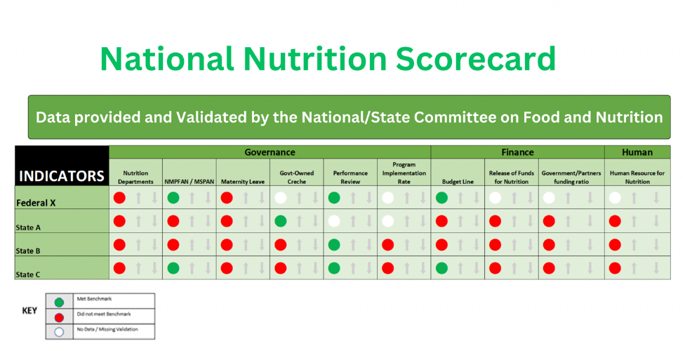

|  |
| --- |
| **Key Takeaways:** Before we break, take a minute to think of one or two things you learned that you’re going to take away from this session and how this new knowledge can apply to your work. |

# Session 4.6

## SCFNs’ Role in the Nutrition Information System

TIME TO COMPLETE: 15 MINUTES

**Instruction for facilitators:** The purpose of this session is to understand how the SCFN collects and reviews data, and integrates it in the DHIS2 and nutrition information system.

This session covers slides 202-203:

SLIDE 203: The nutrition information system will warehouse data coming from the six result areas of the NMPFAN. The SCFN should review the data available in the DHIS2 in preparation for their transfer to the nutrition information system, when operational.

The SCFN can review nutrition data in the DHIS2 on a quarterly basis during quarterly review meetings.

|  |
| --- |
| **Key Takeaways:** Before we break, take a minute to think of one or two things you learned that you’re going to take away from this session and how this new knowledge can apply to your work. |

# Session 4.7

## SCFN Quarterly Reporting

TIME TO COMPLETE: 30 MINUTES

**Instructions for the facilitator:** The purpose of this session is to understand how the SCFN reports on the progress of its activities.

The session covers slides 204-209:

SLIDE 205: The SCFN should refer to the annual Multi-Sectoral Nutrition Implementation Workplan and Budget and the Multi-Sectoral Nutrition M&E Framework from the MSNAP to report on quarterly progress toward each activity’s annual target. The SCFN should call on partners and MDAs to provide updates and data.

Timing and frequency: The SCFN should provide updates on activities planned for and completed during the quarter and activities anticipated for the upcoming quarter. Examples of the types of activities to be reported on under each section of the report are detailed in the next slide.

#### SLIDE 206-209: Examples of Activities to Be Reported on Under Each Section of the Report

* **Technical Guidance:** nutrition guidance provided by the SCFN to departments and partners, including capacity-strengthening activities and issues presented to the technical planning committee during the quarter and the resulting actions
* **Coordination and Partnerships with Nutrition Stakeholders:** the number of coordination meetings and joint activities conducted with stakeholders, detailing those involved and platforms used; results of stakeholder coordination efforts; and planned next steps
* **Planning, Budgeting, and Resource Mobilization:** efforts made to align MDA and partners’ plans with activities, challenges implementing plans, budgetary challenges, and resource mobilization activities
* **Monitoring and Reporting:** frequency and types of data provided to the SCFN by MDA and partners; descriptions of supervision activities undertaken; and actions taken because of monitoring, supervision, and reporting
* **Advocacy:** advocacy efforts undertaken by the SCFN during the quarter and actions taken by stakeholders because of advocacy efforts; the SCFN should refer to its advocacy implementation plan when completing this section
* **Additional comments:** describe overall SCFN achievements; nutrition innovations from community members, partners, or stakeholders; and any upcoming opportunities that the LGCFN hopes to pursue, and detail any support required from the national level to achieve these efforts.

|  |
| --- |
| **Key Takeaways:** Before we break, take a minute to think of one or two things you learned that you’re going to take away from this session and how this new knowledge can apply to your work. |

# Session 4.8

## LGCFN Monitoring and Supportive Supervision Checklist

TIME TO COMPLETE: 15 MINUTES

**Instructions for the facilitator:** The purpose of this session is to understand how SCFN are to monitor the implementation of nutrition activities at the LGA level, check on the functionality of the LGCFNs, identify gaps, and make recommendations to the LGA.

The session covers slides 210-213:

#### SLIDE 211: LGCFN Monitoring and Supervision Checklist

The SCFN has the mandate to coordinate multi-sectoral nutrition efforts at the LGA level, including monitoring and supportive supervision of the LGCFN. The Monitoring and Supportive Supervision Checklist was developed to support this task. The tool can be used by the SCFN to monitor the implementation of nutrition activities at the LGA level, check on the functionality of the LGCFN, identify gaps, and make recommendations to the LGA. The tool is included in Annex 11.

* The questions in the tool seek to gather information about key aspects of nutrition governance. This includes LGCFN composition and the thematic areas that make up the LGCFN’s core roles and responsibilities.
* Responses to the questions will be gathered during group discussions held with LGCFN members. LGCFN members should come from the following core departments, among others: administration and planning, community development, education, health, and water and sanitation. Participation of the LGCFN chairperson and secretary should be ensured because they are key LGCFN informants.

|  |
| --- |
| **Key Takeaways:** Before we break, take a minute to think of one or two things you learned that you’re going to take away from this session and how this new knowledge can apply to your work. |
| As we close this unit, take a few minutes to write you personal reflections in your handbook, see the prompts. If you only have time for one question, ask yourself, “When I go back to your state or LGA and share what I’ve learned in this unit, how will I teach new SCFN members about this process? |

# UNIT 5

## Action Plan to Operationalize Nutrition Coordination Committees

TIME TO COMPLETE: 1 hour 15 MINUTES

**Instructions for the facilitator**: The purpose of this unit is to explain and discuss the SCFN Action Planning and capacity assessment processes.

Objectives:

* Provide an overview of organizational assessment tools and processes.
* Demonstrate how to develop an action plan.
* Demonstrate how to operationalize the OCAT and Action Planning processes.

This unit covers slides 214-238:

* Session 5.1: SCFN Action Planning slides 216-224
* Session 5.2: OCAT Tool and Process slides 225-236

# Session 5.1

## SCFN Action Planning

TIME TO COMPLETE: 30 MINUTES

**Instructions for the facilitator:** The purpose of this session is to understand the Action Planning and annual budgeting processes and IS NOT to create the nutrition coordination committee’s Multi-Sectoral Nutrition Action Plan.

This session covers slides 216-224:

Note that the template for the Action Plan is provided in Annex 13. Copies of this template should be provided to participants.

#### SLIDE 217: SCFN Action Planning

As discussed in Unit 2, the SCFN Annual Budget Implementation and Tracking Subcommittee is responsible for—

* reviewing annual SCFN budget contributions for multi-sectoral nutrition interventions
* reviewing annual LGCFN/LGA budget contributions for multi-sectoral nutrition interventions.

#### SLIDE 218: SCFN Action Planning (Cont’d.)

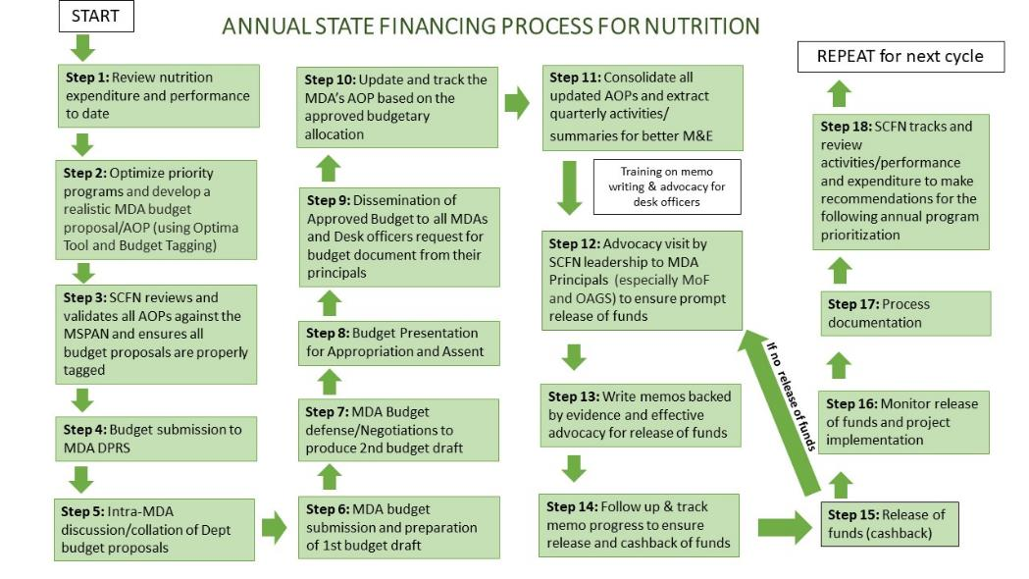

#### SLIDE 219: SCFN Action Planning (Cont’d.)

### Conduct capacity building training on the budget cycle and advocacy:

* Step 1: review the current year’s nutrition budget (expenditure and performance)—at MDA level by the desk officer.
* Step 2: each MDA conducts optimization of priority nutrition programs using the MSNAP and develops its nutrition budget proposal/annual operational plan (AOP)—at MDA level by the desk officer.
* Step 3: SCFN conducts meeting to review and validate all AOPs against the MSNAP—at state level by the SCFN.
* Step 4: nutrition budget proposal is submitted to MDA budget office/DPRS, backed by internal advocacy to MDA principal officers—at MDA level by the desk officer.

#### SLIDE 220]: SCFN Action Planning (Cont’d.)

### Conduct capacity building training on the budget cycle and advocacy:

* Step 5: intra-MDA discussion and collation of departmental budget proposals are conducted—at MDA level by MDA principal officers.
* Step 6: MDA budget is submitted and first budget draft is prepared—at state level by the MDA and Ministry of Budget and Economic Planning.
* Step 7: MDA budget defense/negotiations/bilateral discussions to produce second budget draft are conducted—at state level by the MDA, Ministry of Budget and Economic Planning, and State Executive Council.
* Step 8: budget is presented for appropriation and assent—at state level by the executive council and state houses of assembly.
* Step 9: disseminate approved budget to all MDAs and within MDAs—at state and MDA levels by the Ministry of Budget and Economic Planning and MDA principal officers, respectively.

#### SLIDE 221: SCFN Action Planning (Cont’d.)

### This process marks the beginning of a new year (January):

* Step 10: update the MDA’s AOP based on the approved budgetary allocation—at MDA level by the desk officer.
* Step 11: consolidate all updated AOPs and extract quarterly activities and summaries for better M&E—at state level by the SCFN.

#### SLIDE 222: SCFN Action Planning (Cont’d.)

### Capacity building on memo writing and advocacy occurs:

* Step 12: SCFN leadership conducts advocacy visit to MDA principals (especially MoF and OAGS) to ensure prompt release of funds for implementation—at state level by the SCFN.
* Step 13: write memos backed by evidence and effective advocacy for release of funds—at MDA level by the desk officer.
* Step 14: follow up and track memo progress to ensure release and cashback of funds—at MDA and state levels by the desk officer and MDA principal officer, respectively.
* Step 15: cashback of funds occurs.

#### SLIDE 223: SCFN Action Planning (Cont’d.)

### In case there’s no cashback, refer to step 13:

* Step 16: monitor release of funds and project implementation—at MDA and state levels by the MDA M&E and Ministry of Budget and Economic Planning, respectively.
* Step 17: processes are documented—at MDA level by the desk officer.
* Step 18: SCFN reviews performance and expenditure to make recommendations for the following fiscal year.

This process occurs annually and is mandated by the Government of Nigeria as part of the fiscal year budgeting process.

|  |
| --- |
| **Key Takeaways:** Before we break, take a minute to think of one or two things you learned that you’re going to take away from this session and how this new knowledge can apply to your work. |

# Session 5.2

## OCAT Tool and Process

TIME TO COMPLETE: 45 MINUTES

**Instructions for the facilitator:** The purpose of this session is to introduce the SCFN to a capacity assessment called the OCAT, which will help the SCFN identify areas of strength and areas that need improvement. It will inform an action planning process to map activities to improve areas identified by the OCAT.

This session covers slides 225-236#–#:

* Objectives of the OCAT slides 227-228
* Description of the OCAT slides 229-230
* The OCAT Process slide 231
* Selection of Participants slide 232
* Before the Workshop slide 233
* OCAT Facilitators slide 234
* OCAT Workshop slide 235
* OCAT Scores slide 236

#### SLIDE 226: OCAT and Process

An organizational capacity assessment can be done annually (or more or less frequently) to track progress from the prior year. The OCAT is strictly for capacity strengthening purposes and is outside regular FMOH and FMFBNP reporting. It can be used to check on areas of strength and areas that need improvement. It is closely linked to the Action Planning process, which can improve areas identified by the OCAT.

### Objectives of the OCAT

#### SLIDE 227-228: Objectives of the OCAT

* The OCAT, revised by United States Agency for International Development (USAID) Advancing Nutrition,[1] is a self-assessment tool used to draw insights from an SCFN’s leadership and members to qualitatively diagnose the SCFN’s planning, budgeting, oversight, and organizational capacity and competency to implement state nutrition policies and programs.
* Findings from the assessment can be used to identify areas where gaps exist and to produce an action plan for addressing them.
* The tool will help the SCFN prioritize where it should focus its improvement efforts, decide on responsibilities and time frames, and know when to request possible technical assistance.
* Specifically, the OCAT results will be used to—
  + inform the development of capacity-building plans by identifying specific areas that should be prioritized
  + demonstrate progress in building the SCFN’s capacity.

### Description of the OCAT

#### SLIDE 229-230: Description of the OCAT

* The OCAT is a semi-quantitative assessment tool. It can provide a good understanding of an organization’s capacity across all necessary functions (i.e., highlight the key strengths and weaknesses).
* One of its advantages is that it serves as a learning tool and an assessment tool when applied as a self-assessment, giving respondents a concrete image of higher levels of capacity to strive for and a deeper understanding of one another’s views of the organization’s capacity.
* The OCAT is semi-quantitative because indicators are scored on a five-point Likert scale but some indicators also allow for qualitative responses.
* By providing a specific description of capacity for each possible score on the scale for each indicator, the tool reduces the subjectivity associated with traditional tools, which ask respondents to rate indicators on a scale that uses vague terms such as “weak” and “strong.” It increases reliability and decreases variability among participants. However, the descriptions are considered only a guide.

SLIDE [230]: The OCAT tool assesses six capacity areas:

* institutional context
* structure and functions
* gender equality and social inclusion
* finance and operations
* monitoring, evaluation, and learning
* state and LGA offices.

SLIDE [230]: Under each capacity area, several indicators are listed in the form of questions. For each indicator, five stages of progress are defined:

* low capacity/no attainment
* minimal capacity/start of formal activity
* adequate capacity/some progress shown
* good capacity/ good progress shown
* excellent capacity/complete attainment.

|  |
| --- |
| **Facilitator Discussion Question:** |
| Overall, how does your SCFN score? Which level do you feel best describes your capacity for that indicator at the time? Note that note every word of the description will fit your SCFN, so choose a score based on the essence of the level ? |

### The OCAT Process

#### SLIDE 231: The OCAT Process

The OCAT is to be filled out in a participatory setting with the relevant leaders and members of the SCFN. An external facilitator will guide the group discussion of each question and enter the responses that the group agrees on. In case of disagreement, lack of consensus, or non-applicability of the question, the facilitator can leave the response blank and note the reason in the comments section.

### Selection of Participants

#### SLIDE 232: Selection of Participants

* Before the assessment, the SCFN will determine which committee members will participate in the scoring and discussions for each capacity area.
* There should be a balance of committee leaders and committee members to the extent possible.
* If the SCFN has LGA offices, it may consider including some representatives from the LGA in some or all scoring groups.
* Note that for some capacity areas, not everyone in the room is familiar with all functions that they will be scoring.

### Before the Workshop

#### SLIDE 233: Before the Workshop

* A few days before the start of the workshop, all scorers will be provided with hard and soft copies of the OCAT and an Excel-based scoring template.
* Scorers should review the capacity areas that they will be scoring and discussing and begin thinking about the stage of progress that they believe the organization is at the time for each indicator (i.e., the score they would select).
* They should come to the first day of the workshop with any questions or clarifications that they want on the indicators.

### OCAT Facilitators

#### SLIDE 234: OCAT Facilitators

* An external facilitator who has been trained in conducting OCAT assessments will facilitate the OCAT workshop.
* Partner staff may support the facilitators during the workshop sessions and will participate in the analysis of scores and the development of capacity-building plans.

### OCAT Workshop

#### SLIDE 235: OCAT Workshop

* The day will be divided into scoring sessions, with one capacity area being scored in each session, as mentioned above (see Selection of Participants).
* In each scoring session, the facilitators introduce one capacity area at a time, review the questions to enable proper understanding, and allow a discussion aimed at establishing a mutual understanding among the participants of the SCFN’s processes surrounding the indicators and an agreement on the SCFN score.
* Note that this discussion is critical to the OCAT process and should be allowed to continue. It is often the most important part of the OCAT.
  + If the group is small, one tool can be used with a recorder assigned.
  + The process is repeated for each capacity area being scored by that group.

### OCAT Scores

#### SLIDE 236: OCAT Scores

OCAT scores are compiled in an automated table that produces summary tables with a composite score for each capacity area. The facilitators analyze the scores to identify capacity areas and indicators with significantly disparate scores and identify areas of relative strengths versus the need for capacity development.

|  |
| --- |
| **Key Takeaways:** Before we break, take a minute to think of one or two things you learned that you’re going to take away from this session and how this new knowledge can apply to your work. |
| As we close this unit, take a few minutes to write you personal reflections in your handbook, see the prompts. If you only have time for one question, ask yourself, “When I go back to your state or LGA and share what I’ve learned in this unit, how will I teach new SCFN members about this process? |

# Unit 6

## Gender and Equity

TIME TO COMPLETE: 2 HOURS 15 MINUTES

**Instructions for the facilitator:** The purpose of this unit is to explain and discuss the SCFN Action Planning and capacity assessment processes.

Objectives:

* Understand general gender concepts and understand how gender affects nutrition and health outcomes.
* Identify differences between men and women’s roles and status in the community.
* Discuss adapting SCFN activities to be more gender equitable and promote women’s empowerment.

Sessions: This unit covers SLIDES 239-279

* Session 6.1: Key Concepts, Terms, and Definitions
* Session 6.2: Gender and Equity Domains
* Session 6.3: Gender and Equity Action Planning for Multi-Sectoral Nutrition plans

# Session 6.1

## Key Concepts, Terms, and Definitions

TIME TO COMPLETE: 60 MINUTES

**Instructions for the facilitator:** The purpose of this unit is to provide an overview and discuss how to incorporate gender and equity into SCFN, implementation, Action Planning, and capacity assessment processes.

This session covers slides 241-258:

#### SLIDE 242: Introductory Questions

What is your experience with gender equality, either personally or through programming? What do you hope to learn here?

#### SLIDE 243: Group Exercise: Values Clarification

Everyone stand in the middle of the room. The facilitator will read aloud a statement. Step to the right if you agree. Step to the left if you disagree. The facilitator will ask a few people to explain their answer. Everyone step back to the middle.

|  |
| --- |
| Group Exercise: Values Clarification |
| **Instructions:**   * Stand in the middle of the room. * The facilitator will read aloud a statement.   Statements for the facilitator to read aloud: The facilitator can select five statements from the following.   * A woman’s place is in the home. * The most important thing a woman can do is have babies and care for them. * A man is only valued for his ability to make money and provide for his family. * A man is more of a man once he has fathered a child. * In today’s world, a boy child is more valued than a girl child. * A woman can do any kind of work a man can do. * It is common for a man to watch the children and cook. * It is easier to be a man than a woman in today’s world. * Men sometimes have a good reason to use violence against their partners. * Brothers (or husbands) deserve more respect than sisters (or wives) simply because they are boys. * Step to the right if you agree. * Step to the left if you disagree. * The facilitator will ask a few people to explain their answer. Everyone step back to the middle.   TIME TO COMPLETE: 15 MINUTES |
| Once completed, let’s gather as a group to reflect on the exercise:  Even though we may be familiar with gender equality concepts, some questions are still difficult for us to answer. Our own experience with and beliefs on gender can affect how we view and understand our projects, programs, and participants. We need to keep this in mind as we ask fellow staff, partners, and project beneficiaries to discuss gender issues. |

#### SLIDE 244: Group Exercise: Reflection

Even though we may be familiar with gender equality concepts, some questions are still difficult for us to answer. Our own experience with and beliefs on gender can affect how we view and understand our projects, programs, and participants. We need to keep this in mind as we ask fellow staff, partners, and project beneficiaries to discuss gender issues.

|  |
| --- |
| Let’s look at some key definitions. These terms are the foundation for some of our most basic concepts and frameworks, and they are important to use with precision. This is not an exhaustive list; it is intended only to give SCFN members more background for their work. |

#### SLIDE 245: Sex

Refers to the biological differences between males and female. Sex is typically assigned at birth (male/female).

First, let’s review the difference between “sex” and “gender.” This may be review for some of you, but it is important that we are all on the same page. **SEX** refers to the biological state of being a male or female. Another definition: Sex is the biological characteristics that define men and women (DFID 2008).

#### SLIDE 246: Gender

Describes what it means to be a man or woman, based on culture, beliefs, attitudes, and norms.

Each place and culture has a different understanding of what it means to be a “real man” or “real woman.”

**GENDER** refers to the culturally-defined aspects of being a woman or a man.

Men and women are expected to behave in certain ways, and those expectations differ across cultures. Think about what it means to be a “real man” or a “real woman.” These are gender-related roles and responsibilities. How we define a man and woman changes over time and by part of the world.

Gender roles have very real effects on men and women’s access to education and economic opportunities; decision-making power; services; and the health and well-being of boys and girls and men and women.

**Another definition:** Gender is the socially defined roles, behaviors, activities, and attributes that differ between countries and cultures (DFID 2008).

#### SLIDE 247: Gender and Nutrition

Globally, women are twice as likely to be malnourished than men. Women are more likely to experience food insecurity than men. Girls are more likely to be wasted, stunted, and overweight than boys of the same age group.

#### SLIDE 248: Gender-Sensitive Programming

Gender-sensitive programming takes into consideration the differences and inequalities between women and men [and girls and boys] (DFID 2008). It considers and raises awareness on the socially constructed roles, behaviors, activities, and attributes that society considers appropriate for each and their related dynamics (UNICEF 2018).

#### SLIDE 249: Gender-Responsive Programming

Gender-responsive programming goes one step further and not only considers gender norms, roles, and inequalities but also ensures measures are taken to actively reduce their harmful effects (WHO 2011). Gender-sensitive efforts need to include gender-responsive actions to achieve gender equality and transform gender relationships and power structures (UNICEF 2018).

#### SLIDE 250: Gender-Transformative Programming

Gender-transformative programming is the highest level of gender-responsive programming.

It considers gender norms, roles, and inequalities for men and women, as well as the specific needs of men and women (and girls and boys) and how all these affect access to and control over resources.

It also addresses the causes of gender-based inequities, including ways to transform harmful gender norms, roles, and relations and strategies to foster progressive changes in power relationships between men and women (WHO 2011).

#### SLIDE 251: Gender-Transformative Programming (Cont’d.)

Gender-transformative programming is the highest level of gender-responsive programming. It considers gender norms, roles, and inequalities for men and women, as well as the specific needs of men and women (and girls and boys) and how all these affect access to and control over resources. It also addresses the causes of gender-based inequities, including ways to transform harmful gender norms, roles, and relations and strategies to foster progressive changes in power relationships between men and women (WHO 2011).

#### SLIDE 252: Gender Equity

Equality refers to equal chances and opportunities for women and men (or girls and boys) to access and control social, economic, and political resources, including protection under the law. Simply, when men and women enjoy equal freedom, liberties, and well-being.

Gender equality is what we hope to achieve—one day women, men, boys, and girls will all have completely equal access, freedom, and liberties in society. When this happens, we will not see that women and girls are more likely to be malnourished then men and boys. We will see equal opportunity to health and well-being for all!

#### SLIDE 253: Gender Equity (Cont’d.)

Equity refers to fairness and considers women’s and men’s (and boys’ and girls’) different needs to achieve gender equality (WHO 2011). Simply, the process of being fair to men and women.

Gender equity means that we give women and girls “a fair shot” at health, nutrition, and all other aspects of life. **We do not treat everyone the same, regardless of women or men—instead we give everyone a fair opportunity to participate in or lead our programs and activities.** We may need to do more to help women and girls participate and benefit from our programs given the other disadvantages they face.

#### SLIDE 254: Empowerment

Empowering women (or men) to make decisions about their own health, nutrition, and life overall.

Facilitator can check for questions and see if definitions are well understood. More details on definitions below (to help clarify only).

**Empowerment:** Improving people’s status to enhance their decision-making capacity at all levels, especially as it relates to sexuality and reproductive health.

#### SLIDE 255: Male Engagement

When men and boys are involved and support women and children’s well-being (e.g., caregiving, fatherhood, domestic labor).

**Male engagement:** Involves men in promoting gender equity in caregiving, fatherhood, and other forms of domestic labor; increases men’s support for women’s reproductive health and children’s well-being; and advances the reproductive health of both men and women.

#### SLIDE 256: Gender-Based Violence

Violence directed at people based on their biological sex, gender identity, or culturally-defined expectations of being a woman, man, girl or boy.

**Gender-based violence (GBV):** Violence directed at people based on their biological sex, gender identity, or culturally-defined expectations of being a woman, man, girl, or boy. It includes physical, sexual, and psychological abuse, threats, and coercion. GBV occurs throughout the life cycle. GBV includes female infanticide, early and forced marriage, “honor” killings, female genital cutting, child sexual abuse and exploitation, trafficking, sexual coercion, harassment,abuse, neglect, domestic violence, and elder abuse.

#### SLIDE 257: Group Exercise: What did you learn Q&A

Do you remember the difference between “sex” and “gender”? Let’s see!

The facilitator will read aloud a statement. If you think this statement refers to a person’s sex, then stand up! If you think this statement refers to a person’s gender, then stay seated. The facilitator will read the correct answer, address any questions, then continue to the next statement.

|  |
| --- |
| Group Exercise: What did you learn Q&A |
| Do you remember the difference between “sex” and “gender”? Let’s see!  NOTE TO FACILITATOR: DON’T READ THE ANSWER UNTIL EVERYONE VOTED.   * Women give birth to children, men do not. Answer: Sex * Girls are gentle; boys are tough. Answer: Gender * Women are able to provide nutrients to their babies through breast milk. Answer: Sex * Men are more often smokers than women. Answer: Gender * Women are more likely to look after chickens and goats, while men look after cattle and other large livestock. Answer: Gender * When women marry, they often move to their husband’s family’s house. Answer: Gender * Men grow beards, women do not. Answer: Sex * Women are usually responsible for feeding and cleaning children, and men are not. Answer: Gender * Nutrition counseling is for women to attend. Answer: Gender   Instructions:   * The facilitator will read aloud a statement. * If you think this statement refers to a person’s gender, then stay seated.   TIME TO COMPLETE: 15 MINUTES |
| Once completed, let’s gather as a group to reflect on the exercise:  We may have assumptions about work, tasks, or certain foods for men, women, boys, and girls. But as we learned earlier, beliefs around what is “right” for each gender can change over time. In our work, we can examine whether certain gender-related beliefs, attitudes, and norms are harmful or helpful to good nutrition and health. We can then work with community members, religious leaders, and authority figures to support helpful gender norms and shift harmful ones. |

|  |
| --- |
| **Key Takeaways:** Before we break, take a minute to think of one or two things you learned that you’re going to take away from this session and how this new knowledge can apply to your work. |

# Session 6.2

## Gender and Equity Domains

TIME TO COMPLETE: 30 MINUTES

**Instructions for the facilitator:** The purpose of this unit is to provide an overview and discuss how to incorporate gender and equity into SCFN, implementation, Action Planning, and capacity assessment processes.

This session covers slides SLIDE 259-263:

|  |
| --- |
| Group Exercise: How do tasks get assigned? |
| **Instructions:**   * Brainstorm a list of task for about 10 minutes. * Circle the tasks usually done by a woman or girl. * Underline the tasks usually done by a man or boy. * Circle and underline the tasks done by women or men.   The facilitator will ask groups a few questions about their answers.  TIME TO COMPLETE: 15 MINUTES |
| Once completed, let’s gather as a group to reflect on the exercise:  Men and women, boys and girls do not always have equal division of tasks. Some activities take a lot of time, and some require a lot of energy. Women and girls’ tasks at home, on the farm, and in the community may limit their time for ensuring their own good health and nutrition, and the good health and nutrition of their children. |

### Gender-Transformative Program/Activities

* Challenge harmful gender norms, roles, and dynamics.
* Recognize and strengthen supportive gender norms.
* Promote relative position of women, girls, and marginalized groups.
* Change social structures, policies, and norms that allow gender inequality to continue.
* Do No Harm—under no circumstance should the projects or activities take advantage of gender inequalities and stereotypes or worsen gender inequalities.

The facilitator will divide participants into three groups. Each group will receive a piece of paper.

Each group will write down **daily activities about nutrition or food** that occur in the home, on the farm, or in the community. Group 1 will write down daily activities **in the home**. Group 2 will write down daily activities **on the farm**. Group 3 will write down daily activities **in the community**. Groups have 15 minutes to write down answers. After groups decide whether tasks are completed by women or men, the facilitator will ask the group the following questions:

* Who is responsible for most of the nutrition/food-related activities?
* Which activities are the most physically demanding?
* Which activities take up a lot of time during the day?
* Is there a difference in who does the activity based on age?
* Which activities generate income for the family?
* How do you think the division of tasks between men and women affects their energy? Time for child care and feeding? Time for rest and recovery?

#### SLIDE 261: Group Exercise: Reflections

Men and women, boys and girls do not always have equal division of tasks. Some activities take a lot of time, and some require a lot of energy. Women and girls’ tasks at home, on the farm, and in the community may limit their time for ensuring their own good health and nutrition, and the good health and nutrition of their children.

*How can you use what your learned in this activity in your work?*

#### SLIDE 262: Gender-Transformative Program/Activities

Here are four principles to consider when designing gender-transformative policies and programs:

1. Challenge harmful gender norms, roles, and dynamics.
2. Recognize and strengthen supportive gender norms.
3. Promote relative position of women, girls, and marginalized groups.
4. Change social structures, policies, and norms that allow gender inequality to continue.

Our nutrition programs have an opportunity to improve gender equality by adopting these approaches. As a project and a team, it is important to be explicit and intentional about our gender-transformative approaches.

#### SLIDE 263: Do No Harm

Under no circumstances should the projects or activities take advantage of gender inequalities and stereotypes. Under no circumstances should the project or activities worsen gender inequalities.

**Under no circumstances should projects or activities adopt an exploitative approach,** because one of the fundamental principles of development is to “do no harm.”

|  |
| --- |
| **Key Takeaways:** Before we break, take a minute to think of one or two things you learned that you’re going to take away from this session and how this new knowledge can apply to your work. |

# Session 6.3

## Gender and Equity Action Planning for Multi-Sectoral Nutrition Plans

TIME TO COMPLETE: 45 MINUTES

**Instructions for the facilitator:** The purpose of this unit is to provide an overview and discuss how to incorporate gender and equity into SCFN, implementation, Action Planning, and capacity assessment processes.

This session covers slides SLIDE 264-279:

#### SLIDE 265: Why Consider Gender in Nutrition Action Plans?

Socially constructed gender roles can lead to unequal access to and control of education, resources, information, income, and political forums, which can reduce a household’s ability to provide sufficient food, care, and health care to all its members. Considering gender in national-level policies and programs can support actions that will eliminate barriers to maximum nutrition improvement.

Socially constructed gender roles of men, women, boys, and girls, in conjunction with biological differences in sex and age, influence nutritional needs and status of individuals, households, communities, and societies. Inequalities in decision-making and autonomy, especially for women, can lead to unequal access to and control of education, resources, information, income, and political forums, which can negatively affect a household’s ability to provide sufficient food, care, and health care to all its members. Integrating gender considerations into national-level policies and programs can support actions that will eliminate key barriers to maximum nutrition improvement, to advance the attainment of the Sustainable Development Goals.

#### SLIDE 266: Why Consider Gender in Nutrition Action Plans? (Cont’d.)

By integrating gender into nutrition planning, the SCFN can—

* contextually understand the differences that exist between men and women and boys and girls and what cultural, societal, and infrastructural factors contribute to existing inequalities
* develop the appropriate actions to improve household food security and consumption of diverse, nutritious foods of all household members.

|  |  |
| --- | --- |
| Group Exercise: How can we promote gender and equity and women’s empowerment in our activities? | |
| **Instructions:**   * Brainstorm a list of existing SFCN activities. * Discuss how you can adapt them to be more gender-sensitive and equitable. * Use the table below and present to the group when finished. | |
| SCFN Activity | Adaptations to Promote Gender Equity and Women’s Empowerment |
| 1. |  |
| 2. |  |
| 3. |  |
| 4. |  |
| The facilitator will ask groups a few questions about their proposals.  Once completed, let’s gather as a group to reflect on the exercise.  TIME TO COMPLETE: 15 MINUTES | |

#### SLIDE 269: Gender-Transformative Approaches

* Strengthen family support for nutrition of pregnant and lactating women.
* Nurture shared family responsibility and care for women with shared household tasks.
* Support “harmonious households” for improved communication between couples.
* Facilitate collective action on traditional gender roles and social norms for greater gender equality.
* Engage families to empower adolescent girls for improved nutrition and health.
* Support and empower women leaders in the community.

|  |
| --- |
| The facilitator can review participants’ ideas for how to adapt project activities and connect them to the Transform Nutrition Gender Action Plan. The Gender Action Plan was created this year, based on interviews with community members. The gender action plan has the following gender-transformative approaches. Do they match what participants suggested today? How are they the same? How are they different? |

#### SLIDE 270: Developing and Reviewing Nutrition Plans through a Gender Lens

* Guidance from the SUN Movement
* A core aim of SUN was to ensure equity, equality, and nondiscrimination for all, with women and girls at the center of efforts.
* The following slides are adapted for implementation on the Maximising the Quality of Scaling Up Nutrition Plus national nutrition plan gender assessment tool.

#### SLIDE 271: Integrating Gender into Situational Analysis

Information in the situational analysis includes—

* sex-disaggregated data by key age groups (e.g., children under age five and adolescents) for both nutrition-specific and nutrition-sensitive indicators.

|  |
| --- |
| **Facilitator Discussion Question:** When reviewing a multi-sectoral nutrition plan, ask: Does the situational analysis include sex-disaggregated data for key nutrition-specific and nutrition-sensitive indicators? |

#### SLIDE 272: Integrating Gender into Situational Analysis (Cont’d.)

The situational analysis includes—

* gender-related analysis beyond data disaggregation alone, particularly discussion around gender norms, roles, and relations and how this may influence nutrition (e.g., the typical role of men and women, the influence of gender roles on time, decision-making).

|  |
| --- |
| **Facilitator Discussion Question:** When reviewing a multi-sectoral nutrition plan, ask: Does the situational analysis include discussion of the gender dimensions of nutrition beyond data disaggregation alone? |

#### SLIDE 273: Integrating Gender into Stakeholder Planning

The planned actions include—

* incorporating the gender dimensions of nutrition based on the needs identified in the situational analysis (e.g., actions that promote women’s decision-making, girls’ education, male involvement or activities targeting men).

|  |
| --- |
| **Facilitator Discussion Question:** When reviewing a multi-sectoral nutrition plan, ask: Does the plan contain actions that incorporate gender dimensions of nutrition? |

*When reviewing a multi-sectoral nutrition plan, ask: Does the plan contain actions that incorporate gender dimensions of nutrition?*

#### SLIDE 274: Integrating Gender into Stakeholder Planning (Cont’d.)

The plan development actions include—

* consulting stakeholders and groups with gender expertise (e.g., Ministry of Women’s Affairs, women’s rights org, gender divisions in the United Nations)
* also mentions how stakeholders and groups with gender expertise were included or consulted.

|  |
| --- |
| When reviewing a multi-sectoral nutrition plan, ask: Does the plan reference if/how stakeholders with gender expertise were consulted and included in the plan development process? |

#### SLIDE 275: Integrating Gender into Capacity Strengthening/Assessments

The capacity assessment includes—

* discussion of the unique needs of men and women and potential barriers to participation
* measures to encourage active participation of both men and women
* integration of gender discussions into capacity-building efforts to address gaps in knowledge and action.

|  |
| --- |
| When reviewing a multi-sectoral nutrition plan, ask: Do the capacity assessment and planned capacity-building actions consider and address the unique needs of men and women? |

#### SLIDE 276: Integrating Gender into M&E

The M&E plan includes—

* gender consideration in how progress will be measured, analyzed, and reported
* gender equality indicators to assess power dynamics, empowerment, gender norms, resource control, GBV, employment, household decision-making, and women’s status
* gender-sensitive indicators, such as quantitative measures disaggregated by sex, age to assess outcome differences.

|  |
| --- |
| When reviewing a multi-sectoral nutrition plan, ask: Does the M&E framework include gender equality indicators or gender-sensitive indicators? |

#### SLIDE [277]: Integrating Gender into M&E (Cont’d)

The M&E framework (data collection or analysis plan) includes—

* disaggregation of data by sex and age to evaluate equity of the plan with respect to women, men, girls, and boys
* discussion around addressing data gaps where sex-disaggregated data are not currently available
* an analysis plan that includes the use of sex-disaggregated data to inform decision-making.

|  |
| --- |
| When reviewing a multi-sectoral nutrition plan, ask: Does the M&E plan include planned collection/disaggregation of relevant data by sex and age, how data gaps will be addressed and analysis of disaggregated data to inform decision-making? |

#### SLIDE 278: Discussion: Key Takeaways

|  |
| --- |
| Take a minute to think of one or two things you will take away from this session. How will this new knowledge apply to your work? |
| Ask for any final questions from group, encourage discussion |

|  |
| --- |
| **Key Takeaways:** Before we break, take a minute to think of one or two things you learned that you’re going to take away from this session and how this new knowledge can apply to your work. |

|  |
| --- |
| As we close this unit, take a few minutes to write you personal reflections in your handbook, see the prompts. If you only have time for one question, ask yourself, “When I go back to your state or LGA and share what I’ve learned in this unit, how will I teach new SCFN members about this process? |

# Closing Session

TIME TO COMPLETE: 30 MINUTES

Objective for This Session

* Facilitators close the orientation, debrief on lessons, and solicit feedback for improvement.
* Complete post-training assessment (see Annex 2).
* Complete orientation evaluation.

Group Discussion

* What did you learn?
* How did this orientation meet your expectations?
* What questions came up during the orientation?
* What will you bring back to your SCFN and how will you transfer this knowledge to new SCFN members?

|  |
| --- |
| Group Exercise: Final reflections |
| Gather as a group to reflect on the exercise:   * What did you learn? * How did this orientation meet your expectations? * What questions came up during the orientation? * What will you bring back to your SCFN and how will you transfer this knowledge to new SCFN members?   The facilitator will ask a few questions about participants’ answers. |

# Annexes

**Annex 1:** List of Contributors

**Annex 2:** Sample Four-day Agenda

**Annex 3:** Pre- and Post-training Assessment

**Annex 4:** Glossary of Terms

**Annex 5:** Problems/Gaps Associated with Food System/Security and Likely Solutions

**Annex 6:** Sample OCAT Tool/Assessment

**Annex 7:** SCFN Quarterly Reporting Template (summary table)

**Annex 8:** SCFN Quarterly Reporting Template

**Annex 9**: National Nutrition Scorecard

**Annex 10:** Sample SCFN Appointment Letter

**Annex 11:** Monitoring and Supportive Supervision Checklist

**Annex 12:** National/State Multi-Sectoral Plan of Action for Food and Nutrition Implementation M&E Tool/Checklist

**Annex 13:** References

# 

## Annex 1

### List of Contributors

|  |  |  |
| --- | --- | --- |
| **LIST OF PARTICIPANTS AT THE SCFN ORIENTATION PACKAGE DEVELOPMENT WORKSHOP (February 1–3, 2023 Lagos)** | | |
| **S/N** | NAMES | ORGANIZATION |
| 1 | Joel Aiki | Kebbi State Ministry of Agriculture (Kebbi SCFN Member) |
| 2 | Dr. Yusuf A. Bashir | Federal University Birnin Kebbi (Kebbi SCFN Member) |
| 3 | Idris Saleh Giade | Bauchi State Ministry of Budget & Economic Planning (Bauchi SCFN Member) |
| 4 | Mahmood Bala Umar | Bauchi State Ministry of Agriculture (Bauchi SCFN Member) |
| 5 | Oluwatosin Abayomi | Office of the vice President |
| 6 | Chidinma Ezenwa | Nigerian Governors Forum |
| 7 | Unah Nnenna Alice | Ebonyi State Ministry of Budget and Planning (Ebonyi SCFN Member) |
| 8 | Nwankwo Ifeoma | Ebonyi State Primary Health Care Development Agency |
| 9 | Henrietta Ugwu | Enugu SCFN |
| 10 | Mr. Yehuza Abdullahi | Niger SCFN |
| 11 | Linda Yakubu | Kaduna SCFN |
| 12 | Olubunmi Braheem | Lagos SCFN |
| 13 | Clementina Okoro | FCT Primary Health Care Development Board |
| 14 | Adekunle Folashade | Office of the vice President |
| 15 | Chukuma Anene | USAID Advancing Nutrition |
| 16 | Stantley U.Nwosu | USAID Advancing Nutrition |
| 17 | Hadiza Joy Marcus | USAID Advancing Nutrition |
| 18 | Zainab Sauri Omiunu | USAID Advancing Nutrition |
| 19 | Grace Matu | USAID Advancing Nutrition |
| 20 | Dahiru Mohammed Bello | Sokoto State Primary Health Care Development Agency |
| 21 | Ijanada Aliyu Jacob | USAID Advancing Nutrition |
| 22 | Umar Sulaiman | USAID Advancing Nutrition |
| 23 | Augustine Ajijelek | USAID Advancing Nutrition |
| 24 | Prof Kola Anigo | Lead Capacity Strengthening Consultant |
| 25 | Livinus Ibiang | Lead Capacity Strengthening Consultant |
| 26 | Ishola Jonathan Adekunle | Civil Society Scaling Up Nutrition in Nigeria (CS-SUNN) |
| 27 | Adeoluwa Adegbemile | Nigerian Governors Forum |
|  |  |  |
| **LIST OF PARTICIPANTS AT THE SCFN ORIENTATION PACKAGE DEVELOPMENT WORKSHOP (September 2022—Abuja)** | | |
| **S/N** | NAMES | ORGANIZATION |
| 1 | Mohammed Sani Umar | NHHCA |
| 2 | Mr. Joel AIKI | Kebbi State Ministry of Agriculture |
| 3 | Idris Saleh Giade | Bauchi Ministry of Budget and Economic Planning |
| 4 | Yakubu Jibrin Abdullahi | Ministry of Agriculture |
| 5 | Mahmood Bala Umar | State Ministry of Agriculture Bauchi |
| 6 | Abubakar Saleh | Bauchi State Primary Health Care Development Agency |
| 7 | Usman Umar Muhammad | Bauchi Ministry of Budget and Economic Planning |
| 8 | Michael Daniel Eveshoyan | USAID Advancing Nutrition |
| 9 | Ibrahim Bashir Ibrahim | USAID Advancing Nutrition |
| 10 | Israel Odiba | USAID Advancing Nutrition |
| 11 | Olugbodi Toluwalope | USAID Advancing Nutrition |
| 12 | Dr Yusuf A. Bashir | Federal University Birnin Kebbi |
| 13 | Abdulmalik Muhammad | Kebbi State Primary Health Care Development Agency |
| 14 | Shuaibu Am. Bankanu | Ministry of Agriculture Sokoto |
| 15 | Usman Arzika | Ministry of Budget and Economic Planning, Sokoto |
| 16 | Sean Maher | JSI |
| 17 | Zainab L. Tumaki | Ministry of Budget and Economic Planning, Sokoto |
| 18 | Umar Sulaiman | USAID Advancing Nutrition |
| 19 | Dr Abubakar A. Kaoje | Kebbi State Primary Health Care Development Agency |
| 20 | Hadiza Joy Marcus | USAID Advancing Nutrition |
| 21 | Adedayo Abiodun | USAID Advancing Nutrition |
| 22 | Marvellous Olatunji | Nigerian Governors’ Forum |
| 23 | Chukwuma Anene | USAID Advancing Nutrition |
| 24 | Nelson Chito | Federal Ministry of Budget and National Planning |
| 25 | Muhammad Ali Hamza | Sokoto State Primary Health Care Development Agency |
| 26 | Barrister Nnena Unah | Ministry of Finance and Economic Development, Ebonyi |
| 27 | Nwankwo Ifeoma | Ebonyi State Ministry of Health |
| 28 | Utobo Ukamaka C. | Ministry of Agriculture, Ebonyi |
| 29 | Ogbona Cyprian | Ebonyi State Primary Health Care Development Agency |
| 30 | Okike Onwuasuanyas | Agric Development Program, Ebonyi |
| 31 | Adamu A. Romo | Sokoto State Primary Health Care Development Agency |

## Annex 2

### Sample Four-Day Agenda

|  |  |  |  |  |
| --- | --- | --- | --- | --- |
| Time | Day 1 | Day 2 | Day 3 | Day 4 |
| 8.30–9:00 | Registration | Recap of Day 1 | Recap of Day 2 | Recap of Day 2 |
| 9:00–9:30 | Session A.1: Opening and Introductions | Session 2.1 | Session 3.1 | Session 4.5 |
| 9:30–10:00 | Session A.2: Training Objectives and Expectations | Session 2.2 | Session 4.7 |
| 10:00–10:30 | Session 1.1 | Session 2.3 | Session 3.2 | Session 4.6 and 4.8 |
| 10:30–11:00 | Tea break | | |  |
| 11:00–11:30 | Session 1.1 Cont’d | Session 2.3 Cont’d | Session 4.1 | Over flow |
| 11:30–12:00 | Session 1.2 | Session 2.4 | Session 5.1 |
| 12:00–12:30 | Session 5.2 |
| 12:30–13:00 | Session 2.5 | Session 4.2 |
| 13:00–14:00 | Lunch | | |  |
| 14:00–14:30 | Session 1.2 Cont’d | Session 2.5 Cont’d | Session 4.3 | Session 6.1 |
| 14:30–15:00 |
| 15:00–15:30 | Session 1.3 | Session 2.6 | Session 4.4 | Session 6.2 |
| 15:30–16:00 | Session 6.3 |
| 16:00–16:30 | Session 2.7 | Session 4.5 |
| 16:30–17:00 | Session 1.4 | Session 2.9 and 2.9 | Closing | Session Z.1 and Z.2 Closing |
| 17.00–17:30 | Tea Break | | | |

## Annex 3

### Pre- and Post-Training Assessment

### State/Local Government Committee on Food and Nutrition Orientation Package

#### Pre- and Post-Test Orientation Assessment

Name:_________________________________________________ Date:______________

**Nutrition is not a critical part of health and development:**

(a) True

(b) False

**2. Failure to prevent and treat malnutrition can result in all of the following, except:**

(a) Long-term cognitive and growth impacts

(b) Loss of income for households and up to 15 percent GDP loss for Nigeria

(c) Long life and prosperity

(d) Increased morbidity and potential death

**3. At least 12 of the 17 SDGs contain indicators that are highly relevant for nutrition which reflects nutrition’s central role in SDGs:**

(a) True

(b) False

**4. What is/are the effects of malnutrition?**

(a) Low birthweight

(b) Premature death

(c) Low productivity and increased health care cost

(d) Weakened immune system

(e) All of the above

**5. The Nutrition Governance Framework comprises the following:**

(a) Inter-sectoral cooperation

(b) Sustainable funding

(c) Vertical coordination

(d) All of the above

**6. The SCFN is established to help in achieving the National Food and Nutrition Policy:**

(a) True

(b) False

**7. The SCFN Secretariat is located in the**

(a) State Ministry of Budget, Finance, and Economic Planning

(b) State Ministry of Agriculture and Rural Development

(c) State Ministry of Information

(d) State Ministry of Health

**8. One of the mandates of the SCFN is to provide necessary technical and professional assistance and support to the Secretariat on food and nutrition planning and program implementation:**

(a) True

(b) False

**9. The role of the SCFN is to enhance the domestication of the National Policy on Food and Nutrition in the state and also develop a strategic costed work plan for the domesticated policy:**

(a) True

(b) False

**10. According to the policy establishing the SCFN, the Chairperson is the Permanent Secretary of which Ministry** _____________________________ **and the Secretary should be** _______________________________. (fill in the blanks)

## Annex 4

### Glossary of Terms

**Adequate diet:** Food consumed that contains all the nutrients (calories, protein, fats, vitamins, and minerals) in amounts and proportions required to promote growth and good health in an individual.

**At-risk groups:** Persons or segments of the population most likely to suffer from nutritional deprivation.

**Baby-friendly hospital initiative:** A hospital-based program that seeks to promote good breastfeeding practices by mothers (e.g., exclusive breastfeeding for the first six months of life).

**Complementary foods:** Foods, in addition to breast milk, given to infants after six months of age.

**Food groups:** A composite of nutrients (protein, fat, carbohydrates, vitamins, and minerals) consumed, digested, and ultimately used to meet the body’s needs.

**Food security:** Access by all people at all times to enough food all year round for an active, healthy life.

**Food insecurity:** When a household is unable to provide adequate food for its members on a sustainable basis either due to inability to produce its own food or through food purchases.

**Growth monitoring and promotion:** A process that involves regular weighing of a child, plotting the weight on a growth chart, using the information obtained to assess how the child is growing, and then taking appropriate actions to improve or promote the health and growth of the child.

**Household food security:** The ability of a household to gain access to adequate food (both in quantity and quality) to meet its nutritional requirements for an active life throughout the year.

**Intrauterine growth retardation:** Gradual decline in the development of a fetus due to maternal factors, such as illness or malnutrition.

**Iodine deficiency disorders:** The spectrum of disorders resulting from inadequate iodine intake, including mental retardation, reduced growth, spontaneous abortions, still-births, and physical disabilities.

**Iron deficiency anemia:** Reduced hemoglobin and oxygen carrying capacity of the blood due to inadequate iron intake or high iron losses (e.g., blood loss), characterized by fatigue, decreased capacity to work, learning disorders, and increased complications of pregnancy.

**Macronutrients:** Carbohydrates, fats, and proteins, comprising the major components of most foods that supply energy and amino acids for proper growth and development.

**Malnutrition:** The impairment of health due to a deficiency, excess, or imbalance of nutrients. It includes undernutrition, which refers to a deficiency of calories and other nutrients and overnutrition, which refers to excess of calories and nutrients (but usually of calories).

**Micronutrients:** These are the vitamins and minerals present in foods and required by the body in very small quantities for proper functioning.

**Night blindness:** An inability to see in the dark, due to a deficiency of vitamin A resulting from inadequate vitamin A intake in the diet.

**Nutrition:** The end result of various processes in society (e.g., social, economic, cultural, psychological, agricultural, and health) that culminate in food being eaten by an individual and subsequently absorbed and used by the body for physiological processes.

**Nutritional surveillance:** The process of keeping watch over the nutritional situation of a community or a population and the factors that affect it to take appropriate actions that will forestall problems or lead to improvement in nutrition.

**Nutritive value:** The amounts of a given nutrient in a food item that will be potentially available for use by the body.

**Prenatal mortality:** Death of babies before birth.

**Prevalence rate:** The percentage of individuals in a sample or population who are affected by a certain disorder or condition.

**Provitamin A:** A substance (beta carotene) found in plants that can be converted by the body to vitamin A.

## Annex 5

### Problems/Gaps Associated with Food System/Security and Likely Solutions

|  |  |  |
| --- | --- | --- |
| S/N | PROBLEMS/GAPS | SOLUTIONS |
| 1. | Limited access to extension services by farmers to produce nutritious food | Smart Led Farmers pass information to other farmers |
| 2. | Wasting and hunger in the lean season | Provision of food bank |
| 3. | High inputs cost | Private sector extension services  Private sector-led credit financing |
| 4. | Improper use of agro chemicals and consumption of chemical residues | Private sector sensitization on non-organic agriculture |
| 5. | Limited access to financing to small-scale farmers | Pre-financing farmers by private sector |
| 6. | Limited access to mechanization | Linking farmers to private sector mechanization service providers to hire tractors |
| 7. | Limited access to nutritious foods by people in the base of the pyramid (low-income populations) | Support private sector actors to adapt their business models, marketing, and distribution strategies to ensure that nutritious food products reach low-income communities |

## Annex 6

### Sample (screenshots of) OCAT Tool (please see USAID Advancing Nutrition for Implementation Guide and OCAT for full versions and guidance)

**Organizational Capacity Assessment Tool**

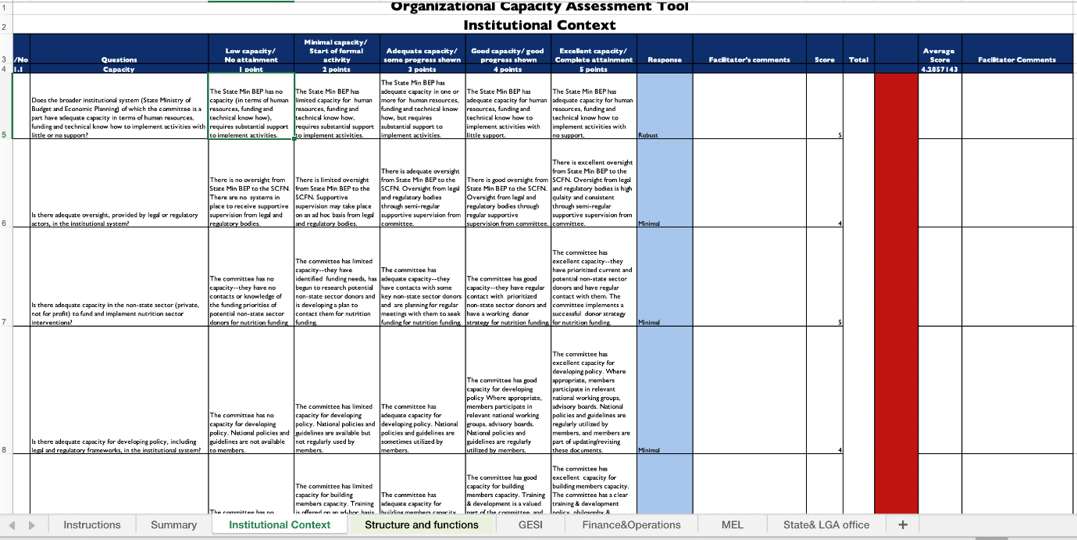

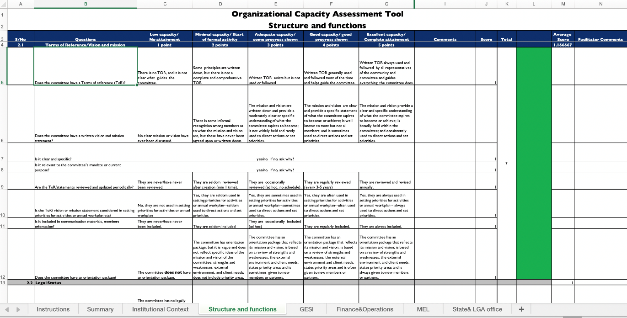

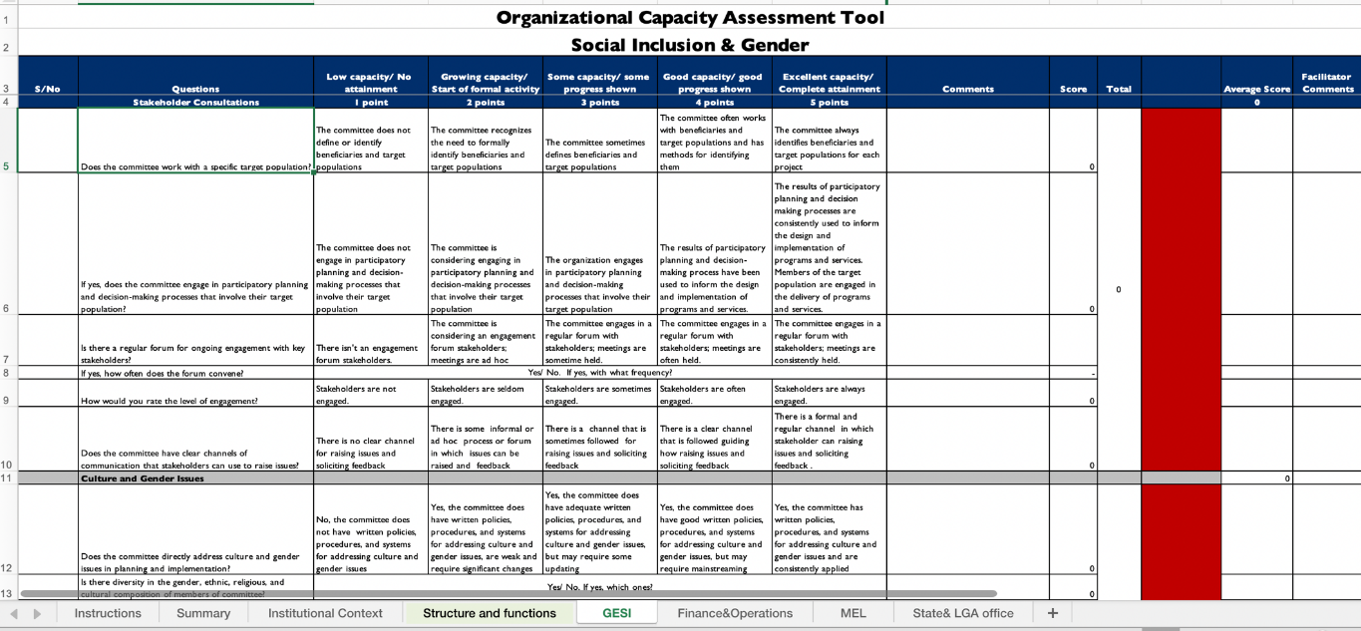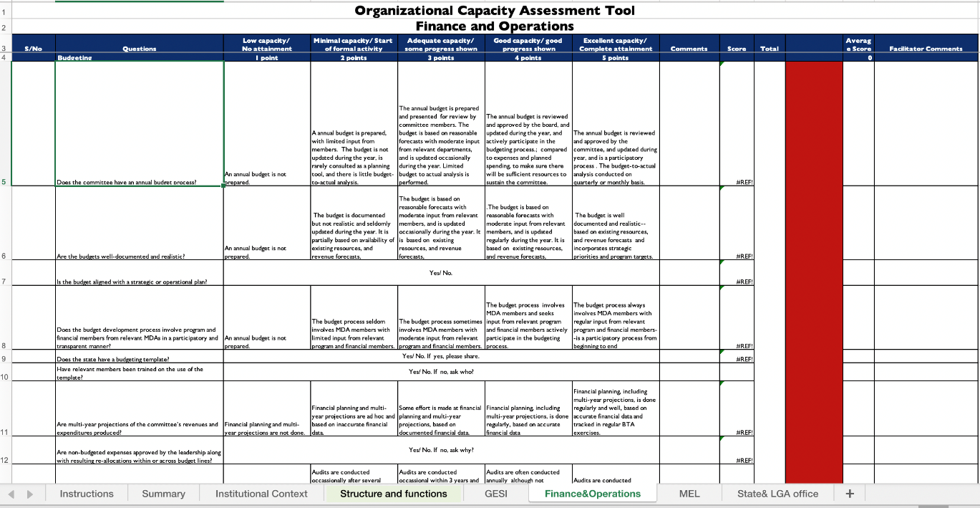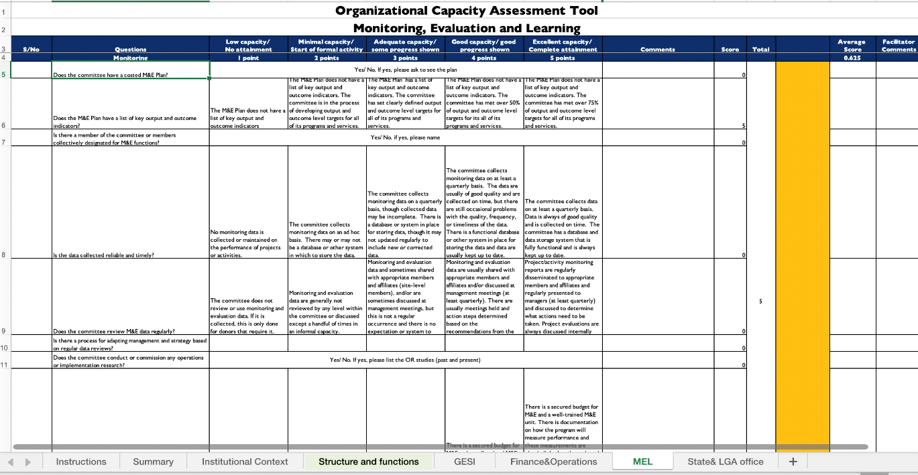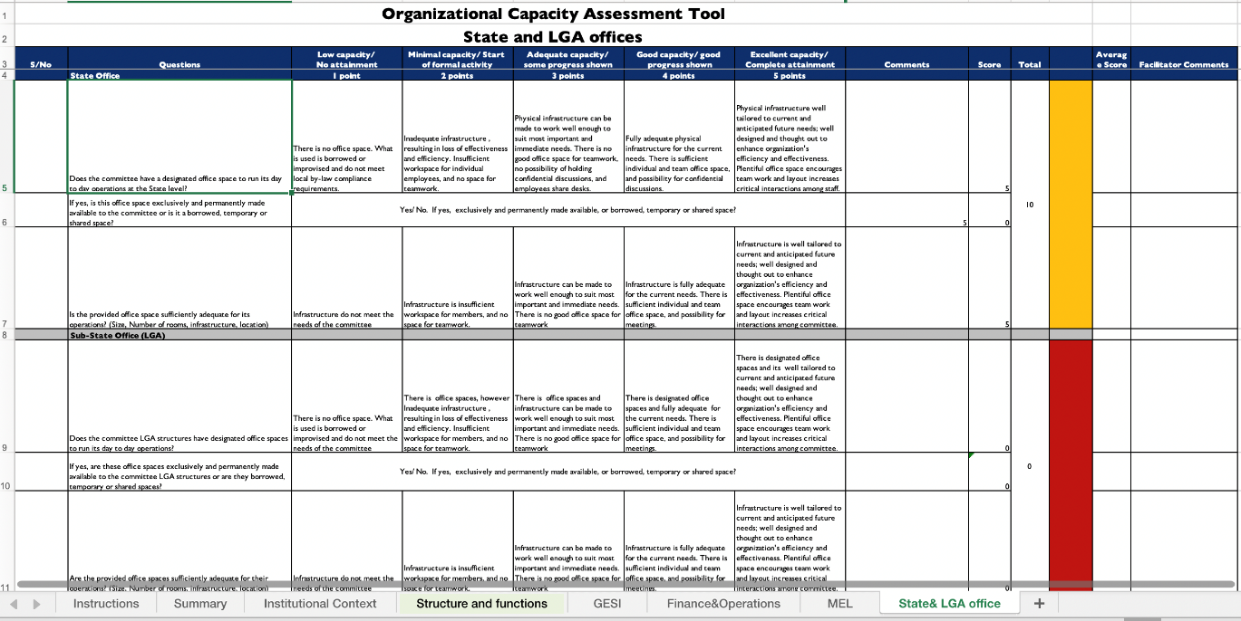

## Annex 7

### SCFN Quarterly Reporting Template (summary table)

|  |  |  |  |
| --- | --- | --- | --- |
| SCFN:  Reporting period (Quarter, Year):  Report compiled by: | | | |
| Responsibility area | Planned activities for quarter | Activities conducted this quarter | Planned activities for the next quarter |
| Technical Guidance |  |  |  |
| Coordination and Partnerships with Nutrition Stakeholders |  |  |  |
| Planning, Budgeting, and Resource Mobilization |  |  |  |
| Monitoring and Reporting |  |  |  |
| Advocacy |  |  |  |
| Additional comments: | | | |

## Annex 8

### SCFN Quarterly Reporting Template

|  |  |  |  |  |  |  |  |  |  |  |  |  |  |
| --- | --- | --- | --- | --- | --- | --- | --- | --- | --- | --- | --- | --- | --- |
| S/N | Activities | Indicator | Quarterly Targets | | | | Annual Target | Department/ partner responsible for collection | Quarterly Budget | | | | Cumulative budget |
| Q1 | Q2 | Q3 | Q4 | Q1 | Q2 | Q3 | Q4 |
| 1.0 | Objective 1 | | | | | | | | | | | | |
| 1.2 |  |  |  |  |  |  |  |  |  |  |  |  |  |
| 1.3 |  |  |  |  |  |  |  |  |  |  |  |  |  |
| 2.0 | Objective 2 | | | | | | | | | | | | |
| 2.1 |  |  |  |  |  |  |  |  |  |  |  |  |  |
| 2.2 |  |  |  |  |  |  |  |  |  |  |  |  |  |
| 3.0 | Objective 3 | | | | | | | | | | | | |
| 2.3 |  |  |  |  |  |  |  |  |  |  |  |  |  |
| 3.1 |  |  |  |  |  |  |  |  |  |  |  |  |  |

## Annex 9

### National Nutrition Scorecard



## Annex 10

### Sample SCFN Appointment Letter

Below is a sample of an appointment letter from the Permanent Secretary of the State Ministry of Budget and Economic Planning to the appointees to add new members to a SCFN.

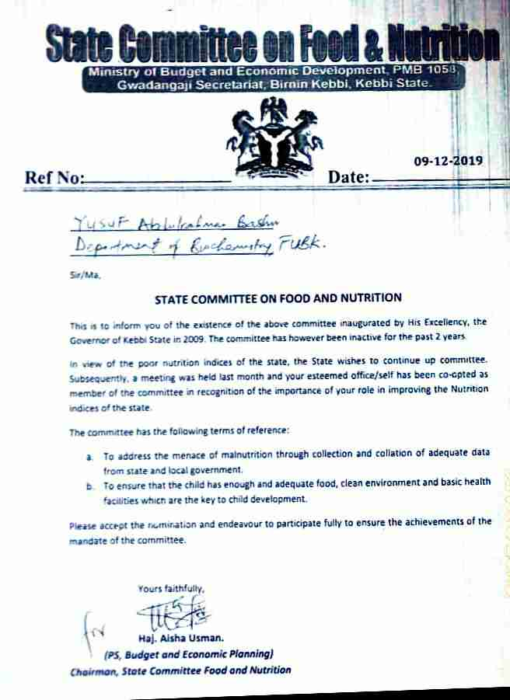

## Annex 11

### Monitoring and Supportive Supervision Checklist

|  |  |
| --- | --- |
| LGA |  |
| Core departments represented |  |
| Date |  |
| Administered by (Name/ Position/ Institution) |  |

|  |  |  |
| --- | --- | --- |
| SECTION 1: LGCFN COMPOSITION | | |
| No. | Questions | Responses |
| Q 1.1 | Does the LGCFN include all core departments?  **Tick all that apply**  ☐ Administration  ☐ Community development  ☐ Education ☐ Health ☐ Production ☐ Planning ☐ Trade and industry  ☐ Water | ☐ Yes (If yes, skip to 1.2) ☐ No  If no, list core departments that are missing and state why they are not included.  What is being done to engage missing departments with the LGCFN?  Means of verification - Circular on formation of LGCFN |
| Q 1.2 | Have all members received letters of assignment from the Chairperson? | ☐ Yes. Probe if the letters include clear terms of reference/roles and responsibilities.  ☐ No. Probe for who has not received, why, and what is being done.  Means of verification - Copies of assignment letters |
| Q 1.3 | Has the Chairperson formally designated a nutrition officer for the LGCFN? | ☐ Yes. Probe who is the appointed nutrition officer and list the position:  ☐ No. Probe why the nutrition officer has not been appointed and what is being done to recruit one.  Means of verification - Copy of nutrition officer assignment letter |
| Additional comments on LGCFN composition: | | |
| SECTION 2: TECHNICAL GUIDANCE | | |
| No. | Questions | Responses |
| Q 2.1 | For municipalities only:  How many divisions does the municipality have? | Number of divisions:  How many have established a LGCFN?  What is being done to facilitate the establishment of the remaining LGCFN?  Means of verification - Circular on formation of LGCFN |
| Q 2.2 | Has the SCFN oriented the LGCFN? | ☐ Yes. Probe to find out if any institution supported the orientation.  ☐ No. Probe what is being done to orient the LGCFN.  Means of verification - Orientation report |
| Q 2.3 | What nutrition issues were presented to the TPC in the last quarter? | List the nutrition issues presented:  What actions have been taken because of presenting nutrition issues to the TPC in the last quarter?  Probe for challenges if no nutrition issues were presented.  Means of verification - Action memo from the technical planning committee on nutrition issues |
| Q 2.4 | What nutrition issues were presented by the TPC in the last quarter? | List the nutrition issues presented:  What actions have been taken because of presenting nutrition issues to the Council in the last quarter?  Probe for challenges if no nutrition issues were presented.  Means of verification - Council minutes with nutrition issues |

|  |  |  |  |  |  |  |  |
| --- | --- | --- | --- | --- | --- | --- | --- |
| SECTION 3: COORDINATION AND PARTNERSHIPS WITH NUTRITION STAKEHOLDERS | | | | | | | |
| No. | Questions | | | | | | Responses |
| Q 3.1 | Does the LGCFN have an approved annual coordination work plan for the LGA? | | | | | | ☐ Yes. ☐ No. Probe what is being done to develop an  annual coordination work plan.  Means of verification:  - Copy of the approved annual coordination work plan |
| Q 3.2 | Were any nutrition coordination meetings held in the last quarter? | | | | | | ☐ Yes. ☐ No. Probe what is being done to overcome the  challenge.  Means of verification  - Minutes and action memos from coordination meetings |
| Q 3.3 | Were any joint activities undertaken with stakeholders in the last quarter? | | | | | | ☐ Yes. Provide details of activities.  ☐ No. Explain.  Means of verification - Activity reports |
| Q 3.4 | Is there an up-to-date nutrition partner database? | | | | | | ☐ Yes. ☐ No. Probe what is being done to develop or  update the database.  Means of verification - Database of nutrition partners |
| Q 3.5 | What platforms did the LGA use in the last quarter to share nutrition information (e.g., reports, presentations, results) with relevant stakeholders?  **Tick all that apply**  ☐ Council meetings ☐ Sectoral committee meetings ☐ Senior management meetings ☐ Technical Planning Committee meetings ☐ Nutrition Coordination Committee meetings ☐ Extended Technical Planning Committee meetings  ☐ Departmental meetings ☐ School management meetings ☐ Budget conferences  Probe for examples of the types of information shared, the stakeholders and LGCFN members involved, and what is being done to continue or improve nutrition information sharing in the LGA.  Means of verification - Minutes, reports, action memos  ☐ Experience sharing events ☐ Other (list) | | | | | | |
| Additional comments on coordination and partnerships with nutrition stakeholders: | | | | | | | |
| SECTION 4: PLANNING, BUDGETING, AND RESOURCE MOBILIZATION | | | | | | | |
| No. | Questions | | | | | Responses | |
| **Questions for LGCFNs or first monitoring and supervision visit:** | | | | | | | |
| Q 4.1 | Does the LGA have a five-year development plan? | | | | | ☐ Yes. If yes, list all cross-cutting issues (verify information provided from the development plan):  ☐ No. Probe for the stage the LGA is at in the development of the development plan. What is being done to ensure that nutrition issues are included?  Means of verification: - Copy of the development plan | |
| Q 4.2 | Does the LGA have an approved Multi-Sectoral Nutrition Action Plan? | | | | | ☐ Yes.  ☐ No. Probe for the stage the LGA is at in the development of the MSNAP. What is being done to ensure its development/approval?  Means of verification: - Copy of the MSNAP | |
| Q 4.3 | Does the LGA have an approved annual multi- sectoral nutrition implementation work plan and budget? | | | | | ☐ Yes.  ☐ No. Probe for the stage the LGA is at in the development of the annual multi-sectoral nutrition implementation work plan and budget. What is being done to ensure its development/approval?  Means of verification:  - Copy of the annual multi-sectoral nutrition implementation work plan and budget | |
| Q 4.4 | What resources are available for nutrition in the LGA? | | | | **Tick all that apply**  ☐ Local revenue ☐ Central government grants ☐ Implementing partners ☐ In-kind ☐ Direct support ☐ Private sector ☐ Other (list)  Which of the above resources are currently being used for nutrition?  Is there a resource gap (provide % if known)? What is being done to mobilize additional resource for nutrition? | | |
| Q 4.5 | Were activities undertaken to mobilize additional resources in the last quarter? | | | | ☐ Yes. Provide details of activities.  ☐ No. Probe what is being done to overcome the challenge. | | |
| Additional comments on planning, budgeting, and resource mobilization: | | | | | | | |
| SECTION 5: MONITORING AND REPORTING | | | | | | | |
| No. | Questions | | Responses | | | | |
| Q 5.1 | For municipalities only:  Did the LGCFN conduct joint monitoring and supportive supervision visits for the LGCFNs in the last quarter? | | ☐ Yes. Probe for the report and check for the composition of the monitoring team.  Which platforms were used to share the reports? ☐ LGCFN meeting ☐ Extended Technical Planning Committee meetings  ☐ Others (list)  What nutrition actions were taken because of the LGCFN monitoring and supportive supervision visit?  ☐ No. Probe for the challenges and what is being done to facilitate this action.  Means of verification - Monitoring and supportive supervision reports | | | | |
| Q 5.2 | Did the LGCFN receive a joint monitoring and supportive supervision visit in the last quarter? | | ☐ Yes. Probe for the report and check for the composition of the monitoring team.  If yes, did you receive feedback on your LGCFN monitoring and supportive supervision visit? What nutrition actions were taken because of the LGCFN monitoring and supportive supervision visit?  ☐ No. Probe what is being done to overcome the challenge.  Means of verification - Monitoring and supportive supervision reports | | | | |
| Q 5.3 | Did the LGCFN prepare a consolidated quarterly coordination report last quarter? | | | ☐ Yes ☐ No. Probe for the challenges and what is being done.  If yes, which departments submitted written reports to the LGCFN to be included in the consolidated report?  **Tick all that apply:** ☐ Administration ☐ Community development ☐ Education ☐ Health ☐ Production ☐ Planning ☐ Trade and industry ☐ Water  **Others**  ☐ Implementing partners (list): Did the LGCFN share the consolidated quarterly report?  Probe who they shared the report with. What actions were taken because of the LGCFN quarterly  report?  Means of verification - Consolidated LGCFN quarterly report | | | |
| Additional comments on monitoring and reporting: | | | | | | | |
| SECTION 6: ADVOCACY | | | | | | | |
| No. | Questions | Responses | | | | | |
| Q 6.1 | Does the LGCFN have an approved advocacy implementation plan? | ☐ Yes.  ☐ No. Probe for the stage the LGA is at in the development of the advocacy implementation plan. What is being done to ensure its development/approval?  Means of verification:  - Copy of the approved advocacy implementation plan | | | | | |
| Q 6.2 | Has the LGCFN identified nutrition champions at the LGA level? | ☐ Yes.  ☐ No. Probe for the challenges and what is being done.  Means of verification: - Database of nutrition champions | | | | | |
| Q 6.3 | What nutrition advocacy activities were conducted in the last quarter? List the activities: | | | | | | |

## Annex 12

### National/State Multi-Sectoral Plan of Action for Food and Nutrition Implementation M&E Tool/Checklist

| SN | ITEM | MDAs | No  success (1.0– 1.4) | Minimal success (1.5– 2.4) | Little success (2.5–3.4) | Moderate success (3.5– 4.4) | Considerable success  (4.5– 5.0) | Means of verification |
| --- | --- | --- | --- | --- | --- | --- | --- | --- |
| A | SO 1: REDUCED HUNGER AT HOUSEHOLD LEVEL | | | | | | | | |
|  | IR 1.1: Increased availability of nutritious food | | | | | | | | |
| 1 | Establishment of Farmers cooperatives/clusters for commercial production of food crops by government and private sector | Federal Ministry of Agriculture and Rural Development (FMARD)/State Ministry of Agriculture and Rural Development (SMARD) |  |  |  |  |  | Activity reports |
| 2 | Review all land tenure and land use laws with a view to increasing women access to land for agricultural activities | SMARD/HOA |  |  |  |  |  | Copy of legislation |
| 3 | Facilitate the reactivation of prison farms in each geopolitical zone | FMIA |  |  |  |  |  | Activity reports |
| 4 | Provide starter packs for fruits and vegetable farming (in seven agro-ecological zones) for 1000 smallholder farmers by zone (including women for Household gardening) | FMARD/SMARD |  |  |  |  |  | Activity reports |
| 5 | Provide small ruminant starter packs (five sheep/goats, concentrates, minerals and vitamins, vaccines and drugs) to vulnerable women farmers | FMARD/SMARD |  |  |  |  |  | Activity reports |
| 6 | Provide smoking kilns to clusters of small-scale fish processors/farmers including women fish farmers | FMARD/SMARD |  |  |  |  |  | Activity reports |
| 7 | Provide improved planting materials (staple crops including plantain, banana, and pineapple) to farmers across the country to promote food security | FMARD/SMARD |  |  |  |  |  | Activity reports |
| 8 | Advocate for rehabilitation of the existing rural road network and construction of new ones for easy transportation of farm produce | Federal Ministry of Works, Housing and Power/  Agricultural Development Programme |  |  |  |  |  | Activity reports |
| 9 | Advocate for the establishment of uniform Receipt system for warehouses in government food storage centers | FMARD/SMARD |  |  |  |  |  | Activity reports |
| 10 | Promote regulation for the establishment of commodity trading centers | FMARD/SMARD |  |  |  |  |  | Activity reports |
| 11 | Advocate for scale-up of offtake mechanism for food crops to increase availability of food products | FMARD/SMARD |  |  |  |  |  | Activity reports |
| 12 | Promote access to agricultural inputs (including improved seeds, information on agricultural practices, and irrigation) to scale up production of fruits and vegetable | FMARD/SMARD |  |  |  |  |  | Activity reports |
| 13 | Train farmers on appropriate use of fertilizers, herbicides, and pesticides | FMARD/SMARD |  |  |  |  |  | Training reports |
| 14 | Promote the use of Aflasafe and activities to minimize aflatoxin contamination along the value chain, including GAP and modern drying and storage | FMARD/SMARD |  |  |  |  |  | Activity reports |
| 15 | Sensitization of Farmers on proper use of environmentally friendly agricultural technologies | FMARD/SMARD |  |  |  |  |  | Activity reports |
| 16 | Scale up the production and promote the consumption of vitamin A, and micronutrient-rich foods (orange flesh sweet potato, provitamin A cassava, yellow maize, iron sorghum, and cowpea) | FMARD/SMARD |  |  |  |  |  | Activity reports |
| 17 | Scale up the activities on enforcement of food fortification and salt iodization programs | NAFDAC (National Agency for Food and Drug Administration and Control) |  |  |  |  |  | Activity reports |
| 18 | Support the production and diversification of fruits and vegetables around the homesteads, schools, orchards, and farms | FMARD/SMARD |  |  |  |  |  | Activity reports |
| 19 | Advocate for increase in import levies and excise duties on commodities that can be locally produced | FMOIA |  |  |  |  |  | Activity reports |
| IR 1.2: Increased access to nutritious food | | | | | | | | | |
| 20 | Review and disseminate existing legislation on fortification to cover staples food and promote hammer mill and household level fortification of cereal, root crops and legumes not presently covered (e.g., industrially processed rice, noodles, and palm oil) | Standard Organization of Nigeria |  |  |  |  |  | Activity reports |
| 21 | Cottage industries using improved varieties of micronutrient in final food products/processing | SMARD/OPS |  |  |  |  |  | Activity reports |
| 22 | Establish home and school farms and gardens | FMARD/SMARD |  |  |  |  |  | Activity reports |
| 23 | Conduct regular Stakeholders meeting on reduction of postharvest losses | FMARD/SMARD |  |  |  |  |  | Activity reports |
| 24 | Promote and provide hermetic storage bags to local farmers for food preservation | FMARD/SMARD |  |  |  |  |  | Activity reports |
| IR 1.3: Increased utilization of nutritious food at household level | | | | | | | | | |
| 25 | Consumption of micronutrient-rich foods in household | State Ministry of Information (SMOI)/OPS |  |  |  |  |  | Activity reports |
| 26 | Promote safe, quality, and hygienic food along the food supply chain | FMARD/ State Ministry of Health (SMOH) |  |  |  |  |  | Activity reports |
| 27 | Register and license food handlers and food operators engaged in quality and safe food processing and storage | NAFDAC/SMOLG |  |  |  |  |  | Activity reports |
| 28 | Promote dietary diversification through the consumption of locally produced staples—functional and under-utilized crops | FMARD/SMARD |  |  |  |  |  | Activity reports |
| B | SO 2: INCREASED ACCESS AND UTILIZATION OF CAREGIVERS TO NUTRITION SERVICES | | | | | | | | |
| IR 2.1: Availability of nutritious services, products, and commodities | | | | | | | | | |
| 29 | Procure and distribute zinc, L-ORS and de-worming tablet for community-based management of acute malnutrition (CMAM) and routine services | National Primary Health Care Development Agency (NPHCDA)/State Primary Health Care Development Agency (SPHCDA) |  |  |  |  |  | Activity reports |
| 30 | Health facilities carrying out nutrition counseling during antenatal care | NPHCDA/SPHCDA |  |  |  |  |  | Activity reports |
| 31 | Support local production of ready-to-use therapeutic food (RUTF) through advocacy to potential industries in Nigeria | FMITI |  |  |  |  |  | Activity reports |
| 32 | Support local production of micronutrient powder or premixes through advocacy to potential industries in Nigeria | FMITI |  |  |  |  |  | Activity reports |
| 33 | Procure and distribute RUTF for CMAM | NPHCDA/SPHCDA |  |  |  |  |  | Activity reports |
| 34 | Procure and distribute iron-folic acid supplementation to pregnant women during maternal, newborn, and child health (MNCH) weeks | NPHCDA/SPHCDA |  |  |  |  |  | Activity reports |
| 35 | Procure and distribute vitamin A supplements during MNCH weeks and other supplementary activities for children under age five | NPHCDA/SPHCDA |  |  |  |  |  | Activity reports |
| 36 | Monitor and evaluate micronutrient supplementation program performance at all levels | FMOH/SMOH |  |  |  |  |  | Activity reports |
| 37 | Advocate for legislation of the prolongation of maternity leave and enactment of paternity leave | Federal Ministry of Women Affairs and Social Development (FMWASD)/State Ministry of Women Affairs (SMOWA) |  |  |  |  |  | Activity reports |
| IR 2.2: Resources made available | | | | | | | | | |
| 38 | Production and distribution of materials on micronutrient-rich foods | SPHCDA/OPS |  |  |  |  |  | Activity reports |
| 39 | Provision of health facilities with required growth monitoring equipment | NPHCDA/SPHCDA |  |  |  |  |  | Activity reports |
| 40 | Community level action on nutritional care of vulnerable groups and utilization of primary health care services encouraged | FMWASD/SPHCDA |  |  |  |  |  | Activity reports |
| 41 | Review minimum standards, print and distribute standard operating procedures (nutrition and health) for early-child care centers | FME/FMOH/SMOE/SMOH |  |  |  |  |  | Activity reports |
| 42 | Conduct annual assessment of household consumption of iodized salt using primary school children | FME/National Bureau of Statistics (NBS)/SMOE |  |  |  |  |  | Activity reports |
| 43 | Scale up implementation of community infant and young child feeding for optimal infant and young child feeding | NPHCDA/ FMoH/  SPHCDA |  |  |  |  |  | Activity reports |
| 44 | Promote the establishment of nutrition and food demonstration corner (optimal infant and young child feeding practices) in the health facilities | NPHCDA/ FMoH/  SPHCDA |  |  |  |  |  | Activity reports |
| 45 | Establishment of crèches in workplaces to promote exclusive breastfeeding | FMWASD/ SMOWA |  |  |  |  |  | Activity reports |
| 46 | Implementation of baby-friendly initiative in all health facilities and delivery maternities | NPHCDA/ SPHCDA |  |  |  |  |  | Activity reports |
| IR 2.3: Improved capacity of nutrition service providers | | | | | | | | | |
| 47 | Promote safe, quality, and hygienic food along the food supply chain and training of personnel | Nutrition Society of Nigeria |  |  |  |  |  | Activity reports |
| 48 | Conduct capacity building and provide materials for food and nutrition teachers and food vendors on the need to provide nutritionally adequate meals using locally available foods through linking food vendors and school system | FME/SMOE |  |  |  |  |  | Training reports |
| 49 | Strengthen nutrition education and training in the curricula of early child care, primary, and secondary schools | SMOE |  |  |  |  |  | Published Curricular |
| 50 | Build the capacity of agricultural science teachers to strengthen the establishment of school farms and garden | FMARD/SMOE |  |  |  |  |  | Training reports |
| 51 | Scale up activities in enforcing the provisions of the International Code of Marketing of Breast-milk Substitutes | NAFDAC/ SMOH |  |  |  |  |  | Activity reports |
| 52 | Promote awareness of girl child education, ending child marriage, adolescent nutrition, and health-related practices | FMWASD/ SMOWA |  |  |  |  |  | Activity reports |
| 53 | Provide orientation for health staff to improve antenatal care attendance | NPHCDA/ SPHCDA |  |  |  |  |  | Activity reports |
| IR 2.4 Improved quality of service provided | | | | | | | | | |
| 54 | Regular monitoring of growth and development of children under age five at health facilities and communities | NPHCDA/ SPHCDA |  |  |  |  |  | Activity reports |
| 55 | Support distribution of iron-folate supplements to adolescent (boys and girls) in schools and communities | FMOH/ SPHCDA |  |  |  |  |  | Activity reports |
| 56 | Sustain and scale up distribution of micronutrient powder for children 6–23 months | FMOH/ SPHCDA |  |  |  |  |  | Activity reports |
| 57 | Distribute iron-folic acid supplementation to pregnant women during MNCH weeks | NPHCDA/ SPHCDA |  |  |  |  |  | Activity reports |
| C | SO 3: REDUCED MORBIDITY AND MORTALITY ASSOCIATED WITH MALNUTRITION | | | | | | | | |
| IR 3.1: Increased capacity in management of acute malnutrition | | | | | | | | | |
| 58 | Scale up and strengthen CMAM sites | NPHCDA/ SPHCDA |  |  |  |  |  | Activity reports |
| IR 3.2: Improved management of childhood diseases | | | | | | | | | |
| 59 | Listed health care commodities distributed in health facilities | NPHCDA/ SPHCDA |  |  |  |  |  | Activity reports |
| 60 | Distribute zinc, L-ORS, de-worming tablet, and RUTF for CMAM and routine services | NPHCDA/ SPHCDA |  |  |  |  |  | Activity reports |
| 61 | Training on hygiene promotion, Community Water Safety Plan, and triggering on Community-Led Total Sanitation | Federal Ministry of Water Resources (FMWR)/ State Ministry of Water Resources (SMOWR) |  |  |  |  |  | Activity reports |
| 62 | Provide portable water supply in PHC to enhance sanitation and hygiene | MOWR |  |  |  |  |  | Activity reports |
| IR 3.3: Increased awareness on diet-related noncommunicable diseases | | | | | | | | | |
| 63 | Health promotion activities to provide education and increasing services for prevention and management of diet-related noncommunicable diseases | FMOHSMOH/ SMOI |  |  |  |  |  | Activity reports |
| 64 | Conduct awareness campaign on healthy living, good dietary habits, and food quality and safety | Federal Ministry of Information and Culture (FMIC)/FMoH/SMOH/SMOI |  |  |  |  |  | Activity reports |
| IR 3.4: Increased awareness on infant and maternal nutrition | | | | | | | | | |
| 65 | Disseminate information on nutrition and key household practices through mass media | FMIC/SCFN/  National Orientation Agency |  |  |  |  |  | Activity reports |
| 66 | Conduct social and behavior change communication activities on IYCF and intra-household food distribution targeted at adolescents, pregnant women, and caregivers at all levels | FMIC/FMoH/  SPHCDA/National Orientation Agency |  |  |  |  |  | Activity reports |
| D | SO 4: REDUCED NUMBER OF HOUSEHOLDS WITH POVERTY INDEX | | | | | | | | |
| IR 4.1: Increased equitable access to resources leading to increased household income | | | | | | | | | |
| 67 | Support effective implementation of conditional cash transfer programs, food rations, or food supplements in emergency situation | National Emergency Management Authority/ State Emergency Management Authority |  |  |  |  |  | Activity reports |
| 68 | Procurement and distribution of complementary food packages to nutrition-in-emergency affected people | SMOH |  |  |  |  |  | Activity reports |
| 69 | Support water supply interventions in emergency settings and rural areas | FMWR/ SMOWR |  |  |  |  |  | Activity reports |
| 70 | Construction of sanitation and hygiene facilities in internally displaced person camps, public places, and institutions | FMWR/ SMOWR |  |  |  |  |  | Activity reports |
| 71 | Strengthen coordination platform for early warning mechanisms to cope with food emergencies at community level | FMARD/State Emergency Management Authority |  |  |  |  |  | Activity reports |
| 72 | Advocate to relevant banks to promote increased access to microcredit facilities for farmers, especially women farmers, to expand farm operations (interest rates and collaterals) | MFBNP/ SMARD |  |  |  |  |  | Activity reports |
| 73 | Promote the formation of women farmers into sustainable cooperative groups for the provision of grants and revolving loans | FMARD/FMITI/  SMARD |  |  |  |  |  | Activity reports |
| 74 | Empower farmer cooperatives and clusters for commercial production to received grants and loans | FMARD/ SMARD |  |  |  |  |  | Activity reports |
| 75 | Strengthen nutrition surveillance for early warning mechanisms to cope with emergency | FMARD, FMOH/SMARD/SMOH |  |  |  |  |  | Activity reports |
| 76 | Training emergency managers on mainstreaming nutrition in feeding programs targeted at the vulnerable groups in emergency situations | FMoH/SMOH |  |  |  |  |  | Training reports |
| E | SO 5: INCREASED NUTRITION KNOWLEDGE AND PRACTICE | | | | | | | | |
| IR 5.1: Increased medium of disseminating nutrition information to the public | | | | | | | | | |
| 77 | Promote and disseminate research findings on food processing and preservation technology for use in households | FMST/SMARD |  |  |  |  |  | Activity reports |
| 78 | Promote awareness on improved food quality and safety through electronic and print media | FMIC/SMOI |  |  |  |  |  | Activity reports |
| 79 | Conduct sustained advocacy to policymakers, both traditional and religious leaders, for improved nutrition funding | FMFBNP/SPC |  |  |  |  |  | Activity reports |
| 80 | Conduct stakeholders (consultation) meetings for nutrition-related investment and sectoral policies including social protection policies | FMFBNP/SPC |  |  |  |  |  | Activity reports |
| 81 | Advocate and accelerate the implementation of the State Health Insurance Scheme to incorporate the Community Health Insurance health care to vulnerable groups, especially women and children | SMOH |  |  |  |  |  | Activity reports |
| 82 | Conduct Annual Nutrition Week on topical issues in nutrition | FMFBNP |  |  |  |  |  | Activity reports |
| 83 | Annual review meeting of SCFN with NCFN | FMFBNP |  |  |  |  |  | Activity reports |
| 84 | Mid- and End-line Review of implementation of the National Multi-sectoral Plan of Action for Nutrition | FMFBNP |  |  |  |  |  | Activity reports |
| 85 | Conduct regular and periodic monitoring on food and nutrition activities in collaboration with partners and the private sector at all levels | NCFN/SCFN/  LGFN |  |  |  |  |  | Activity reports |
| 86 | Organize annual NNN meeting of all nutrition stakeholders | FMFBNP/SCFN |  |  |  |  |  | Activity reports |
| IR 5.2: Increased knowledge on nutrition and practice by the public | | | | | | | | | |
| 87 | Collaboration with network providers like MTN, Airtel, GLO, and 9mobile to disseminate nutrition information to the general public | FMIC/SCFN |  |  |  |  |  | Activity reports |
| 88 | Strengthen LGAs for regular and sustained monitoring and inspection on the preparation of food in restaurants, eateries, and food vending | SMOH |  |  |  |  |  | Activity reports |
| IR 5.3: Improved information on locally available diets | | | | | | | | | |
| 89 | Provide small grants to conduct food and nutrition research on standardization of food recipes and portion sizes of locally available diets | FMARD/SPC |  |  |  |  |  | Activity reports |
| 90 | Review, publish and disseminate the Food Based Dietary Guidelines for healthy living | FMOH/SMARD |  |  |  |  |  | Activity reports |
| 91 | Promotion of safe practices on pesticide utilization for food stuff preservation | NAFDAC/ FMARD /SMARD |  |  |  |  |  | Activity reports |
| IR 5.4: Increased practice of good dietary habits by the public | | | | | | | | | |
| 92 | Conduct the National Food Consumption and Nutrition Survey | FMARD |  |  |  |  |  | Activity reports |
| 93 | Review, update, publish, and disseminate existing food composition table for Nigeria | ARCN/NUC/  Research Institutes |  |  |  |  |  | Activity reports |
| 94 | Building the capacity of farmers on cultivation of underutilized crop varieties | FMARD/ SMARD |  |  |  |  |  | Activity reports |
| 95 | Promote dietary diversification through the consumption of locally produced staples | FMARD/ SMARD |  |  |  |  |  | Activity reports |
| F | SO 6: INCREASED ALLOCATION AND UTILIZATION OF FUNDING FOR NUTRITION | | | | | | | | |
| IR 6.1: Increased nutrition funding by government and partners | | | | | | | | | |
| 96 | Conduct regular budget tracking to evaluate budget performance of food and nutrition in all sectors | FMFBNP/SPC |  |  |  |  |  | Activity reports |
| 97 | Domesticate and disseminate state policy on food and nutrition and the Plan of Action at the state levels | FMFBNP/SPC |  |  |  |  |  | Printed Policy and Plan |
| 98 | Conduct assessment at all levels on determinants of low financial investments in food and nutrition programs compared to other life-saving interventions in partnership with private sector | FMFBNP/SPC |  |  |  |  |  | Activity reports |
| 99 | Ensure adequate implementation of the policy through sufficient budgetary allocation | FMFBNP/SPC |  |  |  |  |  | Activity reports |
| IR 6.2: Budget lines for nutrition in MDAs created | | | | | | | | | |
| 100 | Build the capacity of nutrition desk officers in MDAs or LGAs and leaders of professional associations in nutrition through training and retraining on nutrition programming, resource mobilization, and allocation | FMFBNP/SPC |  |  |  |  |  | Activity reports |
| 101 | Advocacy for the creation of budget lines on food and nutrition activities in MDAs or LGAs and ensure timely release of funds | FMFBNP/SPC |  |  |  |  |  | Activity reports |
| IR 6.3: Increased funding releases for nutrition | | | | | | | | |
| 102 | Ensure adequate implementation of the policy through sufficient timely release of funds | FMFBNP/SCFN |  |  |  |  |  | Activity reports |
| IR 6.4: Increased MDAs with established nutrition departments | | | | | | | | | |
| 103 | Advocate for the creation of nutrition department and incorporate nutrition objectives into MDAs’ development policies, plans, and programs | FMFBNP/SCFN |  |  |  |  |  | Activity reports |
| 104 | Ensuring adequate staffing of relevant MDAs at state and LGA levels implementing sectoral nutrition programs with skilled and qualified nutritionists | Head of Service/FMFBNP/SPC |  |  |  |  |  | Activity reports |
| IR 6.5: Established multi-sectoral nutrition portal (National Information System) | | | | | | | | | |
| 105 | Establish a nutrition portal for the collection of core nutrition data in partnership with key stakeholders | NBS/FMFBNP |  |  |  |  |  | Activity reports |
| 106 | Conduct training and retraining of state, LGAs, community-based agencies and organizations, and other stakeholders in the planning and implementation of food and nutrition programs and activities | SPC |  |  |  |  |  | Activity reports |
| 107 | Build the capacity of Nutrition implementers (OICs, NFPs, M&E), agriculture extension officers, and other nutrition officers/workers at all levels on the use and management of level appropriate nutrition dashboard | NBS/FMFBNP  /SPC |  |  |  |  |  | Activity reports |
| 108 | State the amount in budget proposal by your MDA for nutrition (in Naira) | MDAs |  | | | | | Documented budgeting reports |
| 109 | What is the allocated in your approved budget (in Naira)? | MDAs |  | | | | | Documented evidence of budgetary allocation |
| 110 | What was the amount released (in Naira)? | MDAs |  | | | | | Documented evidence of fund release |
| 111 | What was the amount expended (in Naira)? | MDAs |  | | | | | Documented evidence of fund expended |
| H | CHALLENGES/SUGGESTIONS | | | | | | | | |
| 112 | What are barriers to the smooth implementation of nutrition programs? | MDAs |  | | | | | |
| 113 | What are challenges to the allocation and release of funds? | MDAs |  | | | | | |
| 114 | What do you see as major opportunities? | MDAs |  | | | | | |
| 115 | What do you think would help achieve meaningful impacts in nutrition? | MDAs |  | | | | | |

## Annex 13

### References

Ahmed, T, M. Hossain, and K.I. Sanin. 2012. “Global Burden of Maternal and Child Undernutrition and Micronutrient Deficiencies,” *Annual of Nutrition and Metabolism*. 61(suppl 1):8–17. <https://doi.org/10.1159/000345165>

Bhutta, Z.A., J.K. Das, A. Rizvi, M.F. Gaffey, N. Walker, S. Horton et al. 2013. “Evidence-Based Interventions for Improvement of Maternal and Child Nutrition: What can be Done and at What Cost?” *The Lancet.* 382(9890):452–477. <https://doi.org/10.1016/S0140-6736(13)60996-4>

Development Initiatives. 2017. *2017 Global Nutrition Report: Nourishing the SDGs.* Bristol, UK: Development Initiatives.

Development Initiatives. 2020. *2020* *Global Nutrition Report: Action on Equity to End Malnutrition.* Bristol, UK: Development Initiatives.

Development Initiatives. 2021. *2021 Global Nutrition Report: The State of Global Nutrition.* Bristol, UK: Development Initiatives.

FAO (Food and Agriculture Organization of the United Nations), IFAD (International Fund for Agricultural Development), UNICEF, WFP (World Food Program), and WHO (World Health Organization). 2021. *State of Food and Nutrition in the World Report: Transforming Food Systems for Food Security, Improved Nutrition, and Affordable Healthy Diets for All.* Rome: FAO. <https://doi.org/10.4060/cb4474en>

Ministry of Agriculture and Rural Development. 2016. Agricultural Sector Food Security and Nutrition Strategy (2016–2025)

Ministry of Budget and National Planning. 2016. National Policy on Food and Nutrition in Nigeria

Ministry of Finance, Budget and National Planning. 2020. National Multi-sectoral Plan of Action for Food and Nutrition (NMPFAN) (2021–2025)

Ministry of Health. 2021. Health Sector National Strategic Action Plan for Nutrition (2021–2025)

Nigeria Governors’ Forum. 2021. NGF Nutrition Scorecard

UNICEF-WHO. 2015. Checklist on the Criteria and Characteristics of “Good” National Nutrition Plans. <https://scalingupnutrition.org/sites/default/files/2022-01/Scaling-Up-Nutrition-Quality-national-plan-checklist.pdf>

SCALING UP NUTRITION. 2016. Linking nutrition and the SDGs. <https://scalingupnutrition.org/resources/nutrition-info/nutrition-action/linking-nutrition-and-sdgs>

UNICEF. 2016. “The First 1000 Days of Life.” Accessed March 23, 2023. <https://www.youtube.com/watch?v=mpyD19SIiaw>

UNICEF. 2020. *UNICEF Conceptual Framework* *on Maternal and Child Nutrition.* Accessed April 8, 2022. <https://www.unicef.org/documents/conceptual-framework-nutrition>

United Nations. 2019. *SDG 2: End Hunger, Achieve Food Security and Improved Nutrition, and Promote Sustainable Agriculture.* <https://unstats.un.org/sdgs/report/2021/goal-02/>

WHO (World Health Organization). 2021a. “Malnutrition.” <https://www.who.int/news-room/fact-sheets/detail/malnutrition>

WHO. 2021b. “Overweight and Obesity.” <https://www.who.int/news-room/fact-sheets/detail/obesity-and-overweight>

WHO. 2016. “A Decade of Action on Nutrition”. <https://www.who.int/news-room/events/detail/2016/04/01/default-calendar/decade-of-action-on-nutrition>

WHO. 2014. Global nutrition targets 2025: policy brief series (WHO/NMH/NHD/14.2). Geneva: World Health Organization. <https://www.who.int/publications/i/item/WHO-NMH-NHD-14.2>

1. This version was revised in June 2022 and is fit for the purpose of SCFN assessment in three states in Nigeria. The OCAT served as the basis of the tool and incorporates elements from the Organizational Performance Index and Government Performance Index .