Kyrgyz Republic: Module Toolkit for Training Community Health Volunteers
Counseling about Best Nutrition, Hygiene, and Child Care Practices

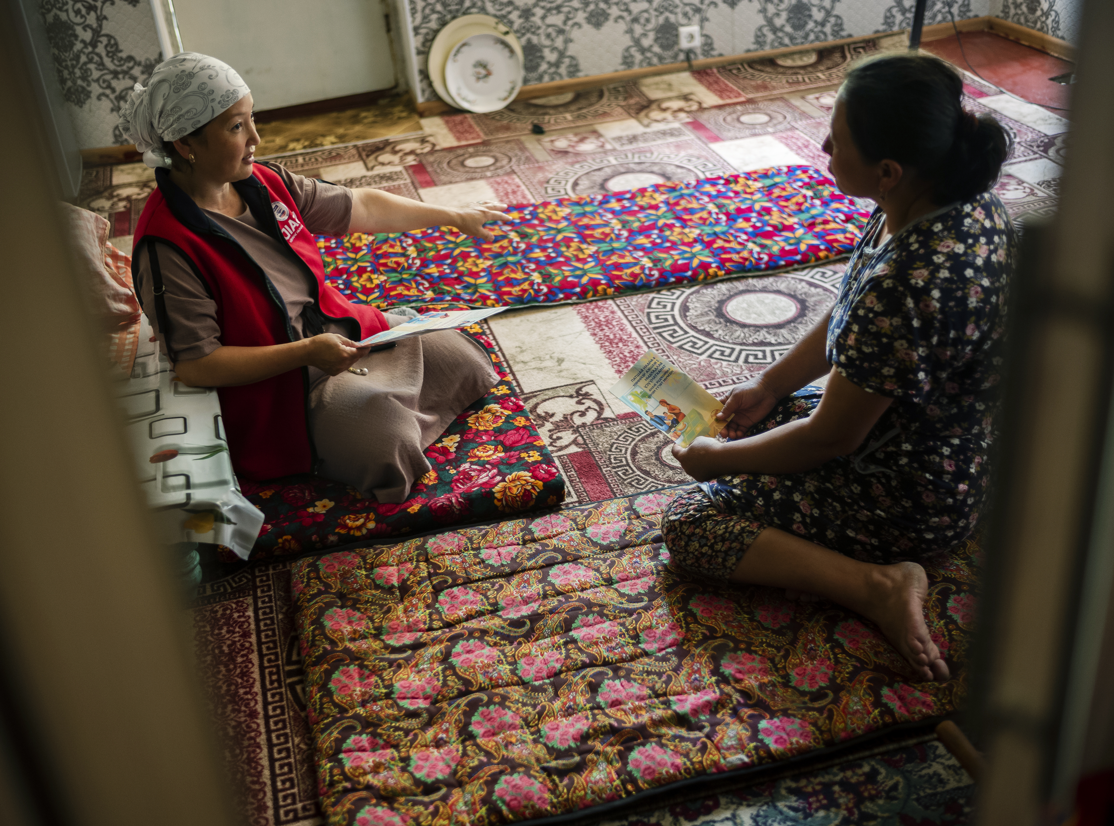

About USAID Advancing Nutrition
USAID Advancing Nutrition is the Agency’s flagship multi-sectoral nutrition project, led by JSI Research & Training Institute, Inc. (JSI), and a diverse group of experienced partners. Launched in September 2018, USAID Advancing Nutrition implements nutrition interventions across sectors and disciplines for USAID and its partners. The project’s multi-sectoral approach draws together global nutrition experience to design, implement, and evaluate programs that address the root causes of malnutrition. Committed to using a systems approach, USAID Advancing Nutrition strives to sustain positive outcomes by building local capacity, supporting behavior change, and strengthening the enabling environment to save lives, improve health, build resilience, increase economic productivity, and advance development.
Disclaimer
This report is made possible by the generosity of the American people through the United States Agency for International Development (USAID). The contents are the responsibility of JSI Research & Training Institute, Inc. (JSI), and do not necessarily reflect the views of USAID or the U.S. Government.
Recommended Citation
USAID Advancing Nutrition. 2023. Kyrgyz Republic: Module Toolkit for Training Community Health Volunteers on Counseling about Best Nutrition, Hygiene, and Child Care Practices. Arlington, VA: USAID Advancing Nutrition.

Photo Credit: Maxime Fossat for USAID/ Kyrgyz Republic.

USAID Advancing Nutrition
JSI Research & Training Institute, Inc.
2733 Crystal Drive
4th Floor
Arlington, VA 22202

Phone: 703–528–7474
Email: info@advancingnutrition.org
Web: advancingnutrition.org

Contents
Acknowledgments v
Acronyms vi
Section 1. Introduction 1
How to Use This Toolkit 1
Project Overview 1
Using Local Networks 3
Establishing a Structure: Targeting and Training Strategies 3
Quality Assurance, Monitoring, and Reporting 5
Supporting Activists and Building Capacity 5
Adapting Program Structure Different Program Settings and Audiences 6
Key Considerations for Adapting the Modules and Materials 8
Section 2. Activist Modules 10
MODULE 1: Community Mobilization, Mapping, and Action Planning 10
MODULE 2: Exclusive Breastfeeding of Infants from Birth to Six Months 18
MODULE 3: Diverse and Timely Feeding of Complementary Foods to Children Beginning at Six Months 25
MODULE 4: Best Responsive Care and Child Feeding Practices 33
MODULE 5: Early Learning through Play and Communication 44
MODULE 6: Practicing Best Handwashing and Maintaining Clean Latrine Practices 51
MODULE 7: Dietary Diversity and Reduced Consumption of Junk Food 56
MODULE 8: Best Practices of Anemia Preventing and Supporting Healthy and Diversified Maternal Nutrition 64
MODULE 9: Improving Family Budget Planning Practices for Contributing to Diversified and Healthy Diet 72
MODULE 10: Food Storage at Households 79
Section 3. Handouts and Training Materials 86
Checklist for Evaluating Module Trainings 87
Checklist for Supervision of Activists 90
Activist Module Planning and Reporting Forms 91
The 5-Step Counseling Approach 94
Section 4. Role Plays for Technical Modules 96
Scenarios for Module 2 Role Play: Exclusive Breastfeeding 97
Scenarios for Module 3 Role Play: Complementary Feeding 98
Scenarios for Module 4 Role Play: Responsive Care and Responsive Feeding 99
Scenarios for Module 5 Role Play: Early Communication and Learning Through Play 100
Scenarios for Module 6 Role Play: Handwashing and Maintaining Clean Latrines 101
Scenarios for Module 7 Role Play: Dietary Diversity and Reduced Consumption of Junk Food 102
Scenarios for Module 8 Role Play: Anemia Prevention and Maternal Nutrition 103
Scenarios for Module 9 Role Play: Family Budgeting 104
Scenarios for Module 10 Role Play: Food Storage and Preservation 105

Acknowledgments
This toolkit is an update of SPRING’s Training Community Volunteers on Nutrition and Hygiene Module Toolkit. We thank the main contributors from SPRING on their amazing work on the original document, including Aida Shambetova and Ashley Aakesson.
For their great contribution to this updated toolkit—drafting and finalizing modules with key messages on nutrition and hygiene—we would like to thank USAID Advancing Nutrition/Kyrgyz Republic Social and Behavior Change Communication Specialist Aida Shambetova and her team, USAID Advancing Nutrition DC Office Technical Advisor Andrew Cunningham, as well as community activists for their feedback on the demonstrations of developed modules. Additionally, we’d like to thank the USAID Advancing Nutrition Early Childhood Development team, in particular Technical Advisor Katie Beck and ECD Specialist Cholpon Abdimitalipova, for their development of the modules on responsive care, and early learning, adapted from the USAID Responsive Care and Early Learning Addendum package.

Acronyms
ANC antenatal care
EBF exclusive breastfeeding
IFA iron-folic acid
HPU health promotion unit
JSI JSI Research & Training Institute, Inc.
KR Kyrgyz Republic
KVHC Kyrgyz Association of Village Health Committees
MOH Ministry of Health
NCD noncommunicable diseases
RCHP Republican Center for Health Promotion
SBC social and behavior change
SBCC social and behavior change communication
SPRING Strengthening Partnerships, Results, and Innovations in Nutrition Globally
USAID U.S. Agency for International Development
VHC village health committee
WHO World Health Organization

Section 1. Introduction
About USAID Advancing Nutrition Kyrgyz Republic
Since 2019, USAID Advancing Nutrition has been working to improve the nutritional status of children under two years of age and women of reproductive age in Kyrgyzstan by promoting the uptake of 11 evidence-based practices. USAID Advancing Nutrition works through strategic partnerships in health and community organizations to improve the nutritional capacity of health providers and households; increase the responsive care and early learning practices at home; and support national-level initiatives likely to improve nutrition outcomes. Partners include local government, village health committees, district health centers, local and international nongovernmental organizations, and other USAID projects. USAID Advancing Nutrition works in 4 rayons and townships of Jalalabad oblast and the entire Batken oblast. Much of the work from USAID Advancing Nutrition Kyrgyzstan builds upon the health and community-based work done by the Strengthening Partnerships, Results, and Innovations in Nutrition Globally (SPRING) project in Kyrgyzstan from 2014–2018.

How to Use This Toolkit
This toolkit, an updated version of the previously designed Kyrgyz Republic: Training Community Volunteers on Nutrition and Hygiene Module Toolkit, provides program implementers with training session modules, job aids, and social and behavior change communication (SBCC) materials to help community volunteers (referred to as Activists) and other frontline workers promote household nutrition, hygiene, and responsive care. The modules can be used in any order, with the exception of module 1 (Activist mobilization, mapping, and action-planning), which provides basic information and should be completed before the specific topic modules. Additionally, module 2 (exclusive breastfeeding) introduces and models the toolkit’s 5-Step Counseling Approach, which is used throughout the toolkit. Any adaptation of this package should ensure that this part of module 2 is integrated into your first technical content module.

Project Overview
The work of USAID Advancing Nutrition to deliver nutrition SBCC interventions through the Activists is part of a broader program to improve national nutrition policy and quality of nutrition service provision at health facilities. USAID Advancing Nutrition builds Activist capacity to raise family and community awareness of nutrition during the first 1,000 days; promote improved nutrition, responsive care, hygiene, and sanitation behaviors; and generate demand for nutrition and health services. The long-term social and behavior change (SBC) needed for improved nutrition require integrating ongoing SBC activities into existing structures and systems, including health promotion units (HPUs) and village health committees (VHCs).
The project’s community-based approach heavily adopts the approach of the Strengthening Partnerships, Results, and Innovations in Nutrition Globally (SPRING) project in Kyrgyzstan from 2014–2018, and has adapted and innovated upon it to reflect new learnings and ensure its appropriate use in Batken and Jalalabad oblasts.
USAID Advancing Nutrition collaborates with local health education and communication mechanisms—including HPUs, VHCs, and Activists—to reach communities with SBC activities. Each district-level administration of primary health services (referred to as family medicine centers) has an HPU staffed by one or two nurses who, with guidance from the health education arm of the Ministry of Health (MOH) and the Republican Center for Health Promotion (RCHP), conduct outreach to all communities in their catchment area. HPU staff are also responsible for training and supporting VHCs and coordinating health education through other government entities and schools through their established cadres of community volunteers. VHCs began in 2002 with funding from the Swiss Red Cross as a pilot project in one rayon (district) and quickly scaled up to more than 1,700 VHCs in 84 percent of the nation’s villages. VHCs are organized into regional networks at the rayon level and operate under the umbrella of the Kyrgyz Association of Village Health Committees (KVHC). VHCs conduct activities to improve the health of their communities. As independent civil society organizations, they collaborate with the government health system through the RCHP. The USAID Advancing Nutrition project has reinforced rehabilitated existing VHCs, and created new groups of community Activists that were trained based on the modules of this toolkit. Most Activists are members of the VHC, some are newly recruited and plan to become VHC members, and some members are participating to improve their own knowledge.
To maintain engagement with the large number of community volunteers, USAID Advancing Nutrition entered into a formal partnership with KVHC through a subgrant. A national nongovernmental organization, KVHC operates an extensive network of community-led health committees, and they routinely disseminate important health information nationally. KVHC provided a team of coordinators who work with USAID Advancing Nutrition field staff (community mobilizers) to extend the program’s reach by recruiting, training, and supporting Activists. As unpaid volunteers Activists are incentivized through regular training, quality-improvement efforts, and public recognition. They also receive small incentives, such as mugs (which they use to demonstrate the correct amount to feed children at different ages), bags to carry materials, and t-shirts.
Evidence-Based Practices Promoted by USAID Advancing Nutrition
- Pregnant women consume iron supplements in accordance with health guidelines during each pregnancy.
- Pregnant and lactating women eat a variety of nutritious foods, with an emphasis on food sources of iron and foods that enhance iron absorption.
- Caregivers feed their children 6–23 months old a variety of nutritious foods in their diet, with an emphasis on food sources of iron and vitamin A and foods that enhance iron absorption.
- Caregivers feed their children 6–23 months old with optimal frequency.
- Caregivers initiate breastfeeding of their child within one hour of birth.
- Caregivers exclusively breastfeed their children from birth–six months.
- Caregivers introduce appropriate complementary foods to their children at six months.
- Caregivers reduce the consumption of foods of low-nutrient value (junk food).
- Pregnant women and young children go to the health center for presumptive treatment for helminth infections.
- Caregivers wash their hands at four critical times (after using the latrine, after changing a diaper/cleaning a child, before preparing food, and before feeding a child).
- Family members adopt safe methods for prolonged storage of nutrient-dense produce in winter.

Building on the SPRING experience, and leveraging lessons learned during USAID Advancing Nutrition’s gender analysis work in 2020, USAID Advancing Nutrition added an additional practice that would support gender transformative dynamics to achieve results in the above 11 practices.

- Couples will communicate and make joint decisions for resources and actions related to nutrition and health of the family (e.g., in-home budgeting).

Finally, in collaboration with USAID Advancing Nutrition’s Early Childhood Development team, the Kyrgyz Republic was selected as a study site for their Responsive Care and Early Learning Addendum. As part of this study, two additional practices were integrated into community-based SBC communication efforts to improve nurturing care in two ways:
- Caregivers interact with their child in a responsive manner (e.g., responding to cues, feeding responsively).
- Caregivers encourage early communication and learning through age-appropriate engagement and play activities.

USAID Advancing Nutrition and KVHC help Activists roll out the topical modules through household visits and community meetings in program areas, based on a seasonal schedule. In addition to supporting RCHP as they develop nutrition content, USAID Advancing Nutrition builds HPU and VHC staff capacity to deliver nutrition SBC to people at schools, health facilities, and in rural and urban communities.

Using Local Networks
As with the SPRING project, USAID Advancing Nutrition’s SBC activities rely on an existing network of community volunteers (Activists) distributed throughout the country and who have been used in the past to disseminate a variety of social messages. This network includes people from a wide range of backgrounds (e.g., school teachers, housewives, local government leaders) who have varying levels of influence and access to social circles and communication channels. Activists have become the primary mode of delivery for community-level behavior change work. USAID Advancing Nutrition, KVHC, and local government authorities have recruited more Activists to complement the existing network, expand its reach, and reduce the burden on individual Activists.
Acknowledging USAID Advancing Nutrition Activists’ voluntarism and competing priorities for time and effort, training consists of a short session every four to six weeks on a different topic, followed by occasional support visits during household visits and community meetings. Short training sessions ensure that capacity is built without taking too much of the volunteers’ time, most of which is spent on household visits and/or community events and meetings. Activists, with additional support from USAID Advancing Nutrition staff and community mobilizers, may also participate in community campaign events related to the SBC strategy. As acknowledged community leaders, the Activists raise awareness of simple, priority family behaviors that are taught in each topical module, and they generate demand for the services of health workers.
USAID Advancing Nutrition’s work on in-service training of health facility staff to improve the quality of nutrition services and counseling helps program staff and Activists feel confident recommending the facility-level workers as an important source of information and care for mothers and children up to two years of age. This is reinforced at each contact with Activists, with the tone and content of modules reflecting this role of general awareness-raising, focused promotion of a few simple family behaviors, and generating demand for the services of health workers. In the USAID Advancing Nutrition and Hygiene Toolkit, Activists are equipped with a 5-Step Counseling Approach; this framework was selected largely to support Activists to listen actively to caregivers’ experience, to praise appropriately, and to specify recommendations for seeking health services. It is still ultimately health workers’ responsibility to provide in-depth, personalized counseling to mothers and their families about maternal and child nutrition, so Activists are instructed to encourage mothers and families to seek regular information, preventive services, and care from health workers. This two-pronged approach also ensures that mothers and family members hear consistent messages at multiple contact points, which reinforces community-level communication.
To the extent possible, USAID Advancing Nutrition delivers its SBC activities through and in support of existing institutions and community mechanisms. All key messages and promotional materials were developed with and approved by the MOH’s RCHP. These materials are owned by the government of Kyrgyz Republic and are available for further use.
Through its partnership with KVHC, USAID Advancing Nutrition has built 38 Activist mobilizers’ institutional capacity on nutrition, hygiene, and community and social mobilization. These trained individuals are a resource for their peers and can serve as master trainers should donors or other development partners want to hire KVHC to roll out this toolkit in other regions of the country.

Establishing a Structure: Targeting and Training Strategies
USAID Advancing Nutrition uses community mobilizers, and Activists to disseminate messages in communities. Using the selected training module, bimonthly community are trained as Activist trainers and supervisors. These trainings typically last three to four hours and are conducted at the oblast (regional) level. During trainings, master trainers model methods that will be used to train Activists in their coverage area. In many cases, due to the COVID-19 pandemic, many of the oblast-level trainings were conducted virtually. The trained mobilizers cascade training to Activists at the township and rayon levels.
All the training modules are—
- Limited to priority messages about a subset of evidence-based behaviors, so that Activists are not overwhelmed and can promote the behaviors with different groups in different settings with confidence.
- Interactive and participatory, respecting learners as adults who bring knowledge and experience to the training.
Training Cascade
Events and household visits (community)
Training community activists (rayon and township)
Training community mobilizers as trainers (oblast)
- Focused on skills, allowing time for role play to practice listening and talking to community members; using job aids to strengthen promotion and to respond to questions or objections from community members.
- Facilitate experience-sharing so trainees learn from each other and find solutions to challenges.
Module Topics
- Activist Mobilization, Mapping, and Action Planning
- Exclusive Breastfeeding
- Complementary Feeding of Young Children
- Responsive Care and Responsive Feeding
- Early Communication and Play
- Handwashing and Clean Latrines
- Dietary Diversity and the Reduction of Junk Food Consumption
- Preventing Anemia and supporting Maternal Nutrition
- Planning a Family Budget
- Food Storage and Preservation
USAID Advancing Nutrition orients Activists to a different theme every five to six weeks through a two-hour training on technical content, key messages, job aids, and any SBC materials (usually given to families) associated with the topical module. The training includes guidance on how to conduct household visits, community meetings, and data collection. USAID Advancing Nutrition’s initial Activist training module was “social mobilization and general nutrition,” which was an introduction to the project and its content. This module is an orientation and planning exercise, and does not include its own community engagement component.
Activists then conduct household visits and community meetings in their catchment areas to raise awareness and promote simple key messages and behaviors. They also help promote facility-level workers as an important source of information and health care. Accompanying SBC materials convey and reinforce the project’s key messages in memorable and compelling ways. They include an informational brochure for mothers; a cookbook; and posters and leaflets on handwashing and clean latrines, dietary diversity, and anemia prevention. These materials complement Activists’ messages, which are also displayed in HPUs and health facilities. In many cases, community members received digital versions of these resources through WhatsApp groups, coordinated by their Activists.
USAID Advancing Nutrition aims for a 1:25 ratio between Activists and households, with community mobilizers dividing the tasks of training, coordinating, and supervising the Activists in their areas (figure 1). While the primary target group for most module topics is 1,000 day households, messages target the whole family to build support for improved behaviors. Activists are encouraged to explain to husbands and mothers-in-law in 1,000 day households that it is important that they support the recommended behaviors, including helping with the work needed to practice them. Although 1,000 day households are prioritized for visits, general community members are also reached by Activists through community meetings and other communication channels, including media spots, posters in health facilities, social media, and special campaigns and events.
Figure 1. USAID Advancing Nutrition’s structure for reaching communities
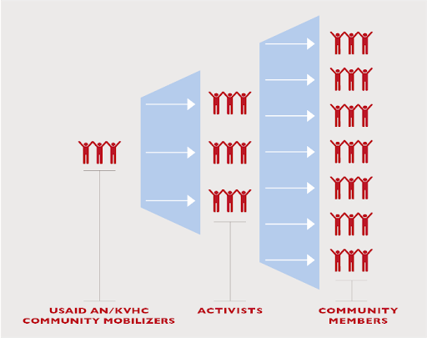

Quality Assurance, Monitoring, and Reporting
Each member of the team (30 KVHC and 8 USAID Advancing Nutrition community mobilizers) visits Activists each month in groups of 10 to assess the quality of communication and build skills through coaching. USAID Advancing Nutrition prioritizes data collection methods that suit Activists’ needs and constraints while facilitating timely collection and analysis of observational checklist data. For example, most Activists use paper reporting forms, but submit electronic copies (photos) through WhatsApp for quick submission. Training on data collection tools is integrated into team trainings.
Team members plan and implement a rotating schedule of observation to maximize on-the-job coaching. Coaching—observing someone at work and providing feedback including suggestions for improvement— helps ensure that interventions are implemented as intended and helps volunteers feel valued and motivated. Section 3 contain sample guides to help community mobilizers provide effective supportive supervision.
USAID Advancing Nutrition adapted monthly planning and reporting forms from SPRING for Activists to use with guidance from the team (Section 3). Every month, project staff collect information from Activists and give it to the SPRING monitoring and evaluation team in the Bishkek office.

Supporting Activists and Building Capacity
Modules are delivered on a cyclical basis and repeated occasionally to encourage sustained behavior change. When a module is repeated, it is updated with new information, activities, and materials. USAID Advancing Nutrition also combines topics in new ways to keep the exercises interesting for both Activists and community members, while reinforcing the content of the nutrition messages. One technical area that was strengthened through refresher trainings was building listening and counseling skills. While the modular nature leads to Activists focusing on the newest topic in home visits, after all topics are trained, there is an opportunity for Activists to switch topics on the home visit based on the family’s circumstances or challenges. In refresher trainings, USAID Advancing Nutrition focused more on the 5-Step Counseling Approach (now found in module 1 to better equip Activists with active listening and discernment skills. This also helps Activists tailor recommendations even within a set topic to respond to a caregiver’s challenges. Of course, all the Activists’ counseling skills were strengthened with the understanding that deeper one-on-one counseling would be performed with health professionals within the health system, as described above.
To reinforce key messages, Activists love using and giving families copies of USAID Advancing Nutrition’s SBC materials when possible: colorful brochures; a cookbook with recipes using diverse, nutritious, and affordable foods; and a guidebook on storing and preserving vitamin-rich foods. Additionally, many of these resources doubly serve as conversation starters, as many Activists feel more comfortable discussing a topic by discussing points from the SBC materials themselves.
Working with volunteers from various backgrounds has yielded unintended secondary benefits for USAID Advancing Nutrition’s reach of nutrition and hygiene messages. Volunteers are encouraged to use their personal networks to convey messages to the broader community. In some cases, volunteers and subgrantee staff have taken this a step further, expanding their communications beyond the scope of the project. USAID Advancing Nutrition welcomes this kind of initiative to reinforce and increase the effectiveness of the project’s SBC activities.

Adapting Program Structure Different Program Settings and Audiences

Urban areas
While this model is highly effective in rural areas, urban settings pose some challenges. USAID Advancing Nutrition and the previous SPRING project found that rural community leaders are highly motivated to serve as Activists but those in urban areas are not as interested for several possible reasons. For one, urban leaders tend to be employed or otherwise occupied during the day and do not have time for the role (to attend trainings, conduct visits for 1,000 day households, and organize community meetings). In addition, urban households are not as likely as rural households to perceive Activists as credible sources of information on nutrition and hygiene, and they feel too busy to participate in community meetings on general health issues. In cities, the intrinsic and powerful motivator of peer recognition is less present. Without this key incentive, the sustainability of the model is greatly compromised.
USAID Advancing Nutrition, therefore, used a different strategy to engage urban dwellers, based on understanding that while the prevalence of malnutrition in the Kyrgyz Republic is high in urban, as well as rural areas, communication interventions to support behavior change and reduce malnutrition in urban areas needs more emphasis on campaigns or events and social and mass media communication channels, rather than household visits.
USAID Advancing Nutrition conducted nutrition- and hygiene-focused events in urban areas (townships) in partnership with local government and HPUs to raise awareness of nutrition during the first 1,000 days and to promote improved nutrition, hygiene, and sanitation behavior. The local HPUs, which had higher capacity and involvement, lead events with support from SPRING and Activists. Events have included musical entertainment, akyn (narrated singing), drama troupe skits, cooking demonstrations, information booths, speeches by authority figures, pop concerts, comedy shows, television appearances, and distribution of social and behavior change communication materials for families to take home.

Virtual adaptation
In 2020, the launch of some community-based activities coincided with the COVID-19 pandemic, and many of our activities required remote adaptation. USAID Advancing Nutrition adapted its training structure to be conducted over virtual meeting platforms (like Zoom), and ongoing mentorship and support was conducted through messaging apps like WhatsApp. Home visits were also suspended and replaced with WhatsApp groups managed by Activists. Following each monthly training, Activists would conduct sensitizations by recording themselves or holding live events within their WhatsApp groups and holding discussions in the chat. The project’s paper materials were shared as digital files through the platform. The program benefited from the high levels of comfort and digital literacy from both its Activists and the local population.
During implementation, USAID Advancing Nutrition had to consider the loss to the program of having individual sessions (home visits) with community members, as Activists and community members were not interested in one-on-one WhatsApp call sessions. Group presentations on WhatsApp were well-received, but did not engender strong engagement. The project responded by trying to leverage the group dynamic to have community members share their challenges, attempts, and successes at behavior change on that month’s topic. Activists posed periodic discussion questions and challenges on WhatsApp in the several weeks between the introduction of new topics. These questions typically followed a pattern where group members were given several challenges and asked to report the results and their thoughts and feelings:
- Share their excitement and doubts about the topic and the idea of trying a new behavior.
- Discuss the topic with a trusted friend or family member and share their response and thoughts.
- Discuss the topic within their family (often a spouse) and agree on a plan of action.
- Take one (small, doable) step toward a behavior and share successes and failures with the group.
The challenges were intended to keep the topic fresh in the minds of community members, and it allowed them to see the experiences of others, to gain ideas on how to address and overcome barriers, and finally to strategize for repeated success.
During the pandemic, supervision activities were also adapted for a virtual setting. Mobilizers and project staff could spot-check Activists’ interactions with their groups easily as they were included in the WhatsApp groups and could follow along as necessary and provide feedback in individual consultations with Activists.
Ultimately, the project did not retain many virtual adaptations in favor of returning to the original plan of in-person visits after it was safe and culturally acceptable to do so. However, some adaptations, such as higher-level module trainings (training mobilizers) were periodically retained with no ill effect on the project.

Considerations for gender integration
The SBC communication activities conducted by USAID Advancing Nutrition were informed and shaped by the project’s ongoing gender analysis and integration work. We recognize that the home visit approach recommended by this model strongly lends itself to be largely focused on a child’s mother as primary caregiver and recipient of home visit discussions. However, family dynamics strongly influence a caregiver's ability to access resources, time, or opportunity to adopt a new behavior and household support is often critical. Any adaptation of this toolkit should adopt a gender lens, and we encourage edits and innovations that push this toolkit toward achieving further gender transformation.
While the program training structure did not give room for training directly on gender concepts to Activists, project staff and mobilizers were trained on gender integration concepts and were encouraged to consider gender-based barriers to behavior adoption. In each module, a short section is reserved for mobilizers and Activists to consider individual-, household-, and community-level challenges to adopting behavior, especially for young mothers who are often the primary discussion partners in home visits. Throughout the training, couples’ communication is highly encouraged, and is the focus of module 9, along with home budgeting. Activists are encouraged to engage with the entire present family on a home visit, but success in reaching men with this approach is limited. Future adaptations should consider creative ways to sensitize husbands, possibly through a separate approach.

Considerations for labor migration
Labor migration in Kyrgyzstan has significant implications for families and communities, particularly in relation to the care and well-being of young children during their first 1,000 days. In 2023, USAID Advancing Nutrition undertook a formative research activity in Issyk-Kul to understand particular challenges and family dynamics for families affected by labor migration, and this section highlights several key points that should be considered when adapting the project to respond to the effects of labor migration.
Prolonged separation: The research reveals that many families experience prolonged periods of separation, with caregivers, including both parents, often departing for other countries such as Russia, Kazakhstan, and Turkey.
Role of grandparents: In the absence of parents, grandparents often become the primary caregivers for children. Recognizing and involving grandparents in the project can provide support and guidance to ensure the well-being of children during this critical period.
Sustained challenges in income: While labor migration may lead to increased income in some cases, many families the project reached reported that they do not always perceive or experience a higher income level.
Decision-making power: When a caregiver leaves for labor migration, it significantly reduces or removes their influence in family decisions. Consequently, caregivers remaining at home gain more control over resources. Understanding the shifting dynamics of decision-making within families is crucial for effective counseling and support for decision-making.
These points may reflect a stark contrast to prevailing gender and family dynamics described in the previous section. Depending on the prevalence of labor migration (i.e., absence of certain caregivers in the home), there may be some gender-focused adaptations that need to be modified. For example, encouraging family discussion might mean long distance communication, or a shift in focus to intergenerational discussions and decision-making.

Key Considerations for Adapting the Modules and Materials
USAID Advancing Nutrition and implementing partners hope these modules will be used to support community volunteers and health workers in Kyrgyzstan and potentially elsewhere in the region. High levels of literacy, strong local administrations, and commitment to nutrition by key government departments (e.g., RCHP) and civil-society organizations (e.g., KVHC) all contribute to the effectiveness of the Activist approach to deliver SBC interventions. However, USAID Advancing Nutrition recommends that the modules, job aids, and SBC materials be adapted to the needs of the target communities before use. Below are factors to consider during adaptation.

Nutrition behavioral gaps and enabling environment
- What are the main nutrition problems in the implementation area? Will the practices promoted in a given module help to solve those problems? It’s important to understand the challenges from the community perspective, as well as that of technical experts or secondary data, and to agree on priority challenges at the beginning of the intervention. This increases community ownership, which then provides a more supportive environment for volunteers or workers.
- How big is the population that is affected by nutrition problems? How many volunteers/workers would be needed to reach the population with regular SBC activities? Do more vulnerable subgroups need special outreach or approaches? Is there a system to train, supervise, and support that many volunteers/workers?
- Are there local policies or conditions that would make it difficult to recruit and work with volunteers/workers? For example, it may be acceptable for volunteers/workers to visit homes, but not acceptable for them to visit classrooms for SBC activities.
- Is there an existing pool of people who have a mandate to improve nutrition (e.g., through health, hygiene and sanitation, education, or agriculture)? Are they open to partnering with you? Will they volunteer or be paid? What will their role be? If a group doesn’t exist, will you be able to create one?

Project/organization/resources fit
- What is the mission of the project or organization, and within that, what are the specific nutrition-related objectives? Will using these modules and materials to train and support community-level workers or volunteers contribute to that mission or those objectives? What other interventions will be needed to achieve these objectives?
- Is it feasible—in terms of time, capacity, and human and financial resources—for the project to promote all the practices in the modules? Will your organization be able to roll out all the modules and support community-level workers with equity and high-quality? If not, ask partners and community members which modules or topics are most relevant to the local context.
- Trying to do too much at once can overwhelm resources, volunteers/workers, and community members. Think about promoting practices in phases that build on each other. Consider promoting the practices that require the least time and fewest resources for community members first.

Audience fit
- Are community members in your implementation area open to learning from volunteers/workers about nutrition? Do they prefer to meet in their homes or public places? Have they been asked about nutrition priorities? If possible, show the materials to small groups of people—such as mothers, fathers, and grandmothers—to find out if the materials make sense to them and if they can suggest ways to adapt the materials to their local area.
- Are the practices promoted in each module feasible for target groups to adopt and to maintain? It’s more effective to promote small, doable actions, and not ask for too many changes at one time. You may need to conduct a context assessment or formative research to determine whether community members will be able to implement and sustain the practices that the modules promote.
- How many people in the community already practice what the modules promote? If few do and there aren’t significant barriers like lacking resources, it might make sense to prioritize that module. For example, if only a few people wash their hands with soap and water at the five critical times, getting a lot more people to do it could reduce illnesses that contribute to malnutrition.
Thinking through these considerations will help you decide whether the SBC approach of working with community-level volunteers or workers to promote awareness and key behaviors and increase demand for services fits your needs, and which materials fit your audience and its context. We wish you the best in bringing about improved nutrition outcomes for Kyrgyz families!

Section 2. Activist Modules

MODULE 1: Community Mobilization, Mapping, and Action Planning

Module Objectives
At the end of the session, participants will be able to—
- Explain the goal activity.
- Explain the role of “community mobilization.”
- List covered topics under the program.
- Discuss the role and importance of community Activists (exploring soft skills).
- Draw catchment areas of households for messages delivery.
Time: Approximately 2 hours

Materials and Preparation
- Before the training, read the module instructions in full below and clarify any doubts or questions with your supervisor.
- This session can be completed using the PowerPoint presentation for this module or by recreating the slides in this presentation to make flip charts. If using flip charts, complete and hang the flip charts before the beginning of the training session. The PowerPoint slides can be found in the folder of supplementary materials (in Kyrgyz only).
- The1000-Days Infographic can be printed from the supplementary materials (available in Russian and Kyrgyz) or recreated in a flipchart.
- The Five Step Counseling Approach Handout can be found under Section 3.
- Module 1 video: Trainers can screen the video for everyone during the training (on a projector or TV), or if such resources are not available, the video can be shared as a link through participants’ WhatsApp accounts. This is the link to the video for Module 1: Social mobilization

Activity I: Introduce Your Activity (10 minutes)
- Greet participants: “Dear community members of “______________” village, we are very happy to have you here for our meeting. It is great to see you all here and we thank you for your time and possibility to join us. We hope you will find today's community meeting, which is for mobilizing community Activists and leaders to improve nutrition and hygiene practices that are also crucial topics for the health and future of community members.

I believe the current situation will help recruit more engaged community members that are eager to learn more about how to stay healthy by practicing the best nutrition, hygiene, and child feeding and caring practices.”

- Explain the need to improve awareness of good nutrition, hygiene, child feeding, and child care practices. in Kyrgyzstan. Say, “Dear community leaders, we would like to share statistics that have been recently revealed under National Integrated Micronutrient and Anthropometric Survey of the KR (NIMAS) 2022.”
Present the data for children between 6–59 months using this chart in the accompanying PowerPoint. If you cannot display a PowerPoint, summarize the chart (Figure 2) with the following statistics:
Figure 2. Prevalence of Anemia, Iron Deficiency and Iron Deficiency Anemia in children 6-59 months by age in months

Ministry of Health of the Kyrgyz Republic, UNICEF, FAO, WFP, WHO, USAID, USAID Advancing Nutrition, MercyCorps. National Integrated Micronutrient and Anthropometry Survey 2021. Snapshots of Key Findings. Bishkek, the Kyrgyz Republic.
As you see, the rate of iron deficiency and anemia is very high. Evidence indicates the vulnerability of children with iron deficiency that will later become anemic and then develop various communicable and noncommunicable diseases (NCDs). It also has an influential impact on a child’s progress in growth and development. Table 1 also shows a high rate of girls with iron deficiency.
Table 1. Prevalence of Anemia, Iron Deficiency and Iron Deficiency Anemia in Adolescent Girls 10 - 18 years by region
Region | Anemia  % | Iron deficiency  % | Iron deficiency anemia  %
National | 14.6 | 46.5 | 12.7
Batken | 15.9 | 42.1 | 15.5
Jalal-Abad | 16 | 44.6 | 13.5
Issyk-Kul | 16.7 | 44.8 | 11.9
Naryn | 15.9 | 48.4 | 13.3
Osh | 8.6 | 43.4 | 9.4
Talas | 16.4 | 59.1 | 14.4
Chui | 18.3 | 48.4 | 18.7
Bishkek c. | 15.5 | 53.5 | 7.2
Osh c. | 12.9 | 43.8 | 6.9
Ministry of Health of the Kyrgyz Republic, UNICEF, FAO, WFP, WHO, USAID, USAID Advancing Nutrition, Mercy Corps. National Integrated Micronutrient and Anthropometry Survey 2021. Snapshots of Key Findings. Bishkek, the Kyrgyz Republic.

Many essential consequences can cause anemia in children and women of reproductive age.
Our community mobilization is to improve existing practices on nutrition, hygiene, sanitation, child caring, and child feeding practices.
This infographic displays the importance of all periods of the first 1,000 days, which is from conception up to the second birthday of the child.

- Introduce the project and explain its goal and objective. Say, “Dear participants, we would like to explain the goal and main objectives of the USAID Advancing Nutrition project in Kyrgyz Republic (USAID Advancing Nutrition). The project works to improve the nutritional status of women of reproductive age (ages 15–49) and children under five in the Kyrgyz Republic, with a specific focus on the 1,000 days, which covers from the pregnancy up to the second birthday of the child.
USAID Advancing Nutrition works in close collaboration with the Ministry of Healthcare of Kyrgyz Republic.
USAID Advancing Nutrition works with partners in the community for improved behaviors related to food, water, health care, hygiene, and sanitation, because all these things affect our nutritional well-being. The project provides recommendations from the World Health Organization (WHO) and the Ministry of Health (MOH) of Kyrgyz Republic to improve awareness and understanding about nutrition and hygiene.

- Discuss the 1,000 day infographic (Figure 3) to explain its importance. The infographic (can be copied to a flip chart with key information) to explain its content or can be found in the supplemental materials folder (in Kyrgyz and Russian):
Figure 3: The 1000-Day Window of Opportunity

(The trainer will follow the infographic display and ask people’s view on its statement.) The infographic explains the importance of the 1,000 day, which is divided into the main important periods: pregnancy (conception), exclusive breastfeeding period from birth to six months, and complementary feeding from six month to two years old.

The first 1,000 days of life: The time between conception and the second birthday of the child is a critical period for optimum health, growth, and neurodevelopment across the lifespan.
After summarizing the infographic, the trainer will speak about the role and importance of community mobilization.

- Explain community mobilization. Community mobilization is defined as the process of building the capacity of communities to plan, carry out, and evaluate activities in a participatory and sustained way with the goal of improving their health. The aim of the community mobilization is promoting positive and sustainable changes in social norms and attitudes and also in individual, household, and community practices. This joint effort of the community addresses the common pressing health care concerns. As mentioned above, we have to fight against anemia for children and women of reproductive age.

Social mobilization video demonstration: Indicate the USAID Advancing Nutrition YouTube channel.

After watching the video, the trainer will have an extended discussion with participants with the following questions:
- What did you learn?
- Was this information new for you?
- How would this information help you support your community to adopt good practices related to nutrition?
- Are you interested in learning more about leading practices on nutrition and hygiene for helping to improve awareness of your community to learn more about healthy eating and hygiene practices?
Summarize all responses with key messages of the video spot.

Activity II: Explain the Role of Community Activists-Volunteers (10 minutes)
- Ask the participants about the role of community Activists (leader), eliciting ideas from the training participants. Below are samples for community mobilization:
- Activists’ role: Raise awareness, disseminate information, and increase motivation of the community toward positive nutrition.
- Probe: If Activists have difficulty defining such a role, remind them of what community Activists did during COVID-19, how communities mobilized their resources to help each other and support with information sharing and referrals to the health center.
- Types of activities: Household visits, hold school meetings or speak at local government meetings, arrange small meetings, attend other community meetings, initiate informal conversations at household meetings/celebrations.
- Time consumption: For example, in one month you might have one large meeting, give a talk to a school or government meeting, and make some household visits.
Invite the group to ask questions.

- Ask each Activist to introduce themselves:
- What is your name?
- What do you do?
- Are you involved in community development activities?
- Ask Activists to share their own community development experience:
- Ask the following questions and summarize responses on a flip chart: Please give an example of positive community development. What did it achieve? What activities did you do to contribute to this success?
- Tell them you appreciate that their experiences will inform their work on nutrition in the community.

Activity III: Community Mapping (20 minutes)
- Explain to Activists that to maintain proper coverage of the community, the Activists will have to decide how to divide the work of reaching families. This can be done by mapping the community.
- Mapping:
  - Ask the Activists to divide themselves into three groups roughly based on where they live in the community; distribute flip chart pages and markers. (Note: This is to ensure the Activists are generally assigned to households near where they live. This may not be possible if Activists are not spread evenly in the community. In those cases, the project may have to assign a coverage area to an Activist who does not live there.)
  - Assign each group an area of the community that (roughly) corresponds to where they live. The entire community should be covered across these three assigned areas. Ask the Activists to think through how they will cover all the households in their community to ensure that everyone becomes aware of the importance of positive nutrition and learns positive practices.
  - Ask each group to draw a map of their portion of the community. Make sure they include homes of people as well as any buildings or sites that are important to the health and nutrition of families and young children (for example, health posts, markets where foods are sold).
  - Ask each group to present its map to the larger group.
- Presentation:
  - Using the groups’ maps, ask each Activist to identify his/her location on the map.
  - Discuss how households can be divided. In rural areas, each Activist should cover 20 households. In urban areas, each Activist can cover as many as 40 households.
  - Discuss ways that Activists can stay in touch with households, between visits (for example, WhatsApp groups).
  - Each participant can define his/her catchment area.
Presentations will help to define the catchment areas of each community Activist. If you plan to have more community Activists, you can reduce number of visited households to 20.

Activity IV: Define Communication Channels (10 minutes)
- Say, “Dear Activists, since we started our work and mutual activities toward improving household and community nutrition, child-feeding, child care, hygiene, and sanitation practices, let’s define which communication channels we can use to extend key messages recommended by the Ministry of Healthcare under promoted practices.”
- The trainer should make a note of listed channels based on catchment area while the mapping exercise, like—
- Household visits: Share with messages, applying five steps of counseling described below.
- WhatsApp groups: Online messages dissemination with the follow-up questions.
- Social media: Make posts and sharing success stories.
- Community formal meetings: Inform meeting participants about gained knowledge and skills.
- Community informal meetings: Inform meeting participants about gained knowledge and skills.

Activity V: Action Planning and Activist Leader Selection (10 minutes)
- Distribute the module planning and reporting form (see Section 3).
- Explain the form to the Activists. Each time we call them for a meeting (about monthly) we’ll provide training, sometimes with materials, and we’ll ask them to make an action plan for the month. As they conduct activities, they should keep track of who they meet with on the form. At the next meeting, we’ll collect that month’s forms and give new ones for the next month. Form 1 is completed during household visits and captures the numbers of women over 15 years old, men, and children under two in each home. Form 2 captures the number of women and men who attend community meetings. Both forms capture data on the number of informed families.
- Invite the participants to ask questions.
- Explain that Activists will be divided into teams of 15, and that each team should select a leader. Activist leaders will communicate with community mobilizers and help coordinate Activists’ work.
- Collect Activist leaders’ names and phone numbers.

Activity VI: Exploring Counseling Skills with 5- Steps to Improve Practices When Introducing Complementary Feeding (30 minutes)
- Hand out copies of the 5-Step Counseling Approach and explain its purpose.
Say, “A large part of your work as an Activist with this project will be to share information and support on good nutrition and health practices through individual home visits in the community. This project supports a counseling model to guide your home visits on each topic. This 5-Step Counseling Approach will help you and your discussion partner feel comfortable talking about each topic. Most important, this approach will help you to LISTEN carefully to your discussion partner, ANALYZE the situation, and ACT in a way that focuses on your discussion partner’s circumstances. This will help your discussion partner feel like he/she is being heard well and will allow you to focus on possible solutions that apply to his/her life. Let’s look at each step.
- Read each step aloud with the participants, or ask them to read aloud in sections. Between each step, pose the following discussion questions.

STEP 1—Open and Welcome:
The Activist invites all the household members to have a joint conversation and discussion. The Activist meets and greets the household members, asks how they are doing, and sets a very positive and welcoming tone.
If the Activist has visited the house before—
After greeting the caregiver the Activist reaches out to the household members and asks about the household’s experience with last month’s topic. The Activist asks if the household changed some of its habits after the session and if they enjoyed the experience, or if anything was difficult. The Activist can help the household remember the messages and can even provide support to overcome barriers if they express any difficulty. Be patient and try to complement what they say with helpful information. If the family expresses strong difficulties, make a note to return to provide more specific help on the topic at a later date.
- Ask the group: What would happen if you began a home visit without properly greeting your partner and setting a welcoming tone? Highlight key answers from the group.

STEP 2—Assess and Recap:
Introduce the new topic of your visit and begin the session by asking the household member about what they know and what they do in the household regarding this topic. It is important to understand the situation in the family, so be patient and give caregivers an opportunity to speak first. The Activist can ask probing questions to help caregivers give their complete thoughts.
Sample questions on exclusive breastfeeding:
How old is your child?
Are you currently pregnant?
Tell me about what you are feeding your child.
- Ask the group: Why might it be important to ask the question about the age of the child when discussing the topic of exclusive breastfeeding? (Hint: Babies should be exclusively breastfed for the first six months of life.)
  - Desired answer: If the child is over six months, it would not make sense to discuss exclusive breastfeeding as the child is already too old.
- Ask the group: Why might it be important to ask about pregnancy when discussing the topic of exclusive breastfeeding?
  - If a woman is pregnant, she should start to think about her plan to exclusively breastfeed when the child is born.
To finish step 2, please summarize what the household members have said and repeat it back to them. This is an important step to show that you are listening to what the household member said and you value their thoughts and contributions to the topic. Thank them for sharing their experience.
- Ask the group: Why do you think it is important to repeat what the household member said?
  - Desired answer: Repeating someone’s responses shows to BOTH of you that you listened well to what they were saying. It’s a good way to build trust, and it prepares you for the next step, which is analyzing.
STEP 3—Analyze and Identify 1–2 topics:
Internally review the information you learned in step 2 and prioritize what you will do next. (In step 3, the Activist makes decisions in his/her head only. The recommendations from the analysis are in step 4.)
From the information the caregiver gives, try to come up with at least one positive attitude or practice that aligns with the key messages—this way you can praise the caregiver for how they care for their child.
Always respond to concerns raised by caregivers. Prioritize no more than two recommendations that you will develop for small, doable actions that the caregivers can practice at home within a short period of time.
For example, in the sample questions about exclusive breastfeeding in step 2, an Activist might learn that a child is under six months, is still breastfeeding, but is already eating complementary foods. An Activist might ANALYZE the situation and decide to praise the mother for continuing to breastfeed, but may also try to focus on discussing what it means to exclusively breastfeed.
In this step, there is not a specific action that the Activist takes in the home visit. All the thinking is done in the Activist’s head. If an Activist cannot identify discussion points, then he/she may return to step 2 and ask more questions to learn more about the family circumstances.
- Ask the group: What would happen if an Activist did not analyze the situation and choose discussion points?
  - Desired answer: The discussion will not be focused on the household member’s circumstances and the advice may not be relevant.
STEP 4—Act (conduct activity with demonstration, practice, and positive feedback): Put into action the discussion points identified in step 3. Praise caregivers for their efforts. Provide counseling using demonstration and allow caregivers time to practice. Be sure to respond to any concerns raised by caregivers.
Counselors can use illustrations from project materials to demonstrate key messages and best practices.

STEP 5—Summarize and Close:
Summarize key messages and encourage caregivers to share their reflections. Discuss barriers to apply recommendations and problem-solve together how to overcome those barriers.
While learning more about the households’ practices about exclusive breastfeeding and responsive care the Activist responds to all needs that are under the given recommendations. If there are more issues the Activist should direct the household to the health provider for more information.
Ask caregivers to demonstrate or explain to you what they agreed to do and how they will apply this at home.
The Activist should check the day and time for the next visit and remind the household that the next module will be about “Complementary feeding, early learning through play and communication.”
Ask Activists to study this approach at home. Say, “When the group holds its next session, the group will be putting the approach in action! The more you study this approach, the better you will be prepared next session!”

Activity VII: Conclusion (2 minutes)
- Conclude the training session, and summarize important key messages. The most important message here is that you have already recruited this group as community Activists and trainers can congratulate them with their noble purpose to support their community.
- Close with, “We are all very much thankful for your coming and delighted to be working with you to mobilize the community toward starting practicing positive nutrition, hygiene, and child-feeding and caring practices.”

TRAINER REFERENCE:
FLIP CHARTS
Before the session, prepare the following flip charts as shown below.
What is the role of an Activist?

Community Mobilization—promoting positive and sustainable changes in social norms and attitudes. This is the joint effort of the community to address the common concerns.

MODULE 2: Exclusive Breastfeeding of Infants from Birth to Six Months

Module Objectives
At the end of the session, participants will be able to—
- Describe the importance of exclusive breastfeeding from birth to six months.
- Discuss possible ways to increase EBF practices.
- Counsel using EBF key messages and the 5-Step Counseling Approach.
Time: Approximately 2 hours

Materials and Preparation
- Before the training, read the module instructions in full below and clarify any doubts or questions with your supervisor.
- This session can be completed using the PowerPoint presentation for this module or by recreating the slides in this presentation to make flip charts. If using flip charts, complete and hang the flip charts before the beginning of the training session. The PowerPoint slides can be found in the folder of supplementary materials (in Kyrgyz only).
- The Five Step Counseling Approach Handout can be found under Section 3. The role play scenario can be found in Section 4. Bring at least one copy for every two participants to use in pairs.
- Module 2 video: This session contains an optional informational video. Trainers can screen the video for everyone during the training (on a projector or TV), or if such resources are not available, the video can be shared as a link through participants’ WhatsApp accounts. EBF video
- This session recommends the use of the USAID Advancing Nutrition brochure on practicing exclusive breastfeeding from birth to six months. If possible, bring at least one copy for every two participants to view and discuss. The brochure can be found in Russian and Kyrgyz in the folder of supplementary materials.
- Data collection forms designed for communities: household visits and community meetings. These forms can be found in Section 3, and copies can be found in the folder of supplementary materials.

Activity I: Introduce the Project and Objectives (5 minutes)
- Remind participants of the overall objectives of the project. A sample script from USAID Advancing Nutrition follows:
“Dear Activists, we would like to remind you of the basic objectives of the USAID Advancing Nutrition project in Kyrgyz Republic (USAID Advancing Nutrition). The project works to improve the nutritional status of women of reproductive age (ages 15–49) and children under five in the Kyrgyz Republic, with a specific focus on the 1,000 days, which covers from the pregnancy up to the second birthday of the child.
USAID Advancing Nutrition works in close collaboration with the Ministry of Healthcare of Kyrgyz Republic.
USAID Advancing Nutrition works with partners in the community for improved behaviors related to food, water, health care, hygiene, and sanitation, because all these things affect our nutritional well-being.
The project provides recommendations from WHO and MOH of Kyrgyz Republic to improve awareness and understanding about nutrition and hygiene.”

Activity II: Introduce the Topic of Exclusive Breastfeeding (20 minutes)
- Define exclusive breastfeeding for the participants (slowly and clearly): “Exclusive breastfeeding means that only breast milk is given to babies from birth until they are six months of age. Exclusive breastfeeding means that no other food or liquid is given to the baby, not even water.”
- Explain the benefits of exclusive breastfeeding, which have been determined after years of scientific study in many countries throughout the world, are recommended by the MOH. You may develop flip charts for this information using the sample flip charts in “Trainer’s Reference.” Explain all key message stated below:
- Breast milk contains all the nutrients and fluids that babies need for the first six months of life.
- Breastfeeding delivers health benefits to the infant and mother.
- Breast milk provides an ideal balance of nutrients for the human infant. The nutrients in breast milk are easily absorbed and digested. Other foods/liquids are hard for babies younger than six months to digest, and expose them to contamination and illnesses.
- Giving your child other foods/liquids may expose them to contamination and illnesses. Infants younger than six months who received drink or food in addition to breast milk have a higher risk of diarrhea. Because infant formula is mixed with water, bottle-fed babies are 17 times more likely to get diarrhea than EBF babies.
- Breastfeeding protects babies against respiratory diseases. Child mortality from pneumonia is higher among infants who are not exclusively breastfed. Breast milk contains immune and anti-infective properties that protect babies from other infections and even allergies.
- Nearly all women are biologically capable of breastfeeding, bar very few with severely limiting medical disorders even if they don’t get enough to eat themselves, are ill, have twins, or become pregnant again.
- Exclusive breastfeeding takes time and patience, because newborns have small stomachs, and should be breastfed eight times throughout the day and four times at night, in total 12 times. Because of this, family and workplace support are very important for moms to exclusively breastfeed.
- Health worker support is also important to help moms and babies establish a good breastfeeding routine and to help moms overcome challenges.
- Giving other liquids or food (including infant formula) can decrease the mother’s supply of breast milk. More breastfeeding means more breast milk is produced. Moms can increase the amount of milk by feeding more frequently, and making sure to feed long enough from each breast (until it feels soft).
- Breastfeeding also stimulates loving feelings between mother and baby. It helps your baby feel safe and comforted.
- During breastfeeding, a baby is learning how to control his appetite and soothe himself. He is determining how much milk he needs and how much he wants to suck to comfort himself.
- Explain hunger and satiety cues for young children in the exclusive breastfeeding period:
- Cues your baby is hungry:
- wakes and tosses or sucks on fist (before 3 months)
- cries or fusses.
- Cues your baby is full:
- closes mouth or lips shut
- turns head away
- decreases or stops sucking
- spits out the nipple
- falls asleep when full.
Explain to the group that understanding these signs are part of “responsive feeding” you will discuss with other signs and techniques related to responsive feeding in a later session.
- Discuss the importance of breastfeeding during a suspected or confirmed case of COVID-19.
- Mothers should continue breastfeeding even if there is a suspected or confirmed case of COVID-19 in the mother or baby.
- If you suspect any symptoms of COVID-19, wear a mask and wash your hands for at least 20 seconds before breastfeeding.
- Present the EBF video (optional): EBF video
The trainer demonstrates the 1.4-minute animated video to all participants that describes the benefits of exclusive breastfeeding for neonates and mothers for the first six months. The video can help to summarize the above stated and explained key message and further will serve for digital sharing to extend exclusive breastfeeding practices for children from birth to six months. (It is suggested to demonstrate the video during the training and be sure that all participants have watched and discussed the video.)
- Explain the role of the Community Activists
- Convey the importance of EBF through key messages and to encourage families with babies younger than six months to seek services that will help them achieve exclusive breastfeeding. Health facility workers have more detailed information and can give mothers and families counseling and support.
- Key messages above can be shared online (provided above presentation, video, and booklet) in the toolkit, because there could be several functioning WhatsApp groups among neighbors and other community members in Community Activists’ catchment area. Community Activists can share and provide full online support for breastfeeding mothers.
- For reaching more effective results a Community Activist can ask feedback about breastfeeding practices online and about successes and challenges of breastfeeding mothers. The Community Activists should be open for any questions; for more specific requests or questions go directly to health providers for detailed medical counseling. Extending awareness in breastfeeding practices is the key for introducing the best child feeding practices.

Activity III: Presentation of the “Exclusive Breastfeeding” Booklet and Key Messages (10 minutes)
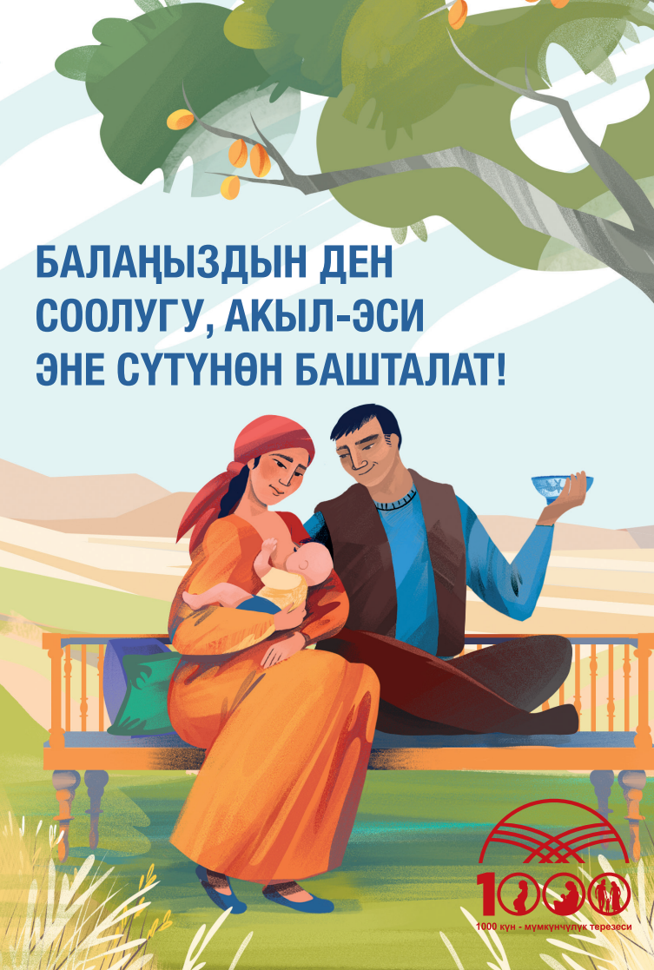
- Share the two-page booklet on exclusive breastfeeding with the group. Explain that this booklet has the main recommendations for supporting exclusive breastfeeding from birth to six months and continued breastfeeding to two years. Also included is guidance for appropriate positioning and attachment while breastfeeding.
The booklet also emphasizes the importance of breastfeeding support even in case of positive COVID-19 infection, reminding critical moments for handwashing and applying to health providers in case of any complications.
- Ask Activists to spend 6–7 minutes reading the booklet and encourage them to raise any questions they have on the content.

Activity IV: Brainstorm (10 minutes)
- Say to the group, “Now that we have knowledge and resources about the best practices for feeding a child under six months, we should spend time discussing what people commonly do in our communities. While some people may already practice exclusive breastfeeding until six months, many do not.
- Ask the following questions and write answers on flip charts (trainer). Collect the answers on the flip charts prepared for 3.1 and 3.2.
- What foods/liquids (besides breast milk) are commonly given to babies younger than six months in Kyrgyz Republic?
- Possible responses: Water, tea, fruit juice, rice, soft foods, bulyamuk
- What challenges do women face in exclusively breastfeeding their babies for the first six months? Why do only 46 percent of women in Kyrgyzstan practice EBF?
- Possible responses: Don’t have good information. Believe that breast milk is not enough and their infants are hungry/thirsty. Believe that other foods or formula may be healthier than breast milk. Don’t have time to stay with the baby or other care givers. Family members, neighbors, or health providers pressure them to give other food or liquids. They become pregnant and believe breastfeeding will harm the fetus.
- Brainstorm problem-solving ideas/responses that Activists can give to families to encourage exclusive breastfeeding for infants from birth–six months. For each reason that a mother does not practice EBF, ask Activists how they might respond. Possible reasons and responses:
- Lack of accurate information:
- EBF is the best thing for your baby until six months of age. Other foods/liquids are not necessary.
- Breast milk is not enough, my baby is hungry/thirsty:
- Approximately 95 percent of women can produce enough breast milk for their baby. The more the baby suckles, the more milk will be produced. Keep breastfeeding. If you are worried, ask your health provider for support and suggestions.
- Other foods are healthier:
- Nothing is healthier for your baby than your breast milk, and other foods/liquids expose your baby to harm. Breast milk is the best gift you can give to your baby. Nothing else is needed for the first six months.
- No time/other caregiver:
- Exclusive breastfeeding is the best thing for your baby. Try to arrange for the mother and baby to stay together so other foods are not necessary. Other family members should help with household tasks, support exclusive breastfeeding, and not give other foods/liquids to babies.

Activity V: Exploring How to Support an Enabling Environment for Mothers on Exclusive Breastfeeding (10 minutes)
- Explain to the group that very often, household tasks related to care and feeding of children is considered the domain of mothers. But we know that mothers have a lot of other tasks, and every adult in the household can contribute to a child’s well-being.
- Ask the group the following questions and collect their answers. The facilitator will highlight the right information and/or guide the group toward the desired responses.
  - How can other household members support breastfeeding mothers?
Expected answers:
    - Support breastfeeding and encourage the mother to breastfeed.
    - Give breastfeeding mothers good nutrition to keep them strong and support milk production.
    - Give more time to breastfeeding. (Probe: How? See below.)
    - Support mothers with household chores.
    - Participate in raising children.
    - Feed expressed breastmilk to babies if the mother is out or away from the baby.
  - What can we as Activists do to help household members be engaged in exclusive breastfeeding?
Expected responses:
    - Include fathers and grandparents in home visit discussions.
    - Follow up with other household members on the next visit.
    - Discuss strategies with a mother on how to talk about the topic with family members.
    - Encourage family members to commit to the behaviors identified in the last question.
- Summarize that participation of all family members in child care and nutrition practices contribute to the child’s growth and development.

Activity VI: Exploring Counseling Skills with 5- Steps (30 minutes)
- Explain the next activity will be done in pairs. Say, “During our community mobilization module, you were engaged for counseling. Let’s review counseling steps today through role play. Today, we will practice the five steps to give EBF messages and counseling to households that need information about EBF practices.”
- Explain to the group that for this topic counselors will be visiting ONLY the 1,000 day households within their assigned area, as the module is based on promoting best young children feeding and nurturing care practices.
- Quickly review each of the five steps using the 5-Steps handout from module 2. Ask participants to give an example of how to apply each step to today’s topic.
  - Greet and welcome. This greeting sets a good rapport between the Activist and the family member. Remind participants that step 1 does NOT change based on the topic.
  - Assess and recap: What questions can Activists ask community members to learn the appropriateness of discussing exclusive breastfeeding?
Sample answers:
    - How old is your child?
    - Are you currently pregnant?
    - (If the child is between birth–six months): Tell me about what you are feeding your child.
    - (If mother says she’s exclusively breastfeeding): Do you ever give your child other foods or drinks? What kinds?
    - What do other members of the family think about breastfeeding the child exclusively? Do they support this practice or not? How?
  - Analyze and introduce the topic: What kinds of responses to the questions above would signal that this person should receive counseling on exclusive breastfeeding? Sample answers:
    - The caregiver has a child under six months.
    - The caregiver is pregnant and will give birth soon (counseling to plan for exclusive breastfeeding).
    - The caregiver gives her child under six months other foods or liquids in addition to breastmilk.
    - The caregiver expresses a lack of support from her family to exclusively breastfeed.
  - Act: What kinds of messages would you like to give a caregiver who has difficulty exclusively breastfeeding? What activities could you do with her to promote the practice?
Sample answers:
    - Breastmilk is the best food for your baby under six months.
    - Your baby needs only breastmilk.
    - Practice discussing EBF with the family (to build family support).
  - Recap and close: What kind of actions can a community member commit to in order to practice exclusive breastfeeding?
Sample answers:
    - Can promise not to feed any food or liquid to the baby.
    - Can promise to share lessons with family members.
    - Can discuss with family members to get time to breastfeed the baby whenever the baby needs to be fed.

- Set up the role play. Say, “Let’s role play counseling on exclusive breastfeeding.” Divide the group into pairs. Give each pair a printout of the role play scenarios for this module found in Section 4. Assign one person to play the role of counselor and another to play the role of a breastfeeding mother. The person role playing the mother can invent any attitudes and practices around breastfeeding they would like, but please choose at least one issue that the counselor can notice and work to counsel on.
  - The counselor should use the 5-Steps Counseling Approach to talk about exclusive breastfeeding with the mother. Give the pairs 8–10 minutes to practice. If they finish early, have them switch roles.
- Spend the last 5 minutes asking the counselors and role players which steps they did well and which steps were difficult, using the scenario below.

Activity VII: Explain the Planning and Reporting Forms (20 minutes)
- Explain, “We need to learn how our messages are disseminated and how many people have received messages on best practices on exclusive breastfeeding from birth to six months. Therefore, we will disseminate two different forms that can help us to understand how many individual households have been reached with the current topic messages.
- Explain, “Every Community Activist receives two different hard copies of forms that are given for indicating data about disseminated key messages in his/her catchment area, preliminary defined at the previous community mobilization meeting.”
- Share the reporting forms with the group. Review the information requested by each form and confirm that the Activists understand and feel comfortable completing the information on the form. Respond to any concerns.
- Explain to Activists how to submit the reporting forms. (For example, for USAID Advancing Nutrition the Activists submitted reporting forms for activities of the previous month when they arrived for training on the new module. During COVID-19 social distancing, Activists submitted photographs of paper forms via WhatsApp.)
The sample form is in the link above under the materials and preparation section.
- Distribute planning forms for the next month and ask them to take a few minutes to make a plan.
- As they plan their activities for the month, ask what they learned and what was most interesting.

Activity VIII: Summarize Key Messages (5 minutes)
- Ask participants what they learned. They should list one or more of the key messages.

Activity IX: Conclusion (5 minutes)
- Close the session by saying, “Thank you for your joining and for your efforts to mobilize the community on exclusive breastfeeding. YOU have become a counselor that can help their communities in adopting key practices about best child feeding, positive hygiene, and nurturing care that will have a crucial impact on the well-being of families and children.
By helping our moms and kids to be strong and well-nourished, we are helping Kyrgyzstan be a strong country. Thank you and I look forward to meeting you all again for our next session soon!”

TRAINER REFERENCE:
FLIP CHARTS
Before the session, prepare the following flip charts as shown below.
What foods/liquids (besides breast milk) are commonly given to babies younger than six months in Kyrgyz Republic?

Why do only 46% percent of women in Kyrgyzstan practice EBF?

Ideas/responses that Activists can give to families to encourage exclusive breastfeeding for infant’s birth–six months.

EBF Key Messages
- Mother's milk is the perfect and best food for the growth and development of the baby.
- Breastmilk is irreplaceable and has all the required nutrients and fluids that babies need for the first six months of life.
- Breastfeeding delivers health benefits to the infant and mother.
- Breastfeeding protects babies from various diseases as breast milk contains immune and anti-infective properties which protect babies from other infections and even allergies.

MODULE 3: Diverse and Timely Feeding of Complementary Foods to Children Beginning at Six Months

Module Objectives
At the end of the session, participants will be able to—
- Explain the principles and importance of appropriate and intime complementary feeding to caregivers.
- Describe importance of appropriate and in time complementary feeding.
- Learn the damage of junk food for health and wellbeing in child feeding practices.
- Strengthen and explore counseling skills of Community Activists on complementary feeding.
Time: Approximately 2 hours

Materials and Preparation
- Before the training, read the module instructions in full below and clarify any doubts or questions with your supervisor.
- This session can be completed using the PowerPoint presentation for this module or by recreating the slides in this presentation to make flip charts. If using flip charts, complete and hang the flip charts before the beginning of the training session. The PowerPoint slides can be found in the folder of supplementary materials (in Kyrgyz only).
- The Five Step Counseling Approach Handout can be found under Section 3. The role play scenario can be found in Section 4. Bring at least one copy for every two participants to use in pairs.
- Module 3 video: This session contains an optional informational video. Trainers can screen the video for everyone during the training (on a projector or TV), or if such resources are not available, the video can be shared as a link through participants’ WhatsApp accounts. This is the link to Complementary feeding.
- This session recommends the use of several materials. If possible, bring at least one copy for every two participants to view and discuss. The materials can be found in the folder of supplementary materials.
- USAID Advancing Nutrition brochure on introducing complementary feeding for children from six months to two years old. (Russian and Kyrgyz)
- USAID Advancing Nutrition infographic on introducing complementary feeding for children from six months to two years old. (Russian and Kyrgyz)
- USAID Advancing Nutrition cookbook. (Russian and Kyrgyz)
- Data collection forms designed for communities: household visits and community meetings. These forms can be found in Section 3, and copies can be found in the folder of supplementary materials.

Activity I: Introduce the Project and Objectives (10 minutes)
- Remind participants of the overall objectives of the project. A sample script from USAID Advancing Nutrition follows:
“Dear Activists, we would like to remind you of the basic objectives of the USAID Advancing Nutrition project in Kyrgyz Republic (USAID Advancing Nutrition). The project works to improve the nutritional status of women of reproductive age (ages 15–49) and children under five in the Kyrgyz Republic, with a specific focus on the 1,000 days, which covers from the pregnancy up to the second birthday of the child.
USAID Advancing Nutrition works in close collaboration with the Ministry of Healthcare of Kyrgyz Republic.
USAID Advancing Nutrition works with partners in the community for improved behaviors related to food, water, health care, hygiene, and sanitation, because all these things affect our nutritional well-being.
The project provides recommendations from WHO and MOH of Kyrgyz Republic to improve awareness and understanding about nutrition and hygiene.”
Have the group share their experiences in the previous month’s dissemination. Divide the participants into groups of three to share with each other for 3 minutes. Reconvene the whole group and ask each trio to share one success or one challenge for the Community Activists’ benefit.

Activity II: Interactive Brainstorm—Importance of Timely and Appropriate Introduction of Complementary Foods from Six Months (30 minutes)
- Explain that to learn about complementary feeding, we will collect what we already know as a group. The facilitator will highlight the right information and/or guide the group toward the desired responses.
  - What is complementary feeding?
    - Desired response: Giving the child foods other than breastmilk.
  - Why do we call it “complementary” feeding? What does it mean for these foods to be “complementary”?
    - Desired response: Complementary means “helping.” Complementary foods “help” a breastfeeding baby get enough nutrition once breastmilk alone is not enough.
  - What age is the right time to start giving other liquids and foods in addition to breast milk to babies?
    - Expected responses: When a baby is crying; baby is not getting enough milk to make a baby grow fast.
    - Desired response: A baby should start receiving complementary foods at six months of age, while continuing to breastfeed.
- Explain that for the next question(s) we are going to write down responses so we can compare them to the best practices we’re about to learn. Show them the prepared flip chart and ask—
  - “In Kyrgyzstan, what types of food are usually given to babies when they first start eating complementary foods”?
    - Expected responses: Bulamyk (national porridge), cookies, bread, airan (national sour milk), other types of porridge
  - What are some new products that people have recently started to give to babies when they first start eating”? (yogurt, etc.)
    - Expected responses: yogurt, pureed fruits and vegetables.

- Explain that you are now going to summarize the recommendations of the Ministry of Healthcare on complementary feeding. Using flip charts and the details below, explain the following points:
  - Continue breastfeeding up to two years. This will help your baby to be healthy and smart.
  - Complementary feeding is food in addition to (complementing) breast milk. After six months, breast milk remains an important part of a child's diet, but by then it does not provide enough nutrients for health and growth, so other foods must be added. Continued breastfeeding and complementary feeding starting at six months guarantees proper weight gain and growth of your baby.
  - Responsive feeding: Feeding new foods to children at this age takes love and patience. They are learning how to eat and every taste and texture is new to them. Caregivers must take time to encourage children to eat and be patient and persistent to ensure that children are eating enough energy and nutrients. Engaging all family members (fathers, mothers-in-law, older children) for supporting to focus on responsive and in-time feeding.
  - Frequency: Feeding must happen frequently because children at this age have small stomachs and can only eat a little bit at a time.
  - Adequacy: The total amount of food and breast milk eaten during the day must be of sufficient quantity. Thick-consistency food gives more energy; you can tell a food is thick enough if it stays on the spoon when you pour it. Thin foods are more watery and have fewer nutrients.
  - Diversity/density: Foods must be nutrient-dense (containing many nutrients per gram). First foods should be thick and include animal source foods and mashed fruits and vegetables. Give children a variety of foods to make sure that all their nutritional needs are met. For healthy growth children need domestic animal products; different kinds of beans; lentils; walnuts; and yellow fruit and vegetables that contain vitamin A.
  - Medical Supervision: Take children for regular health checks. Not all illnesses can be seen, and some interfere with the body's ability to use food for energy, growth, and mental development.
  - Handwashing: Caregivers must wash their and the child's hands at the critical times. Tell Activists that next month’s topic will discuss handwashing and hygiene in more detail.
  - A sick baby needs help drinking and eating. An additional portion a day may expedite recovery. Caregivers should continue giving extra portions to children after illness to build up strength.
  - Share with the online cookbook, which has several sections: importance of nutrition for growth and development of children; what should be first complementary feeding; products ingredients and nutritious value; and a food pyramid and food group information.
- Discuss the complementary feeding infographic (Figure 4) and explain its importance. The infographic can be copied to a flip chart with key information to explain its content or can be found in the supplemental materials folder (in Kyrgyz and Russian):
Figure 4: Introduction of Timely and Adequate Complementary Feeding
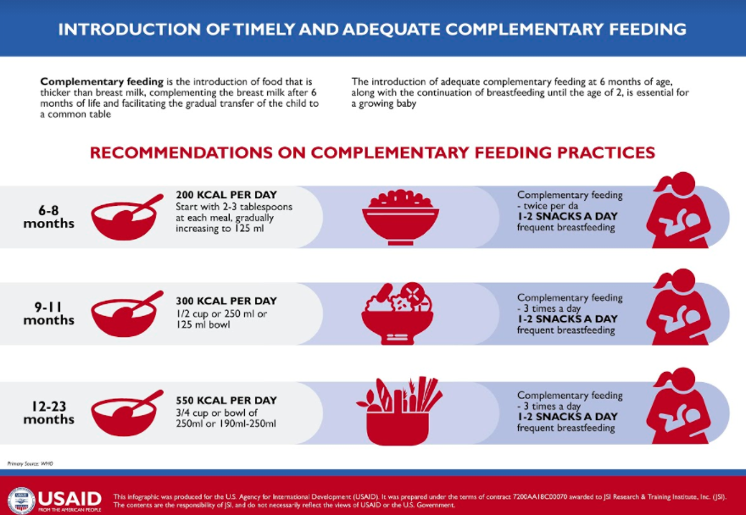
The infographic explains the importance of three freshly cooked meals and snacks for the day’s menu, including the required portion for the certain children's age group. (The digital version of infographic is available for printing, as well as can be copied to the flip chart by hand drawing and used as a visual aid.
- Present the Complementary Feeding video (optional): After watching the video, the trainer will have an extended discussion with participants with the following questions:
  - What did you learn?
  - Was this information new for you?
  - How would this information help you support your community to adopt good practices related to nutrition?
Summarize all responses with key messages of the video spot.

Activity III: Presentation of the “Complementary Feeding” Brochure and Summarizing Key Messages (10 minutes)
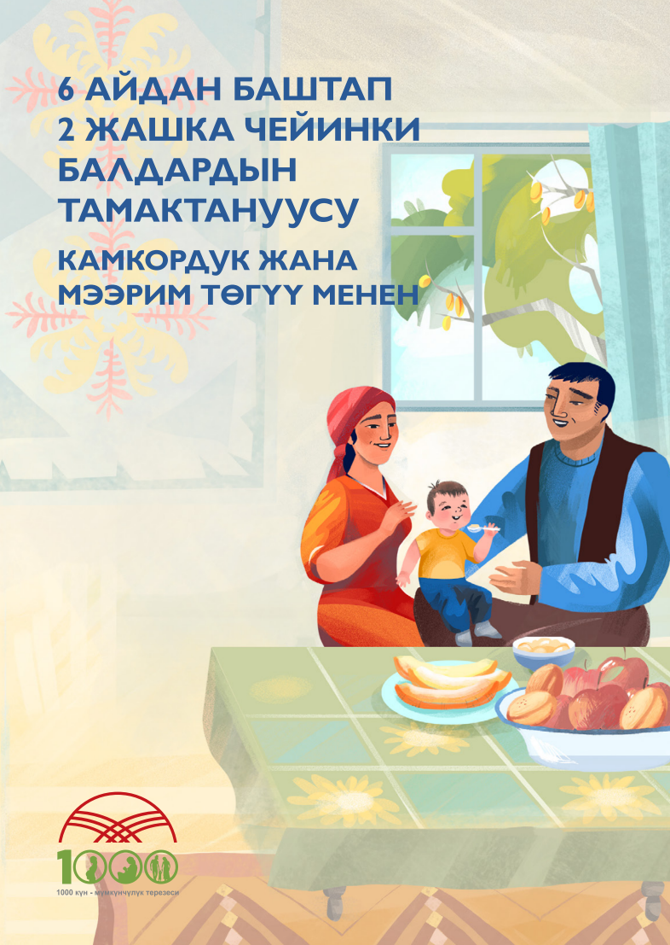
- Share the two-page booklet on complementary feeding with the group. Explain that this booklet is updated with recent WHO recommendations on complementary feeding, which gives comprehensive information about the importance of an appropriate, diversified, and a healthy diet for the children starting from six months, including recommendations on practicing best child care practices while feeding.
- Ask Activists to spend 6–7 minutes reading the booklet and encourage them to raise any questions they have on the content.
- (If using) This Kyrgyz- and Russian-language cookbook published by SPRING, with support from Ergene, was designed to encourage nutritious eating habits for families, especially those with children under two years old.
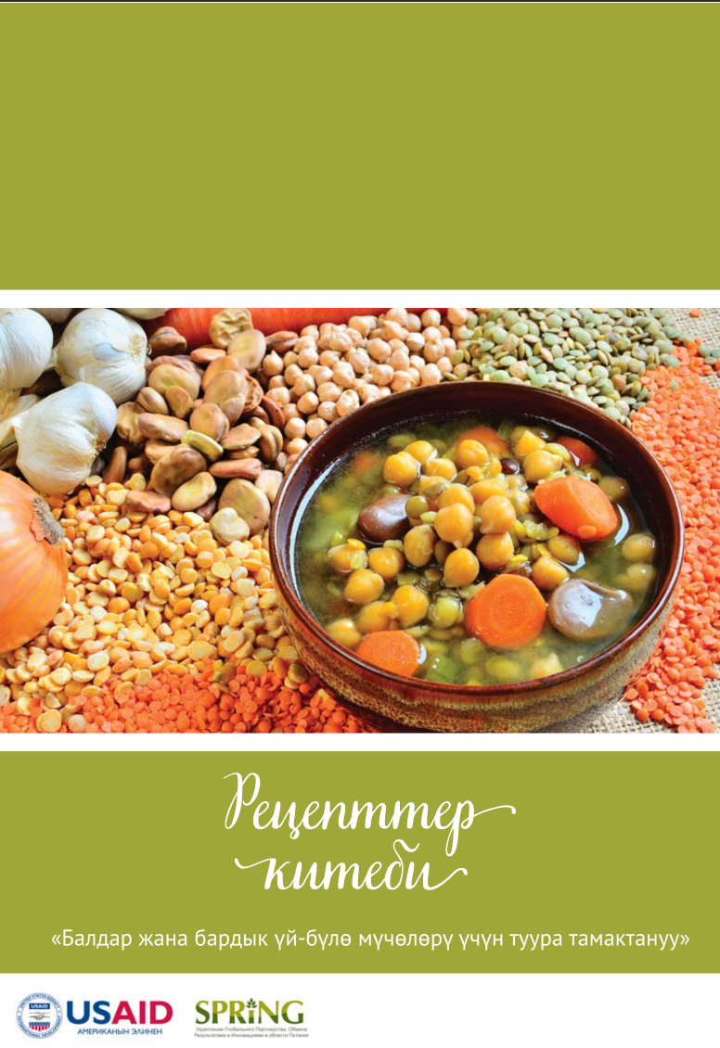
Developed by local experts, it compiles best practices from leading international organizations working in nutrition and dietary recommendations. The cookbook also includes current information regarding nutrition and the composition of basic foods, including specific information on vegetables, fruits, grains, cereals, and animal products unique to the Kyrgyz Republic. Recipes feature the "nutrition facts" for the meals so that families can know the approximate amounts of micronutrients—such as iron, zinc, and vitamins A, E, and C—that they will be consuming.

Activity IV: Avoid Harmful Foods (10 minutes)
- Ask the group “What is junk food” or "sometimes foods”? and “Why should we avoid or reduce its consumption for our young children”?
  - Desired responses: Junk foods are defined as pre-packaged foods with lots of added salt, fat, and sugar.
  - Junk foods take up room in the child's stomach without providing the nutrients they need to grow. They can also be expensive, using money that would be better spent on healthier foods like eggs, dairy, fish, meat, and nutrient-rich vegetables. It is important to give healthy, clean water to children ages six months to two years. Do not give sugary drinks like sodas or fruit juice, which reduces the appetite for healthy foods and can rot the first teeth.
- Say, “Even though most of us know that junk food is not healthy for us and our children, many of us still have a habit of eating junk food and feeding it to our children. What are some things you imagine people might say to defend their consumption of junk food? What can we say in response? Let’s brainstorm:”
  - It tastes good.
    - Response: Lots of foods taste good! As you begin complementary feeding, you are building the child's tastes for foods in life. If you begin with junk food too early, they will develop that preference at a very young age.
  - It's easy because I don't have to prepare things.
    - Response: There are healthy alternatives to junk food snacks that take little or no preparation and can stay fresh until your child wants them. Nuts and some fruits store well. Try hard boiling some eggs at the same time you are cooking lunch so your child can have a healthy afternoon snack.

Activity V: Exploring How to Support an Enabling Environment for Mothers on Complementary Feeding (10 minutes)
- Explain to the group that very often, household tasks related to care and feeding of children is considered the domain of mothers. But, we know that mothers have a lot of other tasks, and every adult in the household can contribute to the child’s well-being.
- Ask the group the following questions and collect their answers. The facilitator will highlight the right information and/or guide the group toward the desired responses.
  - How can other household members support mothers in complementary feeding?
Expected answers:
    - Support breastfeeding and encourage the mother to breastfeed.
    - Prioritize household funds to purchasing nutritious complementary foods for the baby
    - Give more time to a mother to focus on complementary feeding during meal times (Probe: How? See below.)
    - Support mothers with household chores including serving meals to family.
    - Participate in raising other children to allow mother time to focus on complementary feeding.
    - Participate in complementary feeding whenever possible.
  - What can we as Activists do to help household members be engaged in exclusive breastfeeding?
Expected responses:
    - Include fathers and grandparents in home visit discussions.
    - Follow up with other household members on the next visit.
    - Discuss strategies with a mother on how to talk about the topic with family members.
    - Encourage family members to commit to the behaviors identified in the last question.
- Summarize that participation of all family members in child care and nutrition practices contribute to the child’s growth and development.

Activity VI: Exploring Counseling Skills with Six Steps for Improving Practices When Introducing Complementary Feeding (30 minutes)
- Explain the next activity will be done in pairs. Say, “During our community mobilization module, you have been engaged for counseling. Let’s review counseling steps today through role play. Today, we will practice the five steps to give complementary feeding messages and counseling to households that need information about complementary feeding practices.”
- Explain to the group that for this topic, counselors will be visiting ONLY the 1,000 day households within their assigned area, as the module is based on promoting best young children feeding and nurturing care practices.
- Quickly review each of the five steps using the 5-Step Counseling Approach handout from module 2. Ask participants to give an example of how to apply each step to today’s topic (in this case, complementary feeding).
  - Greet and welcome. This greeting sets a good rapport between the Activist and the family member. Remind participants that step 1 does NOT change based on the topic.
  - Assess and recap: What questions can Activists ask community members to learn the appropriateness of discussing exclusive breastfeeding?
Sample answers:
    - How old is your child?
    - Tell me about what you are feeding your child. What do they like and not like to eat?
    - How do you prepare foods for complementary feeding?
    - Show me how you feed your child.
    - What do other members of the family think about your practices doing complementary feeding for your baby? Do they support this practice or not? How?
  - Analyze and introduce the topic: What kinds of responses to the questions above would signal that this person should receive counseling on complementary feeding?
Sample answers:
    - The caregiver has a child who is over six months.
    - The child likes to eat fruits and different kinds of soups as well. The baby particularly likes cookies and crackers.
    - The caregiver mashes foods up very fine into a paste for the two-year-old child to eat (at 12 months, you should counsel on giving larger pieces and finger foods).
    - The caregiver expresses a lack of support from her family to for giving certain foods.
  - Act: What kinds of messages would you like to give a caregiver who has difficulty with appropriate complementary feeding? What activities could you do with her to promote the practice?
Sample answers:
    - Complementary feeding is necessary to begin at six months with continued breastfeeding.
    - Your baby needs high-nutrient foods with vitamin A and iron-rich foods for good growth and development.
    - Your baby is old enough to have finger foods and does not need everything mashed to a fine paste.
    - Practice discussing complementary feeding with the family (to build family support).
  - Recap and close: What kind of actions can a community member commit to in order to practice exclusive breastfeeding?
Sample answers:
    - Can promise to introduce at least two nutrient-rich foods as snacks for the child
    - Can promise to share lessons with family members.
    - Can discuss with family members to buy healthy complementary foods for the baby.

- Set up the role play. Say, “Let’s role play counseling on complementary feeding.” Divide the group into pairs. Give each pair a printout of the role play scenarios for this module found in Section 4. Assign one person to play the role of counselor and another to play the role of a mother. Alternatively, the person role playing the mother can invent any attitudes and practices around the topic they would like, but please choose at least one issue that the counselor can notice and work to counsel on.

The counselor should use the 5-Step Counseling Approach to talk about complementary feeding with the mother. Give the pairs 8–10 minutes to practice. If they finish early, have them switch roles.
- Spend the last 5 minutes asking the counselors and role players which steps they did well and which steps were difficult using the scenario below.

Activity VII: Summarize Key Messages (5 minutes)
Ask participants what they have learned. They should list one or more of the key messages.

Activity VIII: Experience-Sharing on Previous Month’s Message Dissemination (15 minutes or 5 minutes)
Divide participants in two or three groups of four–five people and ask them to talk about their experiences disseminating messages from the previous session, including success and challenges. On a flip chart, make a column for each and list accordingly. Reconvene and ask each group to present its list. Ask the large group to discuss and offer advice to each other.
OR
Ask several volunteers to talk about something that went well in the previous month.

Activity IX: Action Planning for the Coming Month (10 minutes)
- Collect the Activists’ planning forms from the previous month. Make sure they are complete and have the Activists’ names on them. Speak with Activists who haven’t turned in a form or who have not filled in one completely or correctly.
- Distribute planning forms for the next month and ask them to take a few minutes to make a plan.
- As they plan their activities for the month, ask what they learned and what was most interesting.

Activity X: Conclusion (2 minutes)
- Say, “We are thankful for your coming and delighted to be working with you to mobilize the community toward positive nutrition. By helping our moms and kids to be strong and well-nourished, we are helping Kyrgyzstan be a strong country.”

TRAINER REFERENCE:
FLIP CHARTS
Before the session, prepare the following flip charts as shown below.
What is the first food (complementary to breast milk) commonly given to babies after six months in Kyrgyz Republic?

CF Key Messages
- Continue breastfeeding to two years old and more
- Diversified and freshly cooked meal from products rich with vitamins C and A, iron, and zinc (animal source food)
- Three meal times and one–two snacks
- Avoid harmful food for children under two years (exclude salt and sugar); whole milk can be given starting with a one-year-old baby
Responsive feeding—playing and communicating (making feeding time joyful)
Importance of following below principles for complementary feeding

Age
Frequency
Amount
Diversity
Thickness
Use the infographic

MODULE 4: Best Responsive Care and Child Feeding Practices

Module Objectives
At the end of the session, participants will be able to—
- Describe how nurturing care contributes to healthy brain development throughout the first 1,000 days.
- Understand the concept of responsive care and responsive feeding practices through the first two years of life.
- Demonstrate and practice delivering key messages on responsive care and responsive feeding.

Time: Approximately 2 hours

Materials and Preparation
- Before the training, read the module instructions in full below and clarify any doubts or questions with your supervisor.
- This session can be completed using the PowerPoint presentation for this module or by recreating the slides in this presentation to make flip charts. If using flip charts, complete and hang the flip charts before the beginning of the training session. The PowerPoint slides can be found in the folder of supplementary materials (in Kyrgyz only).
- The Five Step Counseling Approach Handout can be found under Section 3. The role play scenario can be found in Section 4. Bring at least one copy for every two participants to use in pairs.
- This session recommends the use of the USAID Advancing Nutrition brochure on responsive care and responsive feeding from birth to six months. If possible, bring at least one copy for every two participants to view and discuss. The brochure can be found in Russian and Kyrgyz in the folder of supplementary materials.
- This session contains a game on brain development that requires printing and cutting of several training aids. The resources for this game are found in the folder of supplementary materials (in Russian only).
- Data collection forms designed for communities: household visits and community meetings. These forms can be found in Section 3, and copies can be found in the folder of supplementary materials.

Activity I: Introduce the Project and Objectives (5 minutes)
- Remind participants of the overall objectives of the project. A sample script from USAID Advancing Nutrition follows:
“Dear Activists, we would like to remind you of the basic objectives of the USAID Advancing Nutrition project in Kyrgyz Republic (USAID Advancing Nutrition). The project works to improve the nutritional status of women of reproductive age (ages 15–49) and children under five in the Kyrgyz Republic, with a specific focus on the 1,000 days, which covers from the pregnancy to the second birthday of the child.
USAID Advancing Nutrition works in close collaboration with the Ministry of Healthcare of Kyrgyz Republic.
USAID Advancing Nutrition works with partners in the community to improve behaviors related to food, water, health care, hygiene, and sanitation, because all of these affect our nutritional well-being.
The project provides recommendations from WHO and MOH of Kyrgyz Republic to improve awareness and understanding about nutrition and hygiene.”

Activity II: Understanding of Nurturing Care (20 min)
      - Introduce the topic. Say, “Dear Activists, in this module we are going to learn about nurturing care. ‘Nurturing care refers to what a child needs to survive, thrive, and achieve healthy growth and development; it promotes good development and protects young children from stressors or potential harm in their environment; and comprises five interrelated components that young children need to thrive: good health, adequate nutrition, safety and security, opportunities for early learning, and responsive caregiving.’”
Always remember the Nurturing Care Framework (prepared flip chart in advance with the five components description):
- Discuss the nurturing care framework infographic (Figure 5) and explain its importance. The infographic can be copied to a flip chart with key information to explain its content:
Figure 5: The Nurturing Care Framework
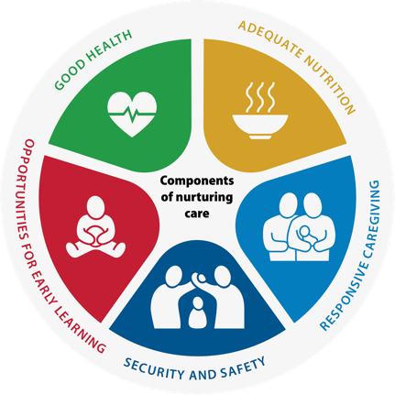
The community mobilizer should also add, “All five components of nurturing care are equally important and interrelated. These five components represent all the care children need to achieve good growth, health, and development outcomes.”
Provide a quick definition and list examples of each component.
Adequate Nutrition: Refers to maternal and child nutrition.
Interventions include—
  - early initiation and exclusive breastfeeding for six months
  - breastfeeding on demand
  - continued breastfeeding after six months with appropriate and responsive complementary feeding
  - responsive complementary feeding
  - adequate physical activity, sedentary behavior, and sleep in early childhood
  - management of moderate and severe malnutrition, as well as overweight and obesity.
Summarize responses with Activists with the shortened list below:
- maternal nutrition
- practicing exclusive breastfeeding up to six months
- iron-folic acid (IFA) supplementation for children and mothers.
Opportunities for Early Learning: Refers to any opportunity for the child to interact with a person, place, or object in their environment. Every interaction (positive or negative) or absence of an interaction contributes to the child’s brain development and lays the foundation for later learning.
Examples include—
Activities that encourage young children to move their bodies, activate their five senses, hear and use language, and explore:
  - Explore books together and read to the child.
  - Talk to and with the child.
  - Smile, imitate/copy, and play simple games (e.g., peekaboo).
  - Initiate age-appropriate play with household objects and people.
  - Set quality standards in formal child care spaces.
Summarize responses with Activists with the shortened list below:
- Communicate with child every day through play.
- Tell various stories and fairy tales to the child.
- Give the opportunity to play with safe household objects (e.g., pots and spoons, plastic cups).
Responsive Caregiving: Refers to the ability of the parent/caregiver to notice, understand, and respond to their child’s signals in a timely and appropriate manner.
Examples include—
  - Caregivers make eye contact, smiling, cuddling, praising the child.
  - Caregivers notice their child’s cues and respond appropriately—for example, respond to signs of hunger, fullness, illness, emotional distress, interest in playing, pleasure.
  - Caregivers identify everyday moments to communicate and play with their child (e.g., feeding, bedtime).
  - Caregivers develop safe and mutually rewarding relationships with their child (e.g., they enjoy being together).
  - Provide interventions that encourage play and communication activities of caregiver with the child.
  - Initiate interventions that promote caregiver sensitivity and responsiveness to the child’s cues.
  - Involve fathers, extended family, and other partners in the care of the child.
Summarize responses with Activists with the shortened list below:
  - Caregivers makes eye contact, smiles, cuddles, praises the child.
  - Provide interventions that promote caregiver sensitivity and responsiveness to the child’s cues.
  - Caregivers develop safe and mutually rewarding relationships with their child.
Safety and Security: Refers to safe and secure environments for children and their families. This includes protection from physical dangers, emotional stress, and environmental risks (e.g., pollution), as well as access to food and water.
Interventions include—
  - access to clean water
  - clean indoor and outdoor air
  - good hygiene
  - safe spaces to play
  - social care services, including cash transfers to the most vulnerable families
  - social support from families, community groups, and faith communities.
Summarize responses with Activists with the shortened list below:
  - child birth registration
  - safe food, hygiene, and sanitation (clean food, avoiding junk food, freshly cooked meal, food availability)
  - safety from physical and emotional violence.
Good Health: Refers to the health and well-being of children and their caregivers.
· Interventions include—
  - prevention of mother-to-child transmission of HIV
  - essential newborn care, including kangaroo care for small babies
  - growth monitoring and counseling
  - promotion of health and well-being
  - health care–seeking behavior
  - prevention and treatment of childhood illness
  - prevention and treatment of caregiver physical and mental health problems
  - care for children with developmental difficulties or disabilities
  - skin-to-skin contact immediately after birth
  - kangaroo care for low-birthweight babies
  - rooming-in for mothers and young infants
  - support for caregivers’ mental health.
Summarize responses with Activists with the shortened list below:
- family planning
- regular medical check ups
- children’s and mothers’ immunization.
Many families are aware of the health and nutrition services available in their community and several training packages for service providers are available on those topics.
“In this module we will focus on responsive caregiving and responsive feeding. In a future session, we will talk about opportunities for early learning.”
Why is nurturing care important for children in the Kyrgyz Republic? In the Kyrgyz Republic, 26 percent of children under five are at risk of poor development.
Tell participants that now we are going to do an activity to show how the different experiences a child has during the first 1,000 days—the time from pregnancy to two years of age when the baby’s brain is rapidly developing—can contribute positively to brain development or negatively to brain development, depending on the type of experience.
- Conduct the activity with Community Activists on exploring “Positive and Negative Experience Cards” on child’s brain development game. The resources for this activity can be found in the folder of supplementary materials (in Russian only).
The community mobilizer should take out the pre-prepared flip chart paper with images of Child A’s and Child B’s brains, two containers of the “Positive and Negative Experiences Cards,” (one for Child A and another for Child B), and the smiley and frowning faces. The community mobilizer should keep the “Responding to a child’s nonverbal communication” positive experience image from Child A’s container to use as a demonstration below.
Explain that these brains represent two different children in the same community, born on the same day and time, but they are not twins or related. The cards in the container represent positive and negative experiences that a child might have during his/her first 1,000 days.
The community mobilizer should say, “For example, we can speak a lot to our baby so he/she learns to recognize familiar voices, learn words, and feel secure.” The community mobilizer shows the image on the “Positive Experiences Card” that was removed from Child A’s container, tapes a colorful smiley face to Child A’s brain, and tapes the “Positive Experiences Card Child A’s brain.
Ask a participant to choose a card from Child B’s container and describe the image or read what is on the card. The volunteer determines if this is a positive (colorful smiley face) or negative (white frowning face) experience. The volunteer tapes the corresponding smiley or frowning face to Child B’s brain. If it is a “Positive Experiences Card,” tape this under Child B’s brain. If it is a “Negative Experiences Card,” the volunteer gives the card to the community mobilizer.
Another participant removes a card from container A. The participant determines if this is a positive or negative experience. This time, the corresponding smiley or frowning face is added to Child A’s brain. If it is a “Positive Experiences Card,” tape this under Child A’s brain. If it is a “Negative Experiences Card,” the volunteer gives the card to the community mobilizer. Continue in this way, alternating between container A (Child A) and container B (Child B), until all of the cards have been removed from the containers.
As the community mobilizer says the following sentences aloud, connections between the smiley faces only should be drawn, demonstrating the connections in these children’s brains. The community mobilizer tells participants and summarizes with the following messages: “These children were born in the same place on the same day, but they have very different experiences. When a baby has an opportunity to explore the world by playing, practicing new things, and seeing and hearing new things, the baby gets more information to the brain and more brain connections are formed. The brain of a baby is like a sponge that can absorb lots and lots of information and learn things quickly. Through interactions with others, their brain forms many connections. But, when a child has few opportunities to interact with others, play, and practice new skills, she will not experience healthy development. Being responsive to the child’s needs we give them more opportunity to reveal all their capabilities. We must be responsive to our child’s signals and interact often to help our children’s brains grow. The brain development in the first few years of life lays the foundation for future learning and success. It is essential to provide a strong foundation.” Refer to Figure 6 for how the completed game should look.
Figure 6: Completed Child’s Brain Development Game
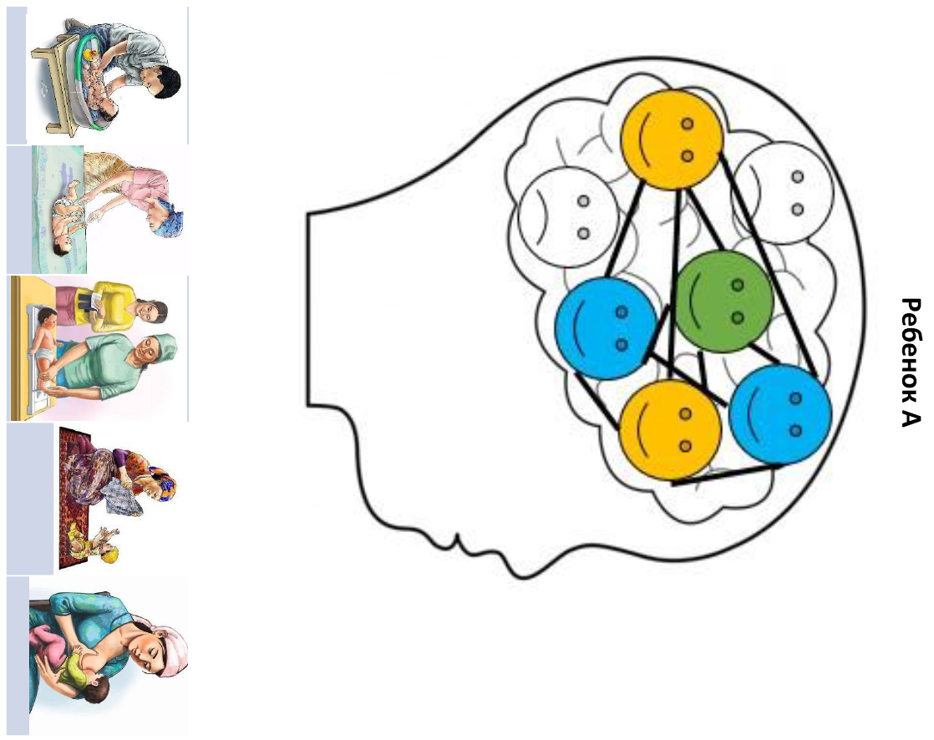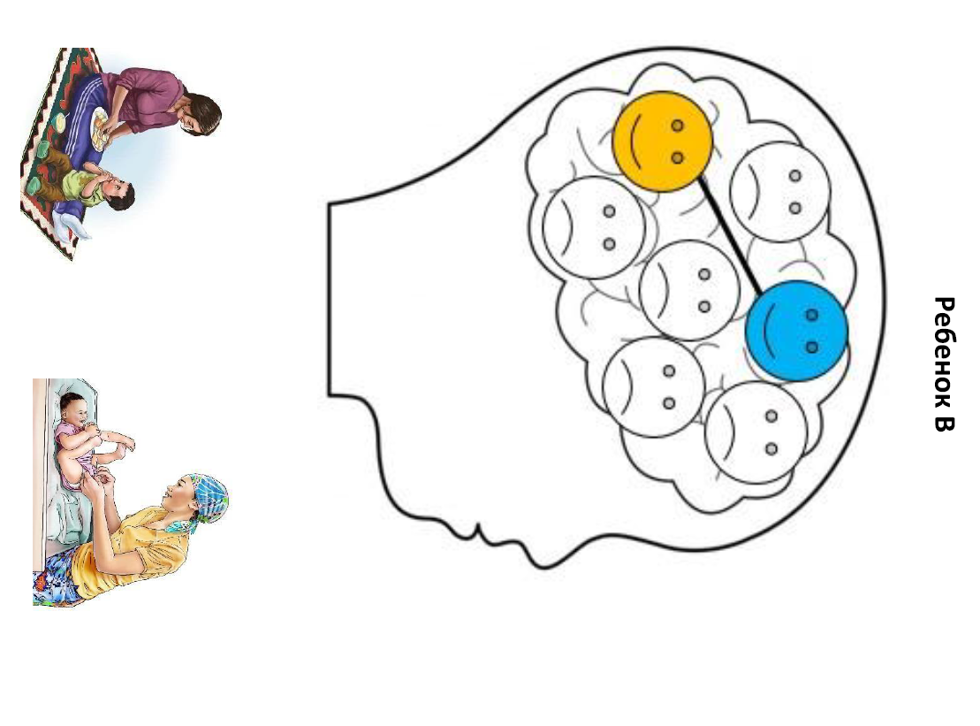
Ask participants what they observe about Child A’s and Child B’s brains. Ask, “What differences do you see”? Child A’s brain will be very colorful with many connections formed, enriched with positive experiences, while Child B’s brain will be very white, with few connections, harmed with adverse or negative experiences. Say, “Adverse experiences, such as violence, abuse, neglect, or enduring hunger can disrupt the process of brain development, as you can see from these images. Almost all children will have some negative experiences, as every family or community often experiences stress of some kind; however, positive experiences help children form trusting relationships with their caregivers, which protects them from the negative impacts of these stresses on their brain.”
Close by telling participants: “This is an activity to help you as the Activist understand why it is important for caregivers in the community to learn about responsive caregiving and opportunities for early learning. The first three years of a child’s life are a crucial window of opportunity to support healthy brain development and to protect children from the effects of negative experiences. Supporting stimulating and caring interactions between caregivers and children is the most powerful mechanism for building healthy brains. We don’t expect you to conduct this activity with caregivers in the community. but it was hopefully a good way to learn about the concept of nurturing care.”
In summarizing the exercise, the trainer can mention the following gender messages:
- Every child needs the support of every family member.
- Father’s, grandmother’s, grandfather's, and siblings’ participation in the growth and development of the child helps the child achieve their full potential.

Activity III: Introduction to Responsive Care and Responsive Feeding and Recap of Complementary Feeding Module (5 minutes)
- Say, “Dear Activists, as we just learned in the activity about nurturing care, responsive care is one of the five components of the Nurturing Care Framework. Responsive caregiving is the ability of the caregiver to notice, understand, and respond to their child’s signals in a timely and appropriate manner. Responsive caregiving is considered the foundational component of nurturing care because responsive caregivers are better able to support children’s health, nutrition, safety/security, and early learning.”
Some examples of responsive care include—
- Learning your child’s cues: Your child tells you what he needs by using sounds, facial expressions, and body movements. Observe your child. With practice, you will often be able to read your child’s cues and respond with what he needs.
- Responding when your child is upset: Gently rock, stroke, hold, or sing to your child. Provide skin-to-skin contact to stimulate and comfort your newborn baby.
- Responding when your child wants to interact with you: Signs your baby wants your attention are wide-open eyes, looking toward your face or toward someone who is talking, being alert, sucking on his fists or objects, clasping his hands or feet together, and grasping on to your finger or an object.
It is also important for caregivers to practice responsive caregiving when they are feeding their child. We call this responsive feeding. Responsive feeding is when a caregiver identifies, is aware of, and interprets their child’s cues or signals and vocalizations that communicate feeding needs and wants, particularly when the child is hungry or full. It is when the caregiver responds promptly and appropriately to the child’s cues or signals and needs for feeding care. Responsive feeding helps make feeding a time of love and learning. It helps you and your child develop a strong bond and encourages good eating habits in your child as she grows.
- Say, “Some examples of responsive feeding include—
- Minimize distractions during mealtimes. Sit facing your child so you can focus on each other and on eating.
- Pay attention to your child’s cues of hunger and fullness to be sure she is getting enough food but you are not overfeeding her. Never force a child to eat and never use food as a reward.
- Be patient and give your child time to eat. If your child shows signs of fullness, slow down or pause. Try offering another bite after a minute or two. End the feeding if he again indicates he is full.
Adequate nutrition is also one of the five components of the Nurturing Care Framework and you may remember that we discussed responsive feeding in the “Complementary Feeding” module, thank you for being so active during this module. We were happy to get all the feedback, let’s remember our key messages.”
Ask each Activist to remember one of the key messages below, then summarize with the big group all the key messages:
Continue breastfeeding for up to two years. This will help your baby to be healthy and smart.
Complementary feeding is food in addition to (complementing) breast milk. After six months, breast milk remains an important part of a child's diet, but by then it does not provide enough nutrients for health and growth, so other foods must be added. Continued breastfeeding and complementary feeding starting at six months guarantees proper weight gain and growth of your baby.
Responsive feeding: Introducing new foods to children at this age takes love and patience. They are learning how to eat and every taste and texture is new to them. Caregivers must take time to encourage children to eat and be patient and persistent to ensure that children are eating enough calories and nutrients.
Between 6 and 12 months is when stunting—insufficient growth and mental development—can begin. To prevent this, caregivers must follow principles of good complementary feeding.
Frequency: Feeding must happen frequently because children at this age have small stomachs and can only eat a little bit at a time.
Adequacy: The total amount of food and breast milk eaten during the day must be of sufficient quantity. Thick-consistent food gives more energy and stays on the spoon.
Diversity/density: Foods must be nutrient-dense (containing many nutrients per gram). First foods should be thick and include animal source foods and mashed fruits and vegetables. Give children a variety of foods to make sure that all their nutritional needs are met. For healthy growth children need domestic animal products; different kinds of beans; lentils; walnuts; and yellow fruit and vegetables that contain vitamin A.
Use: Take children for regular health checks. Not all illnesses can be seen, and some interfere with the body's ability to use food for energy, growth, and mental development.
Handwashing: Caregivers must wash their and the child's hands at the critical times. Tell Activists that next month’s topic will discuss handwashing and hygiene in more detail. For now, refer them to the booklet for mom’s page on handwashing at the five critical times.
A growing child should eat three diverse meals and healthy snacks twice per day.
Avoid harmful foods: Junk foods are defined as pre-packaged foods with lots of added salt, fat, and sugar, taking up room in the child's stomach without providing the nutrients they need to grow. They can also be expensive, using money that would be better spent on healthier foods like eggs, dairy, fish, meat, and nutrient-rich vegetables.
Give healthy, clean water to children ages six months to two years. Do not give sugary drinks like sodas or fruit juice, which reduce an appetite for healthy foods and can rot the first teeth.
Feed healthy snacks like dried or fresh fruit, cheese, or plain bread to children instead of sugary or salty pre-packaged snacks like biscuits/cookies, candies, chips, or croutons.
Limit the addition of oils and fats to food. When possible, boil or steam food because those are healthier methods than frying.

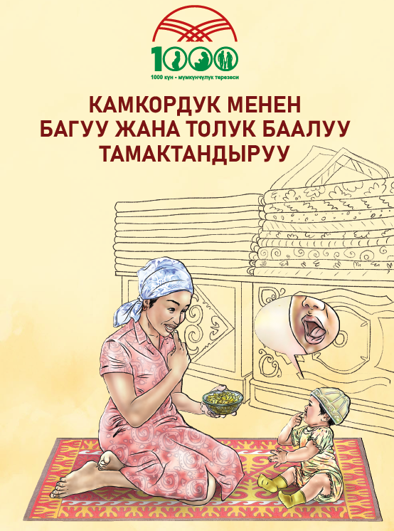
Activity IV: Presentation of the “Exclusive Breastfeeding” Booklet and Summarizing Key Messages (10 minutes)
- Share the two-page booklet on responsive care and responsive feeding with the group. Explain that this booklet has the main recommendations for understanding what responsive care is, and how it can guide your interactions with your child to meet their needs and show them love.
The booklet also reminds them of the importance of responsive feeding, including reading the signs of hunger and satiety, and how to read when your baby is over six months and is ready to try feeding him or herself and try finger foods.
- Ask Activists to spend 6–7 minutes reading the booklet and encourage them to raise any questions they have about the content.

Activity V: Exploring How to Support an Enabling Environment for Responsive Care and Responsive Feeding (10 minutes)
- Explain to the group that very often, household tasks related to care and feeding of children is considered the domain of mothers. But we know that mothers have a lot of other tasks, and every adult in the household can contribute to the child’s well-being.
- Ask the group the following questions and collect their answers. The facilitator will highlight the right information and/or guide the group toward the desired responses.
  - How can other household members support mothers on this topic?
Expected answers:
    - All caregivers can practice responsive care and responsive feeding.
    - Help prepare appropriate foods (purees or finger foods) for responsive feeding.
    - Give more time to mother to practice responsive care and responsive feeding (Probe: How? See below.)
    - Support mothers with household chores.
    - Participate in raising children.
  - What can we as Activists do to help household members be engaged in exclusive breastfeeding?
Expected responses:
    - Include fathers and grandparents in home visit discussions.
    - Follow up with other household members on the next visit.
    - Discuss strategies with a mother on how to talk about the topic with family members.
    - Encourage family members to commit to the behaviors identified in the last question.
- Summarize that participation of all family members in child care and nutrition practices contributes to the child’s growth and development.

Activity VI: Exploring Counseling Skills with 5-Steps (30 minutes)
- Explain the next activity will be done in pairs. Say, “During our community mobilization module, you have been engaged for counseling. Let’s review counseling steps today through role play. Today, we will practice the five steps to give “Responsive care and feeding” messages and counseling to households that need information about child caring and child feeding practices.”
- Quickly review each of the five steps using the 5-Steps handout from module 2. Ask participants to give an example of how to apply each step to today’s topic. (Remind participants that step 1 does NOT change based on the topic.)
  - Assess and recap: What questions can Activists ask community members to learn the appropriateness of discussing responsive care and feeding practices?
Sample answers:
    - On a typical day, how do you interact with your child? How do you mix your work/house chores with what your child needs?
    - How do you understand when your child is trying to tell you what he/she needs?
    - Observe caregiver-child interaction: eye contact, tone of voice, signs of affection, child free to play and explore, communication with child.
    - Do you have any concerns about your child’s feeding?
    - How do you know when your child is hungry or full?
    - Observe the child eating/being fed, if possible.
  - Analyze and introduce the topic: What kinds of responses to the questions above would signal that this person should receive counseling on responsive care?
Sample answers:
    - Difficulties understanding the child’s cues, does not observe the child’s cues or response not appropriate, responds harshly to the child, limited eye contact with the child.
    - Does not know when the child is hungry or full, force feeds the child.
  - Act: What kinds of messages would you like to give a caregiver who has difficulty in learning more about responsive child care and child feeding practices? What activities could you do with her to promote these practices?
Sample answers:
    - Being responsive to the child’s needs: This means the ability to listen and respond to all the child’s needs. Responding to the child’s needs we provide them with more opportunity to grow and develop. Breastmilk is the best food for your baby under six months.
    - Learning your child’s cues: Your child tells you what he needs by using his sounds, facial expressions, and body movements. Observe your child. With practice, you will often be able to read your child’s cues and respond with what he needs. Reading your child’s cues takes practice. Watch your child a lot and look for ways your child uses her eyes, mouth, and body to tell you what she needs. Crying is usually the last form of communication. Create a daily routine for your child’s care, including times for meals (starting at six months), bathing, and bedtime. Routines help your child feel secure because he knows and recognizes daily activities.
Responding when your child is upset: When your child is upset, think through possible solutions—she may be hungry, tired, soiled, uncomfortable, or sick. Your child may just want your attention. After you calm your child, think about the movements and sounds he was making. Over time, you will notice patterns in your child’s movements and sounds and the kinds of things he needs. Gently rock, stroke, hold, or sing to your child. Provide skin-to-skin contact to stimulate and comfort your newborn baby.
Responding when your child wants to interact with you: Your child can see from the day she is born. Look into your child’s eyes often. It will help her to connect with you and she will learn to identify emotions in people. Signs your baby wants your attention are wide-open eyes, looking toward your face or toward someone who is talking, being alert, sucking on his fists or objects, clasping his hands or feet together, and grasping on to your finger or an object. Respond to your child’s sounds and movements, such as reaching out, babbling, smiling, or making faces, by producing similar vocalizations, gestures, and talking to her.
  - Recap and close: What kind of actions can a community member commit to in order to practice responsive care?
Sample answers:
    - Can commit to sitting facing the child with no distractions at mealtime.
    - Can practice reading a child’s cues and prepare to describe some at the next meeting.
    - Can commit to spending more time responding to child’s needs for affection and love.
    - Can commit to letting the child try to feed him or herself (according to the age of the child).
- Set up the role play. Say, “Let’s role play counseling on ‘Responsive Care and Feeding.’” Divide the group into pairs. Give each pair a printout of the role play scenarios for this module found in Section 4. Assign one person to play the role of counselor and another to play the role of a mother. The person role playing the mother can invent any attitudes and practices around responsive care and feeding they would like, but please choose at least one issue that the counselor can notice and work to counsel on.
The counselor should use the five steps of counseling to talk about responsive care and feeding with the mother. Give the pairs 8–10 minutes to practice. If they finish early, have them switch roles.
- Spend the last 5 minutes asking the counselors and role players which steps they did well and which steps were difficult using the scenario below.

Activity VII: Summarize Key Messages (5 minutes)
Ask participants what they learned. They should list one or more of the key messages.

Activity VIII: Experience-Sharing on Previous Month’s Message Dissemination (15 minutes or 5 minutes)
Divide participants in two or three groups of four–five people and ask them to talk about their experiences disseminating messages from the previous session, including successes and challenges. On a flip chart, draw a column for each and list accordingly. Reconvene and ask each group to present its list. Ask the large group to discuss and offer advice to each other.
OR
Ask several volunteers to talk about something that went well in the previous month.

Activity IX: Action Planning for the Coming Month (10 minutes)
- Collect the Activists’ planning forms from the previous month. Make sure they are complete and have the Activists’ names on them. Speak with Activists who haven’t turned in a form or who have not filled in one completely or correctly.
- Distribute planning forms for the next month and ask them to take a few minutes to make a plan.
- As they plan their activities for the month, ask what they learned and what was most interesting.

Activity X: Conclusion (2 minutes)
- Say: “We are thankful for your coming and delighted to be working with you to mobilize the community toward positive nutrition. By helping our moms and kids to be strong and well-nourished, we are helping Kyrgyzstan be a strong country.”

TRAINER REFERENCE:
FLIP CHARTS
Before the session, prepare the following flip charts as shown below.
Nurturing Care Framework
Child A
Child B

MODULE 5: Early Learning through Play and Communication

Module Objectives
At the end of the session, participants will be able to—
- Describe why early learning and play are important for child development.
- Identify play and communication activities that are appropriate for different ages.
- Practice key messages through counseling skills with Community Activists in a role of “counselors.”

Time: Approximately 2 hours

Materials and Preparation
- Before the training, read the module instructions in full below and clarify any doubts or questions with your supervisor.
- This session recommends the use of the USAID Advancing Nutrition brochure on early communication and learning through play from birth to six months. If possible, bring at least one copy for every two participants to view and discuss. The brochure can be found in Russian and Kyrgyz in the folder of supplementary materials.
- The Five Step Counseling Approach Handout can be found under Section 3. The role play scenario can be found in Section 4. Bring at least one copy for every two participants to use in pairs.
- This session contains a game on developmental stages that requires printing and cutting of several training aids. The resources for this game are found in the folder of supplementary materials (in English only).
- Data collection forms designed for communities: household visits and community meetings. These forms can be found in Section 3, and copies can be found in the folder of supplementary materials.

Activity I: Introduce the Project and Objectives (5 minutes)
- Remind participants of the overall objectives of the project. A sample script from USAID Advancing Nutrition follows:
“Dear Activists, we would like to remind you of the basic objectives of the USAID Advancing Nutrition project in Kyrgyz Republic (USAID Advancing Nutrition). The project works to improve the nutritional status of women of reproductive age (ages 15–49) and children under five in the Kyrgyz Republic, with a specific focus on the 1,000 days, which covers from pregnancy up to the second birthday of the child.
USAID Advancing Nutrition works in close collaboration with the Ministry of Healthcare of Kyrgyz Republic.
USAID Advancing Nutrition works with partners in the community for improved behaviors related to food, water, health care, hygiene, and sanitation, because all these things affect our nutritional well-being.
The project provides recommendations from WHO and MOH of Kyrgyz Republic to improve awareness and understanding about nutrition and hygiene.”

Activity II: Why It Is Important to Learn about Early Learning (15 minutes)
- Say, “Dear Activists, as we learned last month in the activity about nurturing care, early learning is one of the five components of the Nurturing Care Framework. Your baby is ALWAYS learning from the moment he is born. Babies learn in two ways: first, by communicating with caregivers and other family members. Second, they learn by playing . Early learning—including both play and communication—is considered an important component of nurturing care because it explains how your child interacts with the world around him, and it is an essential part of a child’s cognitive, verbal, and social-emotional development.”
Your baby communicates from the day he is born (using sounds, eye contact, and gestures), and he learns to communicate by hearing you talk and sing to him.
A trainer can ask a Community Activist to read the key message and explain what he understood from it:
(Each key message can be read aloud by a Community Activist with an extended explanation; all key messages preliminarily will be displayed on a flip chart for Community Activists to read and explain.)
Key messages/communication
- Your child uses eye contact, cooing, facial expressions, and movement to tell you what she needs and wants from the day she is born. Follow her signals to understand her needs.
- Babies begin to understand even the meaning of words before they can speak. Talk and sing to your child often so that he can hear words. He will learn to talk by listening to you talk.
- Have a conversation with sounds, words, and gestures. When your child communicates with you using sounds or movements, respond to him and he will respond back. You are each taking turns in the conversation. You can help your child learn new words by expanding on her language. If she says one word, such as “Papa,” build her language by adding more words: “Papa loves you”!

It is also important for babies to play. We all know babies and children LIKE to play, but when it comes to development, playing is a baby’s JOB. Playing is the way babies learn. We can learn to help babies learn by playing with them and giving them opportunities to play.
A trainer can ask a Community Activist to read the key message and explain what he understood from it:
(Each key message can be read aloud by a Community Activist with an extended explanation; all key messages preliminarily will be displayed on a flip chart for Community Activists to read and explain).
Key messages/playing
- Children learn by playing, observing, copying, and trying new things—starting from the moment they are born. Your child enjoys and learns through playing with you! All your child needs is you.
- Give your child opportunities to explore the world around him through play. He will enjoy playing with his fingers and toes, your face, and household objects. Follow his lead, encouraging play with safe objects that interest him. Observe his body language and sounds and do not force him to play with something when he is not interested.
- Give your child challenging but achievable tasks. Guide her actions and build on what she can do to make the task slightly more difficult.

Activity III: Playing Out through Acting and Demonstrating Play and Communication Activities (20 minutes)
- Introduce this activity by saying: “All babies play and communicate with caregivers. As they grow, babies can achieve more complicated play and communication activities, and so caregivers’ interactions with babies change over time. Let’s look at some communication and play recommendations based on the age of your baby.
- Divide the participants into pairs and distribute situations that should be played out and acted between pairs. This is the link for the cases: Handout: Play and communication “Practical Tips” for caregivers
The trainer can choose four couples to play and demonstrate the game, after which the trainer asks the big group under which milestone can the acted game be related. Milestones are described below:
From birth to six months
Slowly move colorful objects for your baby to see and reach for. Watch his eyes move side to side as he follows the object.
From six to nine months
Play games like “peekaboo” with your baby. While she is looking at you, cover your face with your hands or a piece of fabric. Say, “Where is Daddy”? Open your hands and say, “Boo! Here I am”! Laugh with her as she sees you! She is starting to learn that you do not disappear when she does not see you.
From 9 to 12 months:
Play games like “peekaboo” with your baby. While she is looking at you, cover your face with hands or fabric. Say, “Where is Daddy”? Open hands and say, “Boo! Here I am”! Laugh with her as she sees you! She is starting to learn that you do not disappear when she does not see you.
From 12 to 24 months:
Encourage your child’s imagination using sock puppets. Make up a story using the puppets.
After the demonstration of pairs plays out according to the description, it is necessary to reflect on and discuss in a big group what happened. Participants will share with each other their opinions, comments, and emotions about the pair playing out.
- The trainer summarizes that, “Playing and talking with the child helps him grow and develop in four ways. This includes physical, cognitive, language, and social and emotional aspects.”
In a big group discussion with participants try to describe age-appropriate play with children of each age group. (Participants should use the Early Learning through Play and Communication brochure).
Birth to six months:
- During or after breastfeeding, talk and sing to your baby. She is listening and will find comfort in your voice.
- Imitate your baby’s sounds and gestures. He is communicating with you with his sounds and movements. When he coos, respond to him. Your baby needs to hear you talk. He will learn to talk by listening to others around him.
Six to nine months:
- Your baby can start to recognize common words. When you see your child is no longer hungry, ask her, “All done”? If she shows you that she is still hungry, say, “More”?
- Respond to your baby’s sounds and interests. Call your baby’s name and notice his response.
9 up to 12 months:
- Your baby will start to enjoy different soft foods now, such as soft fruits or cooked vegetables, and she needs diverse, colorful foods to meet her nutritional needs. Use words to describe the food, and slowly she will understand new words. Name the different foods and parts of her body that she is using to eat, like her fingers and mouth.
- Talk to your baby as you prepare his meal. Describe what is happening as you interact with him, such as saying, “Here is your bowl.” or “Dad cooked potatoes for you.” Ask him questions, “Do you want eggs”? Give him time to respond with gestures, such as pointing or sounds, before you provide a verbal answer.
12 up to 24 months:
- As you feed your child, describe the colors and textures of her food. Encourage her to speak by asking her the name or the color of the food she is eating. Point and tell her the names of the foods after she has had a chance to try and answer you!
- Sing with your child. Start a song and let him sing parts that he knows. Over time, he can sing more and more himself as he learns more words and you can practice taking turns.
- Children learn to love stories when they read together with their parents every day. Ask her to point to different people and animals in a book, magazine, or poster. Praise her for finding the animals and objects!
Close the session by telling participants that it is important they feel comfortable practicing these play and communication activities, as they will be teaching caregivers how to do these with their children during home visits. Sometimes these things can feel a bit silly as an adult, but children learn through play so it’s important that caregivers can do these activities with their children.

Activity IV: Monitoring a Child’s Development (15 minutes)
- “Dear Activists, as we saw in the previous activity, there are some activities that are more appropriate to do with children at one age compared to a child who is older or younger. Children develop at different stages—they are learning and developing all the time. For example, an eight-month-old may be able to sit up by himself, BUT the child cannot walk; whereas many two-year-olds can walk and run on smooth surfaces without falling over. These are developmental milestones. Milestones are skills that most children learn by a certain age.
- Ask participants, “What do you think about when you hear the term child development”? The community mobilizer should hear responses from participants. After participants have responded, the community mobilizer can give the definition: “The term child development refers to the cognitive, physical, language, and social/emotional development of a child. Or, more simply, how a child learns, communicates, understands, relates to people, grows, moves her body, and uses her hands and fingers.”
- The trainer will demonstrate by showing how he plays with the child using homemade toys or safe things from the home (cups and other home objects).
Many parents think that playing with a child only serves to make the child quiet or distract him/her. But actually, playing is the child's job, like what we learned in the previous activity.
It is important to remember that children learn at different paces. Some children learn quickly, and some children need more time. But remember, all children can learn! Children’s skills build upon one another. For example, a child must learn to sit before he can stand.
Some children are born with or develop conditions that can affect their abilities. Children may develop differently in how they move, see, hear, learn, think, or interact with others. Many conditions contribute to children developing differently. You may hear many things about disabilities in your community, but it is important to know that disabilities are not the fault of the mom or dad, and they are not a curse. All children can learn, and some children may need extra support.
All children should have their growth, development, hearing, and vision monitored to identify any concerns early. If you are concerned about your child’s development, seek support from a health care provider.

Activity V: Presentation of the “Early Communication and Play” Booklet and Summarizing Key Messages (10 minutes)
- Share the two-page booklet on early communication and play with the group. Explain that this booklet helps readers understand the ways their baby tries to communicate with them from the day they are born, and how they can encourage communication with them from a very young age.
The booklet also reminds them of the importance of play in the development of a child. Playing is like a baby’s job, and it helps them develop their bodies and minds.
- Ask Activists to spend 6–7 minutes reading the booklet and encourage them to raise any questions they have about the content.

Activity VI: Exploring How to Support an Enabling Environment for Encouraging Communication and Play (10 minutes)
- Explain to the group that very often household tasks related to the care and feeding of children is considered the domain of mothers. But, we know that mothers have a lot of other tasks, and every adult in the household can contribute to a child’s well-being.
- Ask the group the following questions and collect their answers. The facilitator will highlight the right information and/or guide the group toward the desired responses.
  - How can other household members support mothers on this topic?
Expected answers:
    - All caregivers can spend time playing with children and learning how babies communicate.
    - All family members should be comfortable talking to and singing to the baby.
    - Give more time to mother to practice responsive care and responsive feeding. (Probe: How? See below.)
    - Support mothers with household chores.
    - Participate in raising children.
  - What can we as Activists do to help household members be engaged in exclusive breastfeeding?
Expected responses:
    - Include fathers and grandparents in home visit discussions.
    - Follow up with other household members on the next visit.
    - Discuss strategies with a mother on how to talk about the topic with family members.
    - Encourage family members to commit to the behaviors identified in the last question.
- Summarize that participation of all family members in child care and nutrition practices contribute to a child’s growth and development.

Activity VII: Exploring Counseling Skills with 5-Steps (30 minutes)
- Explain the next activity will be done in pairs. Say, “During our community mobilization module, you have been engaged for counseling. Let’s review counseling steps today through role play. Today, we will practice the five steps to talk about early learning and communication.”
- Explain to the group that for this topic, counselors will be visiting ONLY the 1,000 day households within their assigned area, as the module is based on promoting the best young child feeding and nurturing care practices.
- Quickly review each of the five steps using the 5-Steps handout from module 2. Ask participants to give an example of how to apply each step to today’s topic.
  - Greet and welcome. This greeting sets a good rapport between the Activist and the family member. Remind participants that step 1 does NOT change based on the topic.
  - Assess and recap: What questions can Activists ask community members to learn the appropriateness of discussing exclusive breastfeeding?
Sample answers:
    - What is your favorite story you tell your child before bedtime?
    - Tell me or show me the ways your baby talks or communicates with you
    - What are some of your baby’s favorite games?
    - What games do you play with your baby?
  - Analyze and introduce the topic: What kinds of responses to the questions above would signal that this person should receive counseling on exclusive breastfeeding?
Sample answers:
    - My baby doesn’t communicate. He is too young.
    - My baby doesn’t play. He just sits there.
    - I don’t play with my baby – I have too many other things to do.
    - I feel silly talking to my baby because my baby doesn’t talk.
  - Act: What kinds of messages would you like to give a caregiver who has difficulty exclusively breastfeeding? What activities could you do with her to promote the practice?
Sample answers:
    - Have caregivers sing a song with their child. Children love songs that include hand gestures, like clapping!
    - Have caregivers share stories they tell to their children.
    - Choose songs and stories that are appropriate to the age of the children.
    - For babies younger than 6 months, have caregivers practice putting their babies on their tummies, if there is a safe space for this. They will enjoy watching other babies!
  - Recap and close: What kind of actions can a community member commit to in order to practice exclusive breastfeeding?
Sample answers:
    - Can practice tummy time with a baby under 6 months.
    - Can practice singing to baby while breastfeeding.
    - Can try making a simple toy or game out of household objects.
    - Can discuss with family members the importance of communication and play for babies of all ages.
- Set up the role play. Say, “Let’s role play counseling on exclusive breastfeeding.” Divide the group into pairs. Give each pair a printout of the role play scenarios for this module found in Section 4. Assign one person to play the role of counselor and another to play the role of a breastfeeding mother. The person role playing the mother can invent any attitudes and practices around breastfeeding they would like, but please choose at least one issue that the counselor can notice and work to counsel on.
  - The counselor should use the 5-Steps of counseling to talk about communication and play with the mother. Give the pairs 8–10 minutes to practice. If they finish early, have them switch roles.
- Spend the last 5 minutes asking the counselors and role players which steps they did well and which steps they had difficulty with using the scenario below.

Activity VIII: Summarize Key Messages (5 minutes)
- Ask participants what they have learned. They should list one or more of the key messages.

Activity IX: Experience-Sharing on Previous Month’s Message Dissemination (15 minutes or 5 minutes)
- Divide participants into two or three groups of four–five people and ask them to talk about their experiences disseminating messages from the previous session, including success and challenges. On a flip chart, draw a column for each and list accordingly. Reconvene and ask each group to present its list. Ask the large group to discuss and offer advice to each other.
OR
Ask several volunteers to talk about something that went well in the previous month.

Activity X: Action Planning for the Coming Month (10 minutes)
- Collect the Activists’ planning forms from the previous month. Make sure they are complete including the name of the Activists. Speak with Activists who haven’t turned in a form or who have not filled in one completely or correctly.
- Distribute planning forms for the next month and ask them to take a few minutes to make a plan.
- As they plan their activities for the month, ask what they learned and what was most interesting.

Activity XI: Conclusion (2 minutes)
- Say: “We are thankful for your coming and delighted to be working with you to mobilize the community toward positive nutrition. By helping our moms and kids to be strong and well-nourished, we are helping Kyrgyzstan be a strong country.”

TRAINER REFERENCE:
FLIP CHARTS
Before the session, prepare the following flip charts as shown below.
Key messages/communication
● Your child uses eye contact, cooing, facial expressions, and movement to tell you what she needs and wants from the day she is born. Follow her signals to understand her needs.
● Babies begin to understand even the meaning of words before they can speak. Talk and sing to your child often so that he can hear words. He will learn to talk by listening to you talk.
● Have a conversation with sounds, words, and gestures. When your child communicates with you using sounds or movements, respond to him and he will respond back.
Key messages/playing
⎯ Children learn by playing, observing, copying, and trying new things—starting from the moment they are born. Your child enjoys and learns through playing with you! All your child needs is you.
⎯ Give your child opportunities to explore the world around him through play. He will enjoy playing with his fingers and toes, your face, and household objects. Follow his lead, encouraging play with safe objects that interest him. Observe his body language and sounds and do not force him to play with something when he is not interested.
⎯ Give your child challenging but achievable tasks. Guide her actions and build on what she can do to make the task slightly more difficult.

MODULE 6: Practicing Best Handwashing and Maintaining Clean Latrine Practices

Module Objectives
At the end of the session, participants will be able to—
- Communicate the five critical times for handwashing with soap and water.
- Demonstrate proper handwashing.
- Explain the importance of properly disposing of children’s excrement and keeping latrines clean.
- The five critical times for handwashing are important for caregivers and also for children, even infants. Caregivers should encourage children to develop their handwashing habits from a very young age.

Time: Approximately 2 hours

Materials and Preparation
- Before the training, read the module instructions in full below and clarify any doubts or questions with your supervisor.
- This session can be completed using the PowerPoint presentation for this module or by recreating the slides in this presentation to make flip charts. If using flip charts, complete and hang the flip charts before the beginning of the training session. The PowerPoint slides can be found in the folder of supplementary materials (in Kyrgyz only).
- The Five Step Counseling Approach Handout can be found under Section 3. The role play scenario can be found in Section 4. Bring at least one copy for every two participants to use in pairs.
- Module 6 videos: This session contains optional informational videos. Trainers can screen the video for everyone during the training (on a projector or TV), or if such resources are not available, the video can be shared as a link through participants’ WhatsApp accounts. These are the links to:
- Handwashing video 1,
- Handwashing video 2.
- Preventing helminth infections.
- Clean latrines.
- This session recommends the use of several materials. If possible, bring at least one copy for every two participants to view and discuss. The materials can be found in the folder of supplementary materials.
- USAID Advancing Nutrition brochure on hygiene and sanitation. (Russian and Kyrgyz)
- USAID Advancing Nutrition infographic on handwashing. (Russian and Kyrgyz)
- Data collection forms designed for communities: household visits and community meetings. These forms can be found in Section 3, and copies can be found in the folder of supplementary materials.

Activity I: Introduce the Project and Objectives (5 minutes)
- Remind participants of the overall objectives of the project. A sample script from USAID Advancing Nutrition follows:
“Dear Activists, we would like to remind you of the basic objectives of the USAID Advancing Nutrition project in Kyrgyz Republic (USAID Advancing Nutrition). The project works to improve the nutritional status of women of reproductive age (ages 15–49) and children under five in the Kyrgyz Republic, with a specific focus on the 1,000 days, which covers from pregnancy up to the second birthday of the child.
USAID Advancing Nutrition works in close collaboration with the Ministry of Healthcare of Kyrgyz Republic.
USAID Advancing Nutrition works with partners in the community for improved behaviors related to food, water, health care, hygiene, and sanitation, because all of these affect our nutritional well-being.
The project provides recommendations from WHO and MOH of Kyrgyz Republic to improve awareness and understanding about nutrition and hygiene.”

Activity II: Introduce the Topic of Handwashing and Clean Latrines (30 minutes)
- Explain that there is a strong link between diseases spread by bacteria and malnutrition because a sick body can’t absorb nutrients from food as well as a healthy body.
Keeping hands clean through improved handwashing is one of the most important things we can do to avoid getting sick and spreading bacteria to others. Many diseases and conditions are spread by unwashed hands.

- Explain the link between hygiene and bacteria/germs.
  - Bacteria are transmitted by dirty hands and latrines.
  - Bacteria are tiny organisms that we can’t see with our eyes. Some bacteria are helpful, but many cause diseases.
  - Diarrhea, food poisoning, some kinds of pneumonia, ear infections, tuberculosis, some infections of skin and eyes, and other diseases are caused by bacteria.
  - We are constantly touching things that have disease-causing bacteria on them. Bacteria grow in human and other animals’ feces, dirt, dirty/stagnant water, and on surfaces and foods that have come in contact with dirt or feces. When people touch any of these things and then don’t wash their hands, they spread the bacteria to other things and people. Infant feces and dirty latrines are also sources of bacteria that can make our families sick. Children’s excrement have more bacteria than adults.
  - The most common way bacteria enter our body is from our hands touching our eyes, nose, or mouth, or eating food that we touched without washing our hands. We have bacteria on our hands even when they do not look dirty.
  - The best way to prevent disease-causing bacteria from entering our body or spreading bacteria to other people is by frequently washing our hands carefully with soap and clean water.
- Ask “Why is it very important to always dispose of infant feces in the latrine, and not just discard feces outside? Why is it important to keep latrines clean”? After several people have responded, show the clean latrines leaflet and explain:
  - The feces of infants and small children carry bacteria and disease in the same way that adult feces do. Always discard infants’ and small children’s feces in the latrine.
  - Because people carry bacteria from the latrines on their shoes and clothes, it is important for everyone who uses a latrine to help keep it clean. To avoid contaminating household water with bacteria from latrines, keep latrines at least 25 meters away from water sources.
- Ask “Why is it important to use soap when washing our hands, not just water by itself”? After several people have responded, explain—
  - Dirt and germs hide in the creases in our hands. Washing motion gets soap into those creases and pulls dirt and oils free from the skin.
  - Soap suspends the dirt and skin oils that trap bacteria.
  - Rinsing with running water washes away the soap that contains the dirt, oils, and germs.

Activity III: Brainstorm on When People Should Wash Their Hands (10 minutes)
- Ask the participants when they should wash their hands. Write down participants’ answers in two columns. If they answer with one of the critical times, write it in the left column. If they name another time, write it on another column to the right.
- Mark the five critical times below (fill in any answers that the group did not give):
  - before, during, and after preparing food
  - before feeding a child (wash your own and the child’s hands)
  - after using the toilet
  - after changing diapers or cleaning a child who has used the toilet
  - after touching an animal, animal feed, or animal waste.
These are the most critical times to wash hands. When we say critical, it means that washing your hands during these five times breaks the pathway of bacteria and viruses from the latrine/excrement to your food/hands and to your body.
- Review the times that participants gave that were NOT part of the five critical times. Most of the situations suggested would be good times to wash hands, so praise them for thinking of those situations.
- Present the Hygiene and Handwashing videos (optional): After watching each video, the trainer will have a short discussion with participants with the following questions:
  - What did you learn?
  - Was this information new for you?
  - How would this information help you support your community to adopt good practices related to nutrition or health?
Summarize all responses with key messages of the video spot.

Activity IV: Presentation of the “Hygiene and Sanitation” Booklet and Summarize Key Messages (10 minutes)
- Share the two-page booklet on hygiene and sanitation with the group. Explain that this booklet has the main benefits and recommendations for handwashing for the family, as well as provides information about improved sanitation conditions for the home.
- Ask Activists to spend 6–7 minutes reading the booklet and encourage them to ask any questions they have about the content.

Activity V: Exploring How to Support an Enabling Environment for Mothers on Exclusive Breastfeeding (10 minutes)
- Explain to the group that very often household tasks related to care and feeding of children is considered the domain of mothers. But, we know that mothers have a lot of other tasks, and every adult in the household can contribute to a child’s well-being.
- Ask the group the following questions and collect their answers. The facilitator will highlight the right information and/or guide the group toward the desired responses.
  - How can other household members support hygiene and sanitation for the family?
Expected answers:
    - Support handwashing and hygiene practices for the whole family.
    - Ensure there is enough water available for handwashing.
    - Install or create handwashing stations that are easy to use and, if outdoors, can be used indoors in the winter for comfort.
    - Buy soap for handwashing.
    - Install and maintain latrines.
  - What can we as Activists do to help household members be engaged in exclusive breastfeeding?
Expected responses:
    - Include fathers and grandparents in home visit discussions.
    - Follow up with other household members on the next visit.
    - Discuss strategies with a mother on how to talk about the topic with family members.
    - Encourage family members to commit to the behaviors identified in the last question.
- Summarize that participation of all family members in child care and nutrition practices contribute to the child’s growth and development.

Activity VI: Exploring Counseling Skills with 5-Steps (30 minutes):
- Explain the next activity will be done in pairs. Say, “We have been practicing counseling skills from module to module. Let’s review counseling steps today using our training aids. Today, we will practice the five steps to give the best hygiene and sanitation practices that are required for preventing different diseases and being in good health.”
- Ask participants to give an example of how to apply each step to today’s topic. Remind participants that step 1 does NOT change based on the topic.
  - Assess and recap: What questions can Activists ask community members to learn the appropriateness of discussing hygiene and sanitation practices?
Sample questions:
    - What are the critical moments of handwashing for you?
    - Who helps keep latrines or toilets clean at home?
    - What are the helminths’ infections preventing measures?
    - What is the importance of hygiene and sanitation positive practices?
  - Analyze and introduce the topic: What kinds of responses to the questions above would signal that this person should receive counseling on hygiene and sanitation practices? Sample answers:
    - Handwashing with soap, for not less than 20 seconds, helps prevent many different diseases.
    - Washing children’s hands before meals is a critical time to reduce illness and infection.
    - Maintaining clean latrines are crucial for the health of the whole family.
    - Children’s feces should be disposed in the latrine.
  - Act: What kinds of messages would you like to give a caregiver who has difficulty in practicing positive hygiene and sanitation? What activities could you do with her to promote the practice?
Sample answers:
    - Practicing positive hygiene practices helps to minimize hygiene-related diseases.
    - Mothers and caregivers are mostly busy with cooking and child feeding errands, therefore latrine cleaning can be done by other family members.
    - Deworming domestic animals can prevent helminths infections for all family members.
  - Recap and close: What kind of actions can a community member commit to in order to practice hygiene and sanitation practices?
Sample answers:
    - Reinforce handwashing practices for the whole family members; install a handwashing basin for proper sanitation.
    - Clean latrines support better health status.
- Set up the role play. Say, “Let’s role play counseling on practicing positive hygiene and sanitation practices.” Divide the group into pairs. Give each pair a printout of the booklet. Assign one person to play the role of counselor and another to play the role of the household members or a family member (better to have all family members).

The counselor should use the five steps of counseling to talk about handwashing, maintaining clean latrines, and preventing helminth infection measures. Give the pairs 8–10 minutes to practice. If they finish early, have them switch roles.
- Using the scenario below, spend the last 5 minutes asking the counselors and role players which steps they did well and which steps were difficult.

Activity VII: Summarize Key Messages (5 minutes)
- Ask participants what they learned. They should list one or more of the key messages.

Activity VIII: Experience-Sharing on Previous Month’s Message Dissemination (15 minutes or 5 minutes)
- Divide participants into two or three groups of four–five people and ask them to talk about their experiences disseminating messages from the previous session, including success and challenges. On a flip chart, draw a column for each and list accordingly. Reconvene and ask each group to present its list. Ask the large group to discuss and offer advice to each other.
OR
Ask several volunteers to talk about something that went well in the previous month.

Activity IX: Action Planning for the Coming Month (10 minutes)
- Collect the Activists’ planning forms from the previous month. Make sure they are complete and have the Activists’ names on them. Speak with Activists who haven’t turned in a form or who have not filled out one completely or correctly.
- Distribute planning forms for the next month and ask them to take a few minutes to make a plan.
- As they plan their activities for the month, ask what they learned and what was most interesting.

Activity X: Conclusion (2 minutes)
- Say, “We are thankful for your coming and delighted to be working with you to mobilize the community toward positive nutrition. By helping our moms and kids to be strong and well-nourished, we are helping Kyrgyzstan be a strong country.”

MODULE 7: Dietary Diversity and Reduced Consumption of Junk Food

Module Objectives
At the end of the session, participants will be able to—
- Explain why it is important to eat a variety of foods every day.
- Explain food groups and portion sizes.
- Identify good local food sources of key nutrients (vitamin A, vitamin C, iron, and zinc) for their region, and what’s available in different seasons.
- Identify “junk foods”: foods that are high in sugar, fat, or salt and that contribute little to nutrition.

Time: Approximately 2 hours

Materials and Preparation
- Before the training, read the module instructions in full below and clarify any doubts or questions with your supervisor.
- The Five Step Counseling Approach Handout can be found under Section 3. The role play scenario can be found in Section 4. Bring at least one copy for every two participants to use in pairs.
- Module 7 videos: This session contains optional informational videos. Trainers can screen the video for everyone during the training (on a projector or TV), or if such resources are not available, the video can be shared as a link through participants’ WhatsApp accounts. These are the links to:
- Dietary Diversity video (animated)
- Junk Food video (animated).
- This session recommends the use of the USAID Advancing Nutrition handout on dietary diversity. If possible, bring at least one copy for every two participants to view and discuss. The handout can be found in Kyrgyz in the folder of supplementary materials.
- Data collection forms designed for communities: household visits and community meetings. These forms can be found in Section 3, and copies can be found in the folder of supplementary materials.

Activity I: Introduce the Project and Objectives (5 minutes)
- Remind participants of the overall objectives of the project. A sample script from USAID Advancing Nutrition follows:
“Dear Activists, we would like to remind you of the basic objectives of the USAID Advancing Nutrition project in Kyrgyz Republic (USAID Advancing Nutrition). The project works to improve the nutritional status of women of reproductive age (ages 15–49) and children under five in the Kyrgyz Republic, with a specific focus on the 1,000 days, which covers from pregnancy up to the second birthday of the child.
USAID Advancing Nutrition works in close collaboration with the Ministry of Healthcare of Kyrgyz Republic.
USAID Advancing Nutrition works with partners in the community for improved behaviors related to food, water, health care, hygiene, and sanitation, because all these things affect our nutritional well-being.
The project provides recommendations from WHO and MOH of Kyrgyz Republic to improve awareness and understanding about nutrition and hygiene.”

Activity II: Introducing the Topic “Importance of Diversified Diet and Reducing Junk Food” (30 minutes)
The trainer can start the new topic introduction with brainstorming with the whole group:
- Ask Activists, “Why do people need to eat a variety of food? Is it okay to eat just bread and tea?
What will happen if we limit ourselves to just one or two kinds of foods”?
- After a few people have responded, explain that eating one or two types of food every day over time leads to nutrient deficiencies. Nutrient deficiencies leave us vulnerable to illness and if severe enough can lead to death. The benefits of eating diverse foods daily, all year, helps us have more energy, feel good, and look bright.
- Ask, “What happens if we eat too much food and regularly drink sugary drinks”?
- After a few people have responded, explain that too much food and sugary drinks lead to people becoming overweight. Over time, these behaviors contribute to poor health, including diabetes and heart disease. This can mean that young children will refuse to eat the nutrient-rich foods important for their growth and the development of their body and brain.
- After brainstorming the trainer will explain:
  - People eat food both for energy and for nutrients that our body uses for growth, replenishment, and keeping us healthy. Calories are the unit of measurement for the energy in food.
  - In this activity we are going to learn about different nutrients in food and what they do for our health. There are many nutrients in different foods and scientists are discovering new ones.
  - Show the SPRING resource on the food pyramid and ask participants if they know which foods or food groups are rich in the following nutrients. If they don’t know, remind them that the group will summarize the correct information at the end.
    - vitamin C–rich foods
    - vitamin A–rich foods
    - iron-rich foods
    - zinc-rich foods.
- After receiving responses from the other end of lines, summarize—
- vitamin C: lemons, oranges, red and green bell peppers, tangerines
- vitamin A: pumpkins, carrots, tomatoes, dark green leafy vegetables
- iron: meat, fish, and eggs, some in dried apricots and dried plums
- zinc: meat, fish, and eggs, some in dairy.
- Explain to the group that in addition to these four important nutrients, many other nutrients have benefits for health, growth, and development. Share copies of Table 2 with the group and read each of the nutrients, its function, and the foods where it is found:

Table 2. Functions and Food Sources of Different Nutrients
Nutrient | Function | Food sources
Protein | Builds and repairs body cells; forms part of various enzymes, hormones, and antibodies | Meat, poultry, fish, eggs, beans, milk and milk products, grains, seeds, and nuts
Fat | Provides energy; carries fat-soluble vitamins; part of cell membranes, forms membranes around nerves, hormones | Meat and poultry, some fish, milk and milk products, nuts and seeds, oils, butter, margarine, salad dressing, chocolates, pastries
Carbohydrates | Provides energy needed by the brain, nervous system, and red blood cells | Breads, grains, pasta, rice, fruit, starchy vegetables, sugar and all products containing sugar, honey
Vitamin A | Promotes healthy eyes, good eyesight, strengthens immunity, helps maintain skin | Pumpkin, carrots, apricots, persimmon, yellow melon, egg yolk, liver, green leaves, tomatoes
Vitamin C  (ascorbic acid) | Promotes healthy teeth and gums. Essential for iron absorption. Promotes wound healing and immunity to illness. | Citrus fruits, red and green bell peppers, berries, tomatoes, potatoes, cabbage, pears, plums, grapes, quince, pomegranate
Folic acid  (folate) | Helps form red blood cells, prevents birth defects | Beans, chick peas, lentils, green leaves such as sorrel, beetroot
Calcium | Builds bones and teeth | Milk and milk products, dark green leafy vegetables, broccoli
Iron | Forms red blood cells to carry oxygen throughout the body | Beef, mutton, lamb, goat, poultry, eggs, beans, dried fruits, green leaves such as sorrel, fortified flour
Zinc | Supports immune function, as well as the reproductive and nervous systems.  Promotes growth in children. | Beef, mutton, lamb, goat, eggs, milk products, almonds, peanuts, chickpeas, soy foods
Iodine | Makes thyroid hormones and prevents goiter and cretinism, forms of mental and physical disability. | Iodized salt is the only source in Kyrgyzstan
Notes: Apples do not contain iron. Iodine is not found in local fish or persimmons.

- Summarize the activity: Point out the nutrients that are bolded (vitamin A, vitamin C, iron, and zinc) because research shows they are often too low in the diets of families in Kyrgyzstan. This means that Activists should emphasize foods high in vitamins A and C, iron, and zinc when discussing dietary diversity with families.
- Present the Dietary Diversity video (optional): After watching the video, the trainer will have an extended discussion with participants with the following questions:
  - What did you learn?
  - Was this information new for you?
  - How would this information help you support your community to adopt good practices related to nutrition?
Summarize all responses with key messages of the video spot.

Activity III: Importance of Reducing Consumption of Junk Food
- Ask, “What is junk food? How does the consumption of junk food affect our health”? Record all ideas.
- Explain: Our health depends on different factors, and nutrition is one factor. Food gives us all the nutrients, vitamins, minerals, and micro-elements we need. However, apart from necessary, vital elements many food products contain ingredients that are useless or even destructive for health. Unfortunately, very often unhealthy food is tasty, appetizing, and relatively inexpensive; so, we are tempted to buy it again and again. As a result, we lose out on healthy elements, such as protein, unsaturated fats, and fiber and we take in too many empty calories, trans fats, and carbohydrates. It causes various health problems—from obesity to metabolic disease and accelerated physiological aging. Eating a healthy diet today helps prevent health complications in the future.
- Explain: Now we’ll discuss some foods that are readily available and consumed by most people but can lead to poor health.
- Sodium. Too much sodium leads to hypertension. Where is sodium found? Salt. What kinds of foods do we consume that have a lot of salt?: snacks, sausages, instant noodles. We should limit salt to less than 6 grams per day, including what is added to cooking.
- Eating too much fat and oil leads to being overweight. Animal fats may cause heart disease. How can we reduce the amount of fat and oil we consume? Use less oil when cooking; bake or boil foods instead of frying; trim fat from meat before cooking; skim fat off soup before serving.
- Refined carbohydrates—white flour and sugar—are in many foods we like. They are considered “empty calories” because they give energy without nutrients. Eating too much leads to obesity and may lead to diabetes. What sugary foods do we consume (or add sugar)? Tea, coffee, candy, chocolates, biscuits, jam, compote, etc. How can we reduce the amount of sugar we consume to less than 50 grams per day, including foods we buy in shops or the market? Gradually put less in tea, cut down on jam, use less in making compote (or dilute compote with water before drinking), don’t introduce or accustom babies to the taste of sugar, etc. Young children have small stomachs. Giving them junk food means they do not eat enough nutrient-rich food that they need for body and brain development. It also creates their taste for junk food during the critical early years. Giving young children healthy foods as treats and gifts—on the contrary—gives them health and good habits!
- Junk food is especially harmful for young children with their small stomachs. Giving them junk food means they do not eat enough nutrient-rich food that they need for body and brain development.
- Present the Junk Food video (optional): After watching the video, the trainer will have an extended discussion with participants with the following questions:
- What did you learn?
- Was this information new for you?
- How would this information help you support your community to adopt good practices related to nutrition?
Summarize all responses with key messages of the video spot.

Activity IV: Practicing a Diversified Diet and Healthy Diet with the Food Pyramid
- Explain that the quantity of different types of food is very important. The amount of food we need for good nutrition is called “portion size,” which are estimates to guide us and those who prepare our food to eat enough but not too much. Discuss the number of servings from each part of the pyramid. Explain the range for the number of portions depends on the size of the person and how active they are. Ask participants to think about what they ate yesterday and how it compares to the number of recommended portions for each group. The table below has samples of one serving. You can find a Kyrgyz version of Table 3 in the folder of supplementary materials:
Table 3: Portion sizes for different food groups
Food | Example | Portion size
Bread, cereals | 1 small piece | 25g
 | Cooked rice – one small teacup | 95g
 | Cooked pasta | ½ c
 | 1 medium-sized potato | 1 unit
Vegetables | Cooked vegetables – t small teacup | 80g
 | Raw vegetables – 2 large cups | 70g
Fruit | 1 apple or pear medium-sized | 1 unit
 | Canned or cooked compote | ½ c or 100g
Dairy products | Milk or kefir – 1 large teacup | 225g
 | Cottage cheese – 1 small teacup | 100g
 | Hard cheese | 45g
Foods containing protein – fish, poultry, beef, legume products | Prepared fish, poultry or beef | 85 g.
 | Beans | 80 g.
 | Eggs | 2 eggs

- It should be noted that pregnant women need to eat an additional small meal each day and more vegetables and fruits than usual. They should also take iron supplements. While breastfeeding for the first six months, women need to eat one extra meal a day and eat more meat, vegetables, and fruits. As we said in previous training sessions, children should have only breast milk for the first six months then be introduced to a variety of foods, including fruits, vegetables, egg yolk, and finely chopped or ground meat and fish. If there are new Activists please ask your peers for disseminated materials. But, there is more information about maternal nutrition during pregnancy and an anemia prevention module.
- Ask, “Why is it important for men as well to learn about dietary diversity and the food pyramid? What role do men play in shopping for food? Do they help with gardening and food storage? Do men resist changes in diet? If so, what might convince them to try new things? How can men help to ensure that women, especially pregnant and breastfeeding women in the household, get the extra food they need”?
- Summarize with Table 4, 10 steps below to healthy eating—key messages:
Table 4: Ten Steps to Healthy Eating
TEN STEPS TO HEALTHY EATING
1. Eat a nutritious diet every day based on a variety of foods, as shown in the food pyramid.
2. Eat bread, grains, pasta, rice, or potatoes several times per day (total of 450–850 grams). Black bread and all porridges have more nutrients and fiber than white bread, pasta, or rice.
3. Eat a variety of vegetables and fruits, preferably fresh, several times per day (at least 400 grams per day for adults).
4. Maintain body weight between the recommended limits (below body mass index of 25) by taking moderate levels of physical activity, preferably daily.
5. Limit fat intake, including oil, butter, margarine, and other animal fat. Use as little oil in cooking as possible.
6. Replace fatty meat and meat products (sausages) with lean meat, beans, legumes, lentils, fish, or poultry. These foods are iron-rich and good sources of protein, which builds the body. Trim fat from beef, lamb, and mutton before cooking.
7. Use milk and dairy products (kefir, yoghurt, and cheese) that are low in both fat and salt and without added sugar.
8. Eat sugar sparingly, limiting the frequency of sugary drinks and sweets, including candy, chocolates, cakes, biscuits. Consume less than 50 grams of sugar per day (including sugar in tea and prepared foods).
9. Choose a low-salt diet. Total salt intake should not be more than one teaspoon (6 grams) per day, including the salt in bread and processed, cured, and preserved foods. Avoid instant noodles and salty snacks.
10. Give children under six months breast milk only, then add a variety of soft foods, including vegetables, fruits, egg yolk, potato, and ground meat. By one-year-of-age, the child should eat a good variety of family foods. Continue breastfeeding for up to two years.

Tell Activists that while this training has a lot of information, Activists should focus on three key messages during household visits and community meetings:
- Eat a variety of foods.
- Reduce intake of foods and drinks that are high in fat, salt, and sugar.
- Plan your meals using the food pyramid and 10 steps handout.

Activity V: Exploring Counseling Skills with 5-Steps (30 minutes)
- Explain the next activity will be done in pairs. Say, “Dear Activists, we have conducted our series of training on best nutrition, child feeding, child care, hygiene, and nutrition practices. Every module in the role play explores and practices counseling skills on the introduced topic. Let’s review counseling steps today through role play on ‘Dietary Diversity and Reducing Junk Food’ module. As usual we will be exploring counseling skills through five steps to give tailored and needed messages and counseling to improve the household.”
- Quickly review each of the five steps using the 5-Steps handout from module 2. Ask participants to give an example of how to apply each step to today’s topic (remind them of the topic). Remind participants that step 1 does NOT change based on the topic.
  - Assess and recap: What questions can Activists ask community members to learn the appropriateness of discussing the family diet?
Sample questions:
    - Do you try to have a diversified diet in your family?
    - What are the most commonly consumed food products or dishes?
    - What about fruit and vegetables; do you have them on a regular basis? How often?
    - Do you have information about nutrient-rich food?
  - Analyze and introduce the topic: What kinds of responses to the questions above would signal that this person should receive counseling on dietary diversity and reducing junk food.
Sample answers:
    - Pregnant woman are in the household (talk about maternal nutrition).
    - Household member is not aware of nutrient-rich food.
    - Mentioned about consuming mostly junk food.
  - Act: What kinds of messages would you like to give the household member in practicing health and a diversified diet? What activities could you do with her to promote the practice?
Sample answers:
    - Diversified diet and healthy diet helps to prevent all forms of malnutrition, including NCDs, diabetes, heart disease, stroke, and cancer.
    - Animal source food (any meat, fish, eggs), fruits and vegetables, leafy vegetables, dried berries and fruit, and beans and nuts. All these products should be part of the family diet.
    - Healthy and diversified diet helps to be healthy and successful.
    - Reducing junk food helps to prevent NCDs and other diseases.
  - Recap and close: What kind of actions can a community member commit to in order to practice a diversified and healthy diet?
Sample answers:
    - Trying out the recipes from the cookbook, provided earlier.
    - Cooking nutrient-rich dishes.
    - Practicing a healthy and more diversified diet.
- Set up the role play. Say, “Let’s role play counseling on dietary diversity and reducing junk food.” Divide the group into pairs. Give each pair a booklet on “Importance of diversified and healthy diet.” Assign one person to play the role of counselor and another to play the role of a household member. The booklet can be given to the role player practicing the counseling skills.

The counselor should use the five steps of counseling to talk about healthy and diversified diet with the household. Give the pairs 8–10 minutes to practice. If they finish early, have them switch roles.
- Using the scenario below, spend the last 5 minutes asking the counselors and role players which steps they did well and which steps were difficult.

Activity VI: Summarize Key Messages (5 minutes)
- Ask participants what they learned. They should list one or more of the key messages.

Activity VII: Experience-Sharing on Previous Month’s Message Dissemination (15 minutes or 5 minutes)
- Divide participants into two or three groups of 4–5 people and ask them to talk about their experiences disseminating messages from the previous session, including successes and challenges. On a flip chart, draw a column for each and list them accordingly. Reconvene and ask each group to present its list. Ask the large group to discuss and offer advice to each other.

OR

Ask several volunteers to talk about something that went well in the previous month.

Activity VIII: Action Planning for the Coming Month (10 minutes)
- Collect the Activists’ planning forms from the previous month. Make sure they are complete and have the Activists’ names on them. Speak with Activists who haven’t turned in a form or who have not filled out one completely or correctly.
- Distribute planning forms for the next month and ask them to take a few minutes to make a plan.
- As they plan their activities for the month, ask what they learned and what was most interesting.

Activity IX: Conclusion (2 minutes)
- Say, “We are thankful for your coming and delighted to be working with you to mobilize the community toward positive nutrition. By helping our moms and kids to be strong and well-nourished, we are helping Kyrgyzstan be a strong country.”

TRAINER REFERENCE:
IMPORTANT INFORMATION
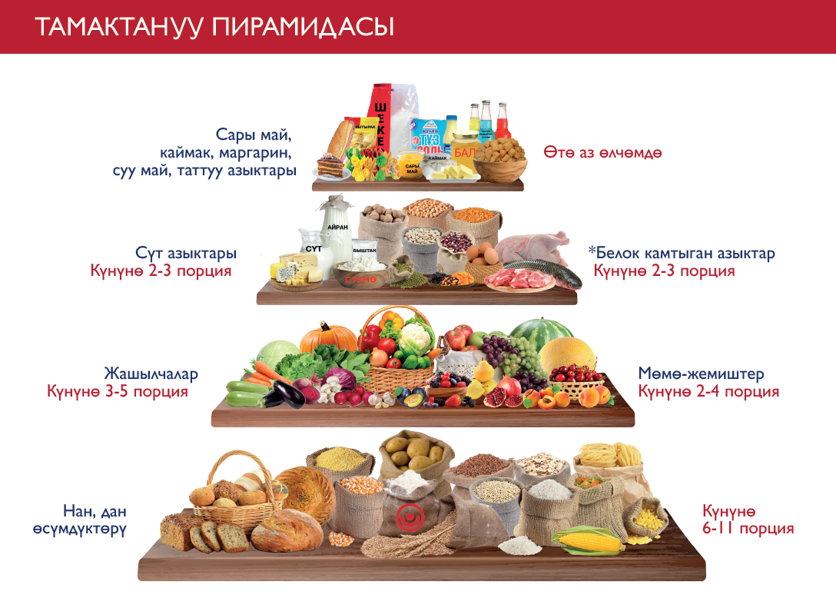

MODULE 8: Best Practices of Anemia Preventing and Supporting Healthy and Diversified Maternal Nutrition

Module Objectives
At the end of the session, participants will be able to—
- Explain what anemia is, how to prevent it, and its consequences.
- Communicate the consequences of anemia in children and women during the 1,000 days.
- Identify foods that prevent iron deficiency and anemia and the role of tea.
- List supplements available to women and children, including deworming, according to protocol.
- Explain how pregnant women can use the iron/folic acid supplement reminder card. Explain why handwashing with soap and keeping latrines clean are important for preventing anemia during the 1,000 days.
- Explain the importance of maternal nutrition.
Time: Approximately 2 hours

Materials and Preparation
- Before the training, read the module instructions in full below and clarify any doubts or questions with your supervisor.
- The Five Step Counseling Approach Handout can be found under Section 3. The role play scenario can be found in Section 4. Bring at least one copy for every two participants to use in pairs.
- Module 8 video: This session contains an optional informational video. Trainers can screen the video for everyone during the training (on a projector or TV), or if such resources are not available, the video can be shared as a link through participants’ WhatsApp accounts. This is the link to Malnutrition.
- This session recommends the use of the USAID Advancing Nutrition brochure on prevention of anemia. If possible, bring at least one copy for every two participants to view and discuss. The brochure can be found in Russian and Kyrgyz in the folder of supplementary materials.
- Data collection forms designed for communities: household visits and community meetings. These forms can be found in Section 3, and copies can be found in the folder of supplementary materials.

Activity I: Introduce the Project and Objectives (5 minutes)
- Remind participants of the overall objectives of the project. A sample script from USAID Advancing Nutrition follows:
“Dear Activists, we would like to remind you of the basic objectives of the USAID Advancing Nutrition project in Kyrgyz Republic (USAID Advancing Nutrition). The project works to improve the nutritional status of women of reproductive age (ages 15–49) and children under five in the Kyrgyz Republic, with a specific focus on the 1,000 days, which covers from the pregnancy up to the second birthday of the child.
USAID Advancing Nutrition works in close collaboration with the Ministry of Healthcare of Kyrgyz Republic.
USAID Advancing Nutrition works with partners in the community for improved behaviors related to food, water, health care, hygiene, and sanitation, because all of these affect our nutritional well-being.
The project provides recommendations from WHO and MOH of Kyrgyz Republic to improve awareness and understanding about nutrition and hygiene.”

Activity II: Introduce the New Topic of Anemia and Preventing Iron Deficiency for Maternal Nutrition (10 min)
- Say, “Before we introduce new information on today’s topic, let's talk about what you know about iron deficiency or anemia. Can anyone explain what anemia is”? Collect several responses, highlight correct information, and then summarize in the following steps.
- Define anemia for the participants (slowly and clearly): “Anemia is when a person has low numbers of red blood cells or red blood cells that aren’t functioning properly. Red blood cells carry oxygen throughout the body, and if a person has anemia, the blood can’t take enough oxygen to the body. Severe anemia can result in death, but even moderate anemia has serious consequences.”
- Explain the causes of anemia. You may want to develop flip charts for this information. Explain all key message stated below:
  - Anemia has various causes. The most common cause of anemia in Kyrgyzstan is iron deficiency. As we said in the previous section, women and children in Kyrgyzstan suffer the most from anemia.
  - Low consumption of iron-rich foods or poor absorption of iron in foods eaten is a key cause of anemia. Iron is found in many foods.
  - Another cause of iron deficiency that leads to anemia is when the body is not able to absorb the iron in food—which occurs when people become ill because of poor handwashing and sanitation. In the previous month we talked about the importance of handwashing and sanitation. If families don’t practice handwashing with soap at the five critical times and don’t keep latrines clean—including disposing of children’s feces in latrines—women and children will be ill more frequently. Illness makes their bodies less able to absorb the iron in food, and they may become anemic.”
  - Another cause of the body being unable to absorb iron from food is intestinal worms and other parasites. Research has shown that there is a high prevalence of parasites in children in Kyrgyzstan. Therefore the Government of Kyrgyzstan supports deworming for children and women. Families can access deworming medications at health facilities.
  - According to the data of the National Integrated Micronutrient and Anthropometric Survey (NIMAS) in Kyrgyz Republic 25.3 percent of women of reproductive ages 15–49 are anemic, and 55.9 percent women have iron deficiency, which puts them at risk of developing anemia.
- Explain the requirements for dietary iron for women during pregnancy and adolescence:
  - Women of childbearing age (including adolescent girls who have begun menstruating) risk iron deficiency with the continued loss of iron during menstruation and repeated childbirth.
  - Women draw on iron stored in the body before pregnancy and must increase iron intake.
  - Iron requirements are highest in the second and third trimesters of pregnancy.
  - Iron deficiency in pregnant women leads to low iron reserves in the fetus and newborn, and can result in more complications and even death during and after delivery.

Activity III: Brainstorming on Best Practices to Prevent Iron Deficiency (20 minutes)
  - Say, “We have learned that anemia is most often caused by iron deficiency, which can result from not eating enough food with iron, or from illnesses from intestinal parasites that inhibits iron absorption.”
  - Remind Activists that we learned about foods that contain iron in the module on dietary diversity.
  - Ask, “Which foods are good sources of iron”? (Suggest they refer to their notes and handouts from the dietary diversity training.) Write their responses on a flip chart in two columns: one for meat and one for the other plants.
      - Answers for meat column: (meat from) cows, sheep, and goats; dark meat from poultry; liver from any animal; and egg yolks.
      - Answers from plant category: beans, lentils, dried fruits, and dark green leaves such as sorrel. Note that dark green leaves from pumpkin, radish, turnip, and beetroot are also good sources of iron, but are rarely consumed in this country.
  - Ask participants which vitamin helps our bodies absorb iron from foods (they can look at their handouts from the dietary diversity module).
    - The answer is vitamin C, but note that this is true only if foods that contain it are eaten with foods that contain iron in the same meal.
  - Ask participants to list vitamin C–rich products (facilitator can add this in a new flip chart or a new column). At the end of this brainstorm, remind participants that these foods have the most vitamin C when eaten fresh.
    - Answers: oranges, lemons, mandarin are best, then berries and other fruits, including tomatoes, bulgarski, and cabbage.
  - Remind the participants that drinking tea with a meal blocks the body from absorbing the iron in the food. Children younger than two years should never drink tea, as it will negatively affect their growth. Women should wait for 1½ or 2 hours after meals before drinking green or black tea. Ask participants to suggest beverages that women and children can drink with meals instead of tea (boiled water, homemade compote without sugar, or “tea” made from rose hips, mint, or another herb). Instead of telling women not to drink tea with meals, Activists can say, “Substitute boiled water, juice, or tea made from herbs at meals. You can still drink regular green or black tea between meals.”

Activity IV: Supplementation with IFA Tablets for Pregnant Women (10 minutes)
- Explain: Iron-folate tablets are pills women can take to help prevent or treat iron deficiency. They are of great benefit to the mother and help ensure good stores of iron in the child. These tablets should be taken every day during pregnancy.
- Women should get antenatal care early in their pregnancy so they and their child can get the maximum benefit from the tablets. There should be at least nine visits to a doctor during pregnancy period (antenatal care). We would like to highlight how the support of family members is necessary and important to help a mother receive antenatal care and IFA supplementation, which is significant for the health of the fetus and mother.
- Ask, “What are some reasons that women don’t like to take the tablets”? For each reason given that a woman would not take the tablets, encourage Activists to brainstorm problem-solving ideas/responses that they can give to families to encourage them.
- Metallic taste.
- They will become used to this after a few days. Also, it will be less noticeable if the tablet is taken with a meal.
- Nausea.
- Take tablets with food to prevent this.
- Constipation.
- Take tablets with food and drink about 1.5 liters of liquids per day, mostly fresh, clean water. Eat foods high in fiber (fruits, vegetables, potatoes, whole grains like buckwheat).
- Remind Activists that if a woman’s side effects don’t go away, they should go to the family medical center or family medical group for more advice. Also, tell them not to drink tea with tablets. Just as with a meal, it will prevent the body from using the iron in the tablet.
- (If applicable with similar content) Say, “USAID Advancing Nutrition project issues reminder cards (show the sample) that you can receive from your health facility; the card can help you to mark all supplementation taken days.”

Activity V: Importance of Maternal Nutrition (10 minutes)
- Introduce the new topic, “To advise women and their families on nutrition during pregnancy and lactation, we need a common understanding of which nutrients are required and which foods contain them.” Remind participants about the food groups they learned about in the dietary diversity module. Remind participants that everyone should eat a variety of foods every day.
- Explain the additional nutritional needs of pregnant and breastfeeding women. Summarize and note the following points with the group:
  - Pregnant and breastfeeding women need additional nutrients than they would need if they were not pregnant or nursing. Some of these additional nutrients are to benefit the growing fetus; many will prepare the mother for delivery and breastfeeding.
  - In particular, pregnant women also need extra protein, iron, calcium, vitamin A, vitamin C, and folate. They will need to eat more of the foods that provide these nutrients every day.
  - Quickly review with the Activists the example foods that provide each of these nutrients:
- iron (mostly meat; also dark green leaves, raisins, dried plums, beans)
- protein (meat and dairy, beans)
- calcium (dairy, dark green leaves, broccoli)
- vitamin A (dark yellow and orange vegetables and fruits, dark green leaves)
- vitamin C (citrus fruits, berries, all fruits, tomatoes, bulgarski, cabbage)
- folic acid (green leaves, beetroot, beans, chickpeas, lentils, almonds, walnuts).
- Explain that poor nutrition and lack of IFA supplementation during pregnancy may result in negative consequences, such as—
  - increased risk of maternal complications and death
  - increased risk of infection
  - higher risk of stillbirth
  - anemia
  - lethargy and weakness
  - reduced work productivity.
- Explain possible negative consequences for her baby as a result of poor nutrition and lack of IFA supplementation:
  - increased risk of fetal and infant death
  - low birth weight
  - premature birth
  - birth defects
  - cretinism
  - inadequate brain development
  - increased risk of infection and illness.
- Explain that during the last months of pregnancy and for the first six months of breastfeeding, women need more energy, in addition to the extra nutrients. Which foods can provide more energy? (Breads and cereals are ok but women get more energy by eating more protein and calcium [dairy] foods, too. A woman may add one or two portions of bread, potatoes, or rice).
- Remind Activists about the cookbook and how to use it.
- Optional additional advice that Activists may provide—
  - Women must seek antenatal care as soon as they think they are pregnant so they can get prescriptions for iodine, calcium, and iron or IFA, which they should take as often as the nurse or doctor recommends. These mineral supplements are important for the woman’s health, safe delivery, and a healthy baby.
  - Another advantage of seeking antenatal care as early as possible is that pregnant women will receive home visits from nurses to ensure their pregnancy is going well, treat problems, and get information about the delivery and taking care of the child, including advice on breastfeeding.
  - At the last antenatal visit, women should talk to their doctor or nurse about a family planning method for after the baby is born. A woman who waits two years or more to become pregnant again will have a healthier child and protect her own health.
- Present the Malnutrition video (optional): After watching the video, the trainer will have an extended discussion with participants with the following questions:
  - What did you learn?
  - Was this information new for you?
  - How would this information help you support your community to adopt good practices related to nutrition?
Summarize all responses with key messages of the video spot.

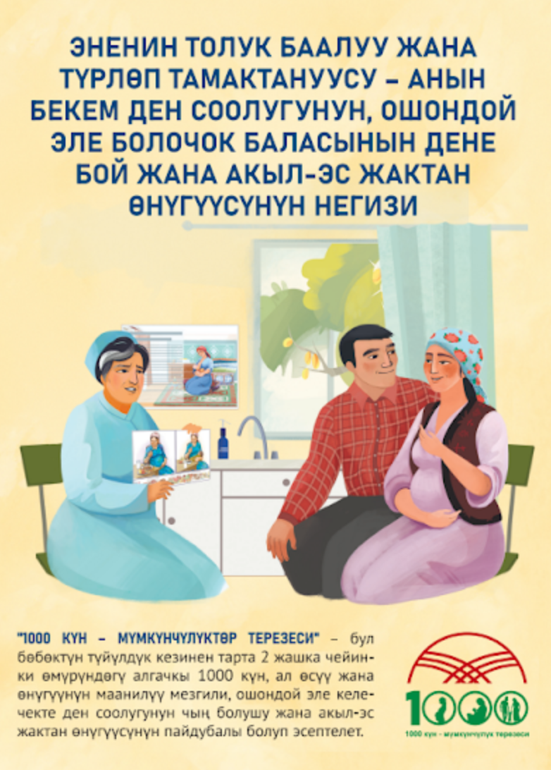
Activity VI: Presentation of the Maternal Nutrition and Anemia Prevention Booklet and Key Messages (10 minutes)
- Share the two-page booklet on maternal nutrition with the group. Explain that this booklet has the main recommendations for maternal nutrition for pregnant and breastfeeding mothers, as well as provides information about required portions of daily meals, including nutrient-rich food information.
- Ask Activists to spend 6–7 minutes reading the booklet and encourage them to ask any questions they have about the content.

Activity VII: Exploring How to Support an Enabling Environment for Mothers to Practice Good Nutrition (10 minutes)
- Explain to the group that very often a young mother’s role in the household can make it difficult for her needs to be prioritized. A mother’s nutrition and health must be supported by everyone in the household, and every adult in the household can contribute to a mother’s well-being.
- Ask the group the following questions and collect their answers. The facilitator will highlight the right information and/or guide the group toward the desired responses.
  - How can other household members support a mother’s nutrition and health?
Expected answers:
    - Support breastfeeding pregnant women to increase their diet with extra foods rich in iron.
    - Support a pregnant or breastfeeding mother (with funds or rides) to go to the health center for regular antenatal care (ANC) visits.
    - Agree together to buy more iron-rich foods for the family, including extra meals and foods for the mother.
    - Support mothers with household chores, especially when they are feeling side effects from IFA supplementation.
  - What can we as Activists do to help household members be engaged in exclusive breastfeeding?
Expected responses:
    - Include fathers and grandparents in home visit discussions.
    - Follow up with other household members on the next visit.
    - Discuss strategies with a mother on how to talk about the topic with family members.
    - Encourage family members to commit to the behaviors identified in the last question.
- Summarize that participation of all family members in maternal care and nutrition practices contribute to a mother’s health and her child’s growth and development.

Activity VIII: Exploring Counseling Skills with 5-Steps (30 minutes)
- Explain the next activity will be done in pairs. Say, “During our community mobilization module, you have been engaged for counseling. Let’s review counseling steps today through role play. Today, we will practice the five steps to give maternal nutrition messages and counseling to households that need information about maternal nutrition practices.”
- Quickly review each of the five steps using the 5-Steps handout from module 2. Ask participants to give an example of how to apply each step to today’s topic (in this case, maternal nutrition and anemia prevention). Remind participants that step 1 does NOT change based on the topic.
  - Assess and recap: What questions can Activists ask community members to learn the appropriateness of discussing maternal nutrition and anemia prevention?
Sample answers:
    - Are you currently pregnant?
    - Tell me about your diet/nutrition.
    - Have you received IFA supplementation tablets from your health facility?
    - Can you tell me what foods are particularly important to consume while pregnant or breastfeeding?
  - Analyze and introduce the topic: What kinds of responses to the questions above would signal that this person should receive counseling on maternal nutrition and/or anemia prevention?
Sample answers:
    - I received IFA supplementation from the health center, but I haven’t started to take it.
    - I think I am pregnant, but I have not yet visited the health center for my ANC visits.
    - I am taking my IFA supplements with black tea.
    - My diet has not changed since becoming pregnant.
  - Act: What kinds of messages would you like to give a caregiver who has difficulty exclusively breastfeeding? What activities could you do with her to promote the practice?
Sample answers:
    - Share recipes from the cookbook that are rich in iron and/or vitamin C.
    - Discuss strategies for overcoming barriers to IFA supplementation (taste, nausea, etc.).
    - Discuss strategies for increasing iron-rich foods in your diet (recipes, gaining family support, allocating more funds toward iron-rich foods).
  - Recap and close: What kind of actions can a community member commit to in order to practice good maternal nutrition and/or IFA supplementation?
Sample answers:
    - Use the reminder card to begin and build a habit of taking IFA supplements.
    - Visit the health center for an ANC visit and receive IFA supplementation and deworming.
    - Try one or two recipes of iron-rich foods from the cookbook.
    - To help iron absorption, avoid black or green tea with meals.
- Set up the role play. Say, “Let’s role play counseling on maternal nutrition.” Divide the group into pairs. Give each pair a printout of the role play scenarios. Assign one person to play the role of counselor and another to play the role of a mother. The person role playing the mother can invent any attitudes and practices around maternal nutrition they would like, but please choose at least one issue that the counselor can notice and work to counsel on.

The counselor should use the five steps of counseling to talk about maternal nutrition with the mother. Give the pairs 8–10 minutes to practice. If they finish early, have them switch roles.
- Using the scenario below, spend the last 5 minutes asking the counselors and role players which steps they did well and which steps were difficult.

Activity IX: Summarize Key Messages (5 minutes)
- Ask participants what they learned. They should list one or more of the key messages.

Activity X: Experience-Sharing on Previous Month’s Message Dissemination (15 minutes or 5 minutes)
- Divide participants into two or three groups of four to five people and ask them to talk about their experiences disseminating messages from the previous session, including success and challenges. On a flip chart, draw a column for each and list accordingly. Reconvene and ask each group to present its list. Ask the large group to discuss and offer advice to each other.
OR
Ask several volunteers to talk about something that went well in the previous month.

Activity XI: Action Planning for the Coming Month (10 minutes)
- Collect the Activists’ planning forms from the previous month. Make sure they are complete and have the Activists’ names on them. Speak with Activists who haven’t turned in a form or who have not filled out one completely or correctly.
- Distribute planning forms for the next month and ask them to take a few minutes to make a plan.
- As they plan their activities for the month, ask what they learned and what was most interesting.

Activity XII: Conclusion (2 minutes)
- Say, “We are thankful for your coming and delighted to be working with you to mobilize the community toward positive nutrition. By helping our moms and kids to be strong and well-nourished, we are helping Kyrgyzstan be a strong country.”

TRAINER REFERENCE:
FLIP CHARTS
Before the session, prepare the following flip charts as shown below:
Anemia is a lack of red blood cells, which are important for getting oxygen to all parts of the body. According to the data of the National Integrated Micronutrient and Anthropometric Survey (NIMAS) in Kyrgyz Republic there are 25.3 percent of anemic women of reproductive age 15–49 and 55.9 percent of iron deficiency among women.
IFA supplementation before pregnancy can improve birth outcomes, increasing the iron and folic acid status in women pre-pregnancy.
What foods contain iron?
What foods contain Vitamin C?
Consequences of anemia for women include—
- Reduced ability to work and reduced quality of life due to fatigue, weakness, and headaches
- Increased chances of infection and illness
- Increased risk that the child will be born with low birth weight
- Increased possibilities for complications during delivery.
Consequences of anemia for infants and children:
- Poor development of the brain and reduced learning capacity
- Loss of appetite and tiredness due to malnutrition
- Reduced ability to work and reduced quality of life due to fatigue, weakness, and headaches
- Reduced ability of immune system to fight diseases.

MODULE 9: Improving Family Budget Planning Practices for Contributing to Diversified and Healthy Diet

Module Objectives
At the end of the session, participants will be able to—
- Understand what home budgeting is and why it is important
- Talk about how they prioritize purchases (what they save money for)
- Talk to other members of the family about money matters
- Understand the importance of a diversified diet for the family.

Time: Approximately 2 hours

Materials and Preparation
- Before the training, read the module instructions in full below and clarify any doubts or questions with your supervisor.
- This session can be completed using the PowerPoint presentation for this module or by recreating the slides in this presentation to make flip charts. If using flip charts, complete and hang the flip charts before the beginning of the training session. The PowerPoint slides can be found in the folder of supplementary materials (in Kyrgyz only).
- The Five Step Counseling Approach Handout can be found under Section 3. The role play scenario can be found in Section 4. Bring at least one copy for every two participants to use in pairs.
- Module 8 video: This session contains an optional informational video. Trainers can screen the video for everyone during the training (on a projector or TV), or if such resources are not available, the video can be shared as a link through participants’ WhatsApp accounts. Budget planning
- The contents of the module is complemented with the Household Budgeting & Dietary Diversity, Trainers' Guide developed under the USAID Agro Horizon Project (2014–2019) and the trainer can use it for deeper research.
- Data collection forms designed for communities: household visits and community meetings. These forms can be found in Section 3, and copies can be found in the folder of supplementary materials.

Activity I: Introduce the Project and Objectives (5 minutes)
- Remind participants of the overall objectives of the project. A sample script from USAID Advancing Nutrition follows:
“Dear Activists, we would like to remind you of the basic objectives of the USAID Advancing Nutrition project in Kyrgyz Republic (USAID Advancing Nutrition). The project works to improve the nutritional status of women of reproductive age (ages 15–49) and children under five in the Kyrgyz Republic, with a specific focus on the 1,000 days that covers from the pregnancy up to the second birthday of the child.
USAID Advancing Nutrition works in close collaboration with the Ministry of Healthcare of Kyrgyz Republic.
USAID Advancing Nutrition works with partners in the community for improved behaviors related to food, water, health care, hygiene, and sanitation, because all these things affect our nutritional well-being.
The project provides recommendations from WHO and MOH of Kyrgyz Republic to improve awareness and understanding about nutrition and hygiene.”

Activity II: Brainstorming about Planning a Family Budget (20 minutes)
- Say, “Today we are going to talk about family budgets and how families can use budgeting to support good nutrition. Before we introduce new information on today’s topic, let's talk about what you know about budgeting. You can all think about your own experience managing money to answer these questions.”
- To participate in brainstorming with participants, ask the following open-ended questions and summarize the answers. The answers can be written on a flip chart and shown as a visual aid. If you are conducting a virtual training session (for example, over Zoom), you can make a simple blank PowerPoint presentation with each group discussion question as the title. When Activists respond, type their answers on the slide as if it is a flip chart. At the end, if participants don’t reach the expected answers, probe them toward the expected answer. Complete the flip chart/PowerPoint slide by adding the expected answers not mentioned and then continue the discussion.
- What is a budget?
Expected answer:
  - A budget is a planning tool with information on how to spend the projected income over a period of time.
- Why is it important to make a budget?
  - Helps a family to plan for the future.
  - Saves money.
  - Ensures that the family is spending money on the things the family values. There is less waste.
  - Helps the family to be more secure against shocks and emergencies.
- What kind of goals have you had in mind when making a budget? Or, what goals are typical for a family budget in your community?
  - good, nutritious food
  - investing in business
  - save money for holidays/celebrations
  - debt repayment
  - emergency fund.
- When your income is not enough to cover the family’s planned expenses, how do they (or a typical Kyrgyz family) cut back on spending?
  - luxury items
  - delay long-term goals (home improvements, business investments)
  - cut back on savings
  - cut back on debt repayment.

NOTE: If a person says, “grocery shopping” or “quality foods” or something similar, thank them for their answer and say, “This might be a common way to reduce spending, but I’d like to reserve this idea for later in the session.” Do not put this answer on the flip chart.

- What information do you need to budget properly?
  - incomes (such as regular salaries from work, revenue from selling of products, remittances, social benefits, etc.)
  - regular expenses (food, rent, clothing, transportation, health costs)
  - goals (what is important to the family, as well as what is needed to reach that goal—how much money and by when.
  - seasonal needs (heating, transportation costs, food costs change at some times of the year).

After receiving replies, summarize the answers and go to the next activity for explanation.
Close the activity by talking about these key messages:

- Budgeting is a powerful skill for making the most of your family’s resources.
- We all practice budgeting at least for short-term goals, but budgeting can be used in the long term as well.
- We can use budgeting to make sure we have the right money at the right time for things that are important to us, like nutrition and care for our families.

Activity III: Prioritizing Expenses for the Family (30 minutes)
This activity can be done in a few different ways. First, there is an optional video from USAID Advancing Nutrition that demonstrates a family making decisions together about the family budget to support good nutrition. Second, there is a short activity that can be done in groups that presents a similar situation in a case study. We recommend doing both, but you may find time or materials to fit only one.
Option A: Present the Family Budgeting Video (optional):
- Say, “The project has a short video that explains the importance of home budgeting for families in Kyrgyzstan.”
- After watching the video, the trainer will have an extended discussion with participants with the following questions:
- What did you think of the video?
- Did either family remind you of your own life? Why?
- Would anyone like to share a time they used a budget? What was it for? How did it go?
Have two to three people share their experiences with budgeting. Relate what they say to the answers given on the importance of budgeting, and thank them for sharing.
Option B: Group Work Exercise: Cholpon and Chingiz
In this exercise, divide the participants into smaller groups of no more than five people. For each group, pass around the following case study for them to read together. If you are conducting a virtual training session (for example, over Zoom), you can paste the case study into a PowerPoint slide and use the breakout rooms feature to make small groups. Before they break into smaller groups, explain to them that they are to role play as the family in the case study, and they must talk about the decisions they would have to make if they were in this situation.

- Scenario: Give each group 10 minutes to discuss and propose a solution for the issue:

Cholpon and her husband Chingiz live in Batken rayon with two children and Chingiz’s mother. Chingiz supports the family, but is struggling to make ends meet. Cholpon works hard to grow fruits and vegetables in a garden plot to help feed the family. She also has a small plot of pumpkins and sells the seeds for a little extra money. By purchasing new seeds and tools for farming, Chingiz also hopes to put a new tin sheet roof on their home. Water leaks into the home in the rainy season because their tile roof is not waterproof. Cholpon can sell her harvest of pumpkin seeds at the market and make KGS 30,000. This is enough for the expenses the family needs and to save a little for later.
Budget: KGS 30,000.
Expenses:
a. food: KGS 3,600
b. upgrading your tools and farming irrigation system: KGS 8,000
c. medical care at the doctor: KGS 3,600
d. new tin roof for your home: KGS 10,000
Savings: KGS 4,800

But, there was a long winter and the growing season was very short. Because of a bad harvest, food prices increased by 30 percent and goods and services are more expensive. The harvest of pumpkin seeds brought only KGS 22,000. This is not enough to cover the rising expenses. Chingiz usually makes all the decisions about money, but this is a very difficult situation. He does not know what is best for the family. What decisions would you make here?
Budget: KGS 22,000.
Expenses:
a. food: KGS 4,800
b. upgrading tools and farming irrigation system: KGS 9,000
c. medical care at the doctor: KGS 3,600
d. new tin roof for the home: KGS 10,000
Budget shortfall: KGS 5,400

After 10 minutes, ask two to three groups to present their budget decisions.
Ask them to explain how and why they made those decisions. Thank them for their participation.

Close the activity by talking about these key messages:
- Budgeting is all about making decisions for your family’s priorities.
- By understanding the family’s goals, you can design your budget to help meet those goals more quickly.
- Tracking income streams (and how they change over the year) is important for understanding how many resources you need to allocate.

Activity IV: Participation of Family Members in Budget Decisions
For the following questions, a flip chart summary is not necessary. You may ask training participants to give some answers aloud to begin a discussion, or you can ask them to reflect quietly on their answers.
- Say, “In the last activity, did everyone follow one person’s advice? Was it helpful to hear the ideas of others and their reasons? Why or why not”? Collect a few responses and thank them.
- Reflection activity:
  - Ask, “When you are making money decisions in your families, do you discuss money as a family, or does one person make all the decisions”? Highlight responses that promote a discussion of family.
  - Ask, “Speaking generally, within families in Kyrgyzstan, who typically makes money decisions—men, or women? What would happen if women made all the decisions around money? What would happen if men and women shared decisions around money equally”? Collect a few thoughts and thank them for sharing.
- Brainstorming activity: To deliver brainstorming with participants, ask the following open-ended questions and summarize the answers. The answers can be written on a flip chart and shown as a visual aid. If you are conducting a virtual training session (for example, over Zoom), you can make a simple blank PowerPoint presentation with each group discussion question as the title. When training respondents answer the questions, type their answers on the slide like a flip chart. At the end, if participants don’t reach the expected answers, probe them toward the expected answer, complete the flip chart/PowerPoint slide by adding the expected answers not mentioned and then continue the discussion.
  - What are some of the benefits of discussing budgets and money decisions with others in the family?
    - more people sharing responsibility
    - different perspectives heard
    - women/wives have strong values that they can share
    - everyone can communicate their needs
    - family harmony when everyone agrees on money decisions.
  - What are some of the challenges?
    - can cause disagreements
    - not a woman’s role to manage money
    - some family members do not live at home
    - a man’s responsibility only.
  - Have any of you faced these challenges? What can you share about those challenges and how you overcame them?
    - Couples show respect for each other by asking their opinions.
    - Disagreements are lessened because everyone discusses and understands where money is spent.
    - The husband feels relieved to share money responsibilities.
    - The wife feels important in the family.
- Close the activity by stating important key messages for couple’s communication:
  - Budgeting is a big responsibility, and it’s a good idea to share it within the family or within your marriage.
  - Wives and husbands may have different perspectives on family priorities because of the different roles they play in earning money, caring for the family, and running the household. This means that both people should speak and listen to ideas on budgeting.
  - Couples that make decisions about money together have improved outcomes in health and well-being of the family.

Activity V: Significance of Diversified Diet for the Household
- Introduce the next topic:
  - “Good nutrition and dietary diversity is very important to your family’s future. Your family’s groceries and food purchases should always be high priorities when making decisions about money in your household. Families can budget money to prioritize high-quality, nutritious, diversified foods. Families can also use similar skills to plan nutritious meals rich in iron, vitamin A, vitamin C, and other nutrients. Additionally, planning meals can help save money. Your family can get into a cycle of nutritious, affordable meals.
  - Making a weekly menu is a great way to budget for the family meal. The weekly menu can help you plan a diversified family diet with iron-rich, vitamins A and C–rich foods, as well as having more fruit and vegetables on a daily basis.
  - Planning a family diet helps to store more vegetables, fruits, and other food products year-round, as well as having more bean products.
  - One example of planning meals to save money is planning for the consumption of bean products once or twice a week that can help save more funds on meat. Meat can cost about 450 KG soms (equivalent to U.S.$5.3) and bean products cost about 100 soms (equivalent to U.S.$1.19), while still providing similar amounts of protein and iron.
  - Beans, known as the legume, pea, or bean family, are an affordable source of protein, fiber, iron, and vitamins that offer many health benefits. Protein is a vital nutrient that plays a key role in maintaining and repairing the body. Beans are high in amino acids, the building blocks of protein.
  - We would like to remind you of our “Recipe book” that also has recipes with beans for salads, soups, and other options.
  - Additionally, planning meals as a family gives all family members the opportunity to discuss their preferences, and understand why some substitutions are made in the week’s meal.
- Ask participants to reflect on how budgeting and meal planning fits in with other practices the group has discussed in the past. Are other activities related to family nutrition and health that can also save money? Activists can take the lessons you learn about budgeting and family goals and think about some of the other important lessons you’ve learned during these conversations:
Possible answers:
  - Breastfeeding is an important investment in the health and nutrition of your baby, and it is important to allow the mother of your child the time to breastfeed a child exclusively during the first six months of life. Exclusive breastfeeding eliminates the need (and costs) of other food for your baby, and continued breastfeeding reduces those needs.
  - Handwashing, hygiene, and sanitation are investments in the health of your family and help avoid illness that costs your family time, well-being, and even money for treatments and medicines.
  - Food storage and preservation is making an investment in your diet and making it possible to maintain a healthy diet throughout the year. We will talk about this topic in the next module.

Activity VI: Exploring Counseling Skills with 5-Steps (30 minutes):
- Explain the next activity will be done in pairs. Say, “During our community mobilization module, you have been engaged for counseling. Let’s review counseling steps today through role play. Today, we will practice the five steps to give budgeting messages and counseling to households that need information about budgeting practices.”
- Quickly review each of the five steps using the 5-Steps handout from module 2. Ask participants to give an example of how to apply each step to today’s topic (in this case, budgeting). Remind participants that step 1 does NOT change based on the topic.
  - Assess and recap: What questions can Activists ask community members to learn the appropriateness of discussing budgeting?
Sample answers:
    - Does your family have a budget?
    - Tell me about how your family decides what to eat. Who decides? What does your family like to eat?
    - Can you tell me about any challenges you face in buying and preparing diverse foods for your family?
  - Analyze and introduce the topic: What kinds of responses to the questions above would signal that this person should receive counseling on budgeting?
Sample answers:
    - In my family we do not have a budget for our incomes and expenses.
    - One person decides what the family will eat.
    - I make the meals, but someone else buys ingredients and we don’t talk about it beforehand.
    - We have very little money left over for daily expenses like food, so I can only buy whatever is cheapest.
    - It is harder to buy and prepare food in the winter when foods are more expensive.
  - Act: What kinds of messages would you like to give a family who has difficulty budgeting? What activities could you do with them to promote the practice?
Sample answers:
    - Share information about how to add up incomes and expenses to build a planning tool (budget).
    - Describe the benefits of sharing information between the family about money (and nutrition) to help make decisions together.
    - Discuss the benefits of planning a weekly meal to ensure a diversified diet while also saving money.
  - Recap and close: What kind of actions can a community member commit to in order to practice budgeting?
Sample answers:
    - Try to plan a weekly meal with the family for one week to see how they react to it.
    - Discuss with a partner the family’s nutrition needs before buying ingredients for meals.
    - Introduce the idea of starting a budget within the family and reporting back their thoughts to the Activist (for more support).
- Set up the role play. Say, “Let’s role play counseling on budgeting.” Divide the group into pairs. Give each pair a printout of the role play scenarios. Assign one person to play the role of counselor and another to play the role of a mother. The person role playing the mother can invent any attitudes and practices around budgeting they would like, but please choose at least one issue that the counselor can notice and work to counsel on.
The counselor should use the five steps of counseling to talk about budgeting with the mother. Give the pairs 8–10 minutes to practice. If they finish early, have them switch roles.
- Using the scenario below, spend the last 5 minutes asking the counselors and role players which steps they did well and which steps were difficult.

Activity VII: Summarize Key Messages (5 minutes)
- Ask participants what they have learned. They should list one or more of the key messages.

Activity VIII: Experience-Sharing on Previous Month’s Message Dissemination (15 minutes or 5 minutes)
- Divide participants into two or three groups of four or five people and ask them to talk about their experiences disseminating messages from the previous session, including success and challenges. On a flip chart, draw a column for each and list accordingly. Reconvene and ask each group to present its list. Ask the large group to discuss and offer advice to each other.
OR
Ask several volunteers to talk about something that went well in the previous month.

Activity IX: Action Planning for the Coming Month (10 minutes)
- Collect the Activists’ planning forms from the previous month. Make sure they are complete and have the Activists’ names on them. Speak with Activists who haven’t turned in a form or who have not filled in one completely or correctly.
- Distribute planning forms for the next month and ask them to take a few minutes to make a plan.
- As they plan their activities for the month, ask what they learned and what was most interesting.

Activity X: Conclusion (2 minutes)
- Say: “We are thankful for your coming and delighted to be working with you to mobilize the community toward positive nutrition. By helping our moms and kids to be strong and well-nourished, we are helping Kyrgyzstan be a strong country.”

TRAINER REFERENCE:
FLIP CHARTS
Before the session, prepare the following flip charts as shown below.
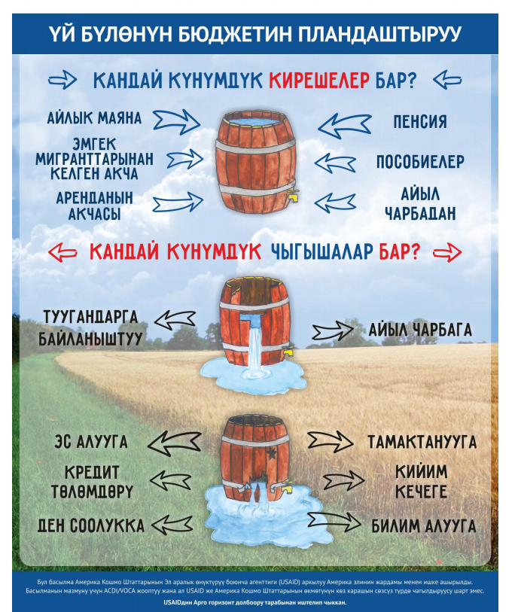
BUDGET BENEFITS
- Eases decision-making about spending and saving
- Encourages cautious spending
- Encourages disciplined saving
- If followed, helps you to meet financial goals
- Helps you take control of your money
- Helps to revise the expenditures for family diet, reducing junk foods and making a more diversified family diet
- Considers the needs of all family members, including IFA supplementation costs, visits of woman to health facility during pregnancy period, taking child for weighting, and health provider’s check-in time on planned regular basis.

MODULE 10: Food Storage at Households

Module Objectives
At the end of the session, participants will be able to—
- Explain the nutritional benefits of foods rich in vitamin A, vitamin C, iron, and zinc (i.e., improved dietary diversity).
- Describe how dietary diversity can be improved by making certain foods available for longer periods of times, such as after that food’s season.
- Explain food storage and preservation methods that can be done at home with little or no cost. ∙ Describe fresh storage methods (e.g., apples, carrot, cabbage).
- Describe methods for drying fruits and berries.
- Discuss appropriate conditions (e.g., cellar), equipment (e.g., drying rack, string) and labor (e.g., digging trench) requirements for various home-based food storage and preservation methods, highlighting the easiest for people in their area to adopt.
- Introduce the Storage of Nutritious Foods at Home guidebook during 1,000 days household visits, explaining the benefits, and highlighting some simple methods to try first.

Time: Approximately 2 hours

Materials and Preparation
- Before the training, read the module instructions in full below and clarify any doubts or questions with your supervisor.
- This session can be completed using the PowerPoint presentation for this module or by recreating the slides in this presentation to make flip charts. If using flip charts, complete and hang the flip charts before the beginning of the training session. The PowerPoint slides can be found in the folder of supplementary materials (in Kyrgyz only).
- The Five Step Counseling Approach Handout can be found under Section 3. The role play scenario can be found in Section 4. Bring at least one copy for every two participants to use in pairs.
- The content of the module is complemented with the Food Storage Guidebook developed under the USAID Advancing Nutrition, updated from the USAID SPRING Food Storage Guidebook (2017). The updated guidebook can be found in English, Russian, and Kyrgyz in the folder of supplementary materials.
- Data collection forms designed for communities: household visits and community meetings. These forms can be found in Section 3, and copies can be found in the folder of supplementary materials.

Activity I: Introduce the Project and Objectives (5 minutes)
- Remind participants of the overall objectives of the project. A sample script from USAID Advancing Nutrition follows:
“Dear Activists, we would like to remind you of the basic objectives of the USAID Advancing Nutrition project in Kyrgyz Republic (USAID Advancing Nutrition). The project works to improve the nutritional status of women of reproductive age (ages 15–49) and children under five in the Kyrgyz Republic, with a specific focus on the 1,000 days that covers from the pregnancy up to the second birthday of the child.
USAID Advancing Nutrition works in close collaboration with the Ministry of Healthcare of Kyrgyz Republic.
USAID Advancing Nutrition works with partners in the community for improved behaviors related to food, water, health care, hygiene, and sanitation, because all these things affect our nutritional well-being.
The project provides recommendations from WHO and MOH of Kyrgyz Republic to improve awareness and understanding about nutrition and hygiene.”

Activity II: Introduce the New Topic about Foods Storage at Households
- Introduce the new topic:
  - Say, “Dear Activists, we have talked a lot before that special attention needs to be paid to the nutrition of pregnant women and children under two.
  - Eating a variety of foods, specifically those rich in vitamin A, vitamin C, iron, and zinc, is good for the health of your family. Planning a family meal can help reduce worthless expenses, as well as expenses for junk food that will keep harmful foods from improving health status.
  - To support all these practices, we are going to talk about the proper storage of nutritious food. Families can buy storable foods in harvest months when they are inexpensive, to be kept over winter months when food costs increase. In this way, food storage helps save money and improves budgeting and ensures that households have nutritious foods available throughout the year.”

Activity III: Brainstorming About the New Topic
- Say, “To begin talking about food storage and preservation, we should talk about food spoilage. Certain conditions accelerate the deterioration process and make food dangerous for consumption. I am sure that all of you have seen food spoil in your own homes.”
- Ask, “Think about those situations. They are all conditions that allow for germs to multiply quickly. What kinds of conditions cause things to spoil”? Allow several participants to give their answers. After each speech, link their responses to one or more of the conditions below. Highlight the condition, and then read the information next to it that describes how germs grow in this condition.
  - Food: Bacteria requires food to survive. Moist, protein-rich foods, such as meats, are at the highest risk of bacterial growth.
  - Acidity: Bacteria grows best in a mostly neutral or slightly acidic environment (between 6.6 and 7.5 pH). Therefore, making food more sour or acidic is one useful food preservation technique.
  - Temperature: Germs don’t grow well in very hot or very cold environments. Harmful germs grow most quickly on foods in the temperature danger zone, or between 5°C–57°C. Be sure to keep food outside the danger zone as much as possible.
  - Time: Harmful germs on food require time to multiply, which is why it is important to ensure food does not remain in the danger zone. Heating or cooling foods quickly is important to ensure harmful germs do not multiply.
  - Oxygen (air): Most dangerous food germs require oxygen to reproduce. However, certain germs like botulism are anaerobic, meaning they do not require oxygen for survival or reproduction. These germs can be avoided through proper sterilization of materials during the canning process.
  - Moisture (water): Most germs cannot grow without adequate water. Drying foods such as beans, dried grains such as rice, and lentils have low risk of containing harmful germs because they are dried.
- Say: “When we work to eliminate or reduce one of these conditions, we can keep our food safe. For example, when you cook a hot meal and eat it right away, it’s good to eat. But if you leave your meal out and let it sit at room temperature, it may go bad. That’s because the germs have time to spoil the food.
- Keeping food safe is an essential part of ensuring you and your family remain healthy and avoid sickness. Below are the five simple steps outlined by the World Health Organization in the flip chart to keep your food safe. (3.1)

Activity IV: Brainstorming about Food Preservation Methods
- Ask, “What food storage and preservation methods do you use in your households”? Later, summarize with the list below. Ask several participants to give their answers. After each speech, link their responses to one or more of the methods below. Highlight the method, and then read the information next to it that links the method to the elimination or reduction of a spoiling condition described in the previous activity.
  - Drying: Removes water thus reducing germ growth.
  - Preservation by salt or sugar: Sugar/salt binds with water, making the water unavailable for germ growth. Consuming too much salt or sugar, however, can be harmful to your health.
  - Refrigeration: Ensure your refrigerator is set between 0°C–4°C to slow the growth of germs.
  - Freezing: Set your freezer at or below -18°C. At this temperature germs may remain alive, but will not actively multiply.
  - Preservation by heating: Pasteurization, blanching, and sterilization are the three primary heating preservation methods.
  - Preservation by smoking: Removes water (moisture) from food over hot smoke. Typically used for meats and fish.
  - Preservation by acid/vinegar: Increases the acidity or sourness of foods, making it difficult for germs to reproduce.
  - Fermentation: Harnesses beneficial germs to prevent harmful bacteria from growing. Can improve the nutrient quality of foods.
Finish by reading any remaining methods that were not addressed in the brainstorming.
- Say, “If you noticed, each one of these food preservation techniques combats one or more of the six conditions that germs need to grow. Can you guess which condition each of these methods combats”? Propose each method and have them identify the spoiling condition most affected:
  - refrigeration: temperature
  - drying: water
  - smoking: water
  - preserving in vinegar: acid
  - fermentation: oxygen and acid.
Say: “All above mentioned preservation storage methods are described in the revised and updated USAID Advancing Nutrition Food Storage Guidebook.”
- Ask the group: “Thinking back to our discussion last time about planning meals and budgets, how can food preservation help families eat a nutrition diet? If we buy and store some foods when it is cheap and consume it when it’s less available and its price is high, we can have dietary diversity in lean times that also wouldn’t be a burden for the family budget.”

Activity V: Learn About Safe Food Storage Techniques
- The trainer explains the following: “Many foods that we grow might already meet many of the conditions to protect from germ growth. In these cases, we don’t have to do a lot of preservation to keep them safe to eat over a long period of time. Instead, we can use simple techniques to store these foods without heavy processing used in preservation techniques. One benefit of this method is that we are not losing nutritional value in these foods and we are also not adding a lot of unhealthy foods into our diet like excessive salt and sugar.”
- Say, “Some of the food storage and food preservation methods overlap (like freezing and drying).” Ask, “Do any of you practice storage of foods? What kind of foods? Where do you store them”? Collect some responses from the group, and use them to highlight information about the storage methods described below:
  - Storing fresh: A common method of food storage at the household level in rural Kyrgyzstan is in basements and cellars. Another method that is becoming more common is storage in refrigerators, although in many areas the supply of electricity is still unstable to ensure uninterrupted operation of refrigerators. Many vegetables and fruits grown in Kyrgyzstan can be stored directly in cellars without drying or freezing, such as apples, pears, potatoes, carrots, onions, garlic, cabbage, pumpkins, radishes, and beets. To ensure proper storage, it is best to choose the right time. Remove fruits and vegetables from the cellar after cold weather and sufficiently cool temperatures are established in the cellar. The optimum condition for storage is when the produce is ripe at the time of harvest and the cellar temperature has been established.
  - Freezing: Freezing foods helps retain many important nutrients in foods, such as the vitamins. Freezing also reduces germ’s ability to multiply. It is one of the most effective ways to keep fruits and vegetables fresh, which allows you to preserve more natural nutrients. Frozen vegetables (except for bell peppers) can be stored for up to a year, fruits and berries up to nine months, bell peppers up to six months, and herbs up to four months. General rules for defrosting: Defrosting should be slow in the refrigerator, or on the kitchen table but only in the package. Once thawed, do not refreeze.
  - Drying: Drying is one of the oldest methods of food preservation. Under Kyrgyz conditions, fruits and vegetables are dried in the sun or in small dryers and, in rare cases, on the stove and in the oven. The most convenient for drying are grids—wooden or metal frames made thickly woven from twigs, wire, or plastic, so that air can flow to them both from the bottom side. If the wicker is made of ordinary wire, cover the grids with a sparse cloth (gauze) so that the dried fruit will not touch the iron. Be sure to dry foods on hot, breezy days. It is best to dry foods at 28°C or above. The food storage guidebook has specific instructions with guidelines for drying foods. Electric dryers can be used as an alternative to solar drying, which significantly speeds up the drying process and does not put food at risk for dust contamination. Store home-cooked dried food in corked glass jars or in paper bags, preferably in the refrigerator. In the package they are well preserved, but the main thing is to monitor the temperature and humidity, otherwise the dried products can get damp and moldy.

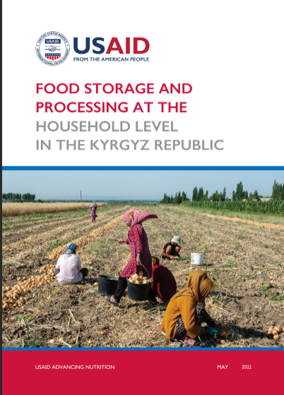
Activity VI: Presentation of the Food Storage Guidebook (15 minutes)
- Share the copies of the food storage book, or share links to the book on the USAID Advancing Nutrition website. Explain that this book has guidance for storage methods and preparation steps for a variety of foods, such as berries, nuts, and vegetables to support a diversified, safe, and healthy diet for the family during the whole year.
- Have Activists quickly divide themselves into pairs. Ask Activists to spend 6–7 minutes reading the book and select one or two foods to read about. After they have read about storage techniques for one or two foods, ask Activists to share one or two things they learned about storing that food.
- Close the session by asking Activists if they have any questions on the content.

Activity VII: Discuss Shared Responsibilities for Food Storage
- Say, “Food preservation carries many benefits for the family, but it also takes a lot of planning and work to complete. The family should carefully consider who in the family has the time and energy to participate in food preservation tasks, as they can be very labor intensive.
In the Kyrgyz Republic, many activities related to food preparation are considered a woman’s domain. However, it may not be logical to assign all the food preservation tasks to the women in the family. For example, the time in the year for food preservation of the harvest may coincide with a period when the husband/father has less work than usual, and it may be best for the family to have him lead the work of food preservation.
Even in cases when it is most appropriate for the wife/mother of the household to lead food preservation activities, the family should think about the other labor burdens for which she must also be responsible (for example, working outside the home, caring for children, cooking, and household chores) and see how the rest of the family can take over these responsibilities so that she is not overburdened. Remember that pregnant women need more care and rest to keep themselves and their babies healthy. Lactating women also need support from the family to have the time to feed the baby, and this should be considered when assigning roles in the family’s food preservation activity.
By including fair participation from all family members in food preservation, the family benefits from fast completion of preservation activities, avoids overburdening any one member of the family, and passes along valuable cooking skills to youth.

Activity VIII: Exploring Counseling Skills with 5-Steps (30 minutes):
- Explain the next activity will be done in pairs. Say, “During our community mobilization module, you have been engaged for counseling. Let’s review counseling steps today through role play. Today, we will practice the five steps to give food storage and preservation messages and counseling to households that need the information.”
- Quickly review each of the five steps using the 5-Steps handout from module 2. Ask participants to give an example of how to apply each step to today’s topic (in this case, food storage and preservation). Remind participants that step 1 does NOT change based on the topic.
  - Assess and recap: What questions can Activists ask community members to learn the appropriateness of discussing food storage and preservation?
Sample answers:
    - Can you tell me how your family keeps a diversified diet throughout the year (including summer months)?
    - Does your family grow any nutritious fruits and vegetables in your garden? Are you able to keep any of those products for consumption by the family? What challenges do you have in doing that?
    - Are you interested in learning more about food storage and preservation?
  - Analyze and introduce the topic: What kinds of responses to the questions above would signal that this person should receive counseling on food storage and preservation?
Sample answers:
    - It is hard to eat diverse foods at times because food gets very expensive in the winter.
    - We grow some foods like apples but we sell everything or else it all goes bad. It’s too much for one family.
  - Act: What kinds of messages would you like to give a caregiver who has difficulty with food storage and preservation? What activities could you do with her to promote the practice? Sample answers:
    - Discuss the benefits of storing foods for consumption at times when finding quality, inexpensive foods is difficult.
    - Talk about strategies for advocating with the family to keep some nutritious foods for storage for the winter.
    - Talk to the family about investing in materials for food storage or preservation (like a refrigerator, freezer, or electric dryer).
  - Recap and close: What kind of actions can a community member commit to in order to practice food storage and preservation?
Sample answers:
    - Discuss buying or budgeting for food storage equipment.
    - Download the food storage and preservation guide and select one or two foods and try a storage technique with them.
    - Practice a food storage technique and test the quality of food (like freezing some vegetables for a week to see how they taste thawed).
- Set up the role play. Say, “Let’s role play counseling on food storage and preservation.” Divide the group into pairs. Give each pair a printout of the role play scenarios. Assign one person to play the role of counselor and another to play the role of a mother. The person role playing the mother can invent any attitudes and practices around food storage and preservation they would like, but please choose at least one issue that the counselor can notice and work to counsel on.

The counselor should use the five steps of counseling to talk about food storage and preservation. If they finish early, have them switch roles.
- Spend the last 5 minutes asking the counselors and role players which steps they did well and which steps they had difficulty with using the scenario below.

Activity IX: Summarize Key Messages (5 minutes)
- Ask participants what they learned. They should list one or more of the key messages.

Activity X: Experience-Sharing on Previous Month’s Message Dissemination (15 minutes or 5 minutes)
- Divide participants into two or three groups of four–five people and ask them to talk about their experiences disseminating messages from the previous session, including success and challenges. On a flip chart, make a column for each and list accordingly. Reconvene and ask each group to present its list. Ask the large group to discuss and offer advice to each other.
OR
Ask several volunteers to talk about something that went well in the previous month.

Activity XI: Action Planning for the Coming Month (10 minutes)
- Collect the Activists’ planning forms from the previous month. Make sure they are complete and have the Activists’ names on them. Speak with Activists who haven’t turned in a form or who have not filled in one completely or correctly.
- Distribute planning forms for the next month and ask them to take a few minutes to make a plan.
- As they plan their activities for the month, ask what they learned and what was most interesting.

Activity XII: Conclusion (2 minutes)
- Say: “We are thankful for your coming and delighted to be working with you to mobilize the community toward positive nutrition. By helping our moms and kids to be strong and well-nourished, we are helping Kyrgyzstan be a strong country. This is our final module with you, we very much hope all our key nutrition and hygiene messages have been helpful for you and your family.”

TRAINER REFERENCE:
FLIP CHARTS
Before the session, prepare the following flip charts as shown below.
The World Health Organization’s 5- Steps for Keeping Food Safe:
- Keep clean (surfaces, hands, cooking materials)
- Separate raw and cooked foods
- Cook thoroughly to proper temperatures
- Keep food at safe temperatures (outside of the danger zone)
- Use safe water and raw materials.
Storing Fresh
Storage in basements and cellars. Many vegetables and fruits grown in Kyrgyzstan can be stored directly in cellars without drying or freezing, such as apples, pears, potatoes, carrots, onions, garlic, cabbage, pumpkins, radishes, and beets.
Freezing
Helps retain many important nutrients in foods, such as the vitamins. Freezing also reduces germ’s ability to multiply.
Drying
- Nutrition-wise, food stays mostly the same, although the drying process can destroy vitamins A and C. And, the calorie count can rise as the food shrinks and nutrients become more concentrated.

Section 3. Handouts and Training Materials

Checklist for Evaluating Module Trainings
QUALITY IMPROVEMENT & VERIFICATION CHECKLIST FOR MODULE TRAININGS
To be filled out by USAID AN Coordinator or Staff.
Name of facilitator:___________________________ Evaluator:__________________________________
Community: ___________________________ Date: ______________________________
METHODS | YES | NO
Set up
- Did the facilitator seat people so that all could see each other’s faces? | □ | □
- Did the facilitator wear appropriate clothing? | □ | □
- Did the facilitator sit at the same level as the other participants? | □ | □
Overall communication
- Did the facilitator speak loud enough that everyone could hear? | □ | □
- Did the facilitator use proper eye contact with everyone? | □ | □
- Did the facilitator use changes in voice intonation (not monotone)? | □ | □
- Did the facilitator speak slowly and clearly? | □ | □
- Did the facilitator move around the room/area without distracting the group? | □ | □
- Did the facilitator always use examples/terminology that were culturally appropriate? | □ | □
- Did the facilitator encourage comments by nodding, smiling, or other actions that show s/he was listening? | □ | □
- Did the facilitator ALWAYS reply to participants in a courteous and diplomatic way? | □ | □
- Did the facilitator prevent domination of the discussion by 1 or 2 people? | □ | □
- Did the facilitator encourage timid participants to speak/participate? | □ | □
- Did the facilitator give participants adequate time to answer questions? | □ | □
- Did the facilitator encourage discussion amongst participants? | □ | □
Beginning
- Did the facilitator introduce the topic well (who s/he is, topic, time)? | □ | □
- Did the facilitator ask questions to relate topic to the participants’ experiences? | □ | □
- Did the facilitator ask about the current practices of the participants? | □ | □
Middle
- Did the facilitator use the brainstorming technique at appropriate moments? | □ | □
- Did the facilitator use any materials (flipcharts, pictures)? | □ | □
- Did the facilitator explain the meaning of used materials? | □ | □
- Did the facilitator encourage comments by paraphrasing what people said (repeating statements in his or her own words)? | □ | □
- Did the facilitator ask participants if they agree with other participants’ responses? | □ | □
- Did the participants make lots of comments? | □ | □
- Did the facilitator summarize the participants’ discussion? | □ | □
- Did the facilitator reinforce statements by sharing relevant personal experience, or asking others to share personal experience? | □ | □
- Did the facilitator encourage participants to share what they know? | □ | □
End
- Did the facilitator verify that people understood the main points using open-ended questions? | □ | □
- Did the facilitator summarize the essential points presented at the end? | □ | □
- Did the facilitator finish the session within the allotted time? | □ | □
Contents
- Was the content of the educational messages CORRECT?
1 2 3 4 5 6 7 8 9 10
POOR EXCELLENT
- Was the content of the educational messages RELEVANT?
1 2 3 4 5 6 7 8 9 10
POOR EXCELLENT
- Was the content of the educational messages COMPLETE?
1 2 3 4 5 6 7 8 9 10
POOR EXCELLENT
- OVERALL EVALUATION OF THE facilitator's behavior change communication PERFORMANCE
1 2 3 4 5 6 7 8 9 10
POOR EXCELLENT
Scoring: Yes = ____ Used (Yes+No) = _____ Score= ______%
Recommendations/suggestions for action/comments:

(continue on the next page if necessary)

Checklist for Supervision of Activists
QUALITY IMPROVEMENT & VERIFICATION CHECKLIST FOR ACTIVIST HOME VISITS AND COMMUNITY MEETINGS
To be filled out by USAID AN Community Mobilizer.
Date:___________________ Rayon:________________ Village:__________________
Community activist’ name:______________________________________________________
Checklist completed by:_________________________________________________________
HH.......................□ Meeting........................□

Overall communication | YES | NO
- Did activist announce goal and objectives of USAID Advancing Nutrition? | □ | □
- Did activist announce the topic of key messages delivering? | □ | □
- Did activist talk about key messages? | □ | □
- Did activist use job aids (brochures etc.)? | □ | □
- Did activist disseminate materials (brochures, etc.)? | □ | □
- Were there any questions or answers? | □ | □
- Did activist complete forms 1 & 2 after conversation? | □ | □

Activist Module Planning and Reporting Forms
FORM 1: Community Activist Information Dissemination Form
Activist Full Name: |  | Oblast:
Topic(s): |  | Rayon:
 |  | Village:

# | Date | FULL NAME of the Household Head  (Last and First Name) | PHONE NUMBER  of those who received information  (one household - one phone number) | Phone number is correct  (Yes/  No) | Information delivered  ONLINE  (Yes/  No) | How many people were given information |  | How many children under 2 years of age are in this household? |  | How many pregnant women are in this household? | Comments  (successes or challenges)
 |  |  |  |  |  | Men  (over 15 years old) | Women  (over 15 years old) | Boys | Girls
1 |  |  |  | ☐ | ☐
2 |  |  |  | ☐ | ☐
3 |  |  |  | ☐ | ☐
4 |  |  |  | ☐ | ☐
5 |  |  |  | ☐ | ☐
6 |  |  |  | ☐ | ☐
7 |  |  |  | ☐ | ☐
8 |  |  |  | ☐ | ☐
9 |  |  |  | ☐ | ☐

USAID Advancing Nutrition project
Activist Full Name: |  | Oblast:
Topic(s): |  | Rayon:
 |  | Village:

# | Date | FULL NAME of the Household Head  (Last and First Name) | PHONE NUMBER  of those who received information  (one household - one phone number) | Phone number is correct  (Yes/  No) | Information delivered  ONLINE  (Yes/  No) | How many people were given information |  | How many children under 2 years of age are in this household? |  | How many pregnant women are in this household? | Comments  (successes or challenges)
 |  |  |  |  |  | Men  (over 15 years old) | Women  (over 15 years old) | Boys | Girls
10 |  |  |  | ☐ | ☐
11 |  |  |  | ☐ | ☐
12 |  |  |  | ☐ | ☐
13 |  |  |  | ☐ | ☐
14 |  |  |  | ☐ | ☐
15 |  |  |  | ☐ | ☐
16 |  |  |  | ☐ | ☐
17 |  |  |  | ☐ | ☐
18 |  |  |  | ☐ | ☐
19 |  |  |  | ☐ | ☐
20 |  |  |  | ☐ | ☐
21 |  |  |  | ☐ | ☐

FORM 2: COMMUNITY MEETING REGISTRY FORM
Purpose: For reporting the number of community meetings (groups of people with at least 4 individuals) conducted by Community Activists. To be completed and submitted at the time of the community meeting.
Activist Full Name: |  | Oblast:
Topic(s): |  | Rayon:
 |  | Village:

Date  (Day/Month/Year) | Meeting Type | Mark “✔” for appropriate | Venue / Place | How many people were given information?  (over 15 years old) |  | Number of pregnant women out of the total number of women | Comments  (successes or challenges)
 |  |  |  | Men | Women
 | Parent meeting (school / kindergarten) | ☐
 | Aiyl okmotu / district administration | ☐
 | Informal meetings (weddings) | ☐
 | Other  _______________ | ☐
Total Number of Participants*:
*Please attach photo of the community meeting

The 5-Step Counseling Approach

STEP 1: Open and Welcome
The Activist invites all the household members to have a joint conversation and discussion. The Activist meets and greets the household members, asks how they are doing, and sets a very positive and welcoming tone.
If the Activist has visited the house before—
After greeting the caregiver, the Activist reaches out to the household members and asks about the household’s experience with last month’s topic. The Activist asks if the household changed some of its habits after the session and if they enjoyed the experience, or if anything was difficult. The Activist can help the household remember the messages and can even provide support to overcome barriers if they express any difficulty. Be patient and try to complement what they say with helpful information. If the family expresses strong difficulties, make a note to return to provide more specific help on the topic at a later date.

STEP 2: Assess and Recap
Introduce the new topic of your visit and begin the session by asking the household member about what they know and what they do in the household regarding this topic. It is important to understand the situation in the family, so be patient and give caregivers an opportunity to speak first. The Activist can ask probing questions to help caregivers express their complete thoughts.
Sample questions on exclusive breastfeeding:
How old is your child?
Are you currently pregnant?
Tell me about what you are feeding your child
To finish step 2, please summarize what the household members have said and repeat it back to them. This is an important step to show that you are listening to what the household member has said and that you value their thoughts and contributions on the topic. Thank them for sharing their experience.

STEP 3: Analyze and Identify 1–2 Topics
Internally review the information you learned in step 2 and prioritize what you will do next. (In step 3, the Activist makes decisions in his/her head only. The recommendation that come from analysis are in step 4.)
From the information the caregiver gives, try to recommend at least one positive attitude or practice that aligns with the key messages—this way you can praise the caregiver for how they care for their child.
Always respond to concerns raised by caregivers. Prioritize no more than two recommendations that you will make for small, doable actions that the caregivers can practice at home within a short period of time.
For example, in the sample questions about exclusive breastfeeding in step 2, an Activist might learn that a child is under six months, is still breastfeeding, but is already eating complementary foods. An Activist might ANALYZE the situation and decide to praise the mother for continuing to breastfeed, but may also try to focus on discussing what it means to exclusively breastfeed.
In this step, the Activist does not take a specific action during the home visit. All of the thinking is done in the Activist’s head. If an Activist cannot identify discussion points, then he/she may return to step 2 and ask more questions to learn more about the family circumstances about the issue.

STEP 4: Act (conduct activity with demonstration, practice, and positive feedback)
Put into action the discussion points identified in step 3. Praise caregivers for their efforts. Provide counseling using demonstration and allowing caregivers time to practice. Be sure to respond to any concerns raised by caregivers.
Counselors can use illustrations from project materials to demonstrate key messages and best practices.

STEP 5: Summarize and Close
Summarize key messages and encourage caregivers to share their reflections. Discuss barriers to apply recommendations and problem-solve together how to overcome those barriers.
While learning more about how the households’ practice exclusive breastfeeding and responsive care the Activist responds to all needs that are under the given recommendations. If there are more issues the Activist should direct the household to the health provider for more information.
Ask caregivers to demonstrate or explain to you what they agreed to do and how they will apply this at home.
The Activist should check the day and time for the next visit and remind what the next module will be about.

Section 4. Role Plays for Technical Modules
Technical modules 2–10 each contain a role play activity that uses the 5-Step Counseling Approach to listen to families speak on their issues in family nutrition and work together to find a solution. Two scenarios were created for each module. Activists work in pairs and take turns. First, Activist A will play the role of the caregiver in scenario 1 while the other Activist B will play the role of the counselor. Then, the roles switch; Activist B will use the caregiver scenario 2 while Activist A plays the role of the counselor.

Print these scenarios ahead of time so that there are enough copies for every two participants in the training.

Scenarios for Module 2 Role Play: Exclusive Breastfeeding
Mother Number 1:
1 child: 3 months old
I am not currently pregnant.
I am exclusively breastfeeding the child, but my mother-in-law tries to feed bulamyk from time to time. It frustrates me.
When I breastfeed, I like to cover the baby with a blanket and watch TV.
Even at three months, I can tell a lot about what the baby needs just from her face and movements. I know what face she makes when she has just pooped, and I can tell when she is tired by the way she fusses.
I never talk to my baby, because a baby cannot talk, so that would be silly. Sometimes the baby begins making noises, but I don’t respond.
I do like to sing a lullaby to my child from time to time. When I sing, the baby always looks right at me.
Mother Number 2:
1 child: 4 months old
Not currently pregnant.
I am still breastfeeding my child a bit, but mostly having complementary foods. My husband thinks the baby should still breastfeed, but I think if she takes the complementary food, then it’s fine.
When feeding the baby, she is not always very interested in breastfeeding. I feed her bulyamuk first, and she won’t breastfeed. If she is full, then I think it’s okay.
One problem is that she seems to get sick a lot. She has pretty frequent diarrhea and I can see she’s always tired. My family, we always take her straight to the health center, but I don’t think she should be getting sick this often.

Scenarios for Module 3 Role Play: Complementary Feeding
Mother Number 1:
1 child: six months old
Not currently pregnant.
I am still breastfeeding my child exclusively, but I want to start complementary foods. I am not sure what to feed her. My mother-in-law says that my baby should have started a while ago and thinks it’s fine to start with something like small crackers. I am not so sure. I think she might choke. I’m scared to start!

Mother Number 2:
1 child: 18 months old
My child eats a lot of complementary foods. At least, I try to feed them to him. He really only takes crackers and cut up fruits regularly. Beyond that, it’s very difficult.
I try very hard to feed my son vegetables—sometimes raw, sometimes cooked, sometimes pureed. Some strategies work better than others.
I learned from my neighbor that it’s not good to give animal products to young children except for milk and dairy products. So, I don’t try to feed him any meats or eggs.
Not serving meat is just as well because it’s very expensive, but the rest of the family has eggs all the time.

Scenarios for Module 4 Role Play: Responsive Care and Responsive Feeding
Mother Number 1:
1 child: 3 months old
I am not currently pregnant.
I am exclusively breastfeeding the child, but my mother-in-law tries to feed bulamyk from time to time. It frustrates me.
When I breastfeed, I like to cover the baby with a blanket and watch TV.
Even at three months, I can tell a lot about what the baby needs just from her face and movements. I know what face she makes when she has just pooped, and I can tell when she is tired by the way she fusses.
I never talk to my baby, because a baby cannot talk, so that would be silly. Sometimes the baby begins making noises, but I don’t respond.
I do like to sing a lullaby to my child from time to time. When I sing, the baby always looks right at me.
Mother Number 2:
1 child: 18 months old
Currently pregnant. I will give birth in two months.
I am still breastfeeding my child a bit, but mostly having complementary foods. My husband thinks the baby is too old to continue breastfeeding. My mother-in-law disagrees and supports breastfeeding.
When feeding the baby, I like to make it fun for him. I always sit facing my baby and try to give him my full attention. At 18 months, my baby is always trying to grab the spoon and feed himself but I think that is dangerous and I do not let him feed himself at all under any circumstances.
At 18 months, it’s easy to know what the baby needs (like when he needs to go to the bathroom or when he is hungry).
Often my baby is trying to play with me and demands to play, but I am so busy with housework that I usually just give him my phone for You-Tube.

Scenarios for Module 5 Role Play: Early Communication and Learning Through Play
Mother Number 1:
When asked about learning and play practices:
I have a lot of songs that I sing to my baby when we’re doing different things, like mealtimes and bathtime. He seems to recognize songs and reacts when I start singing them.
Sometimes my baby will make noises or babbles, but I don’t know how to respond. It feels silly to “talk” to my baby when he’s not saying anything. I just like to listen to his babbles.
I don’t know any games to play with my child. He’s too young to play games, isn’t he? And too young for any toys. He’d just break them.

Mother Number 2:
Caregiver has two children, 23 months and 3 months. In this scenario, the Activist already discussed breastfeeding at the last visit.
When asked about complementary feeding (for the 23-month-old only):
I try to give my child lots of different foods. He really likes most things, and even when he doesn’t, I’ll try a few weeks later, and he seems to like it then! I give my child as many different vegetables as I can find. My baby loves eating small amounts of meat and eggs, too.
During mealtimes, I really don’t want distractions, which means there is no talking during feeding at all.
During the day, it’s difficult to find time to make different snacks. So, usually I give my child a package of cookies or salty chips.
When asked about learning and play practices (for both children):
The older baby loves to mimic doing what I do at home. It’s a fun game we like to play together and he never gets tired of it.
The older child likes to look at the magazines we have in the house, but I don’t want him to mess them up, so I don’t let him look through them.
I don’t really give a lot of attention to the younger baby. He is only 3-months-old, and he can’t communicate with us at all yet.

Scenarios for Module 6 Role Play: Handwashing and Maintaining Clean Latrines
Mother Number 1:
I know the critical times for handwashing are after using the toilet and after cleaning a child using a toilet.
In our family, we don’t really worry about handwashing too much. We eat only hot cooked food, and so cooking kills all the bacteria.

Mother Number 2:
I really wish my family would practice more handwashing and sanitation, but it’s hard. We have a handwashing station, but usually there is no soap available. And it’s outside, so it’s often too cold to wash hands.
I sometimes try to speak to my husband about this, but he says it’s my problem to solve. Secretly, my mother-in-law agrees with me but she says she does not want to take sides between a husband and wife.

Scenarios for Module 7 Role Play: Dietary Diversity and Reduced Consumption of Junk Food
Mother Number 1:
In our family, we eat a lot of meats and breads. My husband says that’s the food he needs to feel strong for work.
For myself, I sometimes add a salad during lunchtime to get more vegetables in my diet. But I don’t do this for my children.

Mother Number 2:
I am a mother of three children, one of which is 16 months. It’s very difficult to manage so many, and so we have a lot of prepared food. For example, for snacks, the kids eat cookies, crackers, or chips, because we can afford them and I don’t have to prepare anything.

Scenarios for Module 8 Role Play: Anemia Prevention and Maternal Nutrition
Mother Number 1:
1 child, 8 months
I am enjoying being a mother to my first child. I am still breastfeeding and we started complementary feeding. It’s a lot of work, and I’m still expected to support the whole family at mealtime.
My nutrition is fine. It’s nearly the same as everyone else, I think, because we share the family meal. But, because I am first serving the whole family, and then I’m focused on feeding my baby, I don’t really eat as much as everyone else. For example, there is usually very little meat left in the family meal because that is for my husband and my father-in-law first. Sometimes, there isn’t much of the meal left. I’m just so focused on feeding my child during mealtimes.

Mother Number 2:
1 child, 3 years.
Currently pregnant
I went to the health post for my antenatal care visit, and I received IFA supplementation. I started to take it, but it was such a bad experience. First, the taste is terrible, and very often, I feel very nauseated after I take it. If this is how it’s going to be during the whole pregnancy, I think it’s not worth it!

Scenarios for Module 9 Role Play: Family Budgeting
Mother Number 1:
In my family, we don’t have a budget. Or at least I don’t know about it because my husband manages all the money. He also makes all the purchases for food himself. I am getting a lot of information about nutrition, and I tell him about these things. But, when it comes to money, it’s hard to talk about this with him.
Sometimes I can tell we have less money available because my husband comes home with less food for me to prepare. And other times we eat the finest foods. I would like it to be a bit more even.

Mother Number 2:
I think my family does well on budgeting. We know what we have and what money is coming, and that helps us make decisions together about what to buy.
… most of the time! Some times of the year, food gets really expensive. Even though we can track our incomes well, it’s hard to plan for changes in expenses. When things get expensive, we stop buying meat and fresh vegetables. There are some weeks where we have a lot of thinner broths.

Scenarios for Module 10 Role Play: Food Storage and Preservation
Mother Number 1:
I think my family does well on budgeting. We know what we have and what money is coming, and that helps us make decisions together about what to buy.
… most of the time! Some times of the year, food gets really expensive. Even though we can track our incomes well, it’s hard to plan for changes in expenses. When things get expensive, we stop buying meat and fresh vegetables. There are some weeks when we have a lot of thinner broths.

Mother Number 2:
I want to try some food storage methods, but I have a lot of questions. My mother-in-law says that food storage isn’t safe. I point out that we often eat pumpkins through the winter, but then she’ll point out a food like berries that we only eat when they are freshly harvested. I think it’s a different case for each product, but I don’t know about these differences.
My husband has a different concern—he says that some stored products (like when things are frozen) taste bad later on. Is that true? He won’t even let me try to freeze something. He says it would be a waste of food.

1
USAID Advancing Nutrition is the Agency’s flagship multi-sectoral nutrition project, addressing the root causes of malnutrition to save lives and enhance long-term health and development.
This document is made possible by the generous support of the American people through the United States Agency for International Development (USAID). The contents are the responsibility of JSI Research & Training Institute, Inc. (JSI), and do not necessarily reflect the views of USAID or the United States government.

USAID ADVANCING NUTRITION
Implemented by:
JSI Research & Training Institute, Inc.
2733 Crystal Drive
4th Floor
Arlington, VA 22202

Phone: 703–528–7474
Email: info@advancingnutrition.org
Web: advancingnutrition.org

July 2023

Note: Delete upon completion.

Ministry of Health of the Kyrgyz Republic, UNICEF, FAO, WFP, WHO, USAID, USAID Advancing Nutrition, MercyCorps. National Integrated Micronutrient and Anthropometry Survey 2021. Snapshots of Key Findings. Bishkek, the Kyrgyz Republic.
National Statistical Committee of the Kyrgyz Republic and UNICEF. 2019. Kyrgyzstan Multiple Indicator Cluster Survey 2018, Survey Findings Report. Bishkek, Kyrgyzstan: National Statistical Committee of the Kyrgyz Republic and UNICEF.

