CORE CONCEPTS IN MENTORSHIP TRAINING FOR THE BREASTFEEDING COUNSELLING MENTORSHIP PROGRAM
Credit: Alan Gichigi/MCSP
Participant’s Manual
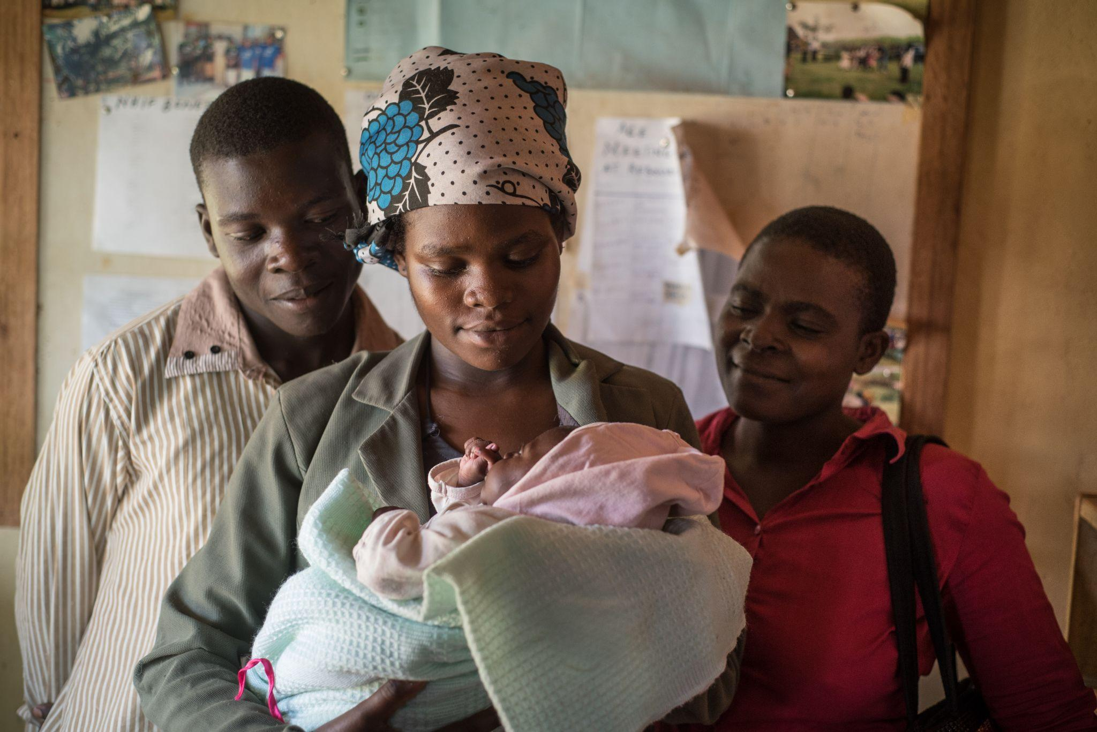
Draft

About USAID Advancing Nutrition
USAID Advancing Nutrition is the Agency’s flagship multi-sectoral nutrition project, led by JSI Research & Training Institute, Inc. (JSI), and a diverse group of experienced partners. Launched in September 2018, USAID Advancing Nutrition implements nutrition interventions across sectors and disciplines for USAID and its partners. The project’s multi-sectoral approach draws together global nutrition experience to design, implement, and evaluate programs that address the root causes of malnutrition. Committed to using a systems approach, USAID Advancing Nutrition strives to sustain positive outcomes by building local capacity, supporting behaviour change, and strengthening the enabling environment to save lives, improve health, build resilience, increase economic productivity, and advance development.
Disclaimer
This report is made possible by the generous support of the American people through the U.S. Agency for International Development. It was prepared under the terms of contract 7200AA18C00070 awarded to JSI Research & Training Institute, Inc. (JSI). The contents are the responsibility of JSI, and do not necessarily reflect the views of USAID or the U.S. Government.
Recommended Citation
USAID Advancing Nutrition. 2023. Core Concepts in Mentorship Training for the Breastfeeding Counselling Mentorship Program: Participant’s Manual. Arlington, VA: USAID Advancing Nutrition.

Photo Credit: Photo credit: Allan Gichigi/MCSP

USAID Advancing Nutrition
JSI Research & Training Institute, Inc.
2733 Crystal Drive
4th Floor
Arlington, VA 22202

Phone: 703–528–7474
Email: info@advancingnutrition.org
Web: advancingnutrition.org

ACKNOWLEDGMENTS
The Core Concepts in Mentorship Training for the Breastfeeding Counselling Mentorship Program has been developed through a consultative and participatory approach that included many partners and stakeholders. The content development process was rigorous and thorough with a lot of input and feedback to build consensus. The authors are greatly indebted to all those who made contributions toward the development of this training, particularly those who participated in and steered the process and contributed technical and financial support including: United States Agency for International Development (USAID) Kenya, USAID Washington, USAID Advancing Nutrition, and Nutrition International. We also are grateful to the Council of Governors for making it possible for county directors of health, and county reproductive health, child health, and nutrition focal persons to participate in various meetings, in particular the leadership from Nairobi County. This work would also not be possible without the leadership from Mbagathi County Referral Hospital which piloted the program in 2023, including Alexander Irungu, PhD, chief executive officer; Dr. Nicholas Tinega, medical superintendent; Dr. Erica Koima, deputy medical superintendent and head of clinical services; and Linet Kwamboka Kinara, nursing services manager. We are also grateful to the mentors and mentees at Mbagathi County Referral Hospital for sharing their experiences implementing the mentorship program, as well as the numerous clients that received breastfeeding counselling during the pilot of this mentorship program and whose feedback helped to inform improvements to this guidance document.
A few other individuals made exceptional contributions to the development of this document, including: Ruth Tiampati, Child Health and Nutrition Team lead, Office of Health, Population and Nutrition, USAID Kenya; Veronica Kirogo, director of the Division of Nutrition and Dietetics Services, Ministry of Health (MoH); Caroline Arimi, program officer for Maternal, Infant, and Young Child Nutrition (MIYCN), Division of Nutrition and Dietetics, MoH; and the late Rose Wambu, former program officer for MIYCN, Division of Nutrition and Dietetics, MoH and former chair of the National MIYCN Technical Working Group. Other individuals made significant contributions, including Esther Mogusu, director of nutrition, Department of Health, Wellness, and Nutrition, Nairobi County; Brian Njoroge; and the late Professor Rachel Musoke. Annex 1 lists all contributors.
Special thanks and gratitude to the senior management of the MoH under leadership of Director General Dr. Patrick Amoth for creating an enabling environment for implementation of breastfeeding counselling services.
We would also like to acknowledge the International Training and Education Center on HIV (I-TECH) whose training content, Basics of Clinical Mentoring, including tools and resources for mentors, were heavily drawn upon in the development of this training.

CONTENTS
ACKNOWLEDGMENTS iii
GLOSSARY OF TERMS vi
BACKGROUND 1
Breastfeeding Counselling Mentorship Program 1
CORE CONCEPTS IN MENTORSHIP TRAINING 4
Overview 4
Goal and Learning Objectives 4
Resources and Worksheets 4
AGENDA 5
WELCOME, INTRODUCTIONS, AND OBJECTIVES 7
Slides and Notes 7
Notes: 9
SESSION 1: ORIENTATION TO THE BREASTFEEDING COUNSELLING MENTORSHIP PROGRAM 10
Learning Objectives 10
Slides and Notes 11
Notes: 27
SESSION 2: WHAT IS CLINICAL MENTORING? 28
Learning Objectives 28
Slides and Notes 29
Notes: 44
SESSION 3: BUILDING RELATIONSHIPS 45
Learning Objectives 45
Slides and Notes 46
SESSION 3: RESOURCES 54
Resource 3.1: Building a Relationship with a Mentee 54
Notes: 58
SESSION 4: EFFECTIVE COMMUNICATION AND FEEDBACK SKILLS 59
Learning Objectives 59
Slides and Notes 60
SESSION 4: RESOURCES 84
Worksheet 4.1: Feedback Scenarios 84
Resource 4.1: Basic Principles of Giving Feedback 85
Notes: 87
SESSION 5: CLINICAL TEACHING SKILLS 88
Learning Objectives 88
Slides and Notes 89
SESSION 5: RESOURCES 105
Resource 5.1: Six Steps of Clinical Teaching 105
Resource 5.2: Demonstration of Clinical Teaching Approach 106
Notes: 108
SESSION 6: MENTORSHIP CASE STUDIES 109
Learning Objectives 109
Slides and Notes 110
SESSION 6: RESOURCES 112
Worksheet 6.1: Case Studies (Participant’s Version) 112
Notes: 126
NEXT STEPS AND CLOSING REMARKS 127
Slides and Notes 127
Notes: 129
REFERENCES 129
LIST OF CONTRIBUTORS 131

GLOSSARY OF TERMS
Attitudes: The behaviour, the way, or manner in which we act towards ourselves or others (WHO and UNICEF 2020b, 6).
Case presentations: A case from a real-life situation that a mentee has encountered is presented to other mentees (and mentors) followed by discussion questions about how to characterise, describe, and/or act on the situation.
Clinical mentoring: The process whereby an experienced, highly regarded, and empathetic person (the mentor) guides another individual (the mentee) in the development and re-examination of their own ideas, learning, and personal and professional development (SCOPME 1998). This one-to-one approach is also referred to as traditional mentoring, as it is the most common approach for developing individual relationships that build trust, and allows the pair to delve deep into areas of strength and development.
Competency: The capability to use a set of related knowledge, skills, and behaviours to successfully perform identified jobs, roles, or responsibilities (WHO 2015).
Feedback: Comments in the form of opinions about or reactions to something. Feedback can be positive (affirming) or corrective. Mentors provide feedback to their mentees to evaluate the mentees’ competencies; enable improvements to be made; and to provide useful information to influence future actions.
Knowledge: The theoretical or practical understanding of a subject gained through formal education or practical experiences (WHO and UNICEF 2020b, 6).
Mentor: An experienced and empathetic person, proficient in her/his content area, who teaches and coaches another individual (mentee) or a group of individuals (mentees) in-person and/or virtually to ensure competent workplace performance and provide ongoing professional development (MCSP 2018).
Mentee: A direct care provider who delivers breastfeeding counselling to clients. They are a dedicated, skilled health provider who seeks to grow and develop personally and professionally to successfully achieve his/her goals to strengthen their breastfeeding counselling competencies with the support of a mentor.
Performance indicator: Help to document that a mentee has acquired necessary competencies and are measurable (WHO and UNICEF 2020b, 6). A mentor verifies each of the performance indicators address knowledge, skills, or attitudes by observation.
Side-by-side mentoring: This involves working alongside the mentee. Mentor and mentee alternate duties of seeing and examining the clients, writing relevant information in the client’s health record, and conducting counselling.
Skills: Abilities to properly perform a job. These include cognitive, communication, interpersonal, and problem-solving techniques (WHO and UNICEF 2020b, 6).

BACKGROUND

Breastfeeding Counselling Mentorship Program

Overview
The breastfeeding counselling mentorship program aims to reinforce and strengthen breastfeeding counselling competencies of health workers covered in the Baby-Friendly Hospital Initiative (BFHI) Training Course for Maternity Staff (WHO and UNICEF 2020a) (BFHI training) and the Competency Verification Toolkit: Ensuring Competency of Direct Care Providers to Implement the BFHI (WHO and UNICEF 2020b) (BFHI Competency Verification Toolkit) at health facilities in Kenya. The goal of the mentorship program is to improve the quality of breastfeeding counselling provided by health workers, helping to ensure that mothers receive skilled breastfeeding counselling during antenatal, postnatal, neonatal, and paediatric points of care to support early initiation and exclusive breastfeeding, as part of the national BFHI program. By the time they have completed the mentorship program, mentees should be able to demonstrate that they possess the knowledge, skills, and attitudes to safely and compassionately deliver counselling to all mothers and support newborns (WHO and UNICEF 2020b).
The breastfeeding counselling mentorship program is a facility-based program focused on strengthening selected breastfeeding counselling competencies of health workers who regularly counsel pregnant and lactating mothers on breastfeeding. It was envisioned for implementation at three levels of health facilities in Kenya (level 3B, health centres; level 4, primary referral hospitals; and level 5, secondary referral hospitals) and at multiple service delivery points (antenatal care, labour and delivery, postnatal care, newborn care, and paediatric care services).

Breastfeeding Counselling Mentorship Program Package
This Core Concepts in Mentorship Training for the Breastfeeding Counselling Mentorship Program: Facilitator’s Guide, is part of a mentorship program package which includes—
- Implementation Guidance for a Facility-Based Breastfeeding Counselling Mentorship Program, including job aids and mentorship program tools, as well as slide decks to use during orientation of health facility management, mentors, and mentees to the program and BFHI health facility assessment tools
- Core Concepts in Mentorship Training: Mentor Training Course for the Breastfeeding Counselling Mentorship Program materials: a facilitator’s guide, participant’s manual, and slide deck.
The mentorship program package was designed in 2021–2022 collaboratively by the Ministry of Health (MoH) Division of Nutrition and Dietetics; the BFHI Task Force of the Maternal, Infant, and Young Child Nutrition (MIYCN) Technical Working Group (TWG); and USAID Advancing Nutrition, the Agency’s multi-sectoral nutrition project from 2018–2023, and included in-depth consultations and two design workshops. For more information on this process, please see Strengthening Breastfeeding Counselling Competencies: The Design of a Facility-Based Mentorship Program in Kenya brief.
The mentorship program package was tested through implementation research at Mbagathi County Referral Hospital in Nairobi County, Kenya, from March–September 2023 (box 1). In November 2023, many of the same stakeholders from the design workshops met with representatives from Mbagathi County Referral Hospital to review and update the mentorship program package, including this Facilitator’s Guide and accompanying training materials, based on the learnings from the implementation research.

Box 1. Implementation Research on the Feasibility of a Breastfeeding Counselling Mentorship Program
Through a collaboration among the MoH Division of Nutrition and Dietetics, the BFHI Task Force of the MIYCN TWG, and USAID Advancing Nutrition, the implementation team tested the breastfeeding counselling mentorship program at Mbagathi County Referral Hospital in Nairobi County, Kenya, from March–September 2023. Mbagathi County Referral Hospital is a level 5 public health facility. The primary objective of the research was to evaluate the feasibility of a facility-based mentorship program to strengthen breastfeeding counselling competencies of health workers in the antenatal care (ANC) and postnatal care (PNC) departments. This included the outpatient ANC clinic, inpatient ANC ward, labour and delivery ward, and inpatient PNC ward. We also had the following sub-objectives: (1) identify factors that enable and hinder implementation; (2) determine if the program improves mentees’ knowledge, practices, and self-efficacy to provide quality breastfeeding counselling; and (3) determine if the program improves pregnant and postpartum women’s perceptions of breastfeeding counselling.

Competencies for the Breastfeeding Counselling Mentorship Program
During the design workshops, stakeholders prioritised 7 out of the 16 competencies (table 1) from the BFHI Competency Verification Toolkit as the focus for the mentorship program. Stakeholders considered these competencies feasible to achieve within the duration of the mentorship program and the ones providers most needed support to strengthen.
Table 1. Competencies for Implementing the BFHI* (Focus Competencies in Red)
Domain 1: Critical Management Procedures to Support the Ten Steps
Competency 1. Implement the Code in a health facility
Competency 2. Explain a facility’s infant feeding policies and monitoring systems
Domain 2: Foundational Skills: Communicating in a Credible and Effective Way
Competency 3. Use listening and learning skills whenever engaging in a conversation with a mother
Competency 4. Use skills for building confidence and giving support whenever engaging in a
conversation with a mother
Domain 3: Prenatal Period
Competency 5. Engage in antenatal conversation about breastfeeding
Domain 4: Birth and Immediate Postpartum
Competency 6. Implement immediate and uninterrupted skin-to-skin
Competency 7. Facilitate breastfeeding within the first hour, according to cues
Domain 5: Essential Issues for a Breastfeeding Mother
Competency 8. Discuss with a mother how breastfeeding works
Competency 9. Assist mother getting her baby to latch
Competency 10. Help a mother respond to feeding cues
Competency 11. Help a mother manage milk expression
Domain 6: Helping Mothers and Babies with Special Needs
Competency 12. Help a mother to breastfeed a low-birth-weight or sick baby
Competency 13. Help a mother whose baby needs fluids other than breast milk
Competency 14. Help a mother who is not feeding her baby directly at the breast
Competency 15. Help a mother prevent or resolve difficulties with breastfeeding
Domain 7: Care at Discharge
Competency 16. Ensure seamless transition after discharge
*These competencies come from the BFHI Competency Verification Toolkit (WHO and UNICEF 2020b).

Objectives
The specific objectives for the mentorship program include—
- Reinforce and strengthen 7 of the 16 competencies (table 1) needed for implementation of the BFHI.
- Support mentees to apply skills learned in the BFHI training during breastfeeding counselling sessions with clients.
- Cultivate a skilled team of on-site mentors who can champion and support quality breastfeeding counselling and serve as a resource for mentees.
- Create an enabling environment for providing quality breastfeeding counselling at all relevant service delivery points.
In addition, the mentorship program aims to—
- Foster strong relationships between mentors and mentees.
- Ensure guidance and support are available on a consistent basis.
- Ensure mentors understand the context in which mentees are working.
- Remove common barriers to successful mentoring such as travel costs and transportation availability.
- Shift focus from off-site, hotel-based, in-service training to on-site, on-the-job capacity strengthening.

CORE CONCEPTS IN MENTORSHIP TRAINING

Overview
The Core Concepts in Mentorship Training course is required for all mentors participating in the breastfeeding counselling mentorship program. Designed to introduce mentors to basic mentoring skills, it includes sessions on interpersonal communication, clinical teaching, and mentoring in the context of the breastfeeding counselling mentorship program. Following a brief orientation to the breastfeeding counselling mentorship program, it helps mentors understand clinical mentoring, and learn how to build rapport, give feedback effectively, and identify teaching moments. Sessions include a variety of participatory exercises and activities to help mentors build the skills required to serve as a mentor and for effective clinical teaching.

Goal and Learning Objectives
The goal of the Core Concepts in Mentorship Training course is to prepare mentors for their role in the breastfeeding counselling mentorship program by providing them with the skills, knowledge, and resources necessary to be an effective clinical mentor.
At the end of the course, it is expected that participants will be able to—
- Describe the structure of the mentorship program.
- Define clinical mentoring.
- Identify mentoring strategies.
- Explain the benefits of clinical mentoring.
- Describe how to build a positive relationship with a mentee.
- Demonstrate effective feedback and communication skills.
- Choose the appropriate mentoring strategy for a given teaching moment.

Resources and Worksheets
The session resources at the end of each session in this guide contain the four resources and two worksheets required for the training including the answer keys, where needed:
- Resource 3.1: Building a Relationship with a Mentee
- Worksheet 4.1: Feedback Scenarios
- Resource 4.1: Basic Principles of Giving Feedback
- Resource 5.1: Six Steps of Clinical Teaching
- Resource 5.2: Demonstration of Clinical Teaching Approach
- Worksheet 6.1: Case Studies (Participant’s Version).

AGENDA
Use this agenda alongside the slide deck and notes for the training.
Day 1
Time | Topics
08:30–09:00  (30 minutes) | Registration
09:00–09:15  (15 minutes) | Welcome, Introductions, and Objectives
09:15–10:15  (60 minutes) | Session 1: Orientation to the Breastfeeding Counselling Mentorship Program  Learning Objectives  By the end of this session, participants will be able to—  - Describe the structure of the mentorship program.
10:15–11:45  (90 minutes) | Session 2: What is Clinical Mentoring?  Learning Objectives  By the end of this session, participants will be able to—  - Define clinical mentoring and distinguish it from supportive supervision.  - Understand the rationale for, and objectives of, clinical mentoring.  - Outline characteristics of effective mentors.  - Explain challenges to mentoring.
11:45–12:00  (15 minutes) | Tea Break
12:00–13:00  (60 minutes) | Session 3: Building Relationships  Learning Objectives  By the end of this session, participants will be able to—  - Explain the importance of building a relationship with a mentee based on trust, mutual respect, and an understanding of cultural differences.  - Identify potential barriers to relationship building.  - Identify techniques for building rapport.  - Practise affirming statements.
13:00–14:00  (60 minutes) | Lunch
14:00–16:00  (120 minutes)  *Stop at slide 82 and continue the remaining slides for Session 4 on day 2. | Session 4: Effective Communication and Feedback Skills  Learning Objectives  By the end of this session, participants will be able to—  - Identify the basic principles of feedback.  - Explain the important role of feedback in the context of clinical mentoring.  - Demonstrate effective communication styles and constructive feedback.
16:00–16:30  (30 minutes) | Distribute evaluation and close

Day 2
Time | Topics
08:30–09:00  (30 minutes) | Recap and questions from day 1
09:00–10:00  (60 minutes)  *Start at slide 83. | Session 4: Effective Communication and Feedback Skills (continued)  Learning Objectives  By the end of this session, participants will be able to—  - Identify the basic principles of feedback.  - Explain the important role of feedback in the context of clinical mentoring.  - Demonstrate effective communication styles and constructive feedback.
10:00–11:30  (90 minutes) | Session 5: Clinical Teaching Skills  Learning Objectives  By the end of this session, participants will be able to—  - Define a teaching moment.  - Use clinical teaching, side-by-side mentoring, and case presentations as teaching strategies.
11:30–11:45  (15 minutes) | Tea Break
11:45–13:00  (75 minutes) | Session 6: Case Studies  Learning Objective  By the end of this session, participants will be able to—  - Apply the clinical mentoring skills and techniques learned in this course to real-life clinical mentoring case studies.
13:00–14:00  (60 minutes) | Lunch
14:00–16:00  (120 minutes) | Session 6: Case Studies  (continued)
16:00–16:30  (30 minutes) | Next Steps and Closing Remarks  Debrief of the training sessions and discussion of next steps

WELCOME, INTRODUCTIONS, AND OBJECTIVES

Slides and Notes

SLIDE 1: CORE CONCEPTS IN MENTORSHIP TRAINING FOR THE BREASTFEEDING COUNSELLING MENTORSHIP PROGRAM

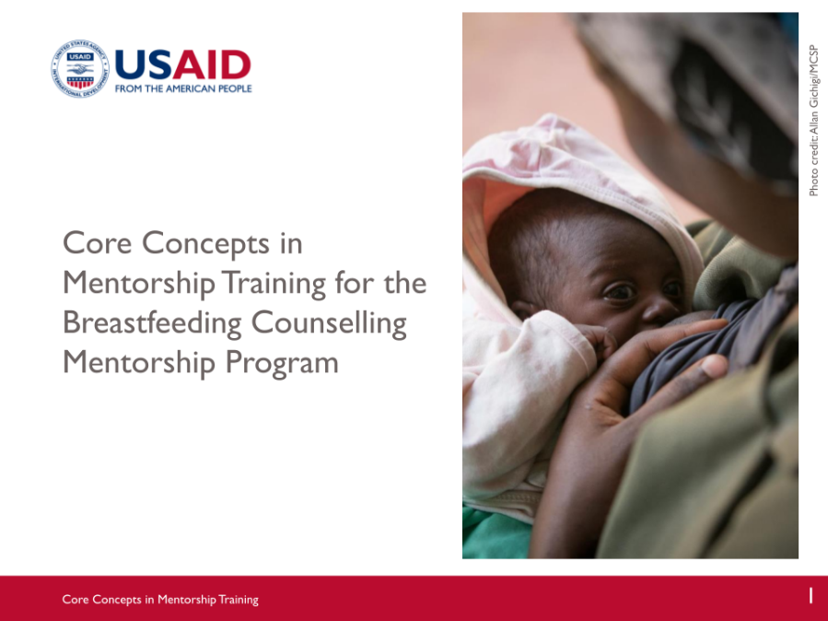

SLIDE 2: WELCOME, INTRODUCTIONS, AND OBJECTIVES

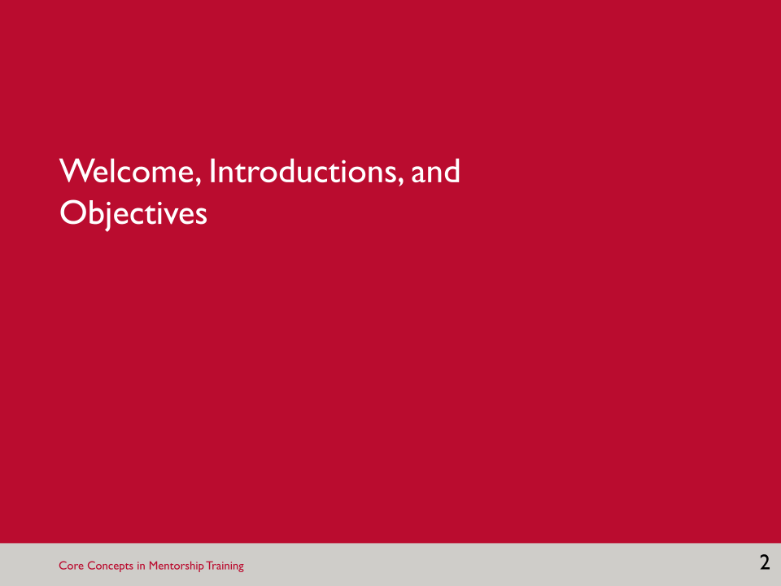

SLIDE 3: INTRODUCTIONS

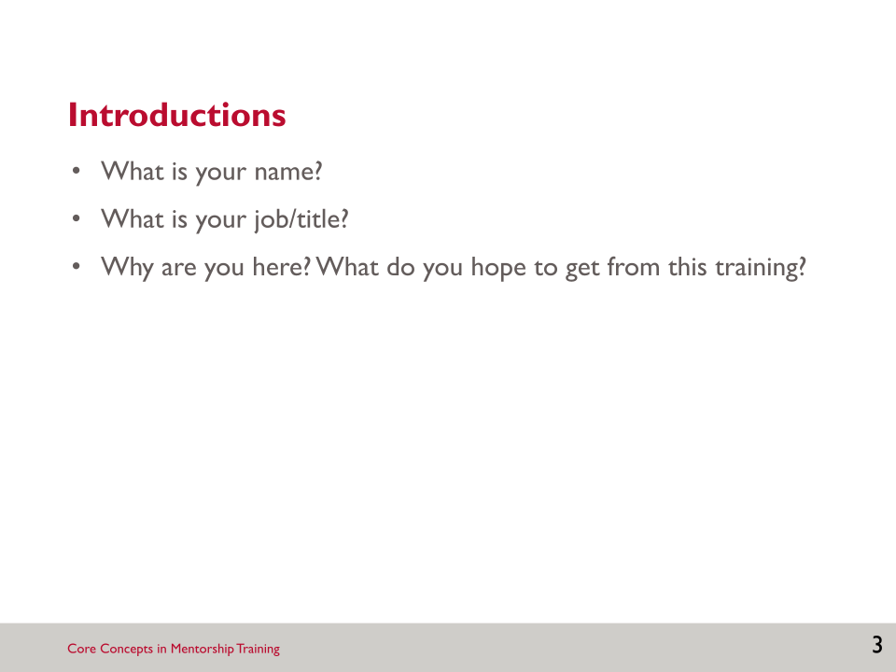

SLIDE 4: GOAL AND COURSE OBJECTIVES

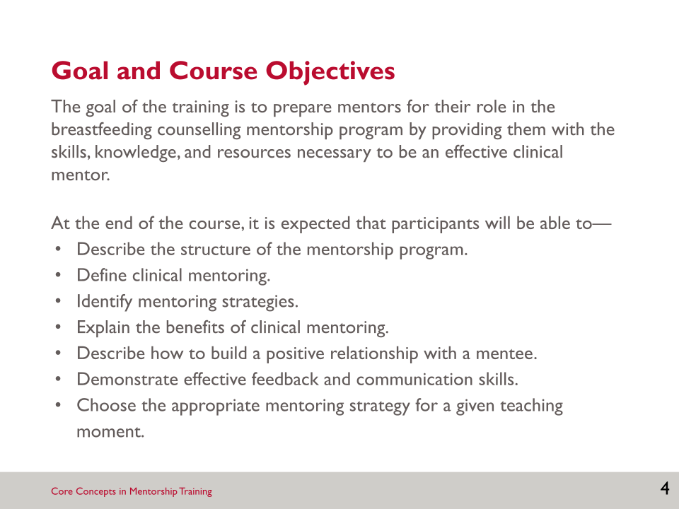

- While the first session will provide a brief orientation to the breastfeeding counselling mentorship program structure, this training is really focused on preparing you to be an effective clinical mentor by providing you with the skills, knowledge, and resources necessary.
- There will be another orientation session that will focus on your roles and responsibilities in the mentorship program, how mentoring sessions will take place, and the tools and job aids that you will use for mentoring.

Notes:
_______________________________________________________________________________________________________________________________________________________________________________________________________________________________________________________________________________________________________________
_______________________________________________________________________________________________________________________________________________________________________________________________________________________________________________________________________________________________________________
_______________________________________________________________________________________________________________________________________________________________________________________________________________________________________________________________________________________________________________
_______________________________________________________________________________________________________________________________________________________________________________________________________________________________________________________________________________________________________________
_______________________________________________________________________________________________________________________________________________________________________________________________________________________________________________________________________________________________________________
_______________________________________________________________________________________________________________________________________________________________________________________________________________________________________________________________________________________________________________
_______________________________________________________________________________________________________________________________________________________________________________________________________________________________________________________________________________________________________________
_______________________________________________________________________________________________________________________________________________________________________________________________________________________________________________________________________________________________________________
_______________________________________________________________________________________________________________________________________________________________________________________________________________________________________________________________________________________________________________
_______________________________________________________________________________________________________________________________________________________________________________________________________________________________________________________________________________________________________________
_______________________________________________________________________________________________________________________________________________________________________________________________________________________________________________________________________________________________________________
_______________________________________________________________________________________________________________________________________________________________________________________________________________________________________________________________________________________________________________
_______________________________________________________________________________________________________________________________________________________________________________________________________________________________________________________________________________________________________________
_______________________________________________________________________________________________________________________________________________________________________________________________________________________________________________________________________________________________________________
__________________________________________________________________________________________________________________________________________________________________________________________________________

SESSION 1: ORIENTATION TO THE BREASTFEEDING COUNSELLING MENTORSHIP PROGRAM

Learning Objectives
By the end of this session, participants will be able to—
- Describe the structure of the mentorship program.

Key Points
- The goal of the mentorship program is to improve the quality of breastfeeding counselling provided by health workers.
- Mentorship was chosen as the preferred approach for strengthening breastfeeding counselling competencies for a number of reasons; it is a flexible teaching and learning process that can address on-the-job challenges, it can fill the gap between trainings and continuing professional development, and it contributes to the Kenya MoH’s efforts to scale up BFHI.
- Mentors have a critical role to play in the mentorship program and were selected based on established criteria.
- Next steps before mentoring begins include selecting mentees, pairing mentors with mentees, and orientation meetings to learn and understand more about your roles and responsibilities in the program.

Slides and Notes

SLIDE 5: SESSION 1: ORIENTATION TO THE BREASTFEEDING COUNSELLING MENTORSHIP PROGRAM

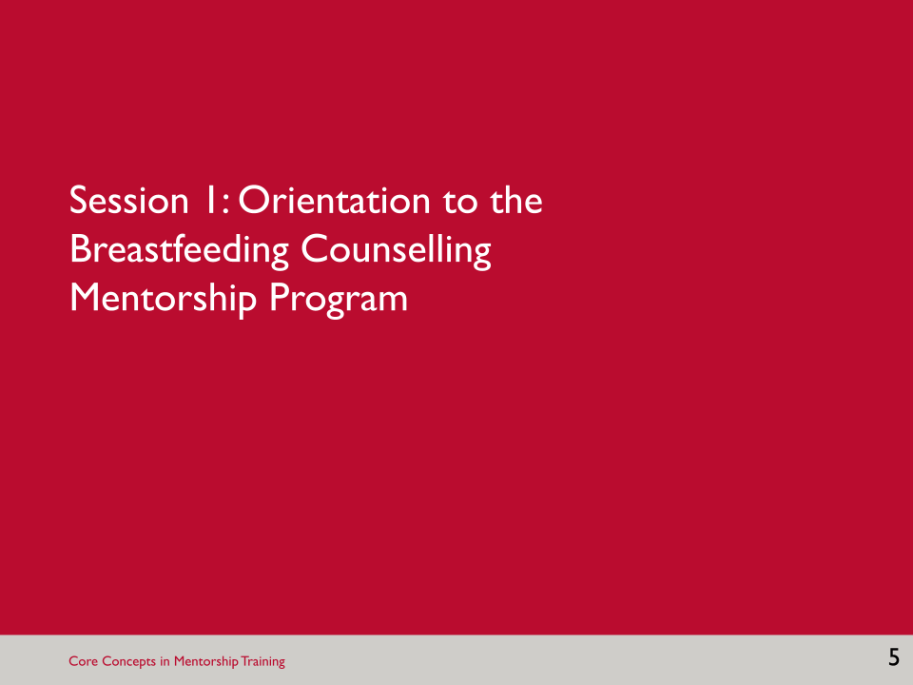

SLIDE 6: LEARNING OBJECTIVES

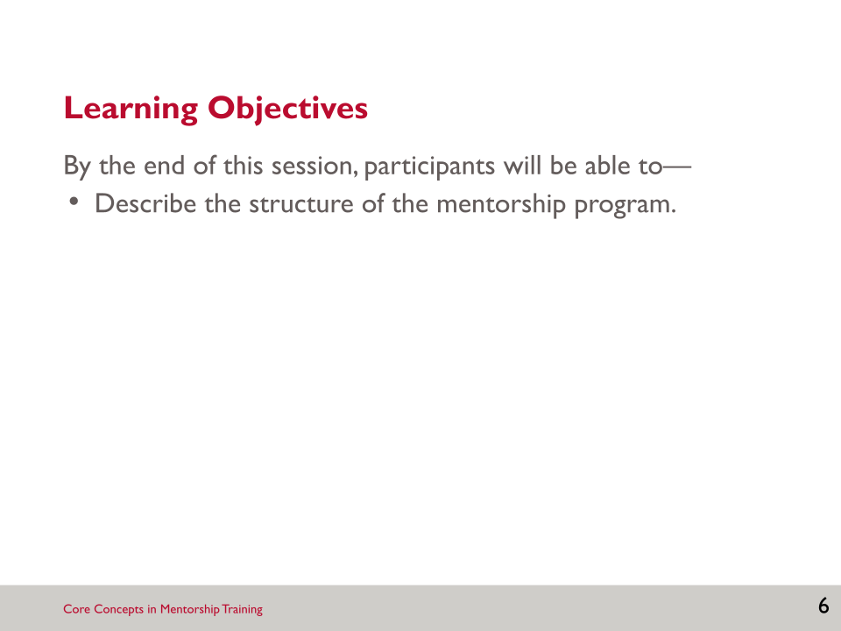

SLIDE 7: REVIEW OF KEY CONCEPTS: THE IMPORTANCE OF BREASTFEEDING

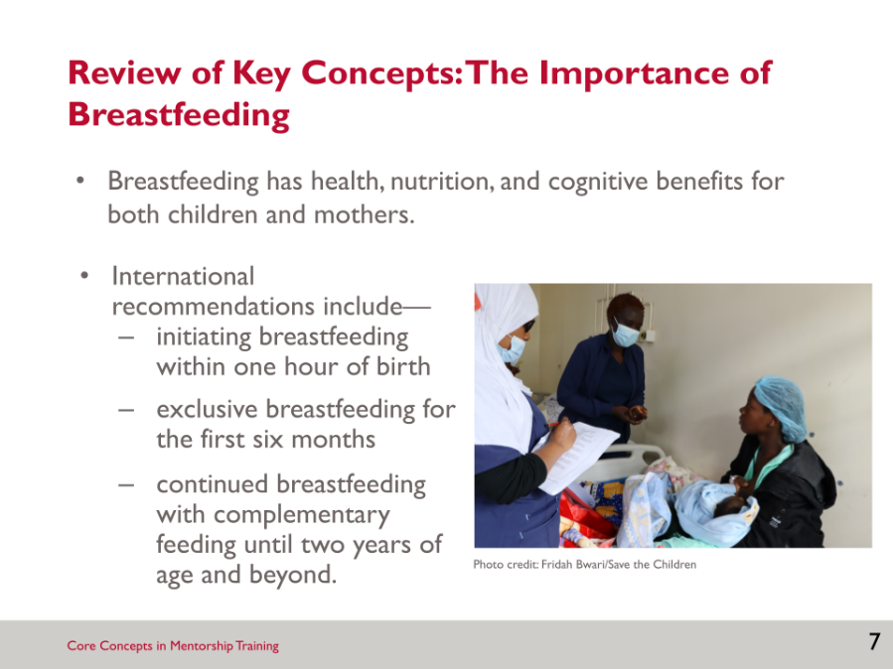

SLIDE 8: REVIEW OF KEY CONCEPTS: BREASTFEEDING COUNSELLING

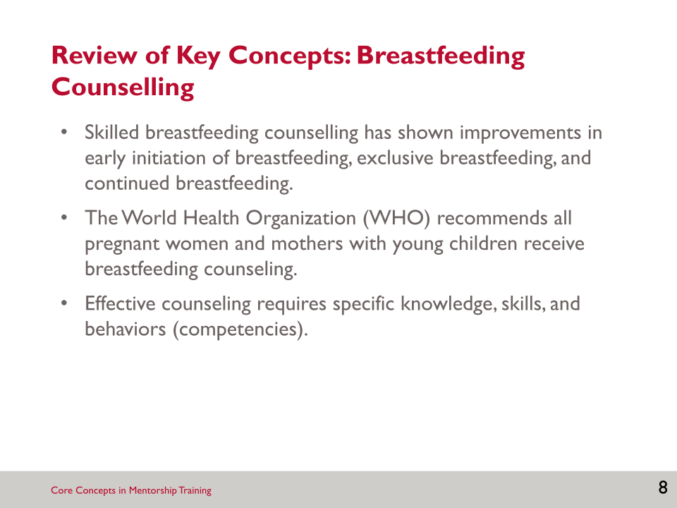

- To do counselling well, health workers must have specific knowledge, skills, and behaviours, also called competencies.

SLIDE 9: REVIEW OF KEY CONCEPTS: THE BABY-FRIENDLY HOSPITAL INITIATIVE

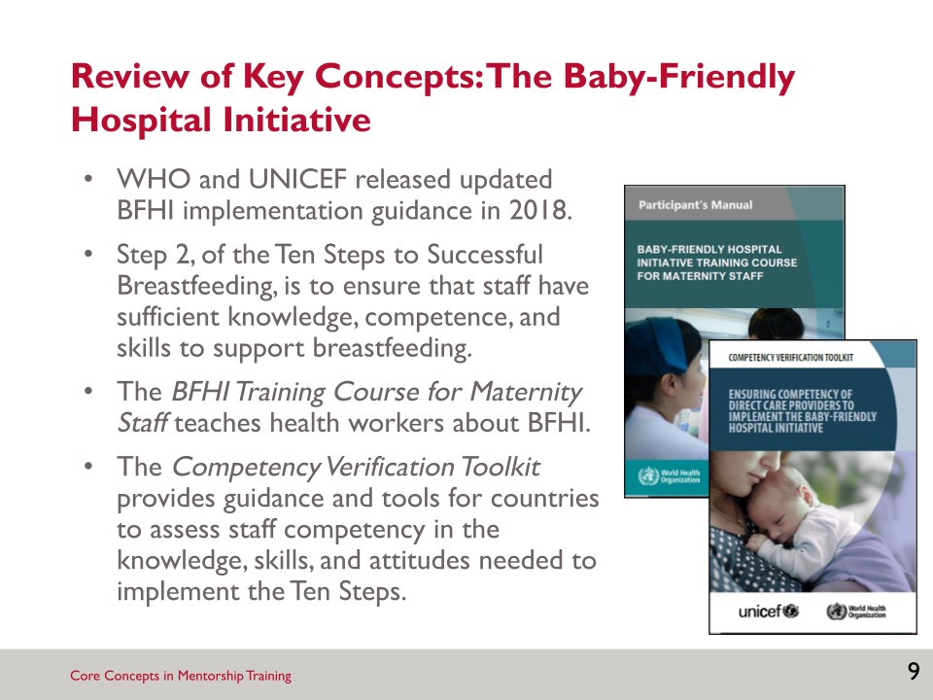

- The World Health Organization recommends that all pregnant women and mothers with young children receive breastfeeding counselling.
- The release of the BFHI implementation guidance (WHO and UNICEF 2018) offers a new and important opportunity to review and strengthen health workers’ competence—“the capability to use a set of related knowledge, skills, and behaviours to successfully perform identified jobs, roles, or responsibilities” (WHO 2015, 15)—in breastfeeding counselling.
- There are other important materials upon which the mentorship program was also based: the BFHI training (WHO and UNICEF 2020a) and the Competency Verification Toolkit: Ensuring Competency of Direct Care Providers to Implement the BFHI (WHO and UNICEF 2020b).
- The Competency Verification Toolkit provides guidance and tools to assess staff competency in the knowledge, skills, and attitudes needed to implement the Ten Steps.

SLIDE 10: PROCESS OF DEVELOPING THE BREASTFEEDING COUNSELLING MENTORSHIP PROGRAM

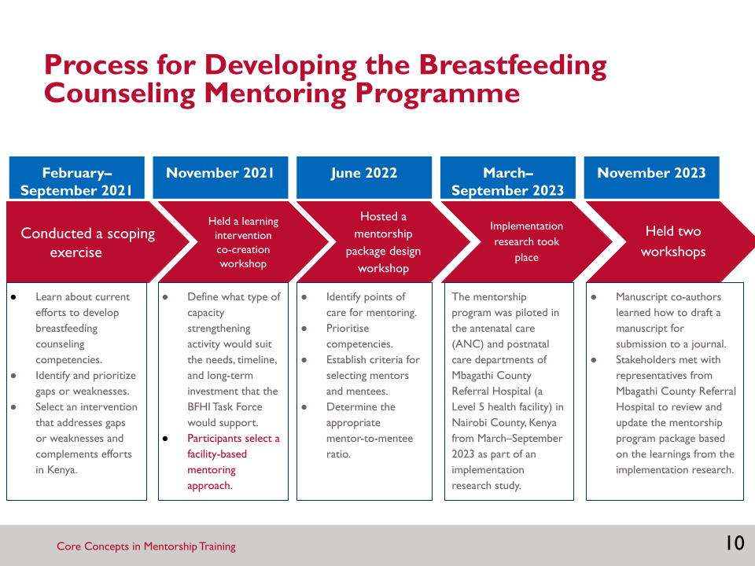

- To determine the best approach to strengthen quality breastfeeding counselling in Kenya, the Kenya MoH, and USAID Advancing Nutrition, the Agency’s multi-sectoral nutrition project from 2018–2023, guided a multi-year co-creation process.

SLIDE 11: IMPLEMENTATION RESEARCH ON THE FEASIBILITY OF A BREASTFEEDING COUNSELLING MENTORSHIP PROGRAM (1)

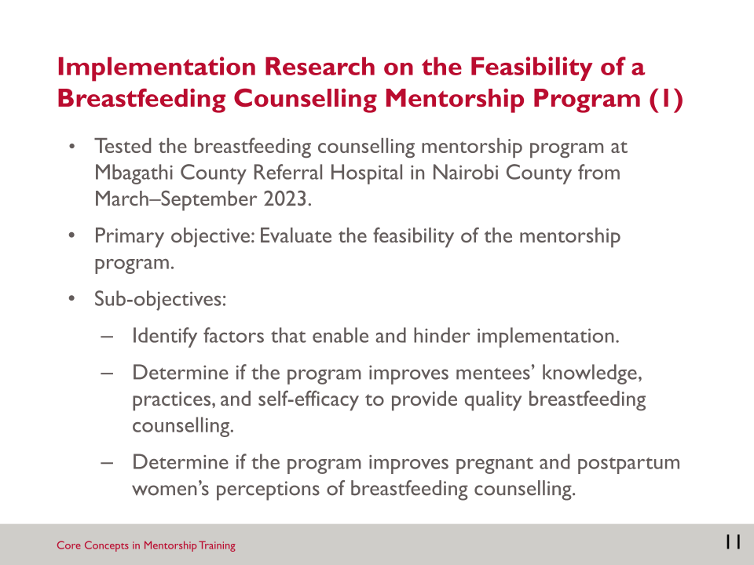

SLIDE 12: IMPLEMENTATION RESEARCH ON THE FEASIBILITY OF A BREASTFEEDING COUNSELLING MENTORSHIP PROGRAM (2)

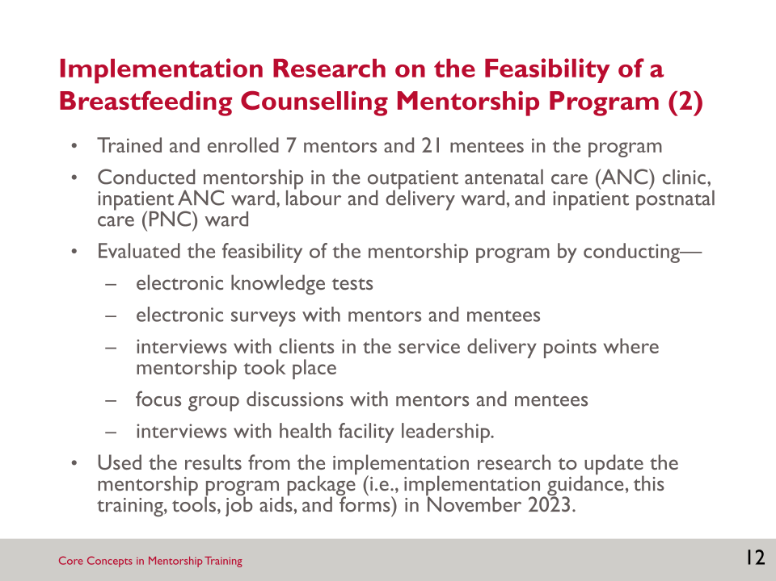

SLIDE 13: RATIONALE FOR A MENTORSHIP PROGRAM TO STRENGTHEN BREASTFEEDING COUNSELLING COMPETENCIES

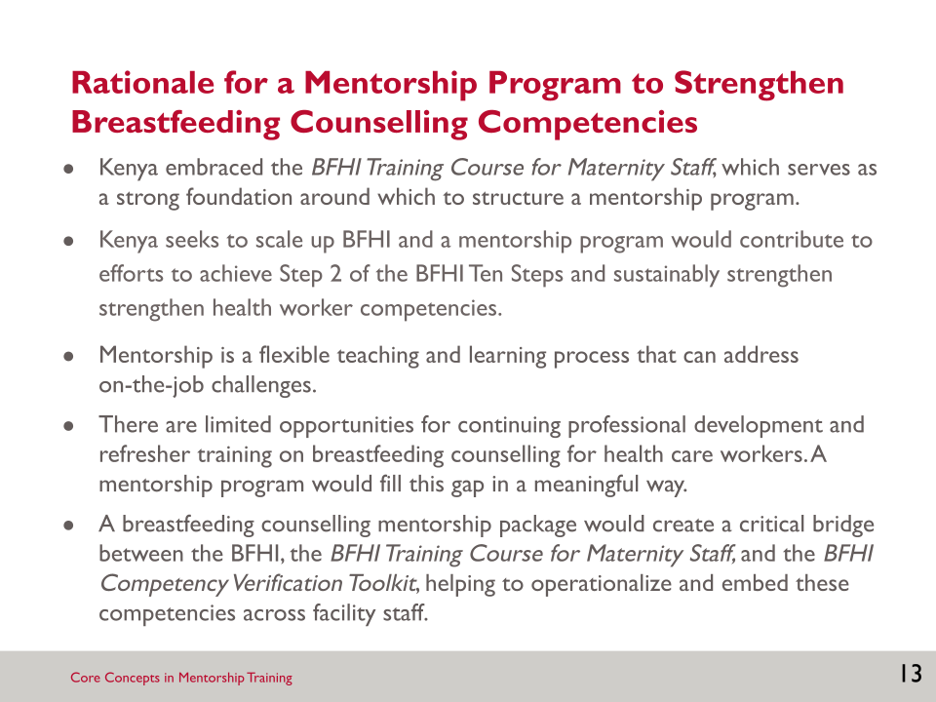

- In November 2021, a team of stakeholders identified mentorship as the preferred approach to strengthening breastfeeding counselling competencies. Mentorship was chosen for the reasons on the slide.

SLIDE 14: GOALS AND OBJECTIVES OF THE MENTORSHIP PROGRAM

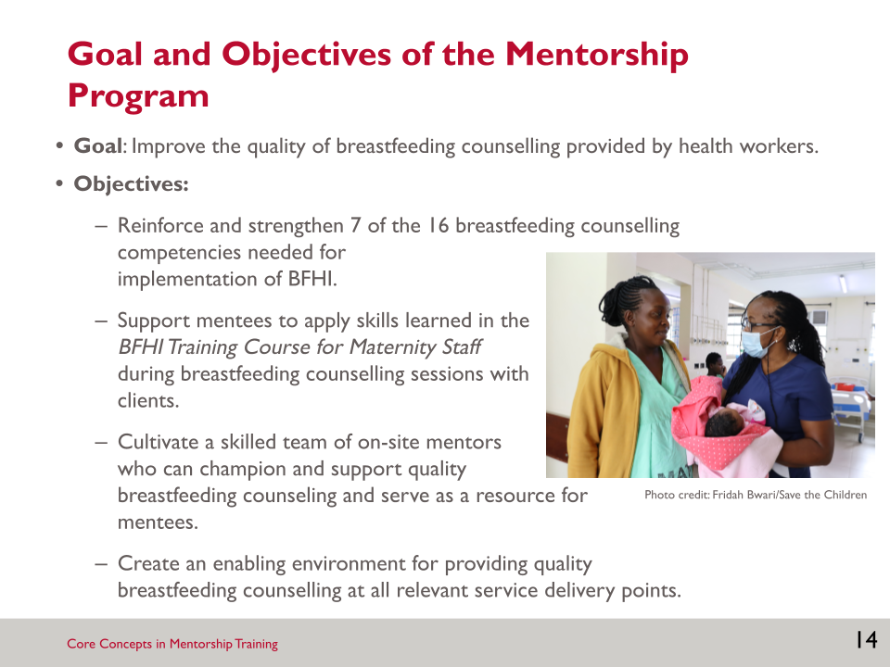

SLIDE 15: MENTORSHIP PROGRAM PACKAGE

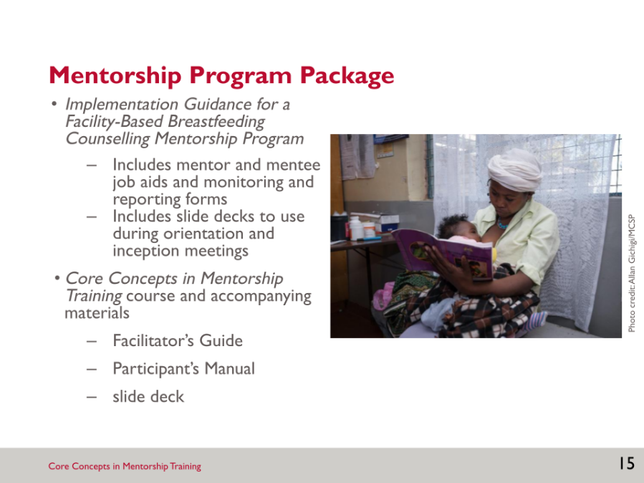

- This Core Concepts in Mentorship Training course for the breastfeeding counselling mentorship program, is part of a mentorship program package for strengthening breastfeeding counselling competencies of health workers.

SLIDE 16: KEY DEFINITIONS

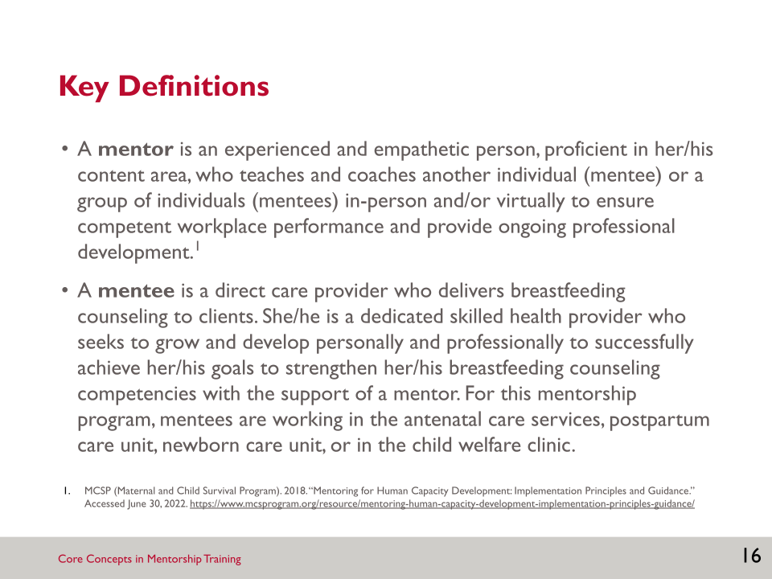

- During this training we will use the terms mentor and mentee often.

SLIDE 17: DESCRIPTION OF THE MENTORSHIP PROGRAM

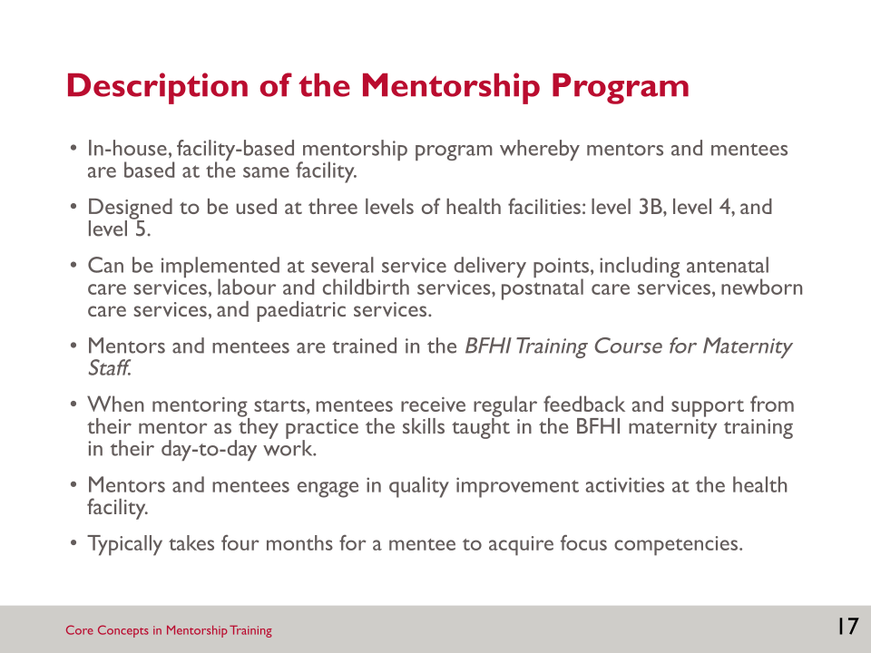

SLIDE 18: COMPETENCIES PRIORITISED FOR THE MENTORSHIP PROGRAM

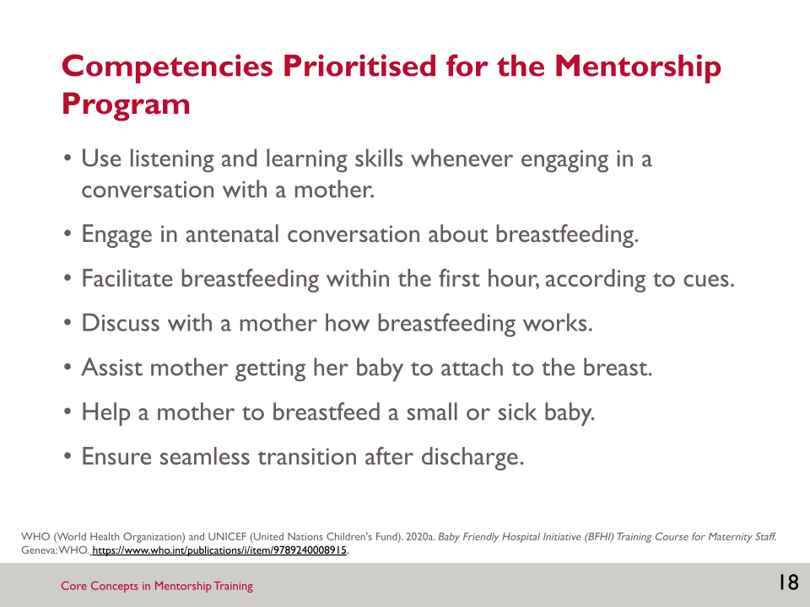

- The mentorship program focuses on reinforcing and strengthening seven competencies from the BFHI Competency Verification Toolkit that have been prioritised in Kenya.

SLIDE 19: FACILITY MANAGEMENT OF THE MENTORSHIP PROGRAM

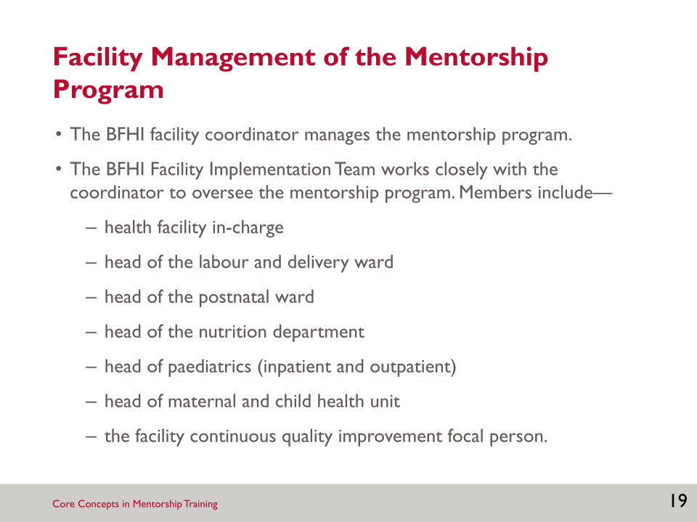

SLIDE 20: IMPLEMENTING THE BREASTFEEDING COUNSELLING MENTORSHIP PROGRAM (1)

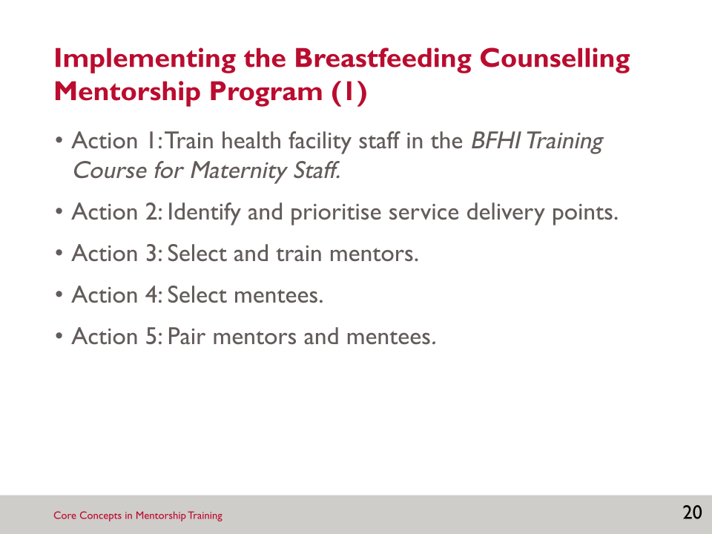

- The implementation process for the breastfeeding counselling mentorship program includes 10 actions.

SLIDE 21: IMPLEMENTING THE BREASTFEEDING COUNSELLING MENTORSHIP PROGRAM (2)

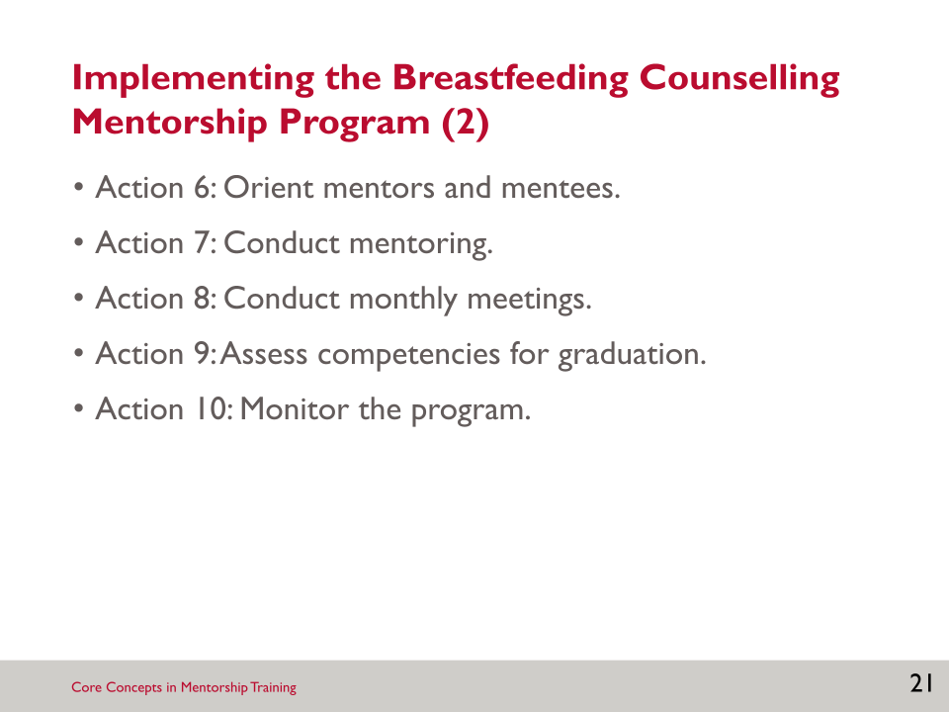

SLIDE 22: SEQUENCE AND TIMING OF ACTIONS FOR IMPLEMENTING THE BREASTFEEDING COUNSELLING MENTORING PROGRAM AT A HEALTH FACILITY

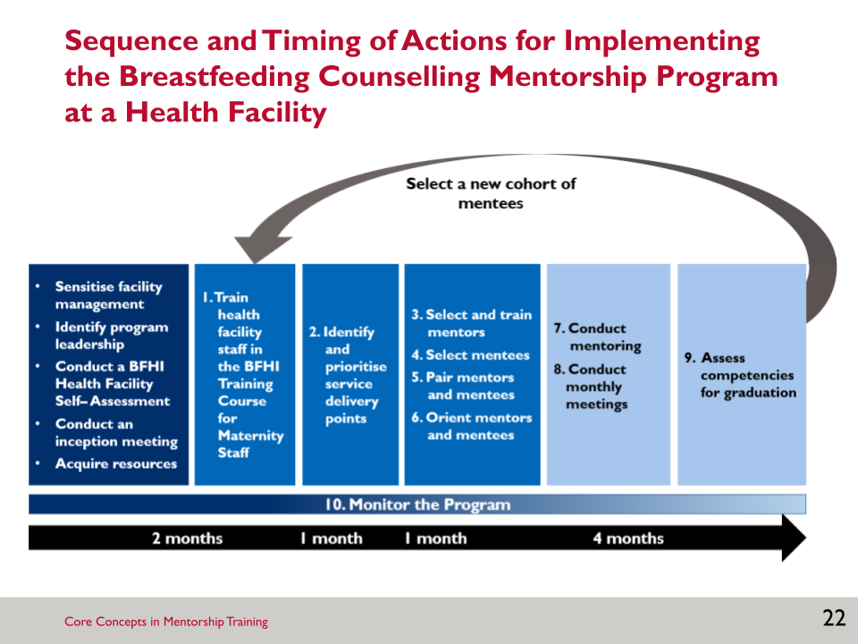

- This slide presents an overview of the sequence and timing of actions for implementing the breastfeeding counselling mentorship program.

SLIDE 23: MINIMUM REQUIREMENTS FOR SELECTING MENTORS

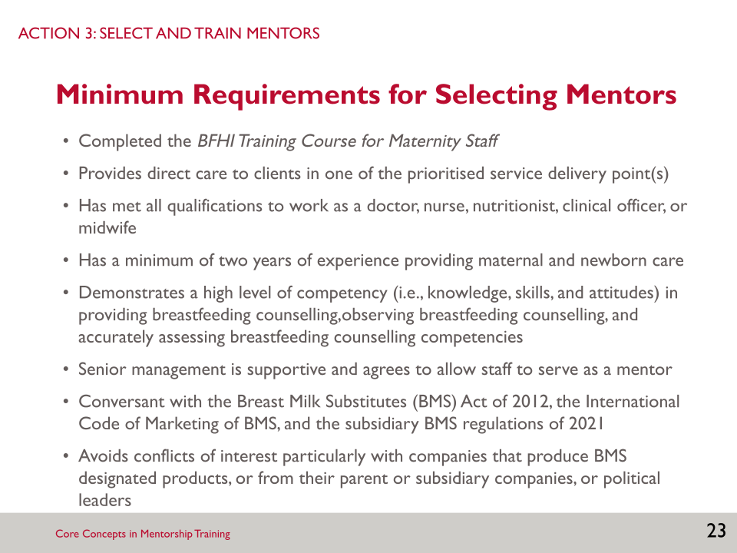

- Each of you had to meet minimum requirements to be selected as a mentor.

SLIDE 24: ADDITIONAL CONSIDERATIONS FOR SELECTING MENTORS

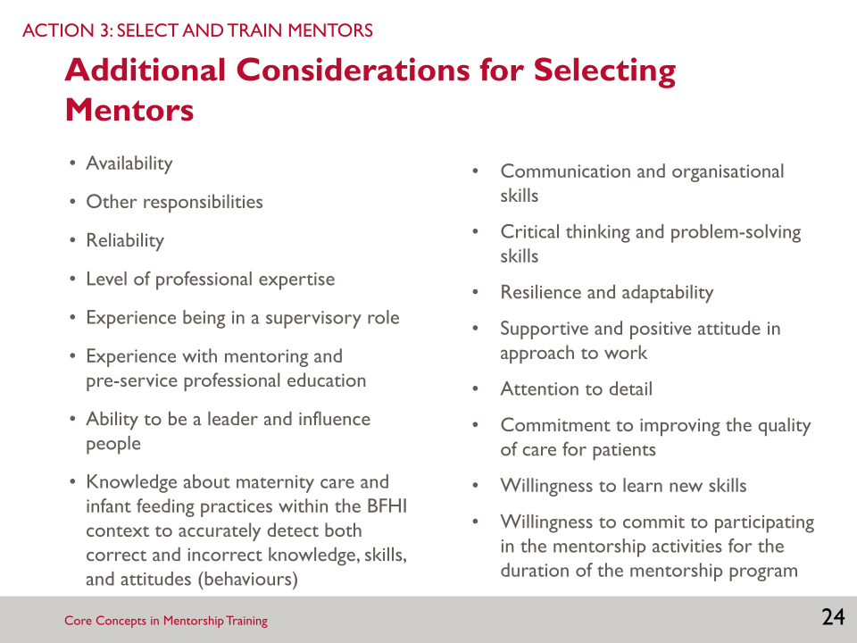

- In addition to the minimum requirements you had to meet, other factors were considered in selecting you as mentors.

SLIDE 25: ROLES AND RESPONSIBILITIES OF MENTORS

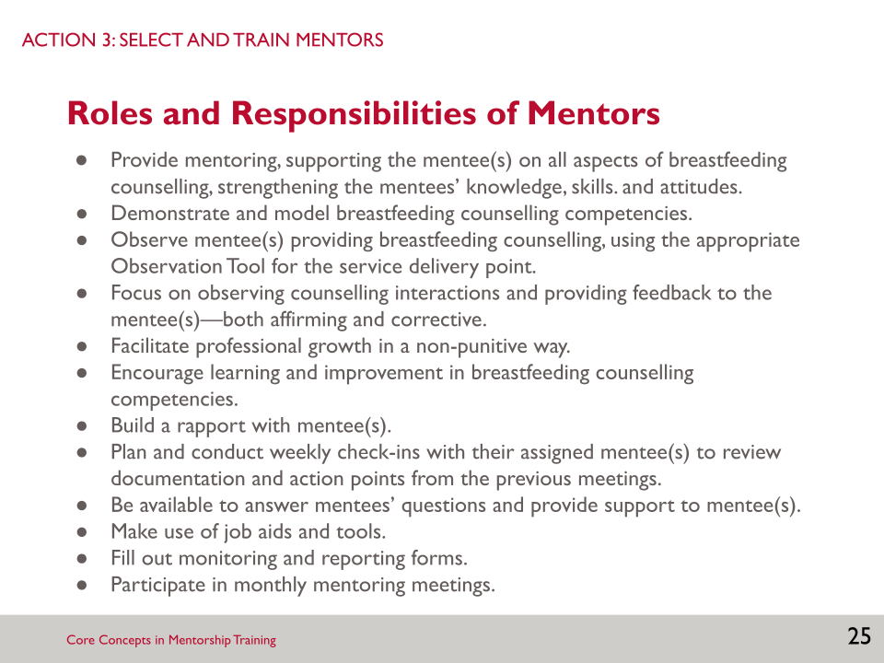

- The list on the slide describes your roles and responsibilities in the mentorship program.

SLIDE 26: MENTORING: DEMONSTRATION, OBSERVATION, DEBRIEF, AND CHECK-IN

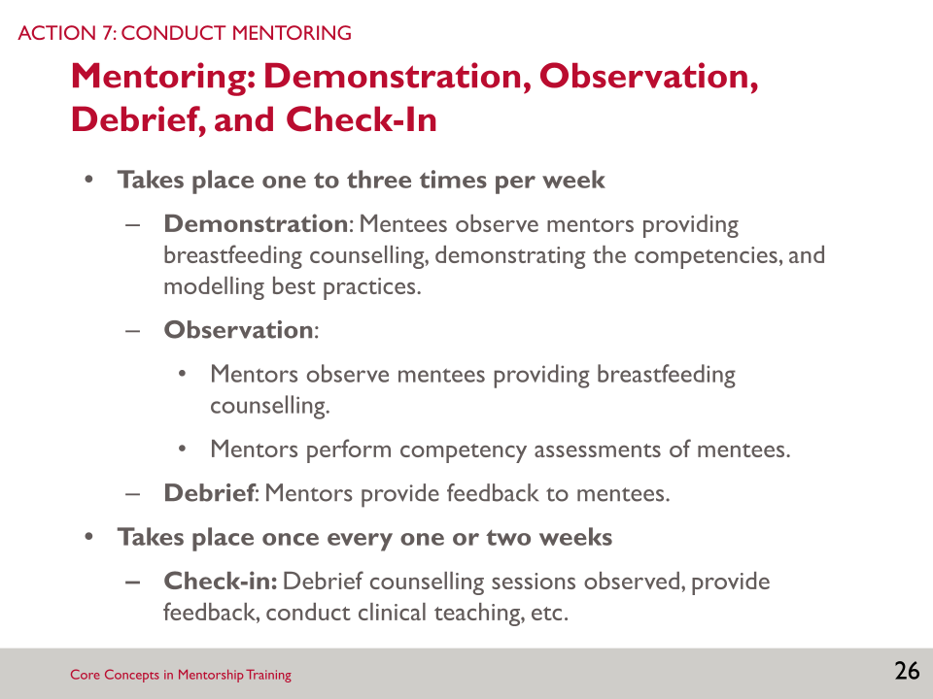

- Initially, mentees will observe mentors demonstrating the competency(ies). Mentors will continue to demonstrate breastfeeding counselling competencies, as needed, throughout implementation of the mentorship program and consistently model good counselling skills.
- Once mentees are ready, mentees then demonstrate their breastfeeding counselling skills while mentors observe.
- Mentors will observe mentees providing breastfeeding counselling between one and three times per week, initially more frequently, throughout implementation of the mentorship program.
- Mentors will assess mentees’ competencies. There are several job aids and monitoring and reporting forms used during mentoring.
- In this training, we will review strategies for mentoring that you will use when observing, debriefing, and checking-in with your mentees.

SLIDE 27: GRADUATION FROM THE MENTORSHIP PROGRAM

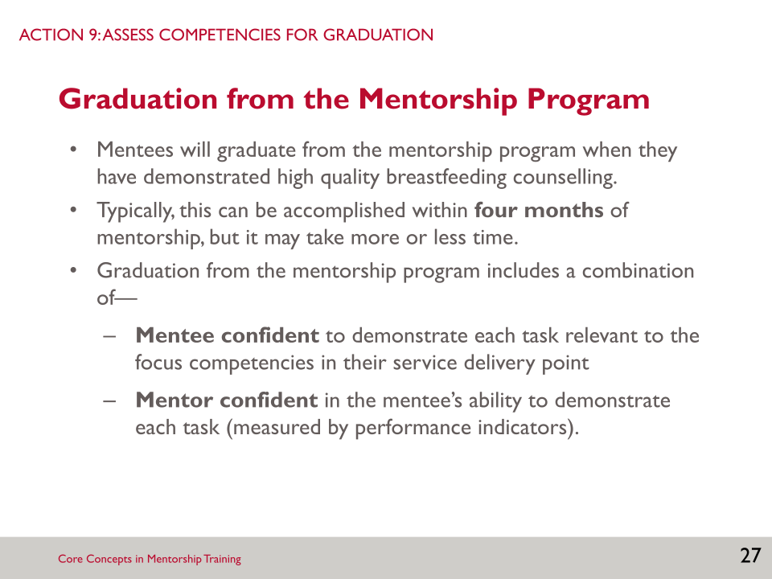

- To graduate—
- The mentee must be confident demonstrating each task (as measured by performance indicators) relevant to the focus competencies in the service delivery point where the mentee works.
- The mentor must be confident in the mentee’s ability to demonstrate each task (as measured by performance indicators) relevant to the focus competencies in the service delivery point where the mentee works.
- You will learn more about how to assess the graduation criteria during the orientation meeting.

SLIDE 28: NEXT STEPS: SELECTING MENTEES

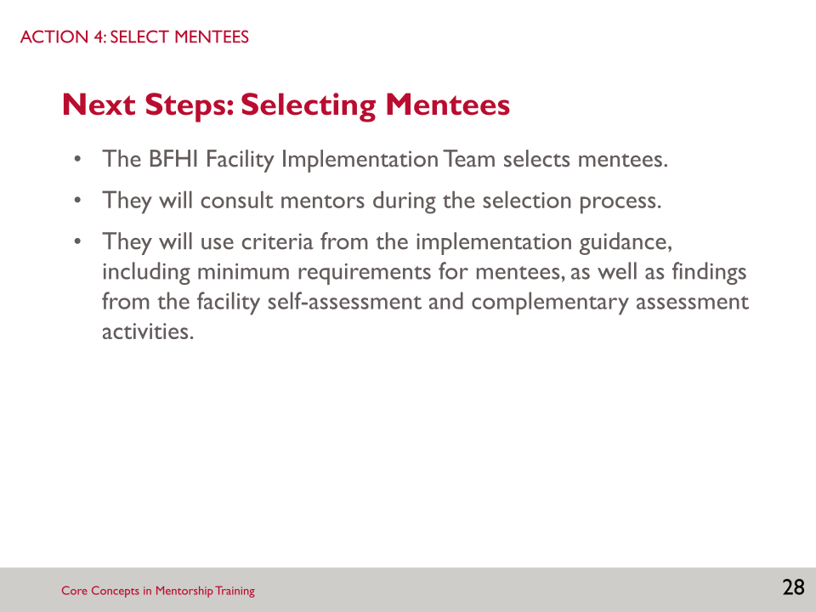

SLIDE 29: MINIMUM REQUIREMENTS FOR SELECTING MENTEES

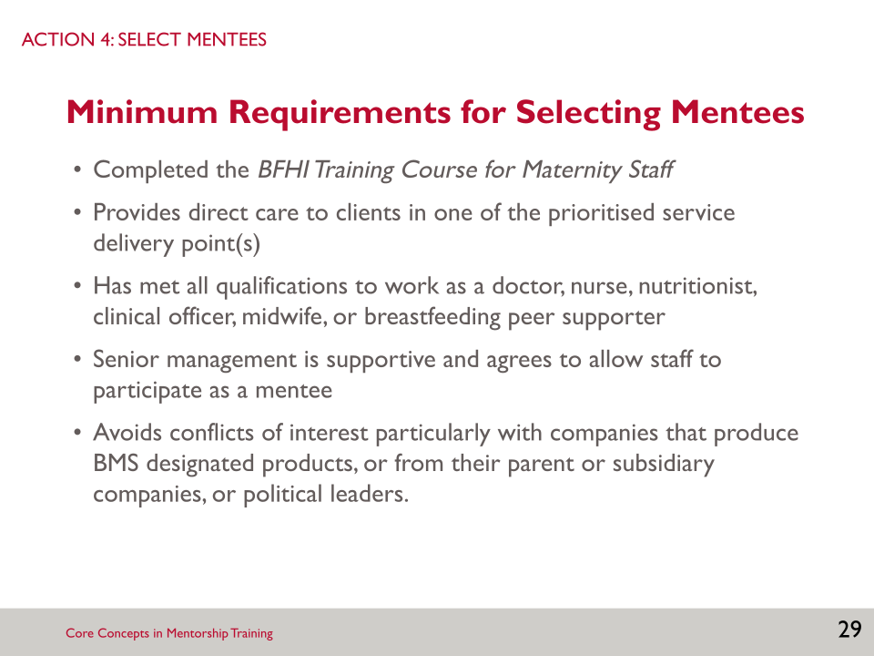

SLIDE 30: ROLES AND RESPONSIBILITIES OF MENTEES

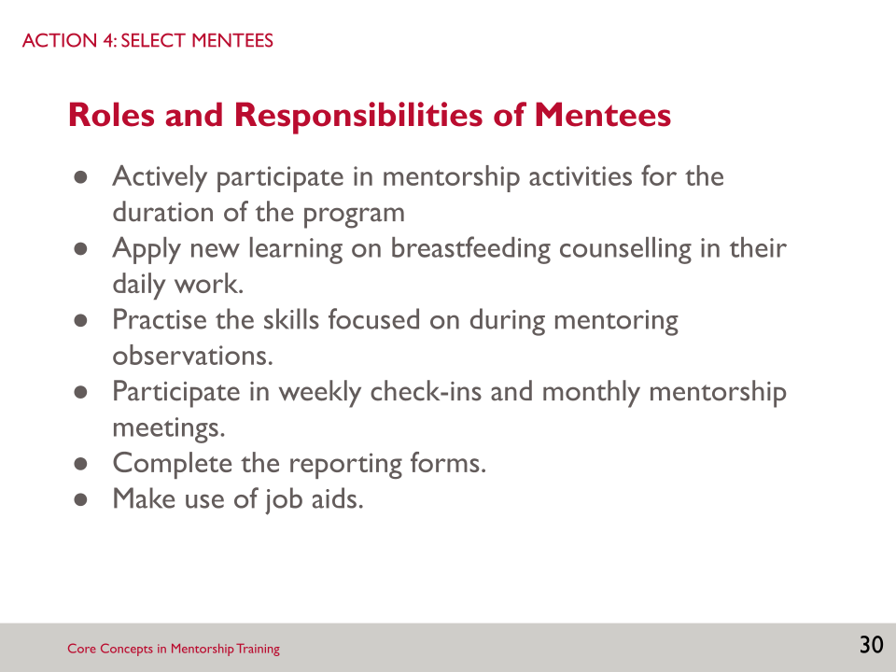

SLIDE 31: NEXT STEPS: PAIRING MENTORS AND MENTEES

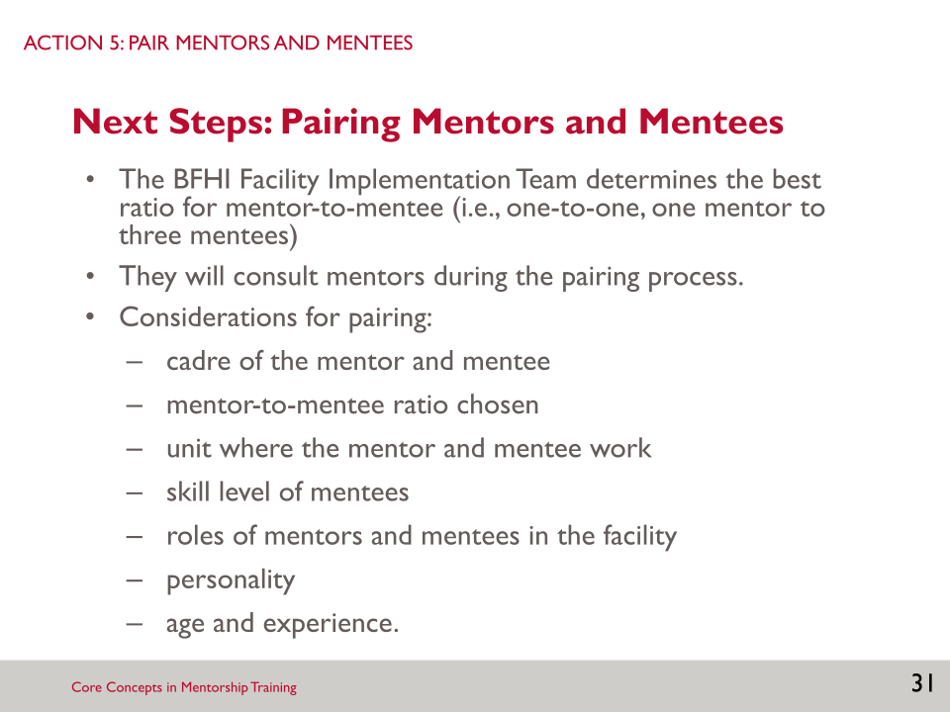

- After mentees are selected, pairing of mentors and mentees takes place.

SLIDE 32: NEXT STEPS: ORIENTATION MEETINGS FOR THE MENTORSHIP PROGRAM (1)

- After pairing of mentors and mentees, two orientation meetings will take place: one for the mentors only and one for the mentors and mentees together.

SLIDE 33: NEXT STEPS: ORIENTATION MEETINGS FOR THE MENTORSHIP PROGRAM (2)

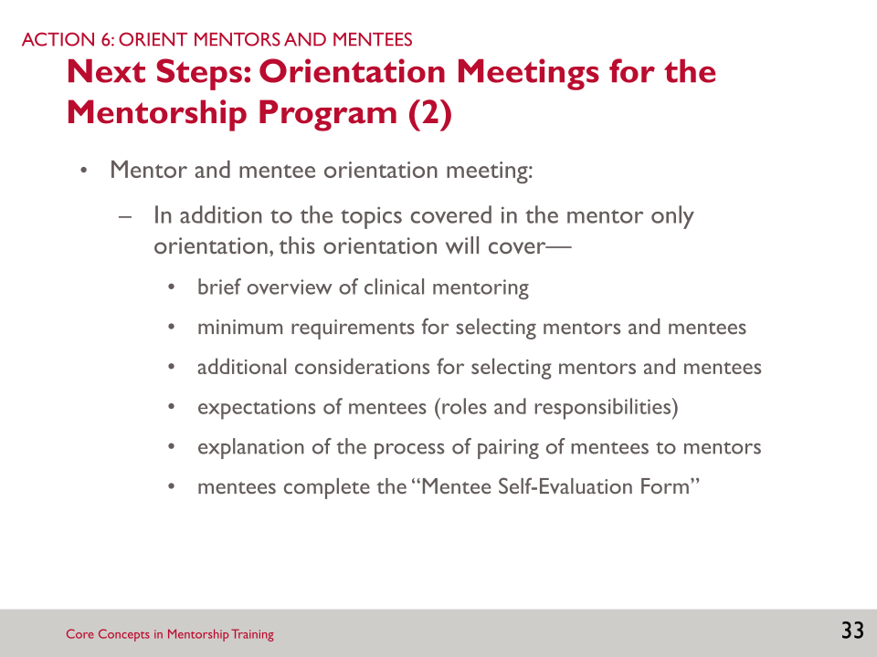

- The mentor and mentee orientation will cover the same topics as the mentor only orientation meeting, but will also include the following topics.

SLIDE 34: KEY POINTS

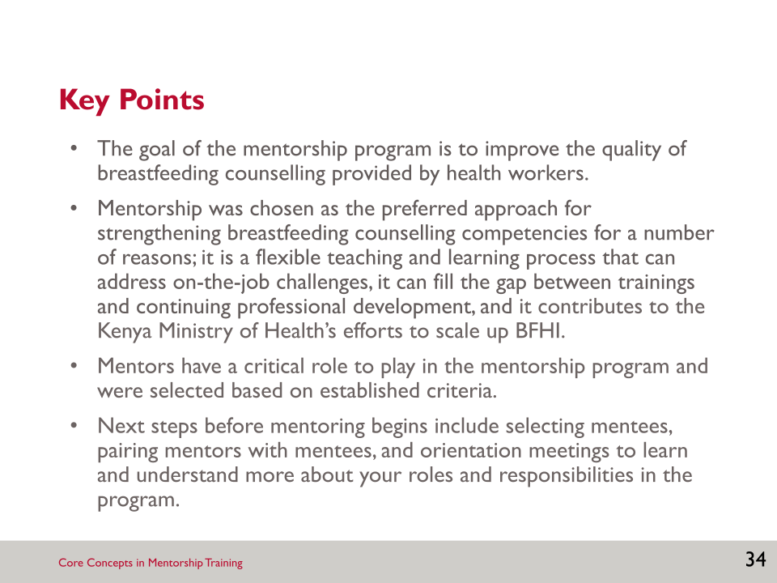

Notes:

____________________________________________________________________________________________________________________________________________________________________________________________________________________________________________________________________________________________________________________________________________________________________________________________________________________________________________________________________________________________________________________________________________________________________________________________________________________________________________________________________________________________________________________________________________________________________________________________________________________________________________________________________________________________________________________________________________________________________________________________________________________________________________________________________________________________________________________________________________________________________________________________________________________________________________________________________________________________________________________________________________________________________________________________________________________________________________________________________________________________________________________________________________________________________________________________________________________________________________________________________________________________________________________________________________________________________________________________________________________________________________________________________________________________________________________________________________________________________________________________________________________________________________________________________________________________________________________________________________________________________________________________________________________________________________________________________________________________________________

SESSION 2: WHAT IS CLINICAL MENTORING?

Learning Objectives
By the end of this session, participants will be able to—
- Define clinical mentoring and distinguish it from supportive supervision.
- Articulate the rationale for, and objectives of, clinical mentoring.
- Outline characteristics of effective mentors.
- Explain common challenges of mentoring.

Key Points
- Clinical mentoring seeks to strengthen specific skills among health care workers to improve services in clinical settings. Clinical mentoring involves building relationships, identifying areas for improvement, coaching and modelling, advocacy, and data collection and reporting.
- Effective mentors are respectful, teach and learn, are adept at supporting breastfeeding families, and enthusiastic about teaching.

Slides and Notes

SLIDE 35: SESSION 2: WHAT IS CLINICAL MENTORING?

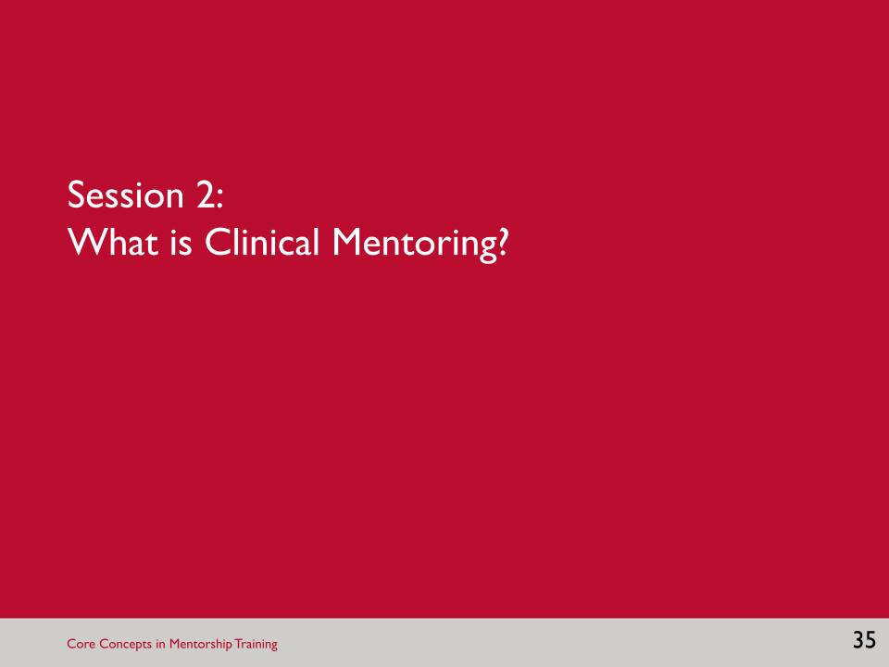

SLIDE 36: LEARNING OBJECTIVES

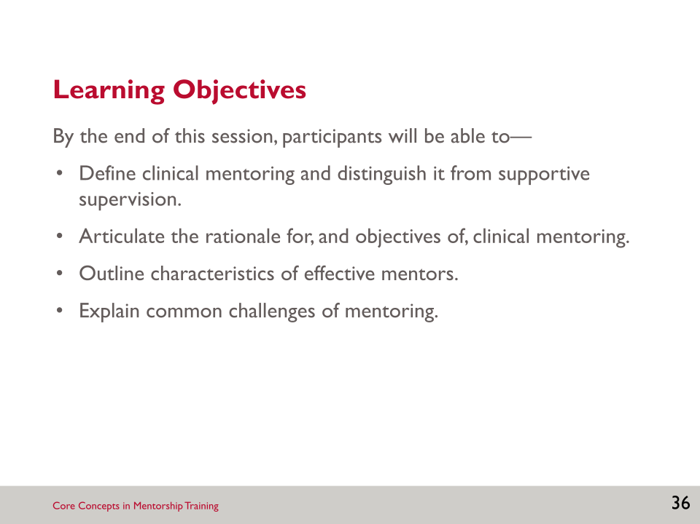

- In this session, we will learn how clinical mentoring can improve health worker skills, and in turn, strengthen health care systems.

SLIDE 37: PARTNER BRAINSTORM: WHAT IS CLINICAL MENTORING?

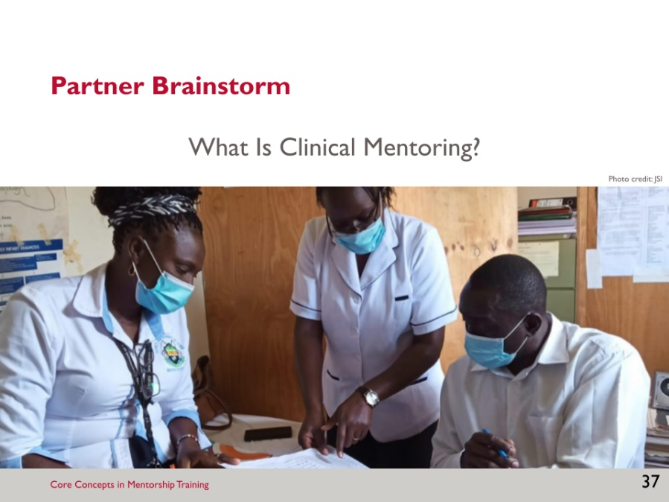

Brainstorm: What is Clinical Mentoring?
- Find a partner for this activity. Think about a mentor you have had in your lives—someone who took time to encourage their skills and motivation—it might have been a teacher, a neighbour, or a health worker.
- Consider the questions: What did you learn from this person? How did this experience motivate you to mentor others? Based on that experience, what does the term clinical mentoring mean to you?

SLIDE 38: CLINICAL MENTORING: DEFINITION

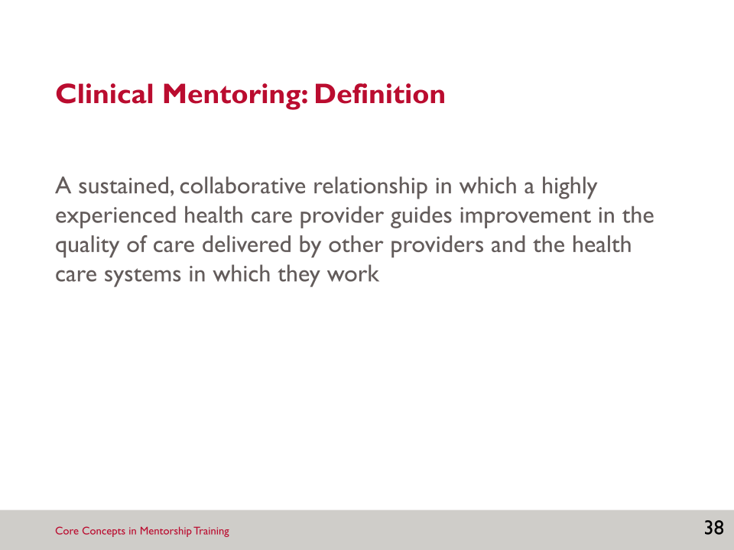

- There are a variety of definitions for clinical mentoring. Clinical mentoring involves a variety of factors, including building relationships, increasing confidence, identifying areas for improvement, coaching and modelling, and even data collection and reporting.
- The most important components are—
- Clinical mentors are experienced clinician trainers who provide case review, problem solving, hands-on modelling, quality assurance, and continuing education.
- In the context of our program, mentors provide increased access to hands-on breastfeeding support for health care workers (mentees) in resource-poor settings.
- A mentor’s ultimate goal is to help each team member to be the best they can be, and do the best job possible to help maximise the number of positive outcomes for breastfeeding families.

SLIDE 39: WHAT BREASTFEEDING COUNSELLING MENTORS DO

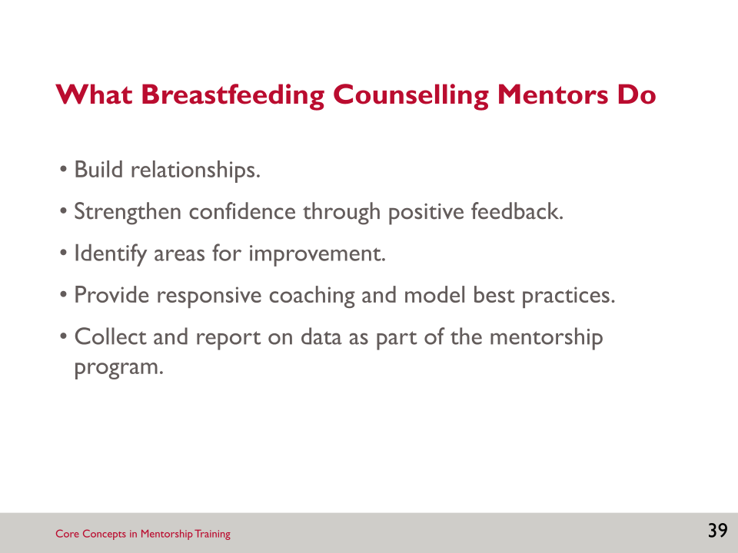

- To be an effective mentor and navigate the challenges that come with mentoring, one must be respectful, enthusiastic about teaching, and be willing to learn themselves.
- As a mentor you will—
- Build relationships: Establishing a trusting and receptive relationship between the breastfeeding counselling mentor and mentee(s) is the foundation for an effective mentoring experience. This component continues over the course of the mentorship program, as the relationship evolves and grows.
- Strengthen confidence by providing positive feedback: Noticing and calling attention to positive skills and areas showing improvement powerfully reinforces those skills and builds the confidence of the mentee.
- Identify areas for improvement: This component involves observation and assessment of existing systems, practices, and policies to identify areas for improvement. Tools in the mentorship package can help with this assessment phase. Information obtained during this assessment helps to inform the establishment of goals and objectives for the mentorship.
- Provide responsive coaching and model best practices: Breastfeeding counselling mentors must demonstrate proper techniques and model good practices. During on-site mentoring, this means working with clients alongside with the mentee; using appropriate, systemic methods; demonstrating professionalism; and creating an open, respectful environment. Mentorship is as much about setting a good example as it is about directly intervening to improve mentee practice.
- Collect and report on data: Breastfeeding counselling mentors support the collection and use of data for the mentorship program.

SLIDE 40: WHY CLINICAL MENTORING FOR BREASTFEEDING SUPPORT?

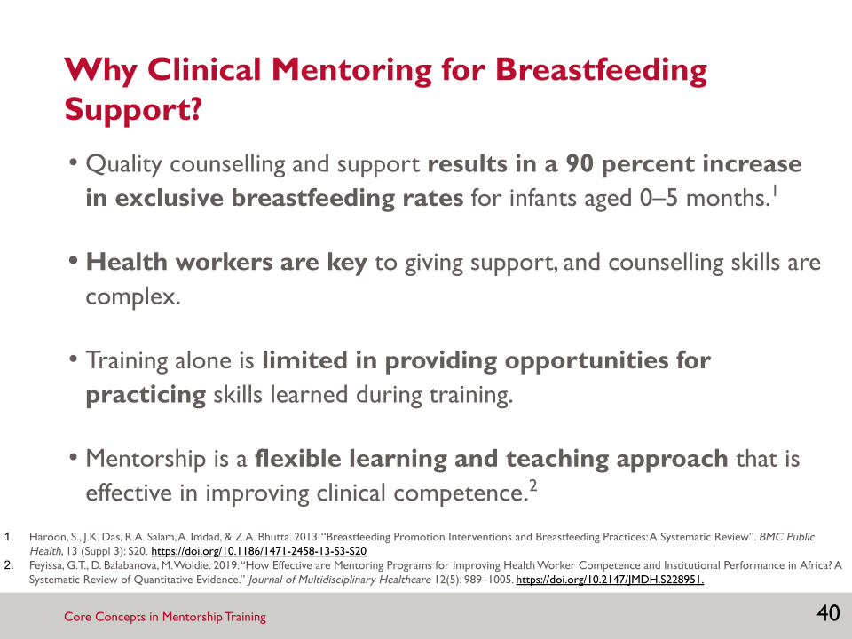

- Clinical mentoring is an effective approach to strengthen breastfeeding support provided to caregivers:
- Quality breastfeeding counselling and support results in a 90 percent increase in exclusive breastfeeding rates in infants aged 0–5 months (Haroon et al. 2013).
- Health workers need to be skilled. Those who care for women and children during the postnatal period have a key role in establishing and sustaining breastfeeding. Training alone is often not sufficient because counselling skills are complex—and mentoring helps to reinforce skills learned in training and build confidence among providers.
- Training alone is limited. Training is often used to build skills in ways that are short, easy to manage, and have a lower cost overall. Training courses are good at developing knowledge, but there is often limited time for practising skills learned.
- Mentorship is a flexible learning and teaching approach that focuses on hands-on practice and feedback in real-world settings; mentorship programs have proven effective in improving health worker performance in maternal, neonatal, and child services (Feyissa et al. 2019).

SLIDE 41: ACTIVITY: MENTORING VS. SUPERVISION (1)

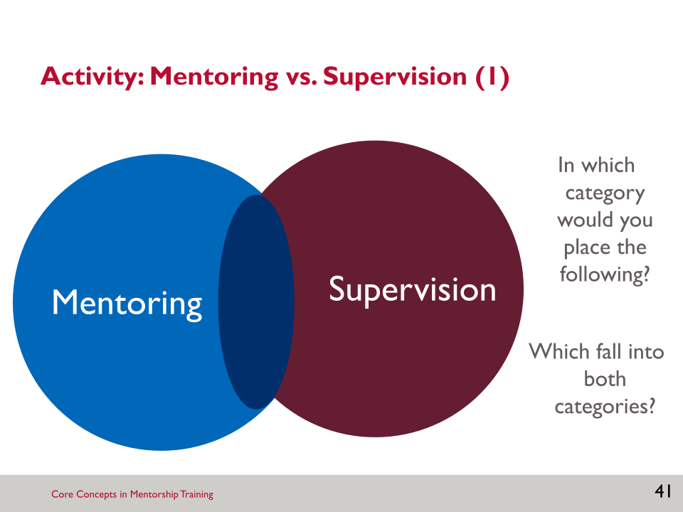

Activity: Mentoring vs. Supervision
- Mentoring is similar to, but different from, supervision.
- Decide as a group where it falls—mentorship, supervision, or in between the two.
- Critical
- Coaching
- Hierarchical
- Participatory
- Monitoring
- Responsible for performance
- Encourages self-evaluation
- Building a relationship and trust
- Available via distance communication for support between visits
- Focused on reports, forms, and data collection
- Focused on building confidence, skills development
- Performance management
- Accountable for performance
- Focused on the success of the team
- Focused on the individual
- Driven by the health care worker/receiver
- Driven by standards for the department/team
- Collaborative, relationship of equals
- Big picture view
- Individualised view
- Sustained over a long period of time
- Typically of a fixed duration
- Summarise: How is mentoring reflected in the following saying? “Not a sage on the stage, but a guide by the side.”

SLIDE 42: MENTORING VS. SUPERVISION (2)

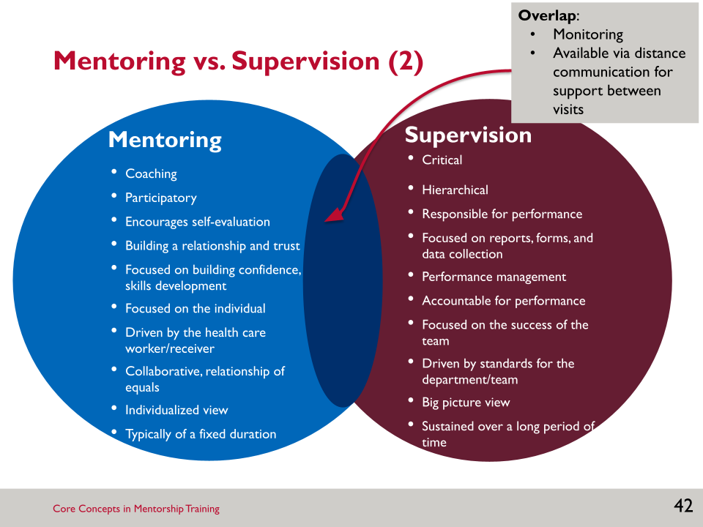

SLIDE 43: COMPONENTS OF MENTORING (1)

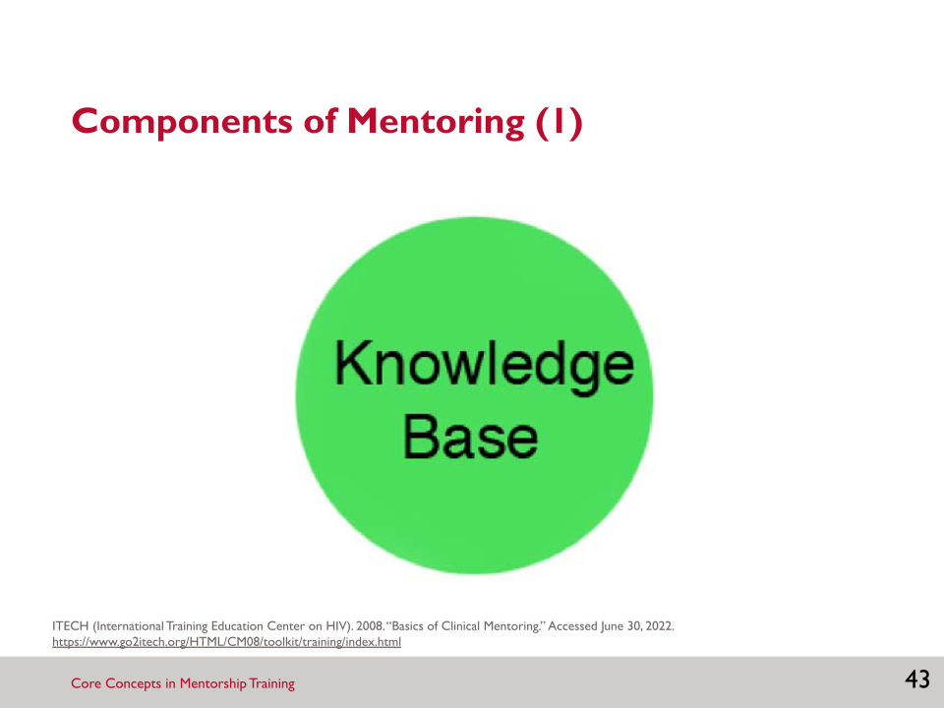
- It is crucial that the breastfeeding counselling mentor has up-to-date information, with a solid base of knowledge about breastfeeding.
- While that is true, the next slides show the multifaceted nature of mentoring, and the importance of components outside of clinical knowledge.

SLIDE 44: COMPONENTS OF MENTORING (2)

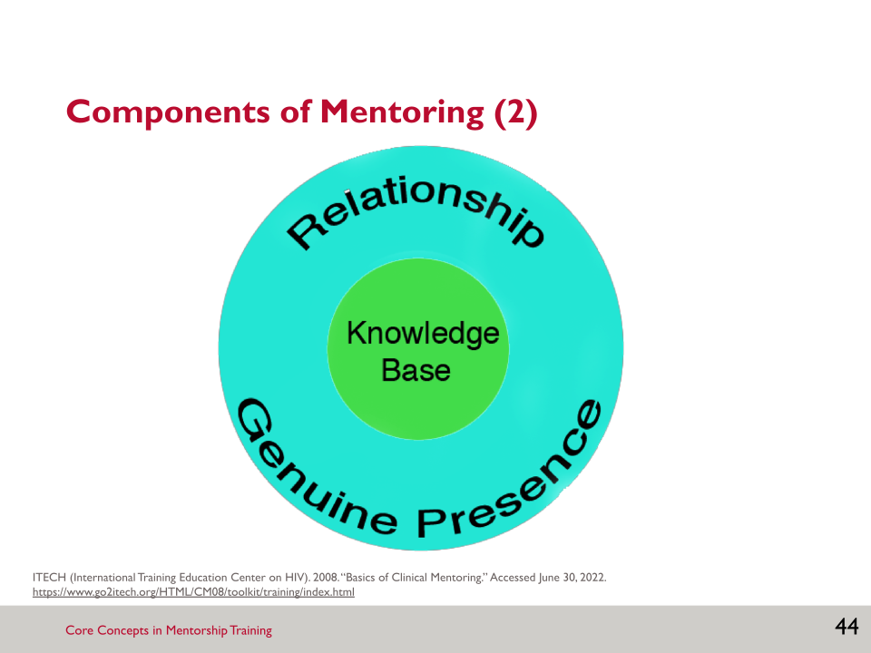

- What you do as a mentor is really all about relationships. You are fully present and empathetic, and you find ways to connect, with heart, to another human being.
- Building this relationship takes time, and is an ongoing process, even over years of working together.
- As you step into your role as a breastfeeding counselling mentor, think about the core values you share with your mentee. Many peoples’ lists include a commitment to—
- optimal care for mothers and babies and breastfeeding families
- lifelong learning
- advocacy of basic human rights and women’s rights
- a credo of ethical medical care
- the idea that all people have a right to medical care.
- It is important to communicate to the mentee that you want to be there.

SLIDE 45: COMPONENTS OF MENTORING (3)

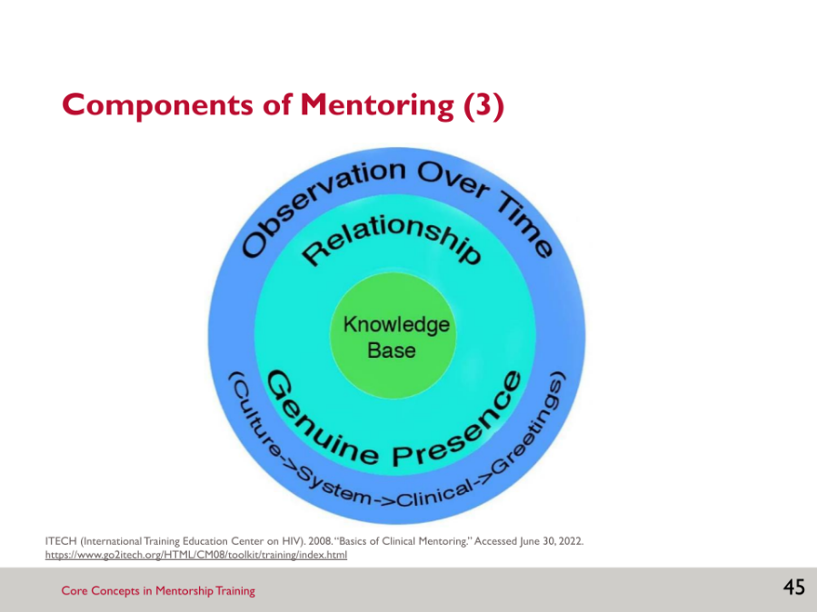

- As a mentor at the same facility as the mentee(s) you are working with, you will be mentoring in a system that you are already very familiar with.
- However, you will still want to begin by observing things: the system of care, the teamwork among the staff, and the clinical and communication skills of the staff you are mentoring.
- You may need to take a step back to see things differently from the usual day-to-day that you are used to. Subtleties are important to recognize when you are mentoring.
- For example, in the outpatient clinics, how does the health care worker greet the next client? Do they just yell out the name of the next client or do they walk out to greet them?

SLIDE 46: COMPONENTS OF MENTORING (4)

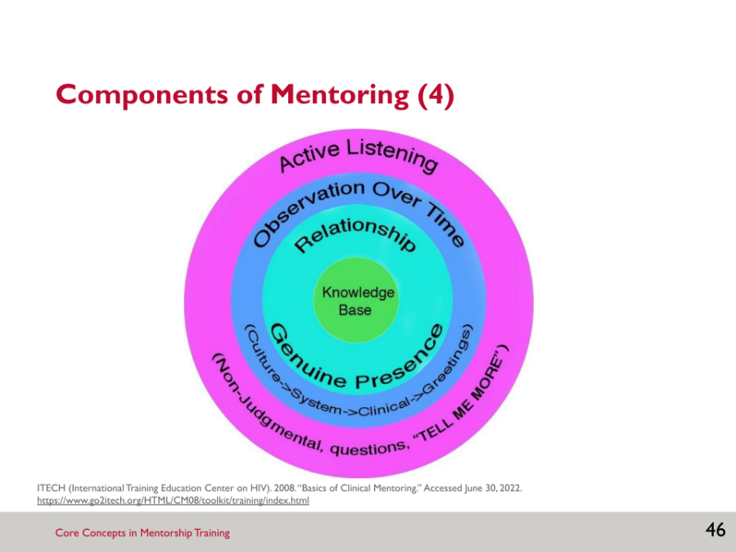

- Beyond your observations, you must be actively listening. This means paying attention to the client, health care worker, nurse, counsellor, and person entering data.
- Mentors must listen with an open mind, looking for opportunities to support the mentee’s learning.
- As a breastfeeding counselling mentor, seeking to understand is integral to good mentoring practice and ultimately strengthens the mentee’s reasoning and communication skills. For instance, you might ask a mentee—
- “Tell me why you are recommending that position for breastfeeding.”
- “Tell me why you think this mother holding her baby skin-to-skin is only for bonding.”
- Open-ended questions are useful for understanding the mentee’s motivation. Open-ended questions cannot be answered with a single word, and therefore encourage meaningful answers.
- Open-ended questions often begin with “Tell me,” “Why,” or “How.” Compare the following ways of asking the same thing:
- “You didn’t think talking to the mother about cluster feeding was important?”
- “Tell me more about why you decided not to talk to the mother about cluster feeding.”

SLIDE 47: COMPONENTS OF MENTORING (5)

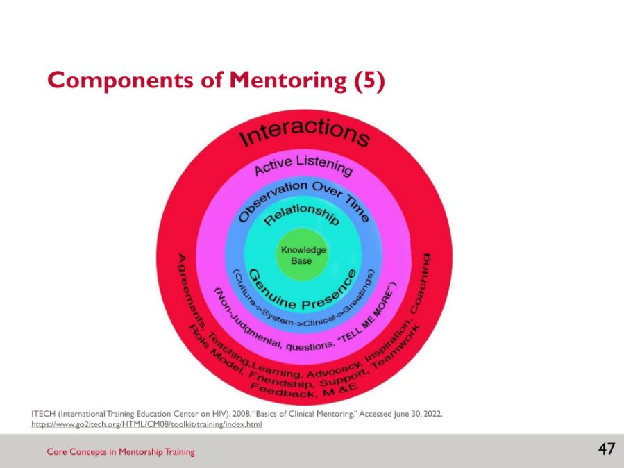
- Mentors are role models. The way a mentor interacts, looks, approaches clients, speaks, etc. is important. The mentee is always observing and noting the standards you set for your own behaviour.
- How you act with clients and colleagues will be noticed.
- In each interaction your relationship and communication skills are crucial.
- Feedback is given from mentor to mentee, but also from mentee to mentor.
- Mentors are always actively learning with and from the mentee and the situation; learning does not stop when you are a mentor.

SLIDE 48: COMPONENTS OF MENTORING (6)

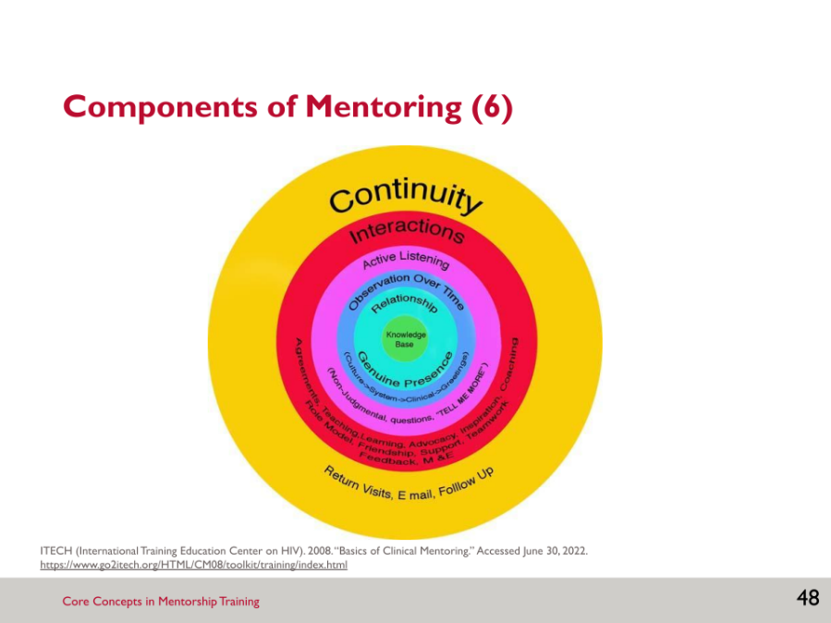

- Growth and learning happen over time. Relationships deepen over time. That’s why continuity in the mentoring relationship is so important.
- The mentoring visits may be more frequent in the beginning and become less frequent, but ideally still weekly, as the mentee becomes more comfortable. It is also possible to check in with the mentee in between mentoring visits, such as phone calls, text messages, or short in-person encounters, especially if the mentee is struggling with a challenging case.

SLIDE 49: CHARACTERISTICS OF A GOOD MENTOR

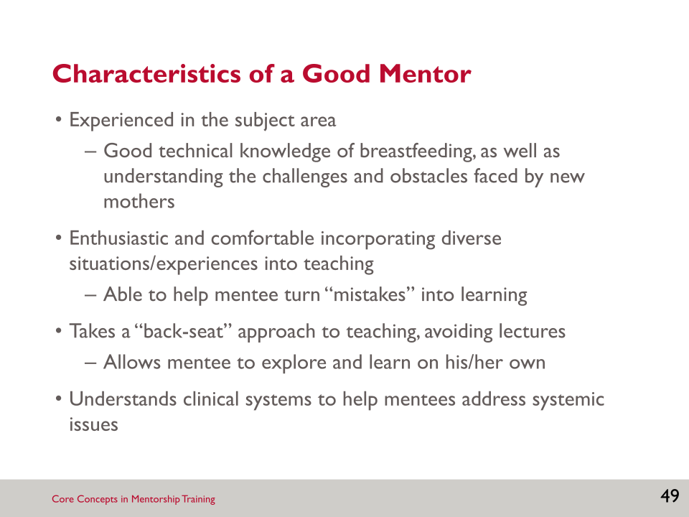

Brainstorm: Characteristics of a Good Mentor
- Think about the mentor who inspired you that we discussed earlier. What traits or skills did this person have that made them an effective mentor? Write a list on a piece of paper. Share yours with a neighbour and ask them to identify the commonalities.
- The traits/skills you appreciated in your mentors are ones that you have or aspire to.

SLIDE 50: CHARACTERISTICS OF EFFECTIVE MENTORING RELATIONSHIPS

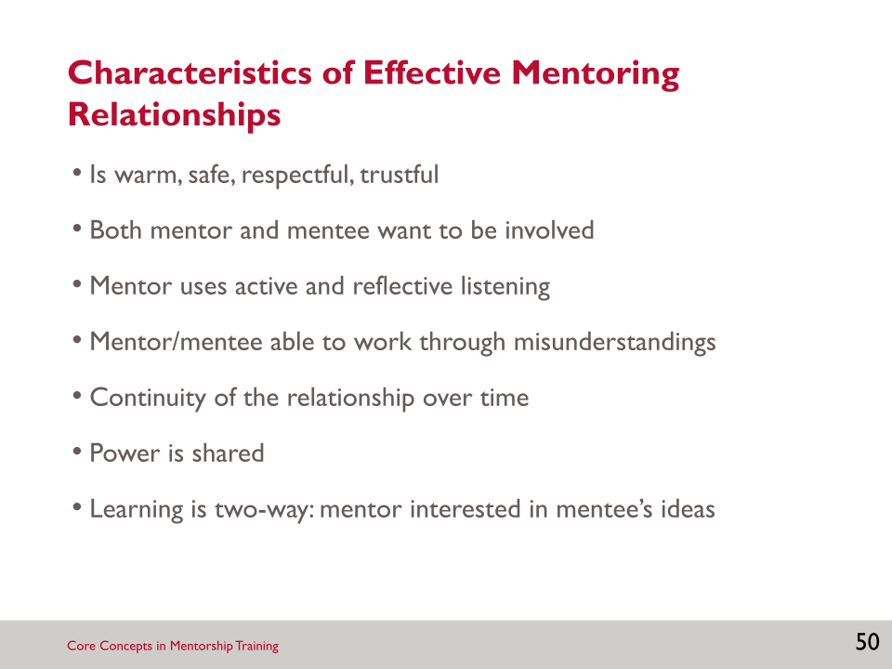

Brainstorm: Characteristics of Effective Mentoring Relationships
- We’re going to brainstorm effective mentor relationships.
- Relationship building continues over the span of the mentorship—even years into the relationship. Mentors can think about mentoring as a dance between the mentor and mentee—it is fluid, with each person requesting information from the other, back and forth.
- Effective mentoring relationships involve mutual learning—not only is the mentee learning from the mentor but the mentor is also learning from the mentee.

SLIDE 51: ACTIVITY: CHALLENGES IN CLINICAL MENTORING

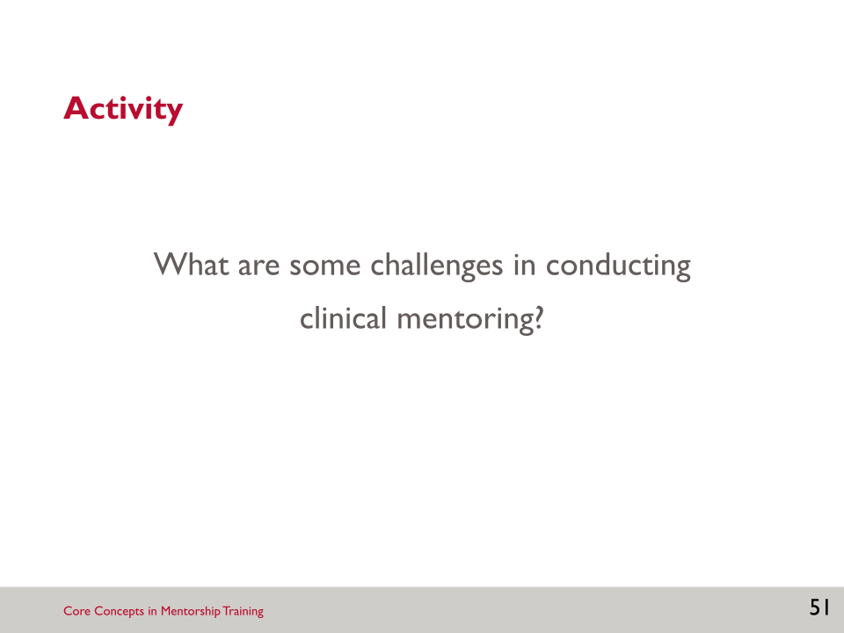

Activity: Challenges in Clinical Mentoring
- Ask participants to brainstorm some of the challenges in conducting clinical mentoring. Examples of challenges:
- ________________________________________________________________
- ________________________________________________________________
- ________________________________________________________________
- ________________________________________________________________
- ________________________________________________________________
- The next slide lists some possible challenges.

SLIDE 52: CHALLENGES TO MENTORING

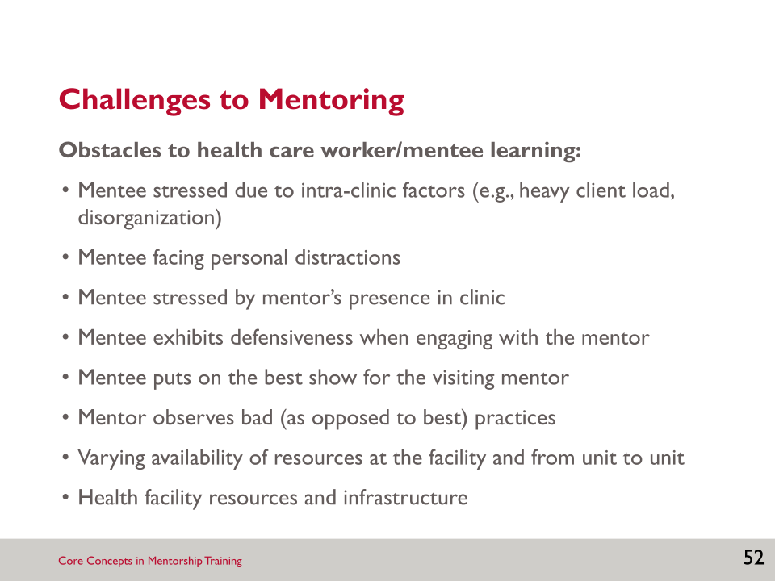

- This slide presents examples of challenges that are specifically obstacles to the health care worker/mentee being able to learn.
- Mentees may be stressed due to factors within the clinic like a heavy workload.
- They also may be facing personal distractions that take their mind away from being able to focus on learning.
- The arrival of a mentor can be seen as a valuable learning opportunity or regarded with defensiveness: “What? You don’t think I know what I am doing?”
- We all like to put on our best show when someone is watching, but those are not the day-to-day practices that mentorship aims to help improve.
- The mentor also has to decide what to do when they directly observe “bad” as opposed to “best” practices. And to consider what to do when we encounter unethical practices.
- Factors at the facility level, like availability of resources and infrastructure, can also be an obstacle to the mentee learning.
- We will discuss more interpersonal challenges to mentoring in the next unit.

SLIDE 53: KEY POINTS

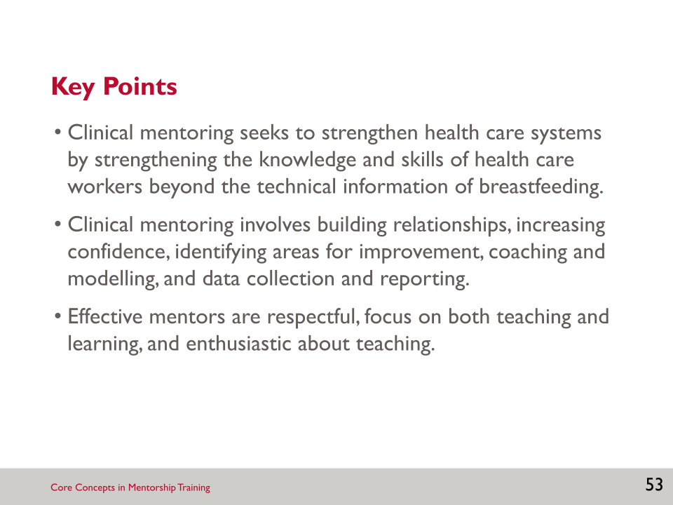

Notes:
______________________________________________________________________________________________________________________________________________________________________________________________________________________________________________________________________________________________________________________________________________________________________________________________________________________________________________________________________________________________________________________________________________________________________________________________________________________________________________________________________________________________________________________________________________________________________________________________________________________________________________________________________________________________________________________________________________________________________________________________________________________________________________________________________________________________________________________________________________________________________________________________________________________________________________________________________________________________________________________________________________________________________________________________________________________________________________________________________________________________________________________________________________________________________________________________________________________________________________________________________________________________________________________________________________________________________________________________________________________________________________________________________________________________________________________________________________________________________________________________________________________________________________________________________________________________________________________________________________________________________________________________________________________________________________________________________________________________________________________________________________________________________________________________________________________________________________________________________________________________________________________________________________________________________________________________________________________________________________________________________________________________________________________________________________________________________________________________________________________________________________________________________________________________________________________________________________________________________________________________________________________________________________________________________________________________________________________________________________________________________________________________________________________________________________________________________________________________________________________________________________________________________________________________________________________________________________________________________________________________________________________________________________________________________________________________________________________________________________________________________________________________________________________________________________________________________________________________________________________________________________________________________________________________________________________________________________________________________________________________________________________________________________________________________________________________________________________________________________________________________________________________________________________________________________________________________________________________________________________________________________________________________________________________________________________________________________________________________________________________________________________________________________________________________________________________________________________________________________________________________________________________________________________________________________________________________________________________________________________________________

SESSION 3: BUILDING RELATIONSHIPS

Learning Objectives
By the end of this session, participants will be able to—
- Explain the importance of building a relationship with a mentee based on trust and mutual respect.
- Identify potential barriers to relationship building.
- Identify techniques for building rapport.
- Practise affirming statements.
- Identify potential challenges and solutions if you are a mentor to your employee.
Key Points
- Relationships are the foundation of effective clinical mentoring.
- Strategies to build rapport include listening, patience, eye contact, and use of affirming statements.
- There can be barriers to building mentorship relationships based on cultural differences and expectations, as well as personal factors. Mentors can come prepared with strategies to overcome these barriers.

Slides and Notes

SLIDE 54: SESSION 3: BUILDING RELATIONSHIPS

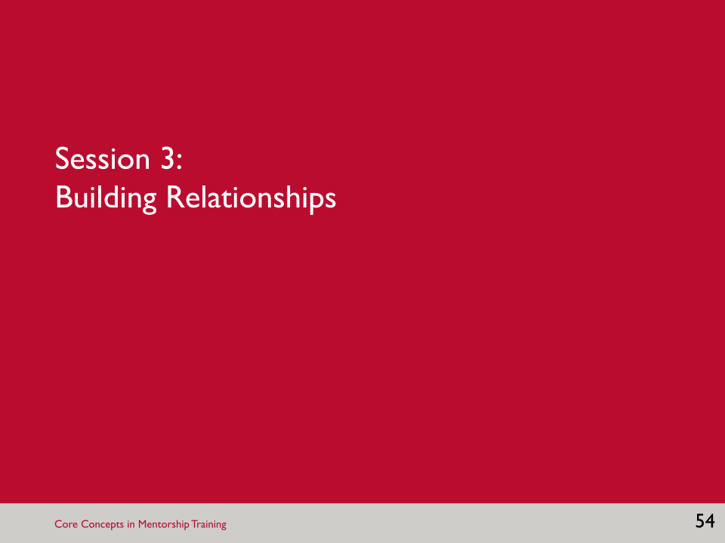

SLIDE 55: LEARNING OBJECTIVES

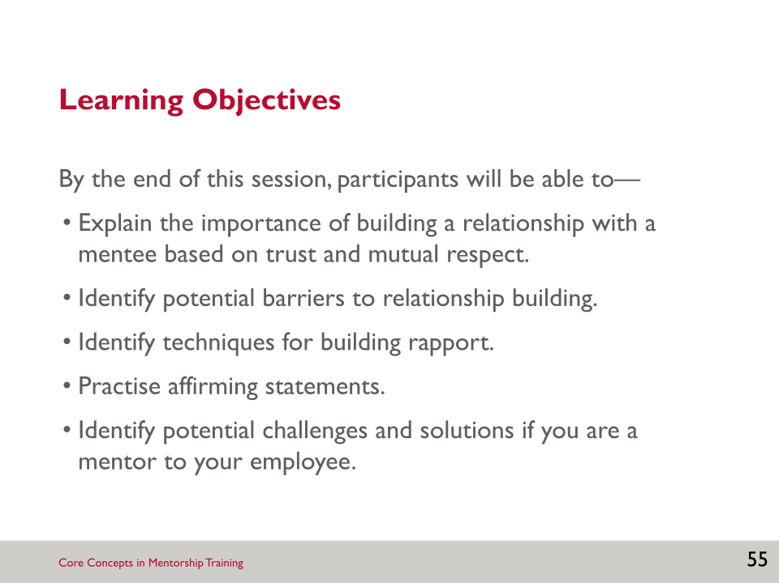

- In this session, we will learn about building a relationship with a mentee. Building a relationship with your mentee is critical to having a successful mentoring relationship.

SLIDE 56: BUILDING A RELATIONSHIP (1)

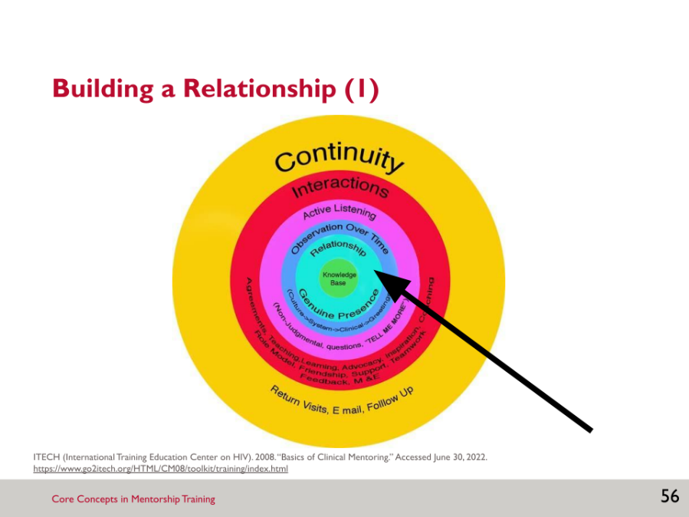

- A strong relationship is at the core of effective mentoring.
- Much of mentoring is strengthening confidence and problem-solving skills, not only technical knowledge. These qualities require a comfortable relationship where the mentee feels safe to ask questions and make mistakes without shame or punishment. This makes the relationship between the mentor and mentee critical to successful learning.

SLIDE 57: BUILDING A RELATIONSHIP (2)

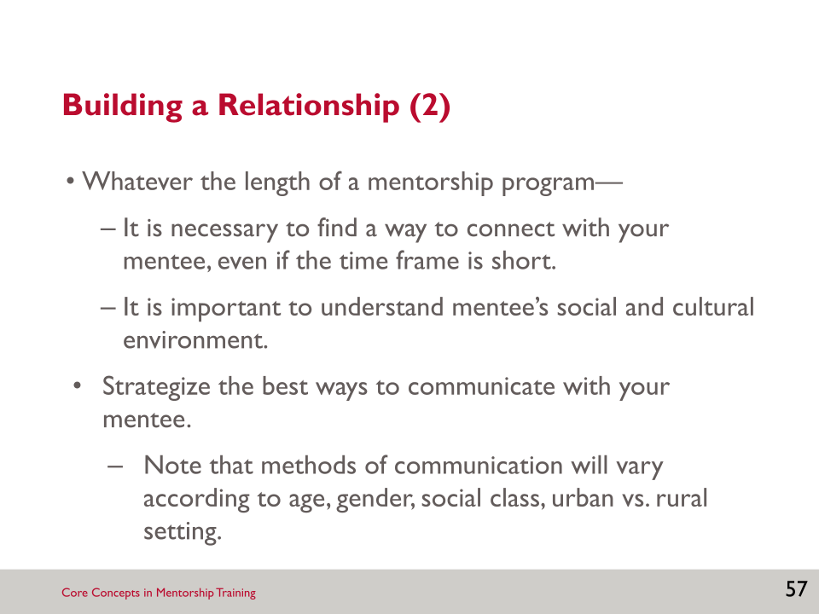

SLIDE 58: RAPPORT

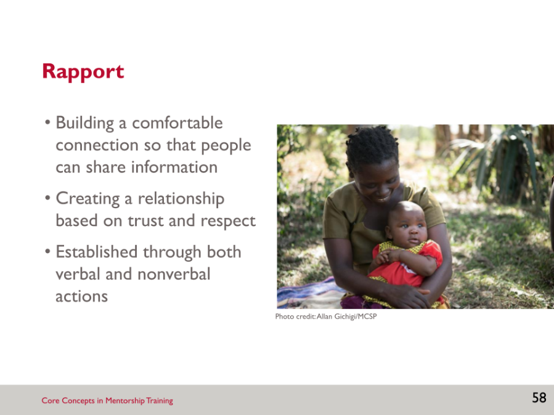

- Establishing rapport is the first phase of effective communication, which includes greeting, welcoming, showing that you care, and have time for the mentee.

SLIDE 59: TECHNIQUES FOR BUILDING RAPPORT

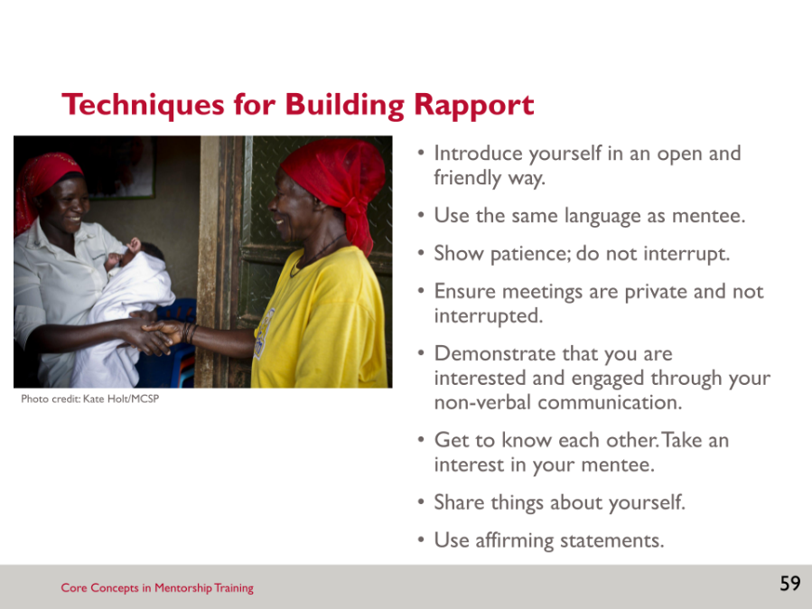

Activity: Techniques for Building Rapport
- Let’s brainstorm techniques or strategies for building rapport.
- The next slides will elaborate on affirming statements and will give you some practice using them.
- Practice activity: Take a few minutes to practise these things with a person sitting near you. Practise on one another on how you would greet your mentee in a way that builds rapport.
- Debrief: How did that go? What did you appreciate about the greeting from your partner? Did anyone learn a technique from their partner that was particularly effective?

SLIDE 60: AFFIRMING STATEMENTS (1)

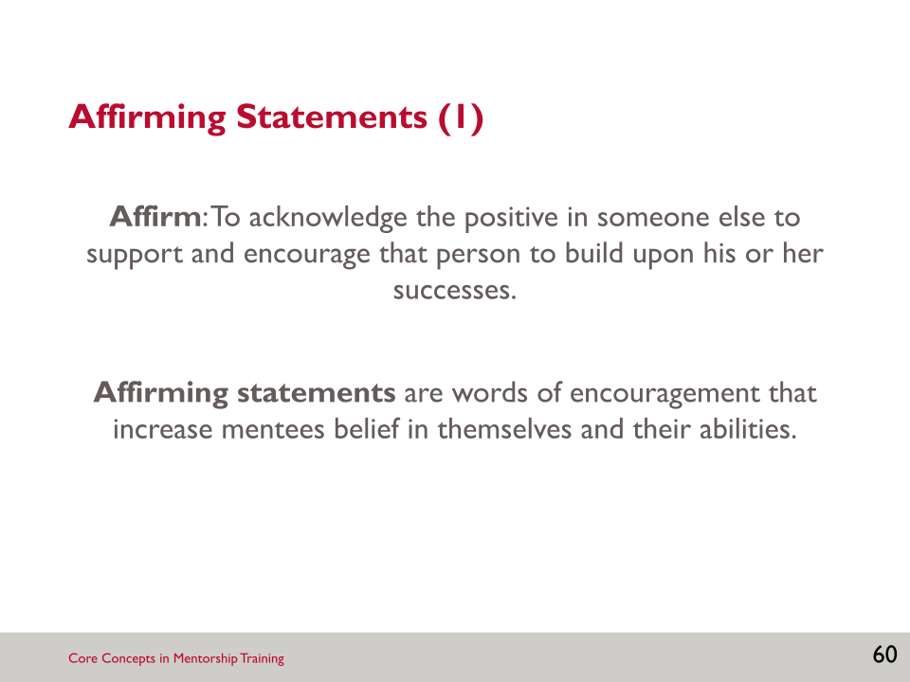

- Directly affirming and supporting the mentee during the mentoring process is an important way of building rapport and reinforcing your relationship, as well as encouraging exploration.
- Modelling affirming statements will both encourage further success among mentees, as well as model behaviour that health care workers can (and should) use with their clients.

SLIDE 61: AFFIRMING STATEMENTS (2)

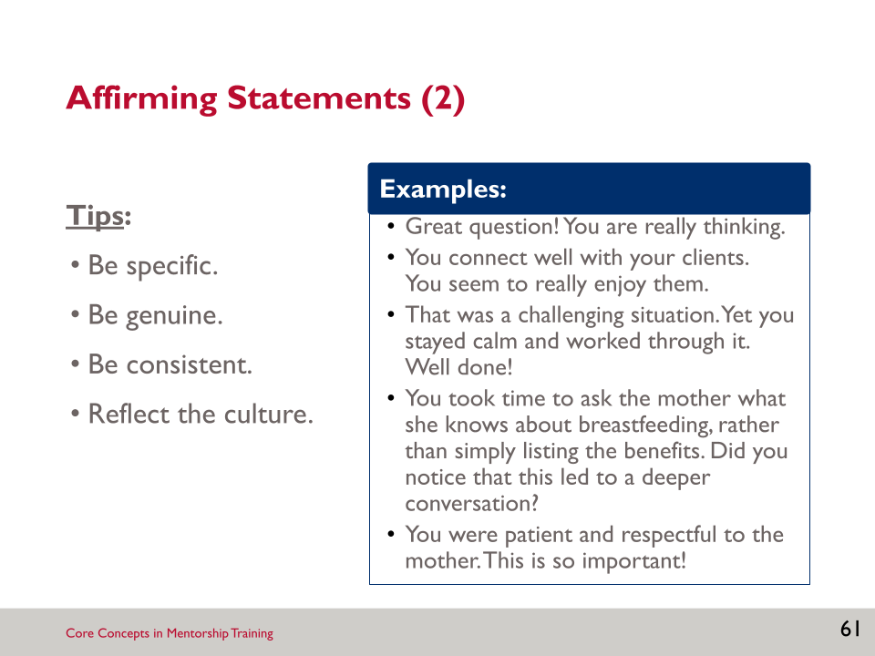

- Some tips on what makes a good affirming statement:
- Be as specific as possible about what they did well. Details help. “You did well,” is good but specifics help the mentee learn more.
- Be genuine! Most people can sense a disingenuous compliment, which damages trust.
- Consistently appreciate the mentee’s strengths and efforts.
- Affirmations will differ by culture and setting.
- Make a habit of consistently noticing and pointing out mentee’s efforts and progress.

SLIDE 62: AFFIRMATION DIALOGUES

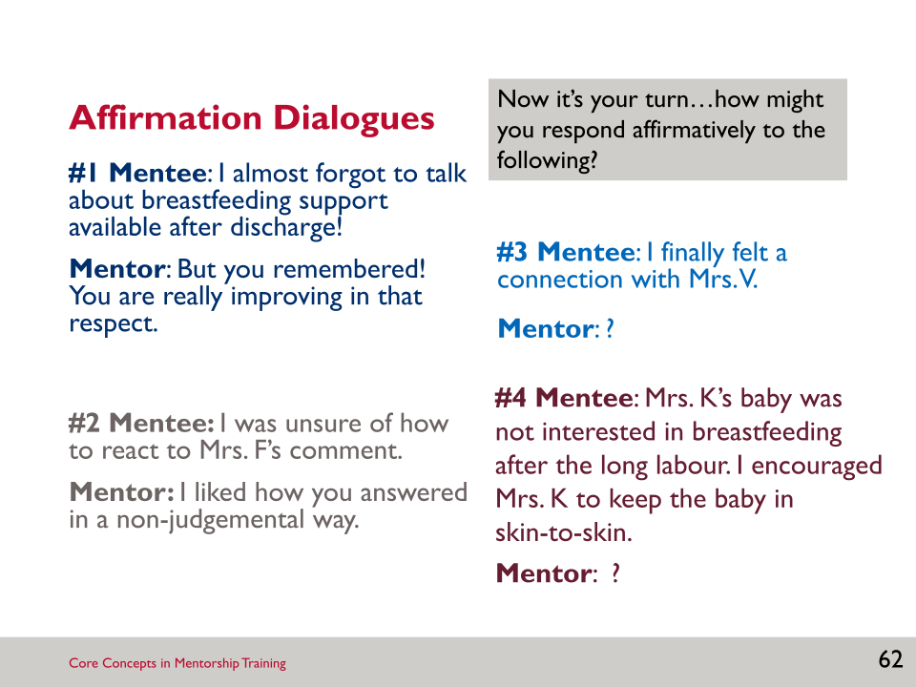

Activity: Affirmation Dialogues
- For the sample dialogues, note how these statements can be used to build mentees’ self-confidence.
- Develop your own affirming statements with the next two. Who would be willing to share how they answered these?

SLIDE 63: ACTIVITY: AFFIRMING EACH OTHER

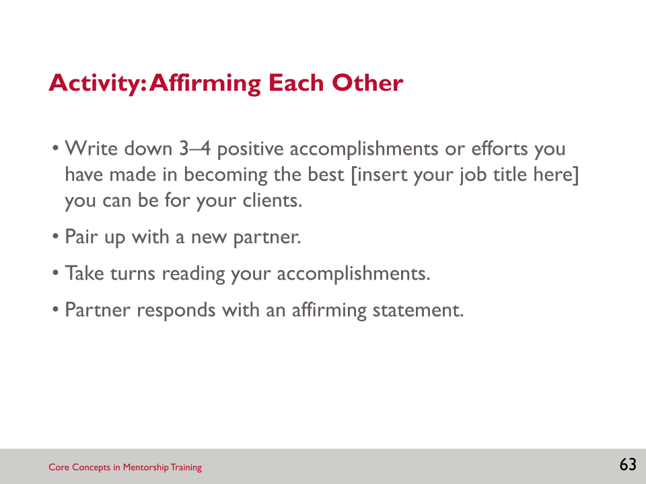

- The accomplishments do not have to be grand accomplishments, but rather can be small positive gains or even efforts that were not completely successful.
Activity: Affirming Each Other
- Write down 3–4 professional accomplishments in a notebook. Then pair up with a partner. You’ll take turns to share what you wrote, and the listening partner should respond with affirming statements.
- Debrief the activity as a large group:
- What was it like to hear affirming statements about your accomplishments?
- What was it like to offer affirming statements?
- How would this make a mentee feel?
- Why is it helpful and important to offer affirming statements?

SLIDE 64: ACTIVITY: WHEN YOU ARE YOUR MENTEE’S MANAGER

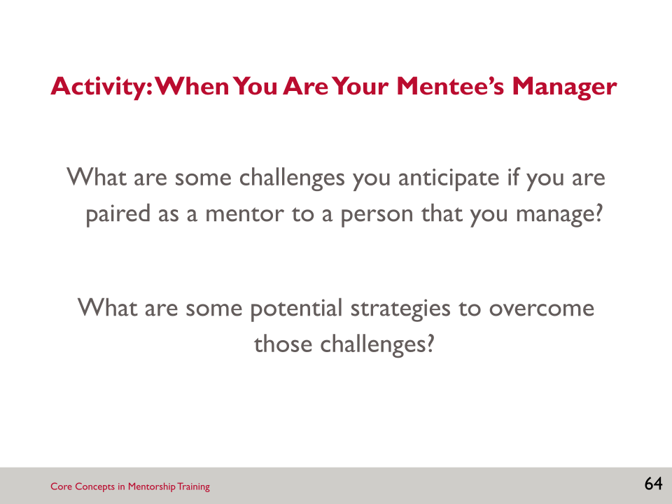

- In some situations, you, as the breastfeeding counselling mentor, may also be your mentee’s manager. This can pose challenges to the mentor-mentee relationship.

Activity: When You Are Your Mentee’s Manager
- Choose a partner for this next activity. Brainstorm possible challenges you may encounter if you are paired as a breastfeeding counselling mentor with one of your employees. Think about some potential strategies to overcome those challenges. Write your ideas in a notebook.

SLIDE 65: TIPS FOR MANAGING THE MENTOR-MENTEE RELATIONSHIP WHEN YOUR MENTEE IS YOUR EMPLOYEE

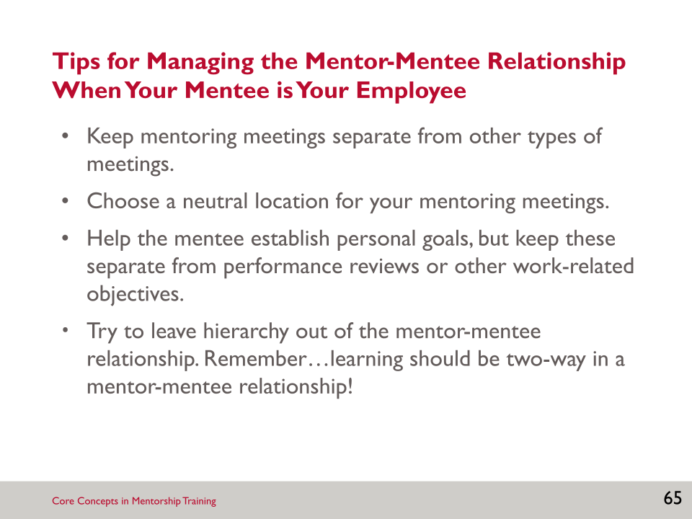

- It is important to set up dedicated time for mentoring meetings and not combine mentoring meetings with discussions of other topics or issues with your mentee.
- If possible, choose a neutral location for your mentoring meetings. If you typically meet with your employees in your office, perhaps meet with your mentee in the cafeteria or a conference room. This may help to put your mentee at ease.
- It’s important to help your mentee establish personal goals for the mentorship program, but these should be separate and distinct from performance reviews and other work-related objectives. Mentoring is for the improvement of a mentee’s skills and not to meet performance objectives.
- Although your manager-employee relationship might be a hierarchical relationship, your mentoring relationship should not be. You and your mentee should come to the mentoring relationship as equals. Even if you are a manager, you can still learn from your mentee just as much as they can learn from you.

SLIDE 66: KEY POINTS

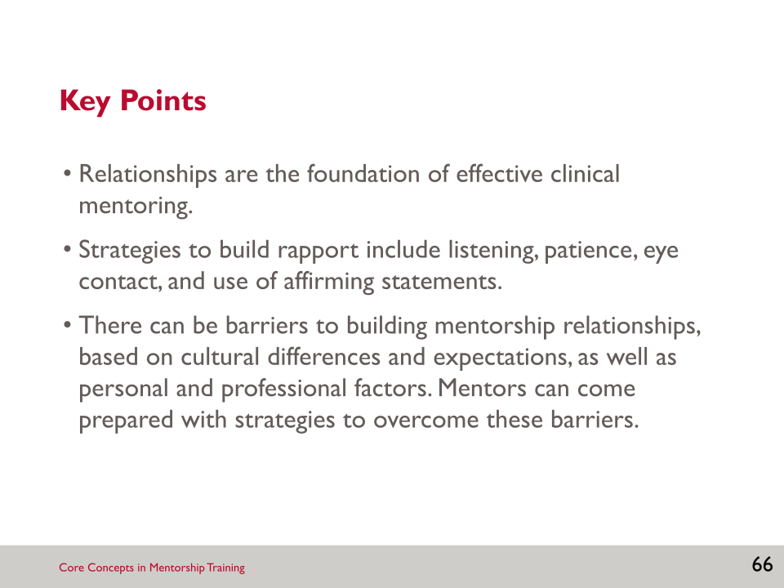

SESSION 3: RESOURCES

Resource 3.1: Building a Relationship with a Mentee
Building an effective relationship of mutual understanding and trust with the mentee is a critical component of effective mentoring. Mentors can establish rapport with their mentees by using effective interpersonal communication skills, actively building trust, and maintaining confidentiality. This document contains information and advice to help mentors build rapport and create positive relationships with mentees so that both parties can achieve the greatest benefit from the mentoring experience.

Interpersonal Communication
Interpersonal communication is a person-to-person, two-way, verbal and nonverbal sharing of information between two or more people. In the context of clinical mentoring, good communication helps to develop a positive working relationship between the mentor and mentee by helping the mentee better understand directions and feedback from the mentor, feel respected and understood, and be motivated to learn from the mentor. Mentees learn best from mentors who are sincere, approachable, and non-judgemental. Facial expressions primarily communicate these qualities, and, to a limited extent, words. People often remember more about how a speaker communicates a subject than their knowledge of the subject.
There are two types of communication: verbal and nonverbal. Verbal communication is the communication that occurs through spoken words. Nonverbal communication occurs through unspoken mediums, such as gestures, posture, facial expressions, silence, and eye contact. It is important for mentors to remember that they are communicating to mentees when they are speaking and when they are not speaking. In fact, the vast majority of human communication is nonverbal. This includes body language, which tells those with whom we are communicating a great deal about what we are thinking and feeling. Examples of positive or open body language include—
- eye contact (depending on the culture)
- open or relaxed posture
- nodding or other affirmation
- pleasant facial expressions.
Examples of negative or closed body language include crossed arms, poor or no eye contact, and pointing fingers. The mentor needs to be aware of what he or she is communicating nonverbally as well as what the mentee is communicating nonverbally.
Verbal communication is a component of most mentoring activities, which include one-on-one sessions (where the client may or may not be present), meetings between a team of mentors and a team of mentees, email or phone conferences, or training sessions between mentors and mentees. When mentoring, effective communication involves more than just providing information or giving advice. It requires asking questions, listening carefully, trying to understand a mentee’s concerns or needs, demonstrating a caring attitude, remaining open-minded, and helping to solve problems. There are many communication skills that mentors can utilise to effectively communicate with mentees, including the following:
- Active listening: Be sure to really listen to what a mentee is saying. Often, instead of truly listening to what the mentee is saying, the mentor is thinking about his/her response, what to say next, or something else entirely. It is important to quiet these thoughts and remain fully engaged in the task of listening.
- Attending: Be physically present for the mentee and give undivided attention. Listen while observing, and communicate attentiveness. This can include verbal follow-up (saying “yes,” or “I see”) or nonverbal cues (making eye contact and nodding the head).
- Reflective listening: Verbally reflect back what the mentee has just said. This helps the mentor to check whether he/she understands the mentee, and helps the mentee feel understood as a health care worker. Examples:
- “So, it seems like you’re overwhelmed with your workload.”
- “It seems that you are concerned about this client’s ability to continue breastfeeding her baby at home because of her family situation.”
- “So, what I am hearing you say is that you are concerned about the missed opportunities to counsel mothers in antenatal care.”
- Paraphrasing: Determine the basic message of the mentee’s previous statement and rephrase it in your own words to check for understanding. Examples:
- “You’re interested in ensuring all mothers receive breastfeeding counselling upon discharge.”
- “It sounds like you’re concerned that the baby is not attaching well to the breast and the mother is getting frustrated.”
- Summarising: Select main points from a conversation and bring them together in a complete statement. This helps to ensure that the listener receives the message correctly. For example, “Let me tell you what I heard, so I can be sure that I understand you. You said that the main thing bothering the client today is nipple pain. Is that right?”
- Asking open-ended questions: Ask mentees questions that they cannot answer with a simple “yes” or “no.” Open-ended questions encourage a full, meaningful answer using the mentee’s own knowledge and feelings, whereas closed-ended questions encourage a short or single-word answer. Examples:
- Closed-ended question: “You didn’t think this mother needed support with positioning?”
- Open-ended question: “What reasons led you to your decision not to work with this mother on a more comfortable position for breastfeeding?”
- Closed-ended question: “Did you understand what we discussed today?”
- Open-ended question: “Can you summarise what we discussed today?”
- Probing: Identify a subject or topic that needs further discussion or clarification and use open-ended questions to examine the situation in greater depth. For example, “I heard you say you are overwhelmed; please tell me more about that.”
- Self-disclosure: Share appropriate personal feelings, attitudes, opinions, and experiences to increase the depth of communication. For example, “I can relate to your difficult situation; I have experienced something similar and recall being very frustrated. Hopefully I can assist you to figure out how to move forward.”
- Interpreting: Add to the mentee’s ideas to present alternate ways of looking at circumstances. When using this technique, check back in with the mentee and be sure you are interpreting correctly before assigning additional meaning to their words. For example, “So, are you saying that when your clients stop exclusive breastfeeding before six months it is usually because the mother no longer thinks her milk is enough? That is likely one reason; have you also considered the challenges mothers face with exclusive breastfeeding, including having other responsibilities at home?”
- Confrontation: Use questions or statements to encourage mentees to face difficult issues without accusing, judging, or devaluing them. This can include gently pointing out contradictions in mentees’ behaviour or statements, as well as guiding mentees to face an issue they are avoiding. Example: “It’s great that you are so committed to helping your clients breastfeed within the first hour after birth. However, I’m confused about the lack of support breastfeeding mothers receive after this time. Mothers are usually in the hospital for such a short time postpartum; it’s key to make sure they receive adequate counselling throughout their stay.”
A number of attitudes and/or behaviours can serve as barriers to communication—these can be verbal or nonverbal. Verbal barriers to communication that you should avoid include the following:
- Avoid moralising: Making judgements about a mentees’ behaviour, including calling it “right” or “wrong,” or telling them what they “should” or “should not” do. For example, “It was wrong of you not to support the mother after the first hour. You should have done it throughout her stay in the hospital.”
- Avoid arguing: Disagreeing with, instead of encouraging, the mentee. For example, “What do you expect? If you’re not using the correct mentoring skills, then you will not be successful.”
- Avoid preaching: Telling the mentee what to do in a self-righteous way. For example, “If it was me, I would not do that. I would do it this way because this is the right way.”
- Be cautious with storytelling: Avoid relaying long-winded personal narratives that are not relevant or helpful to the mentee. For example, “I can relate to your difficult situation. Let me tell you a story about what happened to me when I was working in a rural facility in my earlier days as a young professional.”
- Avoid blocking communication: Speaking without listening to the mentee’s responses, using an aggressive voice, showing impatience, showing annoyance when interrupted, or having an authoritative manner. These behaviours often lead to the mentee feeling down, humiliated, scared, and insecure. As a result, the mentee may remain passive and refrain from asking questions, or distrust the mentor and disregard his/her recommendations. For example, “Let me first finish before you tell me what you have to say.”
- Avoid talking too much: Talking so much that the mentee does not have time to express him or herself. As a mentor, it is important not to dominate the interaction. For example, “So as I was saying, this is how you should do it; but our time is up so we’ll pick this back up where we left off in the next session.”
Examples of nonverbal barriers to communication include looking at your phone, shuffling papers, not looking directly at the mentee when he/she is speaking, and allowing interruptions or distractions. These barriers may have consequences for both the mentor and the mentee. They may lead to a lack of information shared, the mentee asking fewer questions, difficulty in understanding problems, uncomfortable situations, and a lack of motivation on the part of the mentee.

Establishing Trust
Establishing trust is an essential component in building rapport with a mentee. Trust is the trait of believing in the honesty and reliability of others (WordNet 2006). Some mentees may be nervous about working with a mentor. To put them at ease, create a trusting relationship by empathising with their challenges, sharing knowledge without being patronising, and remaining non-judgemental. Along with the other communication skills listed above, establishing a trusting dynamic is essential for a productive and positive mentor/mentee relationship.
The following list provides some ideas for how to build trust with a mentee:
- Share appropriate personal experiences from a time when you received mentoring.
- Acknowledge mentee strengths and accomplishments from the outset of the mentoring process.
- Encourage questions of any type, and tell the mentee that there is no such thing as a bad question. This includes being open to answering questions about the mentor’s personal experiences.
- Build on previous conversations with follow-up questions.
- Take time to learn culturally appropriate ways of relating with the mentee.
- When appropriate, consider how to incorporate cultural practices and knowledge into the mentoring experience.
- Acknowledge the mentee’s existing knowledge, and incorporate new knowledge into that existing knowledge.
- Ask for and be open to receiving feedback from mentees; apply constructive feedback to improve mentoring skills.
- Ask questions about the mentee’s work and life interests, while maintaining professional boundaries.
Trust is especially important when the mentor-mentee pairing does not match traditional hierarchies. For example, building trust is especially critical when the mentor and mentee are not the same gender, the mentor is younger than the mentee, the mentor is a nurse and the mentee is a physician, or if the mentor is not the same ethnicity as the mentee. In these situations, mentoring can still be a positive learning experience for both parties. Establishing a relationship in which trust is a top priority can help alleviate any tensions associated with such differences between the mentor and mentee.

Maintaining Confidentiality
Maintaining confidentiality is a critical component of the mentor-mentee relationship. In such relationships, confidentiality refers to the mentor’s duty to maintain the trust, and respect the privacy of the mentee. Without appropriate confidentiality, mentors will find that it is very difficult, if not impossible, to establish trust and build rapport with their mentees. Note that at the beginning of the mentoring relationship, it is important for the mentor to explain to the mentee any circumstances in which confidentiality may be broken. Such circumstances include when a client’s life is in danger, or if the mentee is engaging in illegal activity.
To maintain confidentiality with their mentees, mentors need to be sensitive to when and where to have conversations with and provide feedback to their mentees. Some mentees may feel shame if they are corrected in front of their supervisors, peers, or clients, so make efforts to offer feedback in a private setting whenever possible. In many clinic settings, this can be difficult, so the mentor should become familiar with locations within the clinic that offer more privacy as well as times when there are fewer people present in the clinic. Additionally, the mentor should refrain from sharing details of mentor-mentee conversations with the mentee’s peers or superiors later.

Conclusion
Using effective interpersonal communication skills, establishing trust, and maintaining confidentiality are key components of building a strong, effective relationship with mentees. Good mentors take care to utilise effective communication skills from the beginning of the mentoring experience to ensure their mentees’ comfort; they also make trust and confidentiality the foundation of their mentor-mentee relationships. By practising these approaches, mentors will build rapport with mentees and both parties will gain from the clinical mentoring experience.

Notes:
___________________________________________________________________________________________________________________________________________________________________________________________________________________________________________________________________________________________________________________________________________________________________________________________________________________________________________________________________________________________________________________________________________________________________________________________________________________________________________________________________________________________________________________________________________________________________________________________________________________________________________________________________________________________________________________________________________________________________________________________________________________________________________________________________________________________________________________________________________________________________________________________________________________________________________________________________________________________________________________________________________________________________________________________________________________________________________________________________________________________________________________________________________________________________________________________________________________________________________________________________________________________________________________________________________________________________________________________________________________________________________________________________________________________________________________________________________________________________________________________________________________________________________________________________________________________________________________________________________________________________________________________________________________________________________________________________________________________________________________________________________________________________________________________________________________________________________________________________________________________________________________________________________________________________________________________________________________________________________________________________________________________________________________________________________________________________________________________________________________________________________________________________________________________________________________________________________________________________________________________________________________________________________________________________________________________________________________________________________________________________________________________________________________________________________________________________________________________________________________________________________________________________________________________________________________________________________________________________________________________________________________________________________________________________________________________________________________________________________________________________________________________________________________________________________________________________________________________________________________________________________________________________________________________________________________________________________________________________________________________________________________________________________________________________________________________________________________________________________________________________________________________________________________________________________________________________________________________________________________________________________________________________________________________________________________________________________________________________________________________________________________________________________________________________________________________________________________________________________________________________________________________________________________________________________________________________________________________________________________________________________________________________________________________________________________________________________

SESSION 4: EFFECTIVE COMMUNICATION AND FEEDBACK SKILLS

Learning Objectives
By the end of this session, participants will be able to—
- Identify the basic principles of feedback.
- Explain the important role of feedback in the context of clinical mentoring.
- Demonstrate effective communication styles and constructive feedback.
Key Points
- Good communication—both verbal and nonverbal—is essential for an effective mentoring relationship.
- Communication techniques, such as appropriate body language, active/reflective listening, and summarising, can aid communication.
- Feedback is integral to adult learning, and is a vital component of the clinical mentoring relationship.
- Knowledge about a subject is important for teaching but knowing how to communicate the knowledge is critical for learning.
- Feedback may be either positive or corrective (or both).
- Feedback should be descriptive, objective, and non-judgemental, focusing on the individual’s actions.

Slides and Notes

SLIDE 67: SESSION 4: EFFECTIVE COMMUNICATION AND FEEDBACK SKILLS

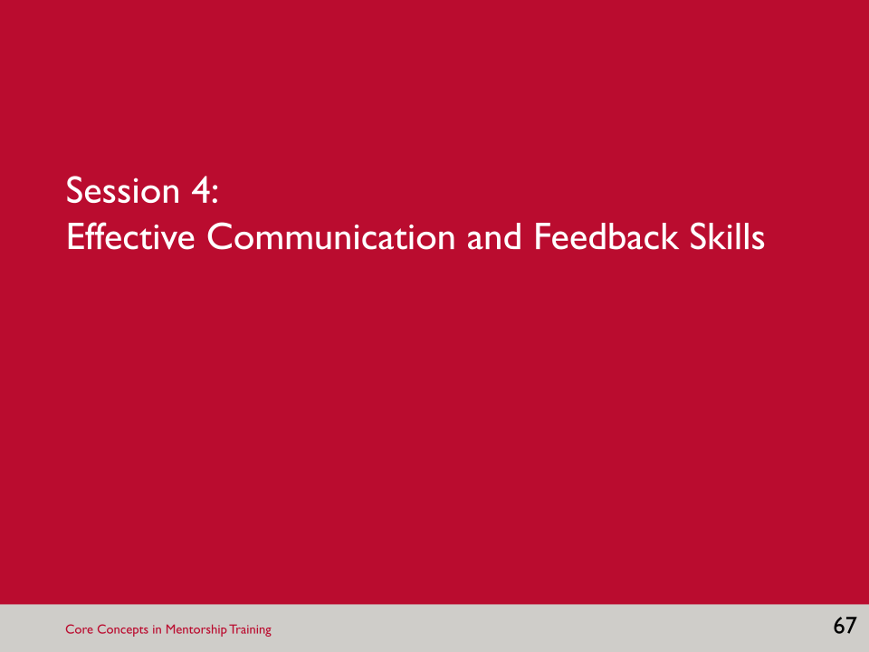

SLIDE 68: LEARNING OBJECTIVES

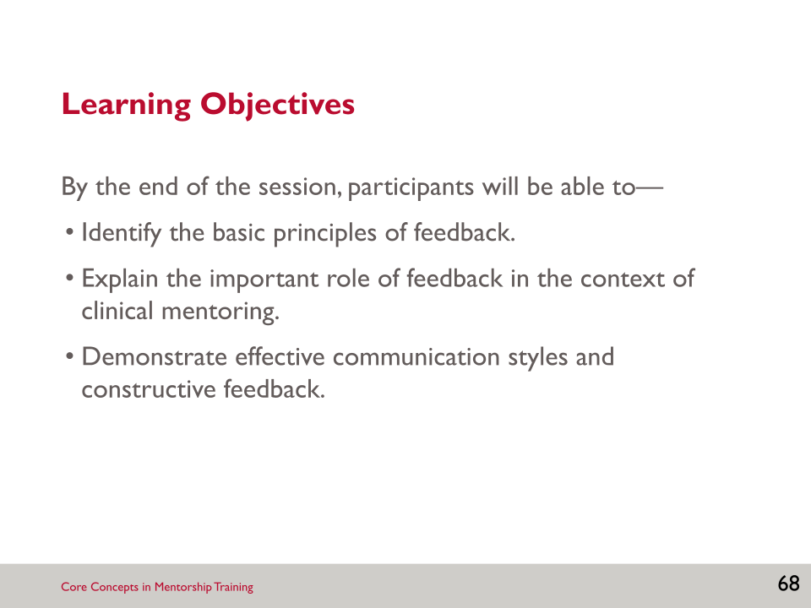

- This session will present basic concepts about feedback but will also try to look at feedback from within a clinical mentoring context.

SLIDE 69: MENTOR-MENTEE COMMUNICATION

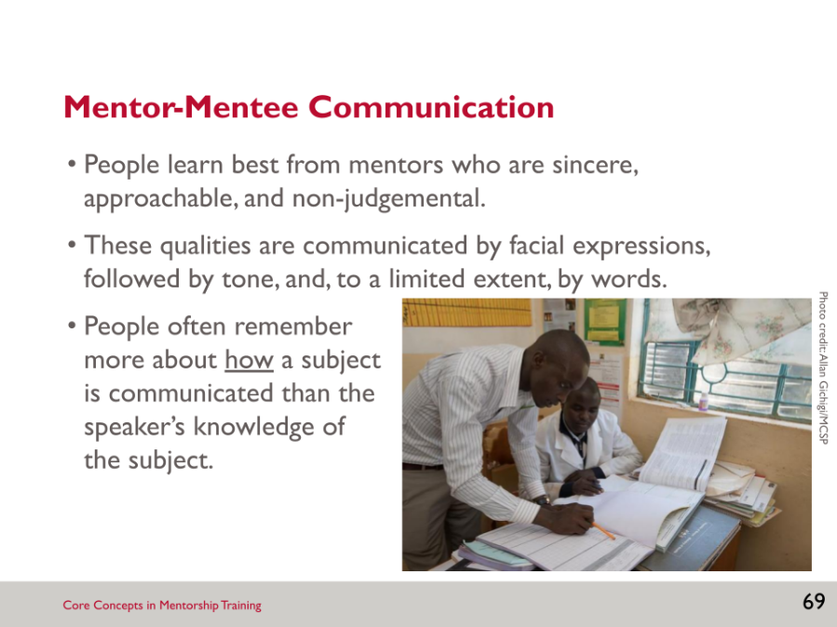

SLIDE 70: TYPES OF COMMUNICATION

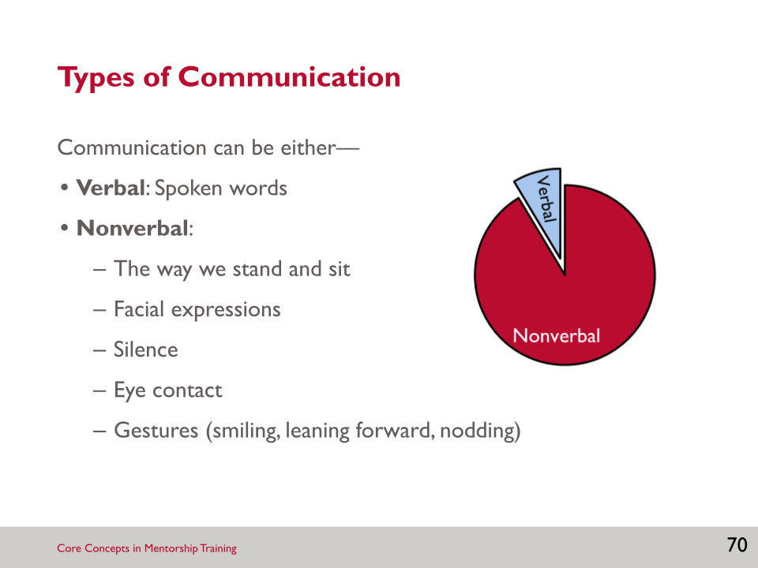

Activity: Types of Communication
- What percentage of communication do you believe is verbal vs. nonverbal? Only ___ to ___ percent of all communication is verbal, and the rest is nonverbal.
- However, things go wrong when the nonverbal communication is contradictory to the verbal message. Differences in how messages are perceived can lead to confusion.
- Can anyone provide an example of when someone says one thing but seems to feel a different way? Some other examples are—
- ___________________________________________________________________
- ___________________________________________________________________
- ___________________________________________________________________

SLIDE 71: NONVERBAL COMMUNICATION

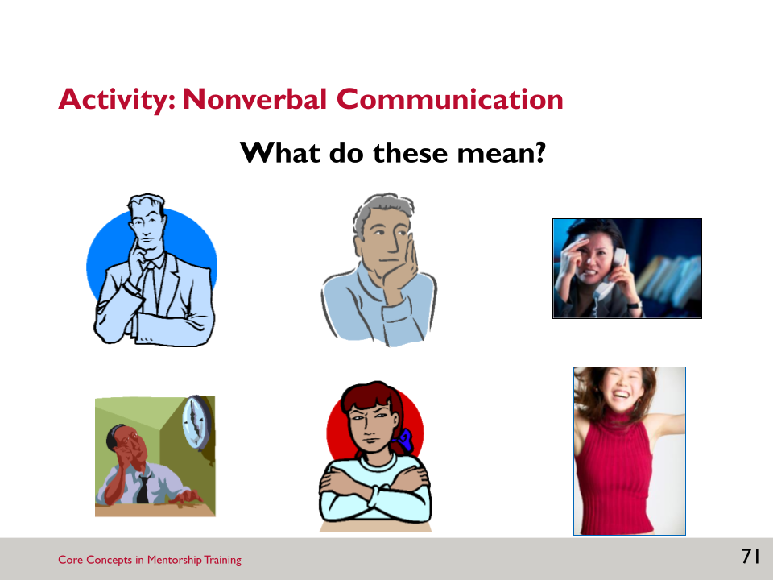

Activity: Nonverbal Communication
- As the facilitator shows pictures on the slide, write down the emotion the person in the image is feeling.
- At times we should check our perceptions to see if we are on track; for example, by saying, “You seem a bit sceptical about this approach. Is that true?”
- Debrief this activity:
- We often communicate without words. For example:
- Drumming
- Dancing
- Drama
- Visual images
- Hand signals
- People use nonverbal communication signs instead of expressing themselves verbally because they may feel uncomfortable expressing emotions such as anger, boredom, or confusion verbally.
- This relates to the mentor-mentee relationship in that the breastfeeding counselling mentor needs to be aware of both verbal and non-verbal communication at several levels: signals that mentors are giving to mentees, signals that mentees are giving to the client, and signals that the mentee is giving to the mentor. There may be times when the mentee is intentionally signalling one thing to the client verbally and something else to the mentor non-verbally (i.e., “Is that right?” or “I need some help, please!”).

SLIDE 72: COMMUNICATION PROCESS

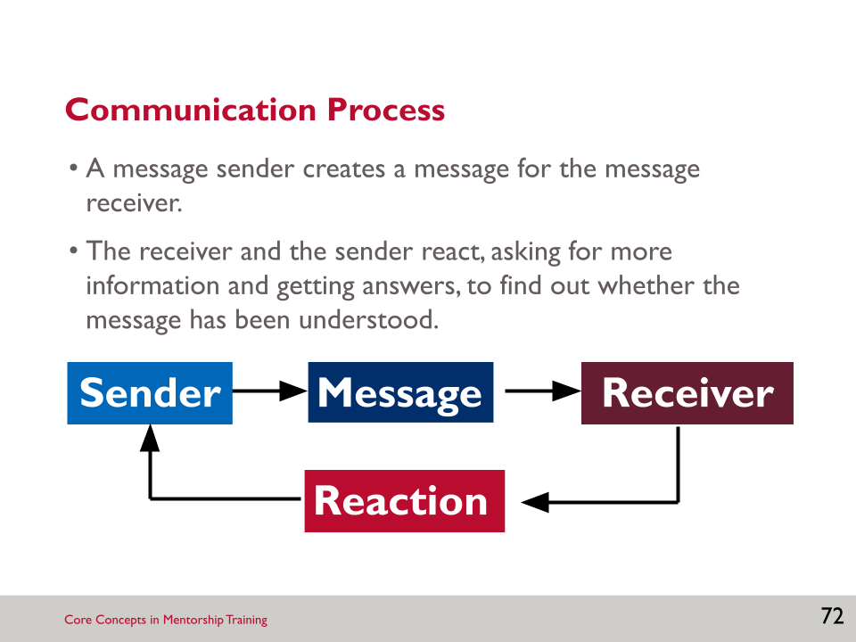

- Effective communication means that the correct message goes from the sender to the receiver successfully, in the way the sender intended. Just because a message is sent does not mean that it was received accurately.
- Effective communication requires the ability of both the sender and the receiver to—
- Listen.
- Pay attention.
- Perceive what the other is trying to communicate.
- Respond verbally or nonverbally (i.e., react).
- Effective communication is more than just providing information or giving advice. It involves asking questions, listening carefully, trying to understand a mentee's concerns or needs, demonstrating a caring attitude, and helping to solve problems.

SLIDE 73: COMMUNICATION SKILLS

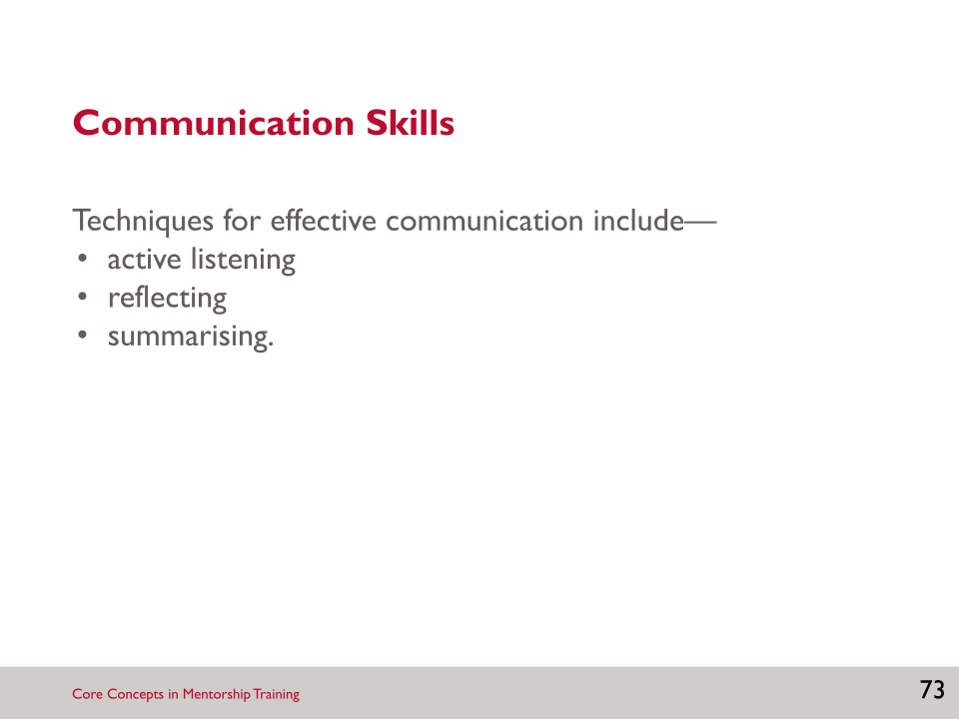

SLIDE 74: ACTIVE LISTENING (1)

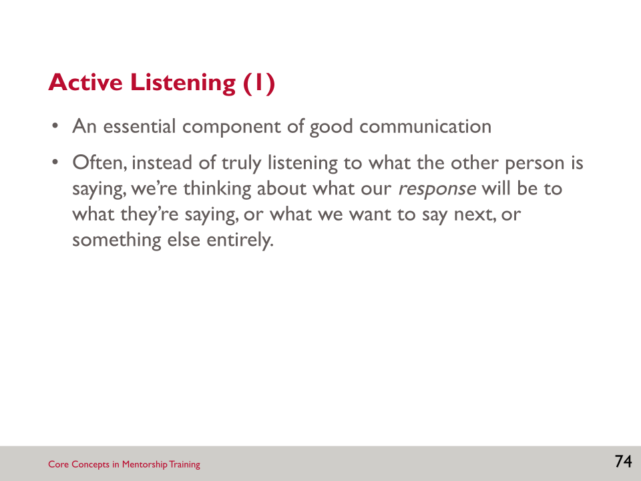

SLIDE 75: ACTIVE LISTENING (2)

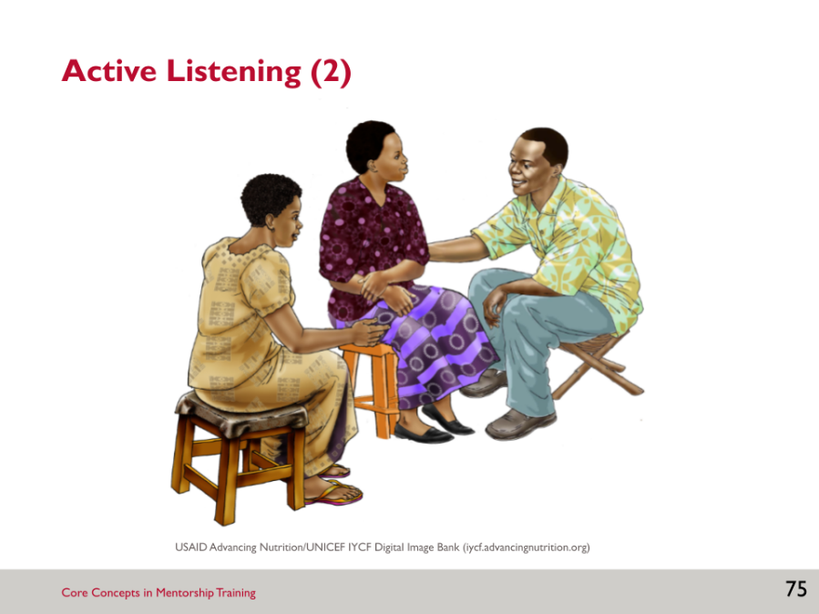

Brainstorm: Active Listening
- Use this picture to identify components of active listening.
- Take a minute or two to think of a time you had to talk to someone who was a bad listener.
- Would a couple of you be willing to share what made that person a bad listener, and how it made you feel?

SLIDE 76: REFLECTIVE LISTENING (1)
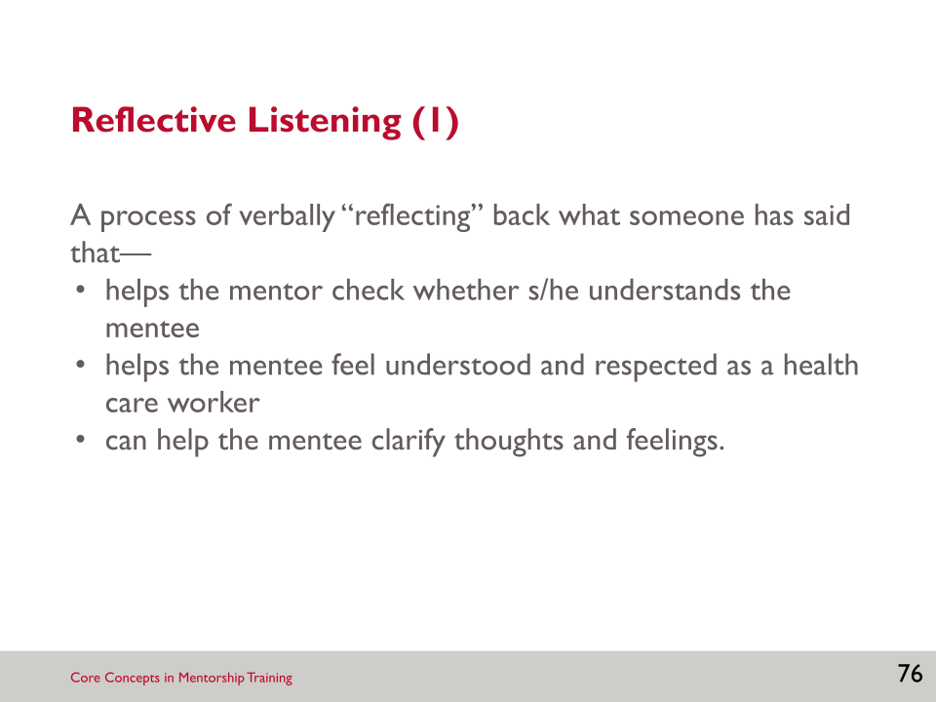

- Reflective listening builds on active listening.

SLIDE 77: REFLECTIVE LISTENING (2)

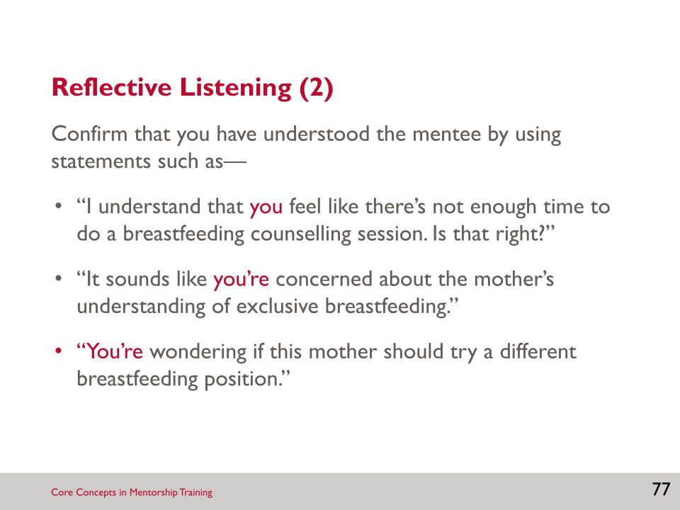

- To demonstrate reflective listening, you confirm that you have understood the mentee.
- The slide provides some examples of statements you could use.
- You’ll note that the sample statements include the word “you,” which emphasises that the you, as the mentor, are actively listening and reflecting back what the mentee has said. This helps to check for understanding.

SLIDE 78: SUMMARISING (1)

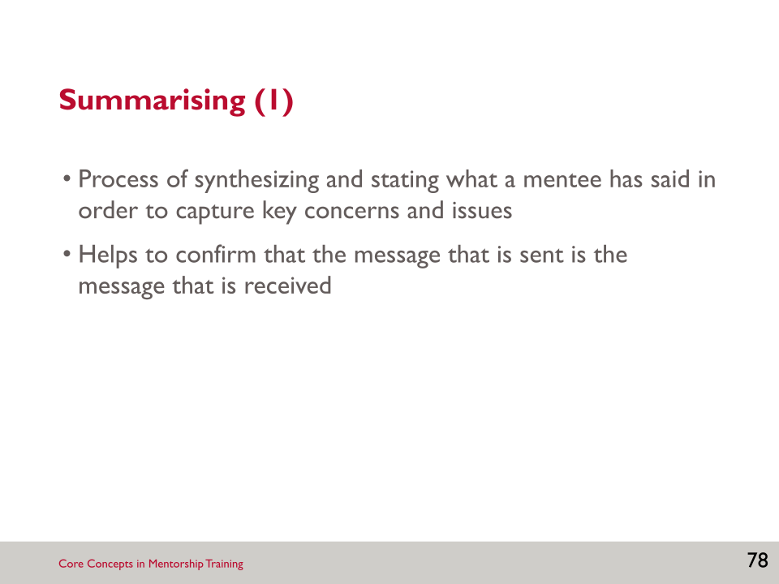

- Summarising is another skill we will practise that may be useful for communicating with your mentee.

SLIDE 79: SUMMARISING (2)

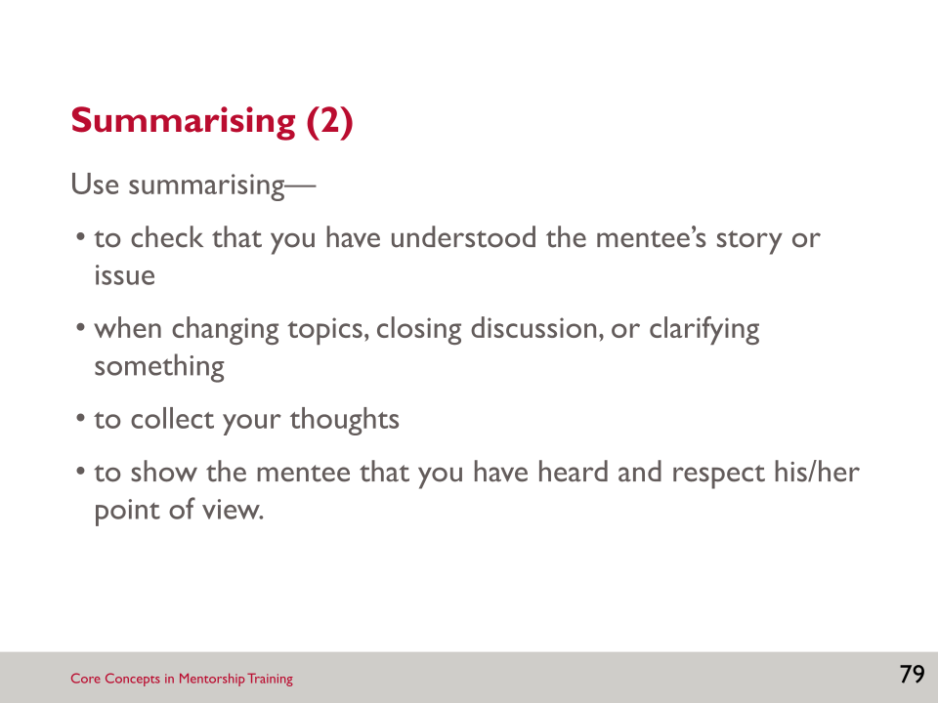

SLIDE 80: ACTIVITY: ACTIVE LISTENING, REFLECTIVE LISTENING, AND SUMMARISING

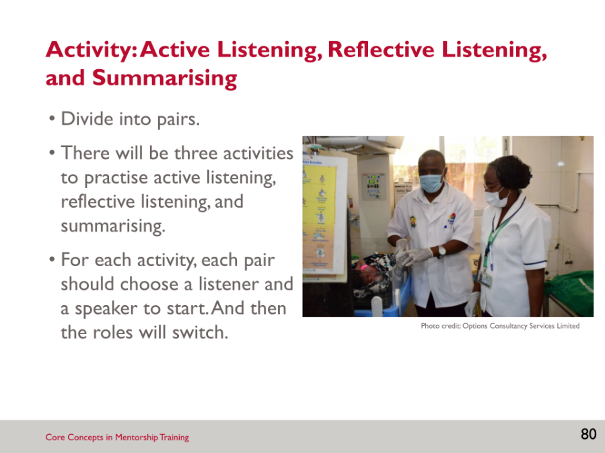

Activity: Active Listening, Reflective Listening, and Summarising
- For this next activity, you’ll need a partner. You will conduct three activities to practise active listening, reflective listening and summarising. For the first activity on active listening, decide on a speaker and a listener.
- Active listening activity:
- Each speaker should talk for 1–2 minutes about a topic of their choice (it does not have to be work-related), while the facilitator keeps time.
- The listener cannot say anything, but must convey active listening using nonverbal skills.
- Then pairs will switch roles and repeat the exercise when prompted.
- Next, we will do an activity on reflective listening.
- Reflective listening activity:
- You can maintain the same pairs. Each pair should choose a first speaker and a listener.
- Using the list of topics provided, the speaker will talk to the listener about his/her topic for two minutes, while the listener should respond only with reflective listening statements.
- Under normal circumstances, it is natural to mix reflection with other skills, but in this exercise, practice reflecting only.
- Partners should switch roles after two minutes. Each person should practise speaking, listening, and observing.
- Each participant should pick one topic from the list below (it is okay to use a different topic if you like).
- Topics for the reflective listening activity:
- Describe what makes a good friend.
- Describe an accomplishment you are proud of.
- Talk about your earliest memory.
- Describe the best workshop you have ever attended.
- Talk about a scary experience you have had that turned out well.
- Talk about someone you admire and why.
- Describe a childhood experience that you remember fondly.
- If you had a day to do anything you wanted, describe what you would do.
- Next, we will do an activity on summarising.
- Summarising activity:
- You can maintain the same pairs. Each pair should choose a first speaker and a listener.
- Refer to the list of topics below.
- The speaker should choose a controversial topic about which to speak (or use one of the examples), uninterrupted, for two minutes. I’ll give you about a minute to think about what you will say, once you have chosen a topic. The speaker can express his/her opinion, or can just choose a position to support.
- The listener should practise active listening, but should not respond verbally. When the speaker has finished speaking, the listener should summarise what the speaker said, taking about 30 seconds. Then you will switch roles and repeat the exercise.
- Suggested topics for the summarising activity:
- If you are short on time, it is better to tell more mothers how to breastfeed than to observe and coach a few, ensuring they get it right.
- Health care workers who refuse to wear masks should not be allowed to work in the hospital.
- Women should exclusively breastfeed, regardless of their situation.
- Hospitals should only provide information on breastfeeding and nothing on supplemental feeding options.
- Debrief in the larger group:
- For the activity on active listening, as the speaker, how did it feel to talk for that long without being interrupted? When you were the listener, how did it feel to listen? Why?
- For the activity on reflective listening, how natural did it feel to be a speaker? A reflective listener?
- For the activity on summarising, was it more difficult to listen quietly when you disagreed with what your partner said? As a listener, was it difficult to summarise? As a speaker, did the listener summarise correctly?
- How does this exercise apply to your mentoring? What will you do to apply what you have practised here?

SLIDE 81: BARRIERS TO COMMUNICATION (1)

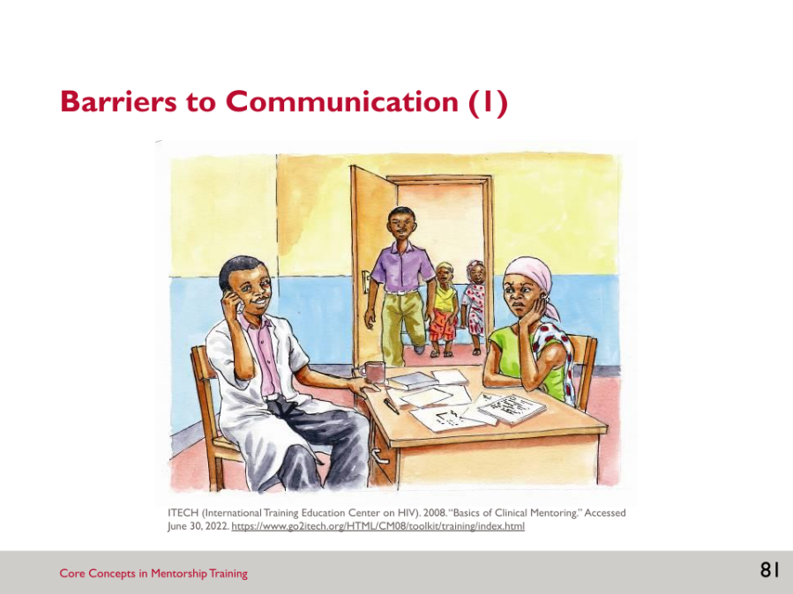

- A number of things can hinder communication. This picture depicts a scene in which many barriers to communication exist. Although this is a picture of a health worker and client, barriers to communication can also be present when you are working with or meeting with your mentee.
- What are the barriers to communication that you observe in this picture?
Activity: Barriers to Communication (1)
- Look at the picture on the slide, and describe any barriers to good communication that you can see.
- Other ways of not communicating well include—
- looking out the window
- looking at the clock or a watch
- starting to speak to someone else
- shuffling papers.
- Negative nonverbal communication can have many consequences, such as—
- Information is not shared or understood.
- The client may ask fewer questions.
- The problem may be difficult to understand.
- The situation may be uncomfortable.
- The client may not adhere to medical appointments and/or treatment.
- Note that this picture depicts a healthcare worker with a client, not a mentor and mentee. However, the same barriers to communication could exist between a mentor and mentee. Alternatively, this is a scene that a mentor might observe in the clinic and give feedback to a mentee about. Give participants an opportunity to describe any barriers to communication that they anticipate could interfere specifically with the mentor-mentee relationship.

SLIDE 82: BARRIERS TO COMMUNICATION (2)

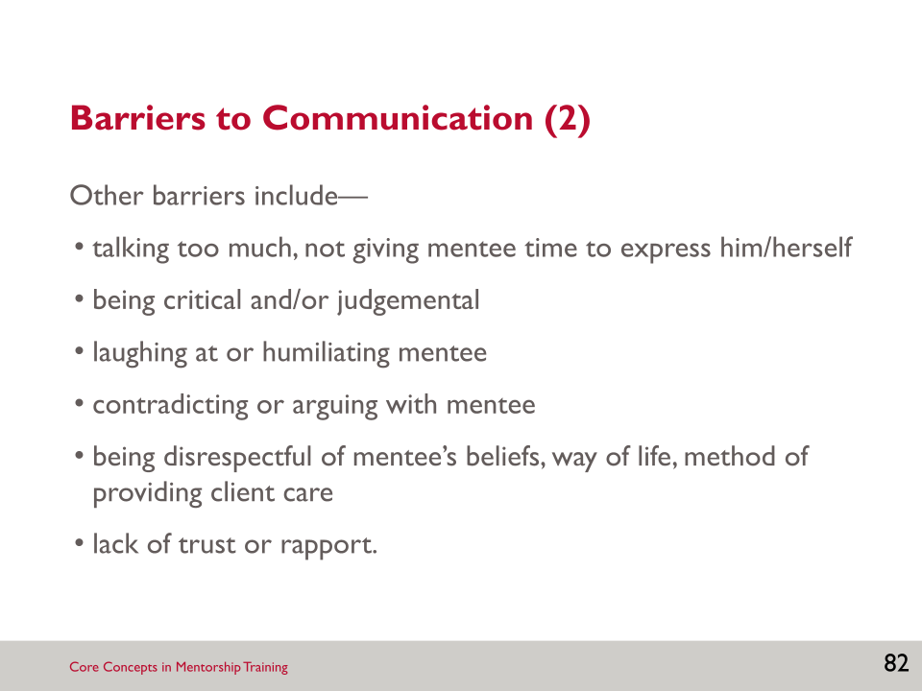

- The last slide dealt primarily with nonverbal barriers to communication. This slide lists barriers to communication that are largely verbal. These barriers to communication are avoidable. However, once barriers to communication have surfaced, a significant amount of work may be necessary to overcome them.

SLIDE 83: PROVIDING FEEDBACK

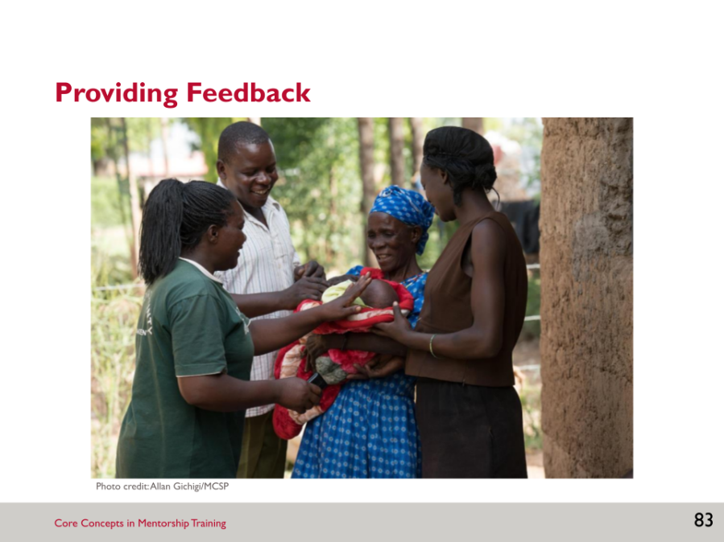

Activity: Providing Feedback
- Brainstorm: We are transitioning into the topic of feedback. Feedback is a critical component of mentoring.
- The facilitator will give you a few minutes to brainstorm definitions of the term “feedback” as you understand it.
- How is feedback different from criticism?
- Role play: Now you will see a short role play on feedback.
- Debrief: What did you observe?
- Summarise: This role play is an entertaining way to demonstrate that there are many different ways to communicate. Our choice of words and how we say something can have a huge impact on whether or not the interaction is positive and effective. This is especially true when giving feedback.

SLIDE 84: FEEDBACK

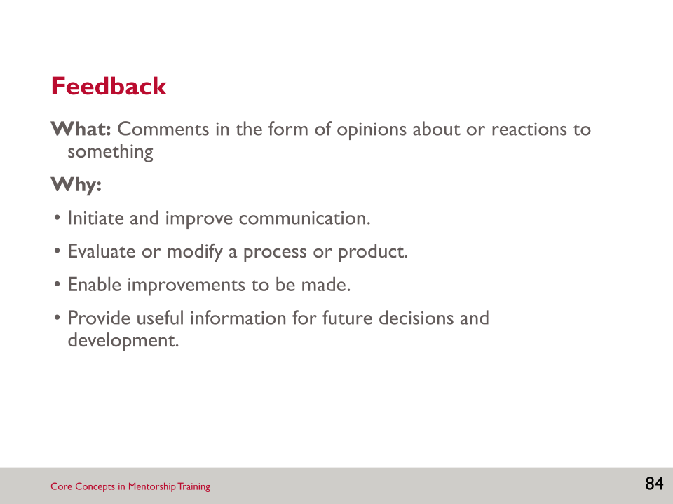

- An article published in 2019 summarised the current research on feedback:
- Article summary: For years, managers have been encouraged to candidly praise and criticise just about everything workers do. But it turns out that feedback does not help employees thrive. First, research shows that people can’t reliably rate the performance of others: More than 50 percent of your rating of someone reflects your characteristics, not theirs. Second, neuroscience reveals that criticism provokes the brain’s “fight or flight” response and inhibits learning. Last, excellence looks different for each individual, so it can’t be defined in advance and transferred from one person to another. It’s also not the opposite of failure. Managers will never produce great performance by identifying what they think is failure and telling people how to correct it.
- Instead, when managers see a great outcome, they should turn to the person who created it, say, “Yes! That!” and share their impression of why it was a success. Neuroscience shows that we grow most when people focus on our strengths. Learning rests on our grasp of what we’re doing well, not what we’re doing poorly, and certainly not on someone else’s sense of what we’re doing poorly.
- NOTE: Reading the Harvard Business Review article, The Feedback Fallacy, requires registering for a free account.
- In a clinical setting, corrections are absolutely necessary to ensure effective patient care. It is important, however, not to underestimate the power of celebrating something done right.

SLIDE 85: FEEDBACK AND CLINICAL MENTORING

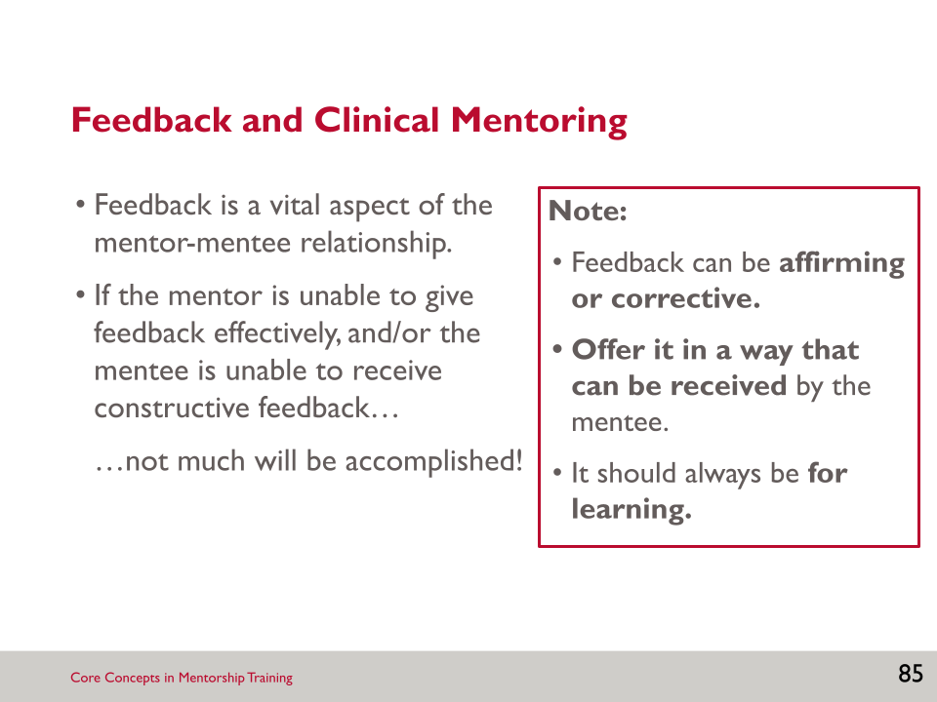

- Feedback is vital to the mentor-mentee relationship, but the mentor must be able to provide feedback effectively and the mentee must be able to receive feedback, otherwise this will negatively impact the relationship.
- Feedback can be positive (affirming) or corrective, but the purpose is to improve performance, not punish poor performance.
- Feedback should be offered in a way that the mentee can receive—not in public or when they are stressed.
- Feedback should always be for learning. It should not be given in anger or to criticise but in the spirit of helping the mentee learn. (This requires self-awareness from the mentor!)

SLIDE 86: SMALL GROUP DISCUSSION: FEEDBACK AND CLINICAL MENTORING

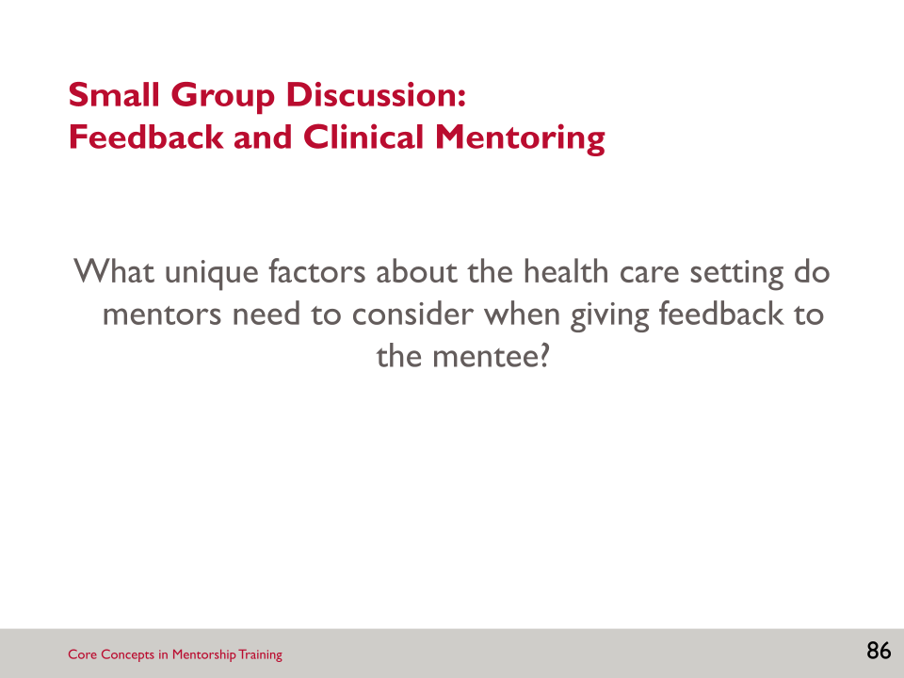

Brainstorm: Feedback and Clinical Mentoring
- In your group, compile a list of factors, based on the question on the slide: What unique factors about the health care setting do mentors need to consider when giving feedback to the mentee?

SLIDE 87: TWO APPROACHES TO FEEDBACK

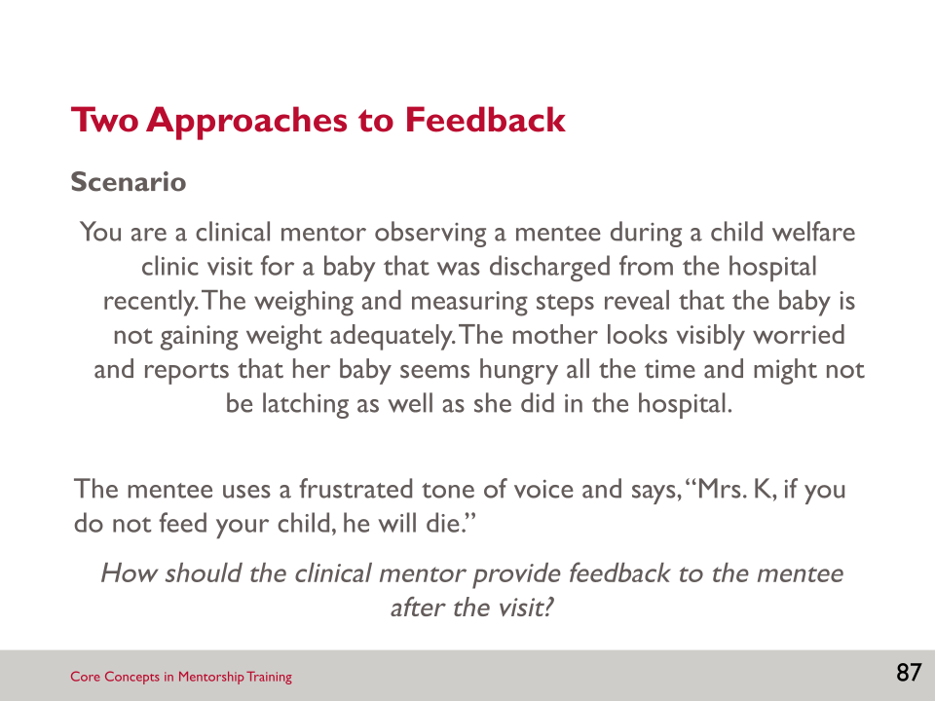

- How we give feedback—what we say, how we say it, when we say it—is critical to whether the feedback is effective and achieves the intended effect.
- I am going to read you a scenario, which is an actual experience of a mother, and we are going to conduct a role play to demonstrate two approaches to a mentor giving a mentee feedback.
- How should the clinical mentor provide feedback to the mentee after the visit?

SLIDE 88: FEEDBACK SCENARIO #1

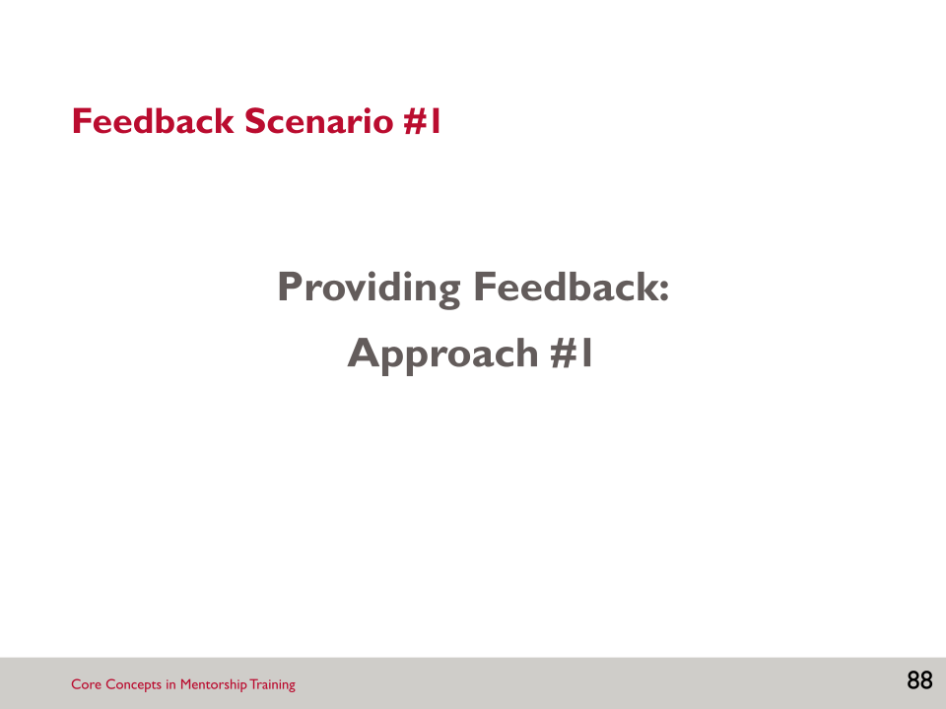

Activity: Facilitator Role Play: Feedback Scenario #1
- Role play:
- Breastfeeding counselling mentor: “Didn’t you see how devastating your reaction was to the mother? You need to have a little compassion for the mother. She was tired and worried. Your reaction only made it worse. This woman may be afraid to return to the clinic in the future which will really put the baby in danger! This is not how we expect counselling to be carried out… You need to do better!”
- Nurse (embarrassed, ashamed): “I’m sorry. I didn’t know what to say. The baby was clearly on a downward trend. I was worried.”

SLIDE 89: FEEDBACK SCENARIO #2
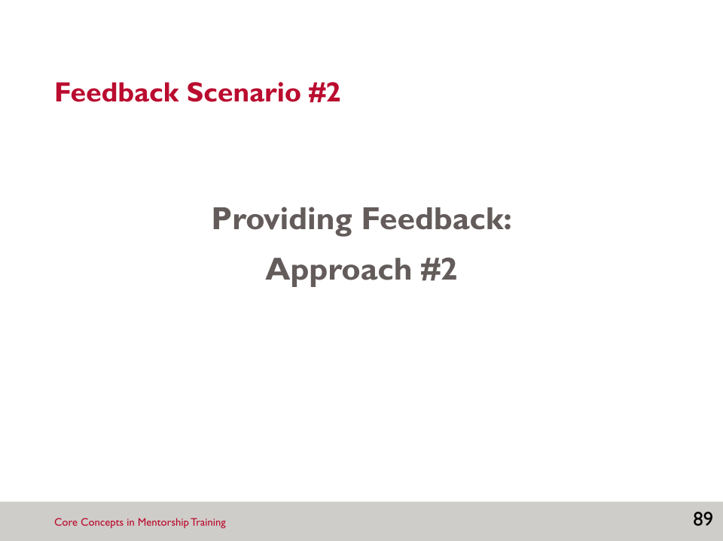

Activity: Facilitator Role Play: Feedback Scenario #2
- Breastfeeding counselling mentor:
- “I just wanted to take a couple of minutes to talk about the last client. I really appreciate your passion for infant health and concern for this child. You did an excellent job taking the vital signs and noting that there was a problem with feeding. At the same time, it is also important to show care for the mother, since she is a key player in ensuring her child is healthy. It is often helpful to ask the mother what she is doing and what challenges she is having with breastfeeding, rather than assuming she is being negligent. For example, you can begin by noting that she looks worried for her child and that breastfeeding is not always easy. Then cover the topics that are essential for the mother to know in the first days after birth, such as infant feeding patterns, adequate milk transfer, and good positioning and latch. Next time you might ask the mother questions, such as—How often does she feed and what is the baby doing then? What happens when she tries to breastfeed? How many wet diapers is the baby having each day?, etc. And you can observe the mother breastfeeding to provide support to her. This can help engage the mother and support to overcome her challenges, rather than possibly coming across as blaming her for the baby losing weight.”
- “It’s also extremely important to counsel clients in a manner that doesn’t make the client uncomfortable with you. If the client starts to feel uneasy during the visit—like you might be judging or blaming them in some way—it’s very likely that she will not be honest or perhaps even not return for her scheduled visits. Ultimately, our role is to support the skills and confidence of the mother to care for the child independent of us.”
- “Do you have questions about what I’ve just talked about? Let’s take a few minutes to replay that visit and test out some different ways to handle that difficult situation. How else do you think you can practise being impartial to client’s responses about their behaviour in the future?”

SLIDE 90: GROUP DISCUSSION

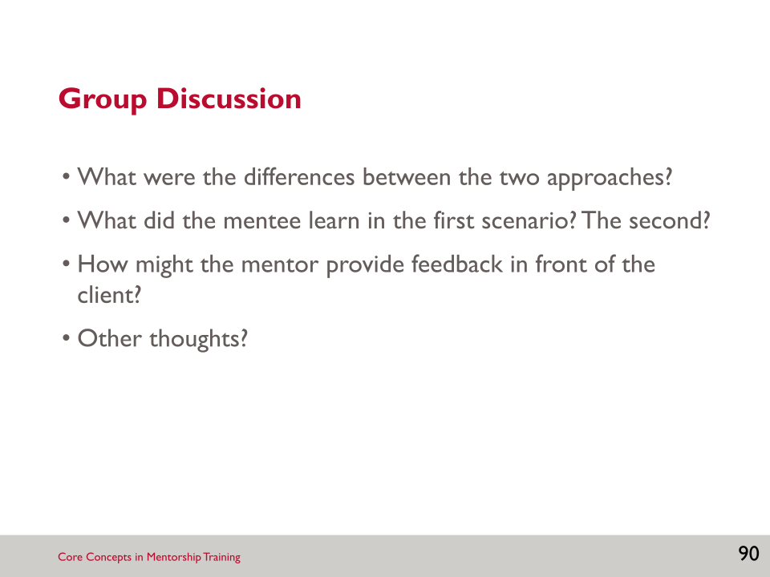

Activity: Small Group Discussion
Possible responses:
- Differences between approaches:
- Different tone
- Different nonverbal communication techniques
- More time taken in the second scenario to explain the situation to the mentee.
- The first approach was very demanding and was not constructive, in that it did not ask the mentee to think of ways to improve.
- The second approach gave examples of how to improve in the future, and invited the mentee to think of ways to practise the improved counselling behaviour.
- What did the mentee learn?
- In the first scenario, the mentee only learned that he/she performed poorly, not how he/she could have improved the situation. In the second approach, the mentee learned a more effective technique for communicating with the client, and also learned that how he/she communicates with the client is important, in terms of whether the information is passed on effectively.
- Note that in the first scenario, the breastfeeding counselling mentor speaks to the mentee in a similar way to how the mentee spoke to the client. Remember that the mentor is always modelling behaviour to the mentee—the mentor needs to model respectful communication.
- Providing feedback in front of the client:
- Due to the seriousness of this situation, the mentor would likely want to provide feedback immediately so that the best care is provided to the mother and child. The mentor should give the feedback in a diplomatic, supportive, yet honest way, counselling the mother regarding her child’s weight loss.
- The purpose of feedback is not to reprimand, but to help mentees perform better in their jobs.

SLIDE 91: FEEDBACK: BASIC PRINCIPLES (1)

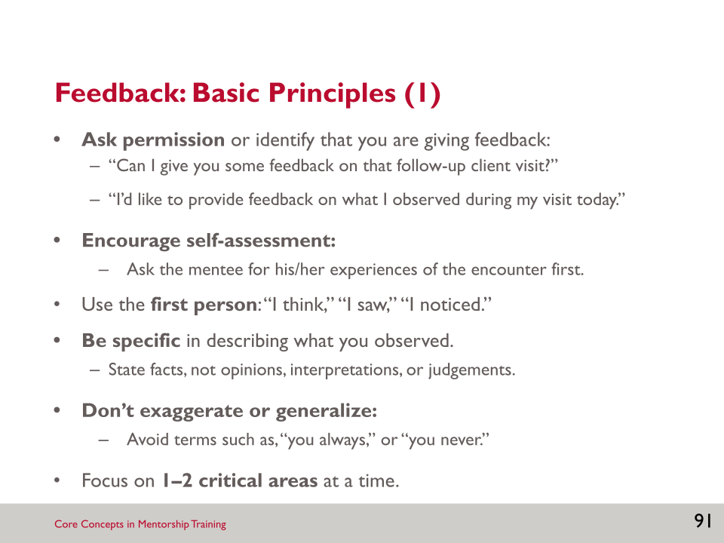

- The following slides describe some basic principles to follow when providing feedback. This list is also in Resource 4.1: Basic Principles of Giving Feedback.
- When you provide feedback to your mentee, always state up front that you would like to provide them with feedback; ask permission to do so. This can help to ensure that the mentee is open to receiving feedback.
- Soliciting an initial self-assessment involves the person receiving feedback, promoting an open atmosphere and dialogue where feedback is the norm. Ask the mentee for his or her version of events, and then ask questions to get to the heart of the matter. A person is almost always aware of his or her own strengths and weaknesses, so by seeking self-assessment, the person will more readily assume responsibility for his or her own abilities and performance.
- Feedback should be given using the first person: what you observed.
- Being specific when providing feedback can give the mentee some tangible examples to reflect on. You should avoid stating your opinion, interpretations, or passing judgement.
- Avoid generalising when providing feedback. Again, it’s important to be specific and avoid saying things like, “you always…”
- It is too hard to examine and try to change many aspects of behaviour at one time. Choosing one or two important points, or critical areas, will avoid overwhelming the mentee and limiting change.

SLIDE 92: FEEDBACK: BASIC PRINCIPLES (2)

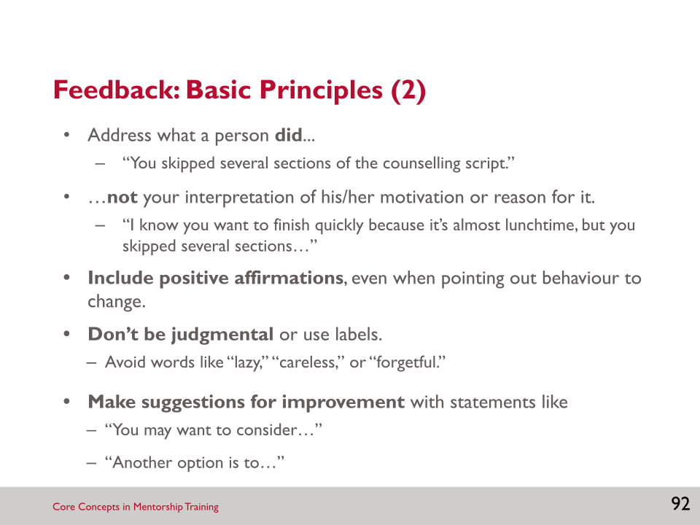

- When providing feedback focus on what the person did—again, be specific—and not your interpretation of his/her motivation for it. This can lead to the mentee getting defensive and not being able to receive the feedback that you are providing.
- It’s important to include positive affirmations. Positive reinforcement is one of the strongest factors in bringing about change. Unfortunately, many people focus on corrective feedback, or make positive feedback general and corrective feedback specific (e.g., “You did well. But you didn’t do this, this, and this …”). When you give corrective feedback, start with the positive.
- Avoid judgemental or negative language when providing feedback.
- You should always make suggestions for improvement and discuss these with the mentee. You can make suggestions by using phrases like “You may want to consider…” and then hearing what the mentee thinks.

SLIDE 93: THREE COMPONENTS OF LEARNING

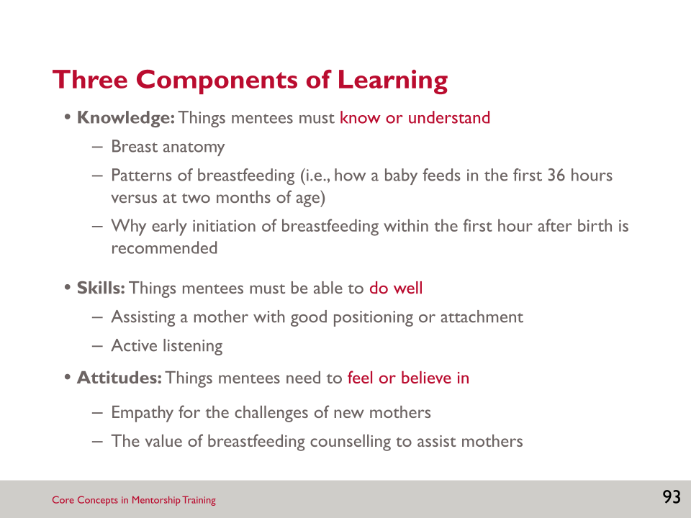

- In addition to using the basic principles when providing feedback, it may also be helpful to think about which component of a task or client encounter may be missing or needs strengthening—knowledge, skills, or attitudes.
- This can help you determine how you will teach and provide feedback to the mentee.
- Consider someone who is learning to drive: What does a person need to KNOW to be able to drive (e.g., rules of the road, basic car mechanics)? What does a person need to be able to DO (e.g., shift gears, pass cars, brake appropriately)? What does a person need to feel and believe (e.g., value of safe and courteous driving)? All these things are needed and are learned in different ways. Some are better from books (knowledge), some from practice (skills), and others from listening to others (attitudes).
- What are some of the knowledge, skills, and attitudes related to breastfeeding?

SLIDE 94: EFFECTIVE LEARNING APPROACHES

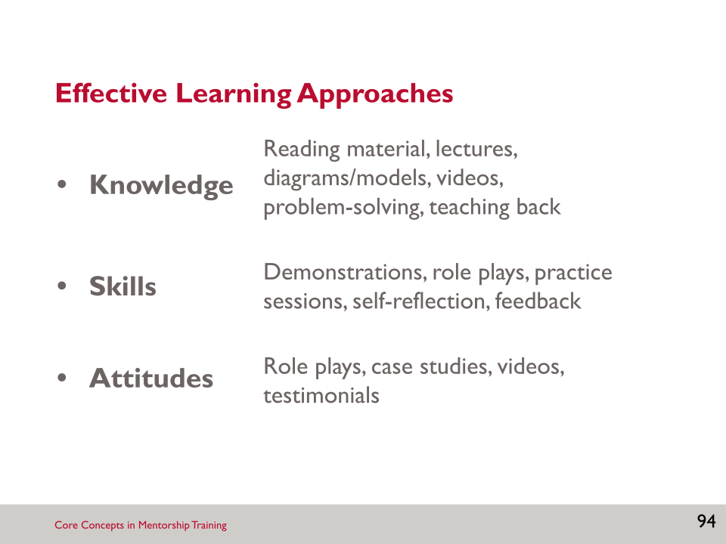

- This slide presents examples of learning approaches to gain new knowledge, to learn new skills or hone skills, and to change or adopt new attitudes.
- Are there other approaches missing that you would add?
Activity: Effective Learning Approaches
- Listen to the following scenarios and identify the appropriate learning component that the mentor should focus on with their mentee. Suggest what learning approach the mentor might use for a teaching moment.
- You observe that your mentee is awkward with hands-on contact with mothers in getting good skin-to-skin contact.
Answer: _______________________________________________________
_______________________________________________________________
- You sense your mentee is impatient to take time to answer questions from a mother struggling with breastfeeding and is more concerned with the physical exam.
Answer: _______________________________________________________
_______________________________________________________________
- You hear your mentee giving inaccurate information regarding the makeup and value of colostrum in early stages of breastfeeding.
Answer: _______________________________________________________
_____________________________________________________________________________________

SLIDE 95: SMALL GROUP WORK

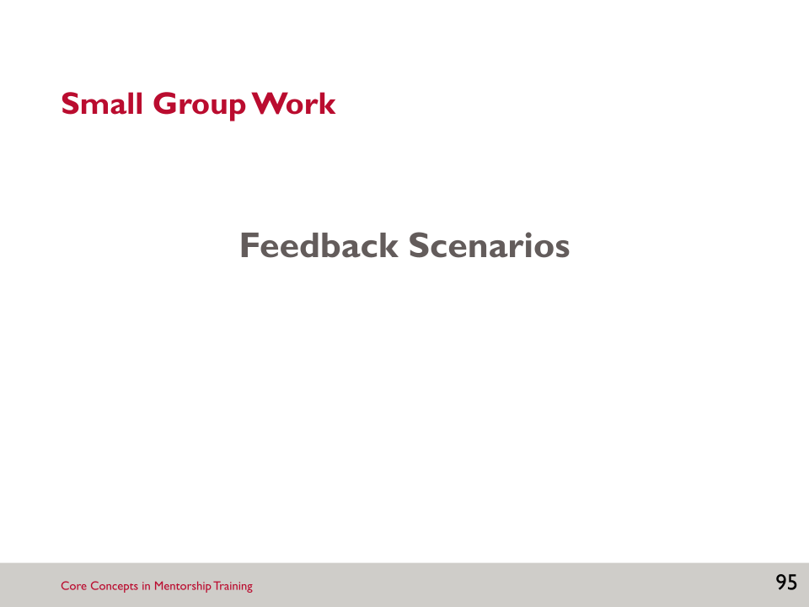

Activity: Feedback Scenarios
- This final activity provides an opportunity to practise all of the skills discussed in this session including giving feedback effectively, nonverbal communication, and active listening.
- Pair up with somebody that you don’t know well.
- Locate Resource 4.1: Basic Principles of Giving Feedback, and Worksheet 4.1: Feedback Scenarios.
- One member of the pair will play the breastfeeding counselling mentor, and the second will play a mentee.
- The facilitator will assign two scenarios to each pair.
- The task is for the mentor to provide feedback to the mentee based on the scenario.
- [After 10 minutes] Switch roles, and move to the second scenario.
- Debrief the activity:
- “How did it feel to give feedback?”
- “How did it feel to receive feedback?”
- “Other thoughts?”

SLIDE 96: KEY POINTS

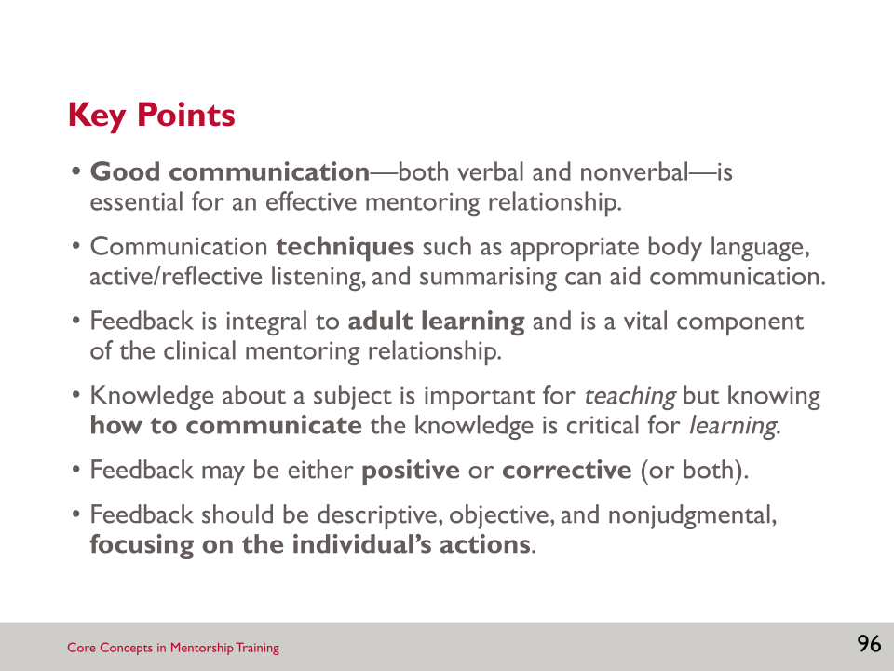

SESSION 4: RESOURCES

Worksheet 4.1: Feedback Scenarios

Instructions
- Divide into pairs with somebody you don’t know well.
- Refer to Resource 4.1 as needed.
- One member of the pair should play the breastfeeding counselling mentor; the second should play a mentee.
- Use the scenarios the facilitator assigns to you.
- Read the first assigned scenario together.
- Role-play; the mentor should provide feedback to the mentee based on the scenario.
- Switch roles and repeat with the second assigned scenario.

Scenario 1
The breastfeeding counselling mentor observed an antenatal clinic visit and noticed the following about the mentee she followed:
- The mentee displayed effective interpersonal skills with the mother, who was in her first pregnancy.
- The mentee did not discuss the benefits of exclusive breastfeeding or ask about the woman’s plans. She did not ask what the woman knows about breastfeeding and what happens when.
- The mentee did not document the discussion properly in the client record to flag a follow-up conversation at the next visit.
- The mentee was good about encouraging the woman to read the breastfeeding material provided and discuss it with her family to seek support.

Scenario 2
The breastfeeding counselling mentor observed interactions on the labour and delivery ward and noticed the following about the mentees she followed:
- Immediately following the delivery, mentees did not guide the mother to breastfeed and support with proper latching.
- The mentees encouraged new mothers to breastfeed after they had rested from delivery but did not always do so within the one-hour window, at times delaying up to four hours.
- During discharge, mentees provided mothers with information on understanding her baby’s feeding cues, achieving a comfortable latch, and signs of milk transfer. They asked the mother to return for a postnatal care check-up.

Scenario 3
The breastfeeding counselling mentor observed a maternity ward visit and noticed the following about the mentee she followed:
- The mentee visited the mothers to observe their first attempts at breastfeeding. The mentee was friendly and encouraging to the mothers, building a quick rapport within a short time.
- The mentee verbally gave instructions to the mother about what she was doing incorrectly and what she should change; she did not point out what she was doing well or provide hands-on guidance on positioning. She also did not show the mother how to make skin-to-skin contact with her baby to initiate nursing.
- The mentee did ask the mother if she had any questions or concerns regarding breastfeeding.

Scenario 4
The breastfeeding counselling mentor observed a new mother and her baby at the child welfare clinic and noticed the following about the mentee he followed:
- The mentee warmly greeted the mother and engaged her in interpreting the results of the weighing and measuring as to whether they were within a normal/healthy range.
- The mentee did not give the mother sufficient time to share her questions, worries, and anxieties around if she was breastfeeding correctly and adequately; instead, he immediately started talking about the importance of exclusive breastfeeding.
- The mentee did not describe the clues that will help the mother determine if the baby is ready to nurse and when the feeding session is complete.
- At the end of the visit, the mentee described the services available to new mothers who want to exclusively breastfeed, including clinical follow-up and available support groups.

Scenario 5
The breastfeeding counselling mentor observed a one-month postnatal follow-up visit in a clinic. The infant was not gaining weight as anticipated.
- The mentee asked whether the mother was breastfeeding, and she responded “yes.” The mentee didn’t ask further questions concerning her experience, such as if she was breastfeeding exclusively or including formula, or when and how she breastfeed.
- The mentee asked follow-up questions about the baby’s response to nursing and if s/he showed signs of irritability or illness.
- The mentee did not conduct an examination of the mother’s breasts or ask about the degree to which the infant attached to the breast.
- The mentee made an appropriate referral to monitor the infant’s weight gain more closely.

Resource 4.1: Basic Principles of Giving Feedback

How to Give Feedback
- Ask permission or identify that you are giving feedback. Examples:
- “Can I give you some feedback on that follow-up client visit?”
- “I’d like to provide some feedback on what I observed during my visit today.”
- Encourage self-assessment:
- Ask the mentee for his/her experiences of the encounter first.
- Use the first person: “I think,” “I saw,” “I noticed.”
- Describe what you observed—be specific.
- State facts, not opinions, interpretations, or judgements.
- Don’t exaggerate.
- Avoid terms such as “you always” or “you never.”
- Focus on 1–2 critical areas at a time. Don’t overwhelm them with a long list.
- Address what a person did, not your interpretation of his or her motivation or reason for it.
- Action: “You skipped several sections of the counselling script.”
- Interpretation: “You skipped several sections of the counselling script. I know you want to finish because it’s almost lunch time, but…”
- Include positive affirmations, even when pointing out behaviour to change.
- Don’t be judgemental or use labels.
- Avoid words like “lazy,” “careless,” or “forgetful.”
- When making suggestions for improvement, use statements like, “You may want to consider…” or “Another option is…”

When to Give Feedback
- You can provide feedback any time, during the client visit, immediately afterwards, or after you leave the ward or clinic premises.
- Don’t wait too long to give feedback. The closer the feedback is to the actual event, the more likely the mentee will remember the teaching point.
- Certain feedback requires more immediate timing (e.g., if you see the mentee doing something in error or omitting an important step).
- If you provide feedback during a client encounter:
- Do not alarm the mentee or client. Put them both at ease.
- Be calm and patient as you explain your recommendation.

Notes:

____________________________________________________________________________________________________________________________________________________________________________________________________________________________________________________________________________________________________________________________________________________________________________________________________________________________________________________________________________________________________________________________________________________________________________________________________________________________________________________________________________________________________________________________________________________________________________________________________________________________________________________________________________________________________________________________________________________________________________________________________________________________________________________________________________________________________________________________________________________________________________________________________________________________________________________________________________________________________________________________________________________________________________________________________________________________________________________________________________________________________________________________________________________________________________________________________________________________________________________________________________________________________________________________________________________________________________________________________________________________________________________________________________________________________________________________________________________________________________________________________________________________________________________________________________________________________________________________________________________________________________________________________________________________________________________________________________________________________________________________________________________________________________________________________________________________________

SESSION 5: CLINICAL TEACHING SKILLS

Learning Objectives
By the end of this session, participants will be able to—
- Define a teaching moment.
- Use clinical teaching, side-by-side mentoring, and case presentations as teaching strategies.

Key Points
- Teaching moments are opportunities to improve clinical skills of a mentee, can take place in a variety of settings, and breastfeeding counselling mentors should maximise the number of teaching moments in interactions with mentees.
- Clinical teaching and side-by-side mentoring reinforce classroom learning, and allow the mentor to model clinical technique, as well as attitudes and behaviours.
- Case studies are an effective tool for clinical teaching.

Slides and Notes

SLIDE 97: CLINICAL TEACHING SKILLS

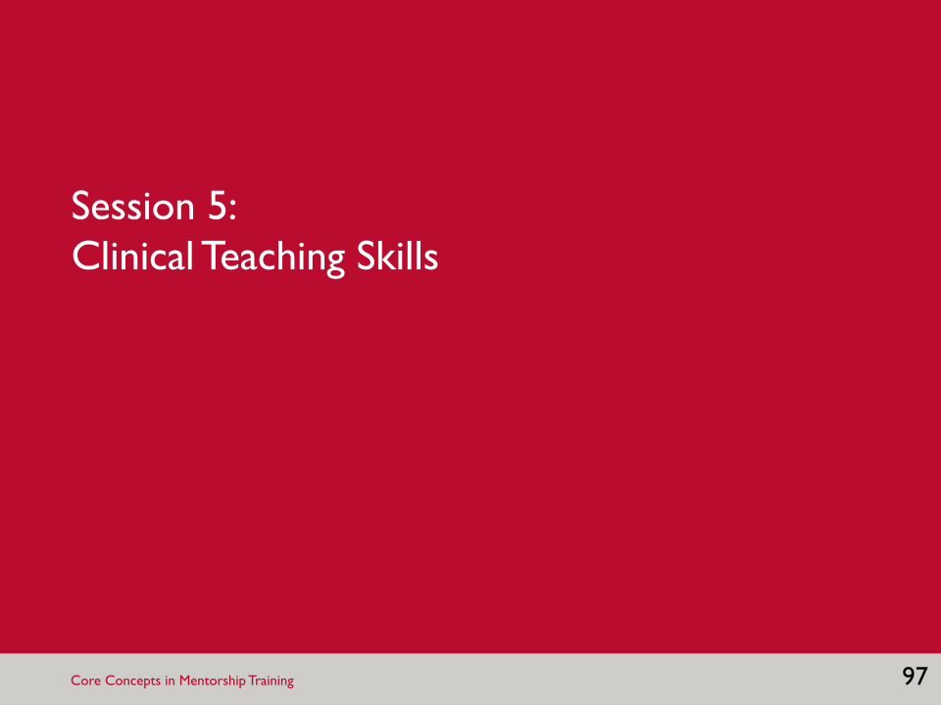

SLIDE 98: LEARNING OBJECTIVES

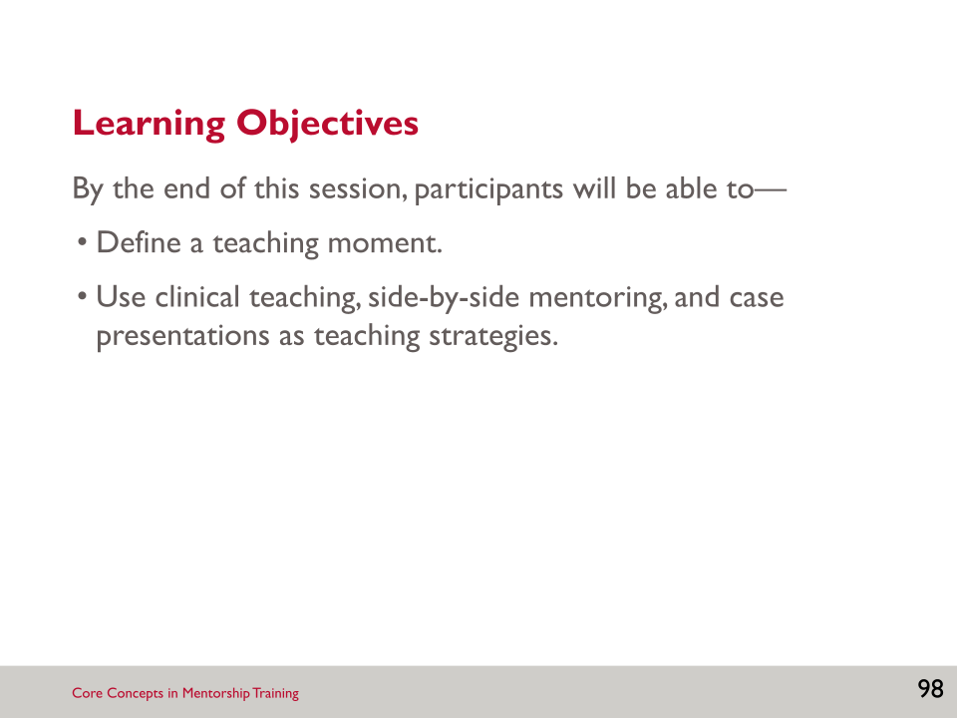

- One of the most important things a mentor engages in is client-centred teaching.
- Breastfeeding counselling mentors are responsible for engaging in a variety of teaching moments with their mentees. These teaching moments will help to improve the mentee’s clinical skills.
- These allow you to reinforce what has been learned, allowing the mentee to model clinical techniques, attitudes, and behaviours.

SLIDE 99: PATIENT-CENTRED TEACHING

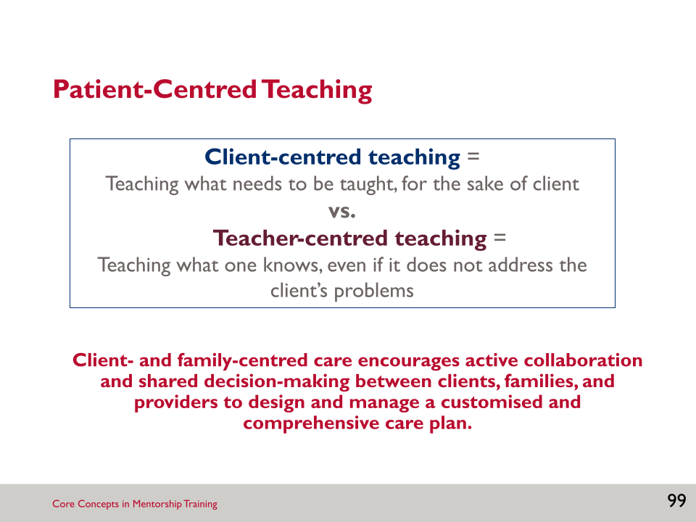

- Everything that you do as a breastfeeding counselling mentor should be focused on achieving the best possible outcomes for the client. This is client-centred teaching, or “teaching what needs to be taught for the sake of the client.”
- This is opposed to teacher-centred teaching which is “teaching what one knows, even if it does not address the client’s problems.”
- Client-centred teaching is an active collaboration and shared decision-making between clients, families, and their health providers to design and manage a customised and comprehensive care plan.
- We will review several approaches to clinical teaching in this session and each one should keep the client at the centre of what you are teaching.

SLIDE 100: TEACHING MOMENT

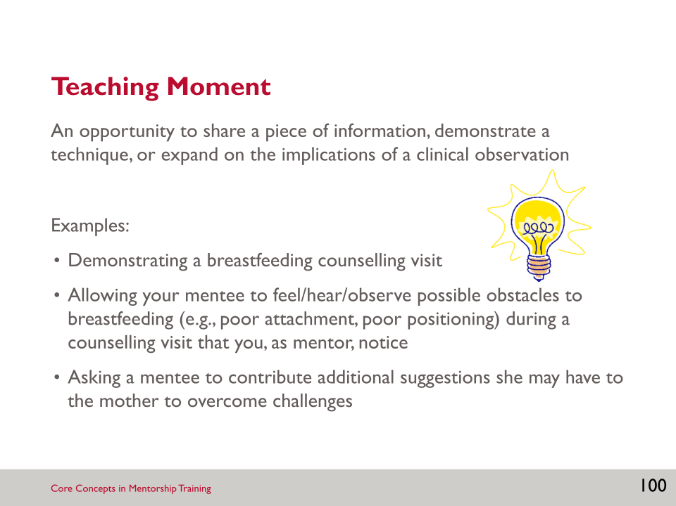

- Teaching moments may involve reminding the mentee about the importance of breastfeeding for the first six months; it might involve reviewing effective communication skills in a counselling session; or it might involve supporting and motivating the mentee to build his/her confidence.
- Teaching moments are also opportunities to provide feedback to the mentee, as we discussed during the last session.

SLIDE 101: CLINICAL TEACHING MOMENTS: TAKING ADVANTAGE

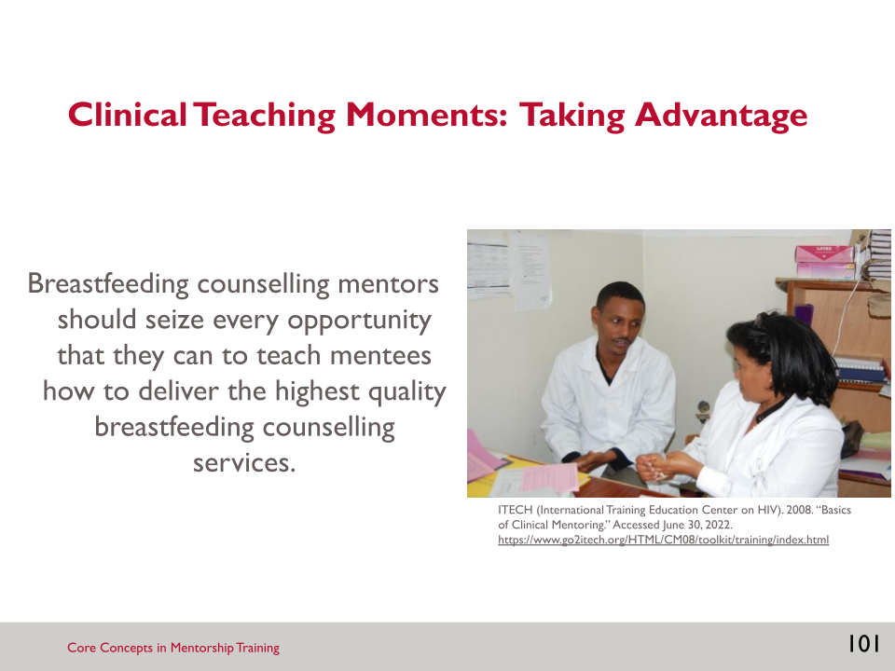

- There will be a variety of opportunities for breastfeeding counselling mentors to teach mentees and it’s important that mentors seize these opportunities to make the most of the mentorship program.

SLIDE 102: WHEN AND WHERE DO TEACHING MOMENTS OCCUR? (1)

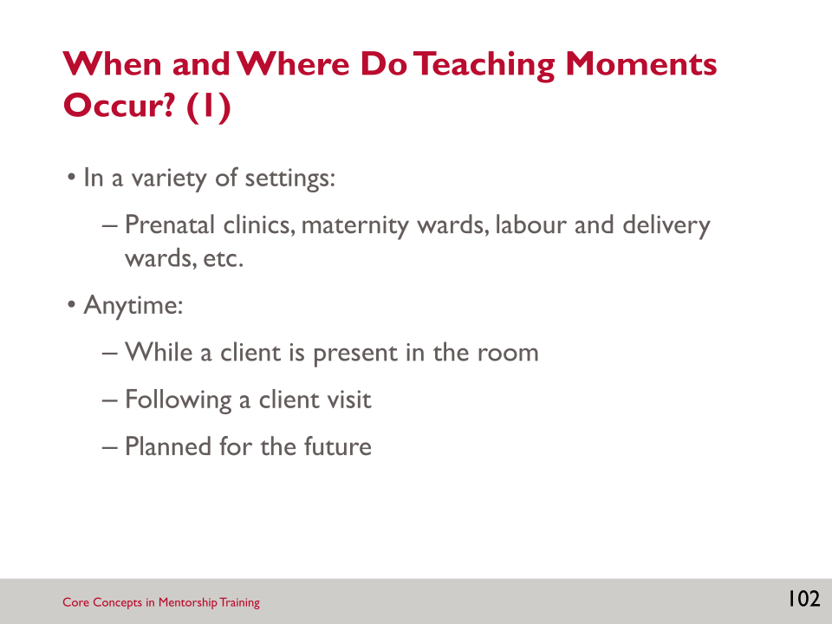
- One way to identify opportunities for teaching moments is to think of where and when they might occur. They can be—
- done while a client is in the room
- done after a client visit (e.g., in the hallway while waiting for the next client, or when you’re both on a tea break)
- planned for in the future (e.g., identify a learning need and schedule a date to give a lecture or lunchtime informational session).

SLIDE 103: WHEN AND WHERE DO TEACHING MOMENTS OCCUR (2)

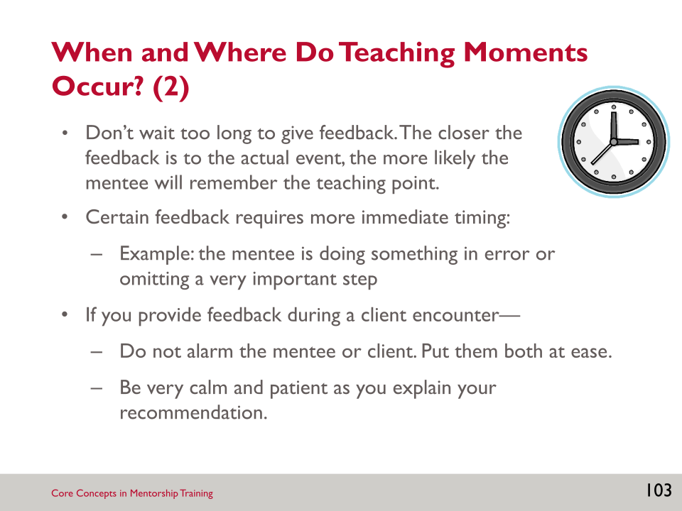

- It is important to distinguish when feedback is needed immediately and when it can wait for a private setting.

SLIDE 104: CONTENT OF A TEACHING MOMENT

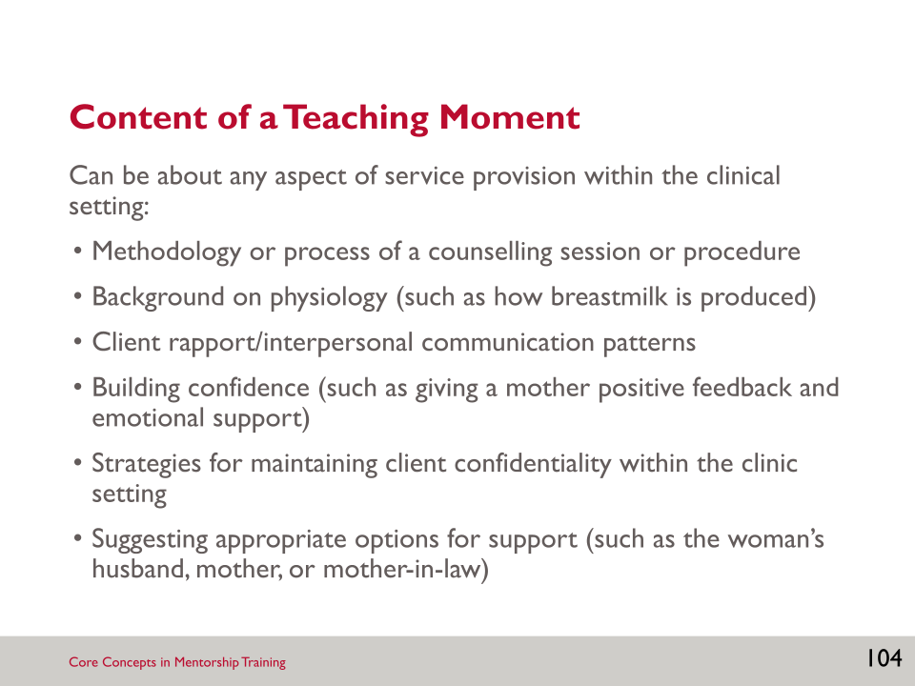

- The content of the teaching moment varies and depends on a number of factors, such as the clinical setting, the clinical condition of the patients, the amount of time you and your mentee have, the goals your mentee has, and more.

SLIDE 105: MENTORING STRATEGIES

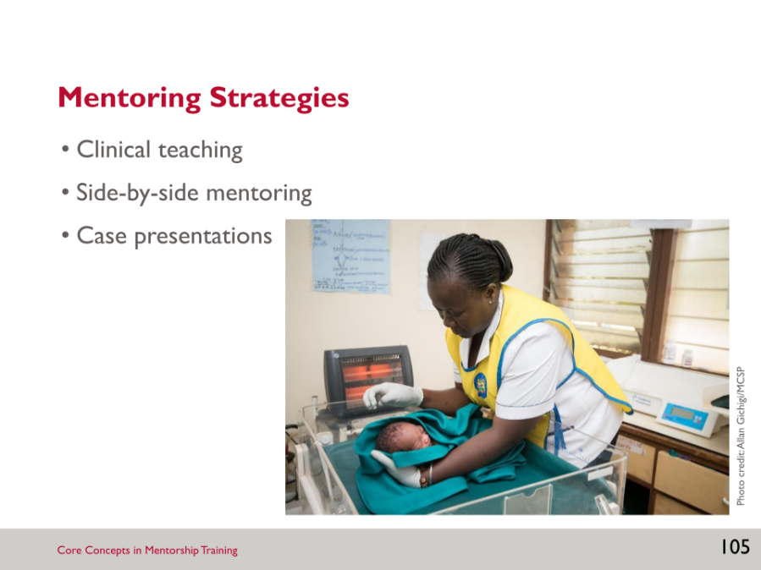

SLIDE 106: CLINICAL TEACHING (1)

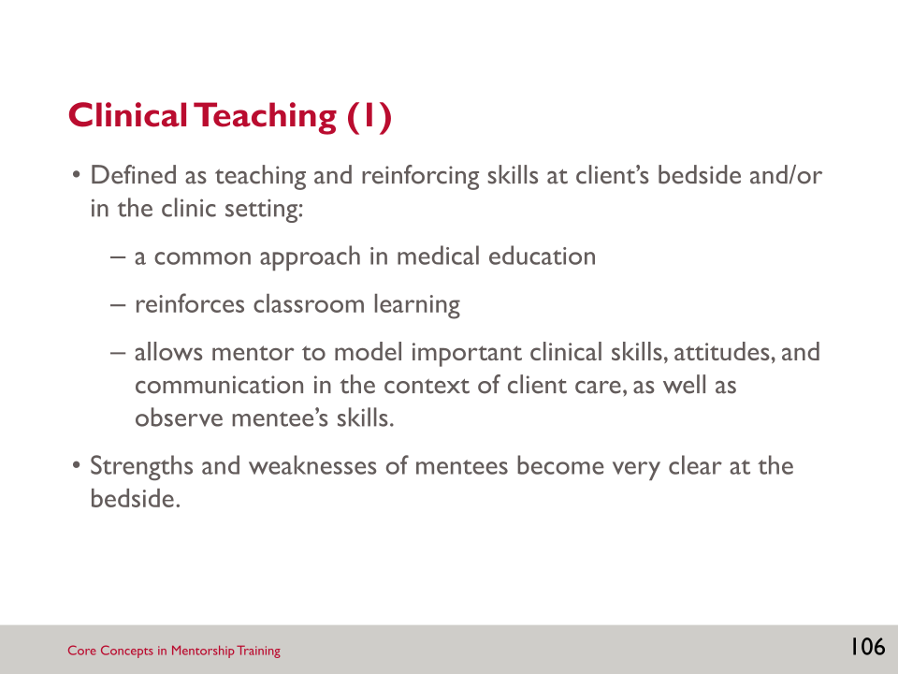

- Strengths and weaknesses of mentees become clear at the bedside because mentors can watch mentees interact with clients. Mentors can experience what mentees do and how they act with clients first hand in a way that cannot happen outside of a client encounter.

SLIDE 107: CLINICAL TEACHING (2)

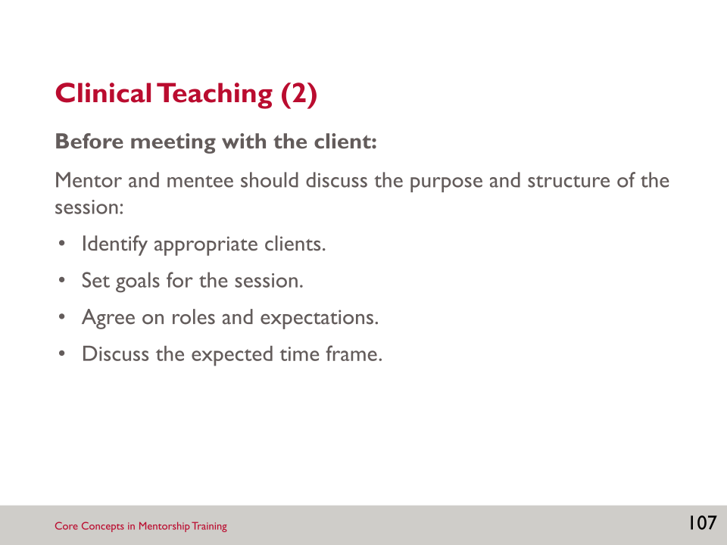

- To make the most out of clinical teaching, it can be helpful to do a few things before meeting with the client.
- Identify appropriate clients: Appropriate clients will be capable of interacting with mentor and mentee, or will have family members present that can interact with them (if possible).
- It is often helpful to arrange sessions with clients ahead of time.
- Set goals for the session: What does the mentee wish to learn or practise?
- Agree on roles and expectations: Who will make introductions? Who will take the lead on each aspect of the visit?
- Discuss the expected time frame: This is especially important if there is a tight schedule, or mentor and mentee are seeing multiple clients.

SLIDE 108: CLINICAL TEACHING (3)

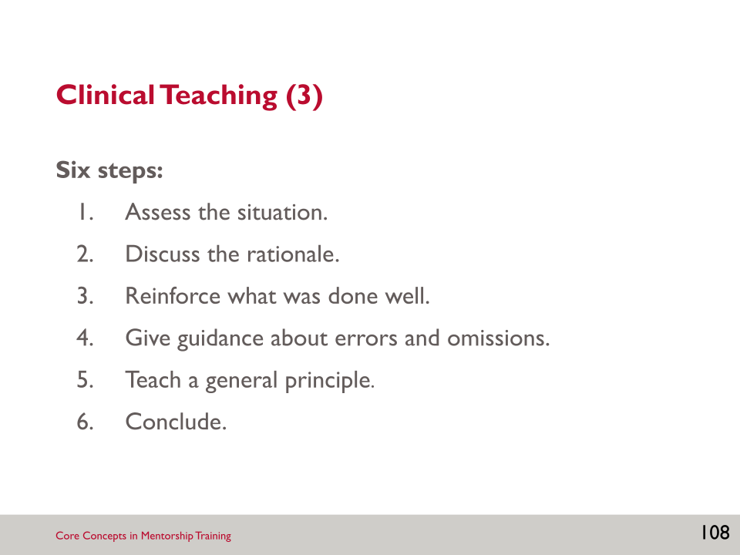

- Open Resource 5.1: Six Steps of Clinical Teaching in your Participant’s Manual. This outlines the six steps that can be used when providing clinical teaching.
- Before going through the six steps, orient the client to everyone in the room and explain the purpose of the session. The mentee should then present the case, without reading from the chart and without interruption from the mentor.
- Following that, employ the six steps of clinical teaching:
- Assess the situation: The mentor asks the mentee to articulate the background information and current situation based upon the client history and primary concerns. Ask the mentee to list the steps to cover during this visit, based on the performance indicators. Asking the mentee to commit to an outline for the visit will ensure the client’s needs are met and will increase the impact of the teaching session by providing a solid point from which to work.
- Discuss the rationale: Ask the mentee to explain why they prioritised the care to be provided during the visit. Listening to their reasoning will help you respond appropriately to their knowledge level.
- Reinforce what was done well: Offer specific feedback rather than a general statement such as, “Good assessment.” Giving specific comments will provide the mentee with tools to use in similar situations in the future.
- Give guidance about errors and omissions: As when offering positive feedback, any corrections should be specific. Care should also be taken to make sure the feedback is constructive and includes specific plans for improvement.
- Teach a general principle: Choose one or two general principles that arose from this encounter to become the “take-home message.” Summarising the encounter in this way will help the mentee apply the lessons learned to other situations.
- Conclude: Time management in clinical teaching is essential. The conclusion defines the end of the teaching interaction and the role of the mentee in the next events.
- You can perform these steps in order, or mix and match according to the situation.

SLIDE 109: CLINICAL TEACHING (4)

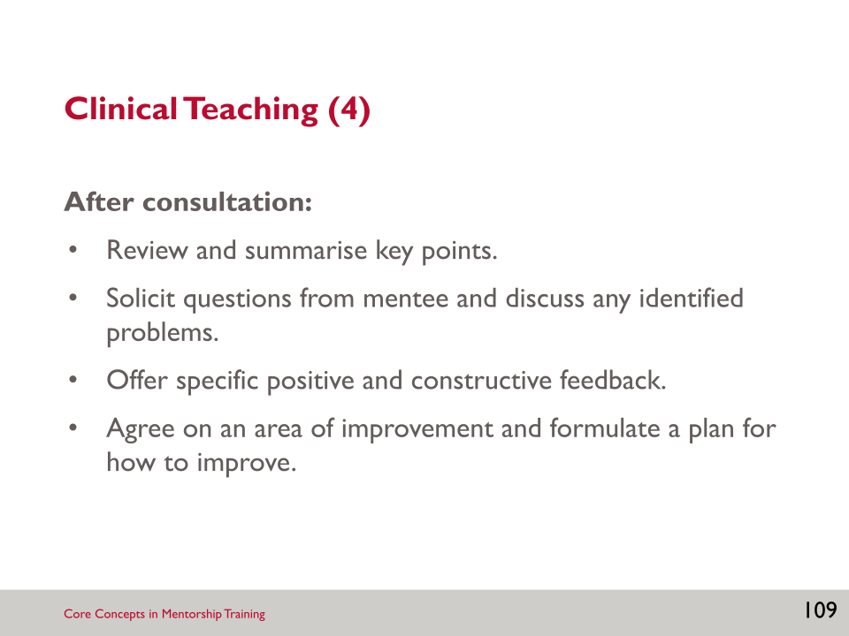

- After the client encounter, there should be a debrief session and time for questions and future planning, if possible.

SLIDE 110: DEMONSTRATION: CLINICAL TEACHING APPROACH

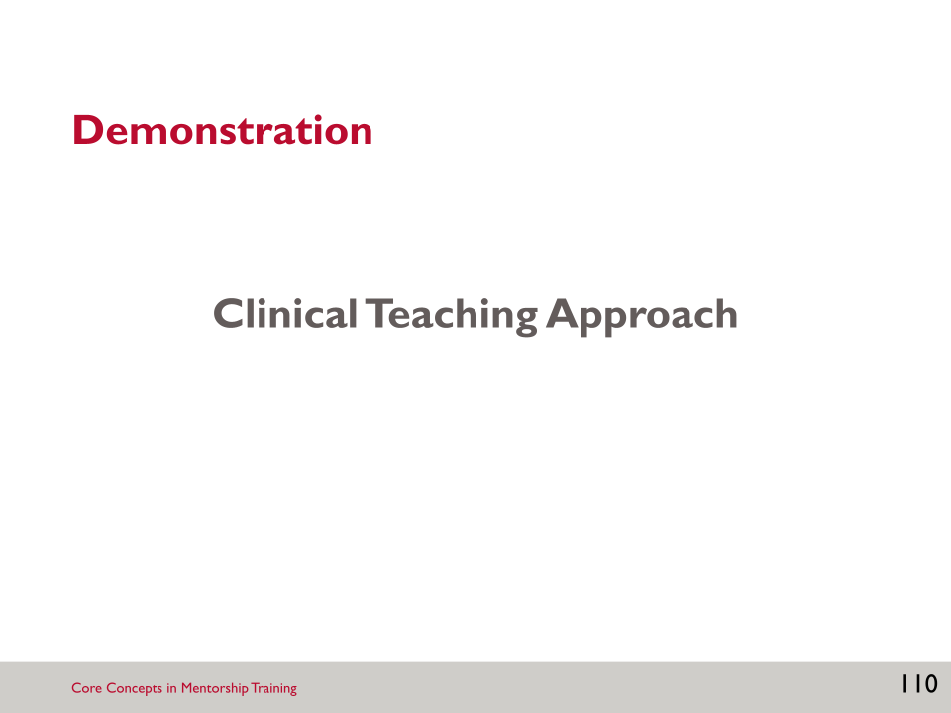

Activity: Clinical Teaching Approach
- The facilitator will ask for two volunteers: one breastfeeding counselling mentor and one mentee.
- Debrief of the demonstration:
- What did you think about this approach?
- Is this an approach you could adopt in your mentoring?
- Other reactions?

SLIDE 111: SIDE-BY-SIDE MENTORING

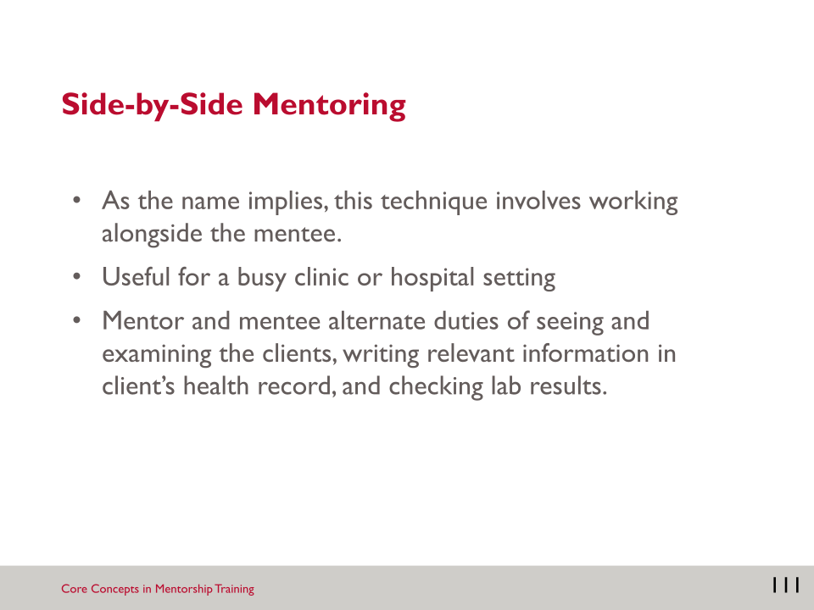

SLIDE 112: SIDE-BY-SIDE MENTORING: BENEFITS

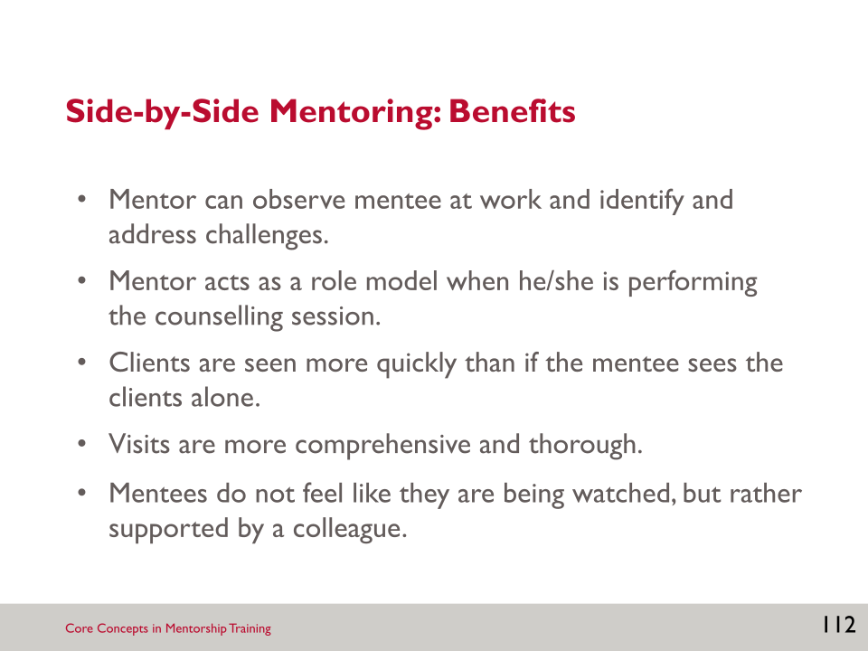

- There are several benefits to side-by-side mentoring.
- This technique allows the mentor to observe the mentee at work in a real work setting. This can help the mentor identify and address challenges they observe.
- Conversely, the mentee also gets to observe the mentor. This allows the mentor to role model behaviour and patient care. In this way, side-by-side mentoring promotes a two-way learning environment.
- This technique decreases wait times. It can enable clients to get more attention from the health care worker, and thereby receive more comprehensive care, and enable the health care worker to feel a level of empathy that can be hard to convey in a busy clinic setting where they are overwhelmed by clients and are working alone.
- Unlike clinical teaching, side-by-side mentoring does not make the mentee feel like they are being watched by the mentor, but rather supported by the mentor who is working next to them.

SLIDE 113: CASE PRESENTATIONS: DEFINED

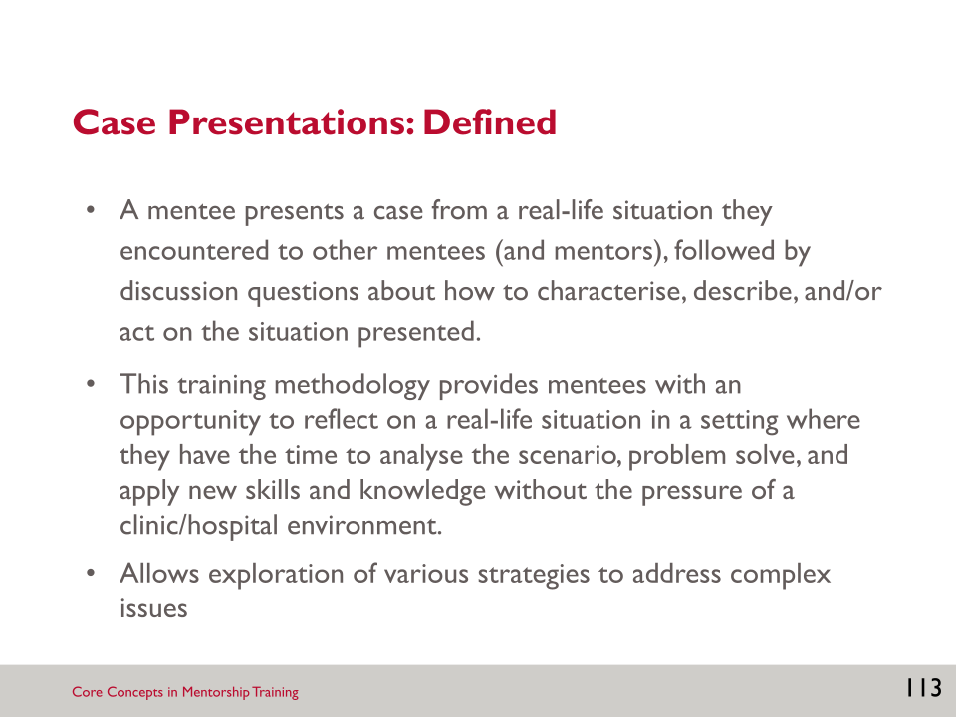

SLIDE 114: CASE PRESENTATIONS: HOW TO DO THEM (1)

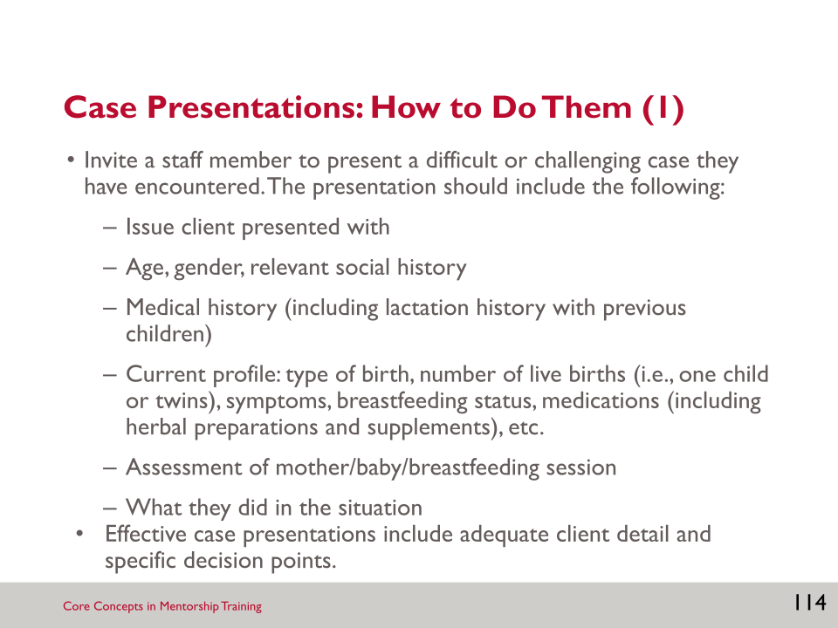

- Case presentations can be used at staff meetings, multidisciplinary team meetings, or in training sessions.
- The case presented should be a case from the facility, which makes it a realistic and relevant case to the staff.
- Ensure that confidentiality is maintained.
- Case presentations provide an opportunity for mentees to practise giving succinct summaries of clients, a skill required in the clinical teaching approach.
- Case presentations also allow mentees to learn from how their colleagues treated clients.

SLIDE 115: CASE PRESENTATIONS: HOW TO DO THEM (2)

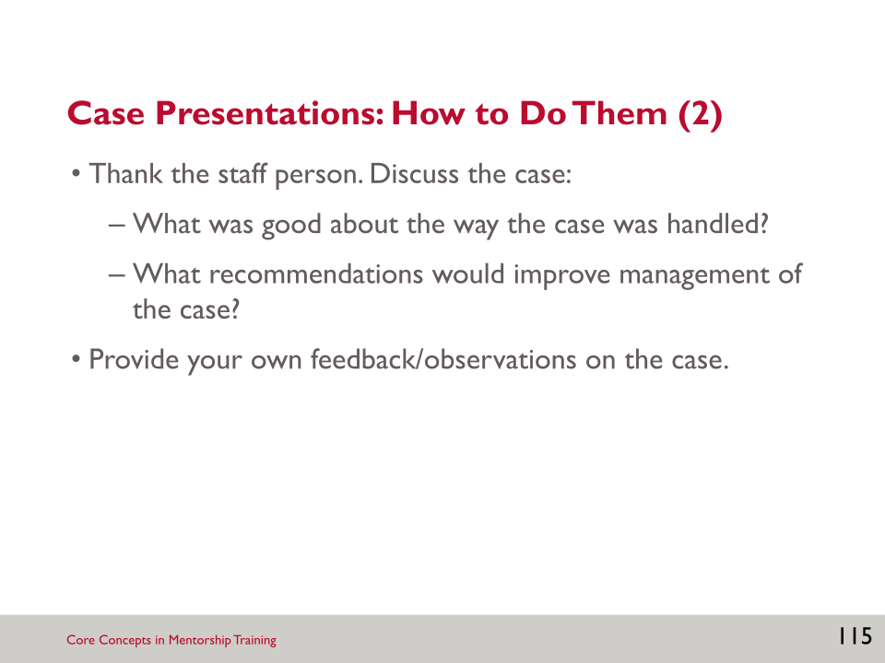

- Once the mentee completes the case presentation, the breastfeeding counselling mentor should lead a discussion about the case and provide feedback/observations about the case.

SLIDE 116: CASE STUDIES: RATIONALE

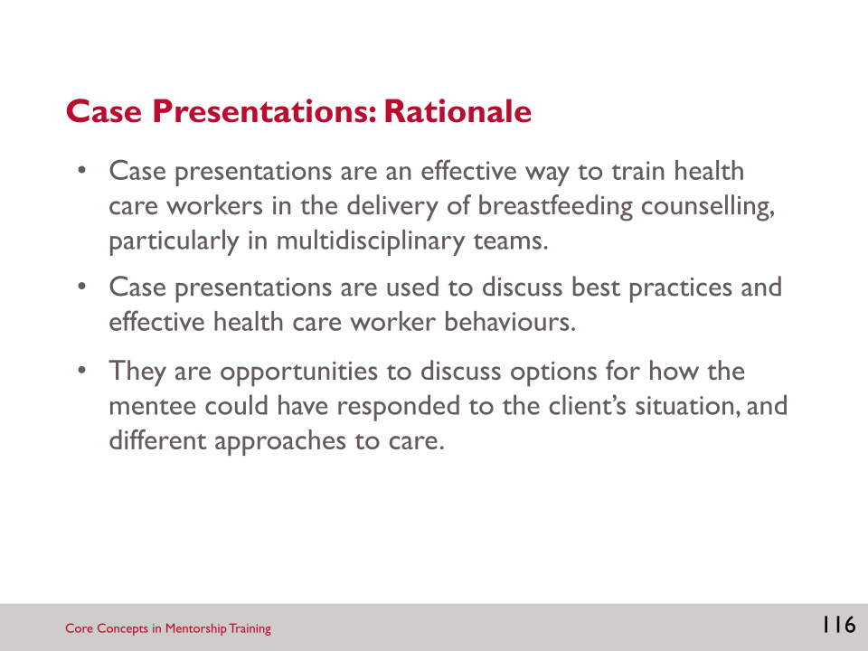

- Case presentations are a good strategy to supplement clinical teaching and side-by-side mentoring. They are an effective way to engage multiple mentees in a learning process.

SLIDE 117: WHAT WILL MENTORING LOOK LIKE FOR YOU? DEMONSTRATION

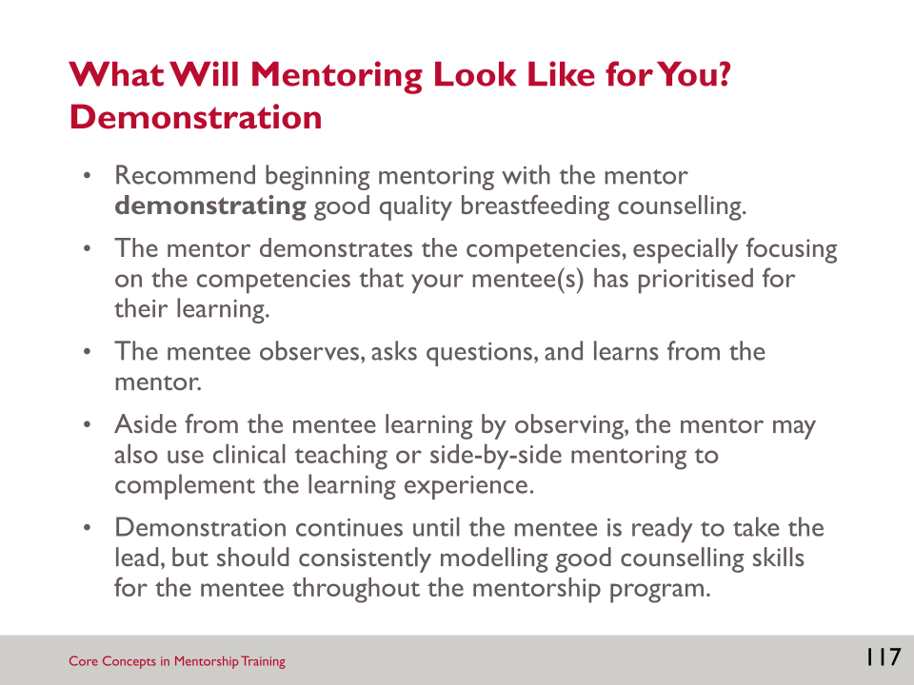

SLIDE 118: WHAT WILL MENTORING LOOK LIKE FOR YOU? OBSERVING

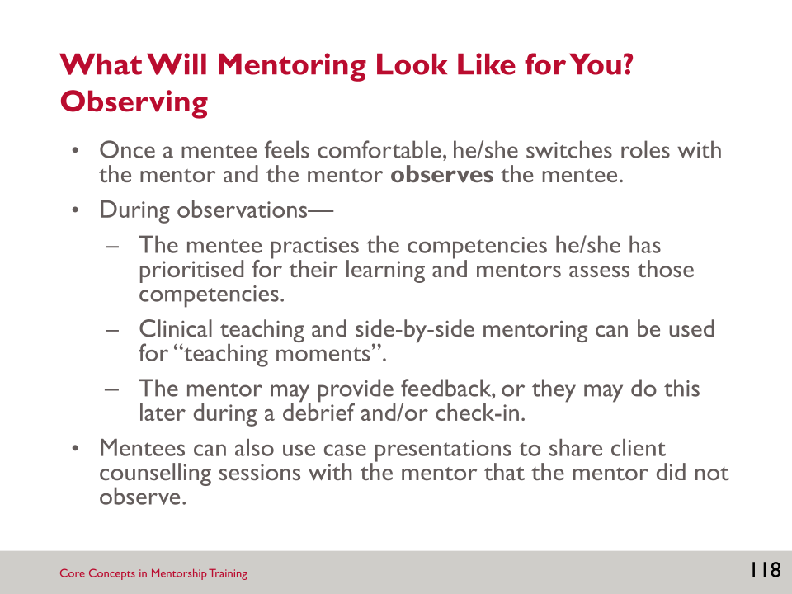

SLIDE 119: WHAT WILL MENTORING LOOK LIKE FOR YOU? DEBRIEF

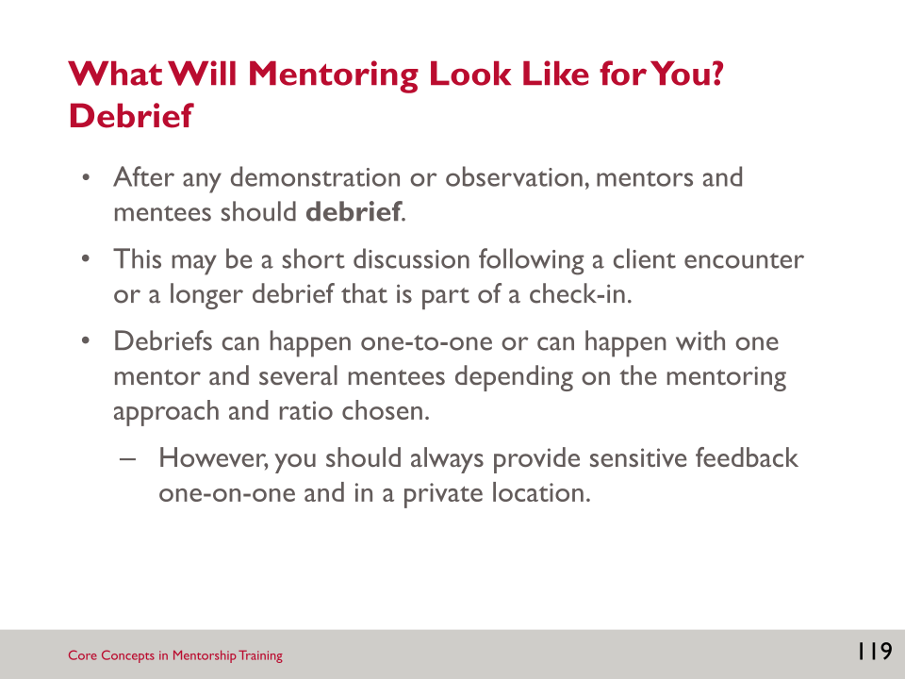

SLIDE 120: WHAT WILL MENTORING LOOK LIKE FOR YOU? CHECK-IN

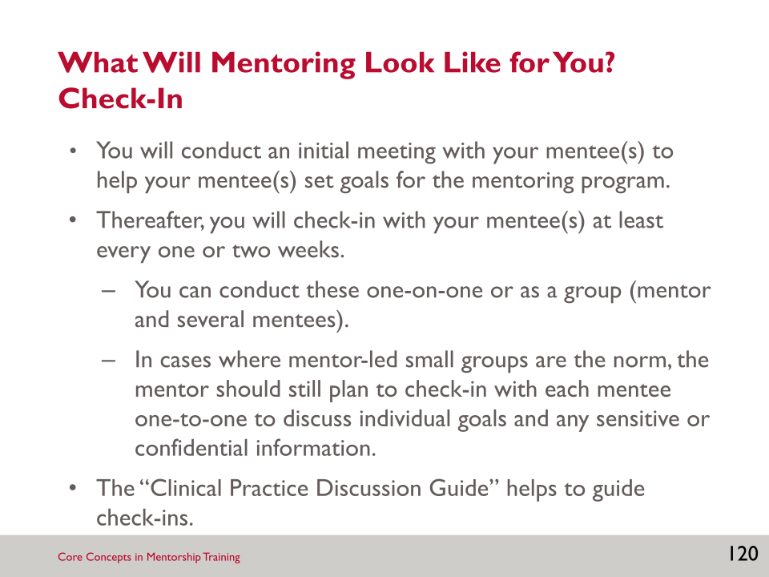

SLIDE 121: LEADING BY EXAMPLE

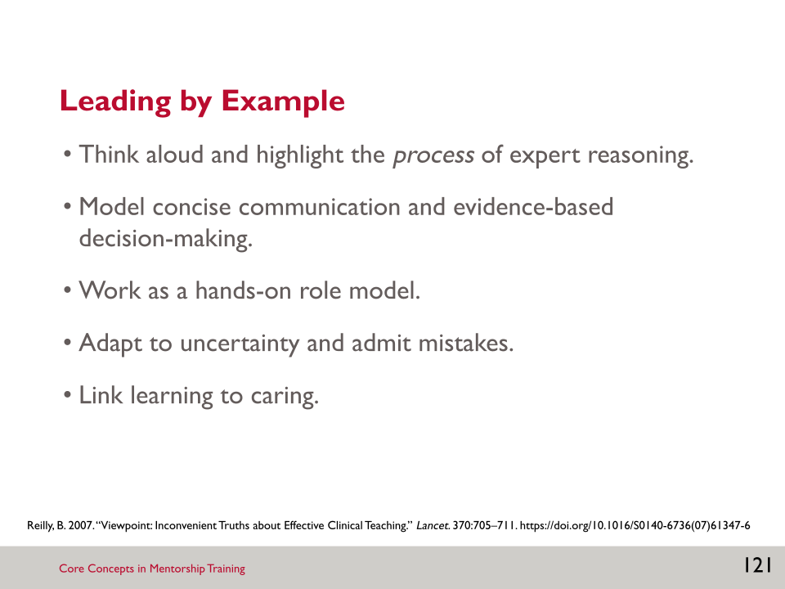

- Mentors should not only be teachers, but should “talk the talk and walk the walk”—that is, they should lead by example when interacting with and teaching mentees. These are specific techniques for teaching mentees effectively.
- Think aloud: A mentor should make his/her own clinical reasoning transparent. This might involve—
- Explaining the thought process that leads to a diagnosis.
- Verbalising the treatment options for a challenging case.
- Explaining why a particular course of action is chosen.
- Keep it simple: Model concise communication and evidence-based decision-making.
- Work as a hands-on role model: Show the clinical utility of physical examination, the therapeutic value of touching, and the diverse benefits of clinical care.
- Adapt to uncertainty and admit mistakes: Uncertainty is always going to be a part of clinical practice. A mentor must be able to change his/her mind, admit mistakes, etc.
- Link learning to caring: It is important to practise client-centred teaching (Reilly 2007).

SLIDE 122: KEY POINTS

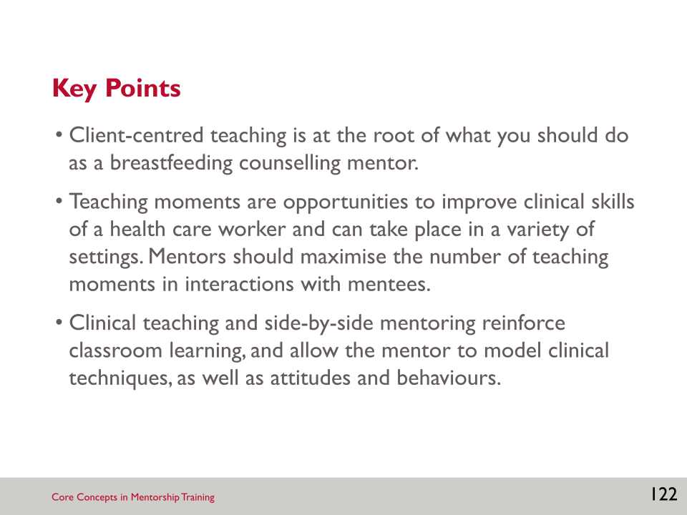

SESSION 5: RESOURCES

Resource 5.1: Six Steps of Clinical Teaching

Step One: Assess the Situation
This engages the mentee to manage the dynamic breastfeeding counselling session and account for shifts in priorities during the session based on client feedback. It also shows respect for the client and mentee and fosters an adult learning style. A main goal of getting the mentee to prioritise care will reveal their reasoning, not just to get more information about the case.
Questions to Ask
- “Based on the client’s concerns, what clinical support should you provide first?”
- “Based on the mother’s history, what anticipatory guidance would you recommend next and why?”
- “Based on the condition of the baby, what anticipatory guidance would you recommend next and why?”
- “What information does the client need during the next visit to prepare for discharge?”

Step Two: Discuss the Rationale
It is important to address the client’s concerns first and encourage an appropriate reasoning process for anticipatory guidance. Instead of giving a right or wrong response to the mentee’s assessment, ask more questions:
- “What factors in your assessment support your current plan?”
- “Why would you choose that specific approach for XXX (e.g., latch and position suggestion)?”
- “Why do you feel this client needs this specific anticipatory guidance?”

Step Three: Reinforce What Was Done Well
The simple statement, “That was a good presentation,” is not sufficient. Comments should include specific behaviours that demonstrate knowledge, skills, or attitudes valued by the mentor:
- “Your prioritisation of position and latch to help with nipple pain first will help the client remain engaged in breastfeeding. You provided the information the client requested first, even though prior to the visit, you wanted to focus on hand expression.”
- “Your counselling skills demonstrated to the mother that you heard her. Did you notice how she responded to your further enquiries and smiled, although she was tired? You engaged with her on a personal level and she appreciated it.”

Step Four: Give Guidance about Errors and Omissions
The main idea is to identify an opportunity for behaviour change and provide an alternative strategy. Instead of using extreme terms such as “bad” or “poor,” expressions such as “not best” or “it is preferred” may carry less of a negative value judgement while getting the point across. Comments should also be as specific as possible to the situation, identifying specific behaviours that the mentee could improve upon in the future:
- “In your initial assessment, you mentioned the mother was experiencing nipple pain. It would be helpful in the future to describe the pain. Does it happen at the beginning of the feeding, at the end, or throughout? Asking the client to describe the pain will provide you with valuable information. Empathising with her will demonstrate your concern for her situation and engage her in working towards a solution.”
- “I agree with you that we need to inform the client about the signs of dehydration prior to discharge. At this moment, she seemed overwhelmed and exhausted. Helping her to get a bit of rest will allow her to listen to that information in an hour or two. Let’s inform the nurse that the father is holding the baby so the mother can get some rest. We can return later.”

Step Five: Teach a General Principle
One of the more challenging—but essential—tasks of this model is for the mentee to take information and accurately generalise it to other situations. The teaching principle does not need to be standard black and white protocol, but can be about strategies or procedures. While there is generally not time to have a major teaching session, one or two statements can make a big impact:
- “You know a lot about position and latch. Deciding what positioning technique to focus on can be challenging when there are so many choices. Let’s discuss the criteria which may help you discern which technique may work best.”
- “The client had several questions about medications and the impact on her milk supply. There are several helpful international resources which specifically review the evidence regarding medications and the impact on the mother’s supply or on the infant.”

Step Six: Conclude
Time management in clinical teaching is essential. The conclusion defines the end of the teaching interaction and the role of the mentee in the next events.

Resource 5.2: Demonstration of Clinical Teaching Approach
Let us look at a sample presentation to help illustrate the steps of the clinical teaching model and their application in a practical setting.

Mentoring Scenario
You have recently started to work with a nurse mentee in the postnatal unit. The mentee has just finished seeing a client and is presenting to you in an empty exam room while the client waits in a different exam room.
Step One: Assess the Situation
Dialogue between Breastfeeding Counselling Mentor and Mentee
Breastfeeding counselling mentor: “Why is the mother concerned about her milk supply? Does she have a medical history which would negatively impact production?”
Mentee response: “The mother does not have a history which would impact milk production. Upon questioning, she stated the baby was awake frequently at night. She said when she attempted to wake the baby this morning, she was not successful. She attributes the sleepiness as the baby ‘knowing’ there is no milk. She is experiencing nipple pain upon initial latch.”
Step Two: Discuss the Rationale
Breastfeeding counselling mentor: “What information or education does she need to address her concerns?”
Mentee response: “Use foundational skills to demonstrate that I heard her concerns. Discuss skin-to-skin therapy to encourage feedings. Educate about normal newborn circadian rhythms, review medical history, and discuss the basics of milk supply.”
Breastfeeding counselling mentor: “What techniques can be taught during the visit and why?”
Mentee response: “Safe skin-to-skin technique, hand expression to demonstrate colostrum is present, and position and latch to reduce nipple pain.”
Step Three: Reinforce What Was Done Well
Breastfeeding counselling mentor feedback: “Good prioritisation of the information provided. Utilising foundational skills will help the mother to feel heard. Placing the baby skin-to-skin to awaken pre-feeding behaviours while you educate is a good idea.”
Step Four: Give Guidance about Errors and Omissions
Breastfeeding counselling mentor feedback: “You mention providing information on hand expression. What will you say to the mother if she is unable to express any colostrum?”
Mentee response: “I should preface the information on hand expression with the statement, ‘you may need to practise this technique before you are able to see any colostrum.’”
Breastfeeding counselling mentor feedback: “Yes, keep expectations reasonable and focus on practising the technique. You may want to teach cup feeding if she does extract colostrum. That will be helpful information if the baby requires supplementation after discharge.”
Step Five: Teach a General Principle
Breastfeeding counselling mentor: “All mothers should be taught hand expression, not only those with babies who are unable to breastfeed. The mother will need to practise before much milk is expressed. It will be important to encourage the mother not to give up if she gets little milk or no milk on the first attempt. The amount of milk obtained increases with practice and will increase quickly after day two or three. Expressing should not hurt. If it does hurt, check the techniques listed above with the mother and observe her expressing.”
Step Six: Conclude
Breastfeeding counselling mentor input: “Let’s visit the mother together. You can assess whether the client is implementing the techniques taught. The baby may be ready to feed and we can provide direct feedback about her position and latch technique. If the baby isn’t demonstrating feeding cues, we can review her hand expression technique and educate about how to know if baby is getting enough.”

Notes:

____________________________________________________________________________________________________________________________________________________________________________________________________________________________________________________________________________________________________________________________________________________________________________________________________________________________________________________________________________________________________________________________________________________________________________________________________________________________________________________________________________________________________________________________________________________________________________________________________________________________________________________________________________________________________________________________________________________________________________________________________________________________________________________________________________________________________________________________________________________________________________________________________________________________________________________________________________________________________________________________________________________________________________________________________________________________________________________________________________________________________________________________________________________________________________________________________________________________________________________________________________________________________________________________________________________________________________________________________________________________________________________________________________________________________________________________________________________________________________________________________________________________________________________________________________________________________________________________________________________________________________________________________________________________________________________________________________________________________________________________________________________________________________________________________________________________________

SESSION 6: MENTORSHIP CASE STUDIES

Learning Objectives
By the end of this session, participants will be able to—
- Apply the clinical mentoring skills and techniques learned in this course to real-life clinical mentoring case studies.

Slides and Notes

SLIDE 123: SESSION 6: MENTORSHIP CASE STUDIES

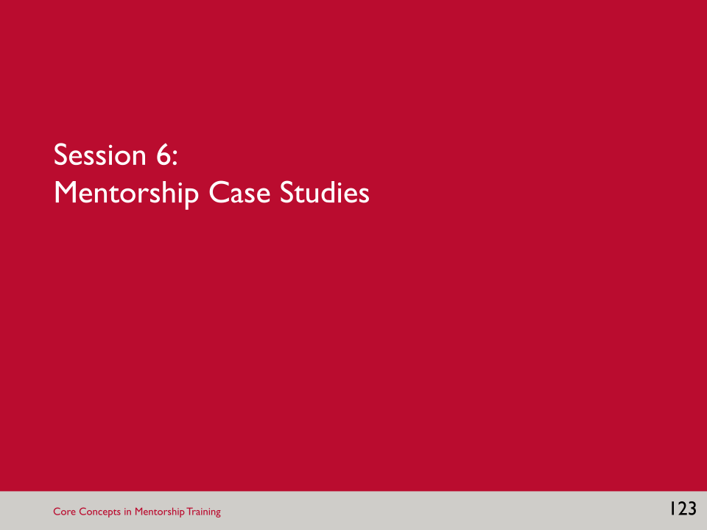

SLIDE 124: LEARNING OBJECTIVES

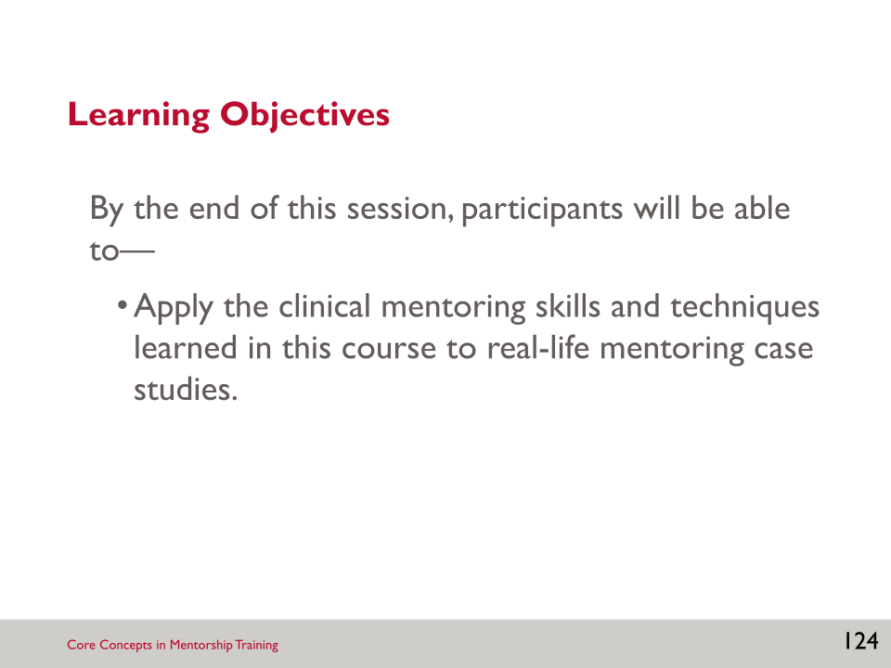

- These case studies were developed based on real-life scenarios and are situations and circumstances that you might encounter in the course of the mentorship program.

Activity: Mentorship Case Studies
- The facilitators will review the first two case studies with the group and you will discuss them together. The facilitator will record the group’s answers on flipchart paper, but you should record your answers and any others you like on your worksheet.
- Participants will split into small groups of about 3–4 participants for the third case study. Work cooperatively to complete your assigned case study worksheets. For each case, think about how these scenarios may play out in their settings and what other considerations they may have. Really think about the mentoring moments within these cases and how you can apply the lessons learned to their setting.
- After the third case study is completed, participants will return to the large group to review answers, ask questions, and discuss the case.

SESSION 6: RESOURCES

Worksheet 6.1: Case Studies (Participant’s Version)

Case Study 1: Antenatal Care Conversation on Breastfeeding
Format: Large Group Discussion with Facilitators Leading the Discussion
Case Description
The nurse (mentee), Sinzani, is working in the antenatal care (ANC) clinic today. She has recently been paired with a mentor, Layla, as part of the breastfeeding counselling mentorship program. They have already had a couple of meetings to get to know each other and discuss Sinzani’s goals.
Because today is the first time that Sinzani and Layla are together in the ANC clinic, the plan is for Sinzani to observe Layla providing counselling during the first visit of the day.
The first client of the day is Zandile, a 28-year-old woman who came for an ANC visit. Prior to the start of the visit with Zandile, Layla and Sinzani discussed Layla’s plan for the visit (pre-meeting).
Question
- Why is it important that Layla and Sinzani had a pre-meeting before entering the room with Zandile?

Answer

Case Description, Continued
Layla and Sinzani meet with Zandile. Layla reviews the information in section 1 of the client’s Mother and Child Health Handbook and notes that Zandile is a primigravida at 36 weeks gestation. The previous provider gave no counselling on infant feeding or benefits of exclusive breastfeeding during prior visits.
Question
- How should Layla introduce Sinzani to the client?

Answer

- What tool from the BFHI Training Course for Maternity Staff could Layla and Sinzani review before the start of the visit that could help Sinzani as she observes Layla?

Answer

- How can Layla model good communication skills as she asks about Zandile’s plans for infant feeding?
Answer

Case Description, Continued
Zandile responds that she hasn’t thought about her plans for feeding her baby yet and would like to talk about what would be best. However, most of her friends have told her that it really doesn’t matter how she feeds her baby.
Question
- How can Layla demonstrate respect and good listening skills with Zandile? Consider both verbal and non-verbal responses.

Answer

- Based on Zandile’s response and her gestational age, what should Layla cover in this visit with Zandile?
Answer

Case Description, Continued
Once the visit is complete, including answering any questions that Zandile has, Layla closes the visit by reminding Zandile when she should return for her next visit.
Question
- After Zandile has left, how should Layla begin the debrief with Sinzani?

Answer

Case Description, Continued
Layla asks if Sinzani has any other questions. Sinzani shares that after watching Layla counsel Zandile, she is feeling self-conscious about her own counselling skills and thinks she probably hasn’t been providing the best care to her patients. She tells Layla that she wants to improve and that is why she has joined this program, but after watching Layla she thinks she has even more to improve on than she realised.
Question
- How can Layla, as Sinzani’s mentor, respond to these concerns? What strategies can she use?

Answer

Case Description, Continued
Sinzani is working in the antenatal clinic again the following week and Zandile is in for another visit. Layla, the mentor, is also there to work with Sinzani, but this time, Sinzani will take the lead. They held a meeting before Zandile’s visit to discuss how Sinzani will approach this visit.
Question
- What should Layla be listening for as Sinzani describes how to start the visit with Zandile?
Answer

Case Description, Continued
The mentor observed the visit and utilised the Observation Tool: Antenatal Care to make note of what behaviours Sinzani reinforced. After the visit, Sinzani and Layla debriefed to reflect on the counselling session.
Question
- What is the most important thing that Layla should highlight as part of her debrief with Sinzani?

Answer

Case Study 2: Sore Nipples Identified During a Postpartum Visit
Format: Large Group Discussion with Facilitators Leading the Discussion
Case Description
Today, Michelle, a nurse mentee, is seeing patients in the outpatient postpartum unit along with her mentor, Betty. The two have been having regular mentorship visits for about two months and the relationship is going well so far; Michelle has demonstrated strong counselling skills overall.
The first patient, Adaku, is three days postpartum. She has been breastfeeding every two or three hours on demand. Her nipples have been getting progressively more tender with each breastfeeding session. Today she notices scabs on both nipples. She heard that breastfeeding hurts in the first few days and she expected to have to “toughen” her nipples, but she feels that this pain is too much.
The infant’s weight is a few ounces below his birth weight. He is alert. Adaku tells Michelle that her baby has had several wet diapers and about four green stools in the past 24 hours and she noticed a bit of yellow in the last stool. There are no signs of the infection in either the mother or baby. Michelle asks Adaku if she can observe her breastfeeding her baby. Adaku agrees and says that it’s been about two hours since she last fed her baby and he is starting to wake up. When Adaku takes out her breast to feed her baby, Michelle asks if it’s okay to do an examination of her breast. She agrees and upon examination, you notice scabs in the centre of each nipple. Adaku tells Michelle that the pain began the first day postpartum and has become worse, not better. Adaku holds the baby across her lap to breastfeed.
Question
- What tool from the BFHI Training Course for Maternity Staff could Michelle use to observe Adaku breastfeeding?
Answer

- What should Michelle and Betty say to Adaku, if anything, about the mentorship program as they begin the counselling session?

Answer

Case Description, Continued
The baby is lying partially on his back with his chin over his shoulder and face turned up toward his mother. It appears as if the baby only has the nipple and a small portion of areolar tissue in his mouth. Adaku winces as the baby begins to suckle.
Question
- What should Betty listen for from Michelle as she assesses Adaku’s problem?
Answer

- What skills do you think are most important for Michelle to use at the beginning of her counselling session with Adaku? Provide a few examples.
Answer

Case Description, Continued
Adaku tells you that she feels a sharp pain every time her baby latches. She usually doesn’t take time to position her baby very carefully because she just “wants to get it over with.” She tells you that she hasn’t been enjoying breastfeeding because of the pain and that this is disappointing because she was looking forward to it when she was pregnant. She says that she is considering giving her baby formula if her pain doesn’t improve.
Betty, the mentor, notices that Michelle is not very empathetic to Adaku’s situation. Michelle has said things like, “Breastfeeding isn’t always easy. You just have to be tough in the beginning and it will eventually get better.” Michelle also told Adaku that if she introduces formula her baby will never want to breastfeed again.
Question
- What should Betty, as the mentor, do in this situation?

Answer

- What should Betty suggest to guide Michelle toward practical tips and skills for building Adaku’s confidence?

Answer

Case Description, Continued
After observing Adaku breastfeeding, Betty and Michelle both notice that Adaku is not holding the baby very close to her body. They also noticed that Adaku leaned down to insert her nipple into the baby’s mouth. They help Adaku and her baby make adjustments to the position and attachment. They ask Adaku how the new position feels and she replies that this feels much more comfortable.

Question
- Betty needs to make sure that Adaku has the right guidance before she leaves the clinic. What should Betty look for as Michelle wraps up the session?
Answer

Case Description, Continued
After Adaku leaves the room, Betty and Michelle conduct a debrief of the counselling session.
Question
- What should Betty discuss with Michelle right after Adaku has left the room? What should Betty plan to discuss later, during their weekly mentorship session?

Answer

- Overall, what are some strategies that Betty can use to maintain the strong mentoring relationship she has started with Michelle? What should she avoid?

Answer

Case Study 3: Basics of Breastfeeding
Format: Small Group Work
Case Description
Carol, a mentee in the breastfeeding counselling mentorship program, is being observed today by her mentor, Josephine. Carol and Josephine have been in a mentoring relationship for about four months. While the relationship has been positive for both overall, in the last few weeks, Carol has started to feel like Josephine is spending too much time focusing on her mistakes. Josephine has noticed that Carol has seemed frustrated and unhappy, but isn’t sure about the source of her frustration.
Carol is conducting her regular morning rounds on the postnatal ward, where she encounters Adanna. As a result of attending four antenatal care (ANC) visits and having discussions with nurses on the benefits of breastfeeding, Adanna, a 26-year-old first time mother, has chosen to breastfeed her baby. She experienced a normal spontaneous vaginal delivery about 24 hours ago, producing a healthy term infant male weighing 3.5 kilograms. She breastfed him within one hour after delivery. She will be going home within the next 24 hours.
Adanna has since attempted to breastfeed three times. Her baby fell asleep each time she tried to breastfeed. She says she doesn’t have any milk and she is afraid her baby isn’t getting enough to eat. She is asking for formula to give her baby.
Question
- Carol is aware the mother requested formula. While she understands the importance of honouring the mother’s request, she wants to provide the mother with information and support first. She is unsure what should be her first priority. What should Josephine suggest?

Answer

- What questions should Josephine listen for as Carol asks the mother about breastfeeding? What skills should Carol use when listening to the mother?
Answer

- What should Carol include in her clinical examination?

Answer

- During the clinical examination the baby starts to stir. What are some things Carol might want to discuss with the mother as the baby starts to wake up?

Answer

Case Description, Continued
The baby is awake and the mother immediately brings him to her breast. The mother, however, doesn’t appear very comfortable. Carol is unsure how to approach this mother’s discomfort and starts to wrap up the session with Adanna.

Question
- How should Josephine handle this?

Answer

Case Description, Continued
While the mother is feeding, Carol decides that this is a good time to also discuss other topics with her that she learned during the BFHI Training Course for Maternity Staff, such as the signs of adequate milk intake (contented baby, weight gain, stooling and urination); the basics of building and maintaining a milk supply (frequent breastfeeding, milk removal stimulates milk production, leave baby on the first side until he signals he is full then offer the second side); and the risks of using formula. Josephine notes that the mother appears to be very tired and seems overwhelmed by all of this information while also trying to position her baby well.
Question
- What should Josephine do now, while the client is still present?

Answer

- What topics would be appropriate for Carol to educate the mother on at this point?

Answer

- Before discharge, what should Carol make sure to discuss with Adanna?

Answer

- What should Carol and Josephine do after the visit with Adanna has ended? What should they discuss immediately following the counselling session? What should they discuss in their weekly mentorship check-in?

Answer

- How can Josephine address the tension that is arising with Carol in a positive way, with the goal to get the relationship back on track?

Answer

Summary
When a mother feels seen and heard, they will view the counsellor as caring and credible. Building an empathetic and respectful relationship is the foundation of good counselling skills. An understanding of the anatomy and physiology involved in the natural process of breastfeeding is essential to provide care that supports optimal breastfeeding practices. The basic breastfeeding routines are based on evidence-based physiologic principles, and adhering to them prevents problems from developing. Helping a mother and infant off to a good start is one of the best investments in time and effort.
The time spent building a trusting relationship between the mentor and mentee is critical to long-term success. Even with a good foundation, sometimes tensions can arise. Mentors should approach these with openness and empathy, with the goal to help the mentee grow and learn. At some point, the mentoring relationship may be ready to conclude, either because the mentee is ready to continue learning on her own (without a mentor) or because the mentee decides to stop. If the mentee is no longer benefiting from the relationship, it is not worth continuing to invest time in the relationship. The mentor can gently help the mentee to see the value, but ultimately, both parties need to be willing participants for mentorship to work.

Notes:

____________________________________________________________________________________________________________________________________________________________________________________________________________________________________________________________________________________________________________________________________________________________________________________________________________________________________________________________________________________________________________________________________________________________________________________________________________________________________________________________________________________________________________________________________________________________________________________________________________________________________________________________________________________________________________________________________________________________________________________________________________________________________________________________________________________________________________________________________________________________________________________________________________________________________________________________________________________________________________________________________________________________________________________________________________________________________________________________________________________________________________________________________________________________________________________________________________________________________________________________________________________________________________________________________________________________________________________________________________________________________________________________________________________________________________________________________________________________________________________________________________________________________________________________________________________________________________________________________________________________________________________________________________________________________________________________________________________________________________________________________________________________________________________________________________________________________

NEXT STEPS AND CLOSING REMARKS

Slides and Notes

SLIDE 125: NEXT STEPS AND CLOSING REMARKS

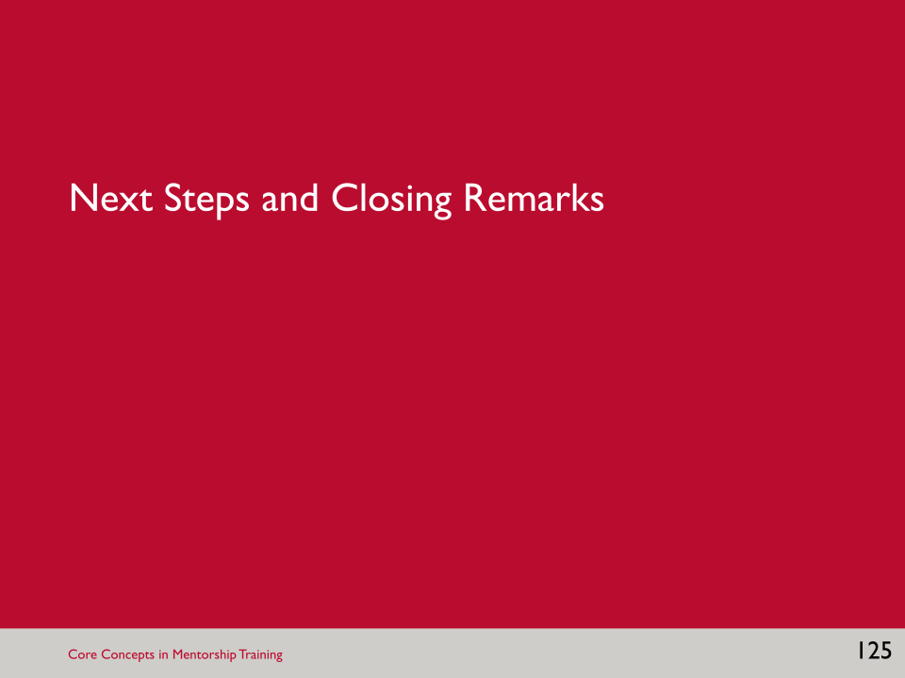

SLIDE 126: NEXT STEPS

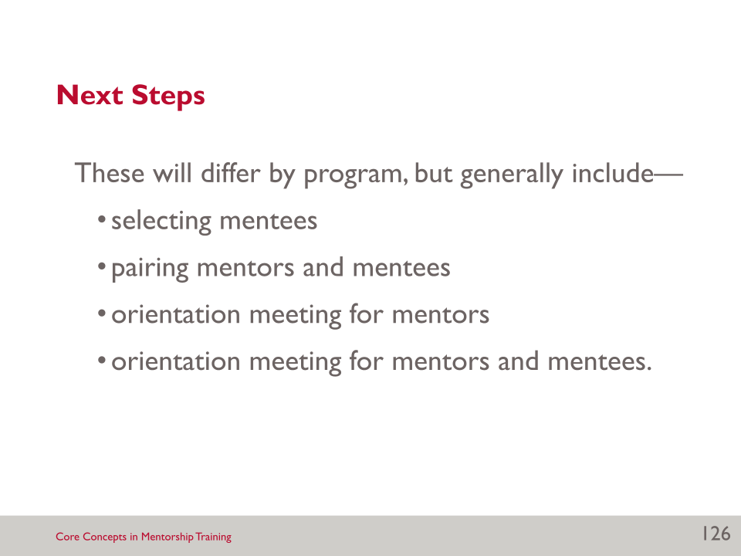

SLIDE 127: ACKNOWLEDGMENTS

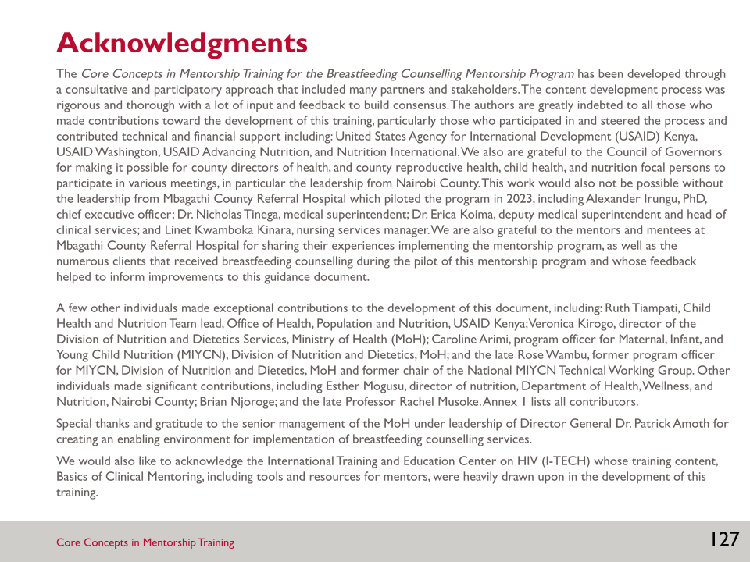

- These materials were adapted from the International Training and Education Center on HIV (I-TECH) Basics of Clinical Mentoring course.

SLIDE 128: USAID ADVANCING NUTRITION

Notes:

________________________________________________________________________________________________________________________________________________________________________________________________________________________________________________________________________________________________________________________________________________________________________________________________________________________________________________________________________________________________________________________________________________________________________________________________________________________________________________________________________________________________________________________________________________________________________________________________________________________________________________________________________________________________________________________________________________________________________________________________________________________________________________________________________________________________________________________________________________________________________________________________________________________________________________________________________________________________________________________________________________________________________________________________________________________________________________________________________________________________________________________________________________________________________________________________________________________________________________________________________________________________________________________________________________________________________________________________________________________________________________________________________________________________________________________________________________________________________________________________
___________________________________________________________________________________________________________________________________________________________________________________________________________________________________________________________________________________________________________________________________________________________________________________________________________________________________________________________________________________________________________________________________________________________________________________________________________________________________________________________________________________________________________________________________

REFERENCES
Feyissa, G.T., D. Balabanova, M. Woldie. 2019. “How Effective are Mentoring Programs for Improving Health Worker Competence and Institutional Performance in Africa? A Systematic Review of Quantitative Evidence.” Journal of Multidisciplinary Healthcare 12(5): 989–1005. https://doi.org/10.2147/JMDH.S228951.
Haroon, S., J.K. Das, R.A. Salam, A. Imdad, & Z.A. Bhutta. 2013. “Breastfeeding Promotion Interventions and Breastfeeding Practices: A Systematic Review”. BMC Public Health, 13 (Suppl 3): S20. https://doi.org/10.1186/1471-2458-13-S3-S20
ITECH (International Training Education Center on HIV). 2008. “Basics of Clinical Mentoring.” Accessed June 30, 2022. https://www.go2itech.org/HTML/CM08/toolkit/training/index.html
MCSP (Maternal and Child Survival Program). 2018. “Mentoring for Human Capacity Development: Implementation Principles and Guidance.” Accessed June 30, 2022. https://www.mcsprogram.org/resource/mentoring-human-capacity-development-implementation-principles-guidance/
Reilly, B. 2007. “Viewpoint: Inconvenient Truths about Effective Clinical Teaching.” Lancet. 370:705–711. https://doi.org/10.1016/S0140-6736(07)61347-6
SCOPME (Standing Committee on Postgraduate Medical and Dental Education). 1998. Supporting Doctors and Dentists at Work: An Enquiry into Mentoring. London: SCOPME.
WHO (World Health Organization). 2015. Roles and Responsibilities of Government Chief Nursing and Midwifery Officers: A Capacity-Building Manual. Geneva: WHO. https://apps.who.int/iris/handle/10665/351684
WHO (World Health Organization) and UNICEF (United Nations Children’s Fund). 2018. Implementation Guidance: Protecting, Promoting, and Supporting Breastfeeding in Facilities Providing Maternity and Newborn Services—The Revised Baby-Friendly Hospital Initiative. Geneva: WHO. https://www.who.int/publications/i/item/9789241513807
WHO (World Health Organization) and UNICEF (United Nations Children's Fund). 2020a. Baby Friendly Hospital Initiative (BFHI) Training Course for Maternity Staff. Geneva: WHO. https://www.who.int/publications/i/item/9789240008915.
WHO (World Health Organization) and UNICEF (United Nations Children's Fund). 2020b. Competency Verification Toolkit: Ensuring Competency of Direct Care Providers to Implement the Baby-Friendly Hospital Initiative. Geneva: WHO. https://www.who.int/publications/i/item/9789240008854.
WordNet. 2006. “Trust.” Princeton University Cognitive Science Library. Accessed June 5, 2008. http://wordnet.princeton.edu/perl/webwn?s=trust.

LIST OF CONTRIBUTORS

Judith A. Abongo
Zamzam Adan
Brenda Ahoya
Iscah Akello
Leila Akinyi
Teresa Akun
Jeniece Alvey
Robina Anene
Caroline Arimi
Kathryn Beck
Kristen Cashin
Celina Chepkemoi
Jackson Cheruiyot
Rosie Eldridge
Elaine Gray
Allan Govoga
Susan Kagia
Stacy Katua
Purity Kibe
Christine Kihara
Mary Kimani
Jacob Kimanzi
Simon Kinyanjui
Veronica Kirogo
Peggy Koniz-Booher
Julie Koroso
Esther Kwamboka Mogusu
Sascha Lamstein
Merina Lekorere
Betty Lessonet
Agneta Makasi
Pam Malebe
Leah Mbatia
Meaghan McSorley
Ann Miceli
Florence Mingusa
Caroline Mola
Florence Mugo
Cynthia Muhambe
Veronica Muia
Altrena Mukuria-Ashe
Rebecca Mulandi
Irene Muluvi
Christine Mumo
Josephine Munene
Rachel Musoke
Felistus Musyoka
Christine Muteria
Stephen Mwangi
Stanslous Ndeto
Rachel Ndungu
Clementina Ngina
Brian Njoroge
James Njiru
Johnstone Nzioka
Christine Oluga
Susan Omondi
Nyakina Orina
Joel Otieno
Abigael Owilla
Betty Samburu
Joyce K. Sitima
Ruth Tiampati
Malia Uyehara
Rose Wambu
Christine Wambugu
Virginia Wanjiku
Alice Wanjiru
Susan Were
Bridget Wesonga
Mariah Yaah
Angela Love Zaranka

1
USAID Advancing Nutrition is the Agency’s flagship multi-sectoral nutrition project, addressing the root causes of malnutrition to save lives and enhance long-term health and development.
This document is made possible by the generous support of the American people through the the U. S. Agency for International Development. It was prepared under the terms of contract 7200AA18C00070 awarded to JSI Research & Training Institute, Inc. The contents are the responsibility of JSI and do not necessarily reflect the views of USAID or the U.S. Government.
USAID ADVANCING NUTRITION
Implemented by:
JSI Research & Training Institute, Inc.
2733 Crystal Drive
4th Floor
Arlington, VA 22202

Phone: 703–528–7474
Email: info@advancingnutrition.org
Web: advancingnutrition.org

January 2024

Adapted from ITECH (International Training Education Center on HIV). 2008. “Basics of Clinical Mentoring.” Accessed June 30, 2022. https://www.go2itech.org/HTML/CM08/toolkit/training/index.html
Adapted from ITECH (International Training Education Center on HIV). 2008. “Basics of Clinical Mentoring.” Accessed June 30, 2022. https://www.go2itech.org/HTML/CM08/toolkit/training/index.html
Adapted from ITECH (International Training Education Center on HIV). 2008. “Basics of Clinical Mentoring.” Accessed June 30, 2022. https://www.go2itech.org/HTML/CM08/toolkit/training/index.html
Adapted from ITECH 2008

