USAID Advancing Nutrition 3.2.B.1 Peer Groups Implementation Research in Zimbabwe
Prototype 4B: Commitment Card Guidance and Monitoring Form

Table of Contents
Background of this tool 1
Guidance for using the commitment card 2
Lead Mother Training 2
Introducing the Card 2
Using the Card 3
Completing the Card 4
Monitoring Form for Lead Mothers 5
Example Commitment Card 7

Note: Commitment Cards are included in a separate document.

Background of this tool
This guide has been designed to support care group participants in making commitments to practice a recommended behavior. The recommended behaviors are reflected on the commitment card. To use the card, caregivers invite a member of their household to be their commitment partner. This provides an opportunity to engage several adult learning principles, including committing to practicing a new skill, reinforcing their learning by sharing knowledge and/or teaching others, learning by doing, and finally, a formal recognition of their accomplishments. To facilitate this commitment activity, Lead Mothers can use this guide to support caregivers in their groups to use commitment cards and invite commitment partners to support them.
This guide was developed based on feedback from neighbor mothers and caregivers, lead mothers, and promoters of care groups supported by Amalima Loko in Tsholotsho, Lupane, and Binga districts. It is reflective of the challenges and opportunities to support behavior change they described and prioritized in individual interviews and district level workshops. These challenges and opportunities include: a design for increased capacity for soft skills among Lead Mothers; and interest in expanding opportunities for social support for Neighbor Mothers. In a series of structured engagements, these stakeholders will be further engaged to continue the co-creation and refinement process of these guides to ensure they are useful and responsive to participant needs.

Guidance for using the commitment card

Lead Mother Training
Lead Mothers will receive an introduction to the card during their training session (for prototyping this might be a separate meeting). During the training, the card should be explained so each Lead Mother understands the meaning of the icons and the purpose of the card.
List of behaviors on commitment card | Breastfeeding attachment  Exclusive breastfeeding  Complementary feeding (positioning)  Complementary feedings (foods) | Child’s hygiene  Handwashing  Responsive care  Caregiver support
Card Purpose | To indicate a shared commitment between a care group member and a member of their household to try recommended behaviors at home.  During a care group meeting, the Lead Mother can refer to the cards to reflect on which behaviors the care group members have committed to try and check in on progress.
Card Process | Introduce the card  - Lead mother introduces card to care group during a care group meeting  - Lead mother introduces cards to households during Home Visit #2 and invites care group member and their commitment partner to pledge to try behaviors and sign the card. Caregivers keep the card.  Use the card  - Caregivers bring the card to care group meetings and discuss which behaviors they tried at home.  - Mark card to indicate successful adoption of a behavior  Complete the card  - Lead Mother signs the card when all behaviors are “adopted”
To complete the card, a neighbor mother must share what she’s learned in a care group session with her commitment partner. The commitment partner can check the box coordinated with the care group session topic once they’ve received the information from the neighbor mother and agree to support her in practicing the recommended behavior. Completed cards are an indication of a knowledgeable and supported caregiver – “together we grow”.
If the neighbor mother or her commitment partner have a question about the recommended behavior, they can bring that question to the lead mother for discussion and resolution.

Introducing the Card
…To the Care Group.
The Lead Mother can introduce the card to the care group during a care group session. First, distribute copies of the card to each care group member. Let them know that you will collect the cards at the end of the meeting and give the cards back to members during Home Visit #2. At Home Visit #2, caregivers will keep the card.
Next, outline the meaning of each icon and describe the related behavior. Invite questions from neighbor mothers to ensure they understand the card well. Inform them of the purpose and process of using the card.
…To the household.
During home visit #2, the Lead Mother can introduce the commitment card and process to the caregroup member’s household. First, give a copy of the card to the caregiver. Let the caregiver and their commitment partner know that they will keep the card. The Lead Mother can refer to the table in the “Lead Mother Training” section of this guide to facilitate the introduction to the commitment card. She should first introduce the purpose and process of the commitment card.
Next, outline the meaning of each icon and describe the related behavior. Invite questions from the neighbor mother and their commitment partner to ensure they understand the card well. Inform them of the purpose and process of using the card. During home visits and in care group meetings the caregiver will use the card to reflect on the behaviors they’ve tried to adopt. The Lead Mother can work with the caregiver and commitment partner to determine which behavior to try; making sure to try one behavior at a time. She can invite the caregiver and commitment partner to mark (e.g., checkmark ✓, initials, X, etc.) the corresponding green box on behaviors that they agree to try during that module. The lead mother can use the corresponding monitoring form to keep track of progress in trying behaviors.
When all boxes are marked and all behaviors are “tried”, the Lead Mother will sign the card to complete it.
Note: During the development and testing of this prototype, at least one Commitment Partner asked if they (a member of a neighbor mother’s household) needed to attend care group sessions. Commitment Partners are important actors in a neighbor mother’s support system, but they are not members of the care group so they do not need to attend care group meetings.

Using the Card
…In a care group meeting: The Lead Mother can remind neighbor mothers to bring their commitment cards to the care group meetings. When reflecting on the behaviors that each member has tried during the module, neighbor mothers can share their cards and offer support to those who may be trying behaviors that they have had success adopting. The lead mother can also ask neighbor mothers about their experiences speaking with their commitment partners:
- What was it like to speak with your commitment partner about the behavior you plan to try?
- Why did or didn’t they agree to support you in trying the behavior?
- What was interesting about your commitment partner’s response to the behavior you discussed?
- How could members of the care group help you and your commitment partner agree to try the behavior?
This exploration into neighbor mother experiences can help the Lead Mother identify challenges she can address during home visits (for households only), and help neighbor mothers in sharing ideas / problem solving. The Lead Mother can use the corresponding monitoring form to track progress in behavior adoption.
The neighbor mother should bring the commitment card to each care group session. During the session,

Completing the Card
The card can be completed when all behaviors are marked. To complete the card, the Lead Mother can sign it.
Completed cards should be recognized in the care group session by the Lead Mother as an accomplishment worthy of pride. This could be verbal praise for the neighbor mother’s effort to share her knowledge and skills with her commitment partner, or another context appropriate form of recognition.
Completed cards could be acknowledged at community or Amalima Loko organized events.

Monitoring Form for Lead Mothers
Print a copy of the following form for each care group member
Care group member name: |  | Date card received:
Commitment partner name: |  | Date card completed:
Commitment partner relationship to care group member:
⬜ Husband ⬜ Mother-in-law ⬜ Father-in-law ⬜ Other: ______________________
In the table below, indicate challenges that the caregiver and commitment partner report facing during home visits, focusing only on ONE behavior at a time. Keep working on a behavior until the household has had “success” trying the behavior and reports sustaining the behavior with support. Use the “action to address challenge” to document what actions the caregiver and commitment partner commit to support success trying and/or sustaining the behavior. Mark the “tried” column when the caregiver and commitment partner agree to try a behavior.
Behavior | Tried | Challenge | Action to Address Challenge | Adopted
Breastfeeding attachment | ⬜ |  |  | ⬜
Exclusive breastfeeding | ⬜ |  |  | ⬜
Complementary feeding (positioning) | ⬜ |  |  | ⬜
Complementary feedings (foods) | ⬜ |  |  | ⬜
Child’s hygiene | ⬜ |  |  | ⬜
Handwashing | ⬜ |  |  | ⬜
Responsive care | ⬜ |  |  | ⬜
Caregiver support | ⬜ |  |  | ⬜

Example Commitment Card
(Use PDF version to print on A4 size paper)
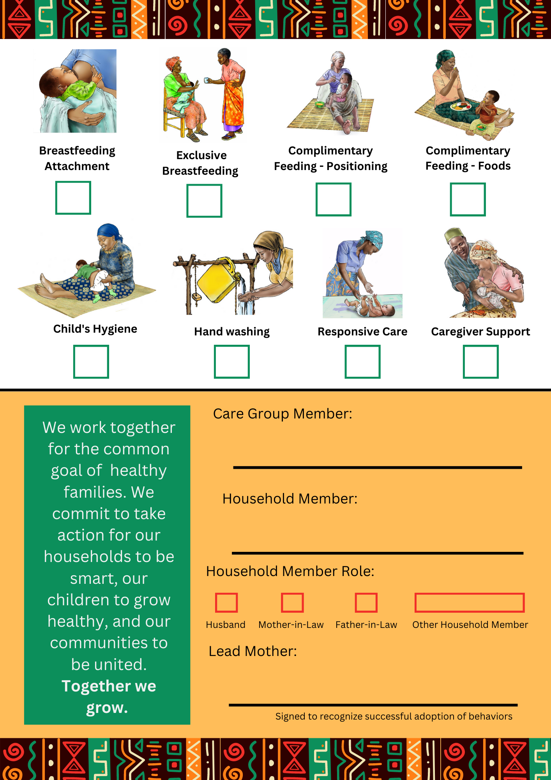
The commitment card draft has been created such that the activities can be checked off when completed and should not require literacy to interpret. Commitment options are flexible and can / should be adapted to Amalima Loko’s programming. Some other options might be:

1
USAID Advancing Nutrition is the Agency’s flagship multi-sectoral nutrition project, addressing the root causes of malnutrition to save lives and enhance long-term health and development.
This document is made possible by the generous support of the American people through the United States Agency for International Development (USAID). The contents are the responsibility of JSI Research & Training Institute, Inc. (JSI), and do not necessarily reflect the views of USAID or the United States government.

USAID ADVANCING NUTRITION
Implemented by:
JSI Research & Training Institute, Inc.
2733 Crystal Drive
4th Floor
Arlington, VA 22202
Phone: 703–528–7474
Email: info@advancingnutrition.org
Web: advancingnutrition.org
November 2023

