USAID Advancing Nutrition Peer Groups Implementation Research in Zimbabwe
Prototype 3A: Look-and-learn Guide for Care Group Leaders

Table of Contents
Background of this tool 2
Guidance for conducting a Look-and-Learn 2
1. Lead Mother Training 2
2. Coordinating the Look-and-Learn 2
Seeking consent 2
Scheduling the session 3
Preparing the host Lead Mother 3
Preparing the visiting Lead Mothers: 4
3. Facilitating a look-and-learn 4
Closing of the meeting and thank you to NMs 5
4. Facilitating a look-and-learn debrief 5

Background of this tool
This guide has been designed to support Promoters and Lead Mothers in coordinating and facilitating look-and-learn sessions. These sessions offer an opportunity for visiting Lead Mothers to engage in observational learning; to recognize the dedication and efforts of the hosting Lead Mother; for all participants to participate in reflection and two-way feedback, as well as to practice soft skills; and to strengthen social bonds between Promoters and Lead Mothers.
This guide was developed based on feedback from neighbor mothers and caregivers, lead mothers, and promoters of care groups supported by Amalima Loko in Tsholotsho, Lupane, and Binga districts. It is reflective of the challenges and opportunities to support behavior change they described and prioritized in individual interviews and district level workshops. These challenges and opportunities included: a desire among Lead Mothers to receive training or mentoring from Promoters; the existence of interpersonal challenges between some care group participants; a desire among Lead Mothers to teach others and build their reputations as leaders; and a interest among Lead Mothers to receive additional capacitation of soft skills. In a series of structured engagements, these stakeholders will be further engaged to continue the co-creation and refinement process of these guides to ensure they are useful and responsive to participant needs.

Guidance for conducting a Look-and-Learn

Lead Mother Training
Lead Mothers will receive an introduction to the look-and-learn activity during their training session. During the training, the activity should be explained so each Lead Mother understands the purpose and process of the activity.
Activity Purpose: To offer a discrete opportunity for Lead Mothers to: 1) observe another care group, 2) share and receive feedback with one another, and 3) to recognize the dedication and efforts of Lead Mothers. The opportunity to host fellow Lead Mothers is a recognition of the hosting Lead Mother’s dedication and commitment to providing high-quality support to her care group members. Visiting a fellow Lead Mother is an opportunity to learn about how others lead their care groups, and to share feedback and discuss reflections as a group of Lead Mothers.
Activity Process: To facilitate the activity, a promoter should coordinate with her Amalima Loko Field Officer and Lead Mothers to select a date and time for one Lead Mother to host visiting lead mothers. The look-and-learn session will consist of two parts: 1) a care group meeting, and 2) a two-way discussion session. The duration of the care group meeting should be no longer than 60 minutes so it is feasible for Lead Mothers to participate in a discussion session that is no shorter than 30 minutes and no longer than 60 minutes. Lead Mothers may wish to bring paper or note taking materials to the activity.
The Promoter might also share expectations for “observation”. See section below “Preparing the visiting Lead Mothers”.

Coordinating the Look-and-Learn

Seeking consent
When a Lead Mother is interested in hosting a look-and-learn, she should confirm that the Promoter is supportive and that members of the care group consent to participate in such a session. The following illustrative consent memo can be shared to solicit consent. The illustrative consent memo can and should be adapted as needed.
Illustrative consent memo:
I, [Lead Mother Name], would like to strengthen and share my skills as a cluster leader by inviting other cluster leaders to observe one of our sessions and mutually offer feedback after our session is over. This type of meeting is called a look-and-learn and impacts you only insofar as being observed by other Lead Mothers. Your participation in the session will help inform the advice that I and the other cluster leaders will discuss after our care group meeting is over. Please let me know if you agree to participate so I may make the necessary arrangements with our Promoter.

Scheduling the session
Promoters can work with Amalima Loko Field Officers and their Lead Mothers to coordinate the look-and-learn sessions. The sessions should be coordinated with enough notice for visiting Lead Mothers to discuss and, as appropriate, seek approval from their husbands and family members.
Promoters might consider gathering 2-5 visiting Lead Mothers, and adapt as needed. Promoters can ask hosting Lead Mothers and their care groups what number of visitors they would be comfortable hosting as well as consider factors such as travel logistics, which may impact the feasibility of visitors attending a session.
In the session prior to the look-and-learn, the Promoter can issue a reminder to participating Lead Mothers (both the host and visiting Lead Mothers) that their next session will be a look-and-learn. The reminder should include the date, time, and location of the look-and-learn as well as the name of the host Lead Mother. Promoters may add additional information as desired such as bringing materials for note taking, reassurance that the look-and-learn is a learning and capacity building activity, not a competition between care groups, etc.

Preparing the host Lead Mother
In addition to supporting her during the activity, the Promoter can support the hosting Lead Mother in advance of the look-and-learn with three key actions: Check-in, Respond, Support.
- Check in: Alongside a reminder to the hosting Lead Mother in the week prior to her look-and-learn session, the Promoter can check in on how the hosting Lead Mother is feeling about her session. The check in could happen virtually/over the phone or, ideally, in a face-to-face interaction. Questions the Promoter might use to check in with the hosting Lead Mother could include:
  - How are you feeling about your upcoming session?
  - What do you think is contributing to those feelings?
  - How can I support you in preparing for the session?
- Respond: It is important to invite and respond to requests for support. The check-in is an opportunity for the Promoter to invite requests for support from the Lead Mother. The next step is to respond to those requests. The requests may be direct (such as, “Can you help me seat everyone?”) or indirect (such as, “I am worried about X-situation”). In instances where there are indirect requests, the Promoter can offer options for how she could support the hosting Lead Mother if those situations arise.
This is also an opportunity for the Promoter to encourage the hosting Lead Mother, by reminding her of skills she has demonstrated. For example, if the hosting Lead Mother is concerned about quarrels in her group, the Promoter might encourage her by reminding the hosting Lead Mother of a time she managed resolving a quarrel or of tools she can use to aid her in conflict resolution.
- Support: Finally, it is important that the Promoter fulfill any promises of support that she makes to the host Lead Mother. Similarly, if the host Lead Mother refuses any support ideas, it is important that the Promoter honor those refusals and not intercede where she hasn’t been invited to do so during the care group session. The discussion session of the look-and-learn can provide an opportunity to reflect on the best ways to offer and provide support in future activities.

Preparing the visiting Lead Mothers:
Prior to the look-and-learn, the Promoter should capacitate visiting Lead Mothers in “observation” skills. This could occur during the Lead Mother training session and include a reminder of observation best practices immediately before visiting the hosting Lead Mother (i.e., in a small group outside of her home).

Facilitating a look-and-learn
The Promoter is the lead facilitator of the two-way discussion. The Promoter should open the session with a welcome, introduce the visiting lead mothers, and describe the look-and-learn activity and purpose to the care group at the start of the meeting. The Promoter can then turn the session over to the hosting Lead Mother. The hosting Lead Mother can begin the care group session as she normally would; this might include one or more of the following: an introduction of her group members to their guests; a prayer; a song and dance; a welcome exercise or energizer; an overview of what they will learn and discuss in today’s care group session, etc.
Facilitation Tips to help everyone feel welcome and engaged:
- Use song and dance to begin the session. Having an engaging welcome can help your care group members and visitors feel more comfortable. Invite your care group members and visiting lead mothers to participate.
- Invite everyone, guests and your care group, to introduce themselves.
- Share the purpose of the look-and-learn with everyone, then introduce the group to the care group meeting topic. Share the following reminders with everyone before beginning the session’s topic.
* Reminders to share with participants*
- Speak loudly so everyone can hear you.
- Visiting neighbor mothers should hold their questions and suggestions for the hosting neighbor mother until after her care group members have concluded the session and left the space. Consider writing them down, if you are worried you might forget them.
In an ideal situation, observation is minimally disruptive or perceptible by those being observed. Because visiting Lead Mothers will be physically present during the care group session, there will be some disruption or perception of the session by the group members which may impact how they engage during the session.
Facilitation Tips to Reduce Disruption of Hosting Care Group
- Seating Arrangement – Visiting care group leaders can sit on the outside or around the care group with enough distance that the primary group can gather as they usually would, but close enough that the visiting care group leaders can hear.
Figure: Illustrative Seating Arrangement
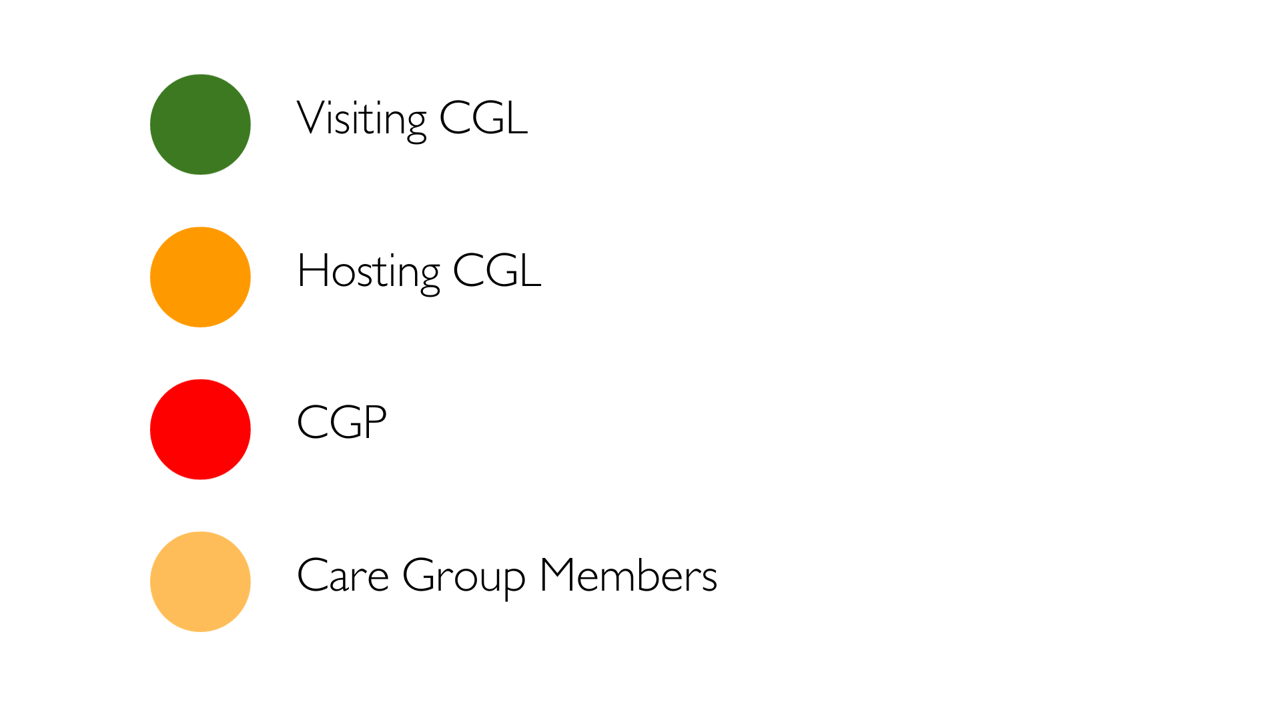
Distance between visiting care group leaders can serve to reduce the temptation to have discussions or otherwise be disruptive during the hosting care group meeting.
- Quiet Observation – Visiting care group leaders to practice quiet observation and listening. If visiting care group leaders have brought note taking materials, the host care group leader could encourage them to write their questions and thoughts down for reflecting on during the two-way discussion.
The Promoter or Hosting Care Group Leader may choose to share the following reminders with visiting Care Group Leaders before the care group meeting starts:
- Avoid side conversations or other disruptions that might distract care group members from their session
- Hold questions and suggestions for the hosting care group leader until after their care group members have concluded the session and left the space. You could consider writing them down, if you are worried you might forget them.

Closing of the meeting and thank you to NMs
The lead mother can end her session as she would usually do and thank the Neighbor Mothers for attending. Hosting Lead Mothers and visiting Lead Mothers should remain for the debrief portion of the Look-and-Learn.

Facilitating a look-and-learn debrief
After the host Lead Mother concludes her care group session and her members have left, the Promoter can call the host and visiting Lead Mothers into a care group circle for the discussion.
- Reflections from the hosting Lead Mother: The Promoter could begin the session by inviting the hosting Lead Mother to share reflections on her session. What did she think about the session? Did her care group understand the material well? What did she like about the session? What would she like to see more of?
- Invitations for feedback: After the hosting Lead Mother finishes her reflection, the Promoter can ask her if she would like specific feedback on an aspect of the session (e.g., facilitation, group dynamics, etc.), or if she would like to open the floor to volunteered-feedback. The hosting Lead Mother may opt to receive both. For the volunteered feedback, the Promoter could consider asking for feedback from visiting Lead Mothers based on skills categories (e.g., quality dimension, soft skills, adult learning principles, etc.) or on a first-volunteer basis. The hosting Lead Mother should be encouraged to dialogue with the visiting Lead Mothers while receiving feedback with the aim to better understand the feedback.
- Conclusion and Thank You: At the end of the session, both the host Lead Mother and the Promoter may wish to share closing remarks to summarize the day and thank visiting Lead Mothers for their attendance and thoughtful feedback. Visiting Lead Mothers and the Promoter may also wish to thank the host Lead Mother for her hospitality and leadership as a look-and-learn host.

1
USAID Advancing Nutrition is the Agency’s flagship multi-sectoral nutrition project, addressing the root causes of malnutrition to save lives and enhance long-term health and development.
This document is made possible by the generous support of the American people through the United States Agency for International Development (USAID). The contents are the responsibility of JSI Research & Training Institute, Inc. (JSI), and do not necessarily reflect the views of USAID or the United States government.

USAID ADVANCING NUTRITION
Implemented by:
JSI Research & Training Institute, Inc.
2733 Crystal Drive
4th Floor
Arlington, VA 22202
Phone: 703–528–7474
Email: info@advancingnutrition.org
Web: advancingnutrition.org
November 2023

Ideally, the Field Officers will develop a system for coordinating sessions that can be sustained beyond the life of the Amalima Loko program. Alternatively, care groups may determine their own structure for sustaining the care groups and capacity building activities, like look-and-learns, between periods of program implementation.

