USAID Advancing Nutrition Peer Groups Implementation Research in Zimbabwe
Prototype 2C: Simple Job Aid for Reflection Sessions

Table of Contents
Background of this tool 1
Adult Learners 2
Instructions for Using the Template 2
Adaptable Template for Facilitating a Reflection Session 2
1. Begin the session with a welcome exercise: 2
2. Invite the group to share what they’ve tried at home related to the topics discussed in the group. 4
3. Review high-level summary of the module 5
4. Invite new commitments to practice behavior with suggestions for how to support one another 6

- aane, balayinzizyana, mpo ooyo walikusandula mibuzyo ulabuzya mweenzinyina mibuzyo.

Background of this tool
This guide has been designed to support care group participants in reflecting on the modules they’ve completed and the behaviors they have practiced and tried to adopt. Reflecting on the modules and receiving feedback from care group participants is one of many ways that Lead Mothers can support their care group members in adopting recommended behaviors.
This guide was developed based on feedback from neighbor mothers and caregivers, lead mothers, and promoters of care groups supported by Amalima Loko in Tsholotsho, Lupane, and Binga districts. It is reflective of the challenges and opportunities to support behavior change they described and prioritized in individual interviews and district level workshops. These challenges and opportunities included: neighbor mothers desire modular content beyond breastfeeding and hygiene; in some groups, neighbor mothers do not have sufficient time for reflection; and there is an interest and need for capacitation of facilitation and soft skills for Lead Mothers to support additional reflection. In a series of structured engagements, these stakeholders will be further engaged to continue the co-creation and refinement process of these guides to ensure they are useful and responsive to participant needs.

Adult Learners
Adults learn differently than children. To best support adults in learning and practicing new skills, it is necessary to leverage adult learning principles, which respond to the ways in which adults learn differently than children. There are seven key adult learning principles; they state that adults learn best when…
- Lessons draw on past learning experiences and leverage member experiences
- Participants learn by doing and have opportunities to practice new skills to solve a relevant problem
- Participants can reinforce their learning through teaching others the new skill or information
- Participants have adequate time for learner feedback and reflection
- Participants commit to adopting a new skill or applying new information
- Participants can self direct their learning by choosing their own learning method and setting their own pace
- Participants’ accomplishments are recognized
Lead Mothers can use this guide to aid their facilitation of reflection sessions. During a reflection session, a Lead Mother can invite caregivers in their group to share their experiences by trying to practice a behavior that was discussed in the previous module. In the following section there is a template which Lead Mothers can adapt to structure a reflection session. Each section of the template includes a suggested amount of time to dedicate to the section and suggestions for how to implement.

Instructions for Using the Template
This template has been developed to support the addition of a reflection session at the end of a care group module. The session is intended to take the entire care group meeting.

Adaptable Template for Facilitating a Reflection Session

Begin the session with a welcome exercise:
Suggested time: 10 minutes
Lead Mothers may choose to select ONE OR TWO of the welcome exercise options below, or use their own welcome exercise. There is NO NEED to use all the welcome exercises in a single session.
- I appreciate… : Invite care group members to share what they appreciate about one other person in the group. Each group member can take a turn doing this by saying "I appreciate..." followed by what they appreciate about someone else in the group. Ideally, each person in the group should have at least one comment expressed about them.
Facilitation Tip
It’s great to have everyone in the group feel appreciated, this can encourage care group members to participate actively. The Lead Mother can consider making a mental or written note about who has appreciated whom. Before ending the exercise, the Lead Mother can appreciate anyone who hasn’t received a comment yet.

Another approach to help everyone feel appreciated is to ask each person to share an “I appreciate” comment about the person sitting to their right. Then each person can share what they appreciate about the person seated to their right; every person gets a turn to comment and to receive a compliment.
- Draw your neighbor: Divide Care Group members into pairs for this activity. Instruct each pair to take turns asking each other questions about their daily routines, like "What do you wear?" "what do you do when you first wake up?", etc. As one person responds, the other should try to draw what that person is describing using a stick to make lines in the soil or a pencil to draw on paper.
- Option 1: One person asks questions of their partner for four minutes. At the end of four minutes, the partners switch, so the person answering the questions is now asking the questions.
- Option 2: Members of the pairs take turns asking questions and drawing each other
At the end of 8 minutes, the two can share and discuss their drawings.
- Draw an animal: Care group members are selected at random to draw an animal without telling the care group what it is. After the care group member has drawn, the rest are given four chances to guess what it is. If they identify the animal correctly within four attempts, the members applaud and another care group member is given a chance to draw while the rest of the members guess the animal. If they fail to identify the animal, the member who drew announces the animal to the rest of the group and may select the next person to draw an animal.
- Map your neighborhood: Divide Care Group members into pairs for this activity. Instruct each pair to take turns asking each other questions about their home and weekly routines, like “What does your house look like?”, “where is your neighbors house?”, “how do you get to your friends house?”, “where is the market from your house?”, etc. As one person responds, the other should try to draw a map of what the person is describing using a stick to make lines in the soil or a pencil to draw on paper.
- Option 1: One person asks questions of their partner for four minutes. At the end of four minutes, the partners switch, so the person answering the questions is now asking the questions.
- Option 2: Members of the pairs take turns asking questions and drawing their neighborhood
At the end of 8 minutes, the two can share and discuss their drawings.
- Search for the rainbow: The Lead Mother can show neighbor mothers the labeled diagram of a rainbow below. As a group, look for at least one (but potentially more) items from each color of the rainbow that is visible in the space around you. How many red things do you see? Orange? Yellow? Green? Blue? Purple?
- Guess an animal: Divide Care Group members into pairs for this activity. Instruct each person to think of an animal. Each pair should take turns asking “yes” or “no” questions about the animal they’re thinking of until they are able to guess the animal.
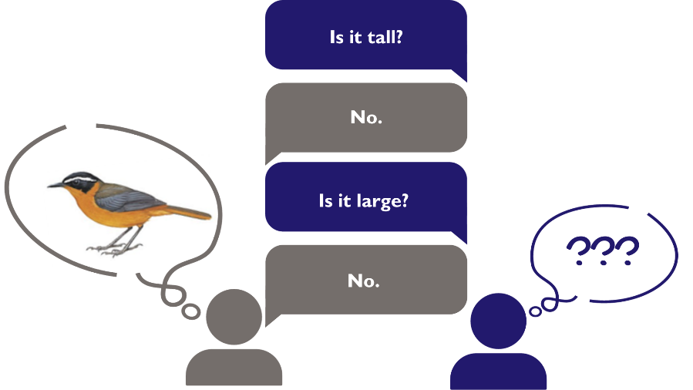
- Built on a short phrase: Sit in a circle. One person asks the person to their right, "describe your week in a short phrase". The next person asks a question that, for them, is answered by the short phrase that answered the last question. Keep going around the circle, from person to person.
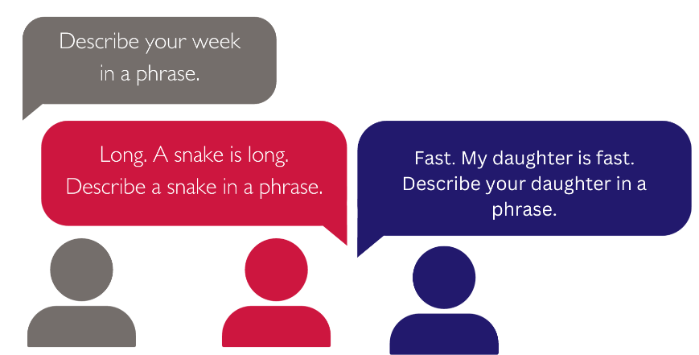
- Song + Dance: To begin the session, use a song and dance with neighbor mothers and caregivers as an engaging way to welcome your care group members.

Invite the group to share what they’ve tried at home related to the topics discussed in the group.
Suggested time: 25 minutes
Illustrative script:
- Lead Mother: Now that we are all warmed up, let’s talk about the last topic we discussed as a group. Can someone share what they remember about the last topic?
- [Pause for responses from caregivers]
- Lead Mother: Probe to inspire more discussion
Probe bank:
- What have you tried?
  - Have you tried anything new for [behavior]?
  - Have you tried anything new that we’ve talked about related to [behavior]?
  - Have you tried any other new behaviors to improve your family's health?
- What helped you practice the new [behavior]?
- What have you not tried?
- If you haven’t tried the new [behavior], why not?
- Have you helped someone else try?
- Can you tell me more about that?
- Did anyone in the group find the new [behavior] challenging or difficult?
  - What made the new [behavior] difficult for you?
  - What do you think would help you practice the behavior?
  - Have you tried anything new to address the challenge?
  - Has anyone in the group had a similar challenge?
  - What are some ways to address this challenge?
  - How can we support each other to address this challenge?
  - Would someone like to assist our neighbor mother with this challenge?
Facilitation Tips
This is to avoid repeating a question you would have asked before, use a pen, ruler, or your hand to mark the question you have asked the care group members.
During the reflection session, you can also pause and use one of the welcome exercises above to energize the care group members when you notice low levels of energy.
If members are hesitant to share, Lead Mothers could: 1) share from their own experiences; 2) recall what someone else shared during a previous reflection; 3) invite members to sing a song related to the most recent topic.

Review high-level summary of the module
Suggested time: 10 minutes
Facilitation Tip
Keep the module review after the session where caregivers are invited to share what they’ve tried at home. This 1) allows caregivers time to engage in authentic recall, and 2) provides a discrete opportunity to support those who are struggling with concepts from the module.
The Lead Mother can consider using this section of the meeting to invite neighbor mothers to share additional reflections on what they learned in the last session. Consider asking the neighbor mothers to complete the following sentence with one key thing they learned in the last module:
“In the last session, I learned or was reminded to…”

Invite new commitments to practice behavior with suggestions for how to support one another
Suggested time: 15 minutes
Opportunity to incorporate solution 4B: Commitment card / tangible commitment mechanism

1
USAID Advancing Nutrition is the Agency’s flagship multi-sectoral nutrition project, addressing the root causes of malnutrition to save lives and enhance long-term health and development.
This document is made possible by the generous support of the American people through the United States Agency for International Development (USAID). The contents are the responsibility of JSI Research & Training Institute, Inc. (JSI), and do not necessarily reflect the views of USAID or the United States government.

USAID ADVANCING NUTRITION
Implemented by:
JSI Research & Training Institute, Inc.
2733 Crystal Drive
4th Floor
Arlington, VA 22202
Phone: 703–528–7474
Email: info@advancingnutrition.org
Web: advancingnutrition.org
November 2023

