USAID Advancing Nutrition 3.2.B.1 Peer Groups Implementation Research in Zimbabwe
Prototype 2C: Simple Job Aid for Reflection Sessions

Table of Contents
Kumazwido achibelesyo chamalembe aaya 1
Bayiyi bachipati 1
Malayilile atobelezegwa mukubelesya kabbuku 2
Kabbuku katambulika kukwendelezya chibaka chilachitondeezyo chiboneka 2
1. Talisya chibaka chako akutambula bantu kuti baangunuke 2
2. Ita bakabunga koonse kuti bapakwidane nzibakeezya kung’anda zyendelana amitwe yamakani yazuwigwa mukabunga. 4
3. Kulangisisigwa kweciyo camojulu. 5
4. Mutambe bapya balipedelede kutobelezya machitilo alamaboneno aatala akugwasyana. 6

Kumazwido achibelesyo chamalembe aaya
Chibelesyo eechi chakabambilwa kugwasizya babeleki bakabunga kabagwasilizyi (care group) mukutondeezya mabbuku ngibakamanisya antoomwe anchito nzibakachita akweezya kutobelezya. Kutondeezya nzibakayiiya mumabbuku antoomwe akutambula mazembe/ nsandulo zizwa kubabeleki bakabunga kabagwasilizyi njiimwi nzila mamama akabunga kaLead njibasungilizya akugwasilizya bendelezyi bakabunga kaCare mukutobelezya machitilo ayandikana.
Chibelesyo eechi chakapangwa akusumpulwa kakubelesegwa nsandulo/ mazembe akazwa kubasimayakilane mamama abagwasilizyi (caregivers), kabunga kamamama aLead, antoomwe abasumpuli bakabunga kabagwasilizyi kagwasigwa aba Amalima Loko bakuzilikiti zyaTsholotsho, Lupane akuBinga. Chitondeezya buyumuyumu antoomwe amyeenya mibotu yakugwasizya kusandula nchito zibandawukidwe azilangililwa kumbuzisisyo yawumwi awumwi ayamumawokisyopu achilikiti. Buyumuyumu oobu amyeenya mibotu ibikkilizya basimayakilane mamama bachiyandisyo chabbuku chilazilimukati zyazyakunyonsya abusanambi, mulitumwi tubunga, basimayakilane mamama tabajani chiindi chakutondeezya, alimwi kulichiyandisyo acheelelo chakupa zyeelede mukweendelezya antoomwe amasikkiluzi ayandikana kumamama aLead kuti bagwasizye kuzitondeezyo zyiingi. Muzibaka zyiingi ziyanda bagwasilizyi, tubunga ootu tuyoyinkilila anembo mukubikkwa kuti tukagwasilizye mukubambwa akubambulula nzila yoonse yachitobelezyo/ chibelesyo kuchitila kuti chibe abukoloondo akuvwilika kubotu kuziyandisyo zyababeleki.

Bayiyi bachipati
Bapati bayiiya busiyene loko kwiinda baniini. Nzila mpati yakugwasilizya bapati kwiiya akujana masikkiluzi mapya, kulimbubo kupa mweenya wakuboleka zibbadazyo kulwiiyo lwabapati, eezi nzizitondeezya kuti bapati bayiiya busiyene abaniini. Kuli nkwidizyo zyanzila zilimusanu azibili zyakwiiya kwabapati, nzila eezi zyaamba kuti bapati bayiiya kabotu naa
- zyiiyo zyalangana akwiiya zyachiindi nzibakali banjilana azyo antoomwe anzibakali baswaananaazyo zyakuboleka.
- babeleki naa basikuchita bayiiya akuchita akujana mweenya wakuchita masikkiluzi mapya lyoonse kuchitila kumanisya mapenzi ngibaswaania.
- basikuchita bakonzya kugwasilizya kwiiya kwiinda mukuyiisya bamwi masikkiluzi mapya naa makani ngibakayiiya.
- basikuchita balachiindi chiingi chakupa bayii nsandulo/ mazembe azitondeezyo.
- basikuchita balalipeda kutobelezya masikkiluzi mapya naa kuyungizya makani mapya.
- basikuchita lwabo bakonzya kutondeezya kwiiya kwabo kwindila mukusaluzya nzila abusena bwendelana abweende bwabo.
- kuzwidilila kwabasikuchita kulaboneka
Mamama aLead akonzya kubelesya chitobelezyo naa chibelesyo kuyungizya kweendelezya azitondeezyo mukweendelezya kwabo. Muchiindi chakutondeezya mukweendelezya kwabo, mama waLead ukonzya kutamba kabunga kamaCaregivers mukabunga kabo kuchitila kupana naa kutondeezyania nzibakaswaananaazyo mukweezya kuchita inchito zyakazuwigwa mumojulu (module) yakutalika. Mulizeezi zitobela kuli kabbuku mamama aLead nkibakonzya kutambula akutobelezya mukuchita zitondeezyo zyakweendelezya kwabo. Chipanzi chimwi achimwi chakabbuku chitondeezya chiindi chaambidwe mukupedekezya chipanzi antoomwe abwaambwe bwanzila zyambukweelede kuchitwa.

Malayilile atobelezegwa mukubelesya kabbuku
Kabbuku aaka kakapangwa kuchitila kugwasizya kuyungizya zitondeezyo ziboneka mukwendelezya kumamanino akabunga kamojulu yabagwasilizyi (Care group). Chibaka eechi chilangilila kubweza miswangano yakabunga koonse kabagwasilizyi.

Kabbuku katambulika kukwendelezya chibaka chilachitondeezyo chiboneka

1. Talisya chibaka chako akutambula bantu kuti baangunuke
Chiindi chilangililwa mukweendelezya chibaka eechi; maminesi alikkumi (10)
Mamama akabunga kaLead bakonzya kusala nzila iimwi kana zyobilwe yakutambula basika kulezi zitobela naa kubelesya nzila yabo yakutambula basika abusena.Tabelede kubelesya inzila zyonseni zyakutambula muciiyo chomwe.
- Ndilabotelwa ….; weelede kwiita bakabunga kabagwasilizyi kuti baambe nzibabotelwa aatala awumwi awumwi mukabunga kabo. Umwi awumwi wamukabunga kweelede wachita oobo kaamba kuti “ ndilabotelwa ….” Mpo kabaamba nzibabotelwa kuli umwi awumwi wamukabunga. Cheelede nchakuti umwi awumwi wamukabunga weelede kwaamba chimwi chintu chilaatala ambabo bakabunga.
Mama waLead ulatalisya kwaambuula mpo wapedekezya umwi) muntu ulikuchilisyo chakwe, naa babili) muntu ngwanga wadombola aawo naati “ndilabotelwa” mumunchali.
Inzila yakwendelezya
Ncibotu bweni kuti woonse muntu mukabunga wajana muntu umweeba akumulumba, ezi zilabasungwazya kuti babelekele ataka abamwi. Mama waLead ulakonzya kuzibamba mumutwe kana kuti kulemba akapepa kuti ngwani weeba ani katyeni. Kacitana mana ciiyo mama waLead weelede kweeba oyoo utayebedwe abamwi mukabunga.
Imwi nzila igwasizya wonse muntu kulumba kaana kweeba nkukumbila kuti muntu ati ‘Ndilumba kana kuti ndeeba” kalokwamba muntu ukeede kuloboko lwakululyo. Awo muntu woonse ulakonzya kweeba muntu ukeede kumbali lyakwe kululyo, kazicita kuti muntu wonse ayebwe ajaane kulumbwa.
- Enga mweenzinyokwe naa simayakilane wako: pambukania bantu bakabunga kabagwasilizyi mutubunga twababili babili mukuchita musobano ooyu. Pa malayilile akabunga kamwi akamwi kuti kabapana mweenya wakubuzyana mibuzyo yatala abuponi bwabo bwalubbe, mbuli kuti uzwatayi lubbe?” niinzi nchuchita lutaanzinwabuka kuseeni?” ayimwi mibuzyo. Umwi nalokusandula mibuzyo, umwi weelede kweezya kweenga aansi katobelezya zilokubandawukwa asikusandula kabelesya kasamu kuchita myeengo mumuseele naa kabelesya pensele kweenga apepa.
- Kapanzi katanzi: muntu umwi ulabuzya mibuzyo yaatala amweenzinyina kwamaminesi aane, kumamanino amaminesi aane, balayinzizyana, mpo ooyo walikusandula mibuzyo ulabuzya mweenzinyina mibuzyo.
- Kapanzi kabili: kabunga kabantu babili kalayinzizyania kubuzyania mibuzyo akweengana umwi awumwi.
Kumamanino amaminesi alimusanu awatatu, mububili balatondezyania akuzuwa nzibajana mukweengana kwabo
- Enga/ tondeezya mayakilane: Bikka mutubunga twaba bili babili bantu ba Care Group kumulimu ooyu. Akamwi kabunga kape zyakuchita kabapana mweenya kukubuzya mibuzyo aatala amuunzi azezyo nzibachita mukati kamviki, mbuli kuti "Ilangika buti ng'anda yako?”, “Ilikuli ng'anda yasimayakilane wako? ", "Weenda biyeni kuti koya kumaanda abeenzinyokwe? ", "Kuchisambalilo nkukuli kuti kozwa ang'anda yako? ",. Muchiindi muntu umwi nalokusandula, uumbi weelede kweenga busena muntu mbwalokupandulula kabelesya kasamu kuchita myeengo aamuseele kana kubelesya chilembyo kweenga apepa na akkwa.
- Nsaluzyo ntanzi: Uumwi muntu abuzye mibuzyo iizwa kumweenzinyina muchiindi chisyoonto biyo maminesi ane (4 mins) Kumamanino kwachiindi chisyoonto (4 mins), beenzinyina babuzye abalabo, muntu walikusandula mibuzyo yino ngwabubuzya mibuzyo
- Yanduula fwilichoongo: kamulikabunga, muyanduule chomwe (pesi zikonzya kuvula) chintu chizwa kumusyobo umwi wafilichoongo uboneka mumweenya umuzyungulukide. Nziinge zisalala nzubwenye? Zyasyamuntondo ke? Zyasokwetete? Ayimwi misyobo
- Zumbuuzya (Guess) munyama umwi biyo: Bikka bantu mutubunga twa Care Group babili babili kumulimu ooyu. Buzya awumwi muntu ayeye munyama omwe. Tubunga twababili beelede kupanana mweenya kukubuzya " iyi" kana "ine" mibuzyo aatala amunyama ngubalokuyeya kusikila bakazumbule
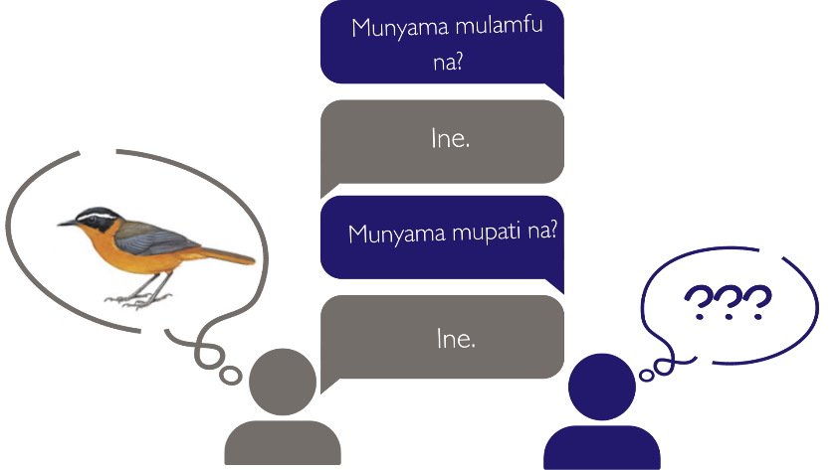
- Yaka bbala: mukkale museekkulu(circle) kamuli moonse. Umwi wanu abuzye uumwi uukkede kuchilisyo chakwe kuti, “bandawuka mviki mubbala lyomwe”. Umwi uutobela abuzye mubuzyo kuli bamwi mpo usandulwe abbala lyomwe kumubuzyo wakumamanino, mwinkilile kunembo kamubuzyana umwi awumwi kusika mumane moonse.
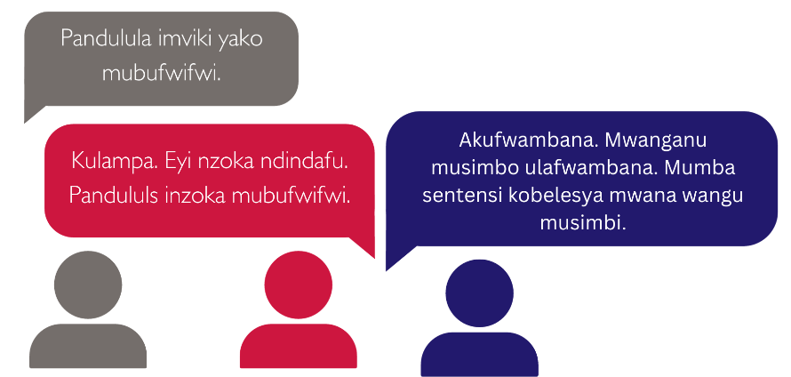
- Kwimba + akuzwana: Kana kotalika ciiyo, belesya kwimba akuzyana anomwe amama simayakilane mboli nzila yakutambula mamama amukabunga.

2. Ita bakabunga koonse kuti bapakwidane nzibakeezya kung’anda zyendelana amitwe yamakani yazuwigwa mukabunga.
Chiindi chipedwe mukwendelezya: maminesi alimakumi abili alaamusanu (25)
Pepa litondeezya:
- Mama waLead: lino mbukunga toonse twakasalilwa, twambuule aatala amutwe wamakani ngutwakazuwa katulikabunga. Umwi ngatubuzye nzyachiyeeyede aatala amutwe wamakani ngutwakazuwa?
- [imikizya (pause) nsandulo zizwa kukabunga kaCaregivers]
- Mama waLead: buzisisya kuchitila kuti mazuwo ayinkilile kunembo
Mibuzyo yakubuzisisya:
- Niinzi nzwakeezya?
- Kuli nzwakeezya na zipya zya [machitilo]?
- Kuli nchwakeezya na cheendelana anzitwakazuwa zya [machitilo]
- Kuli na nwakeezya machitilo aambi mapya akusumpula bulondosi bwampuli yanu.
- Niinzi chakakugwasilizya kuchita [machitilo] mapya
- Niinzi nzimwateezya?
- Kuti temweezya bupya (buponi), mwabonai.?
- Niinzi chakaba chiyumu kutobelezya machitilo? Mumaboneno aako niinzi chikonzya kugwasilizya
- kutobelezya kuchita machitilo?
- Kuli ngwakagwasilizya na kuti ayezye?
- Ndibuzye zyiingi aatala anzizyo
- Mukabunga kuliwajana (buponi) mpya iisyupa kana njumu?
- Niinzi zyachita buponi bupya kuti buyume kulindinywe?
- Niinzi nzimubonanga kuti zyachitwa zilagwasya kubuponi?
- Mweezya na kulizimwi zipya na kuti zyakumaninsya buyumuyumu?
- Mukabunga kuli uumwi na walabuyumuyumu bukozyania?
- Nziizili zimwi nzila zyakumaninsya buyumuyumu?
- Anga tulagwasyania biyeni kuti tumaninsye buyumuyumu?
Machenjezyo
Kukucitila kuti utabuzyi mubuzyo ngowaliwabuzya kale, belesya peni arula kana kuti luboko lwako kukujata mubuzyo ngolikubuzya mamama amukabunga.
Mucindi ceciiyo eci, ulako kwimikila ubelesye inzila yakutambula bantu zitondezedwe ajulu awa awo nowabona kuti balansi.
kuti bamwi bakabunga kabatayandi kwaabila bamwi, mamama baLead beelede 1) kwaabila bamwi nzibazi nzibakaswaananaazyo; 2) beelede kuyeya nzibakali baabilwa awumwi muzitondeezyo zyakweendelezegwa kutaanzi.

Kulangisisigwa kweciyo camojulu.
Chiindi chipedwe mukwendelezya: maminesi alikkumi (10)
Machenjezyo
mojulu yeelede kukkala kilangwalangwa (review) nikwamana kwendelezya aawo bakabunga kaCaregiver nibanga batambwa kuzowaabila nzibakeezya kumuunzi. Eezi zigwasya zintu zibili 1) ipa kuti bakabunga kaCaregiver bakonzye kuyibulukwa zilachoonzyo anguzu, antoomwe; 2) kupa mweenya wakugwasizya aabo baswaanana abuyumuyumu mukumvwisisisya mujolu (module).
Mama waLead ulako kubelesya echi chibaka kukumbila mamama akabunga kuti baambe nzibakayiya muciiyo chakinda. Ulako kukumbila mamama amukabunga kuti bamanisizye awa ebhala lyomwe, atala azintu zibakayiya muciiyo chakainda:
“Muciiyo cakamana, ndakiiya or ndakayubulusigwa atala e…….”

Mutambe bapya balipedelede kutobelezya machitilo alamaboneno aatala akugwasyana.
Chiindi chipedwe: maminesi kkumi amusanu (15)
1
USAID Advancing Nutrition is the Agency’s flagship multi-sectoral nutrition project, addressing the root causes of malnutrition to save lives and enhance long-term health and development.
This document is made possible by the generous support of the American people through the United States Agency for International Development (USAID). The contents are the responsibility of JSI Research & Training Institute, Inc. (JSI), and do not necessarily reflect the views of USAID or the United States government.

USAID ADVANCING NUTRITION
Implemented by:
JSI Research & Training Institute, Inc.
2733 Crystal Drive
4th Floor
Arlington, VA 22202
Phone: 703–528–7474
Email: info@advancingnutrition.org
Web: advancingnutrition.org
November 2023

