USAID Advancing Nutrition Peer Groups Implementation Research in Zimbabwe
Prototype 2C: Simple job Aid for Reflection Sessions

Table of Contents
Okumayelana Lesiqondiso Lesi 1
Abafundi Abangabadala 2
Isiqondiso sokusebenzisa Umzekeliso 2
Umzekeliso wokuqhuba isifundo sokucabangisisa lokuzihlola ngalokhu osokufundiwe 2
1. Qala isigaba ngokwamukela abantu: 2
2. Nxusa iqembu ukuthi likhulume asebekuzamile ezindlini zabo okuhambisana lalokhu okukhulunywe ngakho eqenjini lenu. 5
3. Ukuhlolwa/ukukhangelisiswa kwesifinqo sesifundo 6
4. Nxusa imbono emitsha ekuzinikeleni ekwenzeni okuxoxwa ngakho lendlela zokwesekana 6

Okumayelana Lesiqondiso Lesi
Isiqondiso lesi senzelwe ukuncedisa amalunga eCaregroup ukuthi bazihlole bekhangelisisa izifundo asebezenzile lokunye asebeqalile ukukusebenzisa lokuzama ukukwenza lokukulandela. Ukucabangisisa ngalezi zifundo asebezenzile lokuzwa imbono yamalunga eCare group ngezinye yezindlela ezingasetshenziswa ngomama abakhokhelayo (Lead mothers) ukusekela amalunga eCaregroup ekuthini basebenzise lokhu asebekufundile.
Isiqondiso lesi sakhelwe phezu kwempendulo ezivela kumalunga eqembu labanakekela abantwana (Care givers), omama abakhokhelayo (Lead mothers) labakhuthaza ezempilakahle bamaqembu okunakekela (Promoters) asekelwa yiAmalima Loko eTsholotsho, Lupane lase Binga. Isiqondiso lesi siveza ubunzima lamathuba akhona angenza kubelula ukuncedisa ukutshintsha izenzo ezichaziweyo leziqakathekileyo kungxoxombuzo esabalayo munye ngamunye langamaqembu. Ubunzima lobu lamathuba akhona kugoqela: isifiso kumalunga eqembu ukuthi bafundiswe ngezinye izinto ezingaphandle kokumunyisa lokufundiswa ngokuhlanzeka, amalunga awatholi iskhathi sokuzihlola bekhangele izifundo asebezenzile, kulesidingo sokuthi oMama abakhokhelayo bafundiswe ukuthi bancedise njani amalunga eqembu esikhathini sokucabangisisa lokuzihlola ngalokhu asebekufundile.Ngezigaba ezitshiyeneyo, abayingxenye yaloluhlelo bazaqhubeka bencedisa ekucolisiseni isiqondiso lesi ukwenzela ukuthi sibelusizo njalo zigcwalise izidingo zalabo abaphathekayo kuhlelo lolu.

Abafundi Abangabadala
Abantu abadala bafunda ngendlela etshiyene lendlela abantwana abafunda ngayo. Indlela yokusekela abadala ekufundeni lasekusebenziseni izinto abazifundayo, kuqakathekile ukuthi kuhlanganiswe zonke indlela ezenza abantu abadala bafunde ngendlela yabo eyehlukene lendlela abantwana abafunda ngayo. Kulendlela eziyisikhombisa abadala abangafunda ngazo. Abadala bafunda ngcono nxa:
1. Izifundo zigoqela impilo asebeke bayiphila langezinto omunye lomunye asedlule kizo.
2. Umfundi efunda esenza njalo ethola amathuba okufunda indlela ezintsha zokuxazulula uhlupho.
3. Abafundi bangaqinisa ubuciko obutsha ngokufundisa abanye lokubabela lokhu abakufundileyo.
4. Abafundi bangaba lesikhathi eseneleyo sokuzihlola ngalokhu abakufundileyo njalo baxoxe ngakho batsho imibono yabo.
5. Abafundi bangazinikela ekufundeni ubuciko obutsha njalo bakwenze.
6. Abafundi bangakhokhela ukufunda kwabo ngokukhetha abafuna ukukwenza ngesikhathi abasibona sifanele, ngokukhetha indlela abafuna ukufunda ngayo lesikhathi abafuna ukufunda ngaso.
7. Abafundi abakwenze kuhle kunanzelelwe.
Umama onguye okhokhela iqembu (Lead Mother) engasebenzisa lesi siqondiso ukuxoxisana labomama ngalokhu abakufundileyo. Ngesikhathi sokuxoxisana labomama, umkhokheli (Lead Mother) ulakho ukunxusa abanakekela abantwana eqenjini (Caregivers) ukuthi bakhulume ngasebehlangane lakho ngesikhathi bezama ukusebenzisa lezindlela abazifundisiweyo. Esigabeni esilandelayo ukhona umzekeliso omama abakhokhela amaqembu abakiwo abangawusebenzisa ukwakha imibuzo abangayibuza amalunga ngesikhathi sokuxoxisana. Isigaba lesigaba semzekeliso sigoqela isikhathi esinganikelwa ukuxoxisana labomama lendlela zokuthi bangakusebenzisa njani.

Isiqondiso sokusebenzisa Umzekeliso
Umzekeliso lo wenzelwe ukuncedisa ukungezelelwa kwezigaba zokubuyela emuva ucabangisisa ngesifundo njalo uzihlola ngalokhu osukwenzile okumayelana lezifundo eseziyenziwe.Lokhu kungenziwa ekucineni kwezifundo zamaqembu okunakekela (Care group module). Injongo yesigaba lesi ngeyokuthi ukuxoxisana kuthathe isikhathi sonke somhlangano wamalunga eqembu lokunakekela.

Umzekeliso wokuqhuba isifundo sokucabangisisa lokuzihlola ngalokhu osokufundiwe

1. Qala isigaba ngokwamukela abantu:
Isikhathi esikhuthazwayo: imizuzu elitshumi
ULead Mother engakhetha indlela ezilandelayo zokwamukela abantu kumbe asebenzise eyakhe indlela.Asikho isidingo sokusebenzisa zonke indlela ezilotshiweyo ngasikhathi sinye kusifundo sinye.
- Ngibonga..: Nxusa amalunga eqembu lokunakekela ukuthi bakhulume lokhu abakubongayo ngomunye umuntu oyingxenye yaleloqembu. Ilunga linye ngalinye liyathola ithuba lokuthi “ngibonga ….” Kulandelwa yilokhu akubonga ngomunye wamalunga leqembu akilo. Ngokufaneleyo omunye lomunye kuleloqembu kumele kubekhona okutshiwoyo ngaye.
Indlela zokuqhuba isifundo.
Kuhle kakhulu ukubana wonke umuntu eqenjini azwe ebongwa, ngoba lokhu kuyakhuthaza ukuthi abantu baphatheke emhlanganweni. Umama okhokhelayo engabhala phansi kumbe akugcine engqondweni yakhe ukuthi ngubani obonge ubani. Singakapheli isifundo, umama okhokhelayo engananzelela ukuthi kulomama ongakabongwi kumele ambonge.
Eyinye indlela enceda ukuthi wonke umuntu abongwe yikucela umama wonke athi “ngibonga” eqambe umuntu ohlezi eceleni kwakhe esandleni sokudla. Umuntu wonke sengatsho lokho akubonga ngomuntu ohlezi esandleni sokudla, wonke umuntu uyaba lakho okokutsho njalo laye athole abongwa ngako.
ULead Mother angaqala loluhlelo abesedlulisela 1) kumuntu osesandleni sakhe sokudla, kumbe 2) umuntu akhethe ukukhuluma ngaye kumbe ukumbonga.

- Dweba umakhelwane wakho: Yehlukanisa amalunga eqembu lokunakekela abantu ababili babeliqembu elilodwa. Elinye lelinye iqembu kumele lithathe ithuba lokubuzana imibuzo ngabakwenza nsukuzonke njengokuthi “ugqokani?” “uqala ngokwenzani nxa uvuka ekuseni?”, etc. Nxa omunye ephendula, omunye kumele abe ezama ukudweba lokhu okuchazwa ngomunye wakhe esebenzisa izigojwana ukudweba enhlabathini kumbe esebenzisa usiba ukudweba ephepheni.
  - OPTION 1: Umuntu munye uyabuza imibuzo ngalo asebenzisana laye okwemizuzu emine. Ekucineni kwemizuzu emine sebetshintshana obephendula imibuzo nguye osebuza leyo mbuzo.
  - OPTION 2: Amalunga eqembu ngobubili babo bayathatha amathuba bebuzana imbuzo lokudwebana
Ngemva kwemizuzu eyisitshiyagalombili, sebengabonisana abakudwebileyo baxoxisane ngakho.
- Dweba inyamazana: Amalunga eqembu ayakhethwa ukuthi adwebe inyamazana kodwa engatsheli abanye ukuthi badwebani. Nxa ilunga leqembu selidwebile, abanye bonke bayaphiwa ithuba lokuqagela ukuthi udwebeni. Bengenelisa ukuqamba inyamazana ayidwebileyo ngamathuba amane, amalunga ayaqakeza, omunye abesephiwa ithuba lokudweba abanye baqagele ukuthi udwebeni. Bengehluleka ukuqagela inyamazana ayidwebileyo lo odwebileyo uyabatshela abanye ukuthi udwebeni abesekhetha oyedwa olandelayo adwebe eyakhe inyamazana ayifunayo.
- Cabanga ngesigaba ohlala kiso: Dabula amalunga eqembu babebabili kuhlelo lolu. Tshela iqembu linye ngalinye ukuthi lithathe amathuba libuzane imbuzo ngamakhaya abo langalokhu abakwenzayo ngeviki ngeviki, njengokuthi, “ikhangeleka njani indlu yakho?” “indlu kamakhelwane wakho ingaphi?”, “ufika njani komngane wakho?”, “imakethe ingaphi nxa usuka endlini yakho?”, njalonjalo. Omunye nxa ephendula, omunye kumele azame ukudweba lokhu akuchazelwa ngomunye wakhe esebenzisa isigodo ukwenza imizila enhlabathini loba usiba ukudweba ephepheni.
  - OPTION 1: Umuntu munye uyabuza imibuzo ngalo asebenzisana laye okwemizuzu emine. Ekucineni kwemizuzu emine sebetshintshana obebuza imibizo nguye osebuzwa leyo mbuzo.
  - OPTION 2: Amalunga eqembu ngobubili babo bayathatha amathuba bebuzana imbuzo lokudwebana
Ngemva kwemizuzu eyisitshiyagalombili, sebengabonisana abakudwebileyo baxoxisane ngakho.
- Dinga imbala etshiyeneyo ekumchilo wamakhosikazi: Ulead mother engatshengisa amalunga eqembu umpikitsha womchilo wamakhosikazi ongaphansi. Njengeqembu, dinganini okukodwa loba okunengi okungabe kulombala ongabe ukumchilo wamakhosikazi okuseduzane. Zingaki izinto ezibomvu ozibonayo? okulithanga? okuluhlaza? Okuluhlaza okwesibhakabhaka?
- Qagela (Guess) inyamazana: Faka amalunga eqembu babe babili kuqembu elilodwa ukwenzela umdlalo lowu. Tshela oyedwa ukuthi acabange inyamazana. Iqembu linye ngalinye kumele linikane amathuba ekubuzeni “yebo” noma “cha” imibuzo ngaleyo nyamazana abacabanga ngayo baze benelise ukuqamba inyamazana leyo.
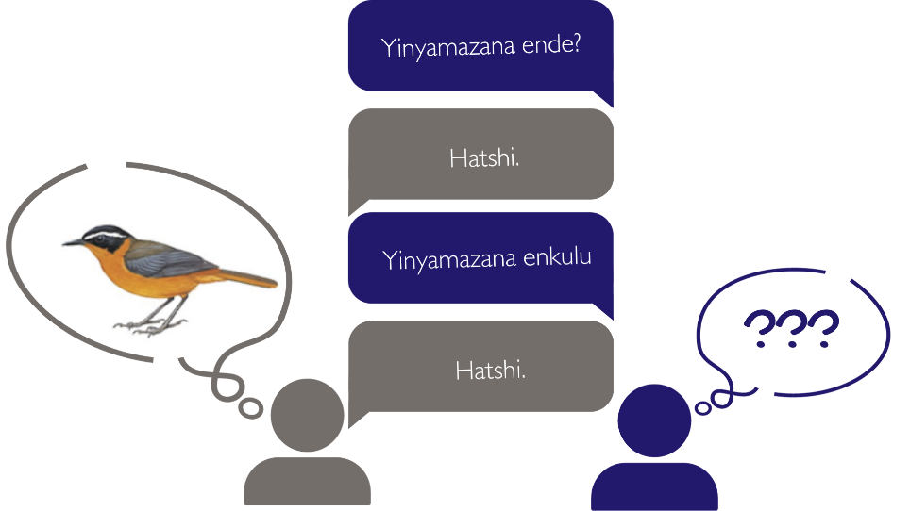
- Yakhela emutshweni omfitshane: Hlalani libe yisigombolozi. Umuntu lomuntu uyabuza lowu osesandleni sakhe sokudla umbuzo, “chaza iviki lakho ngamabala amalutshwana”. Olandelayo uyabuza umbuzo wokuthi, kuye, impendulo yawo ngumutsho omfitshane ophendule umbuzo odluleyo. Kube kulokhe kuhamba ngokulandelana kwabantu kuze kufike ekucineni.
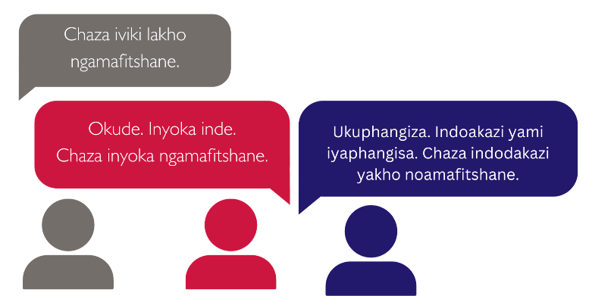
- Ingoma+ukugida: Ukuqala uhlelo, sebenzisa ingoma lokugida lamalunga eqembu kanye lalabo abanakekela abantwana (Caregivers)njengendlela yokwamukela amalunga eqembu lokubenza babeyingxenye yomhlangano.

2. Nxusa iqembu ukuthi likhulume asebekuzamile ezindlini zabo okuhambisana lalokhu okukhulunywe ngakho eqenjini lenu.
Isikhathi esikhuthazwayo: yimizuzu engamatshumi amabili lanhlanu
Umzekeliso wokuxoxisana lamalunga eqembu:
- ULead Mother: Ngenxa yokuthi sonke sesijayele sakhululeka, singaxoxisana ngesacina ukukhuluma ngakho njengeqembu. Kungaba lomuntu ongasitshela ngalokhu abakukhumbulayo ngento esicine ukukhuluma ngayo?
- [Ume isikhatshana umelele impendulo kubanakekeli].
- OLead Mother: Buza udingisisa ukuze ukhuthaze ukuxoxisana.
Indlela zokubuza udingisisa:
- Kuyini osukuzamile?
  - Usuke wazama indlela ezintsha zokwenza izinto?
  - Usuke wazama okunye okutsha esike sakhuluma ngakho okuphathelane lendlela ezikhuthazwayo zokwenza izinto?
  - Usuke wazama ezinye indlela ezintsha ezingathuthukisa impilakahle yemuli yakho?
- Kuyini okwakusiza ukuthi uzijwayeze indlela ezintsha ezikhuthazwayo?
- Kuyini ongakakuzami?
- Nxa ungakazami indlela ezintsha zokwenza izinto, kungani ungakazami?
- Usuke wasiza omunye ukuthi azame?
- Ngichazela okunye ngalokho
- Ukhona okuqembu obona ingani kunzima ukuzama lezi indlela ezikhuthazwayo?
  - Kuyini okwenza kubenzima ukulandela lezindlela?
  - Kuyini obona angani kungakusiza ukuthi uqale ukuzijayeza ukulandela lezindlela?
  - Kukhona okutsha osukuzamile ukuthi uxazulule ubunzima lobu?
  - Ukhona yini okuqembu olenkinga efanayo?
  - Yiziphi ezinye indlela zokuxazulula loluhlupho?
  - Singancedisana njani ukuze sixazulule loluhlupho?
  - Ukhona ongafisa ukuncedisa elinye ilunga leqembu na?
Indlela yokuqhuba isifundo (Facilitation Tip)
Lokhu kwenzelwa ukuthi ungaphindi umbuzo osuke wawubuza ngaphambilini.Sebenzisa usiba, iruler loba isandla sakho uukutshengisa lapho ociame khona ukubuza umbuzo.
Phakathi kwesifundo sokucabangisisa uzihlola ngezifundo esenzenziwe,usungama usebenzise eyinye yendlela eziqanjiweyo zokwamukela amalunga eqembu ukwenzela ukuthi babe lamadlabuzane nxa unanzelela ukuthi bangathi abakhululekanga njalo abaphatheki okusuthisayo.
Nxa amalunga bengakhululekanga ukukhuluma, abakhokheli babo bangabancedisa: 1) bangakhuluma ngasebeke bahlangana lakho, 2) bangakhuluma ngomunye mayelana ngalokho ake ahlangana lakho aseke wakhuluma ngakho ngesikhathi sokuxoxisana esedluleyo.

3. Ukuhlolwa/ukukhangelisiswa kwesifinqo sesifundo
Isikhathi esikhuthazwayo: yimizuzu elitshumi
Indlela yokuqhuba isifundo
Khuthaza ukukhangelisiswa kwezifundo ezihleliweyo ngemva kwesifundo lapho abanakekeli abanxuswa khona ukuthi bazokhuluma ngalokhu asebeke bakuzama ezindlini. Lokhu kulenjongo ezimbili: 1) kuyenza abanakekeli baphatheke bakhumbule okuqondileyo, 2) kunika abantu ithuba elifaneleyo lokusekela labo abalobunzima bokuzwisisa isifundo.
Abakhokheli bamaqembu bengasebenzisa isigaba lesi ukunxusa omama beqembu ukuthi babelane lokhu abakufundileyo esifundweni esadlulayo. Ungakwanisa ukucela omama beqembu ukuthi beqedise umutsho ngebala elilodwa elimqoka ngalokho abakufundileyo ngesifundo esadlulayo:
“Esifundweni esadlulayo, ngafunda kumbe ngakhunjuzwa ngokuthi…….”

4. Nxusa imbono emitsha ekuzinikeleni ekwenzeni okuxoxwa ngakho lendlela zokwesekana
Isikhathi esikhuthazwayo: imizuzu elishumi lanhlanu

1
USAID Advancing Nutrition is the Agency’s flagship multi-sectoral nutrition project, addressing the root causes of malnutrition to save lives and enhance long-term health and development.
This document is made possible by the generous support of the American people through the United States Agency for International Development (USAID). The contents are the responsibility of JSI Research & Training Institute, Inc. (JSI), and do not necessarily reflect the views of USAID or the United States government.

USAID ADVANCING NUTRITION
Implemented by:
JSI Research & Training Institute, Inc.
2733 Crystal Drive
4th Floor
Arlington, VA 22202
Phone: 703–528–7474
Email: info@advancingnutrition.org
Web: advancingnutrition.org
November 2023

