USAID Advancing Nutrition Peer Groups Implementation Research in Malawi
Prototype 1B: Look-and-Learn for Care Group Leaders
Table of Contents
Bukuli lakonzedwa pote 1
Chitsogozo choyendetsera Mikumano ya Look-and-Learn 2
1. Kulimbikitsa ma Promoters 2
2. Kutsogolera Mikumano ya Look-and-Learn 4
Kupempha Chilorezo 4
Kukhazikitsa Nthawi ndi Tsiku za Mkumano 4
Kukonzekeretsa Promoter 4
3. Kutsogolera Mkumano wa Look-and-Learn 6
Kukonzekeretsa Promoter 6
Kuunikira mmene Mkumano wayendera 7
Kulandira ndemanga 7
Mapeto 8

Bukuli lakonzedwa pote
Bukulu linakonzedwa kutengera ndemanga zomwe zinachokera kwama nyumba oyenderedwa, ma lidala ama cluster ndima promoter ama care group ochokera mmadera a mfumu yayikulu (T/A) Kuulunda, Mwanza, Msakambewa ndi Chakhadza, pothandizidwa ndi pulogalamu ya Akule ndi Thanzi. Buku li ndi malingaliro kutengera mavuto ndi mwayi omwe ulipo umene ungathandize kusintha makhalidwe okhudzana ndi care group. Izi zinachitika potengera mene anafotokozelera anthu amadera wa anafotokozelera pa msikokhano yomwe analinayo yomwe inaonetsa kuti mfundo zi ndizofunikira kwambiri pofuna kuthandizira kusintha makhalidwe. Zina za zovuta ndi mwayi omwe ulipo zomwe zinapezeka ndi monga izi: Chilakolako chama cluster leader kukhala ndi upangiri okwanira omwe angagwiritse pa ntchito yawo kuphatikizirapo kupanga kalondo londo.Komanso ma care group ena anafotokoza zamavutowa amene magulu ena afotokozera ndikupereka ndemanga zawo zimene zagwiritsidwa ntchito pophunzira kumfundozi ndikuyeselera kusintha zinthu zomwe zitha kugwiritsidwa ntchito ndimagulu ena.

Ndi ndani angagwiritse ntchito bukuli? | Mtsogoleri wa msonkhanowu ndi amane wayitana ma care group enea komanso a promoter.
Bukuli angaligwiritse bwanji ntchito? | Mtsogoleri wa msonkhanowu angagwiritse ntchito bukuli kuti limuthandazire polinganiza, kukonzekera ndi kutsogolera nkumano uwu wakuphunzira poonelera ena mene akuchitira.
Kodi bukuli ndi la ntchito yanji? | Bukulu ndilowatsogolera ma promoter komanso mtsogoleri wa care group amene wayitana anzake kuti amuyendere ku care group kwake pamene iye akulinganiza komamso kutsogolera nkumano uwu wakuphunzira poonelera ena mene akuchitira .  Nkumano wophunzira pakuonelera ena mene akuchitira umapereka mwayi woti:  - Ma care gropu amene abwere kuzaonelera, athe kutengapo gawo poonelera ndikuphunzira komanso kuchitira umboni za khama ndi luntha limene nzawo amene waayitanayo akuliwonetsa.  - Atsogoleri onse ama care group athe kutenga nawo mbali polingalira ndi kuperenga ndemanga, komanso kutenga nawo mbali pa ma luso  - Kulimbikitsa mgwirizano wapagulu pakati pama promoter a tsogoleri ama cluster.
Kodi anthu omwe akutenga gawo pomvetsera phunzilori ndi ndani? | Atsogoleri ama care group omwe achokera madela ena.

Chitsogozo choyendetsera Mikumano ya Look-and-Learn

Kulimbikitsa ma Promoters
Ma Promoters adzaphunzitsidwa za mmene angattsogolere za mikumano ya Look-and-Learn. Pophunzitsa ma Promoters, zochitika mmikumanoyi zikuyenera kufotokozedwa kuti ma Cluster Leaders amvetsetse cholinga ndi ndondomeko ya zochitikazo.
Cholinga cha Zochitika: Kupereka mwayi kwa ma Promoters kuti athe: 1) kuwona ma Care Group ena mmene akuchitira 2) kugawana ndemanga ndi ma Promoters ena, komanso 3) kuzindikira kulipereka kwa ma Promoters ena. Kupereka mwayi kwa ma Promoters kuti athe kuyenderana ndi njira imodzi yolemekeza ntchito ndi kuzipereka kumene ma Promoters akuchita pothandiza ma Care Group awo. Kuyendera ma Promoters ena ndi mwayi umene ma Promoters atha kuphunzira zambiri zokhuza mmene angatsogolere ma Care Groups wo, komanso kugawana ndemanga ndikukambirana zina zofunika zokhuza ma Care Group.
Ndondomeko ya Zochitika:
Njira ya Kulumikizana 1: Pofuna kutsogolera zochitika, Promoter atha kulumkizana ndi Mlangizi wa mdera wa Akule ndi Thanzi, kapena Mlangizi wa za umoyo wa mderalo (HSA) kuti asankha tsiku ndi nthawi zotii Cluster Leader athe kulandira ma Promoters kuti awonelere zochitika za mu Care Group yawo.
Figure: Communication cascade for logistical coordination option 1
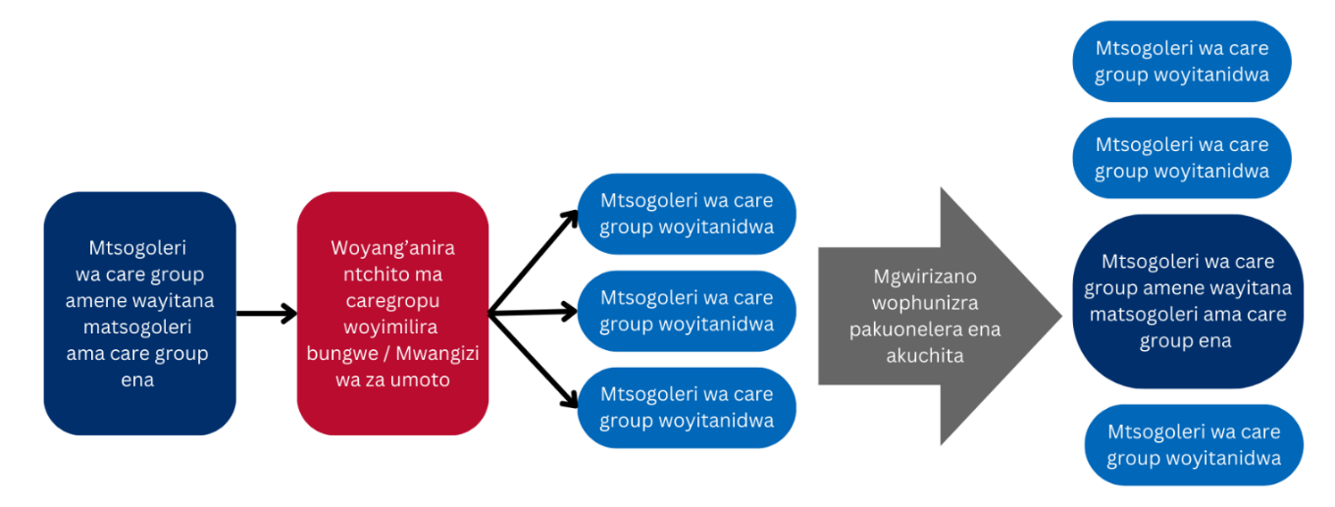
Njira ya Kulumikizana 2: Pofuna kutsogolera zochitika, promoter atha kulumizikizana mwachindunji ndi ma Promoters ama Care Group ena mmadera mwawo ndikusankha tsiku ndi nthawi zimene Promoter atha kulandira ma Promoters ena kuti awonelere zochitika mu Care Group yawo. Ma Promoters atha kusankha njira yoyenderana mosinthasintha ndi cholinga choti Promoter aliyense athe kulandira ma Promoters ena kuti awonele zomwe zikuchitika mu Care Group yawo mu chaka.
Figure: Communication cascade for logistical coordination option 2
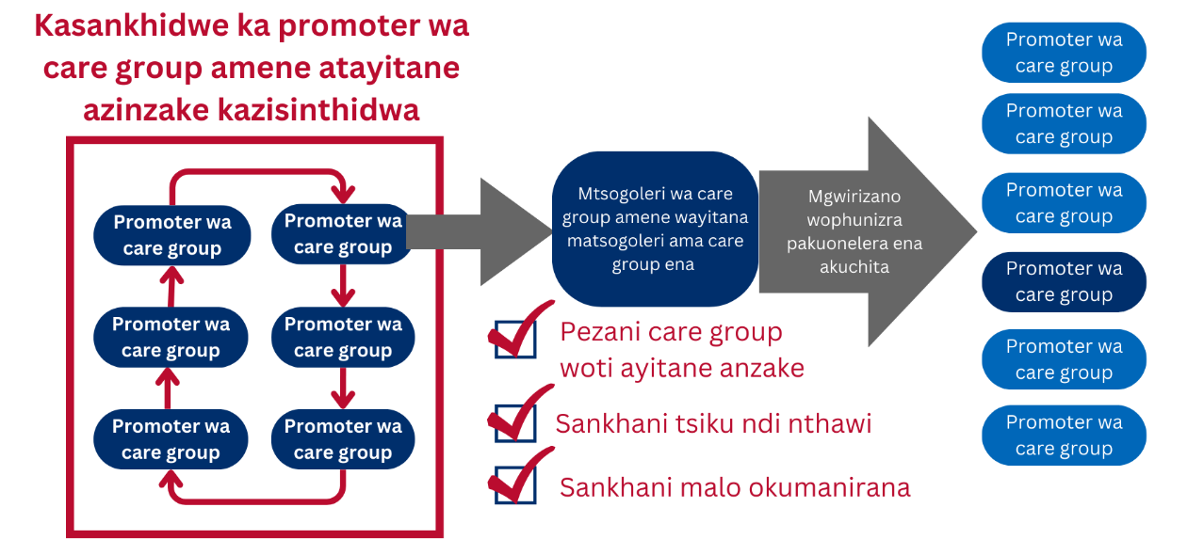
Chikumbutso: Mubukuli, anthu amene ali ndi undindi wo longaniza za nkumanowu akutchedwa ‘’wotsogolera mayendetsedwe a pulogalamu’’ .Izi zithandiza kuchepetsa kusokoneza anthu kusiyanitsa anthu omwe ali ndi udindo wotemnga nawo mbali zosiyana siayana mu pulogalamuyi
Mtundu wa Mkumano: Mikumano ya Kuyang’ana-ndi-Kuphunzira ili mu ma gawo awiri 1) Mkumano wa Care Group komanso 2) Zokambirana mbali zonse ziwiri. Mikumano ya Care Group isapyole mphindi 60 ndi cholinga choti ma Cluster Leaders athe kutenga nawo mbali mu zokambirana zimene ndi zosachepera mphindi 30 komanso zosapyola mphindi 60. Ma Cluster Leaders atha kubweretsa makope kapena malo oti atha kulemba mfundo za zokambiranazo.
Promoter atha kugawana ndi ma Cluster Leaders za zimene akuyembekera mu zowonelera zochitikazo.

Kutsogolera Mikumano ya Look-and-Learn

Kupempha Chilorezo
Ngati Promoter akufuna kutsogolera zokambirana za Kuyang’anira-ndi-kuphunzira, akuyendera kutsimikizira ndi kuonetsetsa kuti ma Promoters ena komanso ma membala ena a Care Group atenga nawo mbali mu mkumanowo. Chikalata chotsatirachi ndi chitsanzo cha mmene mungapemphere chilorezo ndipo Promoter atha kugawana ndi ma membala ena a Care Group. Chikalatachi chitha kugwiritsidwa ntchito ngati kukufunika kutero.
Chikalata chopempha chilorezo
Ine, [Dzina la Promoter] ndikufuna kulimbikitsa komanso kugawana upangiri wanga monga Promoter poyitana ma Promoters ena kuti adzawone zimene imodzi mwa ma Care Group athu ikuchita ndikugawana ndemanga zikatha zonse zochitikazo. Mkumano woterewu tikuutchula kuti Look-and-Learn ndipo mikumano yotereyi imathandiza pamene ma Cluster Leaders akuwonelera zomwe tikuchita. Kutenga nawo mbali mu mumanowu kudzathandiza kuti tipeze nzeru zina zimene tikakambirana ndi ma Promoters ena zikatha zochitikazi. Tikukupemphani kuti mutidziwitse ngati mwavomera kudzapezeka nawo pa zochitikazi kuti tithe kukonzekera moyenerera ndi ma Promoters ena.

Kukhazikitsa Nthawi ndi Tsiku za Mkumano
Mtsogoleri wa care group atha kugwira ntchito ndi oyendetsa za mikumano polinganiza ndikukonzekera za nkumano uwu wophunzira powonelera ena akuchita. Nkumanowu ukuyenereka kulinganizidwa mu nthawi yabwino ndi cholinga chakuti a tsogolera ama care group athe kukambirana komanso kupempha chilolezo kuma bajnja kwao. Nkumanuwu ungakhale bwino kuukhazikitsa potengera ma care group omwe ayandikana ndicholinga chakuti anthu asavutike kuyanga’ana ma thalasipoti.
Mutha kusankha: Mtsogoleri wa care group atha kuganiza ziwafotokozera mafumu za nkumano uwu wophunzira powonelera ena akuchita ndikuwayitan aku nkumanowu. Kapena mwa njira ina, mtsogoleri wa care group yu atha kupanga/ kukhazikitsa nkumanowu mogwirizan andi mafumu ndikuwayitana ma tsogoleri kuti azatenge nawo mbali aja.
Promoter amene akuyendetsa mkumano wa Look-and-Learn akuyenera kuwakumbutsa ma Promoters ena komanso ma Cluster Leaders ama Care Group ake za mmene mikumano ina ya Look-and-Learn idzakhalire akakumanso. Akuyenera kukumbutsidwa za tsiku, nthawi, komanso malo omwe mkumanowo udzachitikire, dzina la Promoter yemwe adzayendetse komanso kutumize ma uthenga. Ndizofunikanso kuwakumbutsa ozawoneleredwa kuti pazakhala owomneram komanso zizatega nthawi yambiri ndi choloinga choti azabwere okenzeka. Ndizofunikanso kuti promoter akumbutsidwe za mkumanowu koma mutu umene angazakambirane ndicholinga chakuto athe kukonzekera mokwanira. Ma Promoters atha kulimbikitsanso ma Promoters ena kuti adzabwele ndi makope kapena zipangizo zolembera ngati kukufunika kutero.

Kukonzekeretsa Promoter
Mu ndondomeko yoyamba ya kulumikizana, alangizi a Akule ndi Thanzi a ku dera kapena ma HSA atha kundandiza Promoter poyendetsa mikumano ya Look-and-Learn mu zochitika zitatu: Kufufuza, Kuyankha, Kuthandiza.
- Kufufuza: Powonjeza kukumbutsa ma Promoters amene akuyendetsa mkumana sabata limodzi tsiku lamkumano lisadafike, alangizi azaumoyo kapena a Akule ndi Thanzi atha kuyamba kufufuza za mmene Promoter akuganizira zokhuza mkumanowo. can check in on how the hosting promoter is feeling about their session. Kufufuza kutha kuchitika pamaso kapena pafoni. Mafunso amene akhonza kufunsidwa pofufuza ndi monga awa:
  - Kodi mukumva bwanji zokhudza mkumano wanu ukubwerawo?
  - Mukuganiza kuti ndi chiyani chimene chikuchititsa kuti muzimva zimenezi?
  - Kodi ndingakuthandizeni motani pokonzekera mkumano wanu ukubwerawu?
- Kuyankha: Ndi zofunika kuitana komanso kuthandizapo pamene tafunsidwa kutero. Kufufuza ndi njira imodzi yopereka mwayi kwa Promoter kuti athe kupempha thandiza kwa alangizi azaumoyo aku deralo. Promoter atha kupempha kuthandizidwa mwachindunji monga, “Mungandithandizeko kuti aliyense akhale panso?” kapena “Ndili ndi nkhawa ndi mmene zakuti zakuti zikukhalira”. Mu zonsezi, alangizi akuyenera kuthandizapo ngati kukufunika kutero
Uwunso ndi mwayi umene alangizi atha kulimnikitsa Promoter yo pom’kumbutsa za upangiri womwe ali nawo. Mwachitsanzo, ngati Promoter akudandaula za mikangano mu Care Group yawo, mlangizi atha kuwalimbikitsa powakumbutsa za nthawi inayake imene padali mikangano koma adakwanitsa kuthana nayo.
- Kulankhula mokweza kuti aliyense azikumvani
- Kumbutsani ma membala onse — Oyitanitsa anzawo ndi oyitanidwa — Ndi chilankhulo chanjii chimene chitagwiritsidwe ntchito pa nkumanowu pophunzitsa, kufunsa mafunso, kuyankha mafunso komamso kupereka ndemangaIzi ndizofunika kwambiri pofuna kuonetsetsa kuti wina aliyense akumvetsetsa zomwe zikuchitoika pa nkumanowu.
- Kulandira wina aliyense amene wafika pa nkumanowu ndikupitiriza nkumanowu nuja mupangira nthawi zonse (Mwachitsanzo, kuyamba ndi pemphero kapena nyimbo).
- Kusunga nthawi ndicholinga choti nkumanowun usapitilire nthawi yake.
- Pamapeto azokambirana, kufotokoza mwachidule zomwe zakambidwa.
- Momveka bwino kuyitana malingaliiro kuchokera kwa omwe anayitanidwa kuti malingalirowa athe kukonza komanso kusintha machitidwe azinthu.
- Kuthandiza: Pomaliza, ndi zofunika kuti alangizi akwaniritse malonjezo aliwonse pothandiza Promoter amene akuyendetsa mikumanoyo. Chimodzimodzinso, ngati Promoter yo akana thandizo lililonse, alangizi akuyenera kulemekeza chisankho cha Promoter yo ndipo awonetsetse kuti asapange zimene sadauzidwe kuti apange. Zokambirana za mu Look-and-Learn zimapereka mwayi pakuunikira njira zabwino zoprekera thandizo mtsogolo.

Kutsogolera Mkumano wa Look-and-Learn
Promoter woyendetsa mikumano ya Look-and-Learn ndi wotsogolera zokambirana za mbali ziwiri. Mkumana wa Look-and-Learn ukatha, ma membala a Care Group atha kuchoka kenako mtsogoleri oyendetsa za kulumikizana ayitane ma Promoters onse kuti ayambe zokambirana.

Kukonzekeretsa Promoter
Mkumano wa Look-and-Learn usadachitike, Mtsogoleri woyendetsa za kulumikizana ndi mikumano akuyenera kuphunzira ma Promoters za luso lowonelera. Izi zitha kuchitika nthawi ya maphunziro ama Promoters komanso akumbutsidwe kuti kuwonelera ndi njira imdozi imene ikuyenera kuchitika mkumano wa Look-and-Learn usadachutuke (izi zikuyenera kuchitika ndi ka gulu kakang’ono ka kunja kwa dera limene kukuyenera kuchitikira mkumano wa Look-and-Learn).
Izi zili choncho chifukwa mu nthawi imene zowonelera zikuchikita, sizikuyenera pakhale kusokoneza kulikonse. Kubwera kwa ma Promoters ena kudzawonelera kutha kubweretsa chisokoneza, choncho pofuna kuchepetsa zimenezi, ma Cluster Leaders akumene kukuchitikira mkumanowu akuyenera kupempha.
*Mfundo zowongolera nkumano ndicholinga chochepetsa chisokonezo kwa amene akutsogolera nkumanoyu (yemwe wayitana anzake)*  - Dongosolo lamakhalidwe – Atsogoleri ama care group omwe ayitanidwa atha kukhala mozungulira ma caregeroup omwe ali ndi zikambirana. Izi zichitike popereka mpata wokwanira molingalira kuti care group imene ili ndi nkumano ija ithe kukhala momasuka mene amakhalira nthawi zonse komabe molingalira kuti asatayane kwambiri ndicholinga chakuti atsogoleri ama care group ayitanidwa aja azimva mawo.  Mpata pakati atsogoleri ama care group omwe ayitanidwa utha kuthandiza kuchepetsa manong’onong’o omwe angasokomeze zokambirana pa nkumanowu. | Figure: Illustrative seating arrangement  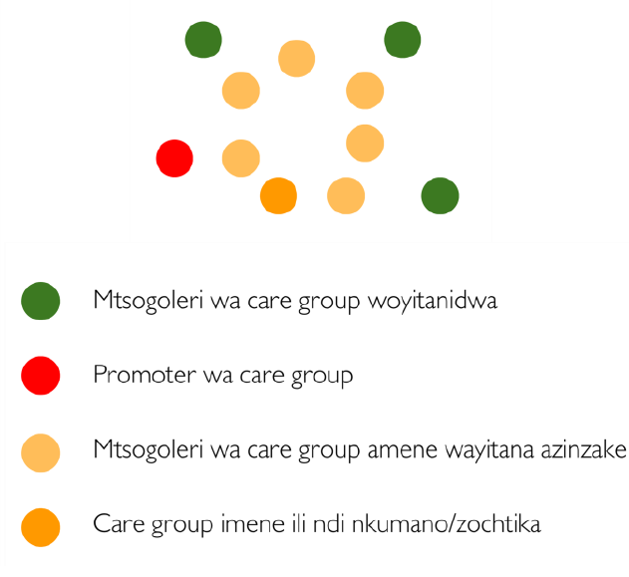
- Kuyang’anitsitsa mwakachete chete – Atsogoleri ama care group omwe ayitanidwa akuyenerakumvetsera ndi kuyang’anitsitsa mwakachete chete. Ngati atsogoleri ama care group omwe ayitanidwa abweretsa polembera, mtsogoleri wa care group amene wayitana azinzake uja akufunika awalimbikitse kuti azilemba zomwe akuwona kuphatikizira kulemba mafunso komanso maganizo omwe ngakhale nawo kuti akambirane kumapeto .
Nkumano usanayambe, promoter kapena ntsogoleri wa care group amene wayitana azinzake atha kusankha kufotokozera izi kwa a tsogoleri ama care group omwe ayitanidwa:
- Pewani manong’onong’o kapena zisokonezo zomwe zitha kusokoneza a care group kumvetsrea komanso kutenga nawo mbali pa nkumanowu.
- Sungani mafunso ndi malingaliro omwe muli nawo mpaka kumapeto ankumano wawo pamene a care group ake apita ndipo ndi nthawi yanu yoti mutha kukambirana ndi mtsogoleri wa care group amane wakuyiotaniyu. Mutha kulemba mfundo zanu kuti musaziyiwale.
Wotsogolera mayendetsedwe a pulogalamu akumbutse matsogoleri ama care group oyitanidwa kuti kutenga kwawo mbali kufun ika kumapeto pamene akukhala ndizokambira ndi mtsogoleri wa care group amene waayitana. Zitsanzo zamalangizo omwe angatsatiridwe alembedwa munsimu zomwe zitha kusinthidwa kutengera mene zinthiu ziliri.
Kutsatira nkumano omwe omwe unalipo lero, pakhala nthawi yomwe mtsogoleri amaen amapangitsa nkumanoyu atha kulingalira komanso ife amene tinayitanidwa titha kupezapo mwayi woti tipereke malingaliro athu a momwe zin tha zayendera. Atsogoleri ama care group oyitanidwa akuyembekezeredwa kutemga nawo mbali nthawi iyi imene titakhale tikucheza ndi zanthun amene watiyitanayu. Pamen mukuonelera zochitika, mutha kumaganizira mafunso awa omwe angakuthandizeni kupeza ndemanga:
- Ndi chani chimene mukuganiza kuti chayenda bwino pa nkumanowu?
- Ndi chani chimene mukuganiza kuti chinakapangidwa mwanjira ina yabwinoko?
- Kodi mwaphunzirako china chili chonse chachilendo chokudzana ndi kutsogolera nkumano chomwe mukuona kuti mutha kukagwiritsa ntchito ndi care group yanu?

Kuunikira mmene Mkumano wayendera
Mtsogoleri woyendetsa za kulumikizana komanso mikumano ayitane Promoter woyendetsa mkumanowo kuti apereke ndemanga zake zokhudza mmene mkumanowo wayendera. Kodi akuganiza kuti mkumano wayenda bwani? Kodi ma membala a Care Group amvetsetsa zophunzitsidwazo? Kodi ndi chiyani chimene akonda kwambiri mu mkumanowo? Ndi chiyani chimene angakonde chikuchitika kwambiri mu mkumanowo?

Kulandira ndemanga
Akamaliza Promoter kupereka ndemanga zake, mtsogoleri wotsogolera za kulumikizana ndi mikumano afunse ndemanga kuchokera kwa ma Promoter amene adabwera kudzawonelera pa mmene mkumanowo wayendera momga kayendetsedwe ka mkumano, kutenga mbali kwa anth amu Care Group mu mkumanowo, ndi zina zotero. Aliyense atha kuyamba kupereka ndemanga. Promoter woyendetsa mkumano atha kuyankha mafunso potengera amene wayamba kufunsa kapena potengera mfundo yomwe yafunsidwa monga mmene Care Group yachitsanzo ingakhalire, ma luso atsopano, njira zophunzitsira anthu akuluakulu, ndi zina zotero. Promoter akuyenera kuwalimbikitsa ma Promoter ena kuti zokambirana zikhala zopereka mwayi kwa aliyense kuyankhulapo kuti mapeto azonse nkumanga chimodzi.
* Chotsogolera * ngati atsogoleri ama care group omwe anayitanidwa sakutenga mawo mbali bwino bwino nthawi yazokambirana ija,wotsogolera mayendetsedwe a pulogalamu atha kuganizira zongulira potsatira wina aliyense kuti apereko maganizo/ malingaliro ake. Onetsetsani kuti zokambiranazi sizolozana chala kapena kunyizana, koma zothandizana wina ndi nzake. Chifukwa ngati anthu azinyozana, anthu ena sangazipereke kuzapangotsanso nkumano ngati uwu. Kumbukirani kumuuza mtsogolerin yemwe anayoitana zainzake uja kuti mfundo zomwe angalandira kuchokera kwa azinzake zikutanthauza kuti iye akupanga zolakwika ayi koma azinzakewo atha kukhala kuti misonkhanoi yawo amayipnga mosiyana ndi iyeyo nde akufuna apereke mfundo zamene iwo amapangira komanso akufuna aohunzire kwa iyeyo mene amapangira.

Mapeto
Pamapeto pa zokambiran, Promoter woyendetsa mkumano komanso mstogoleri wa kulumikizana ndi mikumano apereke ndemanga zomangirira zonse, kuthokoza ma Promoters onse amene adabwera ndi popereka ndemanga zawo. Mtsogoleri wa kulumikizana ndi ma Promoters ena onse athokoze Promoter oyendetsa mkumano chifukwa chowalandira ndi utsogoleri wake mu mkumano wa Look-and-Learn.
* Chotsogolera * Ngati wotsogolera mayendetsedwe a pulogalamu ndi promoter, promoter atha kusankha kulankhulako, kupemphera, kapena kuyimba nyimbo utsekera ankumanowu. Mwachitsanzo, athaa kukambako zamene iye waonera mene nkumanowu unayendera, kutsindika mwachidule zomwe ena nanena kale , komanso kuwonjezera zimene a promoter anena ndizina...
1
USAID Advancing Nutrition is the Agency’s flagship multi-sectoral nutrition project, addressing the root causes of malnutrition to save lives and enhance long-term health and development.
This document is made possible by the generous support of the American people through the United States Agency for International Development (USAID). The contents are the responsibility of JSI Research & Training Institute, Inc. (JSI), and do not necessarily reflect the views of USAID or the United States government.

USAID ADVANCING NUTRITION
Implemented by:
JSI Research & Training Institute, Inc.
2733 Crystal Drive
4th Floor
Arlington, VA 22202
Phone: 703–528–7474
Email: info@advancingnutrition.org
Web: advancingnutrition.org
December 2023

