Table of Contents
Background of this tool 1
Guidance for conducting a Look-and-Learn 2
1. Promoter Sensitization 2
2. Coordinating the Look-and-Learn 4
Seeking consent 4
Scheduling the session 4
Preparing the host care group leader 5
3. Facilitating a look-and-learn 6
Preparing the visiting care group leaders 6
Reflections from the hosting care group leader 7
Invitations for feedback 7
Conclusion and Thank You 8

Background of this tool
This guide was developed based on feedback from caregivers (“household beneficiaries”), cluster leaders, and care group promoters of care groups supported by Akule ndi Thanzi program in Kuluunda, Mwanza, Msakambewa, and Chakhaza Traditional Authorities (TA). It is reflective of the challenges and opportunities to support behavior change they described and prioritized in TA-level workshops. These challenges and opportunities included: a desire for increased capacitation among cluster leaders around care group technical content and monitoring processes, and many care group participants reported similar challenges which some groups have responded to through useful adaptations that could be adopted by other groups.

Who uses this tool? | The facilitators are a hosting Care Group Leader and Promoter
How do they use this tool? | The facilitators can use this tool to guide the coordination, preparation, and facilitation of a look-and-learn.
What is this tool for? | Guidance for promoters and a hosting care group leader to coordinate and facilitate look-and-learn sessions.  Look-and-learns offer an opportunity for:  - Visiting Care Group Leaders to engage in observational learning and recognize the dedication and efforts of their peer who is hosting the session  - All Care Group Leaders to participate in reflection and two-way feedback, as well as to practice soft skills; and  - To strengthen social bonds between Promoters and cluster leaders.
Who is the audience of the facilitator? | Visiting Care Group Leaders

Guidance for conducting a Look-and-Learn

Promoter Sensitization
Promoters will receive an introduction to the look-and-learn activity during their training session. During the sensitization, the activity should be explained so each care group leader (i.e. cluster leader who leads a care group composed of other cluster leaders) understands the purpose and process of the activity.
Activity Purpose: To offer a discrete opportunity for care group leaders to: 1) observe another care group, 2) share and receive feedback with one another, and 3) to recognize the dedication and efforts of other care group leaders. The opportunity to host fellow care group leaders is a recognition of the hosting care group leader’s dedication and commitment to providing high-quality support to their care group members. Visiting a fellow care group leader is an opportunity to learn about how others lead their care groups, and to share feedback and discuss reflections as a group of care group leaders.
Activity Process:
Logistical Coordination Option 1: To facilitate the activity, a care group leader can coordinate with their care group promoter, and Akule ndi Thanzi Field Supervisor or Health Surveillance Assistant to select a date and time for one cluster leader to host visiting care group leaders.
Figure: Communication cascade for logistical coordination option 1
Logistical Coordination Option 2: To facilitate the activity, a care group leader can coordinate directly with other care group care group leaders in their traditional area to select a date and time for one care group leader to host a look-and-learn session. The care group leaders may choose to adopt a rotating structure wherein look-and-learns are scheduled routinely such that each care group leader in a locality is able to host a session during the calendar year.
Figure: Communication cascade for logistical coordination option 2
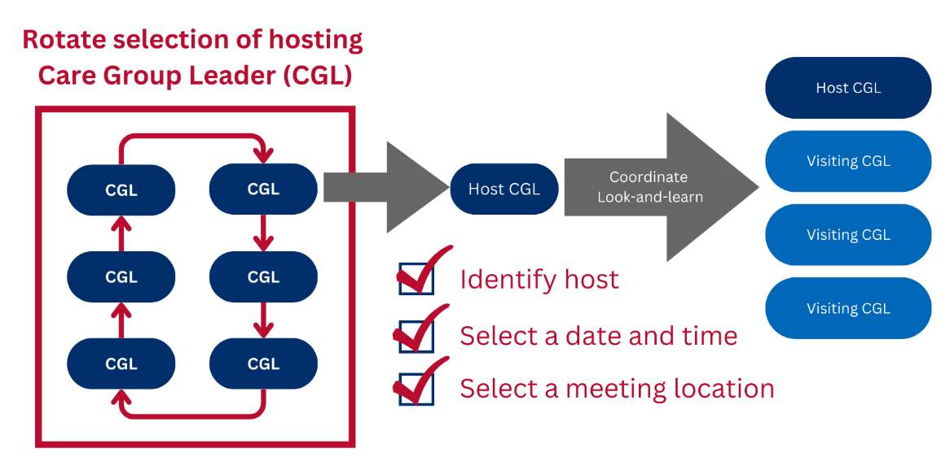
Note: In the remainder of this guide, the individual(s) responsible for logistical coordination are referred to as “the logistical coordinator”. This is to reflect the possibility of both options above and to reduce confusion in terminology.
Session Format: The look-and-learn session will consist of two parts: 1) a care group meeting, and 2) a two-way discussion session. The duration of the care group meeting should be no longer than 60 minutes so it is feasible for cluster leaders to participate in a discussion session that is no shorter than 30 minutes and no longer than 60 minutes. cluster leaders may wish to bring paper or note taking materials to the activity.
The Care Group Leader might also share expectations for “observation”. It is important for the promoter or the hosting care group leader to remind all participants to act as they normally would in a session, despite there being an ongoing observation. See section below “Preparing the visiting cluster leaders”.

Coordinating the Look-and-Learn

Seeking consent
When a care group leader is interested in hosting a look-and-learn, they should confirm that the other care group leaders are supportive and that members of their care groups consent to participate in such a session. The following illustrative consent memo can be shared by the care group’s promoter or the hosting care group leader with their care group to solicit consent. The illustrative consent memo can and should be adapted as needed.
Illustrative consent memo.
I, [Promoter/Cluster Leader Name], would like to strengthen and share my skills as a care group leader by inviting other care group leaders to observe one of our care group sessions and mutually offer feedback to one another after our session is over. This type of meeting is called a look-and-learn and impacts you only insofar as being observed by other cluster leaders. Your participation in the session will help inform the advice that I and the other care group leaders will discuss after our care group meeting is over. Please let me know if you agree to participate so I may make the necessary arrangements with the other care group leaders.

Scheduling the session
Care group leaders can work with the logistical coordinator to coordinate the look-and-learn sessions. The sessions should be coordinated with enough notice for visiting care group leaders to discuss and, as appropriate, seek approval from their spouses and family members. Scheduling the look-and-learn at the locality level may help to minimize the transportation needed.
Optional: Care group leaders might consider informing village leadership of the look-and-learn session and invite them to participate. Alternatively, care group leaders could schedule the session in conjunction with village leaders and invite their participation.
In the session prior to the look-and-learn, the promoter or hosting care group leader can issue a reminder to visiting care group leaders and hosting cluster leaders (i.e. hosting care group members) that their next session will be a look-and-learn. It is important to give both the visiting caregroup leaders, as well as the care group that will be observed, plenty of forewarning: at least a full day, so that everyone can feel adequately prepared. Ideally, four days in advance is a good amount of time to inform the host care group leaders that they will be leading a session and what the topic will be. The reminder should include the date, time, and location of the look-and-learn as well as the name of the hosting care group leader who sends the message. Care group leaders may add additional information as desired; for example, the care group leader might also suggest visiting care group leaders bring materials to take notes, if feasible and appropriate for the setting.

Preparing the host care group leader
In logistical coordination scenario 1, in addition to offering support during the activity, the care group promoter and Field Supervisor and/or HSA can support the hosting care group leader in advance of the look-and-learn with three key actions: Check-in, Respond, Support.
- Check in: Alongside a reminder to the hosting care group leader in the week prior to the look-and-learn session, the promoter and F ield Supervisor/HSA can check in on how the hosting care group leader is feeling about their session. The check in could happen virtually/over the phone or, ideally, in a face-to-face interaction. Questions the Field Supervisor/HSA might use to check in with the hosting care group leader could include:
  - How are you feeling about your upcoming session?
  - What do you think is contributing to those feelings?
  - How can I support you in preparing for the session?
- Respond: It is important to invite and respond to requests for support. The check-in is an opportunity for the promoter and Field Supervisor/HSA to invite requests for support from the hosting care group leader. The next step is to respond to those requests. The requests may be direct (such as, “Can you help me seat everyone?”) or indirect (such as, “I am worried about X-situation”). In instances where there are indirect requests, the Field Supervisor/HSA can offer options for how they could support the hosting care group leader if those situations arise.
This is also an opportunity for the Field Supervisor/HSA to encourage the hosting care group leader, by reminding her of skills they have demonstrated while serving in their role as a care group leader so far. For example, if the hosting care group leader is concerned about quarrels in their group, the Field Supervisor/HSA might encourage them by reminding the hosting care group leader of a time they managed to resolve a quarrel or of tools they can use to aid them in conflict resolution. This is a time to remind the facilitator of a few things:
- To speak loudly enough so that all can hear,
- Remind all members — both hosting and visiting — what language the session will be conducted in and what language in which the feedback will be given/received. It is important that everyone can understand all parts of the session.
- That they should conduct their care group as they normally would, even though there are visitors who are observing.
- To welcome everyone and proceed with normal welcome exercises (such as an opening prayer or song).
- To keep time so that neither the care group session or the feedback/reflection session go over time.
- To summarize the topics of discussion at the end of the session.
- To explicitly invite suggestions for improvement from the visiting care group leaders.
- Support: Finally, it is important that the Field Supervisor/HSA fulfill any promises of support that she makes to the host care group leader. Similarly, if the host care group leader refuses any support ideas, it is important that the promoter and Field Supervisor/HSA honor those refusals and not intercede where they haven’t been invited to do so during the care group session. The discussion session of the look-and-learn can provide an opportunity to reflect on the best ways to offer and provide support in future activities.

Facilitating a look-and-learn
The hosting care group leader is the lead facilitator of the two-way discussion; this is a chance for the HCGL and the VCGL to share feedback as well as their successes and failures as care group leaders. After the hosting care group leader concludes their care group session and their care group members have left, the logistical coordinator can invite visiting care group leaders into a circle for the discussion.

Preparing the visiting care group leaders
Prior to the look-and-learn, the logistical coordinator should capacitate care group leaders in “observation” skills. This could occur during a care group leader training session and include a reminder of observation best practices immediately before starting the look-and-learn session (i.e., in a small group outside of the hosting care group leader’s care group meeting place). Visiting care group leaders may wish to take notes on what they observe, or write down thoughts they have during the session, therefore, having easy access to paper and a pen/pencil is critical. Remind the visiting care group leaders that it is important that they remain engaged and paying attention to the whole session so that they do not give irrelevant or misplaced feedback.
In an ideal situation, observation is minimally disruptive or perceptible by those being observed. Because visiting care group leaders will be physically present during the care group session, there will be some disruption or perception of the session by the group members which may impact how they engage during the session.
*Facilitation Tips to Reduce Disruption of Hosting Care Group*  - Seating Arrangement – Visiting care group leaders can sit on the outside or around the care group with enough distance that the primary group can gather as they usually would, but close enough that the visiting care group leaders can hear.  Distance between visiting care group leaders can serve to reduce the temptation to have discussions or otherwise be disruptive during the hosting care group meeting.  - Quiet Observation – Visiting care group leaders to practice quiet observation and listening. If visiting care group leaders have brought note taking materials, the host care group leader could encourage them to write their questions and thoughts down for reflecting on during the two-way discussion.  The Promoter or Hosting Care Group Leader may choose to share the following reminders with visiting Care Group Leaders before the care group meeting starts: | Figure: Illustrative seating arrangement  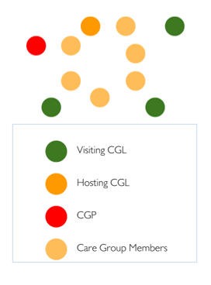
- Avoid side conversations or other disruptions that might distract care group members from their session
- Hold questions and suggestions for the hosting care group leader until after their care group members have concluded the session and left the space. You could consider writing them down, if you are worried you might forget them.
The logistical coordinator should remind visiting care group leaders that their participation will be expected during the feedback section. Sample instructions are included below, these can be adapted as necessary.
Following the care group session today, there will be time for reflections from the hosting care group leader and an opportunity for visiting care group leaders to give feedback. All visiting care group leaders will be expected to participate in the feedback session by sharing their thoughts and opinions. As you observe the session, you may consider these questions to help generate feedback:
- What did you think went well about the session?
- What do you think could have been improved?
- Did you learn anything new about facilitation that you will take back to your own care group?

Reflections from the hosting care group leader
The logistical coordinator could begin the session by inviting the hosting care group leader to share reflections on their session: What did they think about how the session went? Did the care group understand the material well? What did they like about the session? What would they like to see more of?

Invitations for feedback
After the hosting care group leader finishes their reflection, the logistical coordinator can ask them if they would like specific feedback on an aspect of the session (e.g., facilitation, group dynamics, etc.), or if they would like to open the floor to volunteered feedback. The hosting care group leader may opt to receive both. For the volunteered feedback, the hosting care group leader could consider asking for feedback from visiting care group leaders based on skills categories (e.g., quality dimension, soft skills, adult learning principles, etc.) or on a first-volunteer basis. The hosting care group leader should be encouraged to dialogue with the visiting care group leaders while receiving feedback with the aim to better understand the feedback. Prior to starting the feedback process, take a moment for the group to decide if they would like constructive feedback to be given in front of the whole group or individually.
* Tip * If participation from visiting care group leaders is lacking during the feedback section of the look-and-learn, the logistical coordinator may suggest going around the circle with each person offering a piece of feedback. Be sure to express that providing facilitation tips and feedback to colleagues is not meant to criticize, but rather to help each other. This can help by limiting the need for people to volunteer. Remember to let hosting care group facilitators know that any feedback or suggestions they might receive is not because they are doing something ‘wrong’, but because other CGLs conduct CGs differently and you would like to share expertise as well as learn from theirs.

Conclusion and Thank You
At the end of the session, both the host care group leader and the logistical coordinator, if distinct from the hosting care group leader, may wish to share closing remarks to summarize the day and thank visiting care group leaders for their attendance and thoughtful feedback. Visiting care group leaders and the logistical coordinator may also wish to thank the host care group leader for their hospitality and leadership as a look-and-learn host.
* Tip * If the logistical coordinator is the care group promoter, the promoter might choose to say a few words, conduct a prayer, or sing a song to close the session. For example, sharing reflections on how the session went, a summary of suggestions shared by others, additional suggestions from the promoter, etc.

1
USAID Advancing Nutrition is the Agency’s flagship multi-sectoral nutrition project, addressing the root causes of malnutrition to save lives and enhance long-term health and development.
This document is made possible by the generous support of the American people through the United States Agency for International Development (USAID). The contents are the responsibility of JSI Research & Training Institute, Inc. (JSI), and do not necessarily reflect the views of USAID or the United States government.

USAID ADVANCING NUTRITION
Implemented by:
JSI Research & Training Institute, Inc.
2733 Crystal Drive
4th Floor
Arlington, VA 22202
Phone: 703–528–7474
Email: info@advancingnutrition.org
Web: advancingnutrition.org
December 2023

Ideally, the Field Supervisors will develop a system for coordinating sessions that can be sustained beyond the life of the Akule ndi Thanzi program.

