Table of Contents
Mbiri ya Bukuli 2
Mmene Mungagwiritsire Ntchito Ndondomeko ya Chitsanzo 3
Ndondomeko ya Chitsanzo yothandizira Mkumano Wophunzira Luso Lapadera 3
1. Yambani Mkumano wanu ndi Malonje 3
2. Kusankhula momwe akulu akulu amaphunzilira 3
3. Kuyesera maluso ndi upangiri 3
4. Kutsogolera Kuunikira za Kuyesera zomwe takambirana 5
5. Funsani za ena amene angazipereke kuyetsera ma luso ndi upangiri watsopano potsatira ndemanga za mmene tingathandizirane wina ndi nzake 5
Uthenga otsogolera 5
Ophunzira achikulire/akuluakulu 5
Banki limene mutha kupezapo njiora zomwe mungawalandilire anthu ku nkumano 6
Luso lapadera 8
Kugwira ntchito limodzi mu gulu 8
Kuthana ndi mavuto 9
Kulumikizana 9
Kuphunzira kuchokera kukusintha 10
Kusamala nthawi 10
Luso lodziwa kukhala 11
Kudziwa za ntchito 11
Kuyamwitsa mwakathithti 11
Zokudya zowonjezera 12
Kudyetsa mwana yemwe wadwala 12
Chisamalira cha mayi apakati 12
Ukhondo ndi Madyedwe abwino 12
Kulera 13
Bank yachiwongolera cha mene mungapangire ntchito yalingalira 13

Mbiri ya Bukuli
Bukulu linakonzedwa kutengera ndemanga zomwe zinachokera kwama nyumba oyenderedwa, ma lidala ama cluster ndima promoter ama care group pothandizidwa ndi pulogalamu ya Akule ndi Thanzi ochokera mmadera a mfumu yayikulu (T/A) Kuulunda, Mwanza, Msakambewa ndi Chakhadza. Buku li ndi malingaliro kutengera mavuto ndi mwayi omwe ulipo umene ungathandize kusintha makhalidwe okhudzana ndi care group. Izi zinachitika potengera mene anafotokozelera anthu amadera wa anafotokozelera pa msikokhano yomwe analinayo yomwe inaonetsa kuti mfundo zi ndizofunikira kwambiri pofuna kuthandizira kusintha makhalidwe. Zina za zovuta ndi mwayi omwe ulipo zomwe zinapezeka ndi monga izi: Chilakolako chama cluster leader kukhala ndi upangiri okwanira omwe angagwiritse pa ntchito yawo; ndinso kuzindikiritsa kupelewera komwe kulipo kukhuzana ndi upangiri operekera mauphungu kuma nyumba oyenderedwa
Ndi ndani angagwiritse ntchito bukuli | Otsogolera nkumanowu ndi lidala wa care group
Bukuli angaligwiritse bwanji ntchito? | Mtsogoleri wa nkumanowu atha kugwiritsa ntchito chitsanzo chomwe chilipo kale chomwe atha kuchisitha kuti chigwirizana ndi nkumanowu. Pali mitu ingapo yomwe atha kusankhapo komanso zionetsero zomwe mtsogoleri wa nkumanowu atha kugwiritsa ntchito pokhazikitsa kapena kusankha cholinga chankumanowu.
Kodi bukuli ndi la ntchito yanji? | Kuthandizira ma lidala ama care group kuti aonjezere maluso omwe alinawo kale ndikumvetrsetsa kuti kodi munthu wamkulu amaphunzira bwanji ndicholinga chakuti akaonjezera malusowa, zitha kuwathandiza kupereka mauphungu apamwamba.
Kodi anthu omwe akutenga nawo mbali mu phunzilori ndi ndani? | Ma membala a care group (“cluster leaders”)

Mfundo zomwe zingathandize mtsogoleri wa mkumanowu kuti atha kulimbikittsa anthu omwe sakukhala omasuka kapena omwe akuchita manyazi kutenga nawo mbali
Mutha kukhala kuti mwaona kuti pali ma membala ena mu care group mwanu omwe sakhala omasuka kulankhula pagulu. Muli zichito chito zina zomwe zaikidwa mubukuli zoti mutha kugwiritsa ntchito kuti muwalandire mame,bala anu ndicholinga choti athe kukhala omasuka. Komabe,pali ma membala ena omwe anangobadwa amanyazi oti nthawi zambiri amakonda kungokhala chete. Kuti muonetsete kuti aliyense akutenga nawo mbali kuphatikizira ma membala omwe ndi amanyazi, mutha kugwiritsa ntchito mfundo zotsatirazi:
- Khalani ndi chidwi kuma membala omwe sakulankhula lankhula.; nthawi ina awonetsera kuti akufuna atalankhulako, onetsetsani kuti mwawapatsa mpata kuti alankhule ndipo wina aliyense akumvetsera zomwe akulankhulazo.
- Ngati pali anthu ena omwe akungolankhula omwe omwewo, onetsetsani kuti mwapemphakonso/ mwafunsakonso omwe sakulankhula kuti akuganzia bwanji, akumva bwanji za mfundo yomwe ikukambidwayo. Kuwatchula maina awo zitha kuthandizanso. Mwachitsanzo, mutha kunena kuti, ‘’Zikomo kwambiri kwa tonse amnene talankhulako kapena kuti taoerekako maganizo anthu; Grace iwe maganizo ako ndi otani pa nkhani yi”
- Pamene anthu amanyazi aja alankhula, onetsetansi kuti mwawalimbikitsa kuti azitenga nawo mbali, powathokoza, kapena kubwereza zimene anena pofuna konetsetse kuti mwamvetsetsa zomwe anena, komanso kutsimikizira kufunika kwa mfundo imene anena.
- Onetsetasni kuti aliyense amene akutenga nawo mbali akudziwa kuti palibe angalephere mu nkumanowu. Ndemanga zawo ndizofunika, ndipo palibe mfundo imenen ikhangale yolepherea kapena kuti yosakhonza. Kumbutseni wina aliyense kuti nkumanowu ndi malo amene atha kuyeseselera njira zina ndi zina posaopa kulephera kapena kuweruzidwa ndi anthu ena.

Mmene Mungagwiritsire Ntchito Ndondomeko ya Chitsanzo
Bukuli lakonzedwa kuti lithandize potsogolera zokambirana zokhudza luso ndi upangiri ndipo zokambirana zitenga nthawi yonse yomwe Care Group imakumana.

Ndondomeko ya Chitsanzo yothandizira Mkumano Wophunzira Luso Lapadera

1. Yambani Mkumano wanu ndi Malonje
Nthawi: Mphindi 20
Ma Cluster Leaders atha kusankha zisanzo zili munsizi ngati ntchito zoyambirira kuchita nthawi ya malonje:

2. Kusankhula momwe akulu akulu amaphunzilira
Nthawi: Mphindi 10
Anthu akulu akulu amaphunzira mosiyana ndi mene ana amaphunzilira.Kuti muthe kuthandiza akulu akulu kuti aphunzire ndikuyeselera maluso atsopano, ndizofunika kugwiritsa ntchito mfundo zomwe zimathandizilra akulu akulu kuti aphunzire.Ptomter atha kugwiritsa ntchito zomwe zalembedwa munsimu kuti atsogolere zokambirana zokhudza menen akulu akulu angaphunzilire.
Zolembalemba zokhala ndi zifanizo
- Promoter: Tsopano poti tachangamuka, tiyeni tiwunguze wunguze mfundo za momwe anthu akulu akulu amaphunzilira. Mfundo zimenenzi zititsogolera kutha kuthandizira anthu akulu akulu kuti athe kuphunzira ndikuyeselera maupangiri atsoppano.
Kodi mumadziwa chani zokhudzana ndi kaphunzitsidwe ka anthu akulu akaulu? Ndizosiyana bwanji ndi mene tingaphunzitsire ana?
[Dikiranin kaye kwakanthawi kuti munthe kumva mayankho ochokera kwama cluster leader]
- Cluster Leader: [kupereka mfundo zomwe akudziwa zokhudzana ndi mene anthu akulu akulu amaphunzilira]
- Promoter: Zikomo kwambiri [Tchulani mayina anthu omwe aperekako maganizo]. Mfundo zina zokhudzana ndi mene anthu aakulu amaphunzilira ndi izi, [tchulani mfundo zina zomwe sizinatchulidwe kale zokhudzana ndi mene anthu akulu amaphunziliira zomwe zili pa tsamba 7].

3. Kuyesera maluso ndi upangiri
Nthawi: Mphindi 50
Promoter atha kuyitana gulu kuti liyeselere upangiri kapena luso linaliri lonse pogwiritsa ntchito masewero omwe ayikidwa pa tsamba 9 soft skills bank kapena tsamba 13 technical competency bank mubukuli. Maluso kapena kuti maupangiriwa alembedwanso mu bokosi lomwe liri munsimu.Gulu liri lonse lisankhe upangir kapena luso limodzi lomwe akufuna akambirane. Ngati mukufuna kukhala ndi maluso anagapo oti mukambirane, onetsetsani kuti nkumanowu mwaupatsa nthawi yokwanira ndithu kuti muthe kuyeselera ma upangiri kapena maluso angapo.
kumbukirani ! Ndikofunika kuti nkumanowu usakhale ndizokambirana zambiri. Ndikwabwino kukhala ndi nthawi yokwanira yoti mutha kukambirana bwino zolinga za nkumanowu kusiyana ndikukambira zambiri zomwe anthu ena sangatha kuzimvetsetsa poti zochitika zachuluka.
Luso | Upangiri/ukadaulo wochitira zinthu
- Kugwira ntchito limodzi  - Kuganiza mokuya ndikupenza njira zothetsera mavuto  - Luso lodziwa kupereka uthenga moyenelera  - Kuphunzira kuchokera kusintha kwa zinthu  - Kusunga nthawi  - Luso logwirizana/lokhala anthu pamodzi | - Njira zakulera  - Kasamalilidwe kamunthu amene ndi oyembekezera  - Kuyamwitsa mwakathithi  - Zakudya zoonjezera kwa mwana amene akuyamwabe  - Kadyetsedwe ka mwana yemwe akudwala  - Zathanzi ndi ukhondo
Promoter afunse ma membala a Care Group kuti ayetsere luso kapena upangiri womwe ali nawo kudzera mu ntchito zli mumsimu. Mumsimu muli zina mwa zitsanzo za mmene Promoter anagsankhile ma luso ndi upangiri mu mkumano.
Chitsanzo:
● Promoter: Tsopano, tiyeni tikambirane za ma luso ndi upangiri zomwe zimene tikufuna kukambirana lero. Kodi pakati pathu pali yemwe ali ndi upangiri kapena luso lililonse loti tikambirane?
[Dikirani mumve ndemanga kuchokera kwa ma Cluster Leaders. Ngati wina apereke mfundo zoyenera kukambirana, kumbukirani kuwakumbutsa ma Cluster Leaders za ma luso ndi upangiri zimene mungathe kukambirana]
● Cluster leader: [Kupereka ndemanga ya ma luso ndi upangiri]
● Promoter: Zikomo! [maina a anthu amene apereka mfundo zoyenera kukambirana]. Tiyeni tikumbukire kuti zimatanthauza chiyani tikamati luso kapena upangiri. [Perekani tanthauzo komanso chitsanzo cha luso kapena upangiri potengera ndi bukuli]. Kodi alipo ali ndi funso lili lonse pa mfundoyi kapena tanthauzoli?
[Dikirani mumve mayankho komanso mafunso kuchokera kwa ma Cluster Leaders, ndipo yankhani kuti anthu amvetsetse monga kukuyenera kutero]
● Promoter: Tsopano tadziwa komanso kumvetsetsa za luso kapena upangiri ndi chiyani. Tiyeni tipange ntchito yoyetsera zomwe taphunzira.
[Sankhani ntchito imodzi mu buku lino yoti muyetsere pa luso ndi upangiri.]
Lingaliro: Ngati muli ndi nthawi yokwanira mu chigawochi, , ma promoter mutha kuganizira kuonejzeranso masewero kapena zisudzo zomwe zingagwirizane ndi luso kapena upangiri omwe mwasankha. Mwachitsanzo, cluster leader atha kupannga zionetsero zophunzitsa momwe angapangire pa luso kapena upangiri omwe wasankhidwa.

4. Kutsogolera Kuunikira za Kuyesera zomwe takambirana
Nthawi: Mphindi 20
Promoter atha kuuza/ kuyitanira gulu lonse kuti atenge nawo mbali mu masewero owunikira zamene awonera nthawi imene amakambirana za upangiri ndi maluso osiyana siyana. Mafunso okhudza malingaliro amanenewa ayerekezedwa ndipo ayikidwa pa tsamba 7 la bukuli. Promoter atha kusankhako mafunso atatu kapena asanu kuchokera kuchigawo chimenechi, omwe angathe kugwiritsa ntchito pounikra zomwe zayeseleledwa.
Lingaliro: Mu nthawi ya kuunikirayi, uzani ma membala a care group kuti akweze manja awo panthawi imene akufuna kulankhula kapena kugawana ndi gulu lonse maganizo awo. Promoter tsono atha kutchula munthu mmodzi mmodzi yemwe wakweza dzanja kuti alankhule, molingalira kuti aliyense atengepo gawo. Ngati pali ma membala ena omwe sakutenga nawo gawo, mutyha kuganizira zowatchula omwe angokhala chete wo kuti agawane ndi anthu maganizo kapena malingaliro awo pa mfundoyi.

5. Funsani za ena amene angazipereke kuyetsera ma luso ndi upangiri watsopano potsatira ndemanga za mmene tingathandizirane wina ndi nzake
Nthawi: Mphindi 5
Promoter afunse anthu amene angaziperele kuti ayetsere maluso ndi upangiri potsatira ndemanga zimene zaperekedwa kuti tingathandizane bwanji wina ndi nzake ngati ma Cluster Leaders. Promoter afunse ma Cluster Leaders kuti, Kodi tingathandizane bwanji tokhatokha kuti tikhale ndi maluso amene tayetsera lerowa?
Promoter ayitane Cluster Leader aliyense kuti apereke ndemanga zake za mmene angathandizire wina mu Care Group yawo.

Uthenga otsogolera
Ndime zotsatirazi zakonzedwa kuti zipereke mfundo zina zowonjezera za mmene tingaphunzitsire anthu aakulu akulu, za zosowa zawo komanso ntchito zimene ma Promoter atha kugwiritsa ntchito popereka maphunzirowa.

Ophunzira achikulire/akuluakulu
Akulu ndi osiyana ndi ana. Kuti tiwaphunzitse moyenerera, tikuyenera kumvetsetsa za mfundo zina zimene zingathandize kuphunzitsa anthu akulu akulu kuti athe kumvetsetsa mosiyana ndi ana. Pali mfundo zisanu ndi ziwiri (7) zimene zikuwonetsa kuti anthu akulu akulu amaphunzira mosavuta ngati…
- Phunziro lakhudza gawo la zimene akumana nawo moyo wawo
Chitsanzo: Popereka uphungu kwa nyumba yoyenderedwa wokhudzana ndi ubwino womudyetsa moyenera mwana amene akudwala, Mai a Ruth atha kugawana nafe mene ankadyetsera mwana wawo nthawi imene amadwala.
- Ophunzirayo akutenga nawo mbali mukuyetsera zomwe zaphunziridwa komanso kukhala ndi mwayi wothana ndi mavuto amene akukumana nawo poyetsera luso latsopano
Chitsanzo: Pothandiza mai amene akuvutika kuika mwana wake kubere. Mai a Chisomo athandiza mayi yu kumuonetsera njira zosiyana siyana zomwe angathe kugwitsa ntchito kuti mwana wake athe kumuika ku bere bwino bwino, kusiya ndikungomuuza njira zomwe atha kugwiritsa ntchito kuti mwana azimuika ku bere bwino bwino.
- Ophunzira akutha kugawana ndi ena zomwe aphunzira zatsopano
Chitsanzo: Titatha kuphunzira za zakudya zomwe tingamupatsa mwana amene akuyamwabe, Mai a Blessings aphuniztsa mchemwali wao yemwe alinso ndimwana wang’ono za kufunika komupatsa zakudya zoonjezera mwana amwene watha miyezi isanu ndi umodzi.
- Ophunzira ali ndi nthawi yokwanira yopereka ndemanga za mmene maphunzirowo akuyendera
Chitsanzo: Titatha kuphunzira za njira zosiyana siyana zokhudzana ndikulera, amanyumba oyenderedwa apatsidwa nthawi kuti atha kufuna mafunso ndicholinga choti amvetsetse za phunziroli.
- Ophunzira akuchilimika kutengapo mbali pochita zomwe aphunzira
Chitsanzo:: Titatha kuphunzira za zakudya zomwe tingamupatsa mwana amene akuyamwabe, manyumba oyenderedwa ayitanidwa kuti azipereke poonetsetsa kuti akugwiritsa ntchito maphunzirowa podyetsa mwana wao munjirayi.
- Ophunzira akutha kusankha mwaokha za mmene akuyenera kuphunzirira, njira ndi nthawi yophunzirira zokomera iwo eni
Chitsanzo: Mmalo mokhala ndi maphunziro oti alemebdwa kale oti atsatiridwe pankumanowu, funsani manyumba oyenderedwawa ngati pali phunziro limene akulakalaka athaphunzitsidwa.
- Ophunzira akuyamikiridwa pa zimene akutha kuchita bwino
Chitsanzo: Mai a Ruth anyadiridwa popitiriza kuyamwitsa mwakathithi kwa miyezi isanu ndi umodzi.
Promoter atha kugwiritsa ntchito bukuli potsogolera mkumano wophunzitsa maluso. Mu mkumanowo, Promoter ayitane ma Cluster Leaders kuti apereke ndemanga za zimene ma Care Group awo akumana nazo poyetsera luso lastopano zimene aphunzira mweiz watha. Ndime zotsatirazi ndi chitsanzo cha mmene ma Promoters akhodza kuyendetsera mikumano za maluso atsopano. Ndime iliyonse ili ndi nthawi imene zochitikazo zingatenge ndi mfundo zothandizira mmene mungatsogolere zokambirana.

Banki limene mutha kupezapo njiora zomwe mungawalandilire anthu ku nkumano
Cluster Leaders atha kusankha njira imodzi mmunsimu (kuonjezera ku nyimbo kapena kuvina) imene angathe kugwiritsa ntchito polandira anthu kapena atha kupeza njora in ayomwe siili pa ndandandawu imene akuona kuti atha kugwiritsa ntchto polandira anthu.
- Kuyumba nyimbo kapena kuvina: Itanani ma membala a care group kuti aliyense awuze anthu ena dzina lawo ndiponso afotokoze mene akumvera lero pogwiritsa ntchiro mau amodzi okha. Kenako, kumayambiliro komwe pamene simunalandire anthu, itanani ma membala a care group kuti alingalireko kapena kuganizirako za nyimbo kapena mavinidwe odziwika ndi wina aliyense ndicholinga choti wina aliyense athe kudzuka ndikutenga nawo mbala.
- Kenako, itanani ma membala kuti alingalireko kapena kuganizirako za nyimbo kapena mavinidwe odziwika ndi wina aliyense pa care group po musanayamba zochitika zatsikuli. Onetsetsani kuti anthu ambiri akudziwa nyimbo kapena mavinidwewa ndicholinga chakuti ma membala ayambitse nyimboyi osati mtsogoler (makamaka kuopnetsetsa kuti amadziwa mau amu nyiboyi kapena ndondomeko zonse za kavinidweka).
- Ndikuyamikia.: Itanani ma membala a Care group ndipo aliyense agawane ndi anzake zimene angathe kuyamikirana okhaokha mu Care Group yawo. Membala wina aliyense akhoza kuyankhula mbali yake kuti “Ndikuyamikira….” Nkutchula dzina la munthu amene akufuna kumuyamikira mu gulu lawo. Zikuyenera kuti aliyense ayamikiridwe pa chinachake.
Cluster Leader atha kuyamba kuyamikira ndikumpatsira 1) membala wina yemwe ali kumanjaka kwake, kapena 2) munthu amene akumuyamikirayo kuti nayenso apitilize.
- Jambulani nzanu oyandikana naye: Gawani Care Group mmagulu a anthu awiri awiri. Gulu lililonse la anthu awiri afunsane za mmene moyo wawo wa tsiku ndi tsiku ukuyendera, monga, “Kodi mwavala chiyani?”, "Kodi mumapanga chiyani mukangodzuka kumene?", ndi zina zotero. Pamene wina akuyankha, wina azijambula zimene nzakeyo akufotokoza pogwiritsa ntchito pensulo kapena peni ya utoto pa pepala.
○ Ganizo loyamba: Munthu mmodzi afunsa mafunso nzake kwa mphindi 4, kenako asinthane kuti yemwe amayankha mafunso akhale ofunsa mafunso nzake tsopano.
○ Ganizo lachiwiri: Ma membala onse afunsa mafunso ndikujambula zimene oyankha afotokoza aliyense za nzake. Zikatha mphindi 8, gulu lililonse ligawane ndi anthu zimene akambirana ndi zojambula zawo.
● Kufufuza utawaleza: Gulu lililonse lifufuze chinthu chimodzi kapena zingapo kuchokera pa makalala a utawaleza umene ukuoneka pafupi nanu. Ndi makalala ofiira angati amene mukuona? Nanga makaka a chikasu? Obiliwira? Ndi zina zotero.
● Lingalirani za nyama zakutchire: Gawani magulu a anthu awiri awiri ndipo wina aliyense pagululo asankhe nyama imodzi. Gulu lilonse, lingalirani za nyama imene nzanu waganiza ndipo mayankho ake akhale “Inde kapena ayi” ku mafunso okhuza nyama imene mwalingalira mpaka mutalondola nyama imene nzanu walingalirayo.
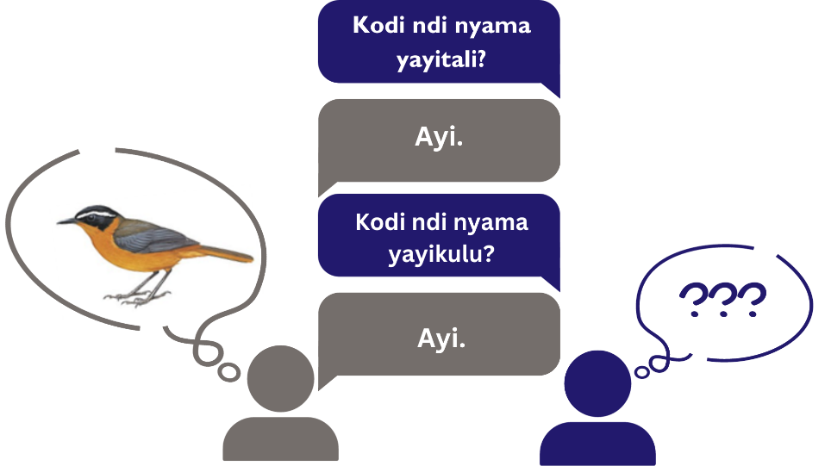
● Kupanga mawu: Khalani mozungulira. Aliyense afunse nzake ku mbali yaku manja kwake kuti afotokoze kuti sabata lawo likakhala lotani mwachidule ndi mawu amodzi, angafotokoze bwanji za sabata yawo mmene imayendera? Funsanani mozungulira wina ndi nzake mpaka aliyense afunsidwe.
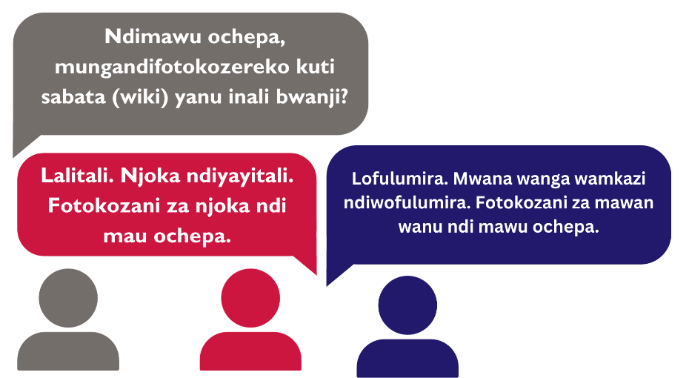

Luso lapadera
Sankhani limodzi lama luso omwe ali munsimu kuti mukambirane komanso kuyesezera pogwiritsa ntchito ndondomeko yomwe yaperekedwa.

Kugwira ntchito limodzi mu gulu
Kugwira ntchito limodzi mu gulu ndi kuthekera kwa anthu awiri kapena kuposera apo komwa ali nako kogwirira n tchito limodzi kuti akwaniritse zolinga ndi masomphenya a gulu.
Chitsanzo chogwirira ntchito limodzi: Amayi ake a Ruth akufuna kuphika chakudya pakhomo pawo. Amayi ake a Ruth apempha amuna awo kuti akagule zofunika kumsika pamene iwo atengana ndi apongozi awo kukapeza zofunika zina ku dimba. Pamene mayi ake a Ruth apeza zonse zofunikira kuti aphike chakudya, iwo ndi apongozi awo ayamba kuphika limodzi, kenako onse ndi kugawa chakudya chija.
Kuchita ntchito yoyetsera:
● Yetsani: Ma membala a Care Group akhale mma gulu awiri mu nambala yogawika ndi 2. Gulu lililonse litumize munthu mmodzi kuti ayende kapena athamange mtunda wotalika ma mita 5-10. Munthu uja akafika wa gulu linalo, gulu linanso litha kutumiza wina, cholinga ndi choti gulu lililonse lithe kutumiza ma membala onse kuposa anzawo a gulu linalo.
● Kugawana zochita: Mumagulu aanthu awiri kapena kuposera apo, pezani ntchito inayake yapakhomo ndipo gwirani limodzi mpaka ithe ntchitoyo. Izi ndi monga kuphika chakudya, kusamalira pakhomo kapena kusamalira dimba.

Kuthana ndi mavuto
Kuthana ndi mavuto ndi kuthekera kwa anthu awiri kapena kuposera apo kuti adziwe kuti vuto lawo ndi chiyani komanso kugwira ntchito limodzi kupeza mfundo zothandizira kuthana ndi vutolo. Kuthana ndi mavuto zimafuna kuganiza mozama.
Chitsanzo: Amayi a Laurette akuvutika kuti ayamwitse bwinobwino mwana wawo wa khanda wa masabata awiri. Amayi a Laurette akufunsa anzawo amu Care Group, “Kodi ndingapange bwanji kuti mwana wanga aziyamba bwinobwino?” Onse ayamba kukambirana za vuto limene limapangitsa kuti mwana asayamwe bwino bwino komanso agawana nawo zimene ena akumana nazo kuti zithandize kuthana ndi vutolo.
Kuganiza mozama ndi njira imene munthu amaunikira zimene akudziwa ndi zimene adutsamo ndikugwiritsa ntchito zimenezi kuti athane ndi zomwe akudutsamo munthawiyo. Nthawi zina zimachititsa kuti munthu atengepo gawo losintha mmene zinthu zikuyendera mu nyengo imeneyo.
Chitsanzo: Promoter wa Care Group ya Amayi ake a Mfufu walandira uthenga wadzidzi umene wapangitsa kuti asabwele ku mkumano wa Care Group. Amayi ake a Mfufu afufuza za zimene akhala akudutsamo, zomwe aphunzira ndi kuthekera komwe ali nako kuti akhodza kukumana ndi ma Cluster Leaders ena popanda Promoter potengera ndi zomwe akumana nazo ndi upangiri omwe ali nawo polimbikitsa makomo amene amayenderedwa. Kenako apanga mkumano ndi ma Cluster Leaders ena ngakhale Promoter palibe tsikulo.
Ntchito zoyetsera:
● Nyamulani nyemba: Ma membala a Care Group akhale mma gulu a anthu awiri awiri kuti aluke basiketi imene ingathe kunyamula nyemba zisanu (5). Basiketiyo ilukidwe potengera zipangizo zimene nzopezekeratu mu Care Group yawo. Ikadutsa nthawi, gulu lililonse lithe kuonetsa zimene apanga kuti anthu awone basikete imene ikugwira ntchito moyenerera.
● Kumasula Mfundo: Ma membala a Care Group ayime mozungulira agwirane manja ndi nzake wina kumanja wina kumanzere. Ma membala a Care group akuyenera kugwirira ntchito limodzi kumasula fundo popanda kusiyana kugwira manja ndi cholinga choti akhalebe mozungulira atagwirana manja ngakhale akugwirira ntchito limodzi.

Kulumikizana
Kulumikizana ndi kuthekera kumene munthu ali nako kuti akhoza kupereka uthenga kwa munthu wina kapena gulu pogwiritsa ntchito mawu kapena zizindikira koma anthu ndikumvetsetsa uthenga ukuperekedwawo.
Chitsanzo chopereka uthenga pa mawu ndi monga: Amake a Laurette akupempha kapena kupereka malangizo
Chitsanzo chopereka uthenga kudzera mu zizindikiro: ndi Amake Ruth kunyatsitsa nkhope. Amake Laurette atanthauzira kuti ndiye kuti Amake Ruth sanazikonde zimene zikuyankhulidwazo. Amake Laurette atha kufunsa Amake Ruth ngati maganizo awo ali owona.
Ntchito:
● Kuganiza mau: Mu zochitika izi ma membala a Care Group azitchula mawu kwa ma membala ena kuti aganize. Poyamba, Promoter akuyenera kupeza mawu amene ma membala onse a Care Group atha kuwazindikira. Gulu lililonse lidzitenga nawo mbali poganiza komanso potchula mawu. Ikakhala nthawi yawo, Promoter azinena mawu ku gululi koma gulu lina lisamve nawo, kenako gulu linalo liziganiza kuti kodi mawu ake ndi otani. Ma membala a Care Group yonseyo aziyetsetsa kuti aganiza za mauwo.
● Phone: Membala mmodzi apereka mau ndipo ma membala ena ayambe kuuzana monong’ona wina ndi nzake mpaka aliyense amve kut kodi mawuwo ndi otani. Fananizani mauwo kuchokera kwa munthu amene adawamva koyambirira ndi amene wawamva komalizira ngati akufana.

Kuphunzira kuchokera kukusintha
Kuphunzira kuchokera kukusintha ndi kuthekera kumene munthu kapena anthu ali nako kuti akhoza kuyamba kuchita zinthu mosiyana potengera ndi kusintha kwa zochitika. Ngati mmene zilili ndi kuthana ndi mavuto, kuphunzira kuchokera kukusintha kumakhuza kuganiza mozama komanso kupereka ndikulandila uthenga.
Chitsanzo: Promoter wa Care Group ya Amake Mpfufu walandira uthenga wadzidzi umene wapangitsa kuti asabwele ku mkumano wa Care group. Amake Mfufu ndi anzawo mu Care Group yawo akugwirira ntchito limodzi kuyendetsa mkumano wa Care Group ngakhale Promoter palibe.
Ntchito:
● Kusintha lamulo: Ntchitoyi ndiyofuna kuthandiza ma Cluster Leader kuti azitha kuphunzira ngati pali kusintha kwa malamulo. Anthu ayambe kuwerenga ma nambala 1 mpaka 10 ndipo aliyense azitchula nambala imodzi. Munthu amene atchule nambala 10 azipereka lamulo, kenako anthu ayambenso kuwerenga 1 mpaka 10 ndipo wa nambala 10 aperekenso lamulo monga “ombani mmanja mukatchula 2” kapena “Imilirani mukatchula 4”, ndiye kuti anthu awerenganso ma nambala 1 mpaka 10 koma atsatira lamulo lomwe laperekedwalo. Izi zitha kuchitika mobwerezabwereza.
● Nyimbo: Sankhani nyimbo yoti anthu ambiri akuidziwa. Gulu lonse thandizanani kusintha mawu ena mu nyimboyo koma uthenga wake ndi tanthauzo lisasinthe.

Kusamala nthawi
Kusamala nthawi ndi kuthekera kumene munthu ali nako kugawa nthawi yochitira zinthu, kuyamba ndi kumaliza ntchitoyo poanda kulowelera nthawi ya ntchito zina.
Chitsanzo: Amake Mpfufu ali ndi mkumano wa Care Group 1 koloko masana komanso akudziwa kuti akuyenera kuti amudyetse mwana wawo isadakwane nthawi imeneyo. Amake Mpfufu akudziwa kuti kuphika chakudya chamwana zimatenga mphindi 30 komanso kuti ayende akafike ku mkumano wa Care Group. Atenge mphindi 30 kuphikira mwana chakudya komanso kuyenda kukafika ku mkumano popanda kutaya nthawi.
Ntchito:
● Kuona nthawi: Ma membala a Care Group aapeze ntchito yapakhomo kuti agwire komanso ayerekezere kuti itenga nthawi yochuluka bwanji. Mwachitsanzo, “Kodi mungamvetsere mobwerezabwereza kangati nyimbo yanu yapamtima ija kuti mumalize ntchito imeneyi?” Ma membala a Care Group ayetsere ndikuona kuti ntchitoyo yatenga nthawi yayitali bwanji potengera ndi mmene nyimboyo yabwerezedwera.

Luso lodziwa kukhala
Luso lodziwa kukhala ndi anthu ndi kuthekera kumene munthu amakhala nako komvetsera, kuzizindikiritsa yekha ndi ena komanso kukwanitsa kumemeza anthu kuti akhale paumodzi ndikuthetsa mikangano mwamtendere.
Chitsanzo: Amake a Blessings ndi wotopa kwambiri chifukwa chogwira ntchito tsiku lonse kudimba. Anzawo awafunsa funso limene lawakhumudwitsa. Mmalo mowabwenzera kapena kuyankha mowapsyera mtima, azizindikiritsa ndi iwo powamvetsetsa ndikuwamvera chifundo ndikuwayankha mwaulemu.
Ntchito:
Kufufuzana wina ndi nzake: Ma Cluster Leaders agawe ma membala a Care Group mmagulu a awiri awiri koma aliyense akhale ndi nzake watsopano. Magulu amenewa aliyense afunse nzake kuti “Kodi sabata lanu layenda bwanji?”, “Kodi anthu apabanja panu ali bwannji?”, ndi mafunso ena otero.

Kudziwa za ntchito
Ndime ino ndi yokhuza chidziwitso cha mfundo zophunzitsidwa mma Care Group monga “Za madyedwe abwino,” ukhondo, komanso kulera.

Kuyamwitsa mwakathithti
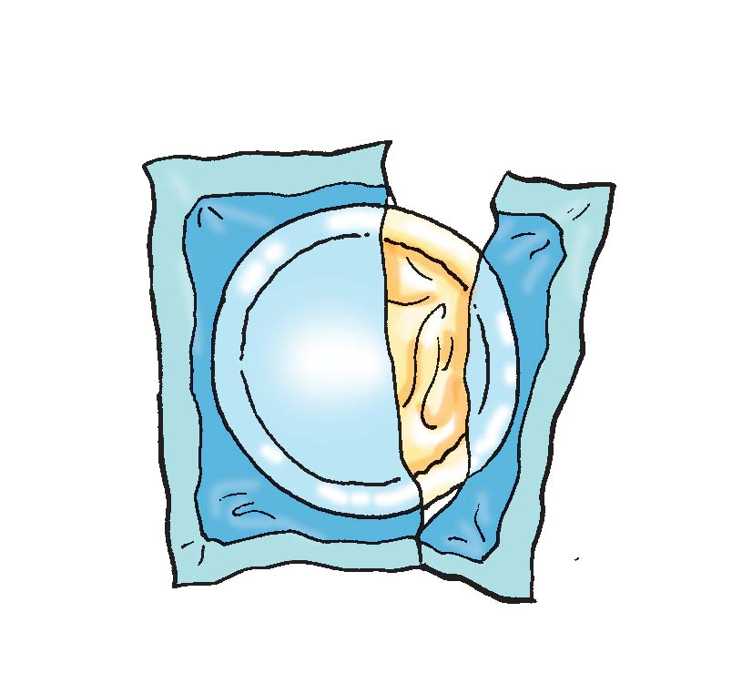 | - Kodi ndi chiyani?Kuyamwitsa mwakathithi ndi kumpatsa mwana mkaka wammawere okha basi kwa miyezi yokwana isanu ndi umodzi (6) yakubadwa.  - Kodi phindu lake ndi lotani?Pali ubwino woyamwitsa mwana mwakathithi kwa mai komanso kwa mwana. Kwa mai, zimathandiza kupeza bwino msanga akangobereka kumene komanso zimachepetsa chiwopsyezo chamatenda monga khansa kapena matenda ena amgonagona. Kwa mwana, zimathandiza kumtetedza kumatenga monga otsegula mmimba, ndi ena a mmapapu. Mkaka wamawere umapereka zonse zofunikira zamadyedye ndi madzi pa thanzi lamwana kwa miyezi yoyambirira isanu ndi umodzi (6).  - Angandithandize ndi ndani kuyamwitsa mwakathithi?Anthu apabanja panu akhodza kukuthandizani

Zokudya zowonjezera
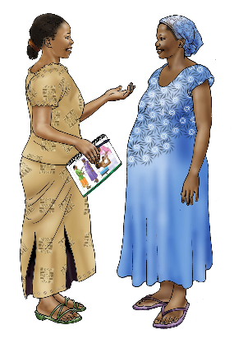 | - Kodi ndi chiyani? Izi ndi zakudya zimene timampatsa mwana akapyola miyezi isanu ndi umodzi (6) kuonjezera mkaka wammawere. Zakudyazi ndi monga phala loikidwa msinjiro komanso zamasamba.  - Kodi phindu lake ndi lotani? Mwana akapyola miyezi 6, mkaka wammawere sumapereka zokudya zoyenerera zonse pa zofunikira mmene mwana akukula. Zakudya zowonjezera zija zimathandiza kulimbikitsa kuti mwana azikula ndi thandzi komanso wamphamvu.  - Kodi angandithandize ndi ndani? Amayi komanso aliyense amene angathe kusamalira mwana athu kukuthandizani.

Kudyetsa mwana yemwe wadwala
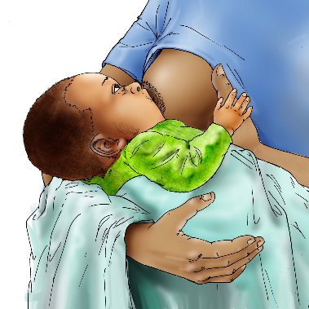 | - Kodi ndi chiyani? Uku ndikumdyetsa mwana nthawi imene akudwala komanso akachira  - Kodi phindu lake ndi lotani? Pamene mwana akudwala, chilakolako chakudya chimachepa. Kumdyetsa mwana oamene akudwala zimathandiza kuwonetsetsa kuti ana akulandira chakudya chopatsa thanzi chimene chithandizire kuti mwanayo achire.  - Kodi ndi ndani angandithandize? Amayi komanso wosamalira angathe kuthandiza

Chisamalira cha mayi apakati
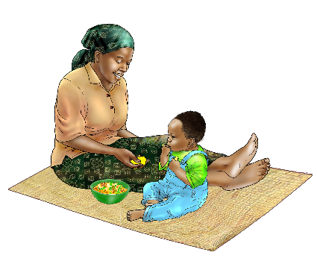 | - Kodi ndi chiyani? Ichi ndi chisamaliro chaku chipatala chimene mayi apakati amalandira. Chisamalirochi amayenera alandire kosachepera maulendo anayi oyendera kuchipatala asanachire.  - Kodi phinud lake ndi lotani? Kupita ku sikelo mayi apakati kumathandiza kuti adziwe za mmene angakhalire wathanzi komanso zimathandiza kupewa mavuto amene amadza kamba ka uchembere.  - Ndi ndani angandithandize? Anthu apabanja pano angathe kukuthandiza mai apakati kuti alandire thandizo lakuchipatala

Ukhondo ndi Madyedwe abwino
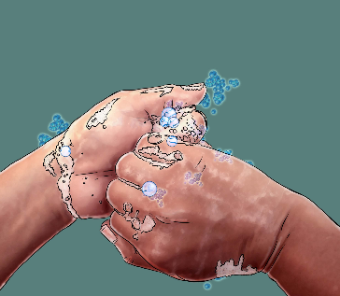 | - Kodi ndi chiyani? Uku ndikulimbikitsa ukhondo ndi chisamaliro makamaka pakakonzedwe ka chakudya. Izi ndi monga kusamba mmanja tisadakonze chakudya, tikasintha mwana thewera kapena tikachoka ku chimbudzi. Ukhondo ndi madyedwe abwino zimakhuzanso kukhala ndi kugwiritsa ntchito chimbudzi, osati kuchita chimbudzi patchire.  - Kodi phindu lake ndi lotani? Kukhala ndi makhalidwe aukhondo pokonza chakudya komanso pakudya zimathandiza kupewa matenda ofala ndi tizilombo.  - Ndi ndani angandithandize ine? Anthu onse apabanja panu akhoza kukuthandizana pa za ukhono ndi kadyedwe kabwino

Kulera
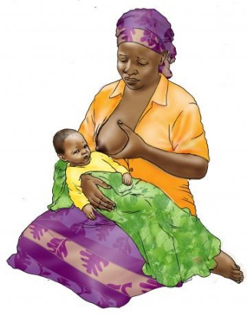 | - Kodi ndi chiyani? Kulera ndi ndondomeko yopereka mpata kapena nthawi pobereka kuti ana  - Kodi phindu lake ndi lotani? Mabanja amene amatha kudikira osatenga pakati kwa zaka ziwiri atachira ku mimba ina amakhala pa chiwopsyezo chochepa kwambiri ku mavuto amene amadza kamba ka umchembere. Ana amene amabadwa ku mabanja oterewa sakhala onyentchera nthawi zambiri.  - Ndi ndani angandithandize? Abambo kapena mayi mbanja lanu

Bank yachiwongolera cha mene mungapangire ntchito yalingalira
Gawo ili lili ndi mafunso ama malingaliro okuthandizirani/kukuwongolerani mene mungapangire ntchito yakulingalira yokhudzana ndima luso komanso upangiri/ukadaulo wochitira zinthu. Cluster leader atha kusankha mafunso angapo omwe angagwiritse ntchito pa mfundo/ntchito iyi yakulingalira.
- Pamene mumayeselera ma luso kapena ma upangiri, panali chinthu china chili chobse chomwe chinali chachilendo kwainu?
  - Ngati inde, chachilendochi chinali chani?
- Kodi lero mwaphunzirako china chili chonse chomwe chitasinthe mene mumaperekera uphungu kwa ma nyumba oyenderedwa?
  - Chifukwa chiyani mutasinthe/ chifukwa chiyani simusintha?
- Ndi chiyani chimene mwachikonda pamene mumayeselera?
- Ndi chiyani chimene simunachikonde pamene mumayeselera?
- Mukuona ngati zinali zovuta pamene mumayeselere?
  - Ngati zinali zovuta, chinapangitsa ndi chani kuti zivute?
- Pazinthi zomwe tayeselera lero, ndi gawo liti limene liinali lotsamwitsa?
  - Kodi tingapange chani kuti kutsamwitsaku kusamakhalepo?
- Kodi zionetsero zimenen taoanga lero, munayemba mwapangako nthawi imene mukupereka uphungu kwama nyumba oyenderedwa?
  - Ndizionetsero ziti zimene mumagwiritsa gwiritsa ntchito nthawi imene mukupereka uphungu?
- Kodi muli ndi funso lina liri lonse lokhudzana ndi ma luso kapena upangiri ?

1
USAID Advancing Nutrition is the Agency’s flagship multi-sectoral nutrition project, addressing the root causes of malnutrition to save lives and enhance long-term health and development.
This document is made possible by the generous support of the American people through the United States Agency for International Development (USAID). The contents are the responsibility of JSI Research & Training Institute, Inc. (JSI), and do not necessarily reflect the views of USAID or the United States government.

USAID ADVANCING NUTRITION
Implemented by:
JSI Research & Training Institute, Inc.
2733 Crystal Drive
4th Floor
Arlington, VA 22202
Phone: 703–528–7474
Email: info@advancingnutrition.org
Web: advancingnutrition.org
December 2023

