Table of Contents
Background of this tool 2
Instructions for Using the Template 3
Adaptable Template for Facilitating a Skills Building Session 3
1. Begin the session with a welcome exercise. 3
2. Review adult learning principles 3
3. Soft skill or technical area practice. 3
4. Facilitated reflection on the practice. 5
5. Invite new commitments to practice soft skill or technical competency with suggestions for how
to support one another. 5
Reference Information 6
Adult Learners 6
Welcome Exercise Bank 7
Soft Skills Bank 8
Teamwork 8
Problem Solving & Critical Thinking 9
Communication 9
Adaptability 10
Time Management 10
Interpersonal 11
Technical Competency Bank 11
Family Planning 11
Prenatal Care 12
Exclusive Breastfeeding 12
Complementary Feeding 12
Nutrition and Hygiene 13
Sick Child Feeding 13
Facilitated Reflection Bank 13

Background of this tool
This guide was developed based on feedback from caregivers (“household beneficiaries''), cluster leaders, and care group promoters of care groups supported by Akule ndi Thanzi program in Kuluunda, Mwanza, Msakambewa, and Chakhaza Traditional Authorities (TA). It is reflective of the challenges and opportunities to support behavior change they described and prioritized in TA-level workshops. These challenges and opportunities included: cluster leaders desire for increased capacitation on technical skills; and an indication of inadequate or neglected counseling of household beneficiaries.
Who uses this tool? | The facilitator is a Care Group Leader
How do they use this tool? | The facilitator can use the adaptable template to guide facilitation of a care group meeting. There are banks of focus topics and practice exercises that the facilitator can use to develop a detailed care group meeting agenda.
What is this tool for? | Support for care group members (“cluster leaders”) to further develop their technical skills, soft skills, and practical understanding of adult learning principles to strengthen their capacity for high-quality counseling.
Who is the audience of the facilitator? | Care group members (“cluster leaders”)

Tips for facilitators to encourage participation from shy members
You may notice that there are some members in your care group that do not feel comfortable speaking up right away. The welcome exercises in this job aid are designed to help these members become more comfortable and to allow them a chance to warm up. However, sometimes some members are naturally shy and quiet. In order to make sure shyer members also have the opportunity to participate, here are a few tips:
- Pay attention to those members that may not have been very vocal; if they appear to wish to say something, make sure to give them your undivided attention and invite others to listen to what they have to say, too.
- If the same few members have been dominating the conversation, make sure to specifically ask those who have not contributed what they think, how they feel, and what their experiences are as it relates to the topic at hand. Using their names can help, too, for example, “Thank you for sharing everyone; Grace, what do you think?”
- When shyer participants finally do speak up, make sure to positively reinforce their participation by thanking them, repeating what they said to make sure you understood, and verbally affirming the relevance of their contribution.
- Make sure all participants know that there is no way to “fail” this session; their contributions are valued and will never be “wrong” and there is very rarely a “correct answer”. Remind all participants that this is a safe space to try new ways of doing things without fear of failure or judgment.

Instructions for Using the Template
This template has been developed to support the facilitation of a skills building session. The promoter can use this template to aid their facilitation of the skills session. Each section of the template includes a suggested amount of time to dedicate to the section and suggestions for how to implement. Content in each section of the template can be repeated or rephrased to reinforce the learning as necessary. The session is intended to take the entire care group meeting; estimated to take 1 hour and 45 minutes.

Adaptable Template for Facilitating a Skills Building Session

Begin the session with a welcome exercise.
Suggested time: 20 minutes
Opening Statement for the Session: Thank you very much for taking time to join the session today. The purpose of today’s session is to [practice some soft skills that help improve care groups] OR improve some [technical capacities relevant to care groups you may lead].
Cluster leaders may choose to begin the session with a song, dance, or prayer prior to doing a welcome exercise. If there are new members of the group, make sure to have everyone introduce themselves.
Cluster Leaders may then choose to select one or more of the welcome exercise options in the bank on page 8 or use their own welcome exercise. Welcome exercises should be selected based on interest and the amount of time available. All cluster group members should participate in the welcome exercise. If some members are reluctant to speak or participate, Cluster Leaders should implement one of the “Tips for facilitators” on page 3 of this guide.

Review adult learning principles
Suggested time: 10 minutes
Adults learn differently than children. To best support adults in learning and practicing new skills, it is necessary to use adult learning principles, as adults learn differently than children. The promoter can use the script below to facilitate a discussion about adult learning principles.
Illustrative script:
- Promoter: Now that we’re all warmed up, let’s review some adult learning principles. These principles will help us best support adults in learning and practicing new skills. What do you know about teaching adults? How is it different from teaching children?
[Pause for responses from cluster leaders]
- Cluster Leader: [shares knowledge on adult learning principles]
- Promoter: Great, thank you [names of individuals who shared]. Some other adult learning principles include, [share any principles from the list on page 7 that have not been addressed].

Soft skill or technical area practice.
Suggested time: 50 minutes
The Promoter can invite the group to practice a soft skill or technical area using the proposed practice exercises in the soft skills bank (page 9) and technical competency bank (page 13) sections of this guide. The soft skills and technical competencies included in the bank are noted in the table below. Each care group should select one soft skill and one technical competency to focus on. If you choose to extend the agenda (give more time to the meeting) you could practice multiple soft skills or multiple technical skills.
Remember! It is important NOT to overload the session with too much information — focus on quality over quantity for the session goals and agenda.
Soft Skills | Technical Competencies
- Teamwork  - Problem Solving & Critical Thinking  - Communication  - Adaptability  - Time Management  - Interpersonal | - Family Planning  - Prenatal Care  - Exclusive Breastfeeding  - Complementary Feeding  - Sick Child Feeding  - Nutrition and Hygiene
The following illustrative script is one suggestion for how the promoter can facilitate the selection of a soft skill or technical competency to focus on during the session. Remember, the cluster leaders should provide insight into which soft skill or technical area they would like to focus on for the session.
Illustrative script:
- Promoter: Now that we’ve been reminded of adult learning principles, let’s discuss a soft skill or technical area that we want to focus on for today’s session. Does anyone have a particular soft skill or technical area they would like to discuss?
[Pause for responses from cluster leaders. If no one suggests a topic, consider reminding cluster leaders of the soft skills and technical areas they could discuss with this guide.]
- Cluster leader: [shares a soft skill and/or technical area they would like to focus on.]
- Promoter: Great! Thank you, [names of individuals who shared potential focus topics]. Let’s start by reminding ourselves what we mean when we say [soft skill or technical area]. [Share definition and example of selected soft skill or technical area from the guide]. Does anyone have any questions about this topic or the definition?
[Pause for responses from cluster leaders and respond to questions to clarify as needed]
- Promoter: Now that we have a clear and unified understanding of [soft skill or technical area] let’s do an activity to practice using it.
[Select a practice exercise from the soft skills and technical competencies banks on page 9 and 13 in this guide.]
Suggestion: If there is extra time in this section. Promoters may consider incorporating a role play or drama based on the selected [soft skill or technical competency]. For example, Cluster Leaders could act out how they would teach the selected technical competency.

Facilitated reflection on the practice.
Suggested time: 20 minutes
The Promoter can invite the group to participate in a reflection exercise by asking care group participants about their experience with the soft skill and/or technical competency. Suggestions for reflection questions are included in the facilitated reflection bank on page 7 of this guide. The Promoter may select 3-5 reflection questions.
Suggestion: During the reflection, invite care group members to raise their hand when they have something to share, the promoter can then call on one person at a time, ensuring that everyone has a chance to speak. If some group members are not participating, you may consider inviting quieter members to share their thoughts and opinions.

Invite new commitments to practice soft skill or technical competency with suggestions for how to support one another.
Suggested time: 5 minutes
The Promoter can invite new commitments to practice the soft skill or technical competency with suggestions for how cluster leaders can support each other. To do this, the promoter might consider asking: How can we support each other in continuing to build the skills we practiced today?
The promoter can invite each cluster leader present to share a commitment and offer support to another person in the care group.

Reference Information
The sections below are intended to provide additional background on the specific needs of adult learners and to share exercises that Promoters can use within the template.

Adult Learners
After facilitating a conversation on adult learning principles, Cluster Leaders should remind cluster group members of any
- Lessons draw on past learning experiences and leverage member experiences
Example: When counseling a caregiver about the importance of sick child feeding, MaRuth may share about a personal experience of feeding her own child while they were sick.
- Participants learn by doing and have opportunities to practice new skills to solve a relevant problem
Example: When assisting a mom who is having difficulty latching her baby at the breast, MaMpfufu assists the mom in practicing different positions and strategies rather than just talking with her about the solutions.
- Participants can reinforce their learning through teaching others the new skill or information
Example: After learning about complementary feeding, MaBlessing teaches her sister, who also has a small child, about the importance of complementary feeding.
- Participants have adequate time for learner feedback and reflection
Example: After being taught about different family planning methods, household beneficiaries are given time to understand and ask questions.
- Participants commit to adopting a new skill or applying new information
Example: After being taught about complementary feeding, household beneficiaries are invited to commit to adopting this feeding practice.
- Participants can self direct their learning by choosing their own learning method and setting their own pace
Example: Instead of having a predetermined list of topics to cover, ask the household beneficiaries if there is something specific that they would like to learn about.
- Participants’ accomplishments are recognized
Example: MaRuth is celebrated for successfully continuing exclusive breastfeeding for six months.

Welcome Exercise Bank
Cluster Leaders may select one (in addition to a song/dance) of the welcome exercise options below, or use their own welcome exercise.
- Song and dance: Invite care group members to share their name and one-word of how they are feeling today. Then, invite care group members to suggest a well-known song and dance that everyone can stand and do together at the start, even prior to the other welcome exercise chosen. Make sure that everyone is at least a little bit familiar with the song and dance, and try to select a song and dance that one of the members can “lead” (perhaps they know all the words to the songs and all the steps to the dance).
- I appreciate … : Invite care group members to share what they appreciate about one other person in the group. Each group member can take a turn doing this by saying "I appreciate..." followed by what they appreciate about someone else in the group. Ideally, each person in the group should have at least one comment expressed about them.
The Cluster Leader can start the exercise and pass to 1) the person to her right (to ensure all members of the group both express a statement of appreciation as well as receive a statement of appreciation) or 2) the person she identified in her “I appreciate” statement. If there are any members of the care group who are not specifically recognized, a strong facilitator can share “I appreciate” statements to those people. The facilitator can also ask everyone to share an “I appreciate” about the person seated to their right/left.
- Draw your neighbor: Divide Care Group members into pairs for this activity. Instruct each pair to take turns asking each other questions about their daily routines, like "What do you wear?" "what do you do when you first wake up?", etc. As one person responds, the other tries to draw what that person is describing using a stick to make lines in the soil or a pencil to draw on paper.
  - Option 1: One person asks questions of their partner for four minutes. At the end of four minutes, the partners switch, so the person answering the questions is now asking the questions.
  - Option 2: Members of the pairs take turns asking questions and drawing each other
At the end of 8 minutes, the two can share and discuss their drawings.
- Search for the rainbow: As a group, look for at least one (but potentially more) items from each color of the rainbow that is visible in the space around you. How many red things do you see? Orange? Yellow? Green? Blue? Purple?
- Guess an animal: Divide Care Group members into pairs for this activity. Instruct each person to think of an animal. Each pair should take turns asking “yes” or “no” questions about the animal they’re thinking of until they are able to guess the animal.
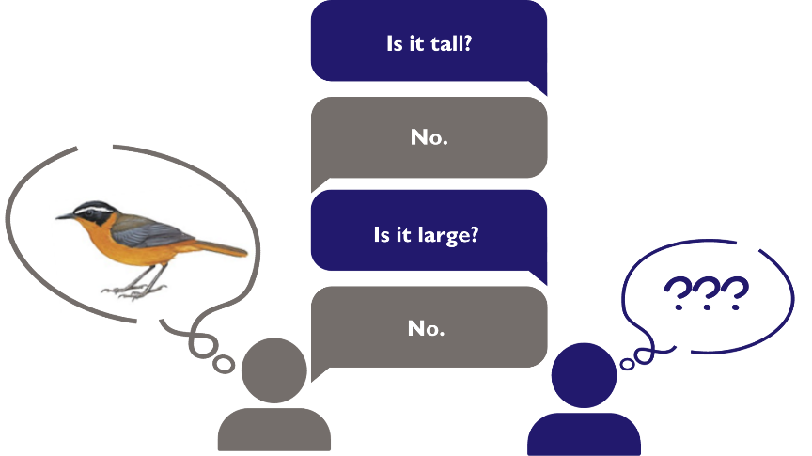
- Built on a phrase: Sit in a circle. One person asks the person to their right, "describe your week in one phrase". The next person asks a question that, for them, is answered by a short phrase that answered the last question. Keep going around the circle, from person to person.
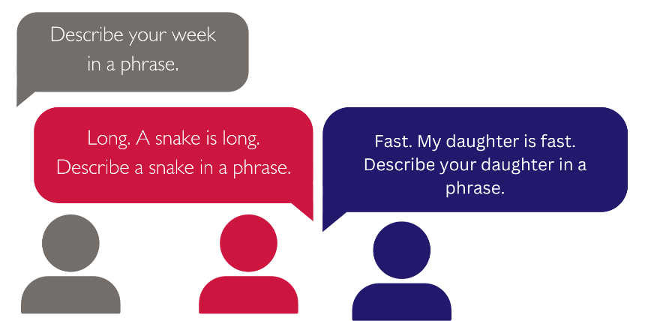

Soft Skills Bank
Select one of the soft skills below to discuss and practice using the proposed practice exercises.

Teamwork
Teamwork is the ability of two or more people to work together on a shared goal.
Example of teamwork: MaRuth needs to prepare a meal for her household. She asks her husband to get the ingredients she needs from the market and works with her mother-in-law to gather other ingredients in the garden. When she has all of the ingredients she and her mother-in-law work together to prepare and serve the meal.
Practice Exercise Options:
- Relay: Caregroup members are split into two teams with an even number of participants. Each team sends one person at a time to walk/run to a designated point 5-10 meters away. Once one team member reaches the designated point, the next team member can begin. The goal is to get all members of the team to the designated point quicker than the other team.
- Shared task: Work together in groups of two or more people to identify a household task and complete it together. These tasks may include preparing food, keeping the home, or tending to the garden.

Problem Solving & Critical Thinking
Problem solving is the ability of two or more people to define a challenge and work together to identify a solution. Problem solving requires critical thinking.
Example of problem solving: MaLaurette is struggling to get her 2 week old baby to latch properly when breastfeeding. She asks her friends in her care group for help, “how did you get your baby to latch?” Together, they discussed what was difficult and what worked well in their experiences to give MaLaurette ideas to try to solve her problem.
Critical thinking is a process wherein a person reflects on what they know or on their personal experiences and uses that information to analyze a current situation. If appropriate, the individual may choose to take action to respond to the current situation.
Example of critical thinking: The promoter for MaMpfufu’s care group has an emergency and cannot come to the care group session. MaMpfufu reflects on her knowledge of behaviors cluster leaders promote to beneficiaries as well as her experiences coming to previous care group sessions. She thinks she and others in the group can meet successfully without the promoter for today’s session.
Practice Exercise Options:
- Carry the beans: Care group members will work in pairs or small groups to build a small vessel (cart, basket, etc.) which is able to carry five beans. The small vessel must be constructed of “found” materials that are available in the caregroup meeting space. After the allotted time, groups will take turns testing their vessel to see if it is able to functionally carry the beans.
- Human knot: Care group members begin by standing in a circle. Each person then reaches across the circle to hold hands with two different people (holding one person’s hand with your right hand and a different person’s hand with your left hand). Care group members must then work together to untangle the “knot” without letting go of each other’s hands. In the end you should have a complete circle.

Communication
Communication is the ability of one person to clearly convey an idea to another person or group of people through words and non-verbal expressions (such as body language).
Example of verbal communication: MaLaurette asking for help or giving advice.
Example of non-verbal communication: MaRuth makes a negative facial expression to an idea MaLaurette suggests. MaLaurette infers from MaRuth’s expression that MaRuth does not like the idea. MaLaurette could consider asking MaRuth about her thoughts on the idea to learn more.
Practice Exercise Options:
  - Charades: In this exercise care group members will act out a word or phrase for other members of the group to guess. The promoter will begin by identifying several words or phrases that everyone in the group will recognize. Each care group member will take a turn. When it is their turn, the promoter will quietly tell them one of the identified phrases so that the other members of the group cannot hear. The care group member will then act out the word or phrase without speaking, The rest of the care group members will try to guess the word or phrase.
  - Telephone: One member of the care group will come up with a phrase. They will then whisper this phrase to the person next to them. Each subsequent person will whisper the phrase to the person next to them until each person has heard the phrase. Compare the phrase that the last person heard to the originally intended phrase.

Adaptability
Adaptability is the ability of one or more individuals to adjust to changes. Like problem solving, adaptability involves critical thinking and communication.
Example of adaptability: The promoter for MaMpfufu’s care group has an emergency and cannot come to the care group session. MaMpfufu and her friends in the care group work together to host the session in absence of the promoters.
Practice Exercise Options:
  - Rule revision: This exercise will require cluster group members to adapt to changing rules. The group begins by counting to 10 in a circle, with each person saying a single number. The person who says 10 is then responsible for creating a rule for the next cycle, for example, “clap when you say 2” or “stand up when you say 4”. The group then counts to 10 again, while implementing the new rule. The group can continue to repeat and add additional rules.
  - Music Mix-up: Select a song that everyone knows the words to. As a group, work together to change the words of the song while retaining the meaning or message.

Time Management
Time management is the ability of an individual to use an appropriate amount of time to complete a task or activity.
Example of time management: MaMpfufu has a care group meeting at 13:00 and she knows she needs to have a meal ready for her child before she leaves. MaMpfufu knows that means she has 30 minutes to prepare the meal and arrive at the care group session on time. She uses 30 minutes and no additional time to prepare the meal before she goes to the care group.
Practice Exercise Options:
- Tick Tock: Care groups members identify a household task and estimate how long it will take to complete. For example, “how many times will you need to repeat your favorite song to complete this task?” The care group members then attempt the task to see if it can be completed in the estimated length of time. The team then adjusts their estimated time based on how many repetitions of the song were required to complete the task.

Interpersonal
Interpersonal (people) skills are an individual’s ability to listen, be empathetic and/or kind, positively manage conflict, and discuss with others.
Example of using interpersonal skills: MaBlessing is very tired from a long day working in the garden, her friend asks her a question that frustrates her. Instead of being frustrated or upset with her friend, she is empathetic and responds to the question with respect and kindness.
Practice Exercise Options:
- Peer-to-peer check in: Cluster leaders will pair up cluster group members each session so that members are working with a new partner each time. Pairs take turns asking each other general questions like, “How was your week?” “How is your family?” etc.

Technical Competency Bank
This section includes an overview of technical content related to “essential nutrition actions”, hygiene, and family planning.

Family Planning
- What is it? Family planning is a practice of controlling the number of children in a family and the amount of time between pregnancies.
- What is the benefit? Families who delay a new pregnancy for two years after the birth of the previous child are less likely to experience pregnancy complications. Infants born to parents who delay pregnancy for at least two years are more likely to be adequately nourished.
- Who can help me practice it? Spouses can assist by being supportive of family planning choices.

Prenatal Care
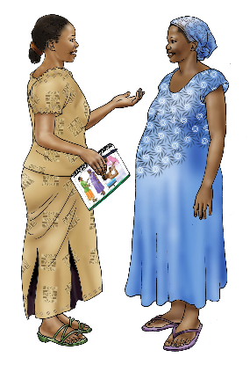 | - What is it? Prenatal care is healthcare that women receive while pregnant. This should include a minimum of four prenatal visits.  - What is the benefit? Attending prenatal care allows women to be informed about behaviors to promote a healthy pregnancy and may aid in identifying or preventing pregnancy complications.  - Who can help me practice it? Household members can make sure that pregnant women are attending their prenatal care appointments

Exclusive Breastfeeding
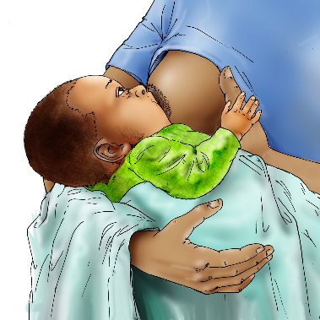 | - What is it? Exclusive breastfeeding is feeding only breastmilk (no other food or drink) for the first 6 months of a baby’s life.  - What is the benefit? There are benefits to exclusive breastfeeding for both mother and infant. For mothers, exclusive breastfeeding promotes a quicker recovery after birth and reduces the risk of developing reproductive cancers and chronic diseases. For infants, exclusive breastfeeding protects against infection including diarrhea and respiratory infections. Breastmilk provides all of the nutrition and hydration infants need in the first 6 months.  - Who can help me practice it? Family members who have breastfeeding experience can assist by offering guidance on how to position babies for breastfeeding.

Complementary Feeding
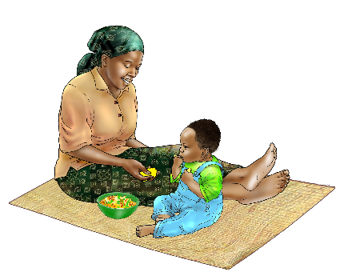 | - What is it? Complementary feeding is the introduction of foods in addition to breastmilk after 6 months of age. Complementary foods may include porridge with the addition of groundnuts or vegetables.  - What is the benefit? After 6 months, breastmilk does not provide all of the nutrients to support a baby's growing nutritional needs. Complementary feeding introduces important nutrients to support baby’s growth and development.  - Who can help me practice it? Mothers, fathers, and caregivers who have experience with complementary feeding can assist by suggesting complementary foods to feed the baby as it grows.

Nutrition and Hygiene
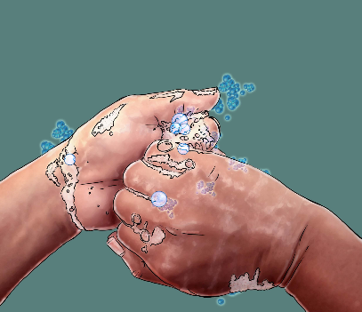 | - What is it? Nutrition and hygiene is practicing adequate sanitation and hygiene, particularly before preparing and eating food. This includes washing hands prior to preparing food, especially after changing a baby’s diaper or going to the bathroom. Nutrition and hygiene also includes the building and use of a latrine rather than practicing open defecation.  - What is the benefit? Using these hygiene practices when eating and preparing food will help to prevent the spread of infection and disease.  - Who can help me practice it? All family members can support practicing nutrition and hygiene by washing their hands prior to preparing food.

Sick Child Feeding
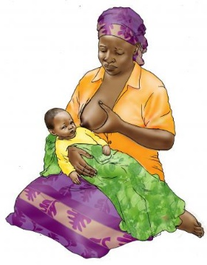 | - What is it? Sick child feeding is the feeding of a sick child during and after illness.  - What is the benefit? During illness, children may have decreased appetite, sick child feeding ensures that children are receiving sufficient nutrients to recover from illness.  - Who can help me practice it? Mothers, fathers, and caregivers who have fed a sick child can provide guidance on how to encourage children to eat, even with decreased appetite.

Facilitated Reflection Bank
This section includes suggested questions for facilitating a reflection on the soft skill or technical competency. Cluster Leaders may select a few questions for the reflection activity.
- While practicing the [soft skill or technical competency] was there anything that was new to you?
  - If yes, what was new?
- Did you learn anything today that will change how you perform counseling sessions with household beneficiaries?
  - Why or why not?
- What did you like about the practice exercise?
- What didn’t you like about the practice exercise?
- Did you find the practice exercise difficult?
  - If yes, what made it difficult?
- What was the most challenging exercise we did today?
  - How can we address this challenge?
- Have you done any of the exercises we did today during counseling sessions with households before?
  - What other exercises do you normally use during counseling sessions?
- Do you have any questions about the [soft skill or technical competency]?

1
USAID Advancing Nutrition is the Agency’s flagship multi-sectoral nutrition project, addressing the root causes of malnutrition to save lives and enhance long-term health and development.
This document is made possible by the generous support of the American people through the United States Agency for International Development (USAID). The contents are the responsibility of JSI Research & Training Institute, Inc. (JSI), and do not necessarily reflect the views of USAID or the United States government.

USAID ADVANCING NUTRITION
Implemented by:
JSI Research & Training Institute, Inc.
2733 Crystal Drive
4th Floor
Arlington, VA 22202
Phone: 703–528–7474
Email: info@advancingnutrition.org
Web: advancingnutrition.org
December 2023

